**Testing – Philip Mortimer**

Testing Approach

In order to test my system, I have decided to make use of a number of testing methods to ensure that my system ultimately operates as well as possible. At all testing stages, I will endeavour to fix any problems identified and perform additional tests to verify that the problem has indeed been fixed. However, certain bugs may be acknowledged but not fixed if appropriate. I have decided that I will first employ acceptance testing using my knowledge of how the system should perform and compare that with what the system actually does. This is essential as if my system does meet the acceptance testing criteria, I know that my system performs as desired (and hence has been successful). My acceptance testing will constitute as my alpha test phase. My final component of the testing plan involves giving my friends and peers access to an executable version of my system. This will be my beta test phase and will hopefully identify most major issues with the system. Unlike my acceptance testing (which is white box), the beta testing phase will be black box. As my system makes use of networking, beta testing is crucial as many errors will only become apparent through system use by multiple users concurrently. This is hard to emulate with acceptance testing as I will be performing it on my own. The goal is that once all testing stages are performed, I will have a strong idea about which parts of my system do and do not function. The goal is to verify that the system is broadly suitable for use and meets the requirements of my client.

Aims and Objectives

1. The system will allow users to log in by providing an email address, username, and password. Both the email address and username must be unique.
   1. To create a database that stores all relevant details, including user details, in the third normal form.
      1. All data stored must have no repeating groups, partial dependencies or transitive dependencies.
      2. Users will be able to log in to the system by providing their email address / username and password. Once logged in, they will be able to view their details such as their ranking or fixtures (if they are a member of the club).
   2. To check that both the email address and username provided are not already the username or email address of another user. This will be done by searching the file storing all user details.
      1. When attempting to create an account, users who input the email address or username of another user will be unable to use that name and will be asked to choose a different one.
      2. When creating an account, a username / email address that has not already been used by another user should be accepted.
   3. To search both user email address and username to find a match when logging in.
      1. Users should not be able to create a username that could be a valid email address. This will be achieved by not allowing @ character in usernames and requiring the @ character in email addresses.
      2. Users will be able to log-in by providing either their email address or username.
2. Players may choose to play as guests who require no passwords but will have more limited features available to them. Guests will be unable to access features such as the club section but will be able to access offline play.
   1. When a guest uses the system, they will be given one id that all guests have. This id will be impossible for a normal user to have. With this guest id, the guest will have the ability to play offline games but will not have a ranking. Hence, the system will have four access levels (for guests, users, club members and the club leader).
      1. A guest will be able to play offline but will not be able to access the club section.
3. There will be an option for users to play online against random people or against friends. People can play against friends by typing in their friend’s username or by sharing a random 6-digit code generated by the system. Users will be able to customise the ruleset for online play to allow for correspondence play and playing on a timer.
   1. The server will have a text file storing all currently ongoing online games. Each time a new game is created, a game id will be generated for it. This will be the six-digit code that users can share. Furthermore, it will store details such as the board state and the user id of players, as well as the ruleset.
      1. Users will be able to play against friends either by sharing a six-digit code or by typing their username. The ruleset for these games will be customisable.
   2. Players will be able to play against random people by pressing a button. They will be matched against another user who also wishes to play online against a random opponent. This will be achieved by requesting to play a random game. The game will then be created when another user makes such a request.
      1. Users will be able to play against random opponents.
4. Users will be able to play chess locally against each other with users using the same computer to play against each other.
   1. A file containing all ongoing offline games will be stored. This will store up to three current games. When a file is clicked on, the game is resumed.
      1. Users will be able to play up to three offline games at a time over multiple session.
   2. Users will be able to play offline and customise the time controls. Each offline game will be given a game id.
      1. When creating a game, users can choose which time control they would like to use. This time control will then be used for the game. This includes the option for no time restrictions.
5. Users will be able to play against a computer of 5 levels of varying difficulty, which should range from easy to challenging.
   1. I will use a depth limited alpha-beta pruned minimax algorithm to deduce which moves should be made. The varying difficulty will come from use of heuristics of different complexities in combination with different search depths.
      1. I will play each of the computer algorithms and rank them in order from easiest to most difficult. Then I will have the computers play each other. If my ranking is the same as the ranking obtained from playing the computers against each other, I will have clearly succeeded in creating five distinct difficulty settings.
6. When playing against the computer or locally, the user should be able to customise timer settings and decide who is what colour.
   1. Create a visual menu that allows the user to select from a range of a time controls, including unlimited and five or ten minutes. Users will also be able to decide what level of computer to play against and whether the computer is white, black or random. These settings will be stored, and a new game will be created.
      1. A user should be able to play local games using various different time controls and against a computer of varying difficulty. This can be verified by testing how long it takes for a user to lose due to running out of time.
7. The system will have a West Cross Chess Club section where Lewis James will have the ability to add, edit and delete member details.
   1. The server will store details of all club members in a table that is in the third normal form. Lewis James will be able to retrieve and view this information. He can then edit user details, which will be updated on the server. He can also remove users from the club or add users to the club. This will be achieved by updating the file on the central server.
      1. The club leader will be able to view all member details and edit these. The leader will also be able to remove or add members to the club. This can be shown to have been successful by viewing club details after changes have been processed.
   2. The club leader will be able to view the user information of non-club members. This information will be editable. The leader will also be able to remove non-members from the system database.
      1. The club leader will be able to view, edit and delete non-member information.
8. Users will be able to request to join the club, a request which the leader can either approve or reject.
   1. Users who are not a member of the club will click on the club section and have the option to send a request to join the server. If they choose to send the request, the request will be sent to the server. The server will then store this request. The leader, currently Lewis James, will then have the option to allow these members to join the club or to reject the request.
      1. Users will be able to request to join the club and Lewis James will be able to see these requests. Lewis James will then either approve or deny these requests. This can be verified through testing by sending a request and seeing if it shows up for the leader. Then, the leader will accept the request. If the user who requested to be a member is now part of the club, the objective will have been fulfilled.
9. The West Cross Chess Club section will generate the fixtures given the name of the people in the chess club. This will result in users playing each other exactly twice.
   1. The computer will use the list of current members to generate a fixtures list for the season.
      1. If the system generates fixtures in a way that each user plays each other exactly twice, the algorithm will have succeeded.
   2. The user will be able to view their fixtures in the club section. They will also be able to see the results of any games.
      1. The user will view their fixture in the club section. The club leader will be able to set the result of each game.
   3. The system will collect all results and use them to update the league table standings. The league table, which is stored by the server, can be viewed by players.
      1. Once results have been set by the leader, the league table should be updated to display the new scores and standing.
10. The system will allow the club leader to generate a new season’s worth of fixtures at any time.
    1. The leader will be able to press a button that generates all fixtures from scratch using the list of chess club members stored in the system.
       1. When the leader presses a button, the server should generate the fixture list from scratch.
11. Lewis James will have the option to make another user the club leader if he no longer wishes to be in charge.
    1. The system will store the user id of the club leader. If Lewis James wishes to make somebody else club leader, he will need to know their username. The system will then set this users id as that of the club leader. This will allow the Lewis James to make somebody else the club leader.
       1. The current club leader will be able to transfer the role of club leader to another valid user. If they do choose to transfer the role, the user who they have transferred the role to will be able to perform all the task that only the club leader can perform (such as updating the club’s contact details).
12. The chess game will feature a two-dimensional chess board which allows users to move by clicking on a piece and then choosing from all available moves. The interface should be visually pleasing and clear and should highlight available moves and which piece has currently been selected.
    1. To create a GUI using built in features such as JFrame to display a visually pleasing chess board. The view will be a top-down view of a two-dimensional board and will be similar to chess.com’s board. The control scheme must be very usable and intuitive.
       1. The board must feature a two-dimensional top-down view and be visually pleasing. To test this, I will ask five members whether the board is visually pleasing and looks somewhat similar to typical two-dimensional top-down boards (such as Lichess’ board). If all five members agree, I will have succeeded. I will also ask the members whether the control scheme is usable and intuitive also.
    2. When a piece is selected, the piece is highlighted, and the system calculates all possible moves for the piece to make. These possible moves will be highlighted.
       1. To test this, I will select each piece across multiple games and use my knowledge of chess to determine whether all legal moves have been identified.
13. The menu system should be clean and visually clear, containing a small range of options which allow the user to perform the tasks they wish to.
    1. I will use the built in NetBeans drag and drop GUI builder to create a clear and visually pleasing menu. The menu will be simple and contain a small range of buttons that allow the user to navigate to the desired section of the system.
       1. Navigation should be intuitive and easy, even for novice users. Text and buttons should be readable and large. To measure this, I will ask five members whether they find navigation easy and whether they find the menu clear. If all five agree, I will have succeeded.
14. The system will have a constantly running server application which handles online play and user log in. The server will store all member details, as well as West Cross Chess Club details such as the table as well as a text file containing all ongoing games. The system will communicate with the server to facilitate online play.
    1. The server application will be constantly running and will handle all elements of the club that are online. This includes the creation of accounts, user log-in, online play, storing chess club details, generating fixtures, updating the league table, storing the chess club leader and scheduling fixtures for the chess club.
       1. If players are able to log-in and perform online tasks such as creating an account or playing against a friend online, the objective will have been met.
15. The system will feature contact information for the club and the leader (currently Lewis James) will have the ability to update this information.
    1. There will be a section in the club tab, which will be accessible to all users connected to the internet (including non-club members), which displays the email address and phone number of the club. These details will be stored on the server and the club leader will have the opportunity to update these details.
       1. All users should be able to view the club’s contact details and Lewis James should be able to change these contact details.
16. The system will rank players via their online play results using a ratings system known as ELO.
    1. After each online game, the server will receive the result and calculate the new ELO score for each player following a set of formulae defined earlier in this document. The ELO rating of a player will be stored by the system and displayed alongside username when playing an opponent.
       1. After a game against an opponent, I will calculate what each user’s new ELO score should be and compare it to what the system determined they should be. If these scores equate, the system will have succeeded.
17. When playing online, the system will display both users’ username and ranking.
    1. When matching against an opponent, the server will store both users’ name and ELO rating. These will be displayed to the other user when playing online. These (and all) calculations should be correct and accurate.
       1. When playing online, users should be able to see both their username and ELO rating as well as their opponent’s rating and username.
18. GENERAL OBJECTIVES AND CRITERIA
    1. The system should be easy to maintain. I will achieve this through use of extensive documentation (e.g. comments in code to explain the purpose of methods). Bugs should be easy to identify and fix, something which I will achieve by designing the system in a modular fashion.
       1. A competent programmer should be able to recreate the system given its documentation.
       2. My system will be modular, making use of many independent methods. To test whether my system is easy to debug, I aim for users to encounter no more than three minor bugs in a session and no major bugs in an average session.
    2. The system should fully meet the requirements of the specification.
       1. I will ask Lewis James whether the system performs as he intends it to once I finish it.
    3. Validation should be employed for all appropriate fields of manual data entry.
       1. I will aim to catch at least 90% of invalid inputs.
    4. All calculations performed should be accurate and correct
       1. Calculations such as ELO rating should be accurate and all relevant success criteria relating to ELO calculation should be achieved. All other calculations should be correct, such as the updating of the league table.
    5. The system should be visually clear and easy to navigate. It should be easy to use, even to those unfamiliar with technology.
       1. I will ask chess club members whether they found the system intuitive and easy to use, and if they all agree, I will have succeeded.

Acceptance Testing (Alpha Testing)

Aim and Objectives

|  |  |  |  |
| --- | --- | --- | --- |
| Aim / Objective | Relevant Tests (If Any) | Has been met? (Y/N) | Further Information (If applicable) |
| 1. The system will allow users to log in by providing an email address, username, and password. Both the email address and username must be unique. | 1-4 | Y |  |
| 1 a. To create a database that stores all relevant details, including user details, in the third normal form. | 10 | Y |  |
| 1 a i. All data stored must have no repeating groups, partial dependencies or transitive dependencies. | 10 | Y |  |
| 1 a ii. Users will be able to log in to the system by providing their email address / username and password. Once logged in, they will be able to view their details such as their ranking or fixtures (if they are a member of the club). | 1-4 | Y |  |
| 1 b. To check that both the email address and username provided are not already the username or email address of another user. This will be done by searching the file storing all user details. | 7-9 | Y |  |
| 1 b i. When attempting to create an account, users who input the email address or username of another user will be unable to use that name and will be asked to choose a different one. | 7-9 | Y |  |
| 1 b ii. When creating an account, a username / email address that has not already been used by another user should be accepted. | 7-9 | Y |  |
| 1 c. To search both user email address and username to find a match when logging in. | 1-4 | Y |  |
| 1 c i. Users should not be able to create a username that could be a valid email address. This will be achieved by not allowing @ character in usernames and requiring the @ character in email addresses. | 7-9 | Y |  |
| 1 c ii. Users will be able to log-in by providing either their email address or username. | 1-4 | Y |  |
| 2. Players may choose to play as guests who require no passwords but will have more limited features available to them. Guests will be unable to access features such as the club section but will be able to access offline play. | 11 | Y |  |
| 2 a. When a guest uses the system, they will be given one id that all guests have. This id will be impossible for a normal user to have. With this guest id, the guest will have the ability to play offline games but will not have a ranking. Hence, the system will have four access levels (for guests, users, club members and the club leader). | 11 | Y |  |
| 2 a i. A guest will be able to play offline but will not be able to access the club section. | 11 | Y |  |
| 3. There will be an option for users to play online against random people or against friends. People can play against friends by typing in their friend’s username or by sharing a random 6-digit code generated by the system. Users will be able to customise the ruleset for online play to allow for correspondence play and playing on a timer. | 12-18 and 20-22 | Y |  |
| 3 a. The server will have a text file storing all currently ongoing online games. Each time a new game is created, a game id will be generated for it. This will be the six-digit code that users can share. Furthermore, it will store details such as the board state and the user id of players, as well as the ruleset. | 13-16 and 18 | Y |  |
| 3 a i. Users will be able to play against friends either by sharing a six-digit code or by typing their username. The ruleset for these games will be customisable. | 12-16 and 18 | Y |  |
| 3 b. Players will be able to play against random people by pressing a button. They will be matched against another user who also wishes to play online against a random opponent. This will be achieved by requesting to play a random game. The game will then be created when another user makes such a request. | 19 | Y |  |
| 3 b i. Users will be able to play against random opponents. | 19 | Y |  |
| 4. Users will be able to play chess locally against each other with users using the same computer to play against each other. | 24 and 27 | Y |  |
| 4 a. A file containing all ongoing offline games will be stored. This will store up to three current games. When a file is clicked on, the game is resumed. | 23 and 25 | Y |  |
| 4 a i. Users will be able to play up to three offline games at a time over multiple session. | 23 | Y |  |
| 4 b. Users will be able to play offline and customise the time controls. Each offline game will be given a game id. | 26, 28 and 29. | Y |  |
| 4 b i. When creating a game, users can choose which time control they would like to use. This time control will then be used for the game. This includes the option for no time restrictions. | 26 | Y |  |
| 5. Users will be able to play against a computer of 5 levels of varying difficulty, which should range from easy to challenging. | 30 | Y |  |
| 5 a. I will use a depth limited alpha-beta pruned minimax algorithm to deduce which moves should be made. The varying difficulty will come from use of heuristics of different complexities in combination with different search depths. | 31 | Y |  |
| 5 a i. I will play each of the computer algorithms and rank them in order from easiest to most difficult. Then I will have the computers play each other. If my ranking is the same as the ranking obtained from playing the computers against each other, I will have clearly succeeded in creating five distinct difficulty settings. | 30 and 31 | Y |  |
| 6. When playing against the computer or locally, the user should be able to customise timer settings and decide who is what colour. | 32 | Y |  |
| 6 a. Create a visual menu that allows the user to select from a range of a time controls, including unlimited and five or ten minutes. Users will also be able to decide what level of computer to play against and whether the computer is white, black or random. These settings will be stored, and a new game will be created. | 32 | Y |  |
| 6 a i. A user should be able to play local games using various different time controls and against a computer of varying difficulty. This can be verified by testing how long it takes for a user to lose due to running out of time. | 26 and 32 | Y |  |
| 7. The system will have a West Cross Chess Club section where Lewis James will have the ability to add, edit and delete member details. | 34 – 37 and 41 - 42 | Y |  |
| 7 a. The server will store details of all club members in a table that is in the third normal form. Lewis James will be able to retrieve and view this information. He can then edit user details, which will be updated on the server. He can also remove users from the club or add users to the club. This will be achieved by updating the file on the central server. | 33 – 35 and 37 and 41 - 42 | Y |  |
| 7 a i. The club leader will be able to view all member details and edit these. The leader will also be able to remove or add members to the club. This can be shown to have been successful by viewing club details after changes have been processed. | 33 – 35 and 37 and 41 - 42 | Y |  |
| 7 b. The club leader will be able to view the user information of non-club members. This information will be editable. The leader will also be able to remove non-members from the system database. | 38 - 42 | Y |  |
| 7 b i. The club leader will be able to view, edit and delete non-member information. | 38 - 42 | Y |  |
| 8. Users will be able to request to join the club, a request which the leader can either approve or reject. | 43 - 46 | Y |  |
| 8 a. Users who are not a member of the club will click on the club section and have the option to send a request to join the server. If they choose to send the request, the request will be sent to the server. The server will then store this request. The leader, currently Lewis James, will then have the option to allow these members to join the club or to reject the request. | 43 and 45 - 46 | Y |  |
| 8 a i. Users will be able to request to join the club and Lewis James will be able to see these requests. Lewis James will then either approve or deny these requests. This can be verified through testing by sending a request and seeing if it shows up for the leader. Then, the leader will accept the request. If the user who requested to be a member is now part of the club, the objective will have been fulfilled. | 43 and 45 - 46 | Y |  |
| 9. The West Cross Chess Club section will generate the fixtures given the name of the people in the chess club. This will result in users playing each other exactly twice. | 47 - 50 | Y |  |
| 9 a. The computer will use the list of current members to generate a fixtures list for the season. | 47 - 50 | Y |  |
| 9 a i. If the system generates fixtures in a way that each user plays each other exactly twice, the algorithm will have succeeded. | 47 - 50 | Y |  |
| 9 b. The user will be able to view their fixtures in the club section. They will also be able to see the results of any games. | 51 - 53 | Y |  |
| 9 b i. The user will view their fixture in the club section. The club leader will be able to set the result of each game. | 51 - 53 | Y |  |
| 9 c. The system will collect all results and use them to update the league table standings. The league table, which is stored by the server, can be viewed by players. | 51 - 52 | Y |  |
| 9 c i. Once results have been set by the leader, the league table should be updated to display the new scores and standing. | 51 - 52 | Y |  |
| 10. The system will allow the club leader to generate a new season’s worth of fixtures at any time. | 47 | Y |  |
| 10 a. The leader will be able to press a button that generates all fixtures from scratch using the list of chess club members stored in the system. | 47 |  |  |
| 10 a i. When the leader presses a button, the server should generate the fixture list from scratch. | 47 | Y |  |
| 11. Lewis James will have the option to make another user the club leader if he no longer wishes to be in charge. | 54 -57 | Y |  |
| 11 a. The system will store the user id of the club leader. If Lewis James wishes to make somebody else club leader, he will need to know their username. The system will then set this users id as that of the club leader. This will allow the Lewis James to make somebody else the club leader. | 54- 57 | Y |  |
| 11 a i. The current club leader will be able to transfer the role of club leader to another valid user. If they do choose to transfer the role, the user who they have transferred the role to will be able to perform all the task that only the club leader can perform (such as updating the club’s contact details). | 54 - 57 | Y |  |
| 12. The chess game will feature a two-dimensional chess board which allows users to move by clicking on a piece and then choosing from all available moves. The interface should be visually pleasing and clear and should highlight available moves and which piece has currently been selected. | 58 and beta testing | Y |  |
| 12 a. To create a GUI using built in features such as JFrame to display a visually pleasing chess board. The view will be a top-down view of a two-dimensional board and will be similar to chess.com’s board. The control scheme must be very usable and intuitive. | 58 and beta testing | Y |  |
| 12 a i. The board must feature a two-dimensional top-down view and be visually pleasing. To test this, I will ask five members whether the board is visually pleasing and looks somewhat similar to typical two-dimensional top-down boards (such as Lichess’ board). If all five members agree, I will have succeeded. I will also ask the members whether the control scheme is usable and intuitive also. | 58 and beta testing | Y |  |
| 12 b. When a piece is selected, the piece is highlighted, and the system calculates all possible moves for the piece to make. These possible moves will be highlighted. | 27 | Y |  |
| 12 b i. To test this, I will select each piece across multiple games and use my knowledge of chess to determine whether all legal moves have been identified. | 27 | Y |  |
| 13. The menu system should be clean and visually clear, containing a small range of options which allow the user to perform the tasks they wish to. | 59 - 60 | Y |  |
| 13 a. I will use the built in NetBeans drag and drop GUI builder to create a clear and visually pleasing menu. The menu will be simple and contain a small range of buttons that allow the user to navigate to the desired section of the system. | 60 and beta testing | Y |  |
| 13 a i. Navigation should be intuitive and easy, even for novice users. Text and buttons should be readable and large. To measure this, I will ask five members whether they find navigation easy and whether they find the menu clear. If all five agree, I will have succeeded. | 60 and beta testing | Y |  |
| 14. The system will have a constantly running server application which handles online play and user log in. The server will store all member details, as well as West Cross Chess Club details such as the table as well as a text file containing all ongoing games. The system will communicate with the server to facilitate online play. | 61 | Y |  |
| 14 a. The server application will be constantly running and will handle all elements of the club that are online. This includes the creation of accounts, user log-in, online play, storing chess club details, generating fixtures, updating the league table, storing the chess club leader and scheduling fixtures for the chess club. | 61 | Y |  |
| 14 a i. If players are able to log-in and perform online tasks such as creating an account or playing against a friend online, the objective will have been met. | 61 | Y |  |
| 15. The system will feature contact information for the club and the leader (currently Lewis James) will have the ability to update this information. | 65 - 66 | Y |  |
| 15 a. There will be a section in the club tab, which will be accessible to all users connected to the internet (including non-club members), which displays the email address and phone number of the club. These details will be stored on the server and the club leader will have the opportunity to update these details. | 65 - 66 | Y |  |
| 15 a i. All users should be able to view the club’s contact details and Lewis James should be able to change these contact details. | 65 - 66 | Y |  |
| 16. The system will rank players via their online play results using a ratings system known as ELO. | 62 - 64 | Y |  |
| 16 a. After each online game, the server will receive the result and calculate the new ELO score for each player following a set of formulae defined earlier in this document. The ELO rating of a player will be stored by the system and displayed alongside username when playing an opponent. | 62 - 64 | Y |  |
| 16 a i. After a game against an opponent, I will calculate what each user’s new ELO score should be and compare it to what the system determined they should be. If these scores equate, the system will have succeeded. | 62 - 64 | Y |  |
| 17. When playing online, the system will display both users’ username and ranking. | 67 | Y |  |
| 17 a. When matching against an opponent, the server will store both users’ name and ELO rating. These will be displayed to the other user when playing online. These (and all) calculations should be correct and accurate. | 67 | Y |  |
| 17 a i. When playing online, users should be able to see both their username and ELO rating as well as their opponent’s rating and username. | 67 | Y |  |
| 18. GENERAL OBJECTIVES AND CRITERIA | 1-9, 30 - 31, 37, 39, 41, 42, 51, 60, 62 – 64 and beta testing | Y |  |
| 18 a. The system should be easy to maintain. I will achieve this through use of extensive documentation (e.g. comments in code to explain the purpose of methods). Bugs should be easy to identify and fix, something which I will achieve by designing the system in a modular fashion. | Beta testing | Y | This is the hardest objective to measure and is certainly not a binary pass / fail test. I would argue that my code is well designed and easy to expand. This was one of the core design philosophies when coding the system. For example, I made sure to use constant as opposed to individual numbers wherever possible. This came in very useful when coding the system as I found that data structures sometimes required adaptation to fulfil the system requirements. Due to my code designed to allow easy expansion, I was able to change a single constant value as opposed to changing about 17 instances of an integer. Hence, I would argue that my code is modular and well-written. However, I accept that the matter is very hard to measure and not as simple as either being “good” or “bad”. |
| 18 a i. A competent programmer should be able to recreate the system given its documentation. | N/A | Y | Once more, this is something I cannot test short of paying somebody to code the entire system from scratch given just its documentation. However, I do feel that my code is extensively documented, with all data structures being recorded. Furthermore, my code is fully annotated, with every method having a comment explaining the purpose of it. Therefore, I would argue that my documentation is strong even if I cannot say with complete certainty that a programmer would be able to reproduce the system. But I feel given my detailed documentation and the fact that I produced the system from my design, I feel that there is a very good chance that a competent programmer could recreate the program. |
| 18 a ii. My system will be modular, making use of many independent methods. To test whether my system is easy to debug, I aim for users to encounter no more than three minor bugs in a session and no major bugs in an average session. | Beta testing | Y | When conducting some general use sessions, I experience an average of 0.5 minor bugs in a given session. I encountered no major bugs that broke the system. This data was taken from 10 use sessions, with each session lasting from between 10 minutes – 1 hour. I would say that my code is fairly modular, with my system making good use of generalised methods. I would not say it is perfect though, as I still think that I would make the validation routines more modular if I were to enhance the system further in the future. However, I would say that the system is still highly modular. And I am confident that the code is well-structured as I have found the debugging process for developmental testing to be very easy. Hence, I have decided that the system meets this objective (although I once more acknowledge the slight subjectivity that comes with this objective). |
| 18 b. The system should fully meet the requirements of the specification. | 68 and beta testing |  |  |
| 18 b i. I will ask Lewis James whether the system performs as he intends it to once I finish it. | 68 and beta testing |  |  |
| 18 c. Validation should be employed for all appropriate fields of manual data entry. | 1-9, 37, 39, 41, 42 and 62 - 64 | Y | Validation is employed for all fields where manual data entry is present. |
| 18 c i. I will aim to catch at least 90% of invalid inputs. | 1-9, 37, 39, 41, 42 and 62 - 64 | Y | It is hard to say for certain whether 90% of invalid inputs have been caught. However, the system has successfully validated all erroneous data I have tested. Therefore, I conclude that the system does probably catch at least 90% of invalid inputs. |
| 18 d. All calculations performed should be accurate and correct | 30 – 31, 51 and 62 - 64 | Y | All explicit calculations are evidently correct. Furthermore, my neural network code (which involves many calculations), produced an AI which plays chess far stronger than a random opponent. The system achieves an accuracy of 74% on the test data set, compared to 50% when the weights were initialised randomly. This shows that the calculations performed to train the network were correct. To verify this, I coded a Neural Network that diagnoses skin cancer using the ISIC dataset. My neural network outperformed dermatologists at skin cancer diagnosis. This shows that the Neural Network code does in fact work. This AI can be found in my software development in the “PhilipM CS5 Software Development Neural Network” folder (specifically, execute the .jar file in the zipped folder called “AITumourClasification – Copy”. Furthermore, my implementation of the minimax algorithm works. This was tested when ranking the different computers. It proved that the computers do play better than random, showing that the minimax algorithm is performing its calculations correctly. |
| 18 d i. Calculations such as ELO rating should be accurate and all relevant success criteria relating to ELO calculation should be achieved. All other calculations should be correct, such as the updating of the league table. | 30 – 31, 51 and 62 - 64 | Y | All explicit calculations are evidently correct. Furthermore, my neural network code (which involves many calculations), produced an AI which plays chess far stronger than a random opponent. The system achieves an accuracy of 74% on the test data set, compared to 50% when the weights were initialised randomly. This shows that the calculations performed to train the network were correct. To verify this, I coded a Neural Network that diagnoses skin cancer using the ISIC dataset. My neural network outperformed dermatologists at skin cancer diagnosis. This shows that the Neural Network code does in fact work. This AI can be found in my software development in the “PhilipM CS5 Software Development Neural Network” folder (specifically, execute the .jar file in the zipped folder called “AITumourClasification – Copy”. Furthermore, my implementation of the minimax algorithm works. This was tested when ranking the different computers. It proved that the computers do play better than random, showing that the minimax algorithm is performing its calculations correctly. |
| 18 e. The system should be visually clear and easy to navigate. It should be easy to use, even to those unfamiliar with technology. | 60 and beta testing | Y |  |
| 18 e i. I will ask chess club members whether they found the system intuitive and easy to use, and if they all agree, I will have succeeded. | 60 and beta testing | Y |  |

Test Plan

|  |  |  |  |  |  |
| --- | --- | --- | --- | --- | --- |
| # | Test | Purpose | Test Data (If Relevant) | Expected Result | Relevant Aims / Objectives |
| 1 | Attempt to log in with a valid email address and password. | To ensure that the log in system functions as intended. | B4 | A successful login should occur with the appropriate user information being loaded. | 1, 1aii, 1c and 1cii. |
| 2 | Attempt to log in with a valid email address and invalid password. | To ensure that the log in system functions as intended. | B5 | An appropriate error message should be displayed indicating that the password used was incorrect. | 1, 1aii, 1c and 1cii. |
| 3 | Attempt to log in with an invalid email address. | To ensure that the log in system functions as intended. | B6, B7, B9 and B11 | An appropriate error message should be displayed indicating that the email address used was invalid. | 1, 1aii, 1c and 1cii. |
| 4 | Attempt to log in with a valid username and password. | To ensure that the log in system functions as intended. | B1 | A successful login should occur with the appropriate user information being loaded. | 1, 1aii, 1c and 1cii. |
| 5 | Attempt to log in with a valid username and invalid password. | To ensure that the log in system functions as intended. | B2 and B8 | An appropriate error message should be displayed indicating that the password used was incorrect. | 1, 1aii, 1c and 1cii. |
| 6 | Attempt to log in with an invalid username. | To ensure that the log in system functions as intended. | B3, B7, B9 and B10 | An appropriate error message should be displayed indicating that the username used was invalid. | 1, 1aii, 1c and 1cii. |
| 7 | Attempt to create an account (typical data). | To ensure that account creation functions and that all desired validation is carried out. | A1 and A2 | A new account should be created and added to the database. | 1b, 1bi, 1bii and 1ci. |
| 8 | Attempt to create an account (extreme data). | To ensure that account creation functions and that all desired validation is carried out. | A3 and A4. | A new account should be created and added to the database. | 1b, 1bi, 1bii and 1ci. |
| 9 | Attempt to create an account (invalid data). | To ensure that account creation functions and that all desired validation is carried out. | A5 – A35 | No account should be created or added to the database. An appropriate error message should be displayed. | 1b, 1bi, 1bii and 1ci. |
| 10 | Verify that all data, including user details, is stored in the third normal form. | Ensure that data is stored as planned to minimise redundancy. | Add typical data to system (i.e., A1 and A2). | All data should be stored as planned and meet all the conditions to be in the third normal form. | 1a and 1ai. |
| 11 | Verify that guests are able to play offline games and view the West Cross Chess Club contact details. Also verify that they cannot access other system features such as online play. | To ensure that the user access structure works as intended. |  | Log in as a guest should be possible with no user details. As a guest, one should be able to play offline games of chess against a human or computer opponent over multiple sessions. One should also be able to view the chess club contact details. The guest should not be able to access other features such as online play. | 2, 2a and 2ai |
| 12 | Attempt to create an online game using an invalid opponent username. | To ensure that online games can only be played against real users. | Enter a username that does not exist in the user database. | The game should not be created, and an error message should be displayed to communicate that the user chosen is invalid. | 3 and 3ai. |
| 13 | Attempt to create an online game without having selected a time control setting. | To ensure that the user has to select a time control before creating a game. |  | The game should not be created, and the user should see an error message which clearly states that a time control needs to be selected before the game can be generated. | 3, 3a and 3ai. |
| 14 | Create an online chess game against a user by entering their username. Play the game using a five-minute time control. Let the five minutes run out to verify that the time control works. | To ensure that games against valid players can be played online. To ensure that the time control setting functions as intended. |  | The game should be created and fully playable. When one user runs out of time, both users should be notified of the game outcome. | 3, 3a and 3ai. |
| 15 | Create an online chess game against a user generating a game code and sharing this. Play the game using a ten-minute time control. Let the ten minutes run out to verify that the time control works. | To ensure that the time control setting functions as intended. |  | The game should be created and fully playable. When one user runs out of time, both users should be notified of the game outcome. | 3, 3a and 3ai. |
| 16 | Play an online game against a person using an unlimited time control. | To ensure that the time control setting functions as intended. |  | The game should be created and fully playable. The time for white and black should not be displayed and the game should not terminate after ten minutes due to time. | 3, 3a and 3ai. |
| 17 | Attempt to create an online game against a user who is already playing three chess games. | To ensure that invalid chess games cannot be generated. This is important as the system is designed to only handle three online games being played by a user at any one time. If users were able to match with more than three players, the system would break and not function as intended. | The username of a player who is already playing three games. | The game should not be created, and the system should display a clear error message explaining why the game cannot be created. | 3 |
| 18 | Play an online game by entering a game code given by another user. | To verify that the system of sharing game codes allows users to play online games with their friends. | The game code of the game. | The user should join the game and play a chess game together. | 3, 3a and 3ai. |
| 19 | Create and play a game against a random opponent. | To verify that online games can both be created and accepted. |  | If no random online requests exist, a new one should be displayed. If one does exist, this game should be joined, and the two players will start a chess game. | 3b and 3bi. |
| 20 | Offer a draw to an opponent and have them accept the offer (in an online game). | To verify that online chess functions as intended. |  | The user should be able to offer a draw. The opponent will be able to accept or decline this offer. If they accept the offer, the game will end and be marked as a draw. | 3 |
| 21 | Resign in an online game. | To verify that online chess functions as intended. |  | The user should be able to resign. Both users will be notified of the game outcome and taken back to a menu. | 3 |
| 22 | Play and end an online game by checkmate or stalemate. | To verify that online chess functions as intended. |  | The game of chess should play exactly the same as offline chess and meet all of the rules of chess. | 3 |
| 23 | Attempt to create and play three offline chess games over multiple sessions | To verify that users can play three offline games simultaneously, over multiple play sessions. |  | The three chess games should be created. These games should be playable regardless of whether the user closes and restarts the application. | 4a and 4ai. |
| 24 | Play an offline chess game against a human opponent | To check that person versus person play is supported and works as intended. |  | The chess game should be created and playable by the two people. | 4 |
| 25 | Create three offline games and then attempt to create another offline game. | To ensure that users can only play up to three offline games at a time. |  | The fourth offline game should not be created, and the system should display a message explaining that only three offline games can be played at a time. | 4a |
| 26 | Create and play offline chess games using all three time control settings. | To verify that various offline game settings can be selected and that they all function as desired. |  | The games should be created without any difficulty and the time control should work as expected (i.e., each player is given five minutes, ten minutes or unlimited time to make their moves). | 4b, 4bi and 6ai. |
| 27 | Play an offline game of chess and verify that all of the rules of chess are obeyed. | To ensure that the game of chess actually functions. |  | The game should work and obey all of the rules of chess. | 4, 12b and 12bi. |
| 28 | Create an offline chess game and verify that it is given a unique game id. | To ensure that each offline game record is unique. |  | The game should be created and given the chosen / assigned unique id. | 4b |
| 29 | Attempt to create an offline chess game with a game id that is already in use. | To ensure that each offline game record is unique. |  | The game should not be created, and a message should be displayed explaining that the chosen game id is already taken. | 4b |
| 30 | Play games against each of the 5 computer levels. I will then verify that they each play the game differently. | To ensure that the five computer difficulty settings are in fact unique. |  | Each of the five computers should play differently at certain board states. | 5 and 5ai. |
| 31 | Have all of the computers play chess games against each other. | To establish that they are all different algorithms and that that they are ranked in order of difficulty. |  | On average, the stronger computer should beat the computer that is ranked as weaker. | 5a and 5ai. |
| 32 | Create all possible types of offline games (using different time control settings and who plays as what colour). | To establish that all offline games can be created and played as intended. | All possible combinations of computer difficultly, which colour pieces the user plays as and time-control. | All games should be generated and playable with the correct ruleset and computer setting. | 6, 6a and 6 ai. |
| 33 | Have the club leader view the user details of all members of the chess club. | To ensure that the club leader can see all the relevant user info of members of the club. |  | The leader should be able to see all known user info on members of the club, other than their password. | 7a and 7ai. |
| 34 | Have the club leader remove a club member from the club and check to see if it worked. | To ensure that the leader is able to remove members from the West Cross Chess Club. |  | The member should be removed from the club. This means that the user should show up in the non-member section. | 7, 7a and 7ai. |
| 35 | Have the club leader add a member to the club and see if it works. | To ensure that the leader is able to add users to the West Cross Chess Club. |  | The added user should appear in the member details section of the application. | 7, 7a and 7ai. |
| 36 | Get the club leader to try and remove themselves from the club (invalid input). | To ensure that the club leader cannot remove themselves from the club without selecting a replacement leader. |  | The system should not allow the leader to remove themselves without selecting a replacement. | 7 |
| 37 | Have the club leader edit a club member’s user information. (Typical Data) | Edit member info with typical data to verify that the server correctly stores the updated info. | C1 and C2 | The new user information should be stored in the server. When going to view member details, the updated user information should be displayed. | 7, 7a and 7ai. |
| 38 | Have the leader view the details of non-club members. | To ensure that the club leader can view the user info of non-members. |  | The information of all non-club members should be displayed. | 7b and 7bi. |
| 39 | Have the leader edit the details of a non-club member. (Typical Data) | To ensure that non-club member information can be altered. | C1 and C2 | The information should be changed and saved. These new details should be visible when the user is viewed by the leader. | 7b and 7bi. |
| 40 | Have the user delete a non-member from the entire system. | To ensure that non-members can be removed from the system completely. |  | The user should be removed from the entire system. | 7b and 7bi. |
| 41 | Validate the edited user data for both the non-member and member forms. (Extreme Data) | To ensure that all edited data is valid. These validation rules should be the same as those when creating an account. | C3 and C4 | The information should be altered to the new values. | 7, 7a, 7ai, 7b and 7bi. |
| 42 | Validate the edited user data for both the non-member and member forms. (Invalid Data) | To ensure that all edited data is valid. These validation rules should be the same as those when creating an account. | C5 – C23 | The changes should not be accepted, and an appropriate error message should be displayed. | 7, 7a, 7ai, 7b and 7bi. |
| 43 | Have a non-member user send a request to join the club and verify that it actually shows up. | To ensure that users can request to join the West Cross Chess Club and that these requests actually work. |  | The request should be stored to the server and visible to the club leader. | 8, 8a and 8ai. |
| 44 | Have a non-member user withdraw a request to join the club and verify that the request is actually withdrawn. | To verify that users can withdraw requests to join the club. |  | The request should be withdrawn. The user should no longer show up in the section storing requests to join the club. | 8 |
| 45 | Have the club leader accept a request to join the club and verify that the user becomes a member of the club. | To ensure that requests to join the club can actually be accepted. |  | The user should become a part of the West Cross Chess Club. | 8, 8a and 8ai. |
| 46 | Have the club leader deny a request to join the club and verify that the user does not become a part of the club. | To ensure that requests to join the club can be turned down. |  | The user should not become a part of the club and should be removed from the group of people who have requested to join the club. | 8, 8a and 8ai. |
| 47 | Verify the fixture generation algorithm by having the system generate the season’s fixtures when the club has: 1,2,3 and 4 members. | To ensure that the fixture generation algorithm works. |  | When there is one member, no fixtures should be generated. Otherwise, each user should play each other exactly twice. The users should also swap colour so for each pair of fixtures, userA is white in one game against userB and then userA is black in the other game against userB. | 9, 9a, 9ai, 10, 10a and 10ai. |
| 48 | Have a user leave the club after a set of fixtures have been generated. | To ensure that the fixture generation algorithm works. |  | All games with the user that has left in them should be replaced with bye games. | 9, 9a and 9ai. |
| 49 | Have a user join the club midway through a season. | To ensure that the fixture generation algorithm works. |  | The user should not be included in any of the fixtures. | 9, 9a and 9ai. |
| 50 | Have a user join the club before any of the games have actually been played. | To ensure that the fixture generation algorithm works. |  | The fixtures should be generated from scratch and include the user who has joined the club. | 9, 9a and 9ai. |
| 51 | Have the leader select the game result for games. Verify this for each of the possible game states: white win, black win, draw, game not yet played and bye game. | To ensure that results generation and league table generation work. |  | The result should be saved, and the league table should be updated to reflect this. | 9b, 9bi, 9c and 9ci. |
| 52 | Have the leader try to change the results of a bye game. | To ensure results generation works. |  | The result should not be editable as the result of bye games is not editable. | 9b, 9bi, 9c and 9ci. |
| 53 | Ensure that non-leader members can view the fixtures and results but cannot edit them. | To ensure that members can view the club’s fixtures and results. |  | The users should be able to view the results and fixtures. However, they should not be able to edit them in any way. | 9b and 9bi. |
| 54 | Get the current club leader to transfer the leadership to another existing non-member user. | To ensure that the leadership can be transferred to any user. |  | The leadership should be transferred to the chosen user. They should have access to all club leader features. | 11, 11a and 11ai. |
| 55 | Get the current club leader to transfer the leadership to another existing member user. | To ensure that the leadership can be transferred to any user. |  | The leadership should be transferred to the chosen user. They should have access to all club leader features. | 11, 11a and 11ai. |
| 56 | Get the current club leader to attempt to transfer the leadership to a user that does not exist. | To ensure that the leadership can only be held valid users. |  | The leadership should not be transferred, and the system should tell the user that the user inputted does not exist. | 11, 11a and 11ai. |
| 57 | Get the current club leader to attempt to transfer the leadership to themselves. | To ensure that the leader cannot transfer leadership to themselves unnecessarily. |  | The system should do nothing. The leadership should not be reset either as it may lead to the leader being needlessly removed from fixtures. | 11, 11a and 11ai. |
| 58 | Verify that chess board used is a two-dimensional board. Ask five members of the West Cross Chess club whether they feel that the control scheme is intuitive. Ask the same five members whether the board is visually pleasing and looks like a typical chess board. Verify that board visual settings function as intended. (Note: this test is arguably a combination of acceptance and beta testing). | To verify that the game looks good and is easy to use. To verify that the system requirements are met. |  | The board should have two layout choices. All five members will hopefully say that the control scheme is intuitive and that the board looks good. | 12, 12a and 12ai. |
| 59 | To verify that users can access all system features available to them from the main menu. | To ensure that the menu functions as designed. |  | The menu should take the user to all areas of the club that are accessible for their user level. | 13 |
| 60 | I will ask five members of the West Cross Chess Club whether they find the menu clear and easy to navigate. (Beta test). | To ensure that the menu is easy to navigate and contributes towards a good user experience. |  | I will ask them to rate how easy the menu is to navigate out of five points. I hope that all five members will give the menu a score of five or four points. | 13, 13a 13ai, 18e and 18ei. |
| 61 | Verify that the server form allows the user to turn the server on and off. | To ensure that the server side of the system works. |  | When the server is off, logging into an account should not be possible. When the server is on however, a log in should happen. | 14, 14a and 14ai. |
| 62 | Play an online game against a user and have the game be a draw. Verify that the ELO update functions. | To verify that the ELO rating is calculated correctly. | D1 | The ELO rating should be updated to the calculated value. | 16, 16a, 16ai, 18d and 18di. |
| 63 | Play an online game against a user and have white win the game. Verify that the ELO update functions. | To verify that the ELO rating is calculated correctly. | D2 | The ELO rating should be updated to the calculated value. | 16, 16a, 16ai, 18d and 18di. |
| 64 | Play an online game against a user and have black win the game. Verify that the ELO update functions. | To verify that the ELO rating is calculated correctly. | D3 | The ELO rating should be updated to the calculated value. | 16, 16a, 16ai, 18d and 18di. |
| 65 | Get all user types to view the club contact information and verify that the data for each user is displayed. | To ensure that all users connected to the internet can view the chess club’s contact information. |  | The contact information should be visible to all user types. | 15, 15a and 15ai. |
| 66 | Get the club leader to change the club contact information and verify that the change is saved. | To verify that the leader can edit the club contact details |  | The new club contact information should be saved and displayed to all users. | 15, 15a and 15ai. |
| 67 | Play online game with two different accounts and verify that both usernames and ELO ratings are displayed. | To verify that both players in an online can see both their own username and ELO rating as well as that of their opponent. |  | The correct username and ELO score of both players should be displayed. | 17, 17a and 17ai. |
| 68 | I will ask my client whether the system meets his requirements. | To verify that the system meets the demands of my client. |  | Hopefully, Lewis James (my client), will feel that the system does meet his vision. | 18b and 18bi. |

Test Data

|  |
| --- |
| **Key** |
| Typical |
| Extreme |
| Erroneous / Invalid |
| Calculation |

|  |  |  |  |  |  |  |  |  |  |  |  |  |  |  |  |  |
| --- | --- | --- | --- | --- | --- | --- | --- | --- | --- | --- | --- | --- | --- | --- | --- | --- |
| **Data Set A** | | | | | | | | | | | | | | | | **Commentary on Data (If Needed)** |
| Data | Username | Email Address | Password | Confirm Password | First Name | Surname | Postcode | Address Line 1 | Address Line 2 | Address Line 3 | Address Line 4 | Discord Username | Discord Number | Date of Birth | Phone Number |  |
| A1 | testName | testAddress@gmail.com | password | password | Test | Name | SA2 RTZ | 4 Downing Street | Westminster | London | Wales | nameTest | 1237 | 07/03/2004 | 07983929243 |  |
| A2 | testName | testAddress@gmail.com | password | password |  |  |  |  |  |  |  |  |  |  |  |  |
| A3 | 15charUsernames | Character39Wmailaaaaaaaaaaaaa@gmail.com | 20charPasswordaaaaaa | 20charPasswordaaaaaa | thirtyfivecharnameaaaaaaaaaaaaaaaaa | fourtycharnameaaaaaaaaaaaaaaaaaaaaaaaaaa | SA2 RTZA | 40CharFirstNameaaaaaaaaaaaaaaaaaaaaaaaaa | 40CharFirstNameaaaaaaaaaaaaaaaaaaaaaaaaa | 40CharFirstNameaaaaaaaaaaaaaaaaaaaaaaaaa | 40CharFirstNameaaaaaaaaaaaaaaaaaaaaaaaaa | 32CharFirstNameaaaaaaaaaaaaaaaaa | 9999 | 29/02/2012 | +12345678910 3456789 | Discord Number is the largest valid number. Password and postcode are as long as they can be. |
| A4 | 15charUsernames | Character39Wmailaaaaaaaaaaaaa@gmail.com | 5char | 5char | thirtyfivecharnameaaaaaaaaaaaaaaaaa | fourtycharnameaaaaaaaaaaaaaaaaaaaaaaaaaa | SA2 RT | 40CharFirstNameaaaaaaaaaaaaaaaaaaaaaaaaa | 40CharFirstNameaaaaaaaaaaaaaaaaaaaaaaaaa | 40CharFirstNameaaaaaaaaaaaaaaaaaaaaaaaaa | 40CharFirstNameaaaaaaaaaaaaaaaaaaaaaaaaa | 32CharFirstNameaaaaaaaaaaaaaaaaa | 0000 | 29/02/2012 | +12345678910 3456789 | Discord Number is the smallest valid number. Password and postcode are the shortest valid length. |
| A5 |  | testAddress@gmail.com | password | password |  |  |  |  |  |  |  |  |  |  |  | No username. |
| A6 | testName |  | password | password |  |  |  |  |  |  |  |  |  |  |  | No email address. |
| A7 | testName | testAddressgmail.com | password | password |  |  |  |  |  |  |  |  |  |  |  | Email address must contain “@”. |
| A8 | 16charUsernamess | testAddress@gmail.com | password | password |  |  |  |  |  |  |  |  |  |  |  | The username is too long. (Valid usernames are 15 characters or less). |
| A9 | testName | Character40Wmailaaaaaaaaaaaaaa@gmail.com | password | password |  |  |  |  |  |  |  |  |  |  |  | The email address is too long. (Valid email addresses are 39 characters or less). |
| A10 | testName | testAddress@gmail.com | 4cha | 4cha |  |  |  |  |  |  |  |  |  |  |  | The password is too short – passwords must be at least 5 characters long. |
| A11 | testName | testAddress@gmail.com | 21charPasswordaaaaaaa | 21charPasswordaaaaaaa |  |  |  |  |  |  |  |  |  |  |  | The password is too long. Passwords must be 20 characters or less. |
| A12 | testName | testAddress@gmail.com |  |  |  |  |  |  |  |  |  |  |  |  |  | All accounts must have a password. |
| A13 | testName | testAddress@gmail.com | password |  |  |  |  |  |  |  |  |  |  |  |  | One password field is left empty. |
| A14 | testName | testAddress@gmail.com |  | password |  |  |  |  |  |  |  |  |  |  |  | One password field is left empty. |
| A15 | testName | testAddress@gmail.com | Password1 | password |  |  |  |  |  |  |  |  |  |  |  | The two passwords do not match. |
| A16 | testName | testAddress@gmail.com | password | Password1 |  |  |  |  |  |  |  |  |  |  |  | The two passwords do not match. |
| A17 | testName | testAddress@gmail.com | password | password | thirtysixcharnameaaaaaaaaaaaaaaaaaaa |  |  |  |  |  |  |  |  |  |  | The first name is too long – it should be 35 characters or less. |
| A18 | testName | testAddress@gmail.com | password | password |  | fourtyonecharnameaaaaaaaaaaaaaaaaaaaaaaaa |  |  |  |  |  |  |  |  |  | The surname is too long, it should be thirty-nine characters or less. |
| A19 | testName | testAddress@gmail.com | password | password |  |  | SA3 R |  |  |  |  |  |  |  |  | The post code is too short. It must contain 6-8 characters and have exactly one space in it. All letters must be capitalised. |
| A20 | testName | testAddress@gmail.com | password | password |  |  | SA3 RTQRR |  |  |  |  |  |  |  |  | Postcode is too long. It must contain 6-8 characters and have exactly one space in it. All letters must be capitalised. |
| A21 | testName | testAddress@gmail.com | password | password |  |  | SA3 a51 |  |  |  |  |  |  |  |  | All letters in postcode must be capitalised |
| A22 | testName | testAddress@gmail.com | password | password |  |  |  | 41CharFirstNameaaaaaaaaaaaaaaaaaaaaaaaaaa |  |  |  |  |  |  |  | The address line must be 40 characters or less. |
| A23 | testName | testAddress@gmail.com | password | password |  |  |  |  | 41CharFirstNameaaaaaaaaaaaaaaaaaaaaaaaaaa |  |  |  |  |  |  | The address line must be 40 characters or less. |
| A24 | testName | testAddress@gmail.com | password | password |  |  |  |  |  | 41CharFirstNameaaaaaaaaaaaaaaaaaaaaaaaaaa |  |  |  |  |  | The address line must be 40 characters or less. |
| A25 | testName | testAddress@gmail.com | password | password |  |  |  |  |  |  | 41CharFirstNameaaaaaaaaaaaaaaaaaaaaaaaaaa |  |  |  |  | The address line must be 40 characters or less. |
| A26 | testName | testAddress@gmail.com | password | password |  |  |  |  |  |  |  | 33CharFirstNameaaaaaaaaaaaaaaaaaa |  |  |  | The Discord username must be 32 characters or less. |
| A27 | testName | testAddress@gmail.com | password | password |  |  |  |  |  |  |  |  | aaaa |  |  | The discord number must be an integer. |
| A28 | testName | testAddress@gmail.com | password | password |  |  |  |  |  |  |  |  | 10000 |  |  | The Discord number must be between 0000-9999 (inclusive). |
| A29 | testName | testAddress@gmail.com | password | password |  |  |  |  |  |  |  |  | -100 |  |  | The Discord number must be between 0000-9999 (inclusive). |
| A30 | testName | testAddress@gmail.com | password | password |  |  |  |  |  |  |  |  | 10.3 |  |  | The Discord number must be an integer |
| A31 | testName | testAddress@gmail.com | password | password |  |  |  |  |  |  |  |  |  | 32/01/2000 |  | The date of birth must be a valid date. |
| A32 | testName | testAddress@gmail.com | password | password |  |  |  |  |  |  |  |  |  | 23/13/2000 |  | The date of birth must be a valid date. |
| A33 | testName | testAddress@gmail.com | password | password |  |  |  |  |  |  |  |  |  | 23rd July 1991 |  | The date of birth must be in the form dd/mm/yyyy |
| A34 | testName | testAddress@gmail.com | password | password |  |  |  |  |  |  |  |  |  |  | a | The phone number must be a valid phone number |
| A35 | testName | testAddress@gmail.com | password | password |  |  |  |  |  |  |  |  |  |  | 012345678901234567891 | The phone number cannot be longer than 20 characters. |

|  |  |  |  |  |  |  |  |  |  |  |  |  |  |  |
| --- | --- | --- | --- | --- | --- | --- | --- | --- | --- | --- | --- | --- | --- | --- |
| **Data Set C** | | | | | | | | | | | | | **Commentary on Data (If Needed)** | |
| Data | First Name | Surname | Postcode | Address Line 1 | Address Line 2 | Address Line 3 | Address Line 4 | Discord Username | Discord Number | Date of Birth | Phone Number |  | |
| C1 | Test | Name | SA2 RTZ | 4 Downing Street | Westminster | London | Wales | nameTest | 1237 | 07/03/2004 | 07983929243 |  | |
| C2 |  |  |  |  |  |  |  |  |  |  |  |  | |
| C3 | thirtyfivecharnameaaaaaaaaaaaaaaaaa | fourtycharnameaaaaaaaaaaaaaaaaaaaaaaaaaa | SA2 RTZA | 40CharFirstNameaaaaaaaaaaaaaaaaaaaaaaaaa | 40CharFirstNameaaaaaaaaaaaaaaaaaaaaaaaaa | 40CharFirstNameaaaaaaaaaaaaaaaaaaaaaaaaa | 40CharFirstNameaaaaaaaaaaaaaaaaaaaaaaaaa | 32CharFirstNameaaaaaaaaaaaaaaaaa | 9999 | 29/02/2012 | +12345678910 3456789 | Discord Number is the largest valid number. Postcode is as long as it can be. | |
| C4 | thirtyfivecharnameaaaaaaaaaaaaaaaaa | fourtycharnameaaaaaaaaaaaaaaaaaaaaaaaaaa | SA2 RT | 40CharFirstNameaaaaaaaaaaaaaaaaaaaaaaaaa | 40CharFirstNameaaaaaaaaaaaaaaaaaaaaaaaaa | 40CharFirstNameaaaaaaaaaaaaaaaaaaaaaaaaa | 40CharFirstNameaaaaaaaaaaaaaaaaaaaaaaaaa | 32CharFirstNameaaaaaaaaaaaaaaaaa | 0000 | 29/02/2012 | +12345678910 3456789 | Discord Number is the smallest valid number. Postcode is the shortest valid length. | |
| C5 | thirtysixcharnameaaaaaaaaaaaaaaaaaaa |  |  |  |  |  |  |  |  |  |  | The first name is too long – it should be 35 characters or less. | |
| C6 |  | fourtyonecharnameaaaaaaaaaaaaaaaaaaaaaaaa |  |  |  |  |  |  |  |  |  | The surname is too long, it should be thirty-nine characters or less. | |
| C7 |  |  | SA3 R |  |  |  |  |  |  |  |  | The post code is too short. It must contain 6-8 characters and have exactly one space in it. All letters must be capitalised. | |
| C8 |  |  | SA3 RTQRR |  |  |  |  |  |  |  |  | Postcode is too long. It must contain 6-8 characters and have exactly one space in it. All letters must be capitalised. | |
| C9 |  |  | SA3 a51 |  |  |  |  |  |  |  |  | All letters in postcode must be capitalised | |
| C10 |  |  |  | 41CharFirstNameaaaaaaaaaaaaaaaaaaaaaaaaaa |  |  |  |  |  |  |  | The address line must be 40 characters or less. | |
| C11 |  |  |  |  | 41CharFirstNameaaaaaaaaaaaaaaaaaaaaaaaaaa |  |  |  |  |  |  | The address line must be 40 characters or less. | |
| C12 |  |  |  |  |  | 41CharFirstNameaaaaaaaaaaaaaaaaaaaaaaaaaa |  |  |  |  |  | The address line must be 40 characters or less. | |
| C13 |  |  |  |  |  |  | 41CharFirstNameaaaaaaaaaaaaaaaaaaaaaaaaaa |  |  |  |  | The address line must be 40 characters or less. | |
| C14 |  |  |  |  |  |  |  | 33CharFirstNameaaaaaaaaaaaaaaaaaa |  |  |  | The Discord username must be 32 characters or less. | |
| C15 |  |  |  |  |  |  |  |  | aaaa |  |  | The discord number must be an integer. | |
| C16 |  |  |  |  |  |  |  |  | 10000 |  |  | The Discord number must be between 0000-9999 (inclusive). | |
| C17 |  |  |  |  |  |  |  |  | -100 |  |  | The Discord number must be between 0000-9999 (inclusive). | |
| C18 |  |  |  |  |  |  |  |  | 10.3 |  |  | The Discord number must be an integer | |
| C19 |  |  |  |  |  |  |  |  |  | 32/01/2000 |  | The date of birth must be a valid date. | |
| C20 |  |  |  |  |  |  |  |  |  | 23/13/2000 |  | The date of birth must be a valid date. | |
| C21 |  |  |  |  |  |  |  |  |  | 23rd July 1991 |  | The date of birth must be in the form dd/mm/yyyy | |
| C22 |  |  |  |  |  |  |  |  |  |  | a | The phone number must be a valid phone number | |
| C23 |  |  |  |  |  |  |  |  |  |  | 012345678901234567891 | The phone number cannot be longer than 20 characters. | |

|  |  |  |  |
| --- | --- | --- | --- |
| **Data Set B** | | | **Commentary on Data (If Needed)** |
| Data | Username / Email Address | Password |  |
| B1 | userNameValid | validPassword | Valid username and password. |
| B2 | userNameValid | invalidPassword | A valid username and an invalid password. |
| B3 | userNameInValid | password | An invalid username with an arbitrary password. |
| B4 | validemail@gmail.com | validPassword | A valid email address and password. |
| B5 | validemail@gmail.com | invalidPassword | A valid email and an incorrect password. |
| B6 | invalidemail@gmail.com | password | An invalid email address. |
| B7 |  |  | Both fields left empty |
| B8 | userNameValid |  | A valid username with no password. |
| B9 |  | password | Username left empty |
| B10 | GUEST_ID9239923 |  | The guest id is reserved for guests and can not be used to make a log in. |
| B11 | GuestEmail9932d3@l.com |  | The guest email is reserved for guests and cannot be used to log in. |

|  |  |  |  |  |  |
| --- | --- | --- | --- | --- | --- |
| **Data Set D** | | | | | |
| Data | ELO for White before Game | ELO for Black before Game | Game outcome | Expected new Elo for White | Expected new Elo for Black |
| D1 | 1000 | 1000 | Draw | 1000 | 1000 |
| D2 | 1000 | 1000 | White Win | 1012 | 988 |
| D3 | 1000 | 1000 | Black Win | 988 | 1012 |

Test Results

|  |
| --- |
| **Key** |
| Test Passed |
| Test Failed |

|  |  |  |  |  |  |  |
| --- | --- | --- | --- | --- | --- | --- |
| # | Test | Purpose | Test Data (If Relevant) | Expected Result | Relevant Aims / Objectives | Actual Result |
| 1 | Attempt to log in with a valid email address and password. | To ensure that the log in system functions as intended. | B4 | A successful login should occur with the appropriate user information being loaded. | 1, 1aii, 1c and 1cii. | A successful log in occurred. |

Test 1 – B4

Here is a screenshot of the user database, which clearly stores a user called “userNameValid” with a password “validPassword” and an email address of “validemail@gmail.com”.

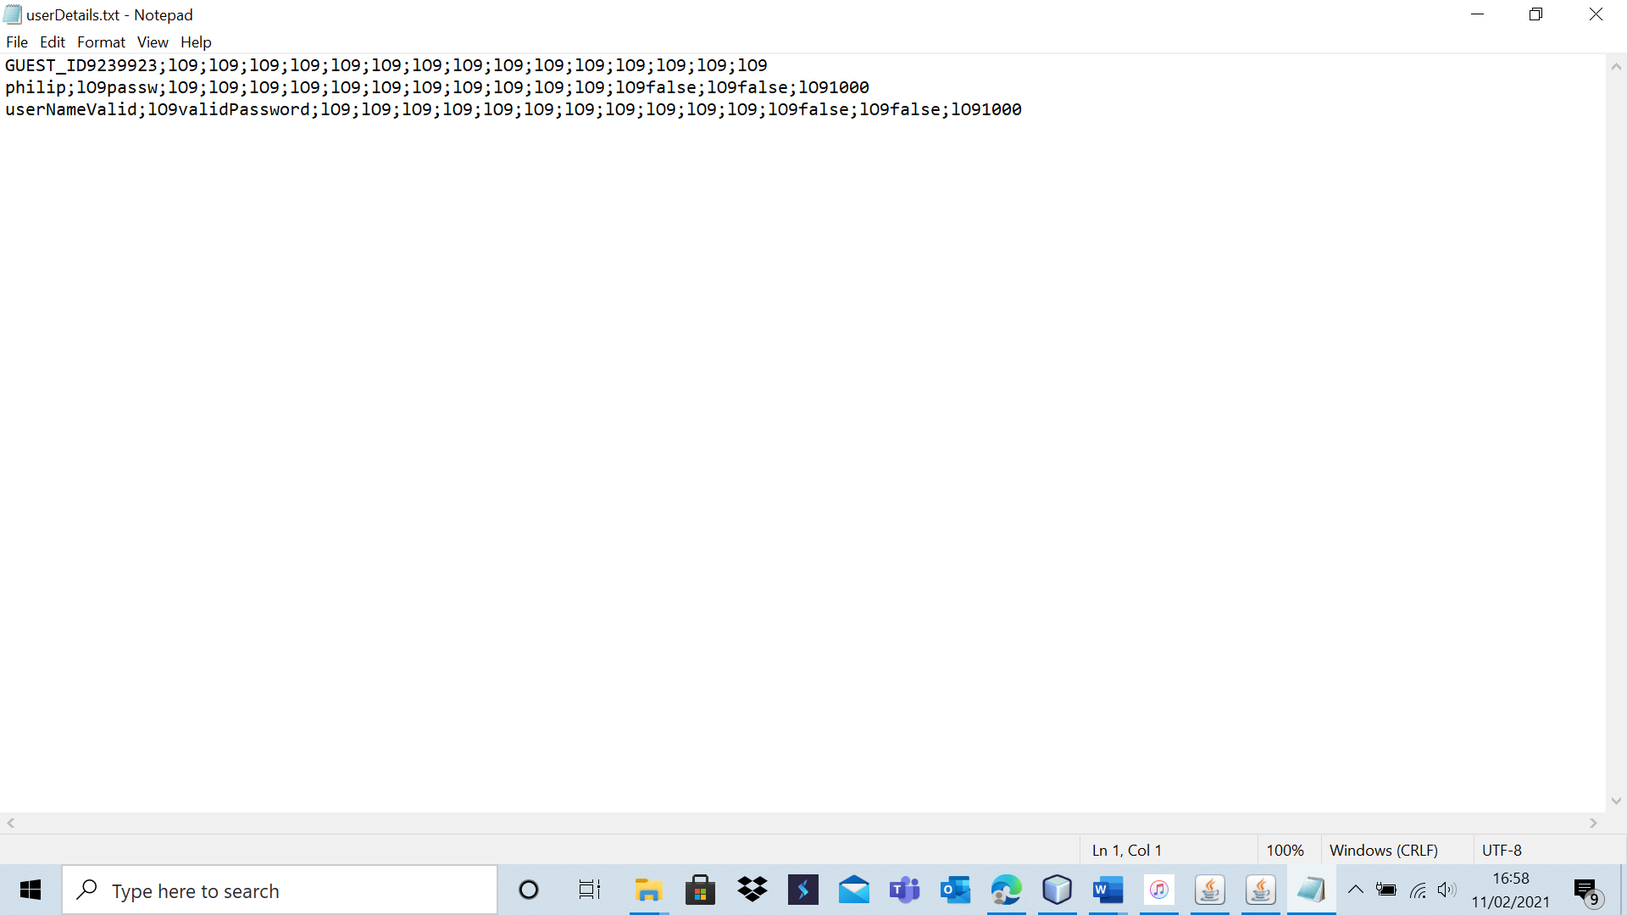

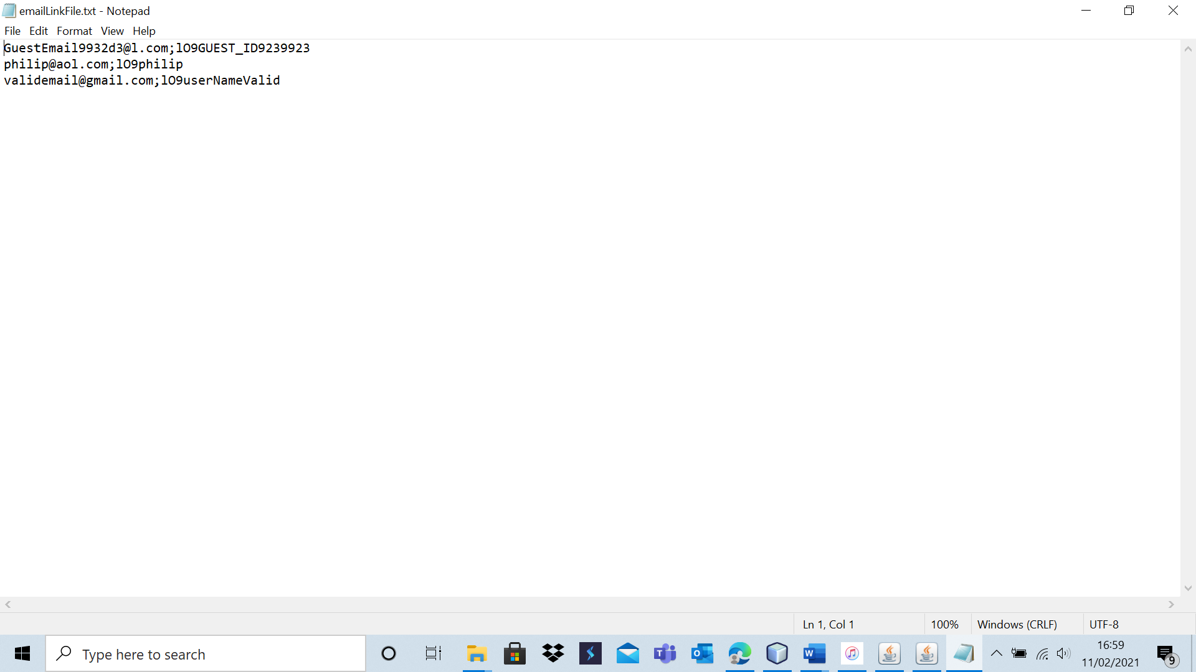

I attempted to log in with this information.

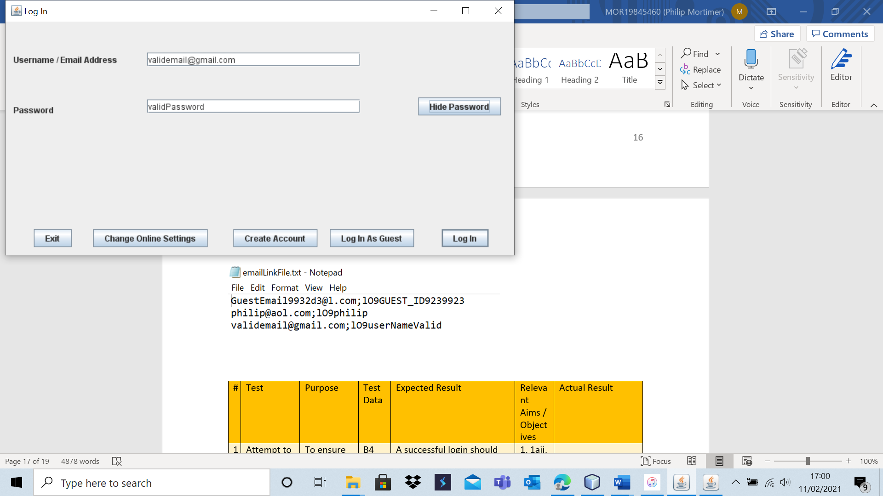

And I was able to log in successfully.

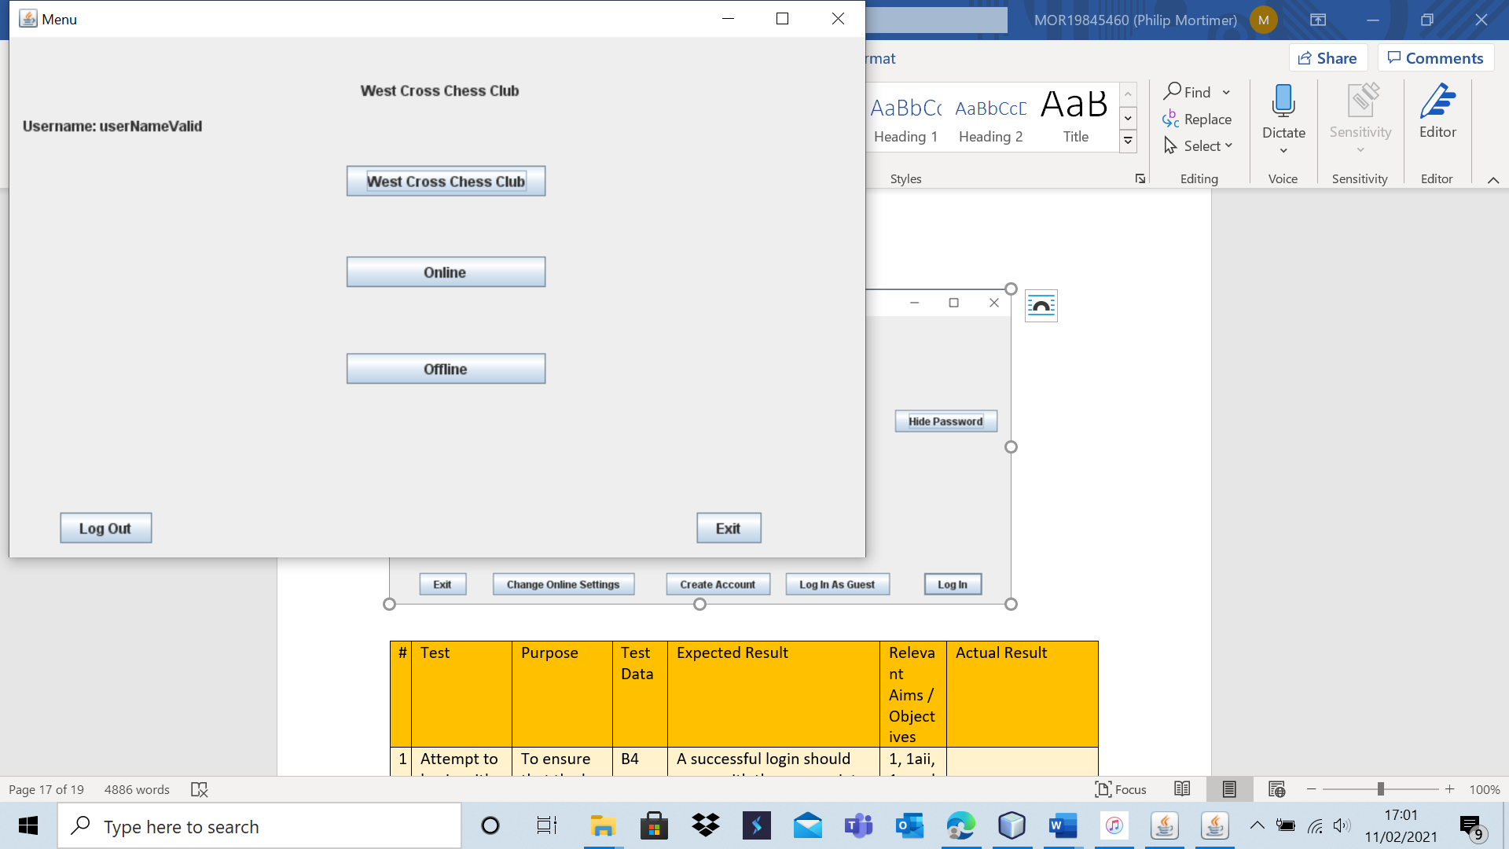

|  |  |  |  |  |  |  |
| --- | --- | --- | --- | --- | --- | --- |
| 2 | Attempt to log in with a valid email address and invalid password. | To ensure that the log in system functions as intended. | B5 | An appropriate error message should be displayed indicating that the password used was incorrect. | 1, 1aii, 1c and 1cii. | The system correctly said that the password was incorrect. |

Test 2 – B5

Using the same user and email data as with Test 1 – B4. I attempted to log in using a valid email address and an invalid password.

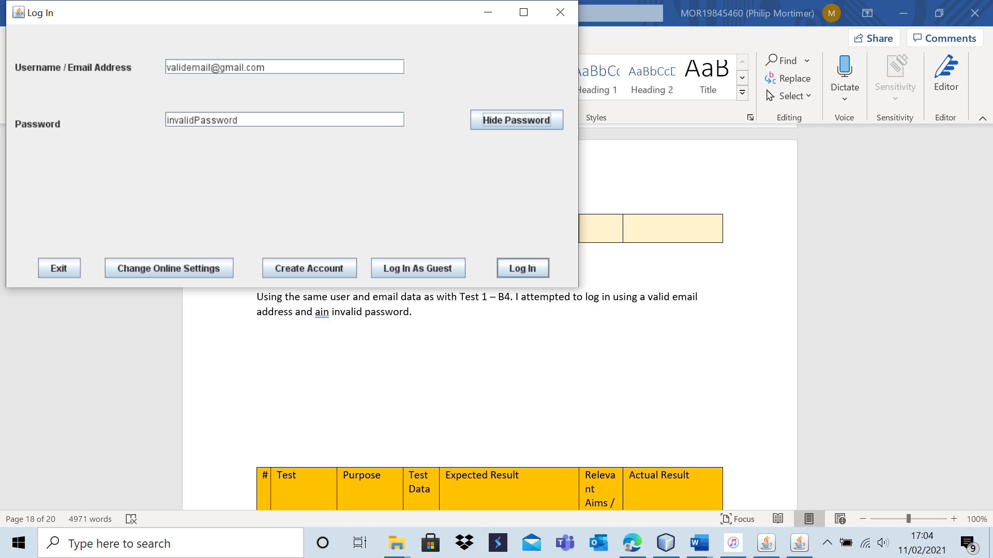

The system correctly stated that the password was incorrect.

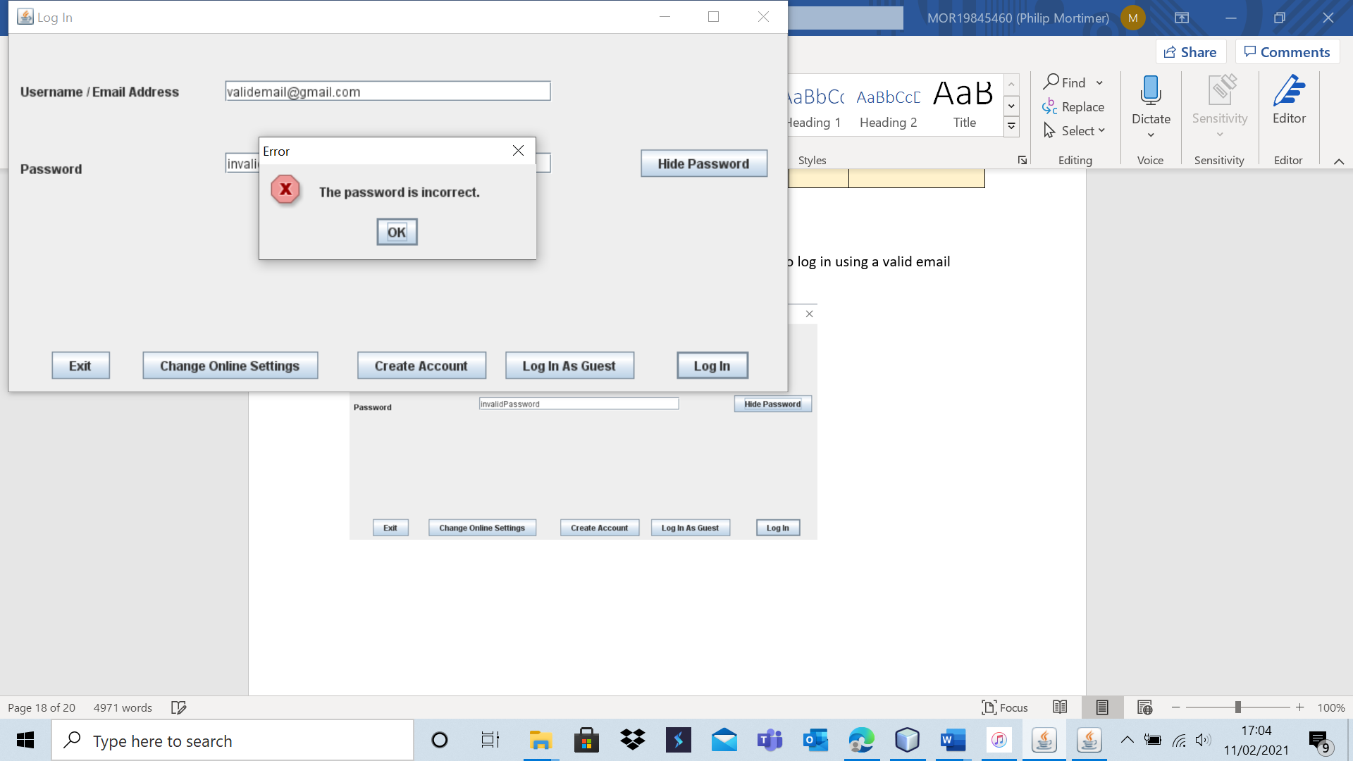

|  |  |  |  |  |  |  |
| --- | --- | --- | --- | --- | --- | --- |
| 3 | Attempt to log in with an invalid email address. | To ensure that the log in system functions as intended. | B6, B7, B9 and B11 | An appropriate error message should be displayed indicating that the email address used was invalid. | 1, 1aii, 1c and 1cii. | The log in is unsuccessful and a clear error message is displayed. |

I am using the same email and user database as in Test 2 – B5 and in Test 1 – B4. I will attempt to log in with multiple invalid email addresses.

Test 3- B6

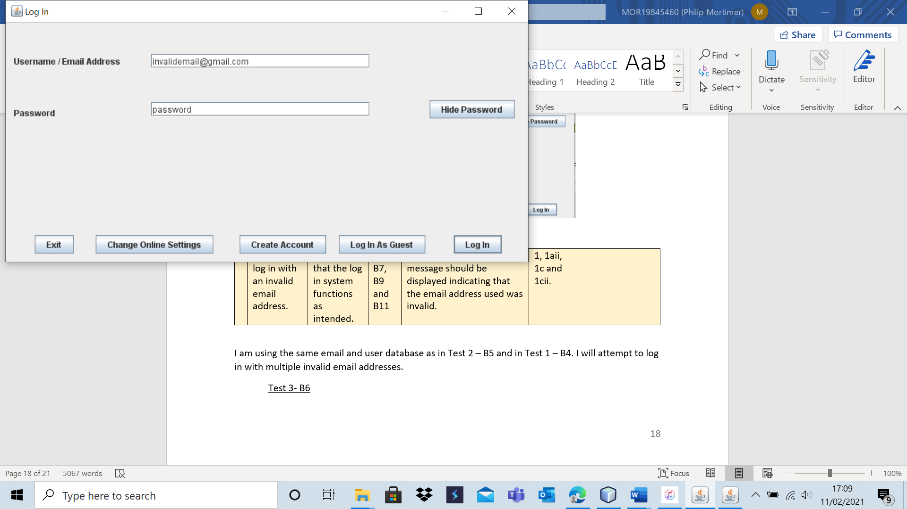

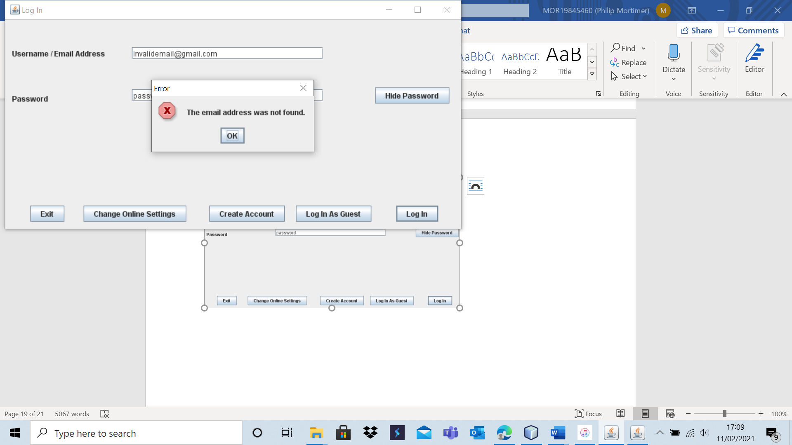

The system correctly states that the email address cannot be found.

Test 3 – B7

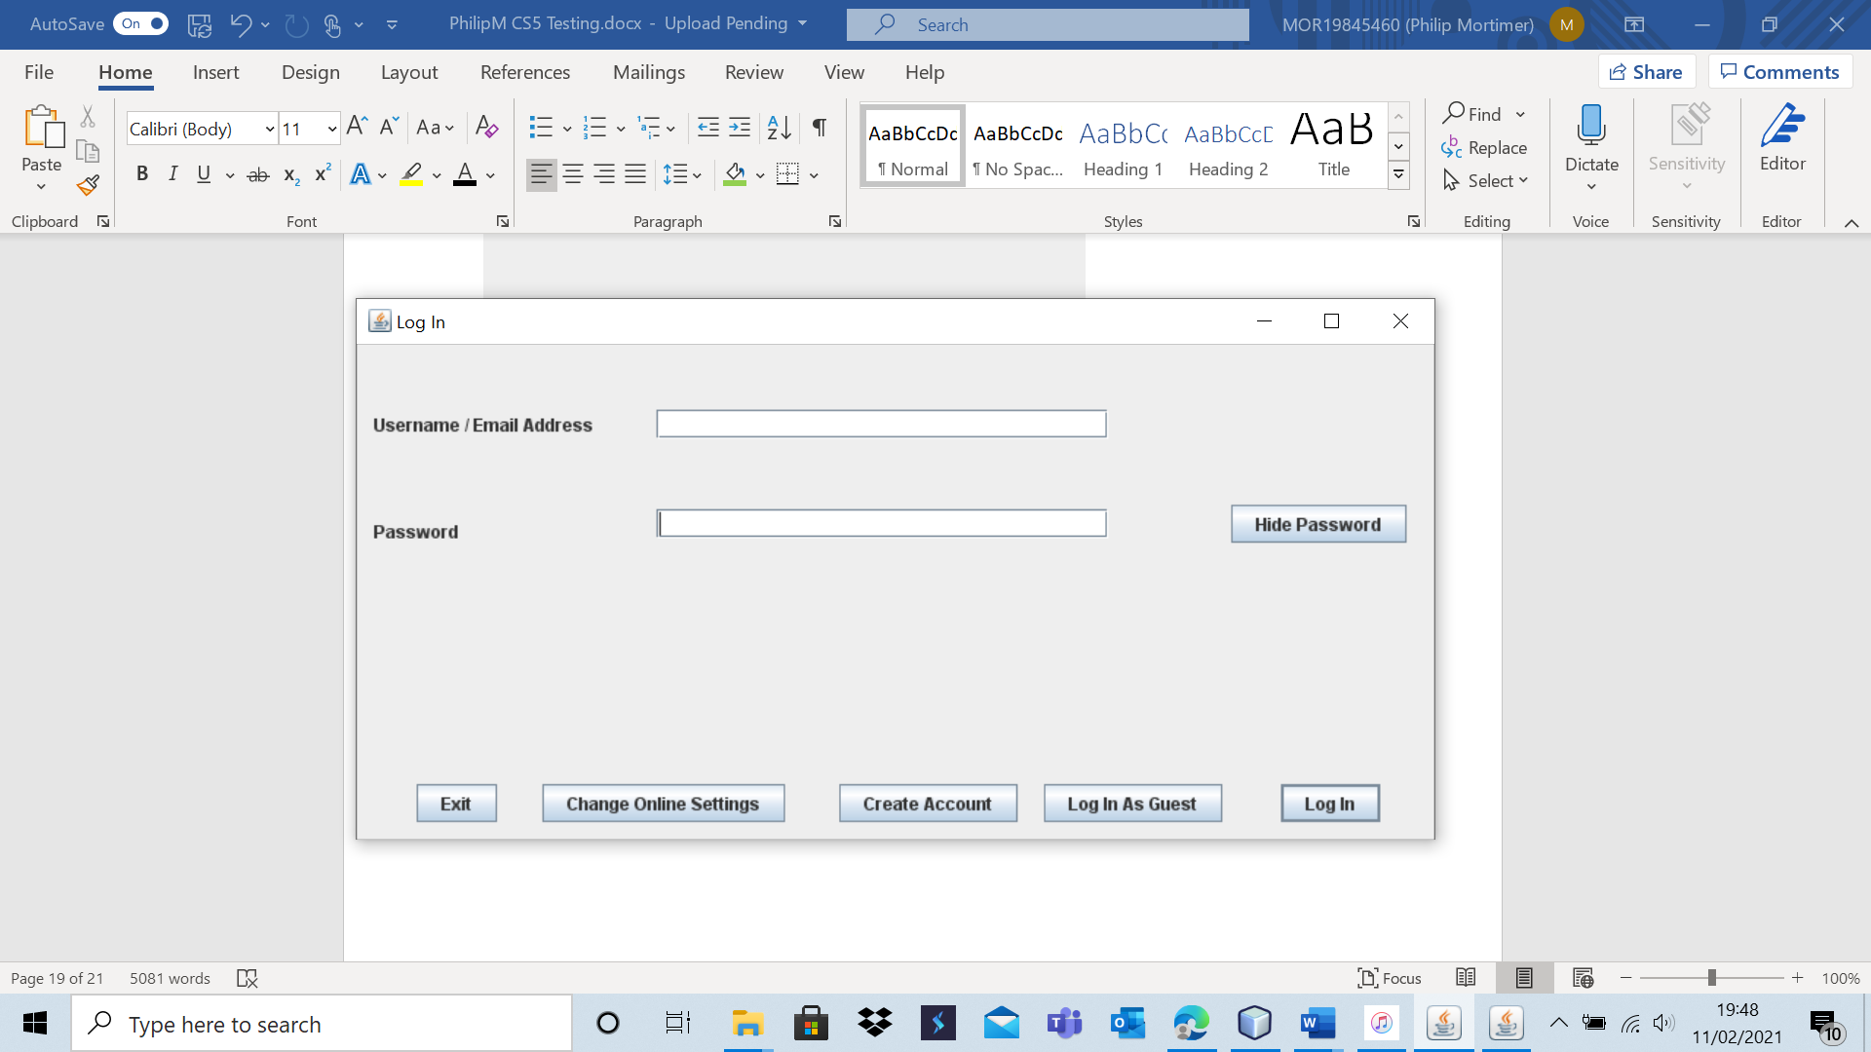

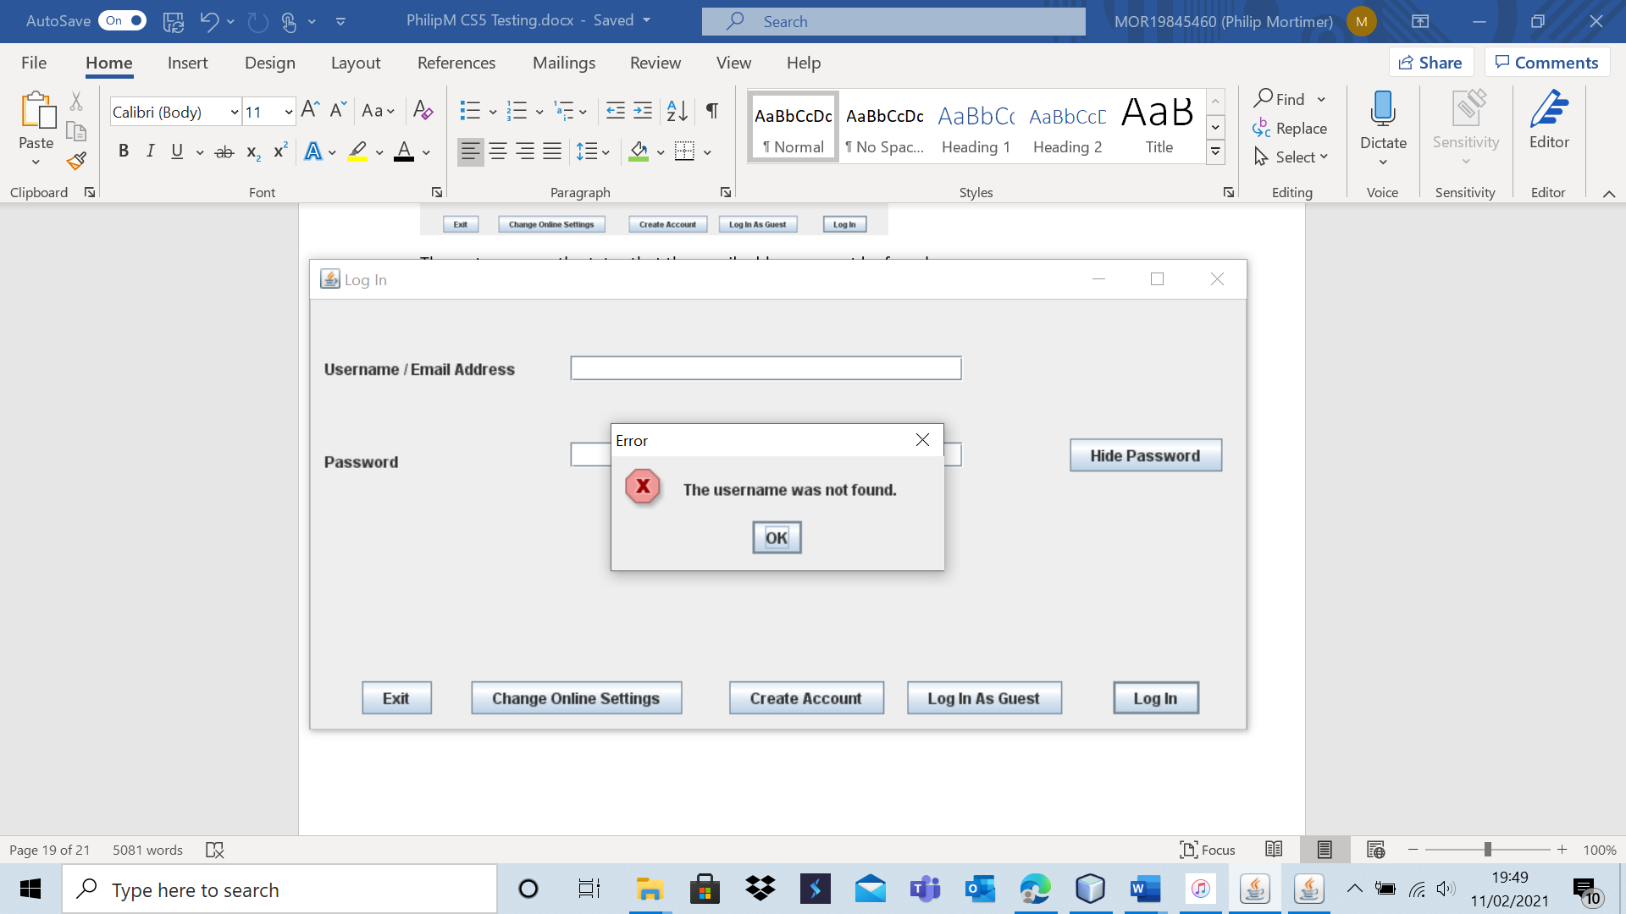

As expected, a valid error message was displayed. It may be more intuitive to include validation to ensure that only valid usernames / email addresses make requests to the server both to minimise the server workload and to provide a more specific error message. However, I feel that this is unnecessary as it is obvious to the user why the log in request has failed – so from a user experience perspective, this is completely justified. As the server is only going to be servicing a very small number of people, the difference in efficiency between the two versions is small. However, my validation for my username is disjointed – there is no single Validation.isValidUserName() method. If I had more time, I may implement such a method. However, I feel that the minimal additional server load combined with no detriment to the user experience does not justify a re-write of parts of my code. If I were to do this from scratch, I would have made my validation more modular.

Test 3 – B9

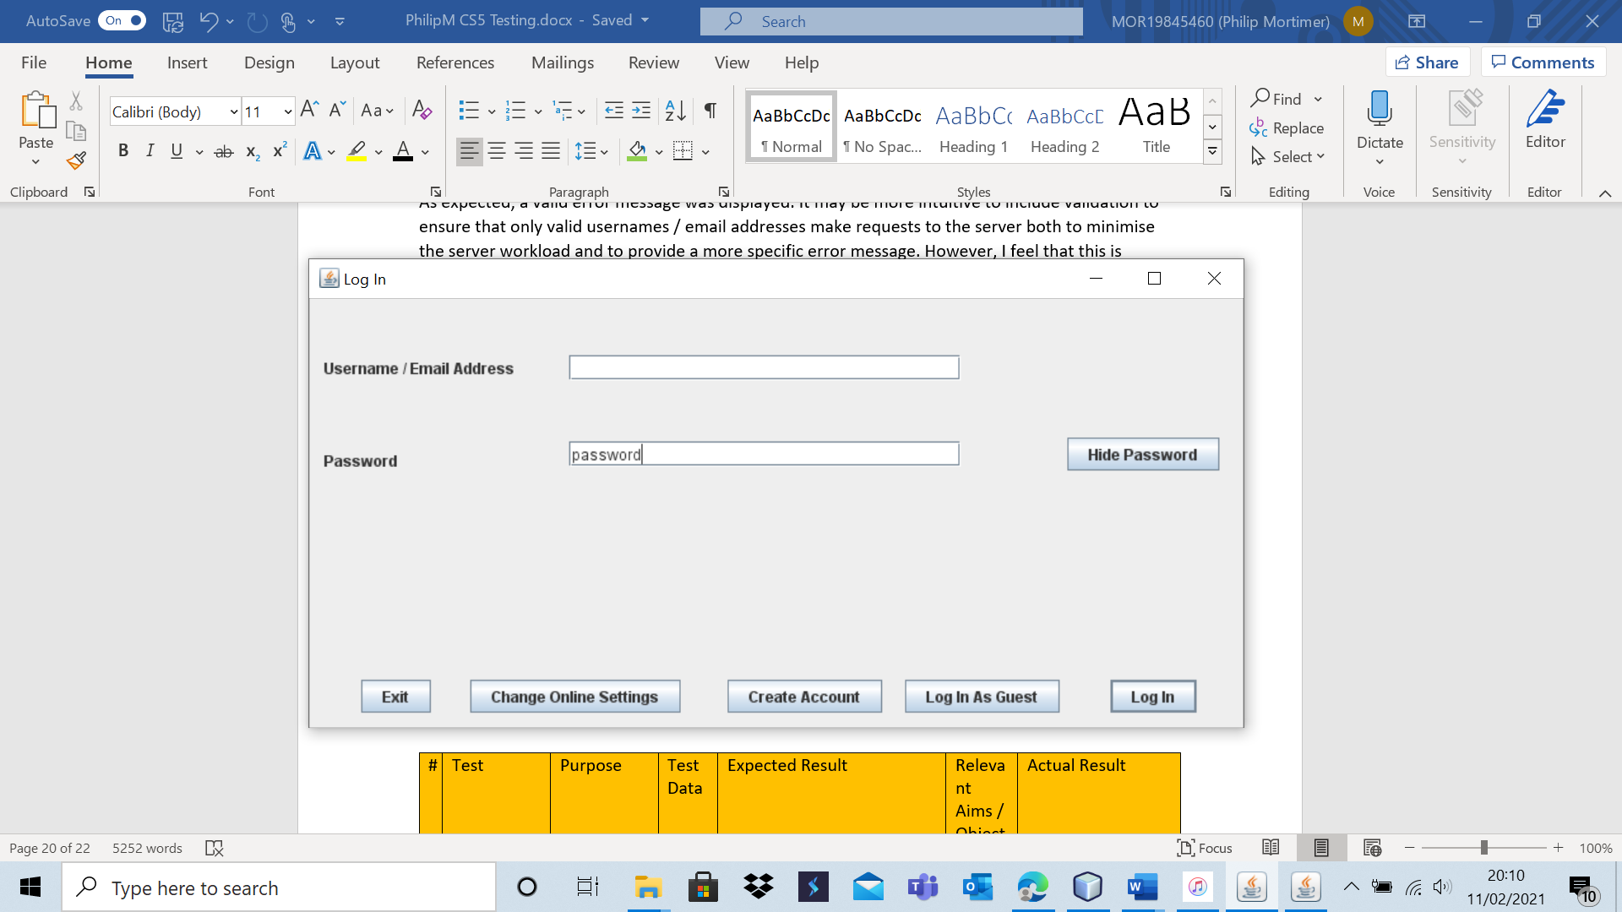

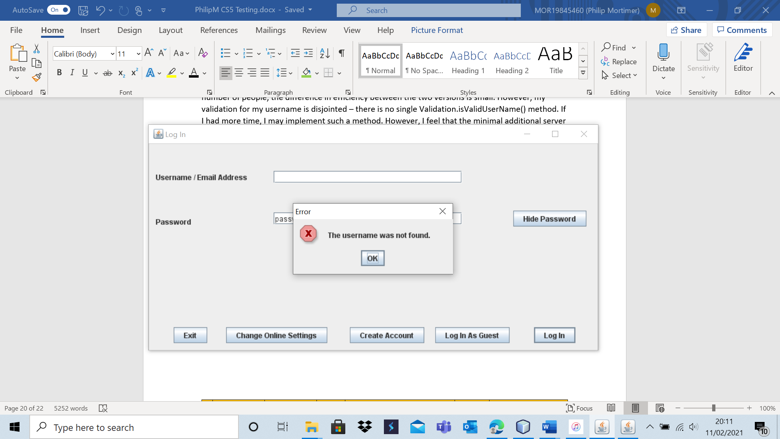

Again, my code performs as expected and passes the test. The comments for Test 3 – B7 are equally applicable here.

Test 3 – B11

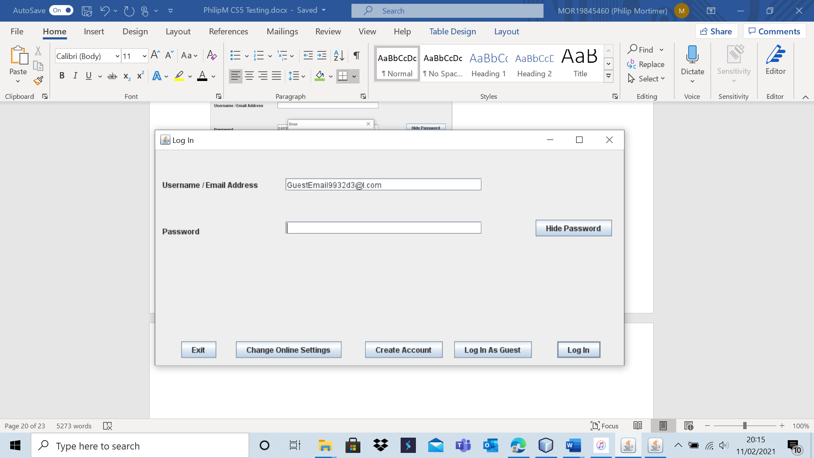

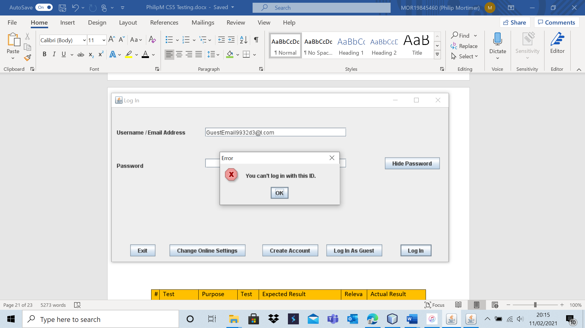

The system does not allow the user to log in with a prohibited email address. The error message is also clear that the ID is a specific ID that cannot be used by a user to make a log in.

|  |  |  |  |  |  |  |
| --- | --- | --- | --- | --- | --- | --- |
| 4 | Attempt to log in with a valid username and password. | To ensure that the log in system functions as intended. | B1 | A successful login should occur with the appropriate user information being loaded. | 1, 1aii, 1c and 1cii. | The user was logged in successfully. |

Test 4 – B1

The user database is the same as in Test 1 – B4 (i.e., “userNameValid” is a user account that has the password “validPassword”).

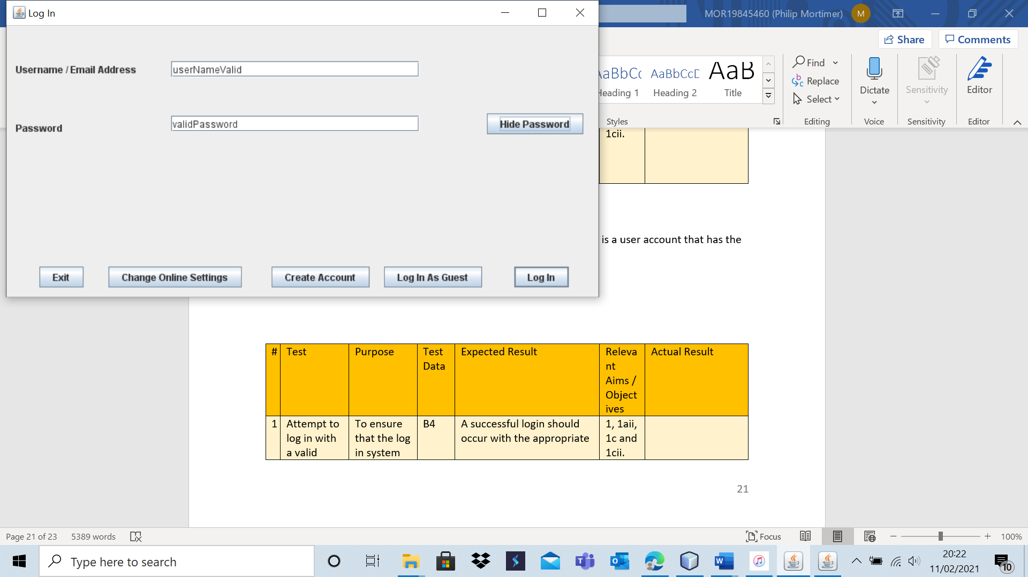

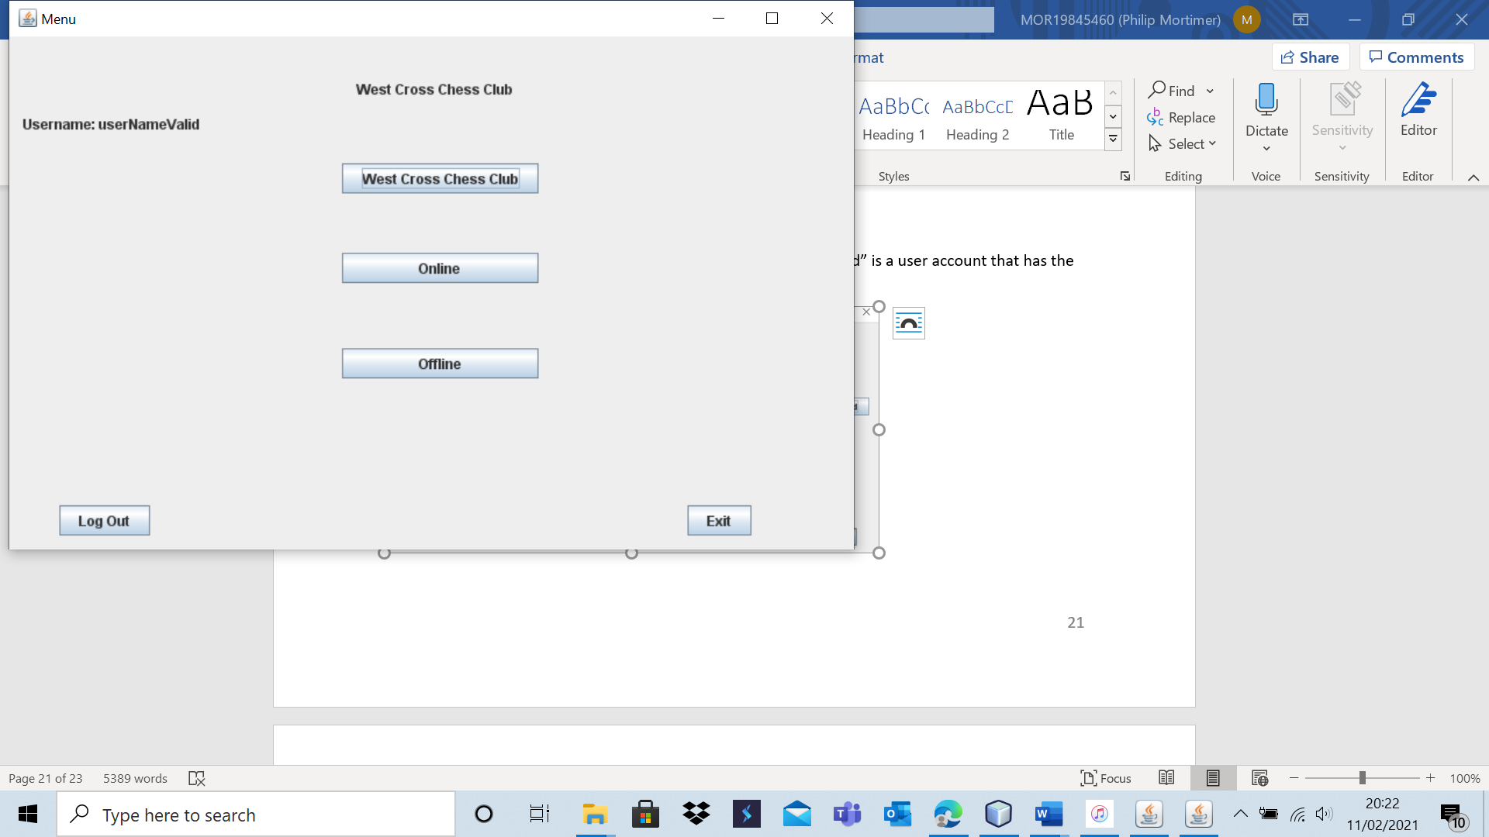

This log in attempt was successful as expected.

|  |  |  |  |  |  |  |
| --- | --- | --- | --- | --- | --- | --- |
| 5 | Attempt to log in with a valid username and invalid password. | To ensure that the log in system functions as intended. | B2 and B8 | An appropriate error message should be displayed indicating that the password used was incorrect. | 1, 1aii, 1c and 1cii. | The log in fails and the user is made aware of the fact that this was due to an erroneous password. |

Test 5 – B2

The user database is the same as in Test 1 – B4 (i.e., “userNameValid” is a user account that has the password “validPassword”).

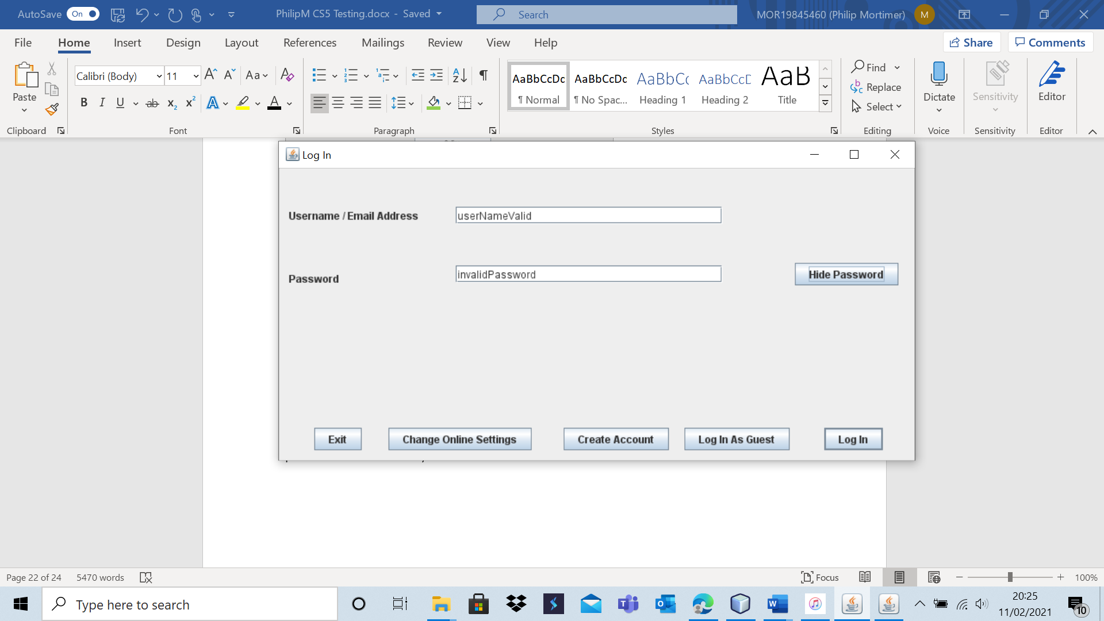

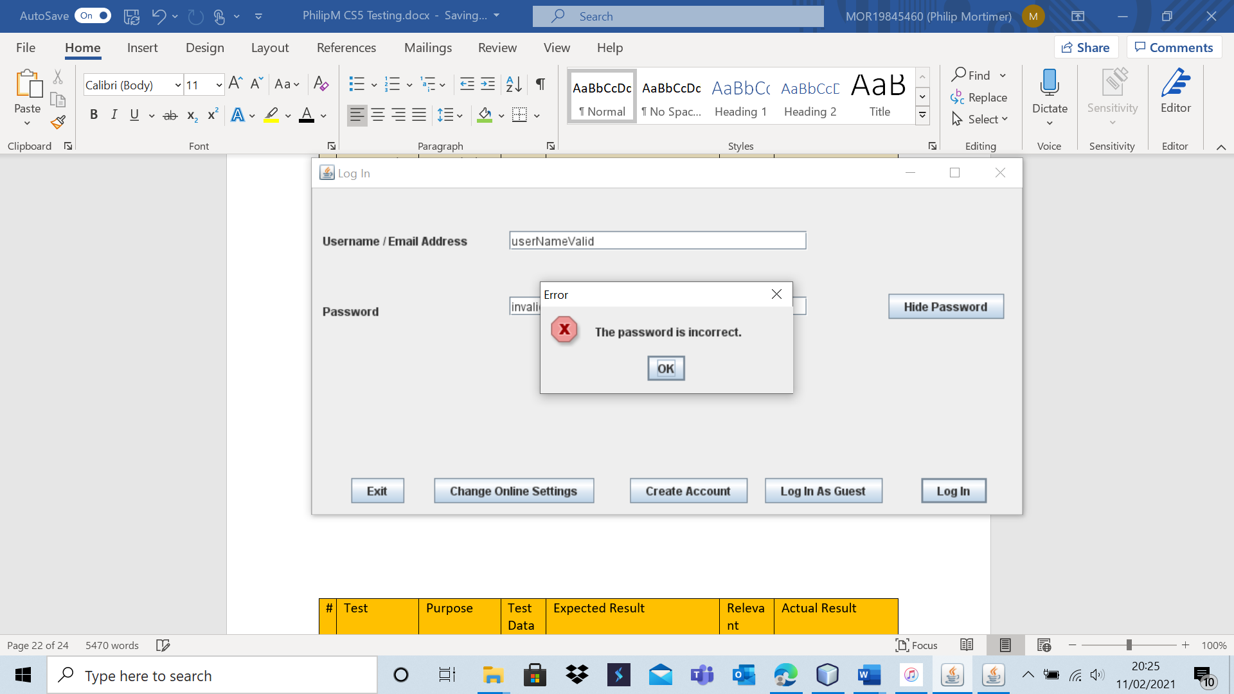

The code runs as expected, indicating to the user that the password is incorrect (which tells the user that the username is valid).

Test 5 – B8

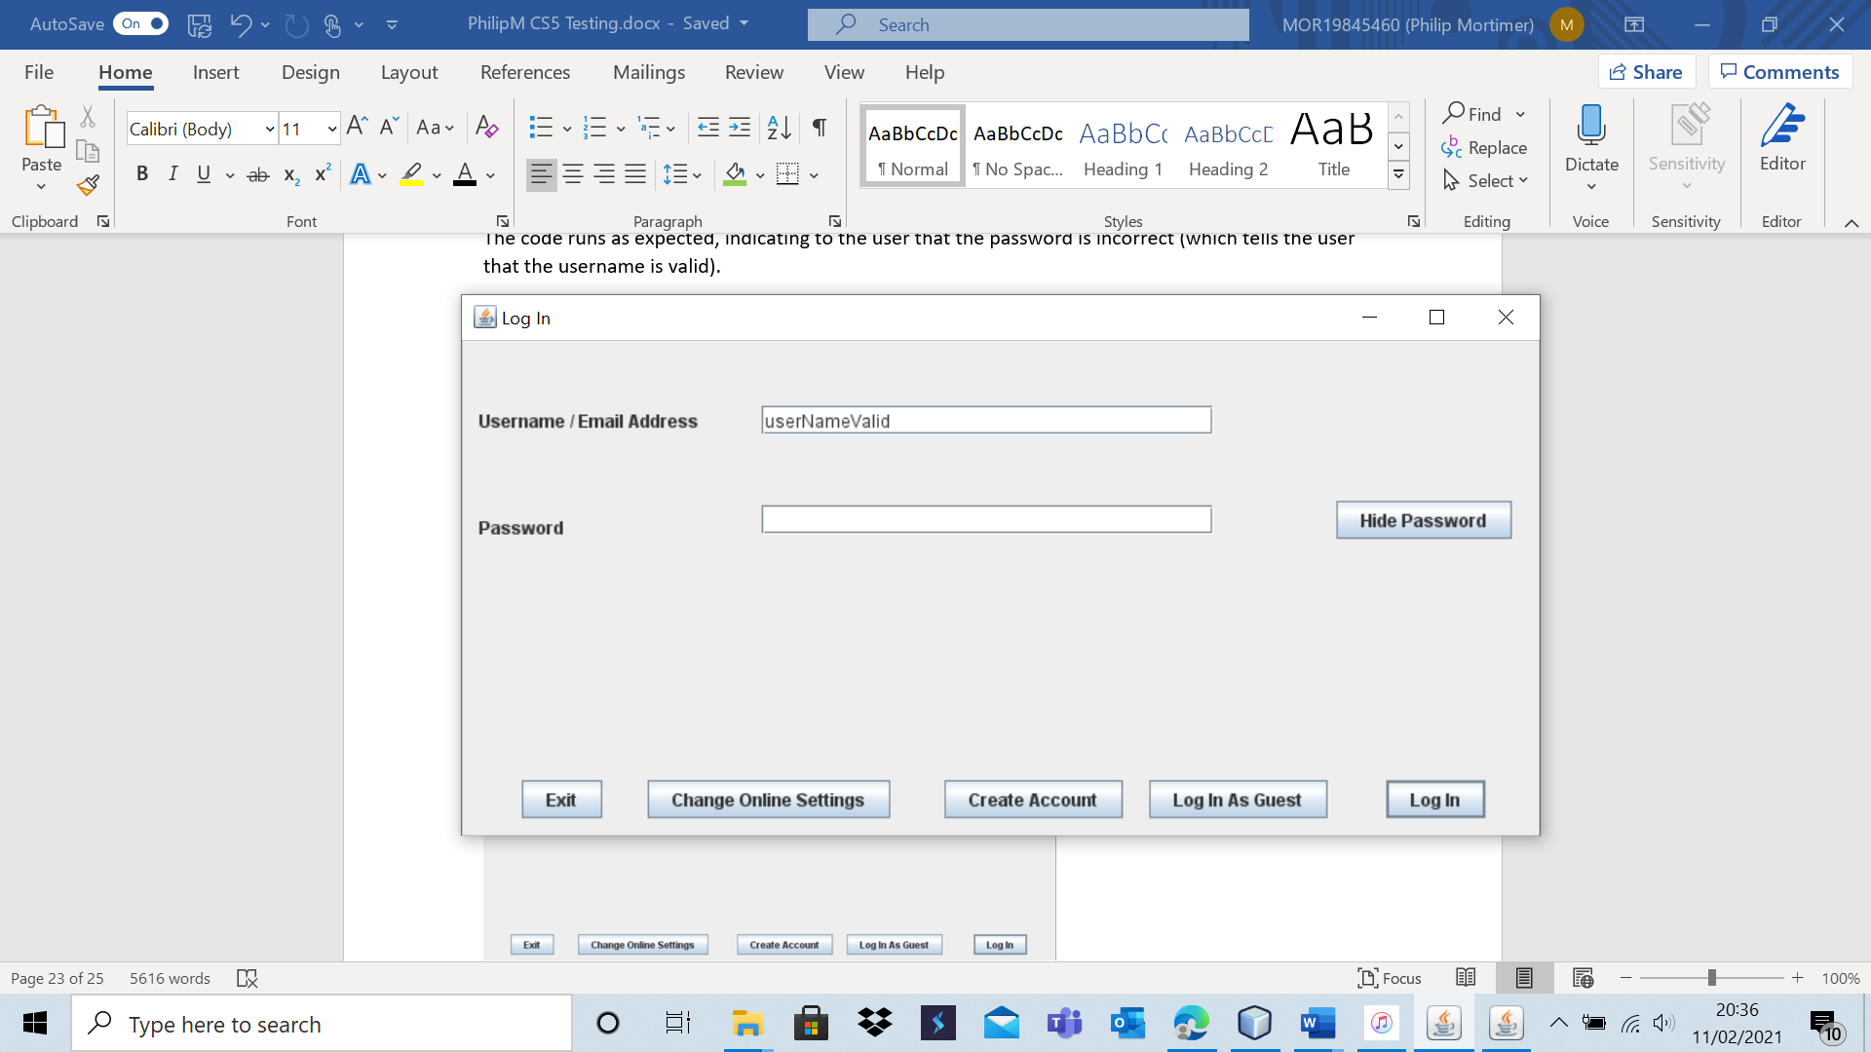

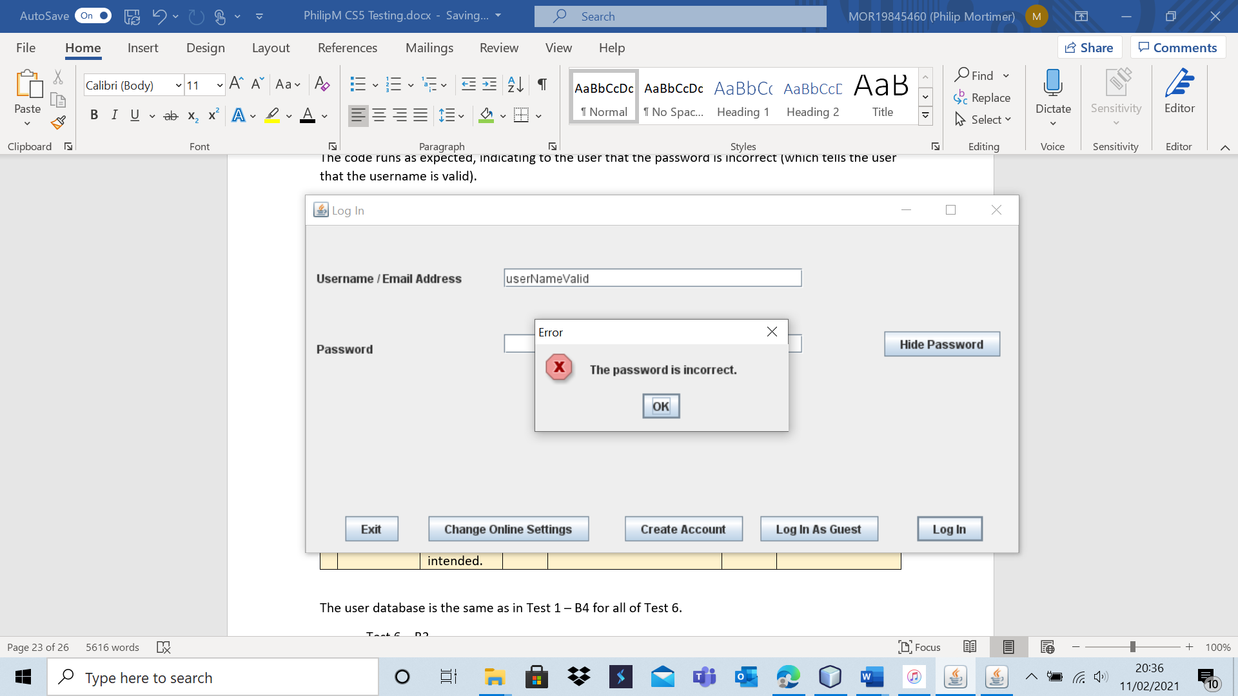

As expected, an error message is displayed showing that the password is incorrect.

|  |  |  |  |  |  |  |
| --- | --- | --- | --- | --- | --- | --- |
| 6 | Attempt to log in with an invalid username. | To ensure that the log in system functions as intended. | B3, B7, B9 and B10 | An appropriate error message should be displayed indicating that the username used was invalid. | 1, 1aii, 1c and 1cii. | The log in attempts fail and an appropriate error message is displayed. |

The user database is the same as in Test 1 – B4 for all of Test 6.

Test 6 – B3

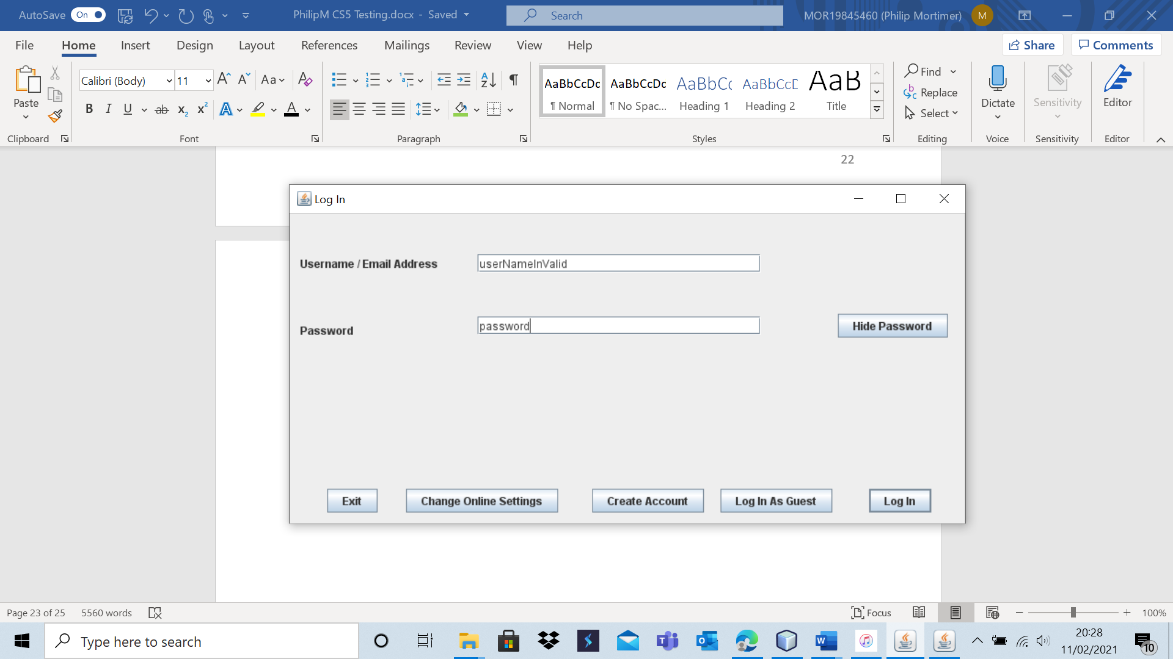

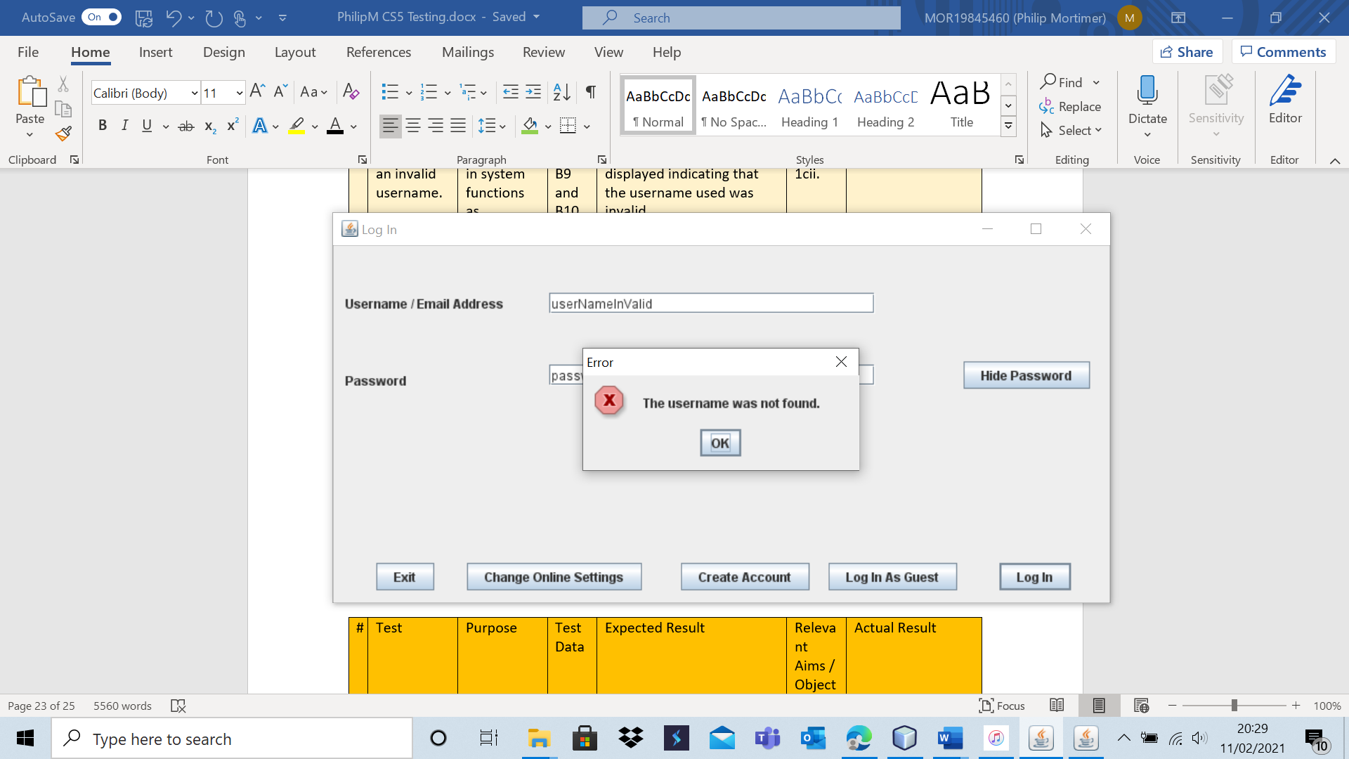

As expected, the system correctly states that the username was not found.

Test 6 – B7

B7 has already been tested – and the system passed. See Test 3 – B7 for more information.

Test 6 – B9

B9 has already been tested – and the system passed. See Test 3 – B9 for more information.

Test 6 – B10

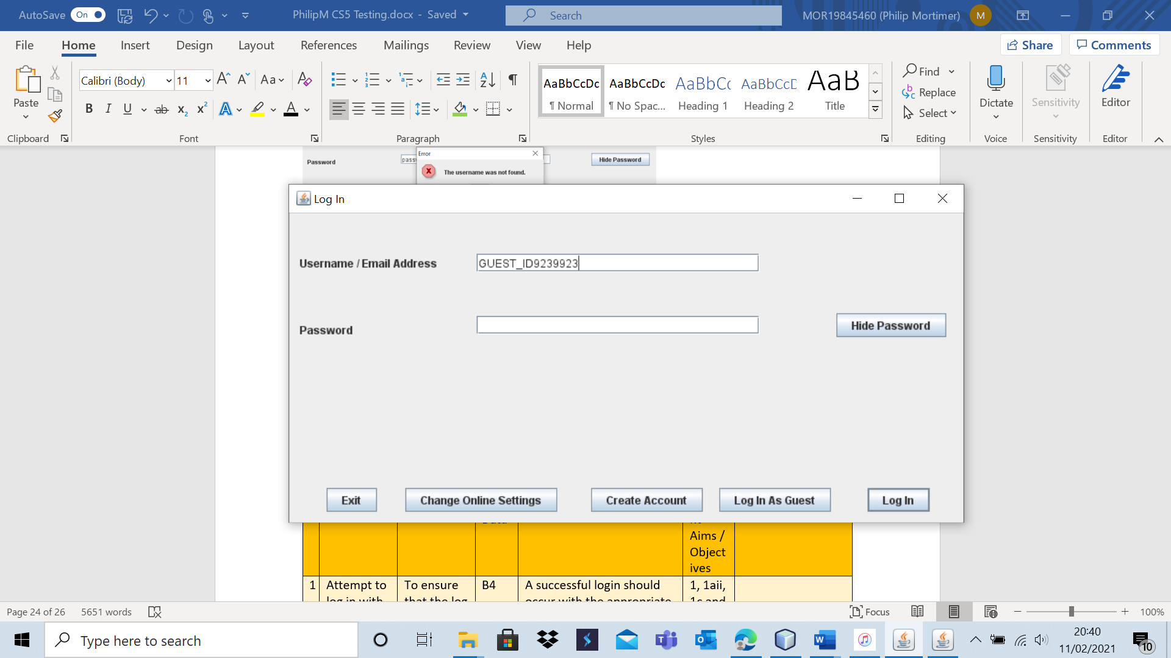

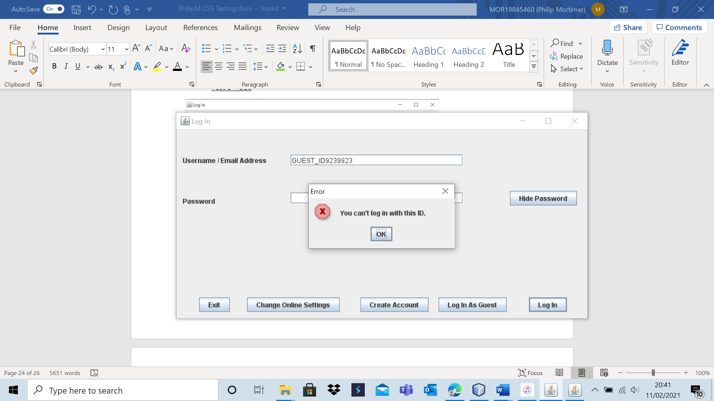

The system performs as desired and tells the user that the given ID cannot be used by users.

|  |  |  |  |  |  |  |
| --- | --- | --- | --- | --- | --- | --- |
| 7 | Attempt to create an account (typical data). | To ensure that account creation functions and that all desired validation is carried out. | A1 and A2 | A new account should be created and added to the database. | 1b, 1bi, 1bii and 1ci. | The account is successfully created. |

Test 7 – A1

This is the user database before this test.

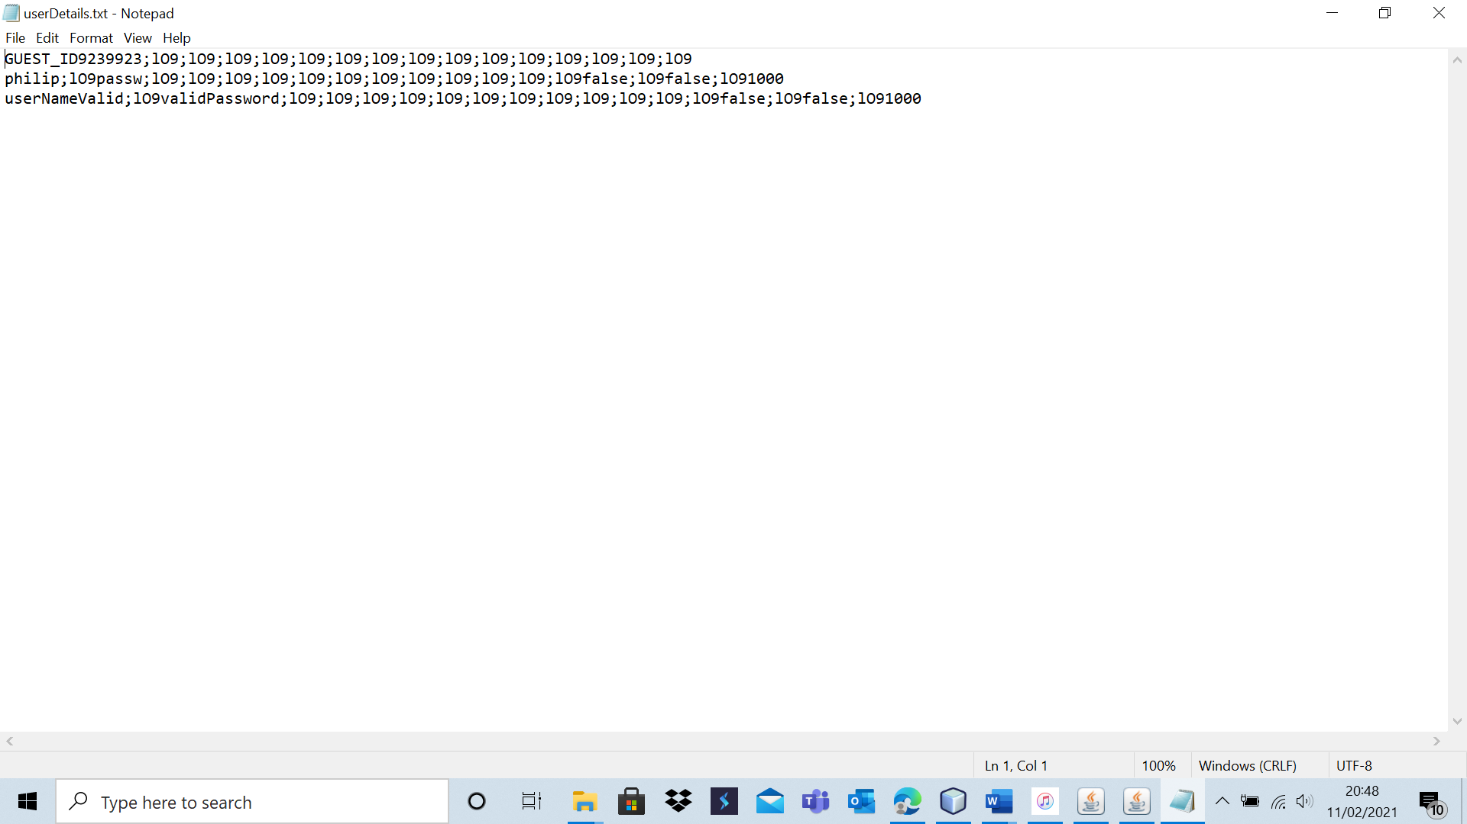

This is the email link file before the test.

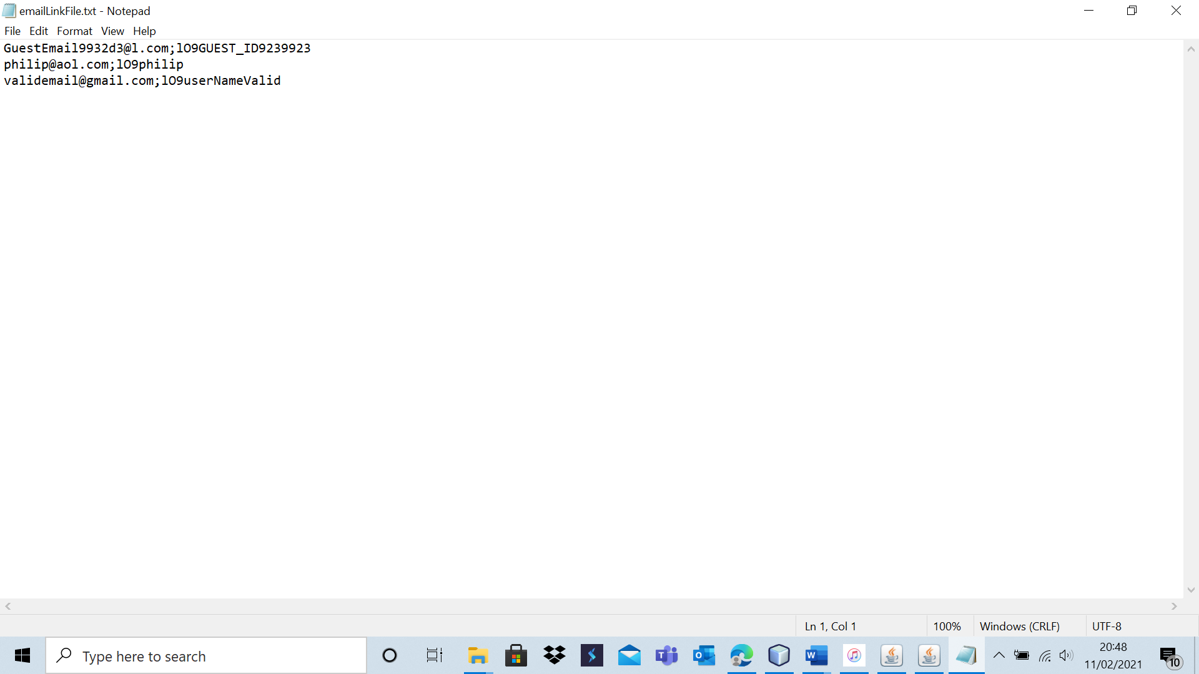

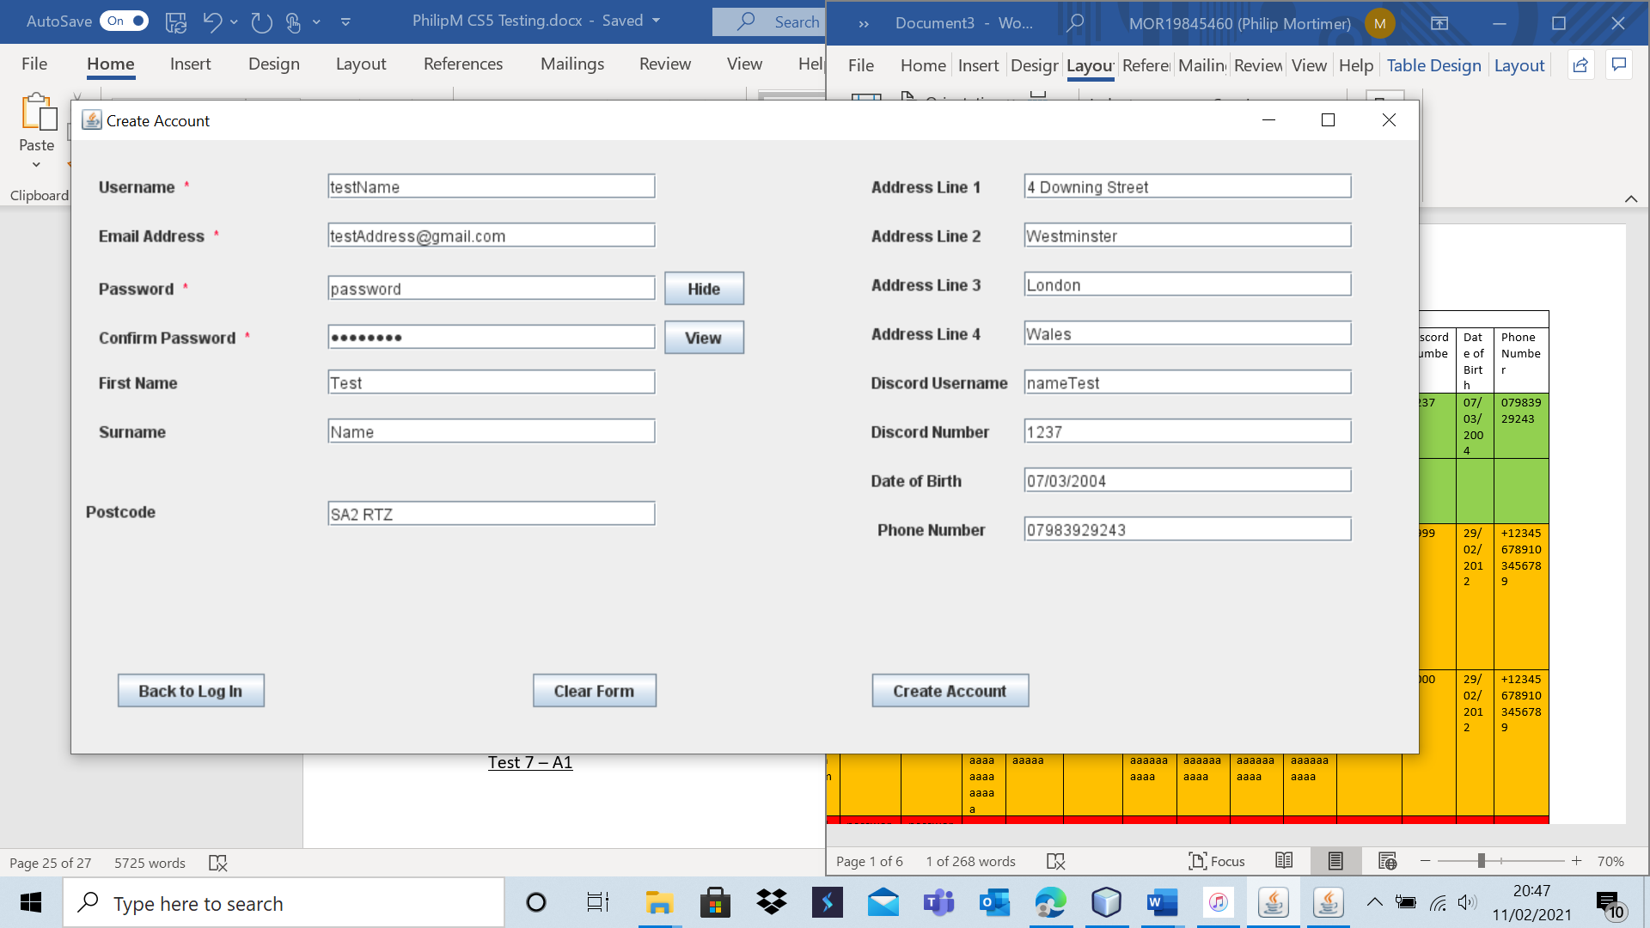

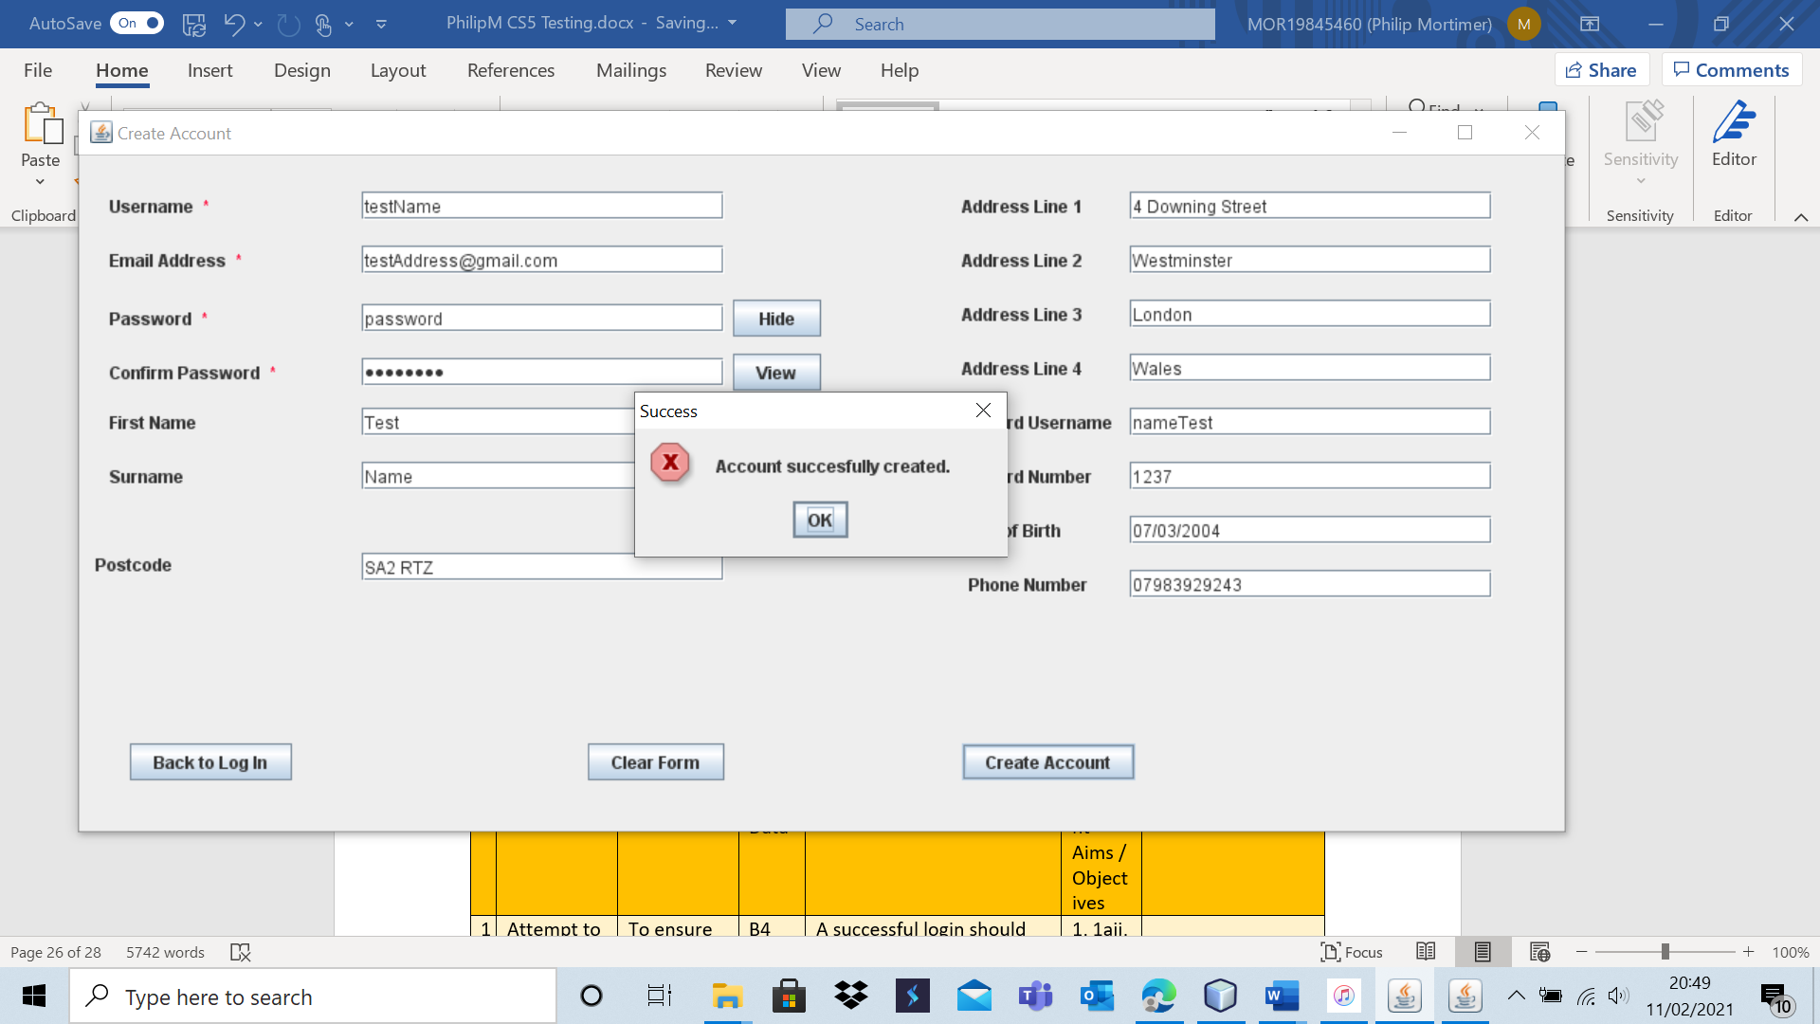

The account was successfully added to the user and email file. Here is the user file after the test.

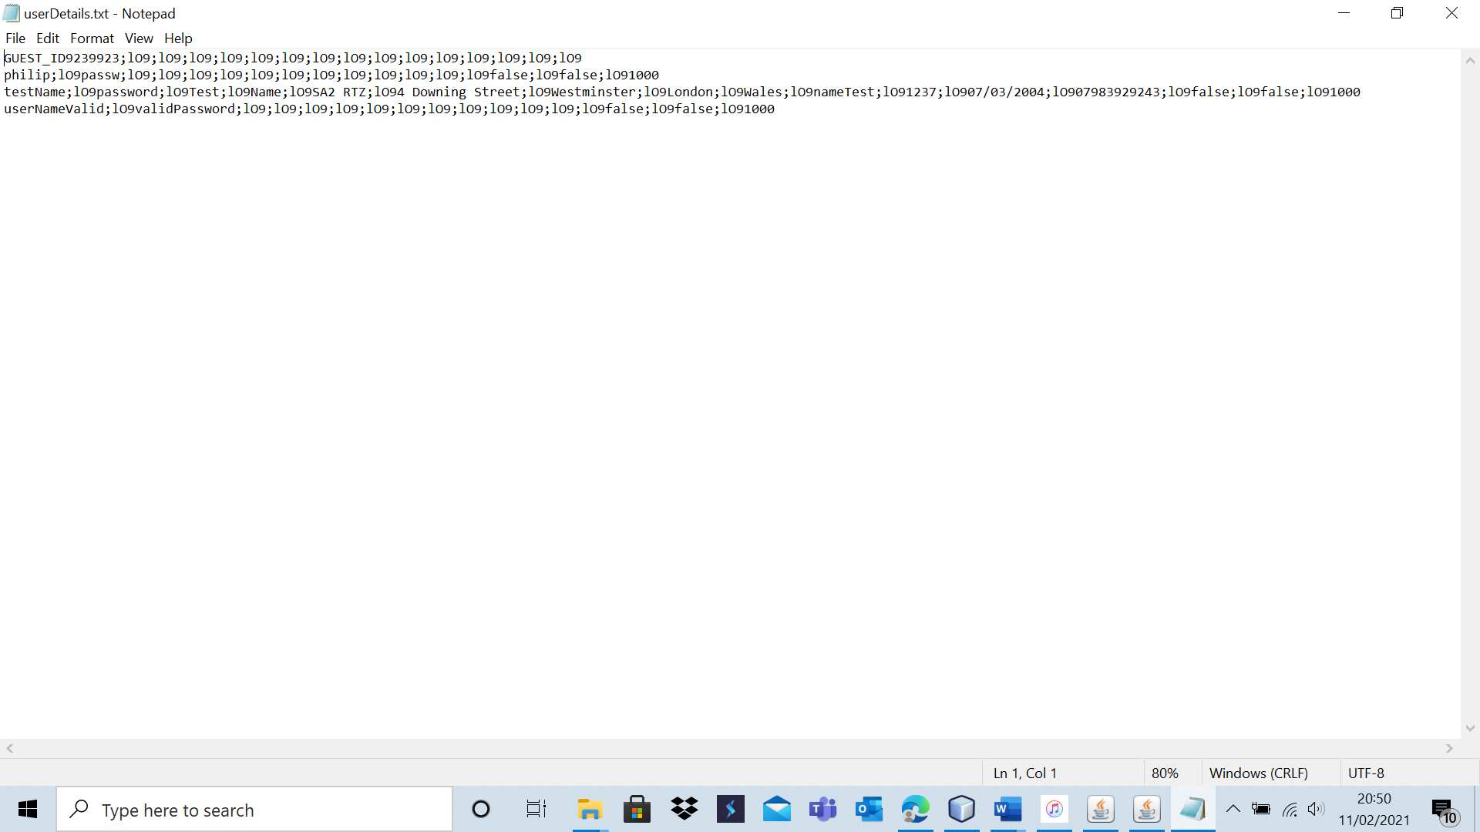

Here is the email file after the test.

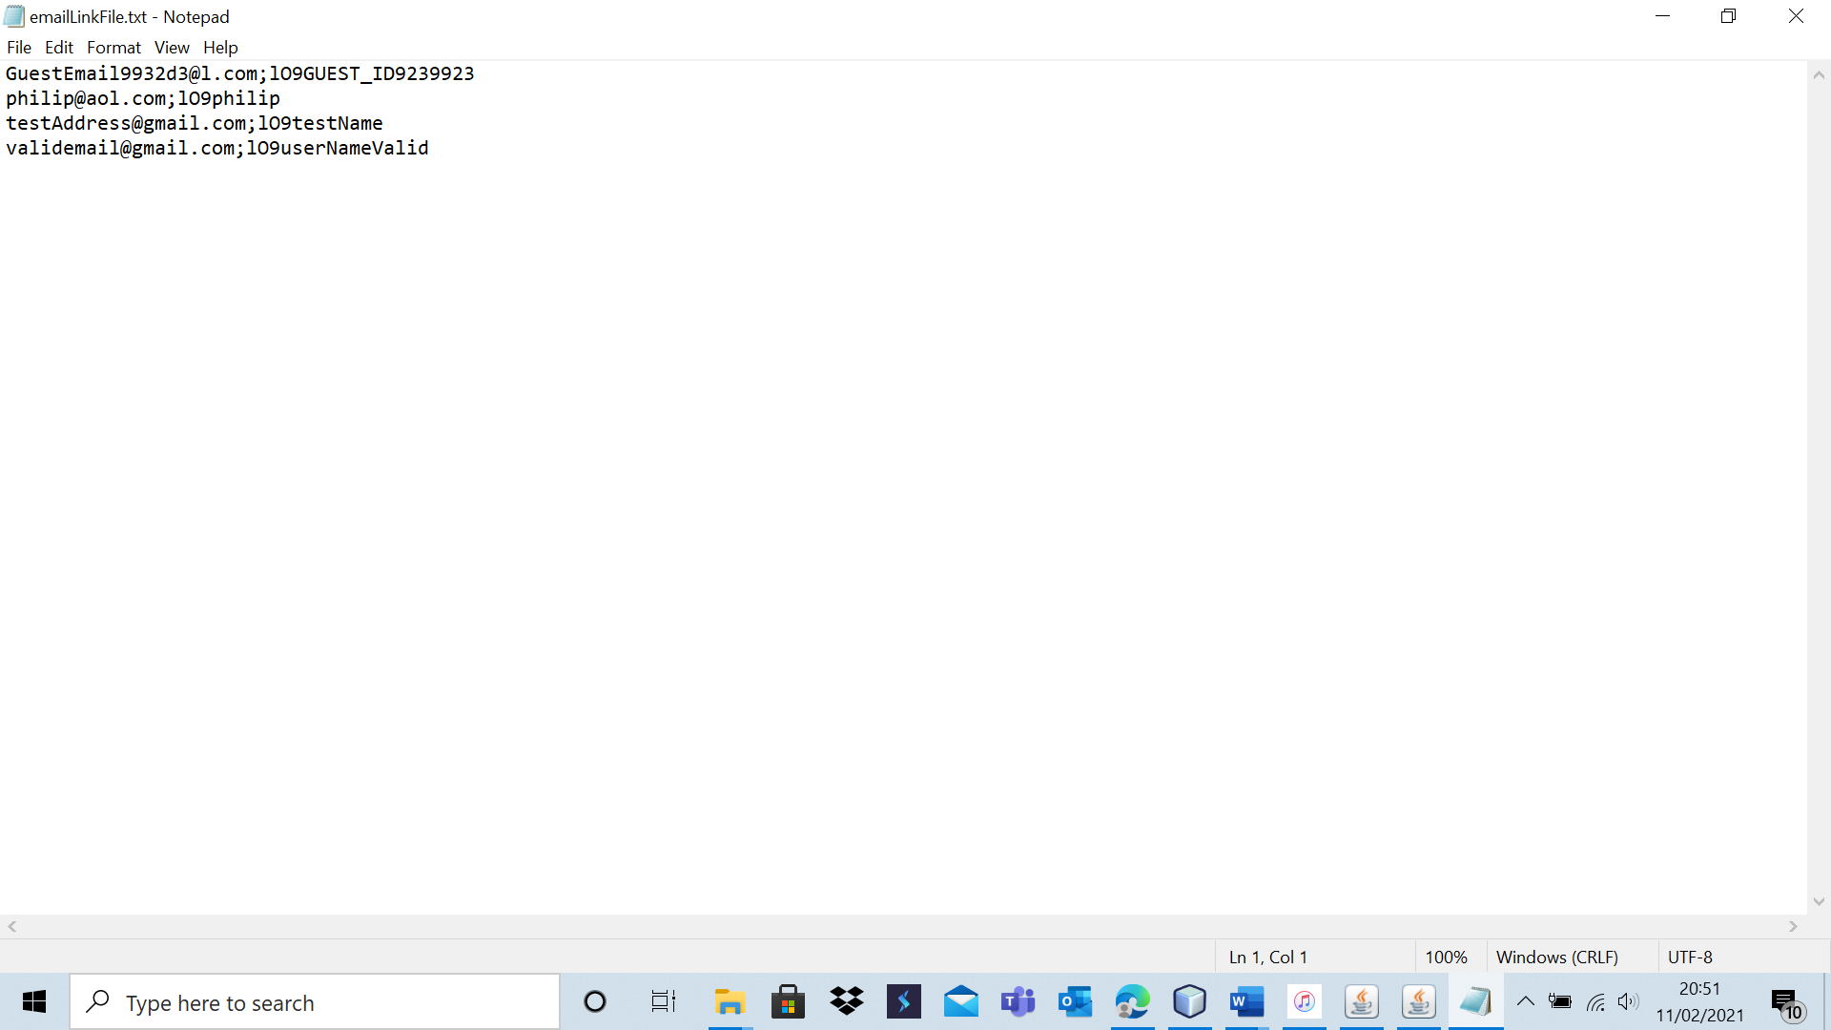

Test 7 – A2

Here is the user file before the test.

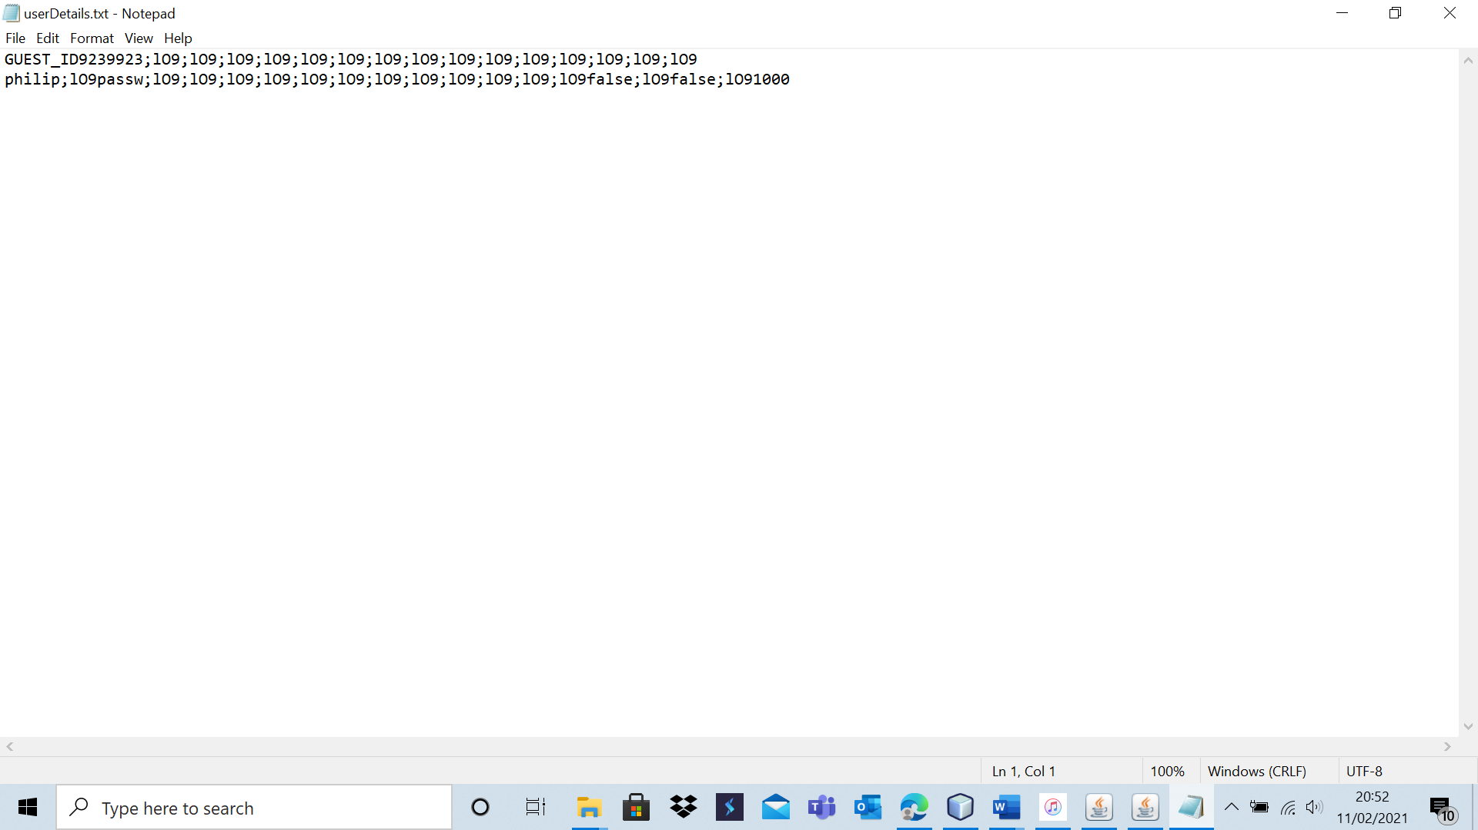

Here is the email link file before the test.

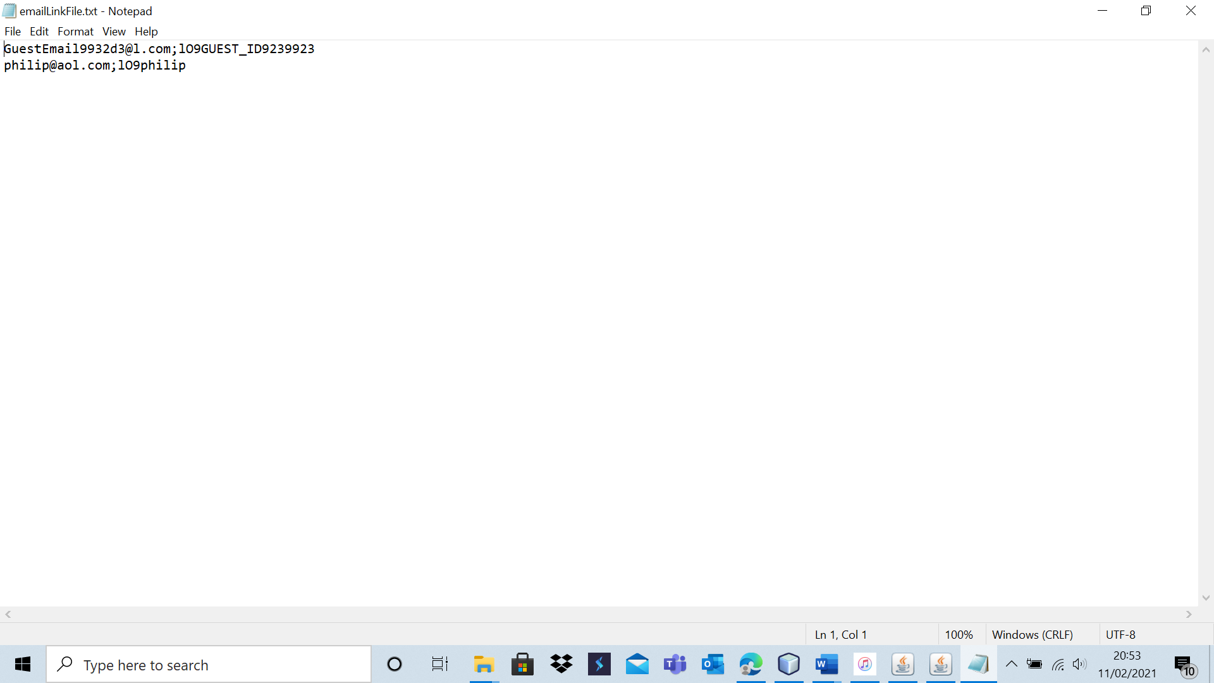

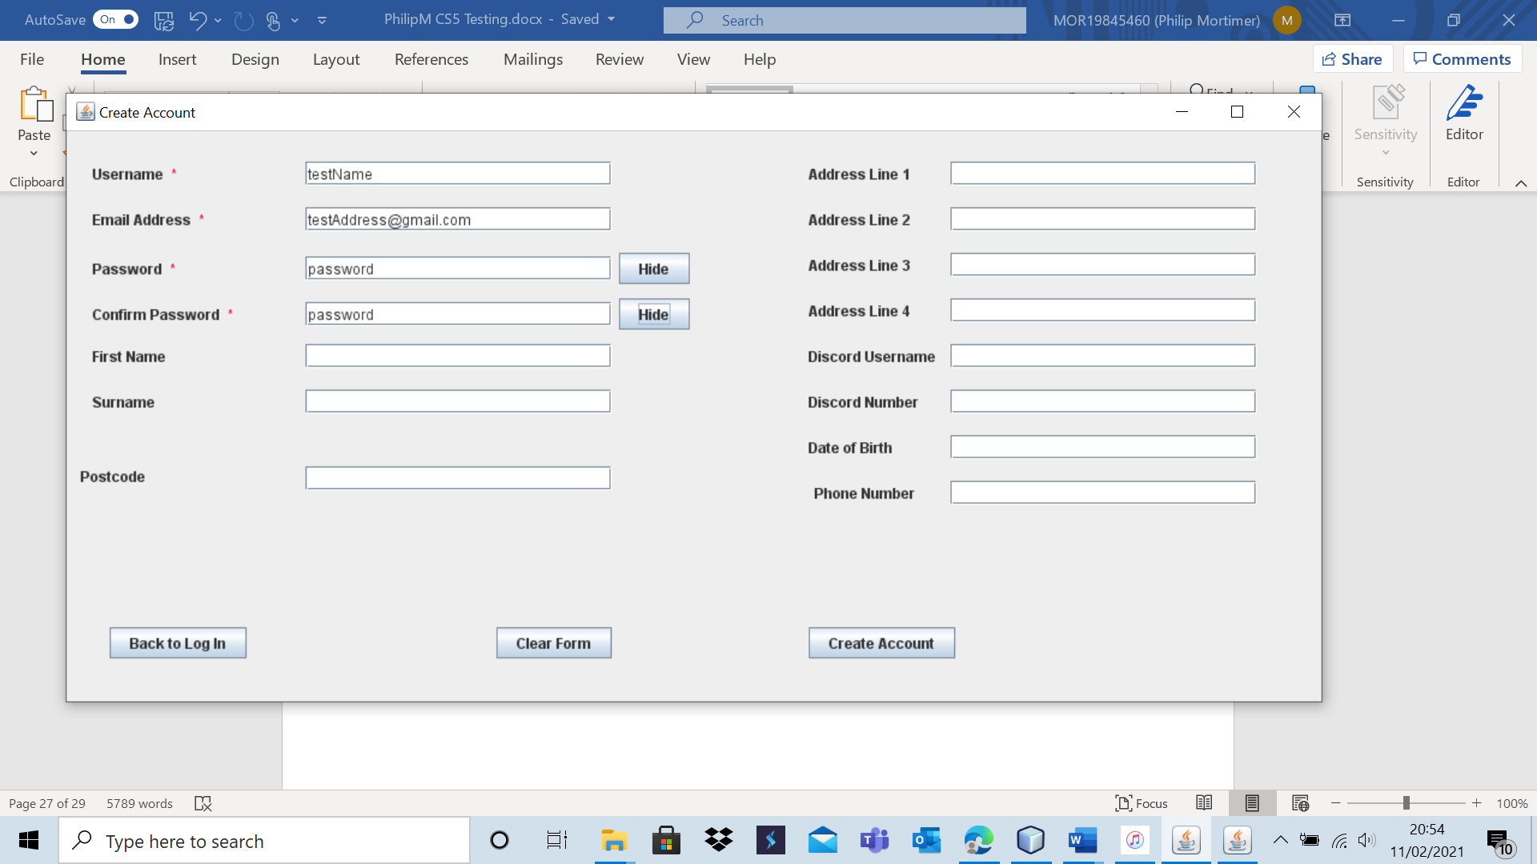

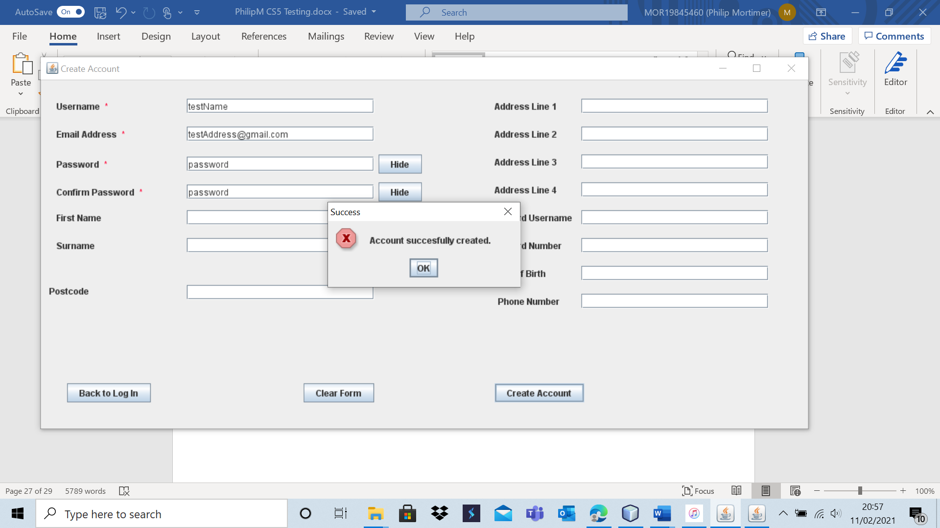

The user file was successfully added to the database. Here is the user file after the test.

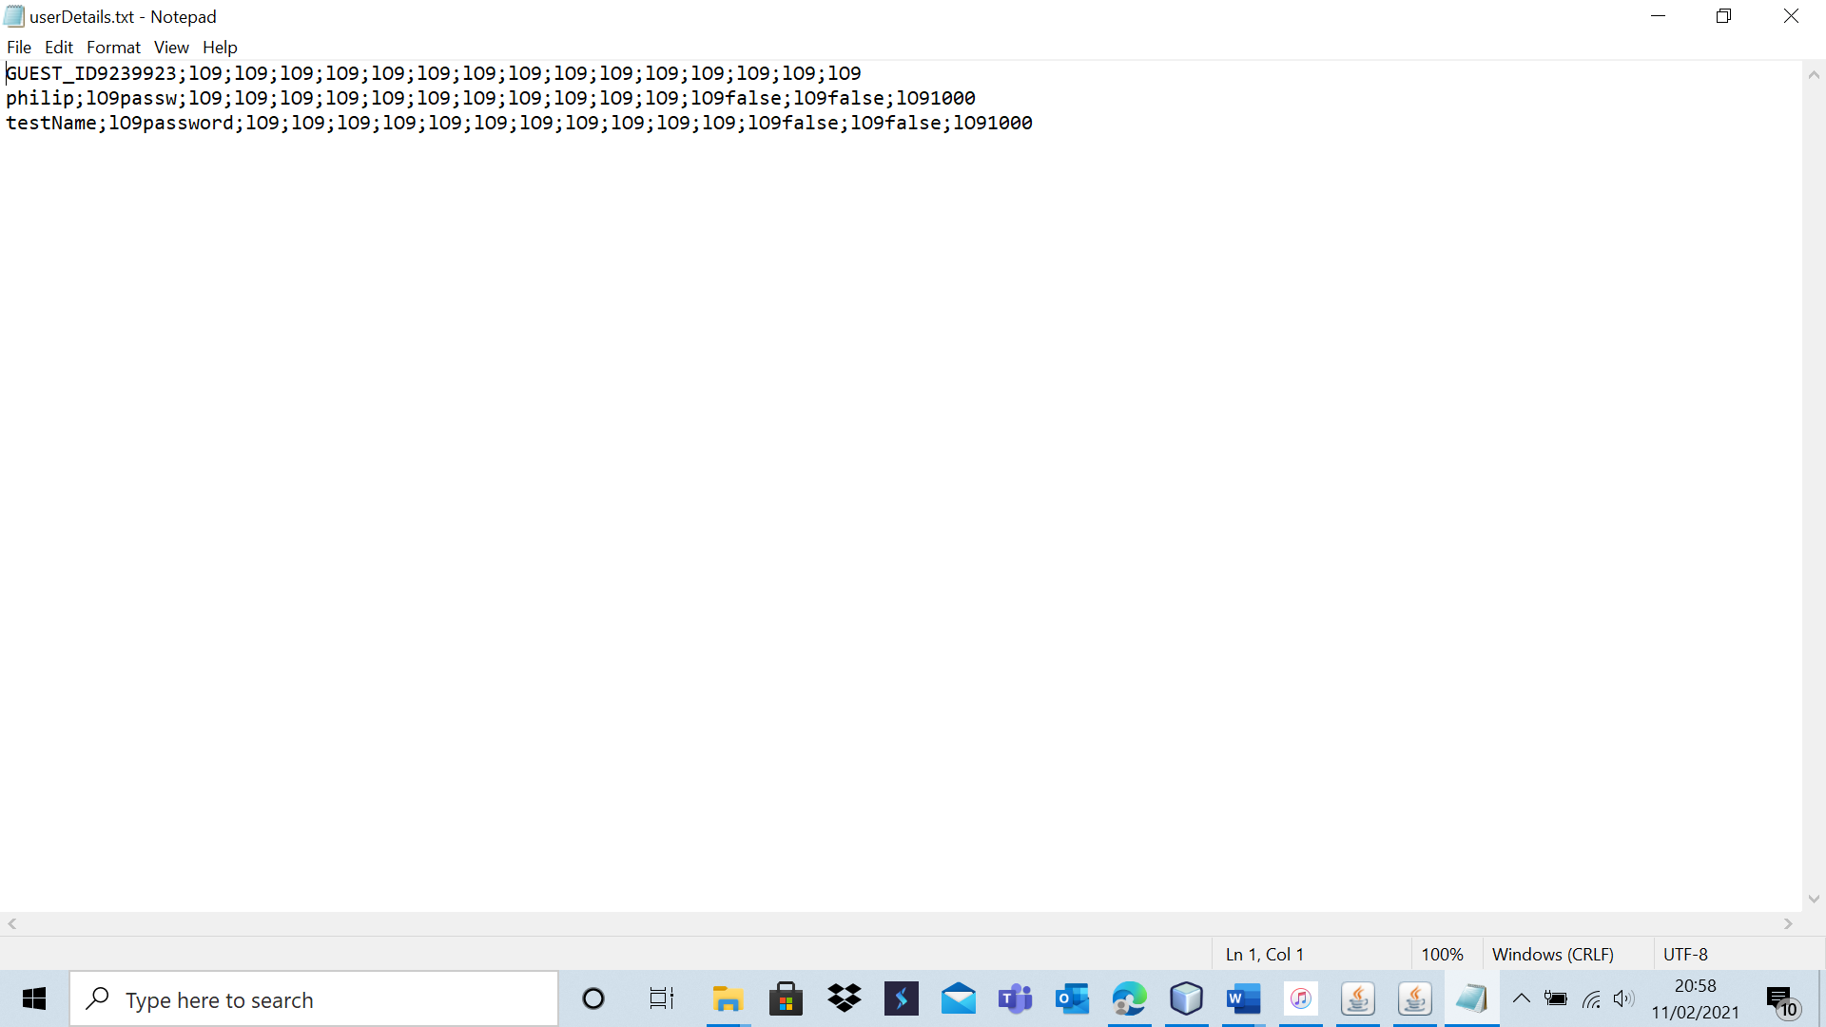

Here is the email file after the test.

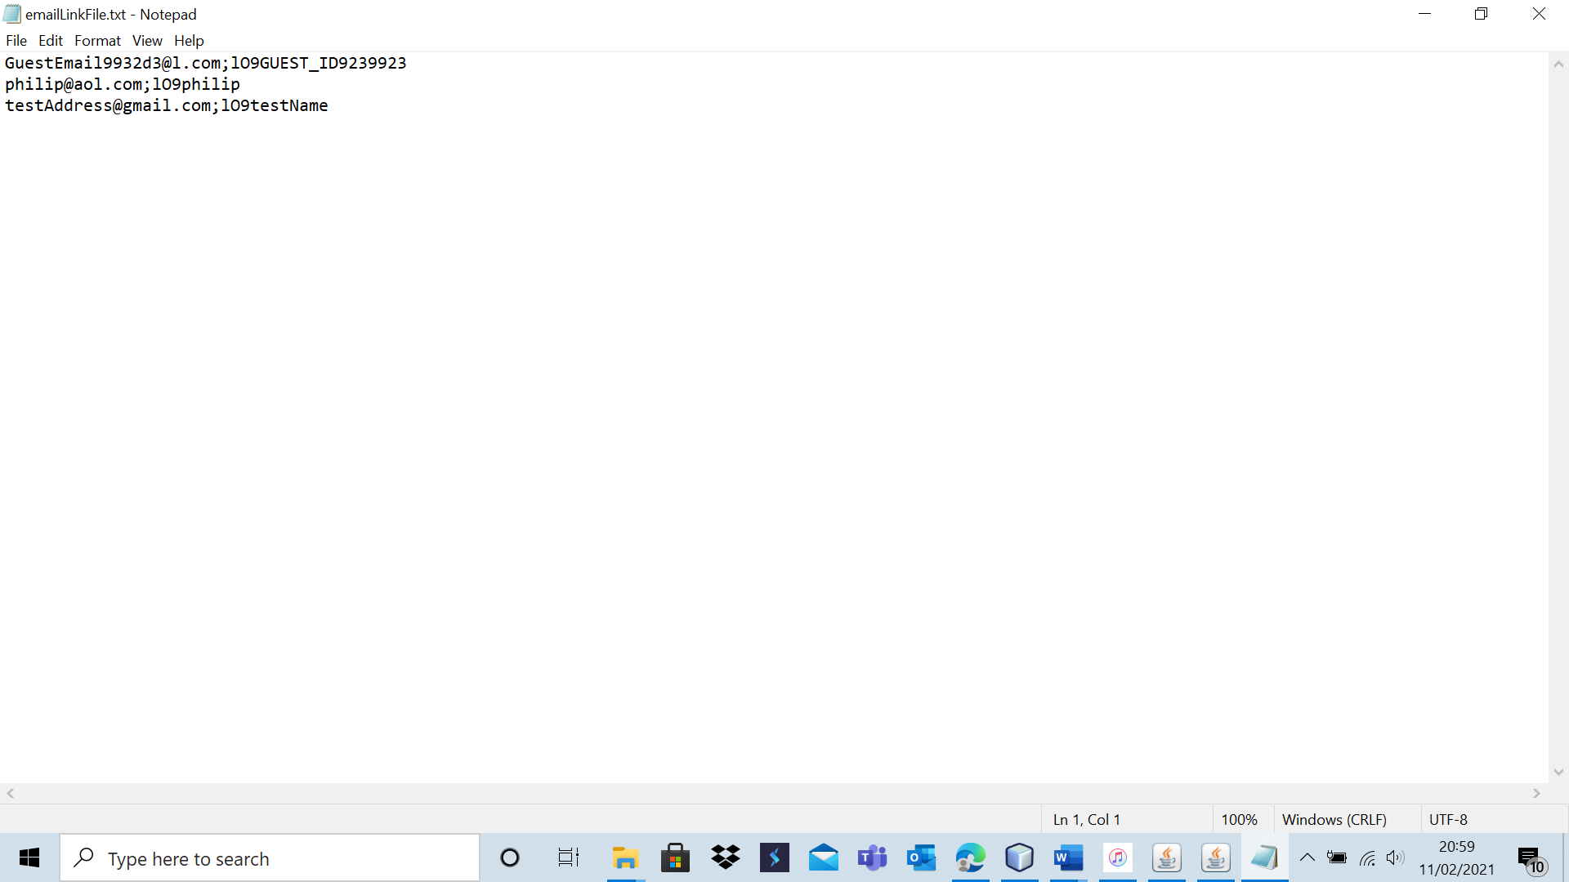

|  |  |  |  |  |  |  |
| --- | --- | --- | --- | --- | --- | --- |
| 8 | Attempt to create an account (extreme data). | To ensure that account creation functions and that all desired validation is carried out. | A3 and A4. | A new account should be created and added to the database. | 1b, 1bi, 1bii and 1ci. | A new account is created exactly as expected. |

Test 8 – A3

Here is the user database before the test.

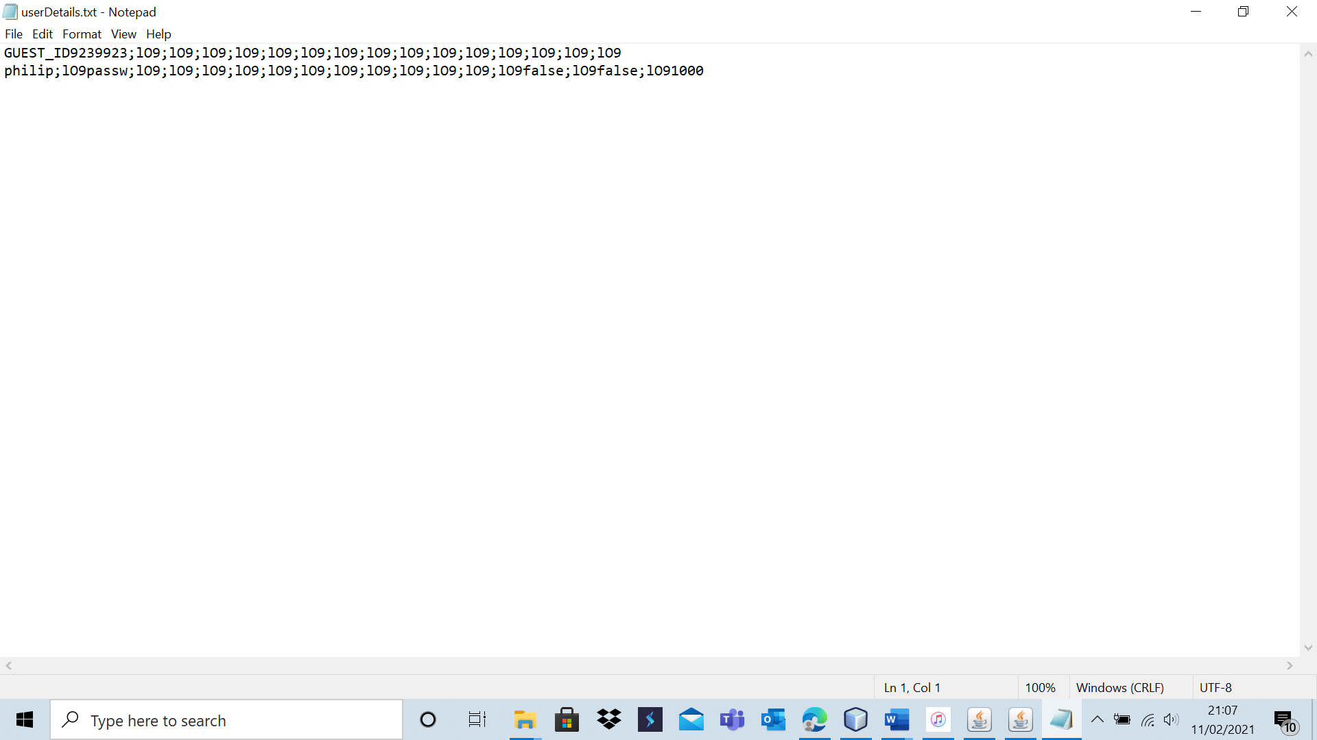

Here is the email link file before the test.

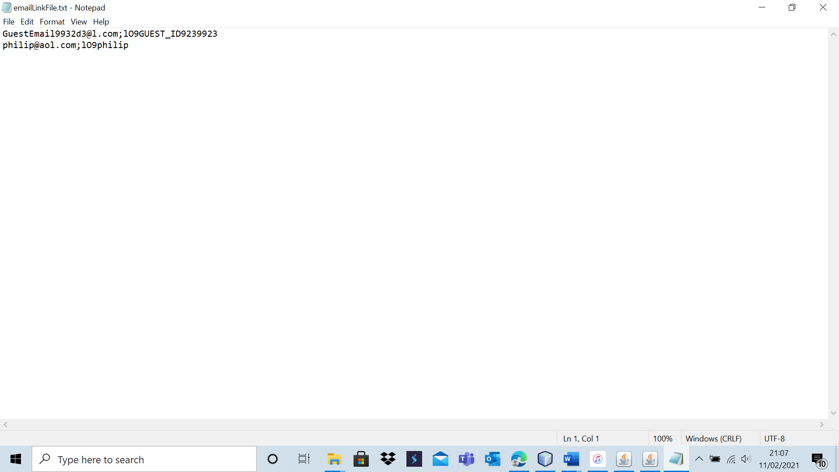

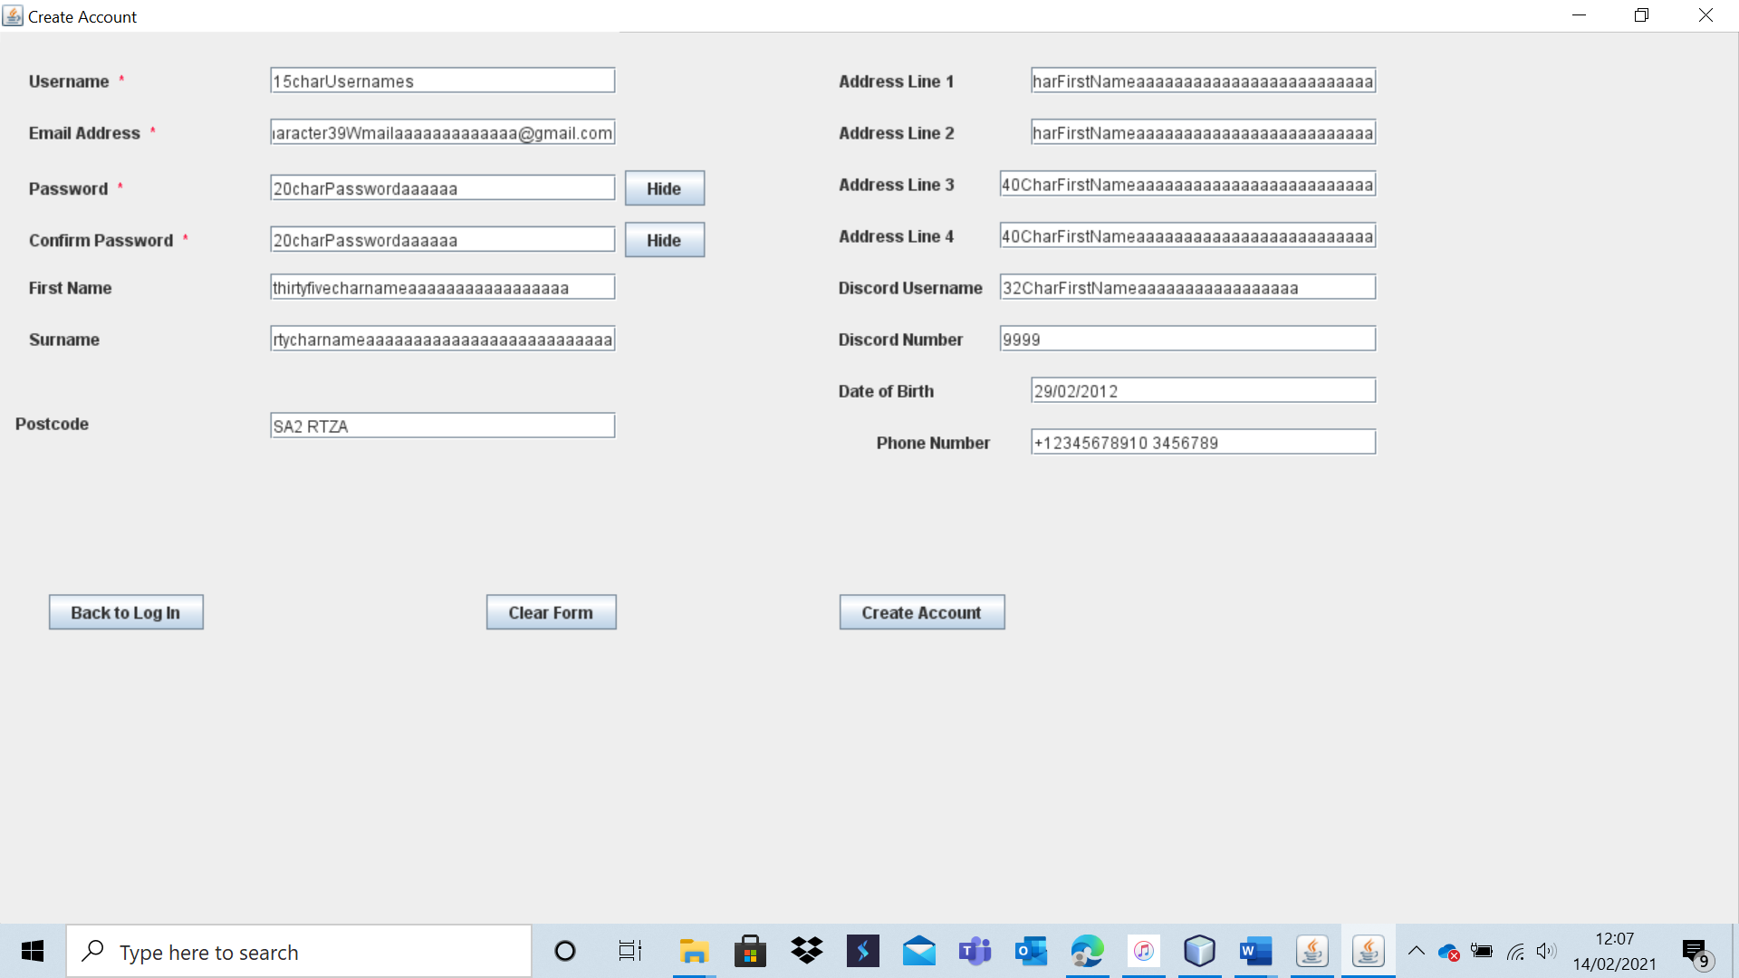

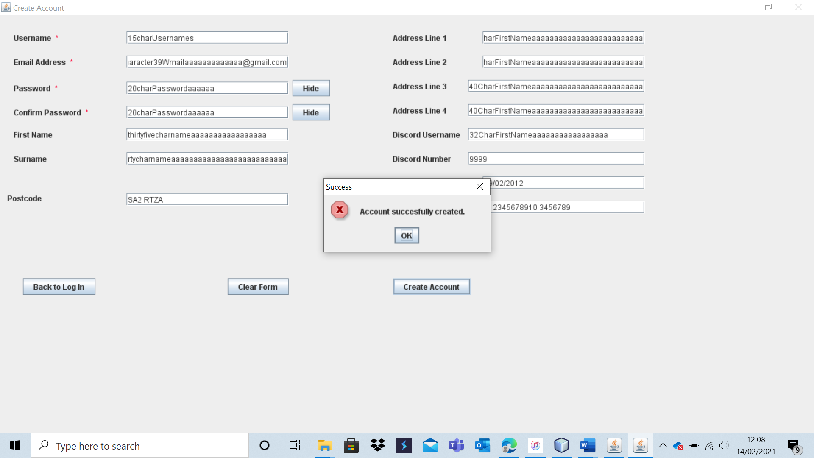

The record is successfully added to the database:

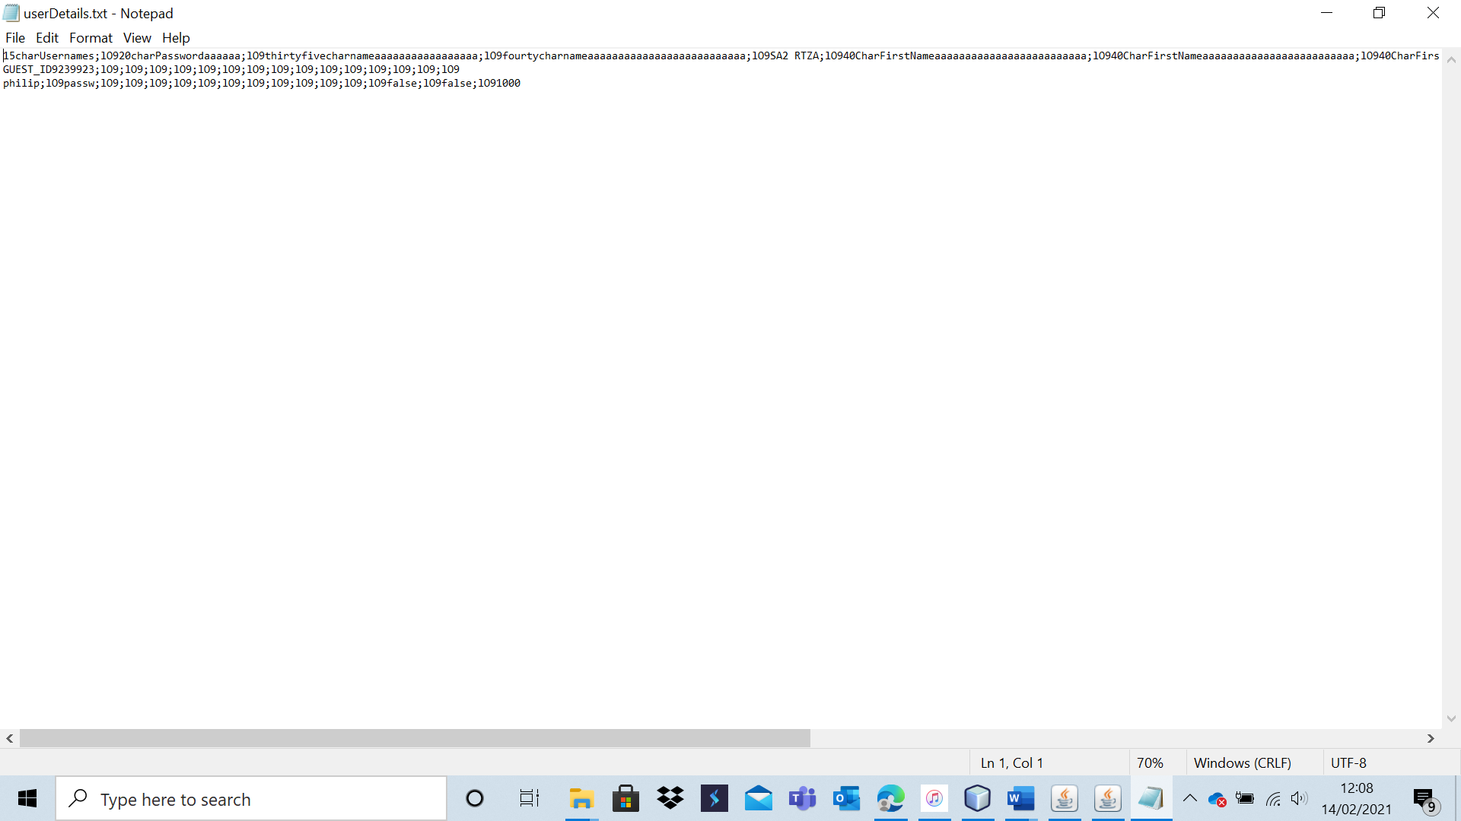

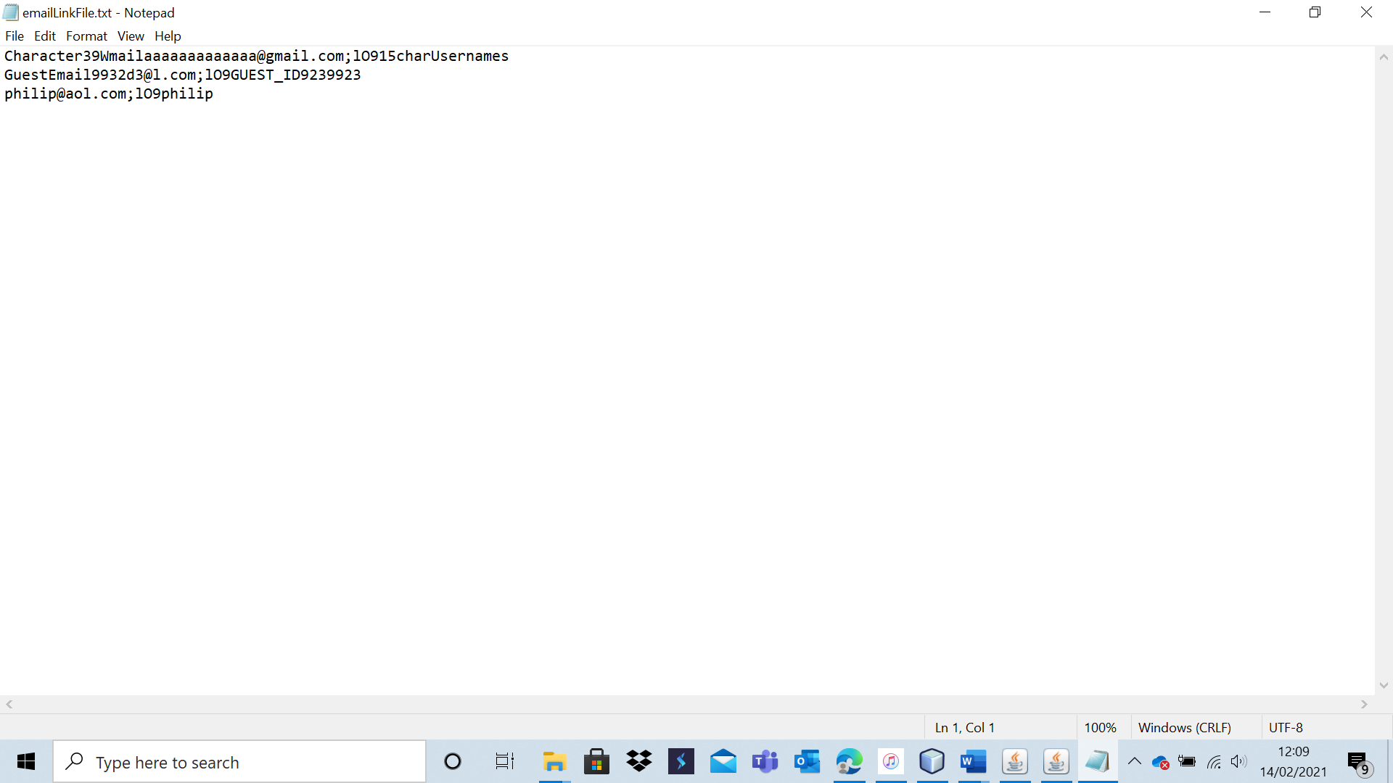

Test 8 -A4

Here is the user database before the test:

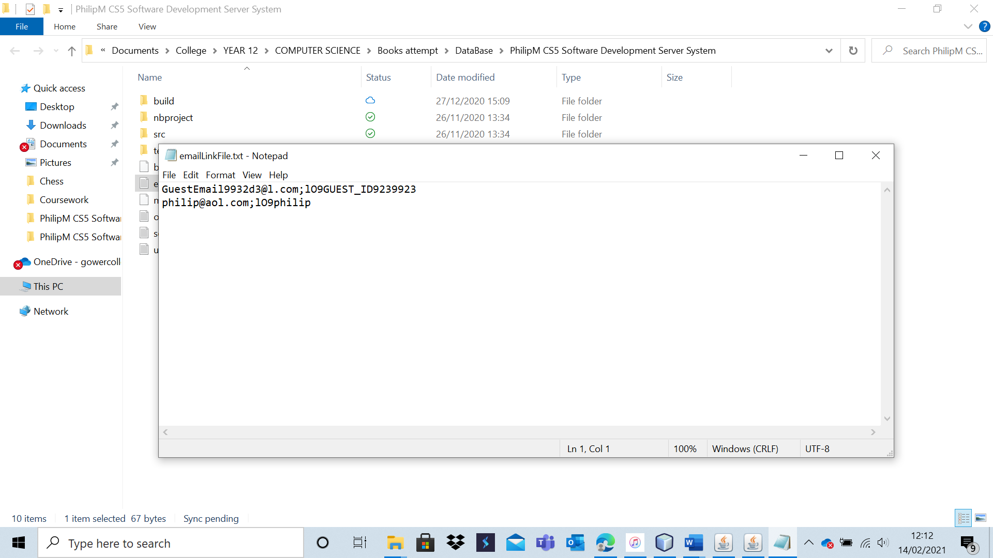

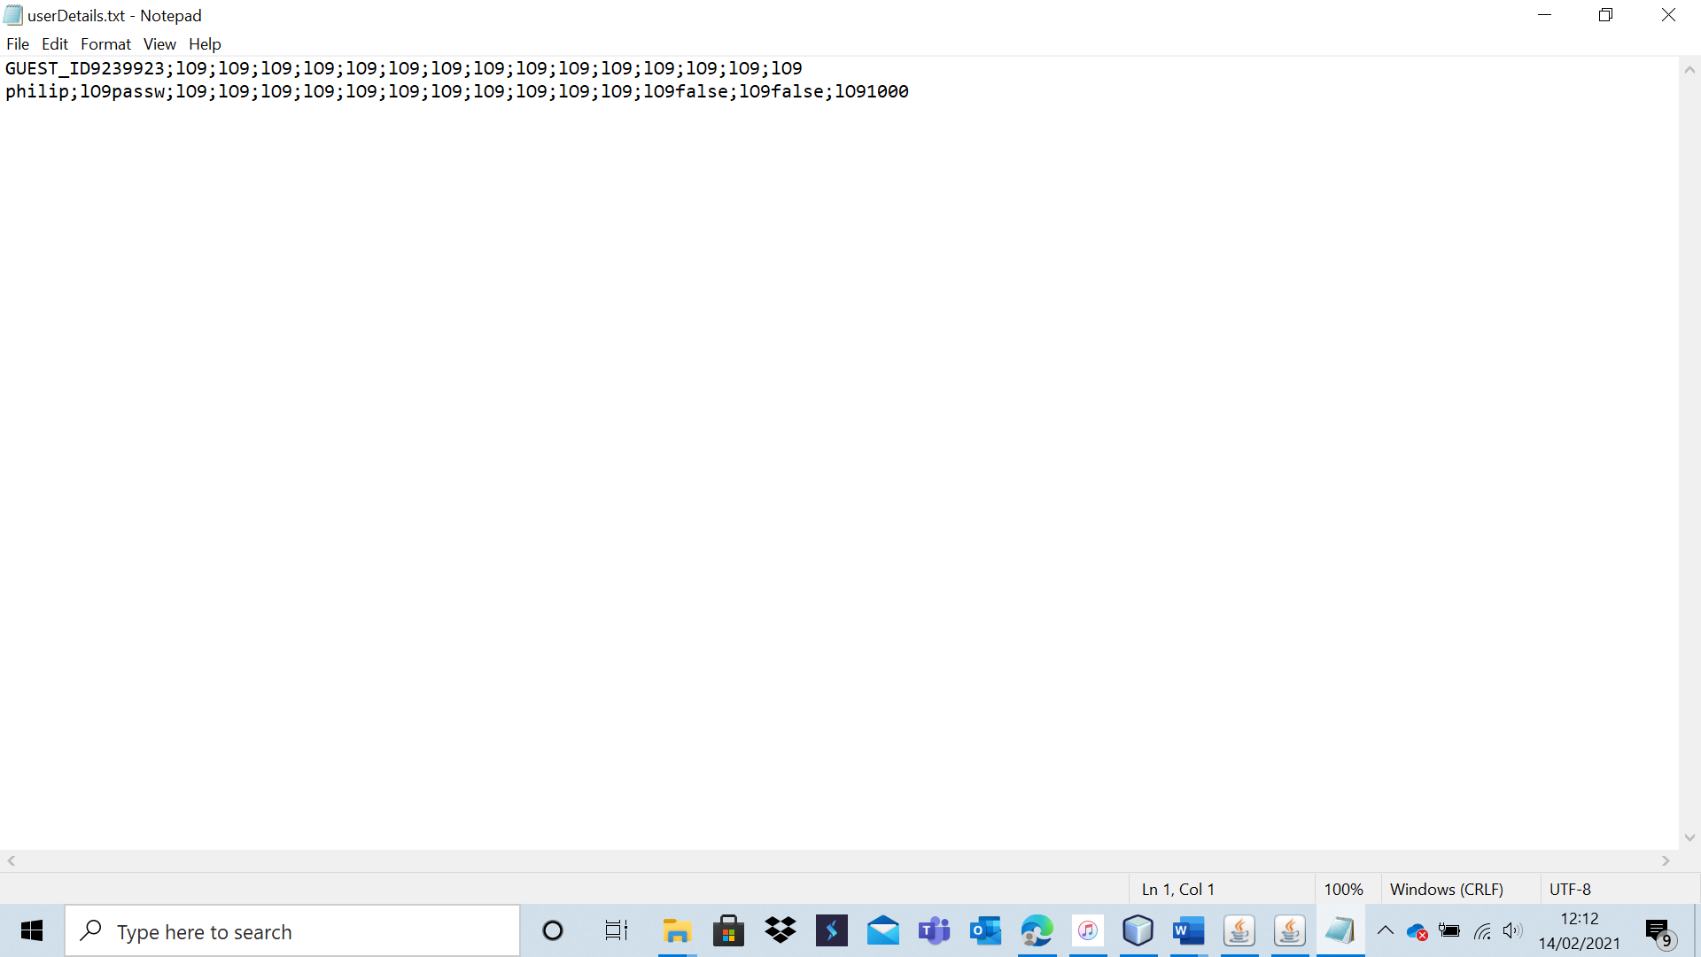

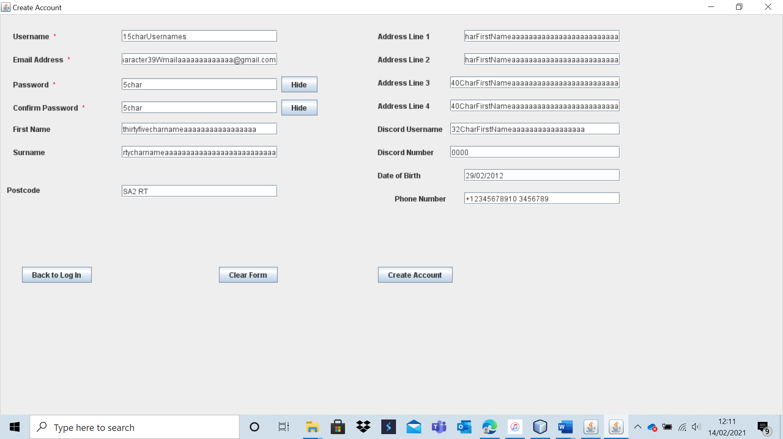

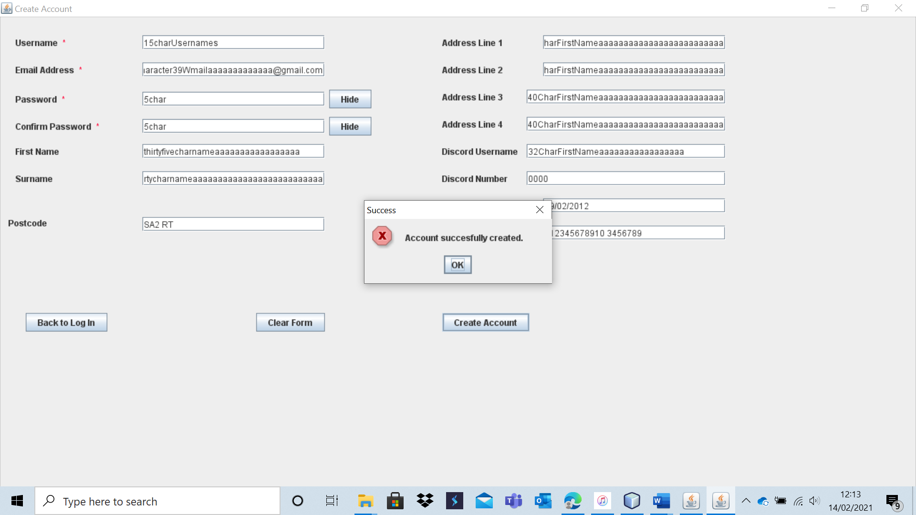

As expected, the account was successfully created. Here is the database to prove it:

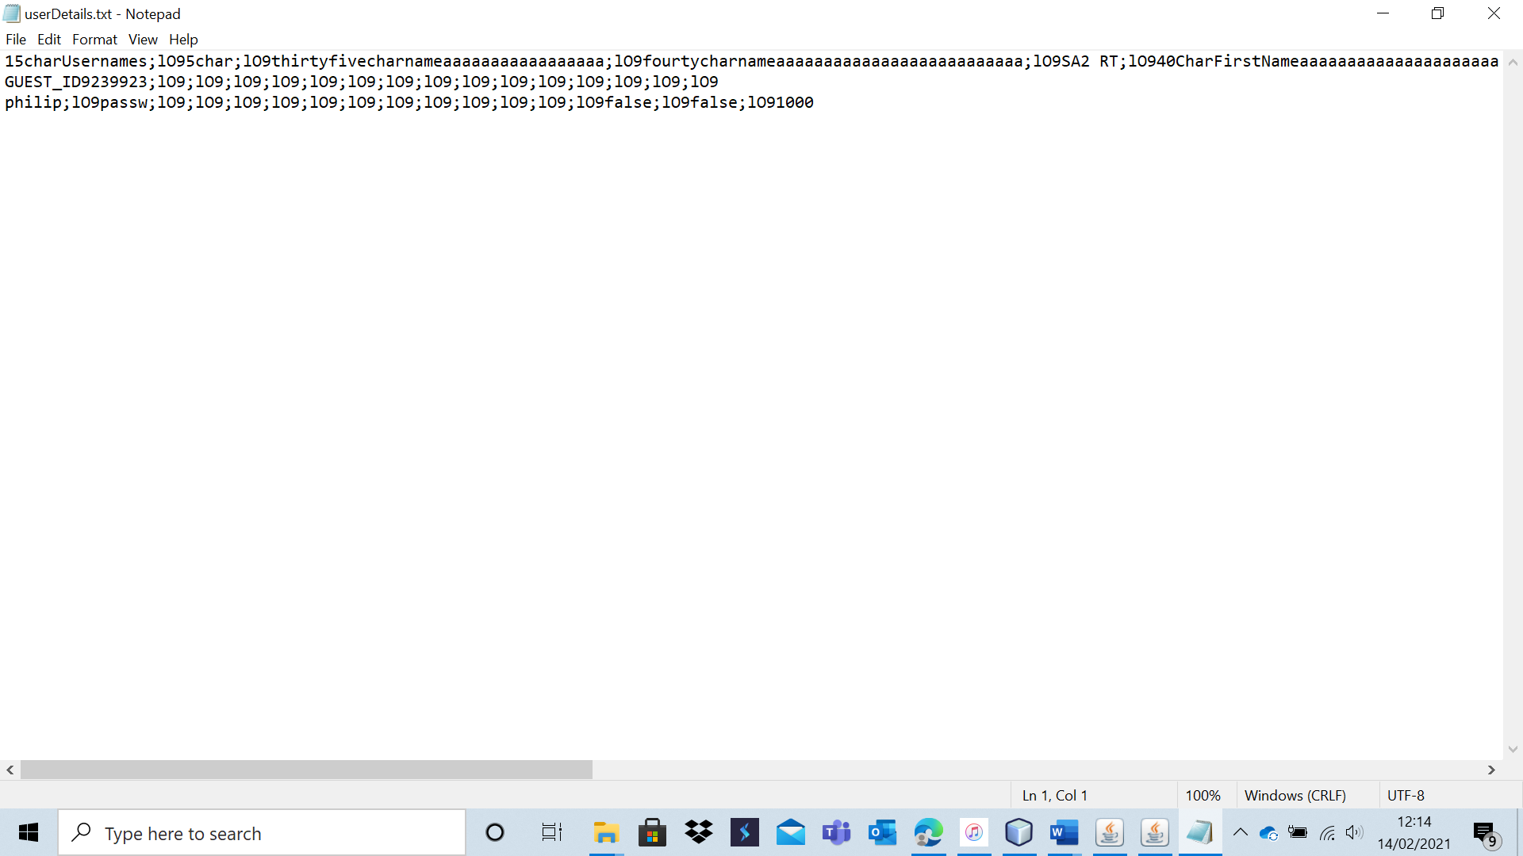

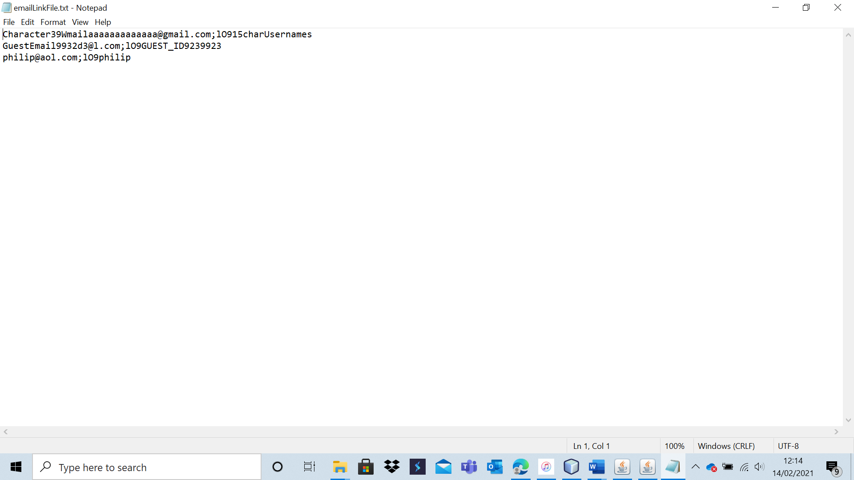

|  |  |  |  |  |  |  |
| --- | --- | --- | --- | --- | --- | --- |
| 9 | Attempt to create an account (invalid data). | To ensure that account creation functions and that all desired validation is carried out. | A5 – A35 | No account should be created or added to the database. An appropriate error message should be displayed. | 1b, 1bi, 1bii and 1ci. | No account was created with the invalid data, showing that the system has robust validation in place. Furthermore, every single invalid input had a clear error message telling the user clearly why the details input were invalid. This shows that the system is usable and robust. I was very pleased that all error messages were clear enough to make it easy for users to fix any mistakes they may have made when attempting to create an account. |

Note: as all data input is invalid, I will not include screenshots of the database before and after attempting to create an account unless the test fails, and a new account is added.

Test 9 – A5

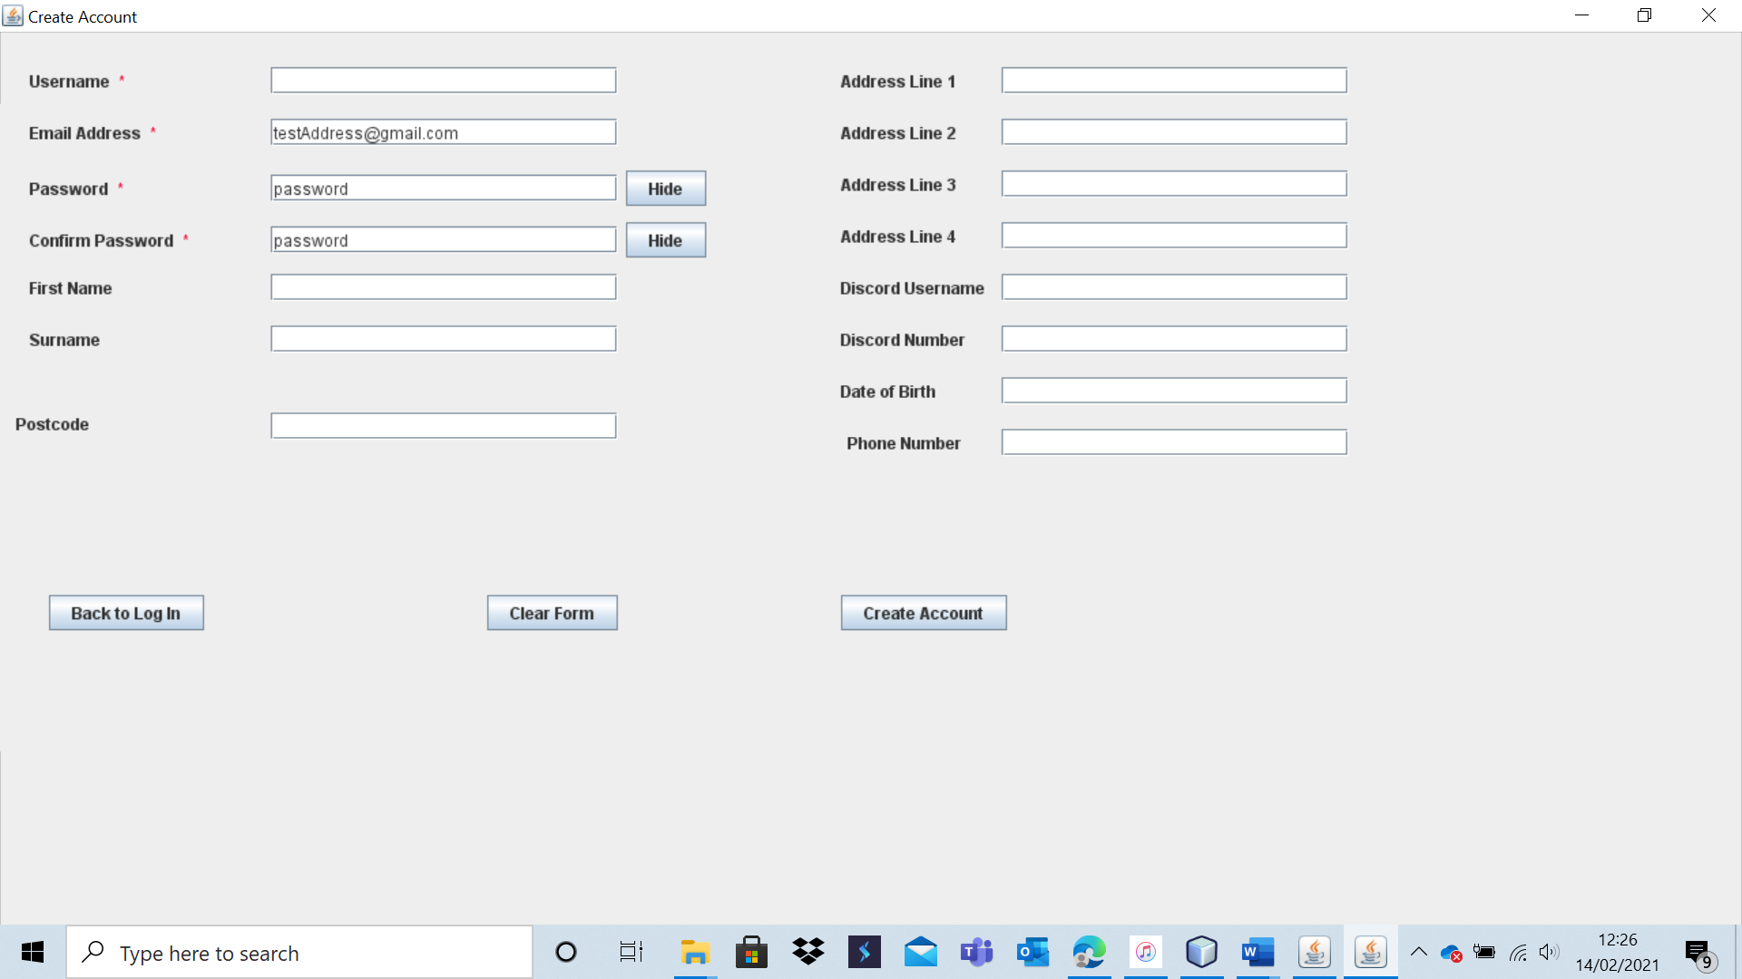

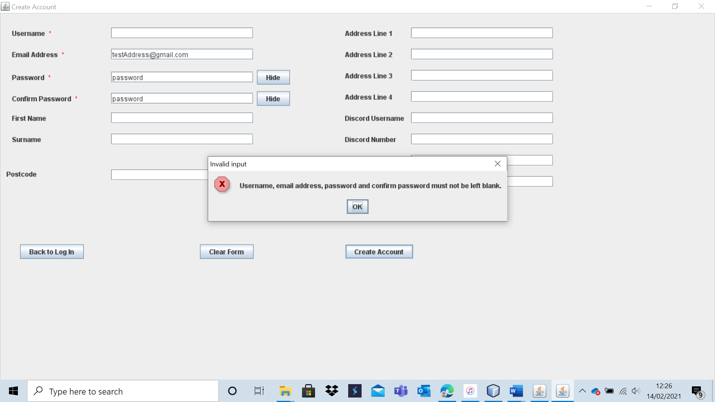

As expected, the system displays an appropriate error message, and the account is not created.

Test 9 – A6

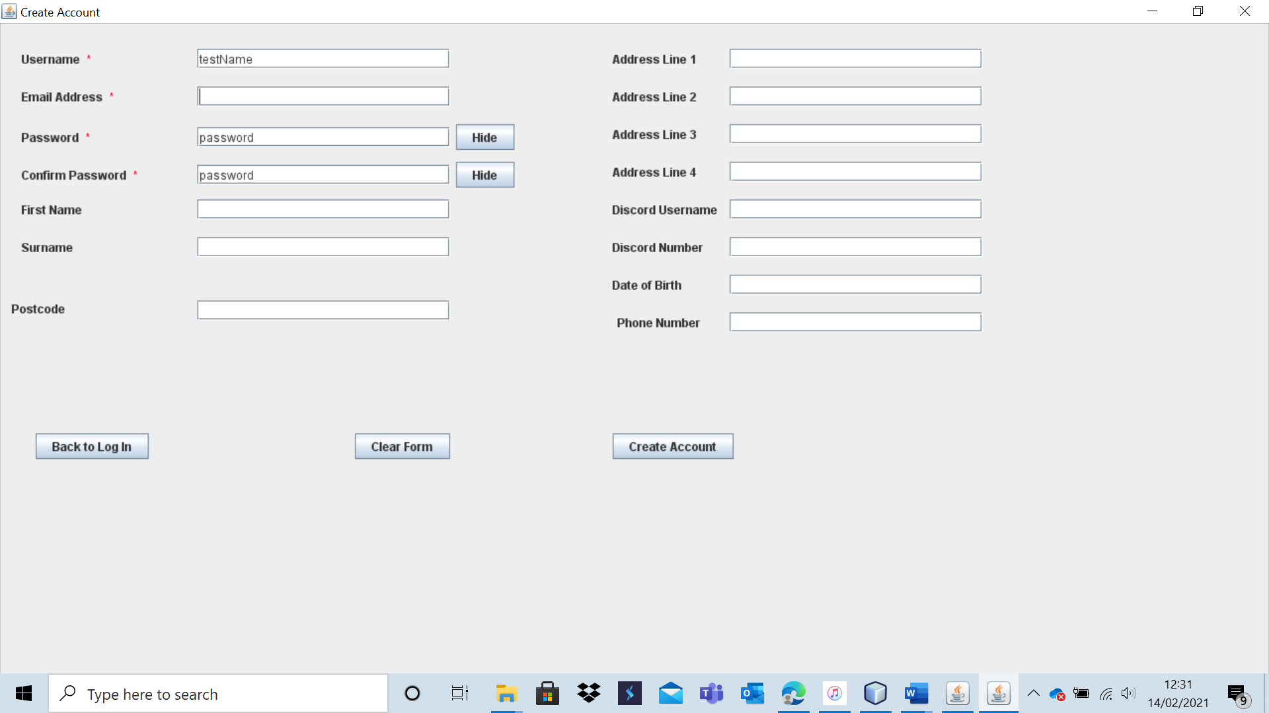

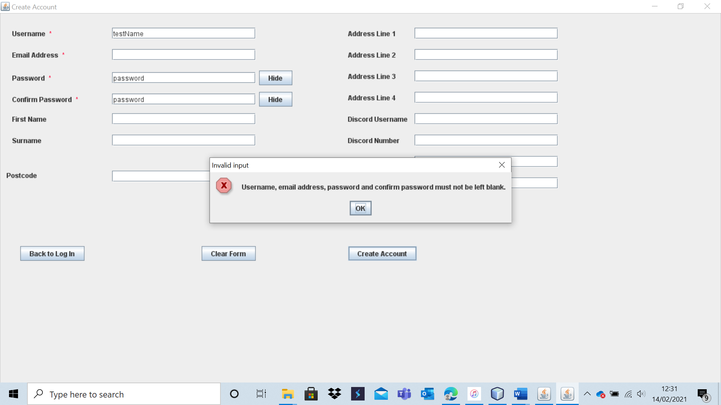

The account is not created, and a detailed error message is displayed.

Test 9 – A7

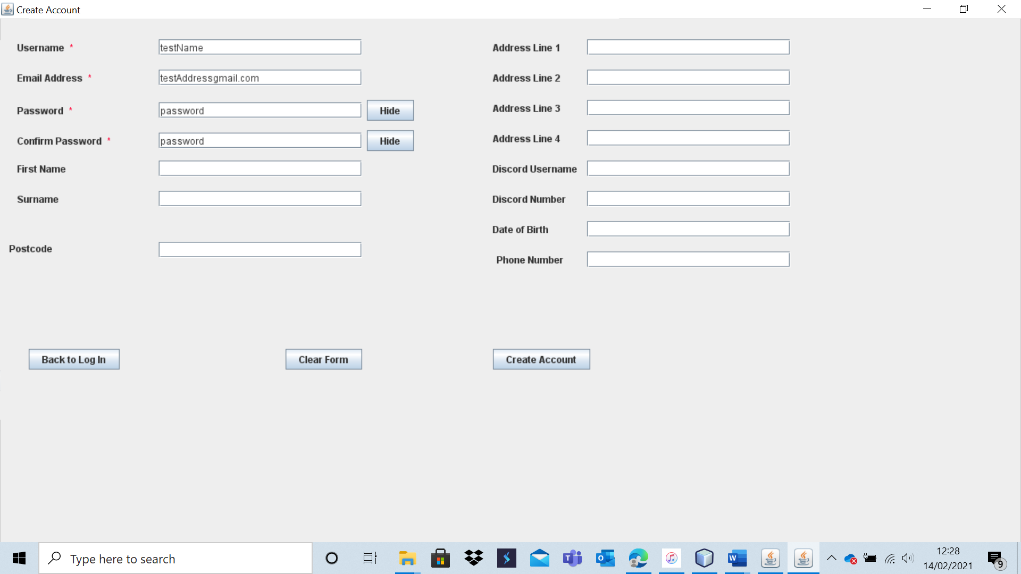

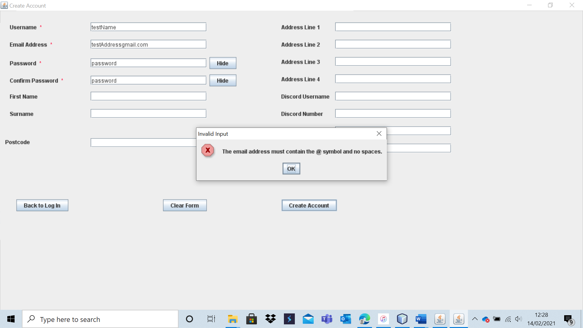

The account is not created, and the system provides a specific error message as to why this occurred.

Test 9 – A8

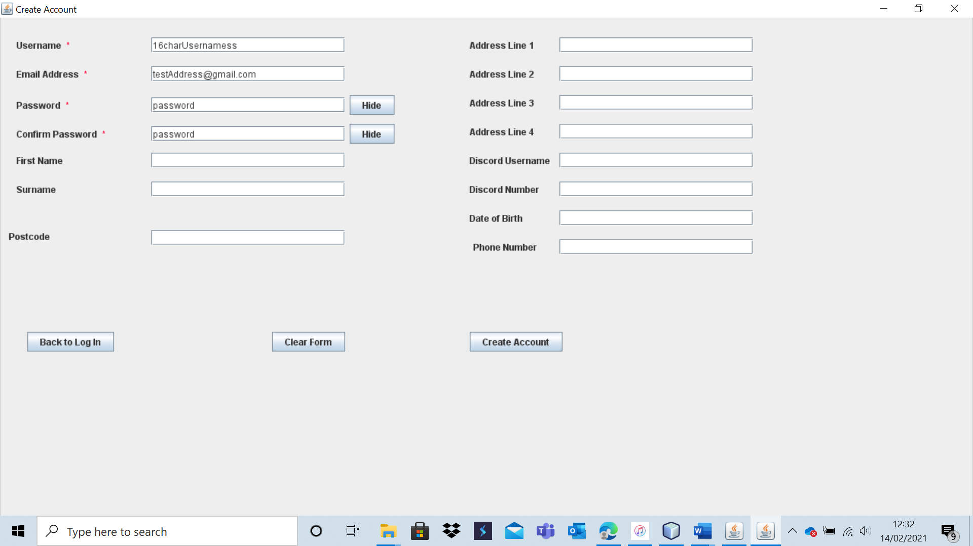

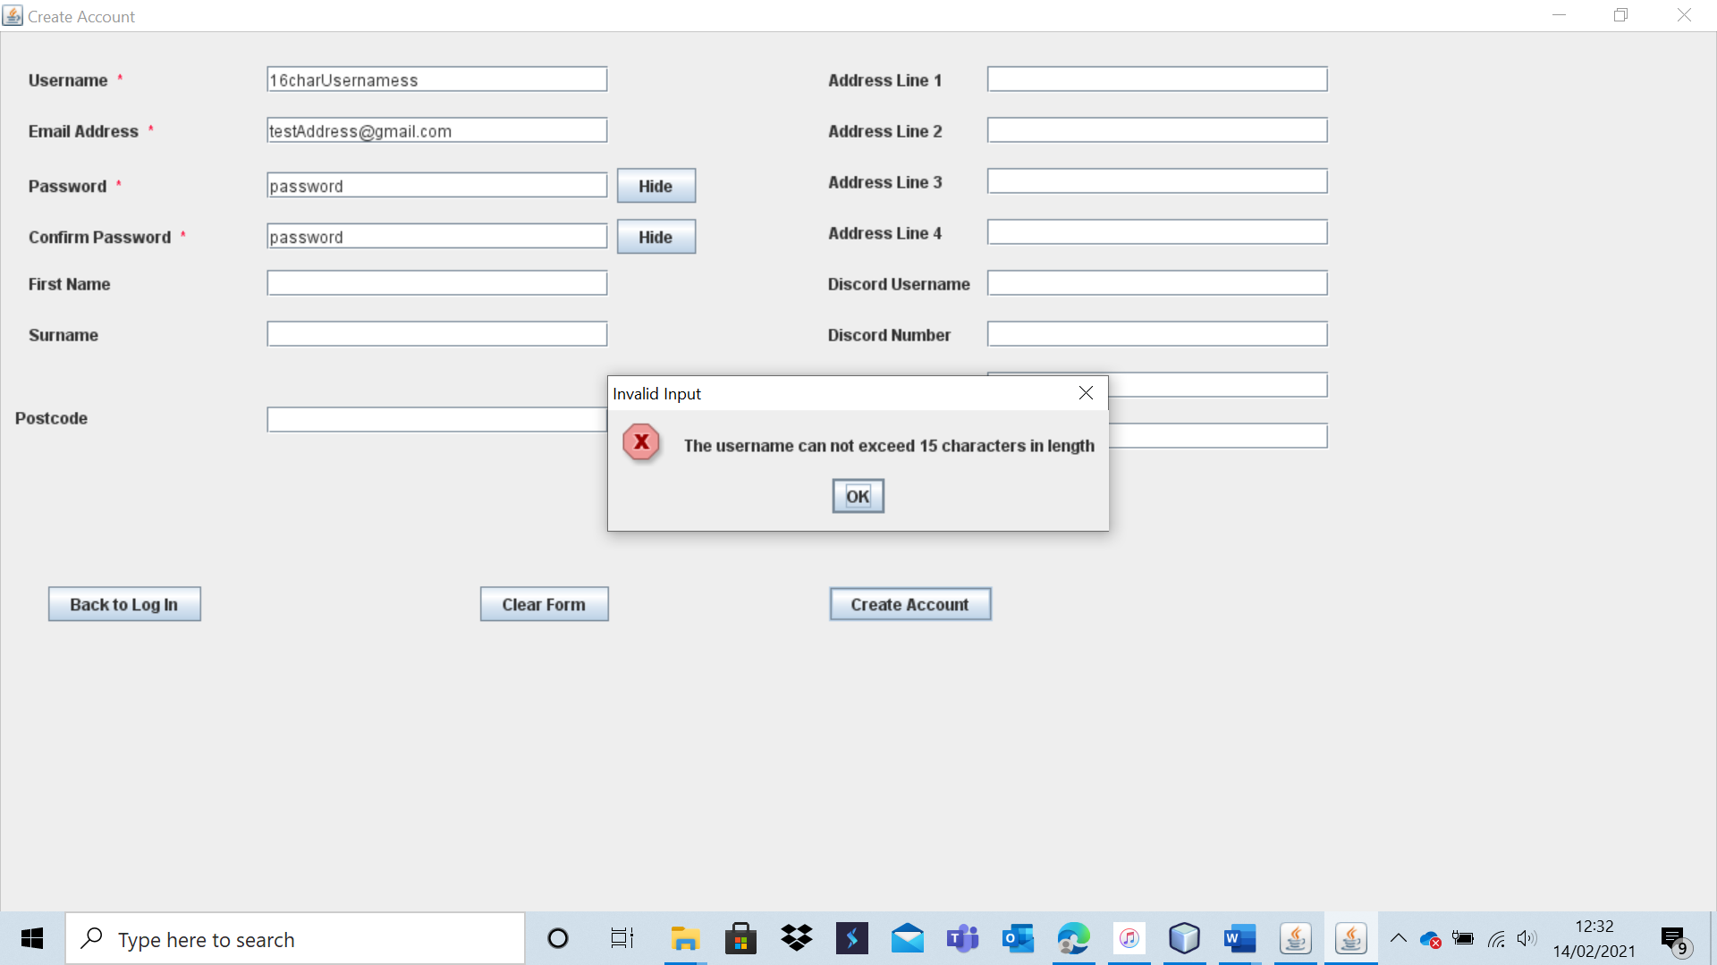

As expected, the account was not created. Once more, a detailed and specific error message was displayed – leaving the user with no doubt as to why the account creation failed.

Test 9 – A9

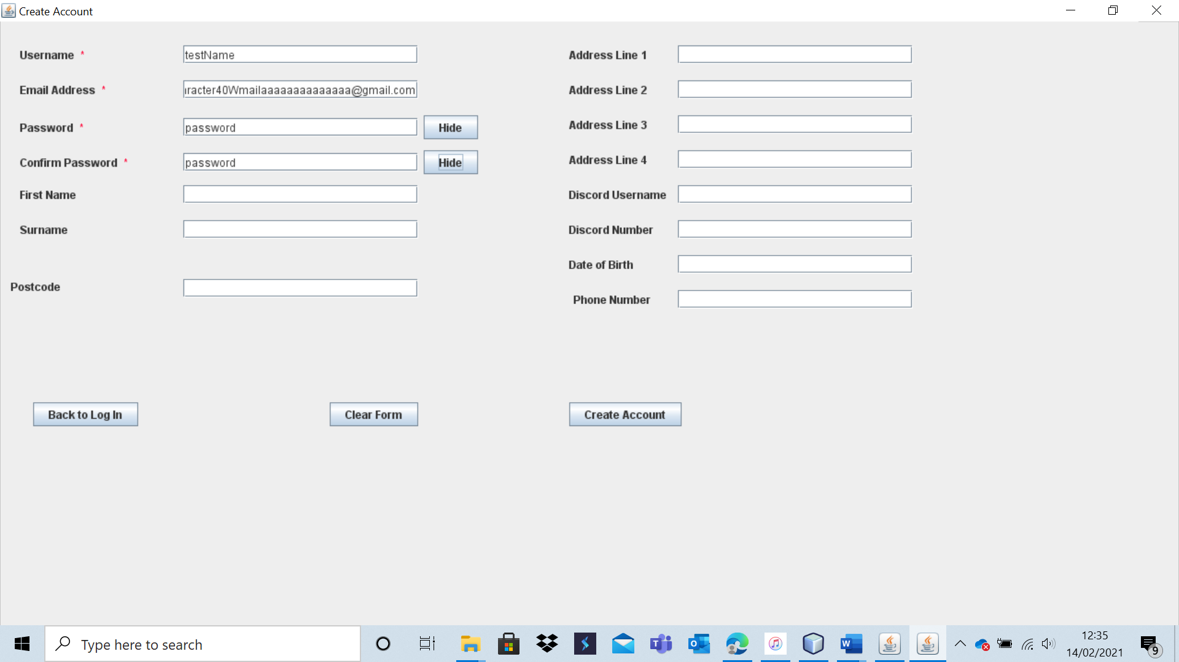

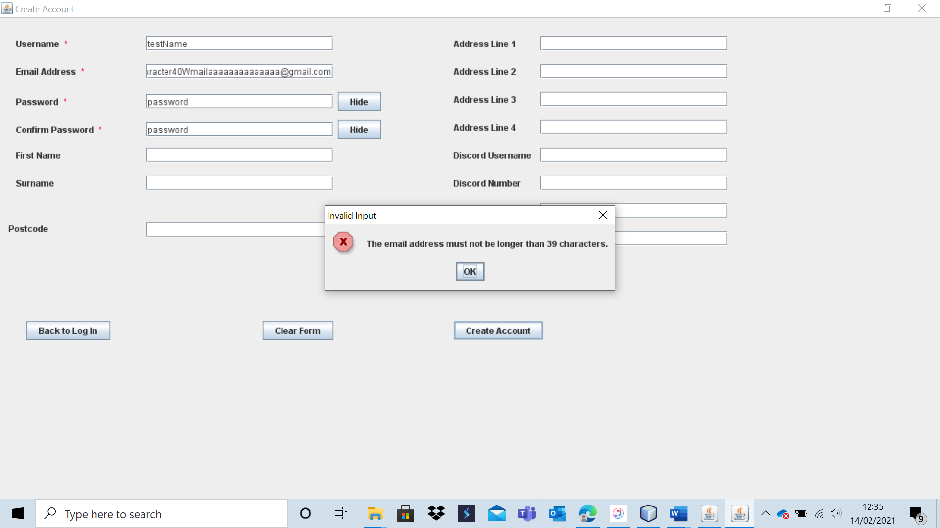

Account creation did not occur.

Test 9 – A10

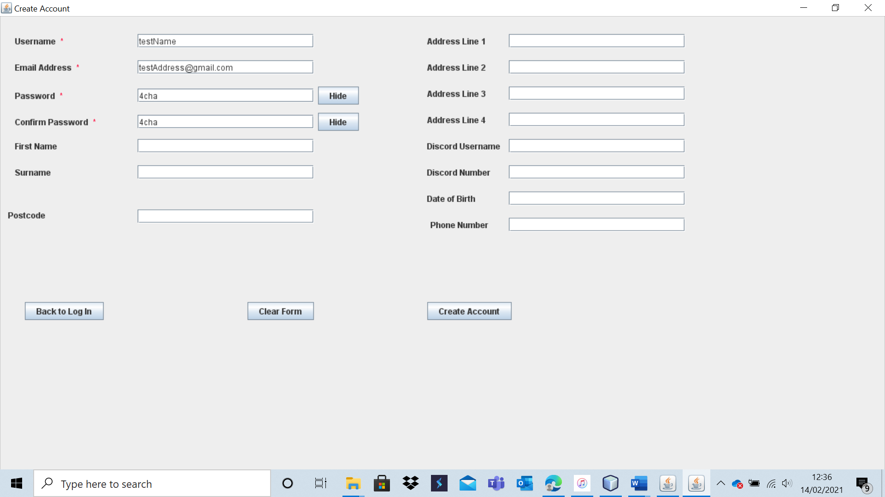

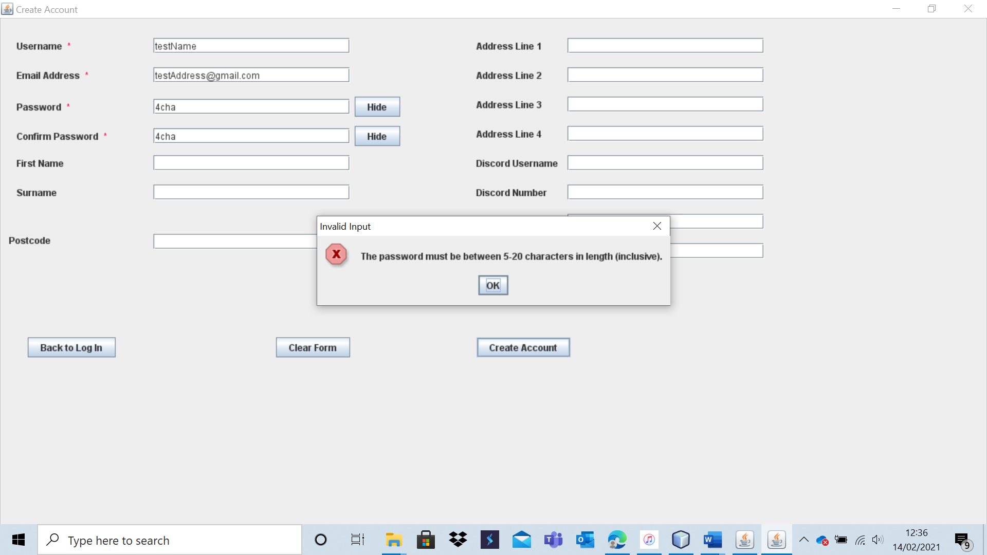

The account was not created, and a detailed message was displayed explaining why.

Test 9 – A11

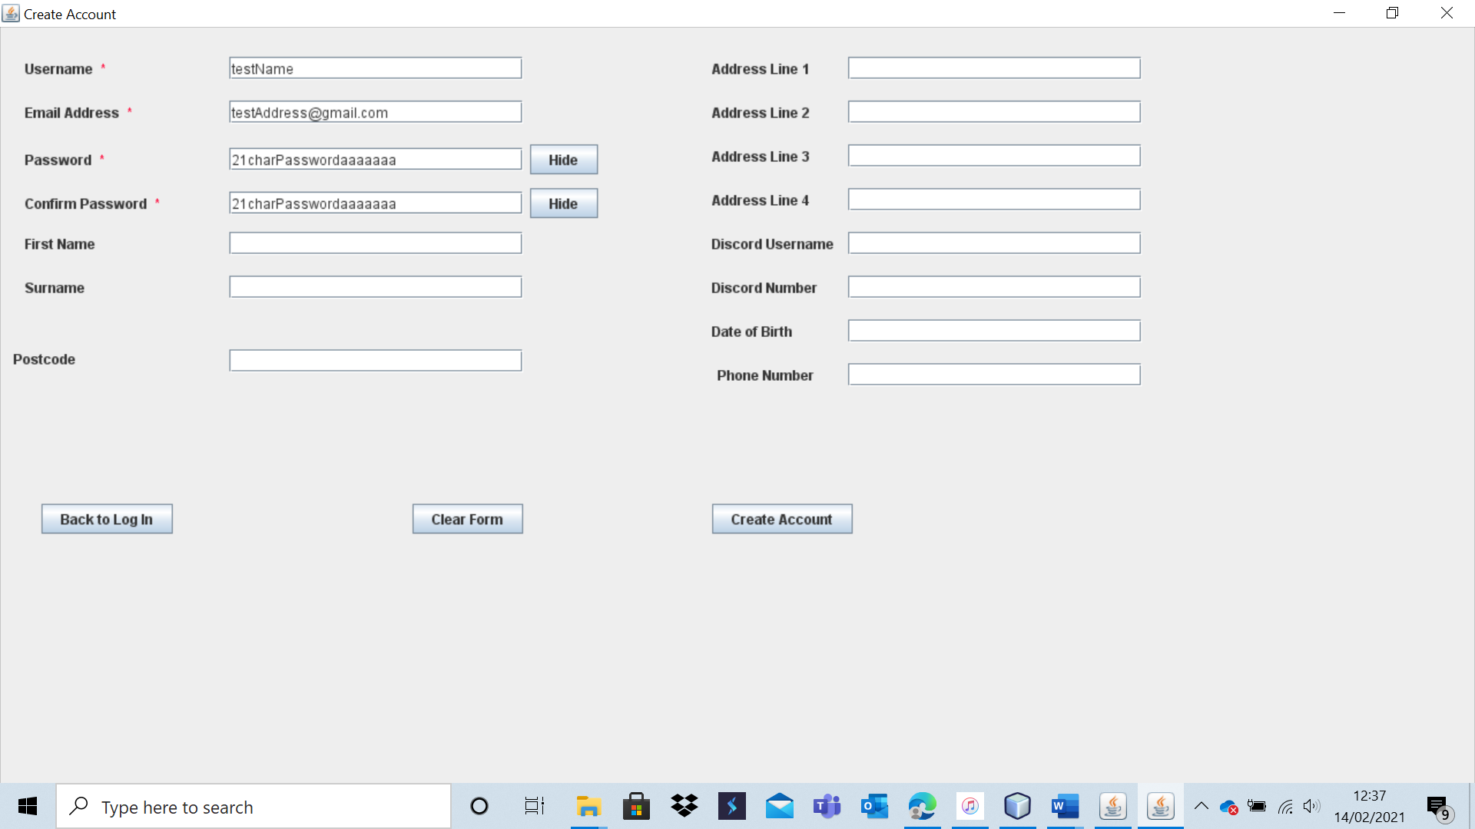

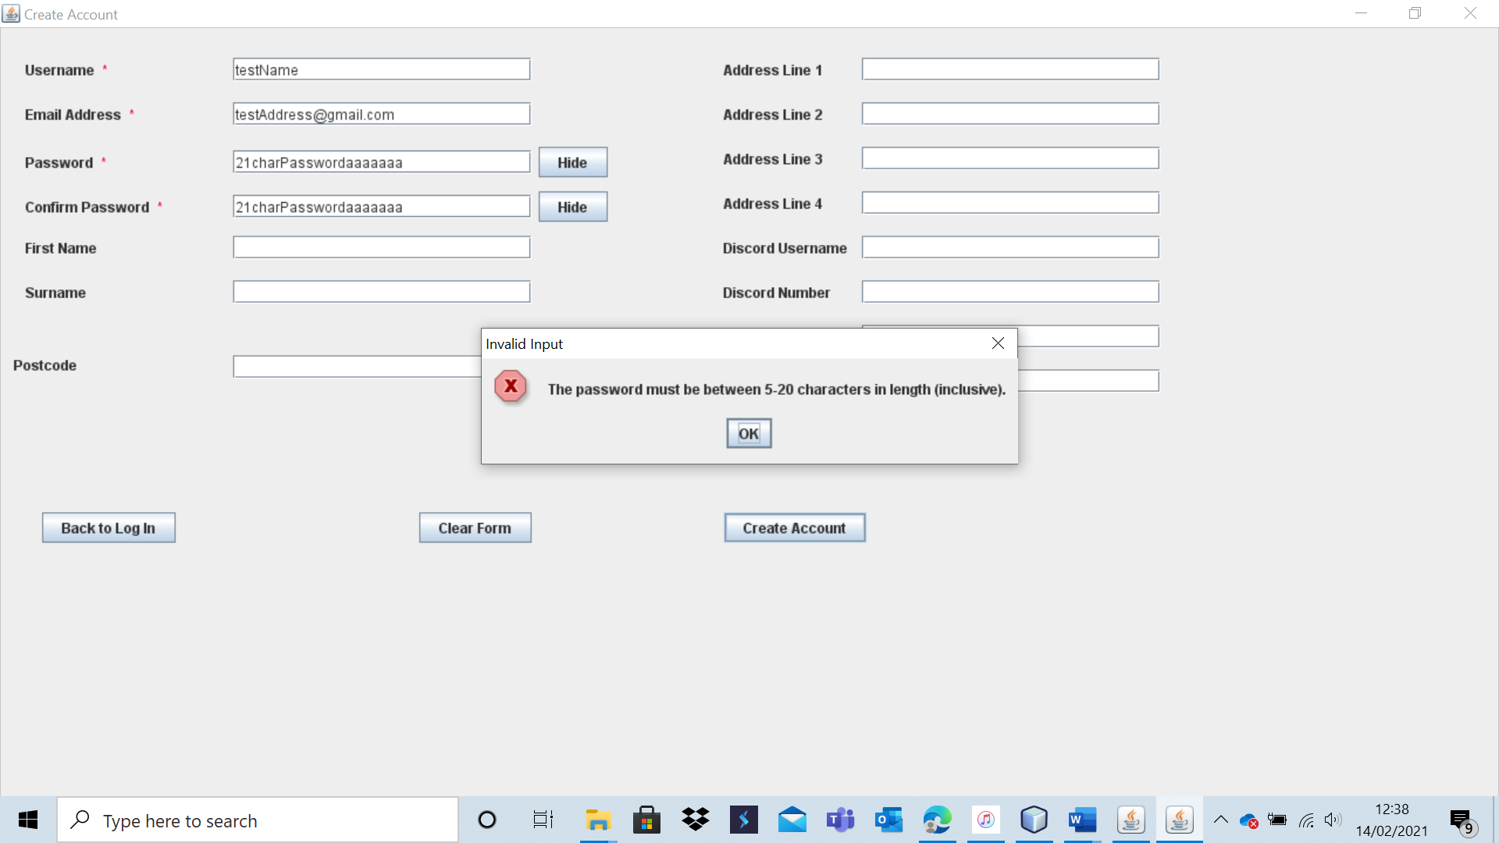

The account is not created, and the system passes the test.  
 Test 9 – A12

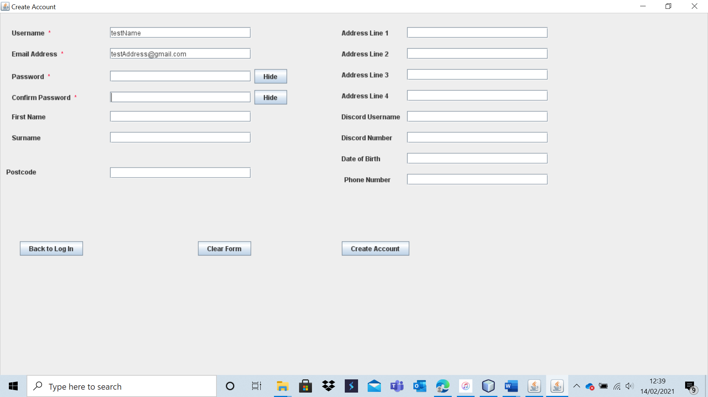

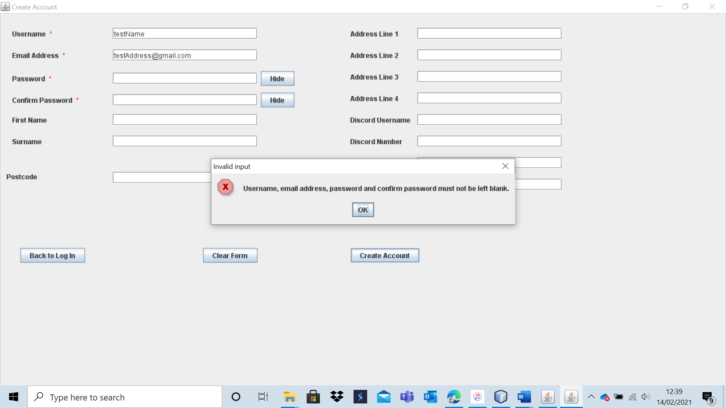

The system passes the test as no new account is created.

Test 9 – A13

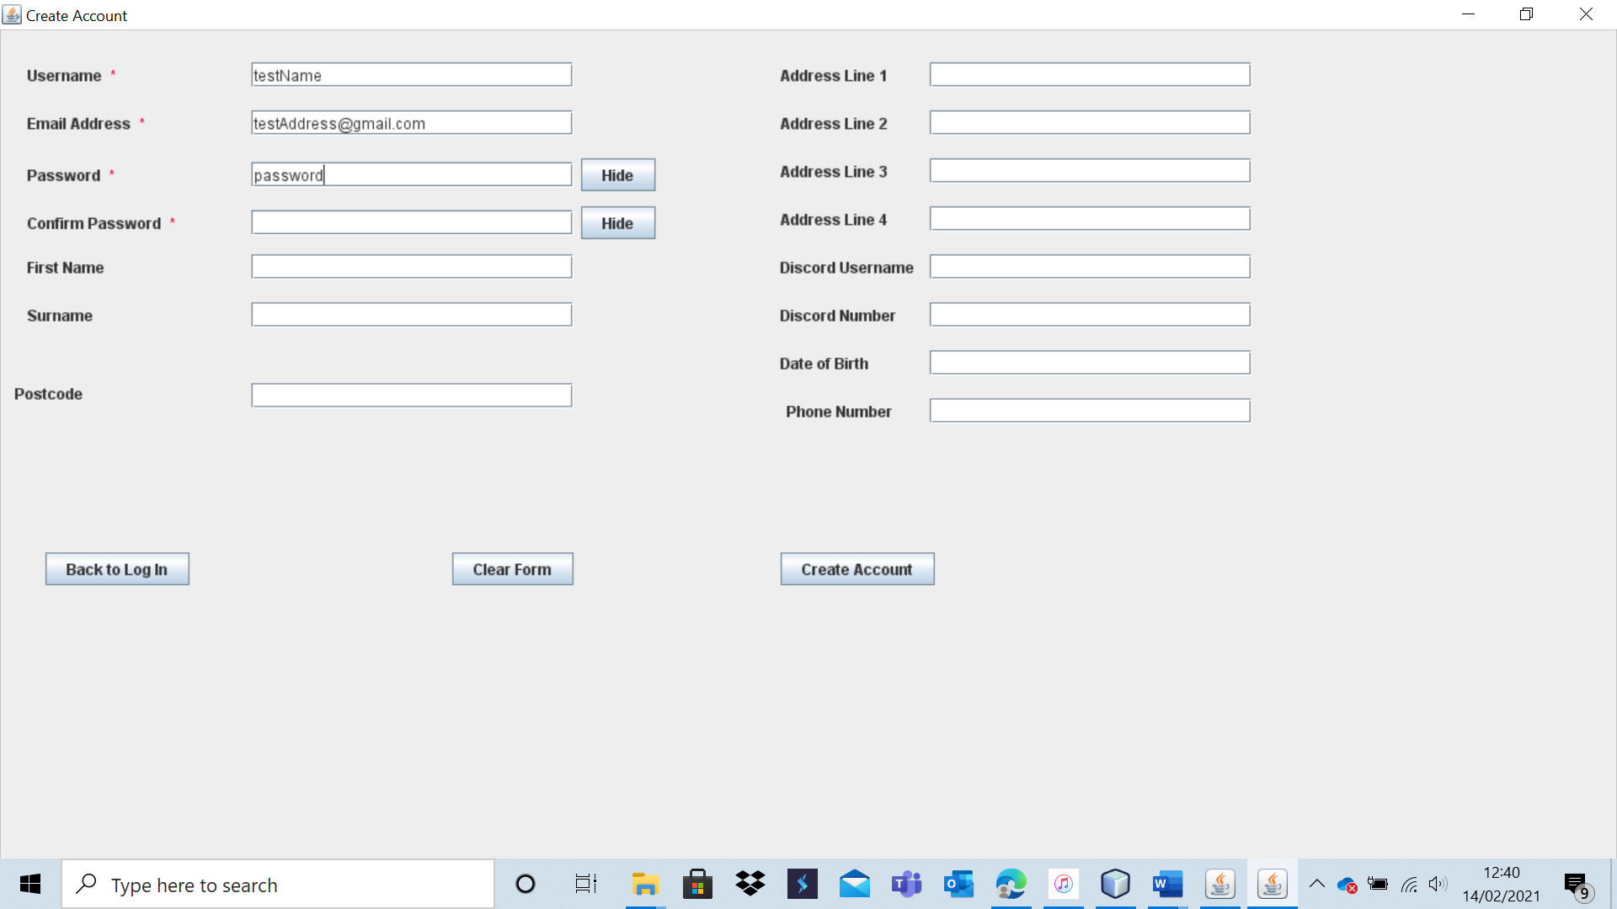

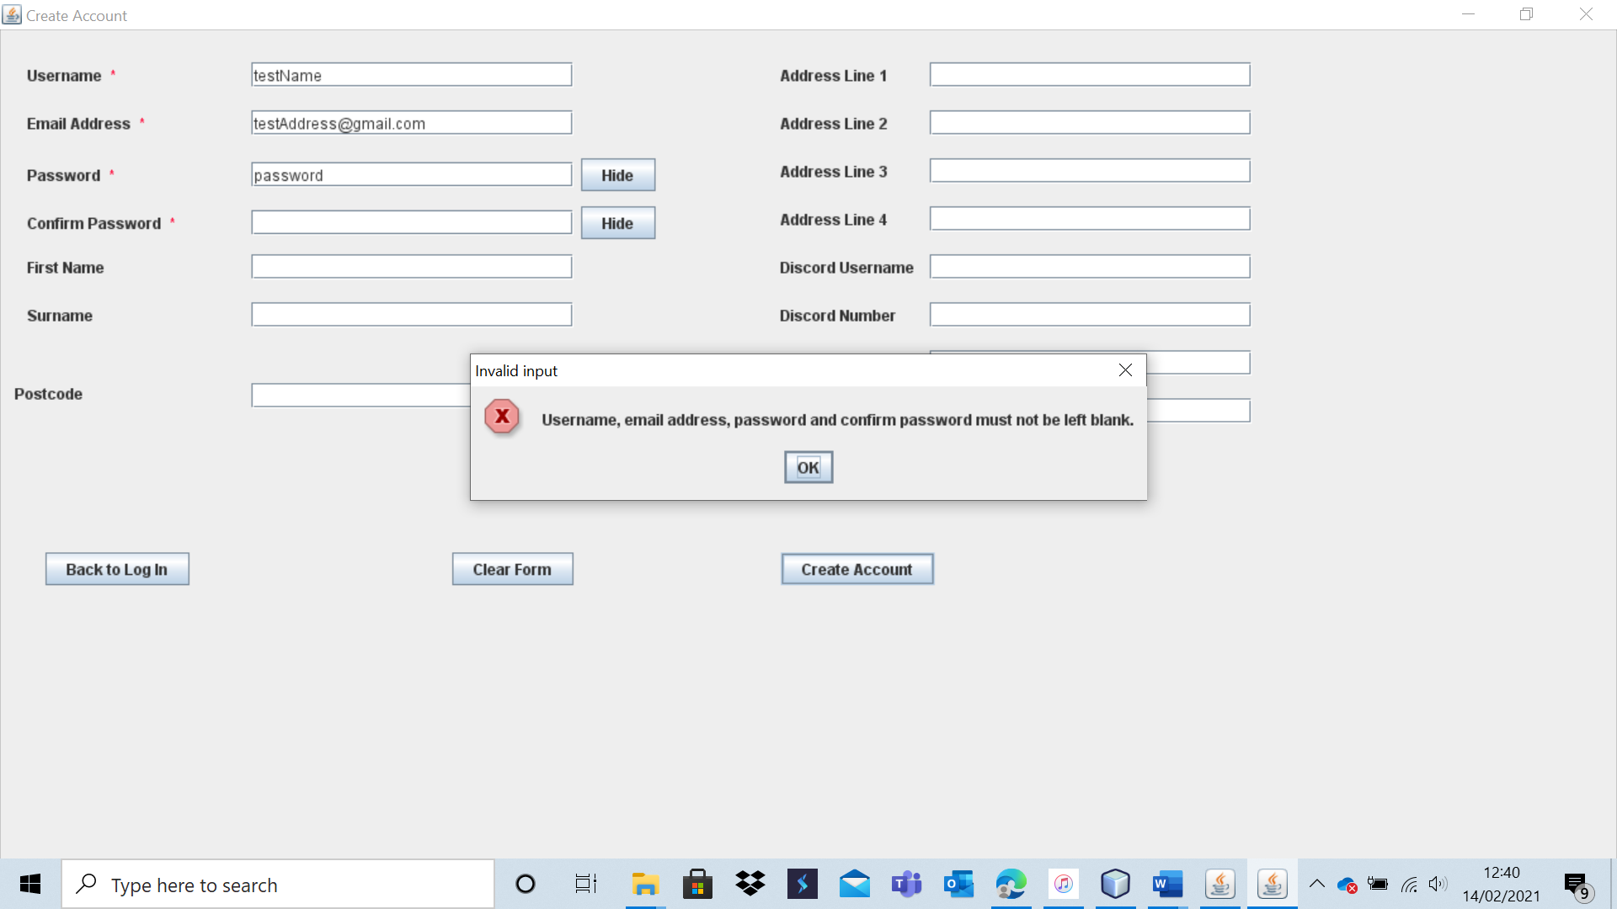

The account is not created (as expected).

Test 9 – A14

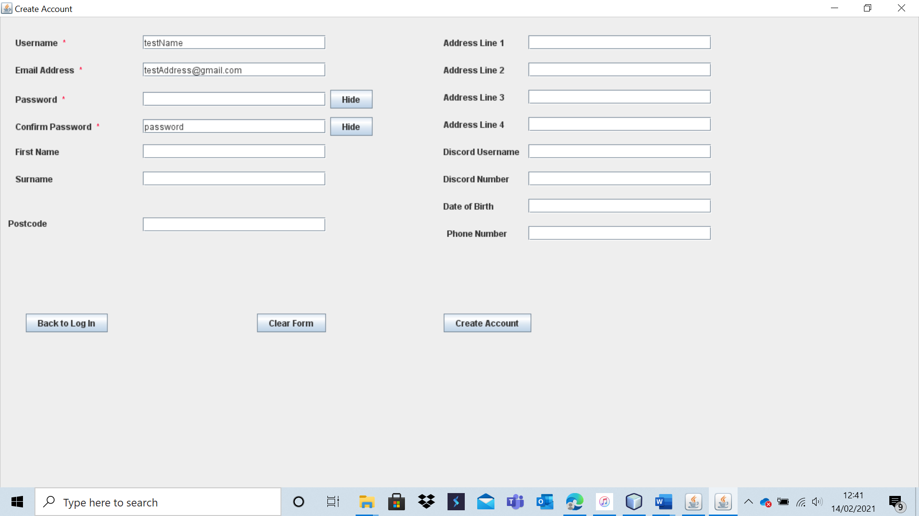

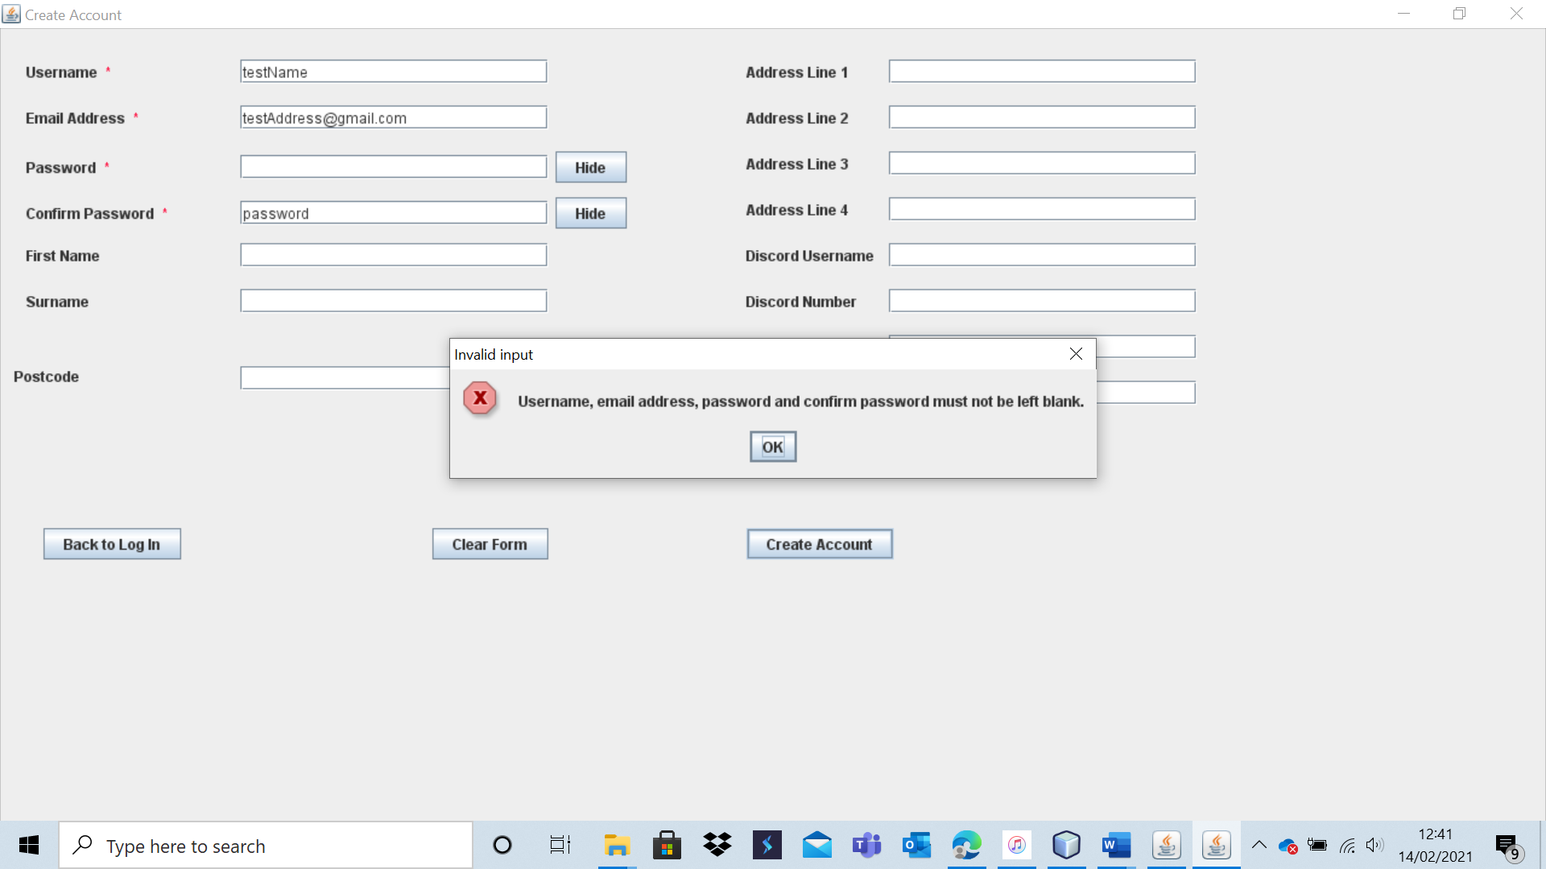

The account creation fails as the password field is left blank.

Test 9 – A15

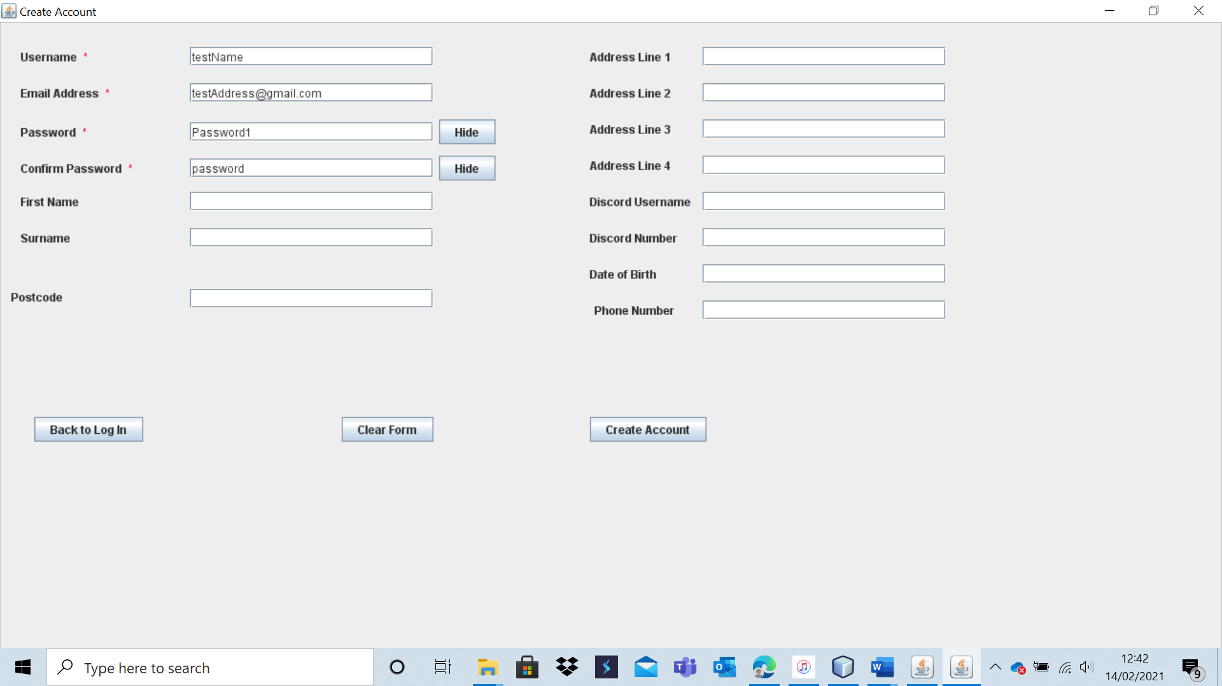

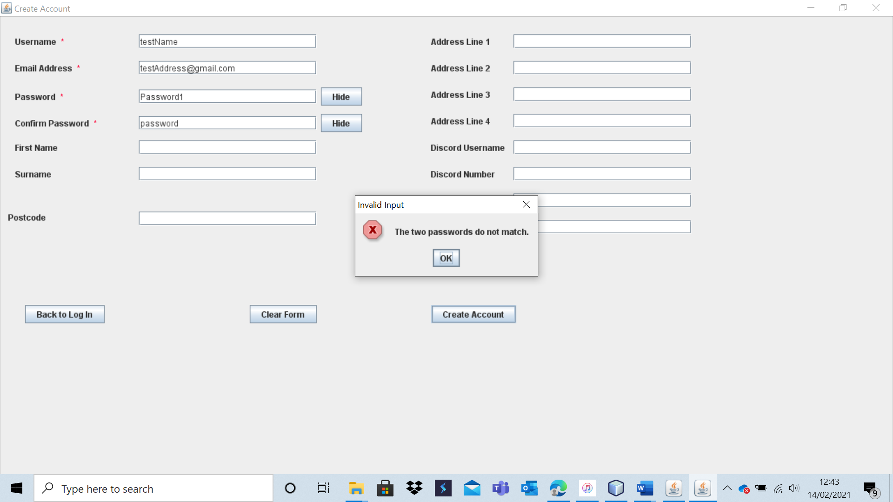

The account is not created as the inputted password differ.

Test 9 – A16

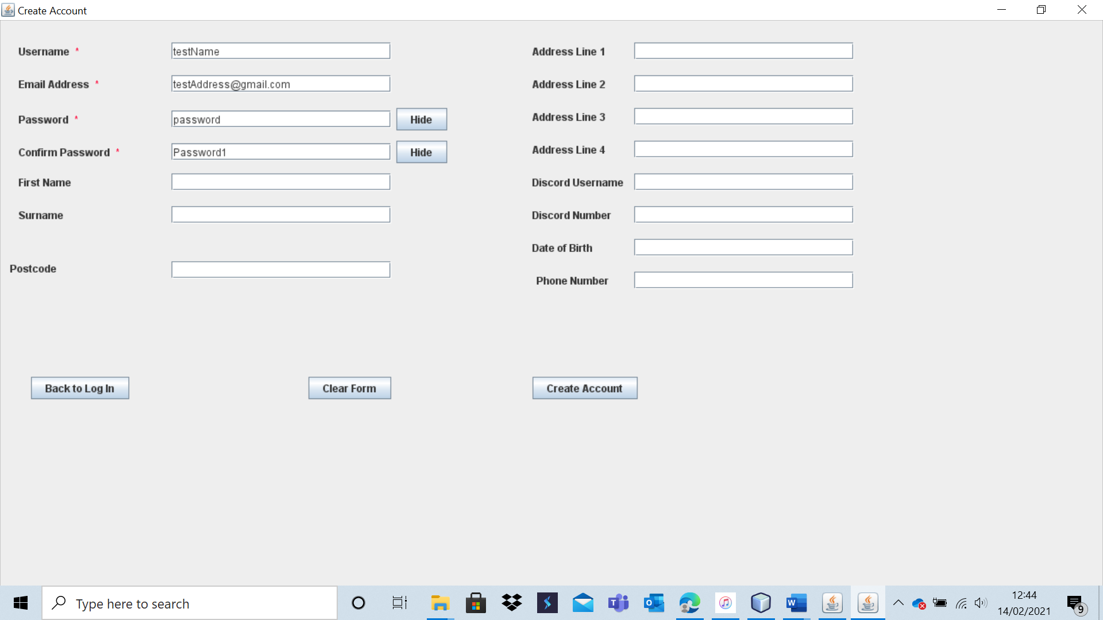

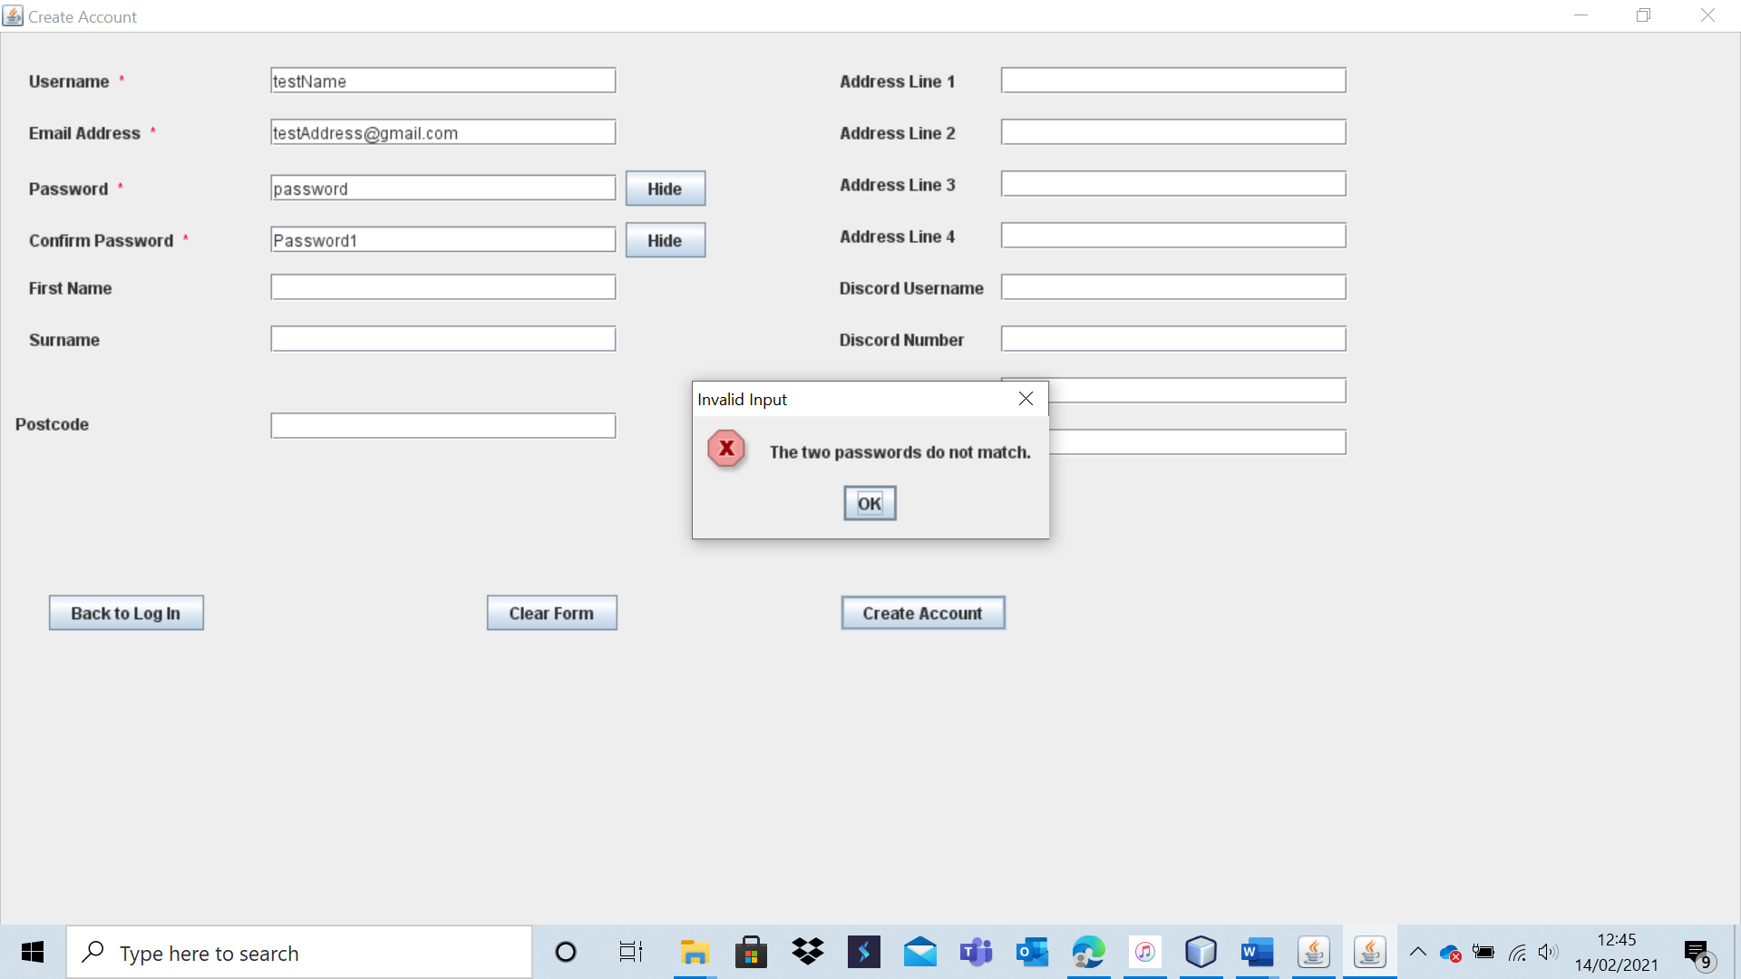

The account is not created as the passwords differ.

Test 9 – A17

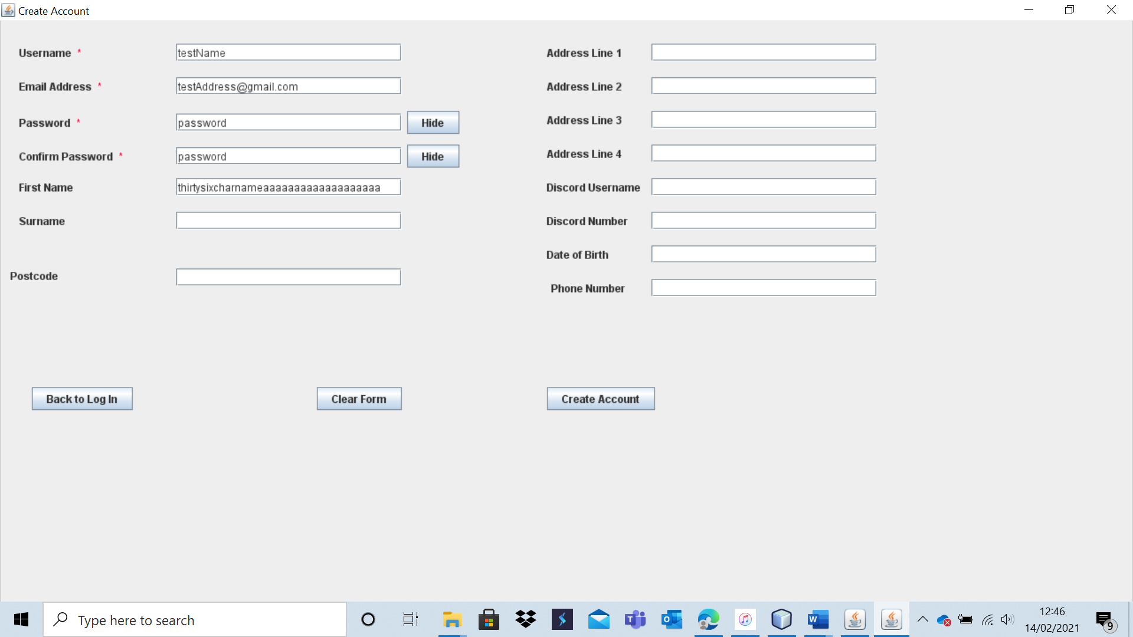

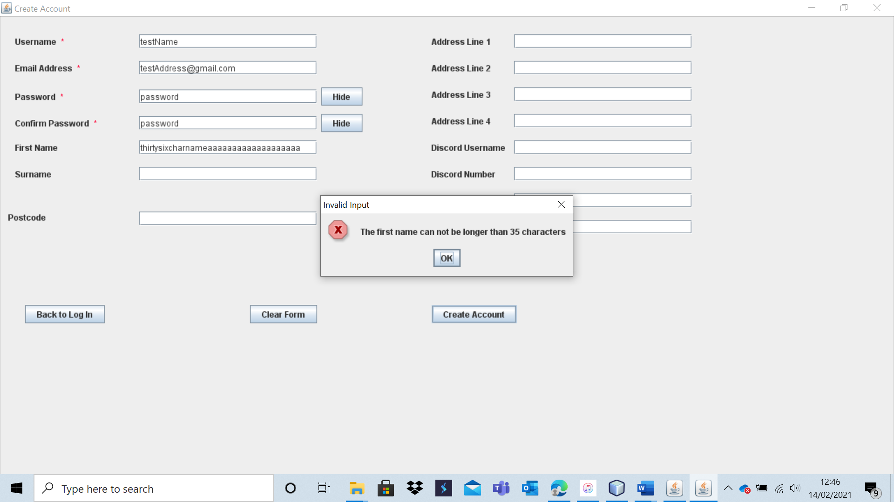

The account is not created as the first name is too long.

Test 9 – A18

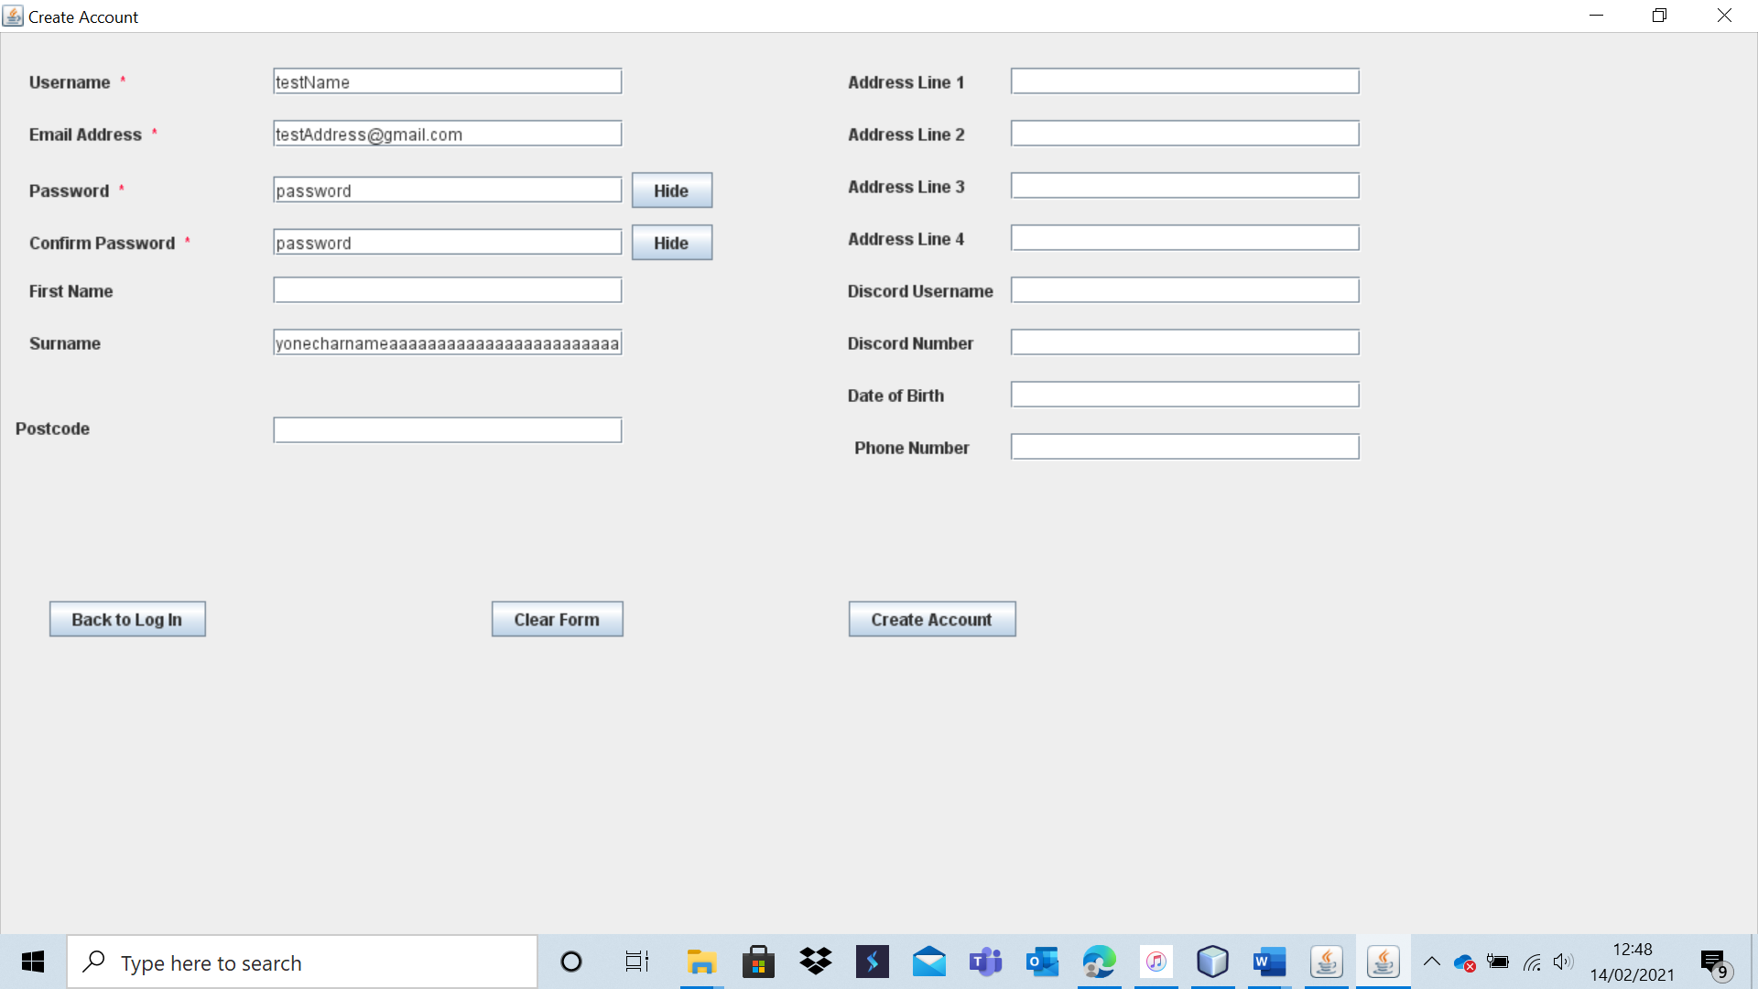

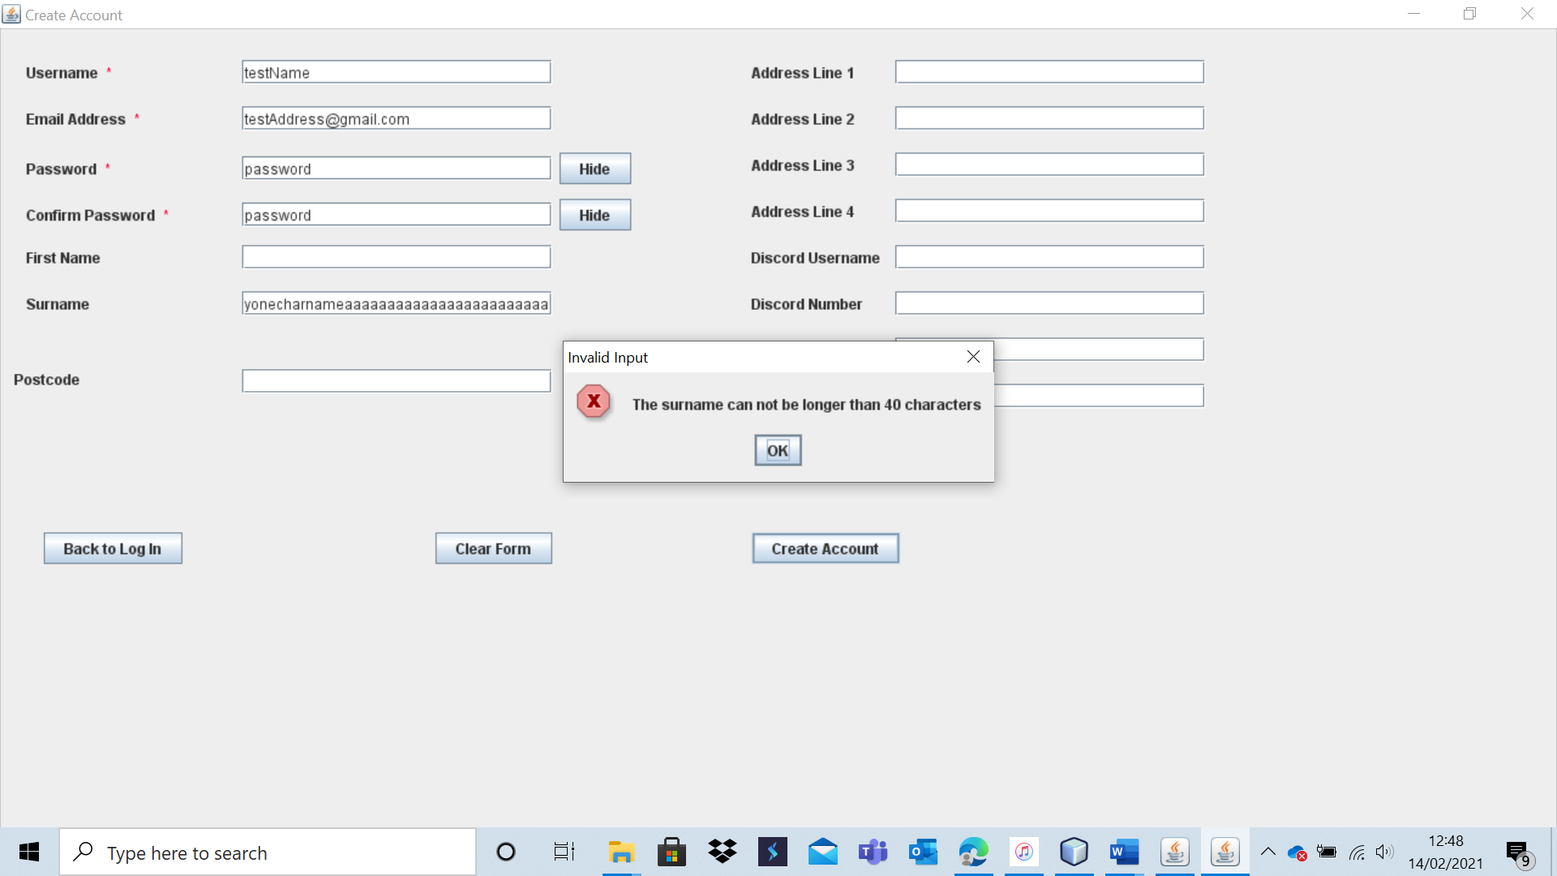

The account was not created as the surname inputted was too long.

Test 9 – A19

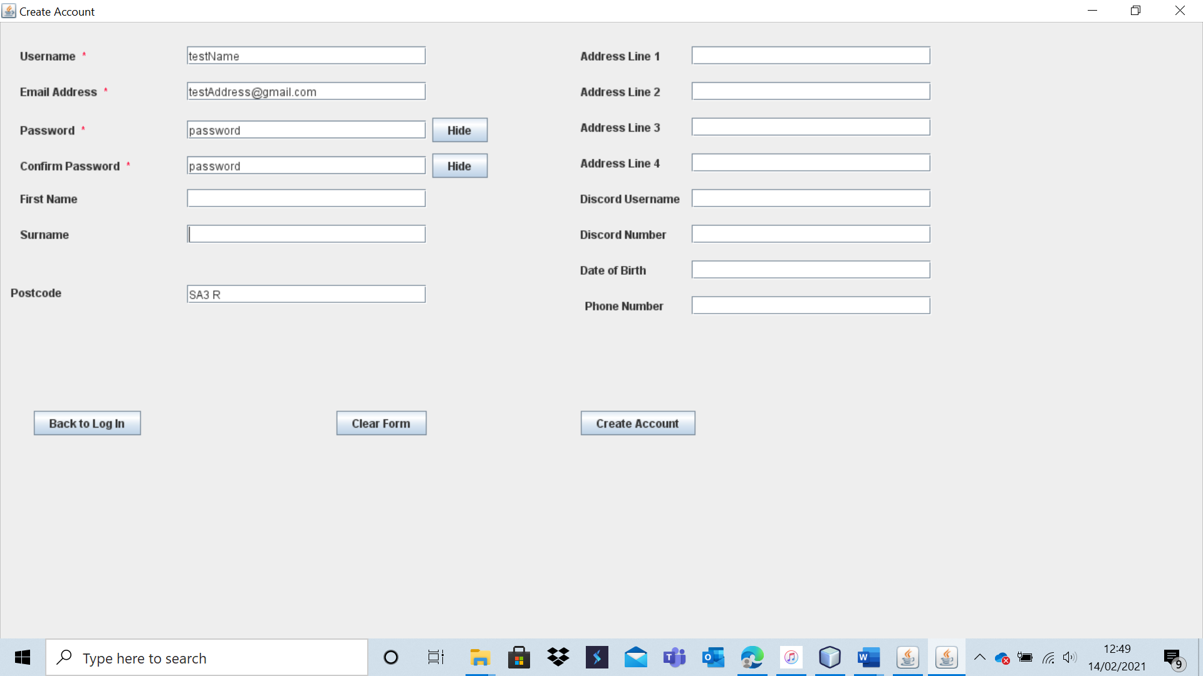

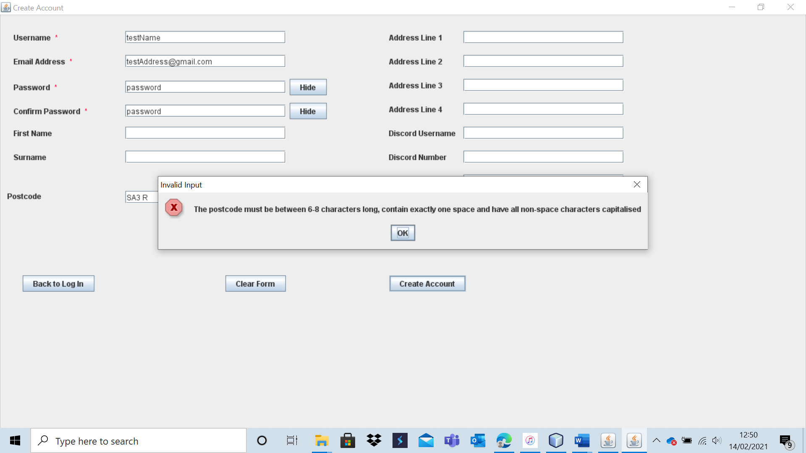

The post code input was invalid and hence the account was not created.

Test 9 – A20

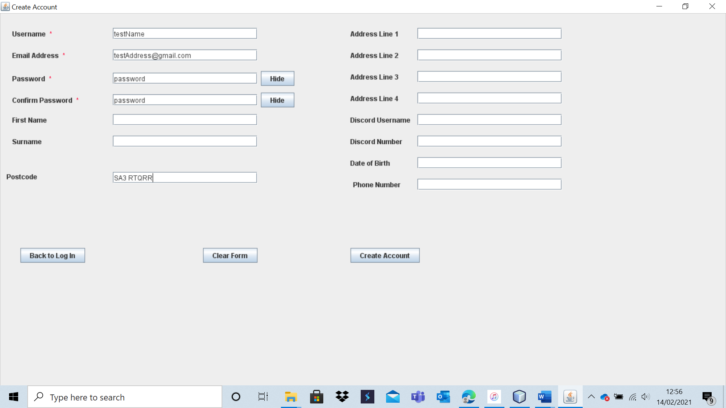

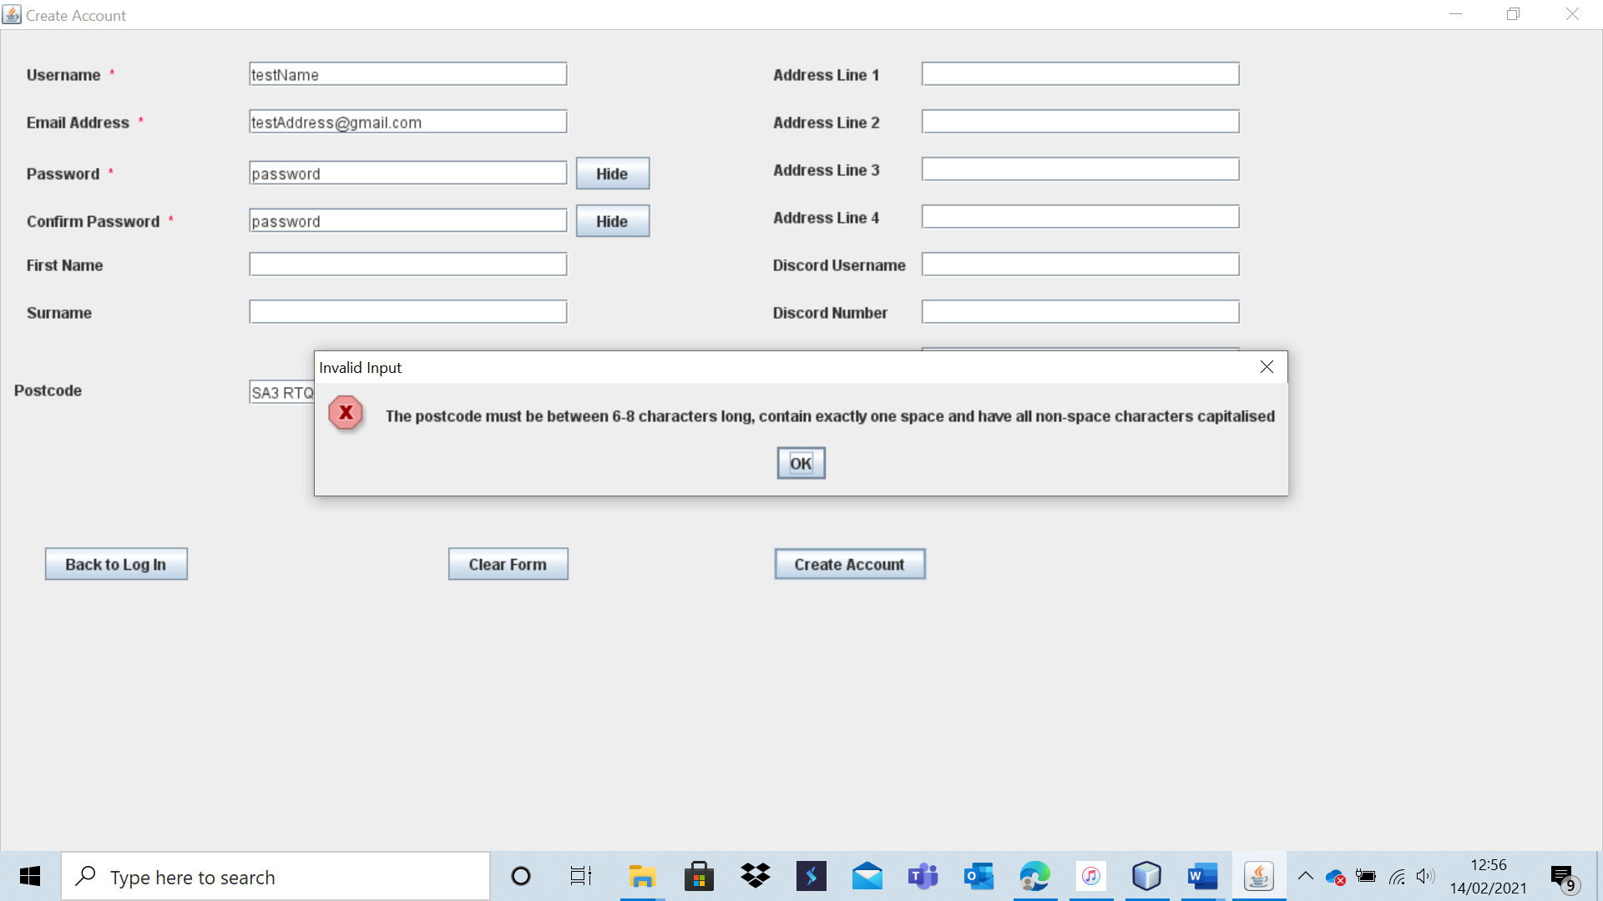

The account is not created as the post code entered is invalid.  
 Test 9 -A21

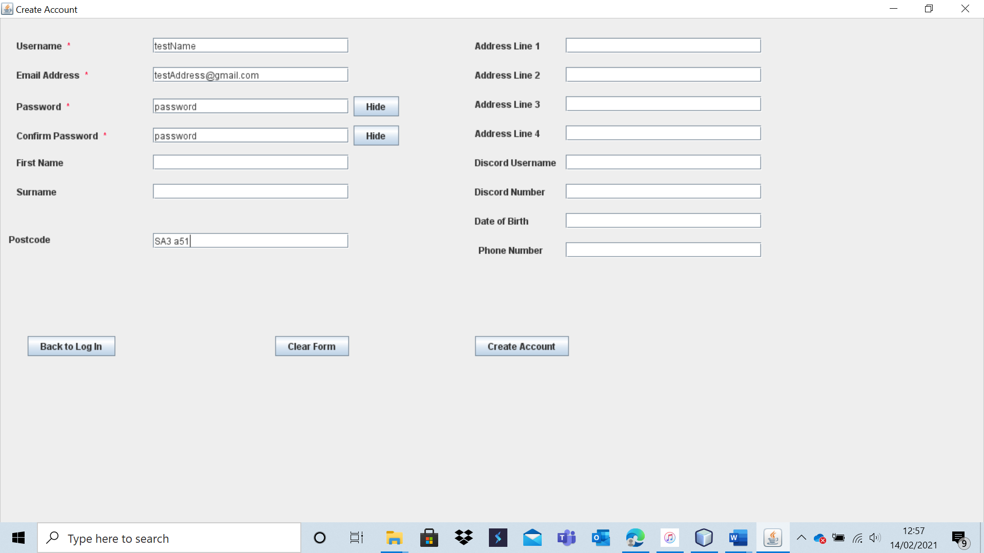

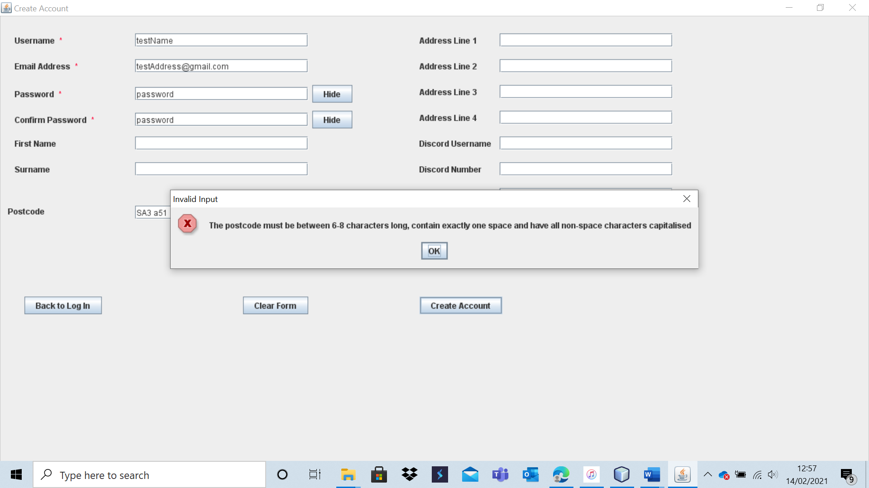

The account is not created as the post code entered is invalid.

Test 9 - A22

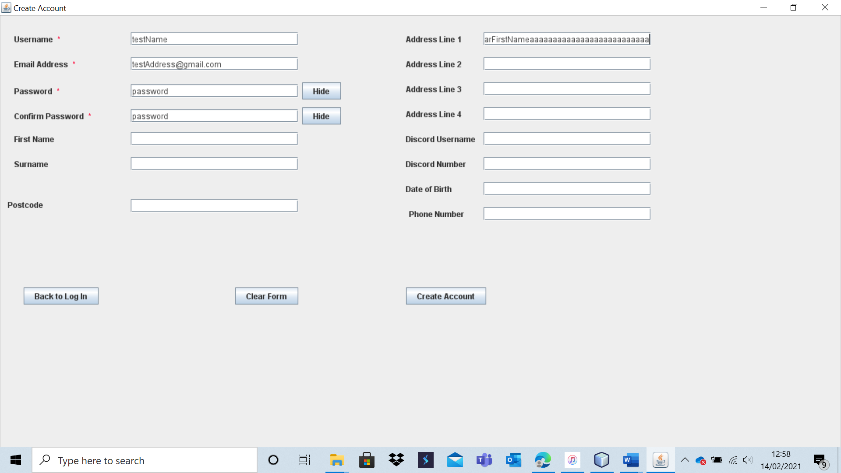

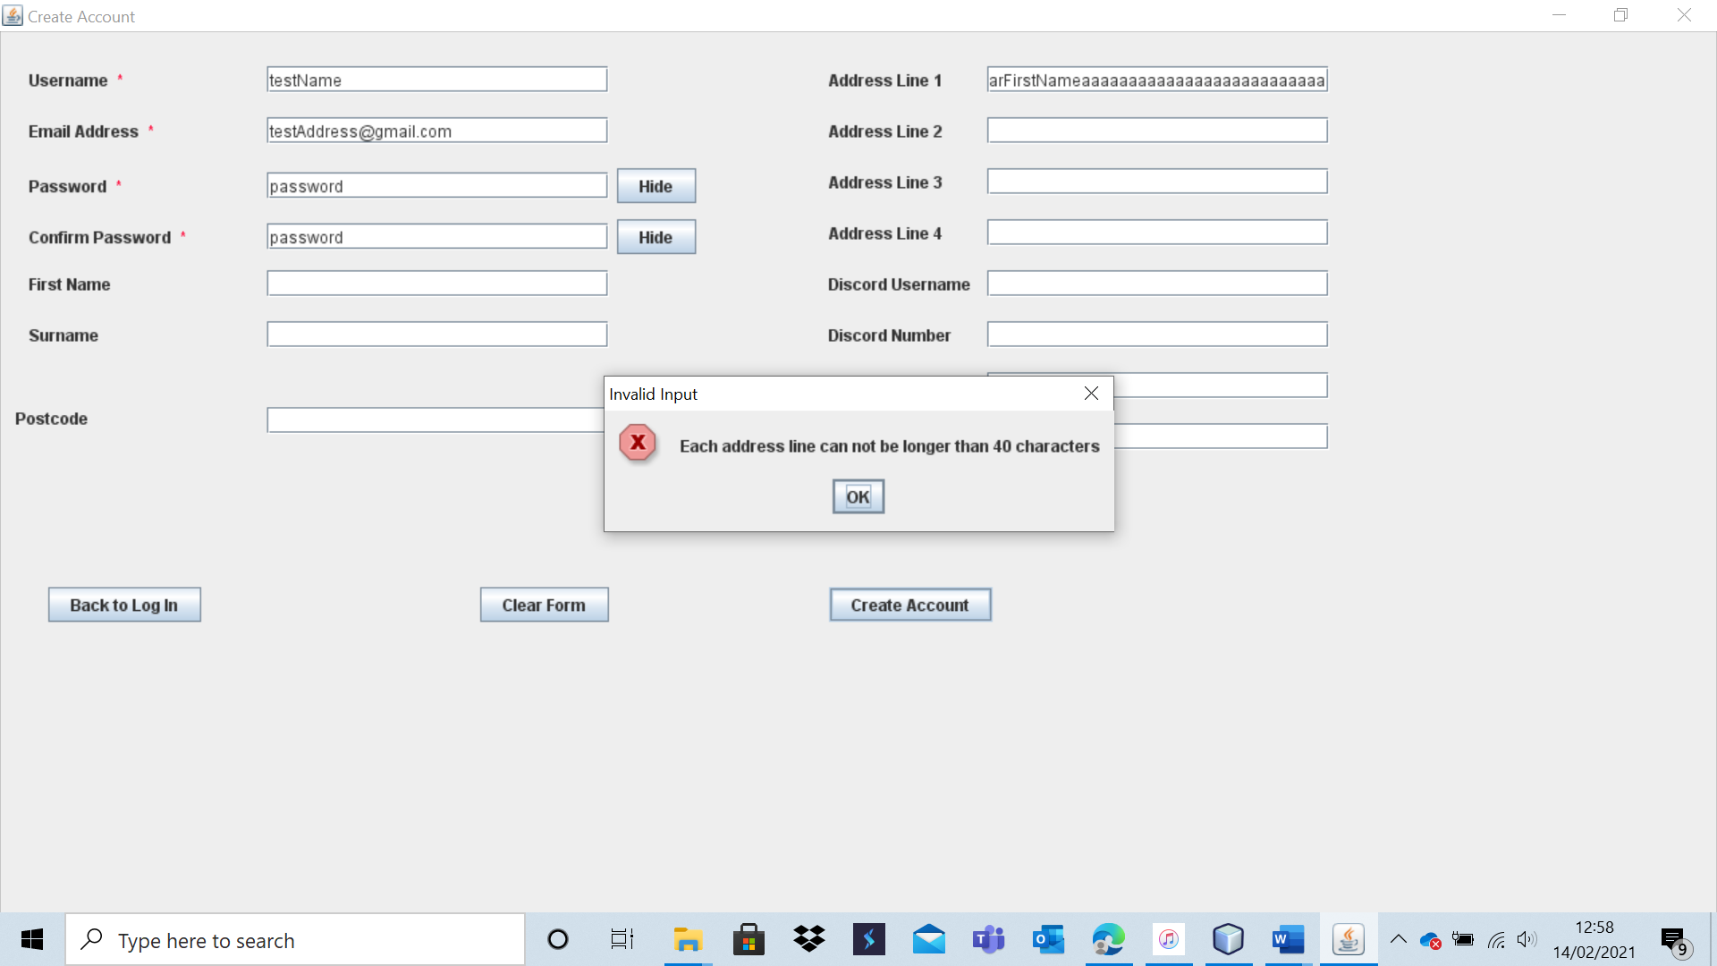

The account is not created as the address input is too long.

Test 9 - A23

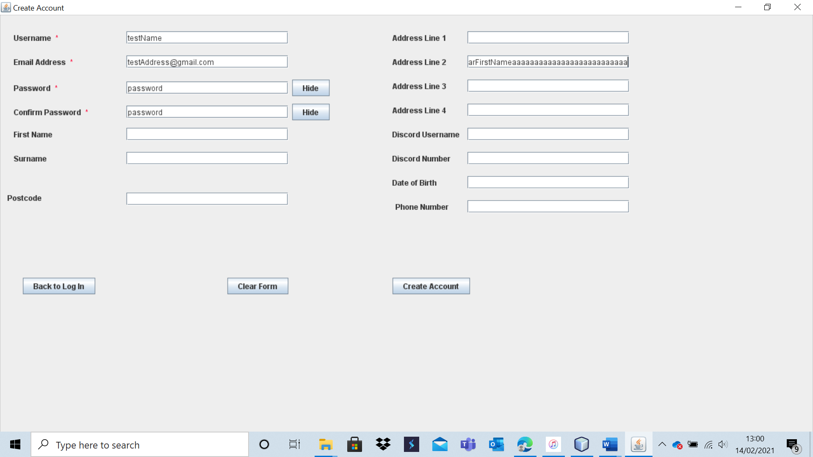

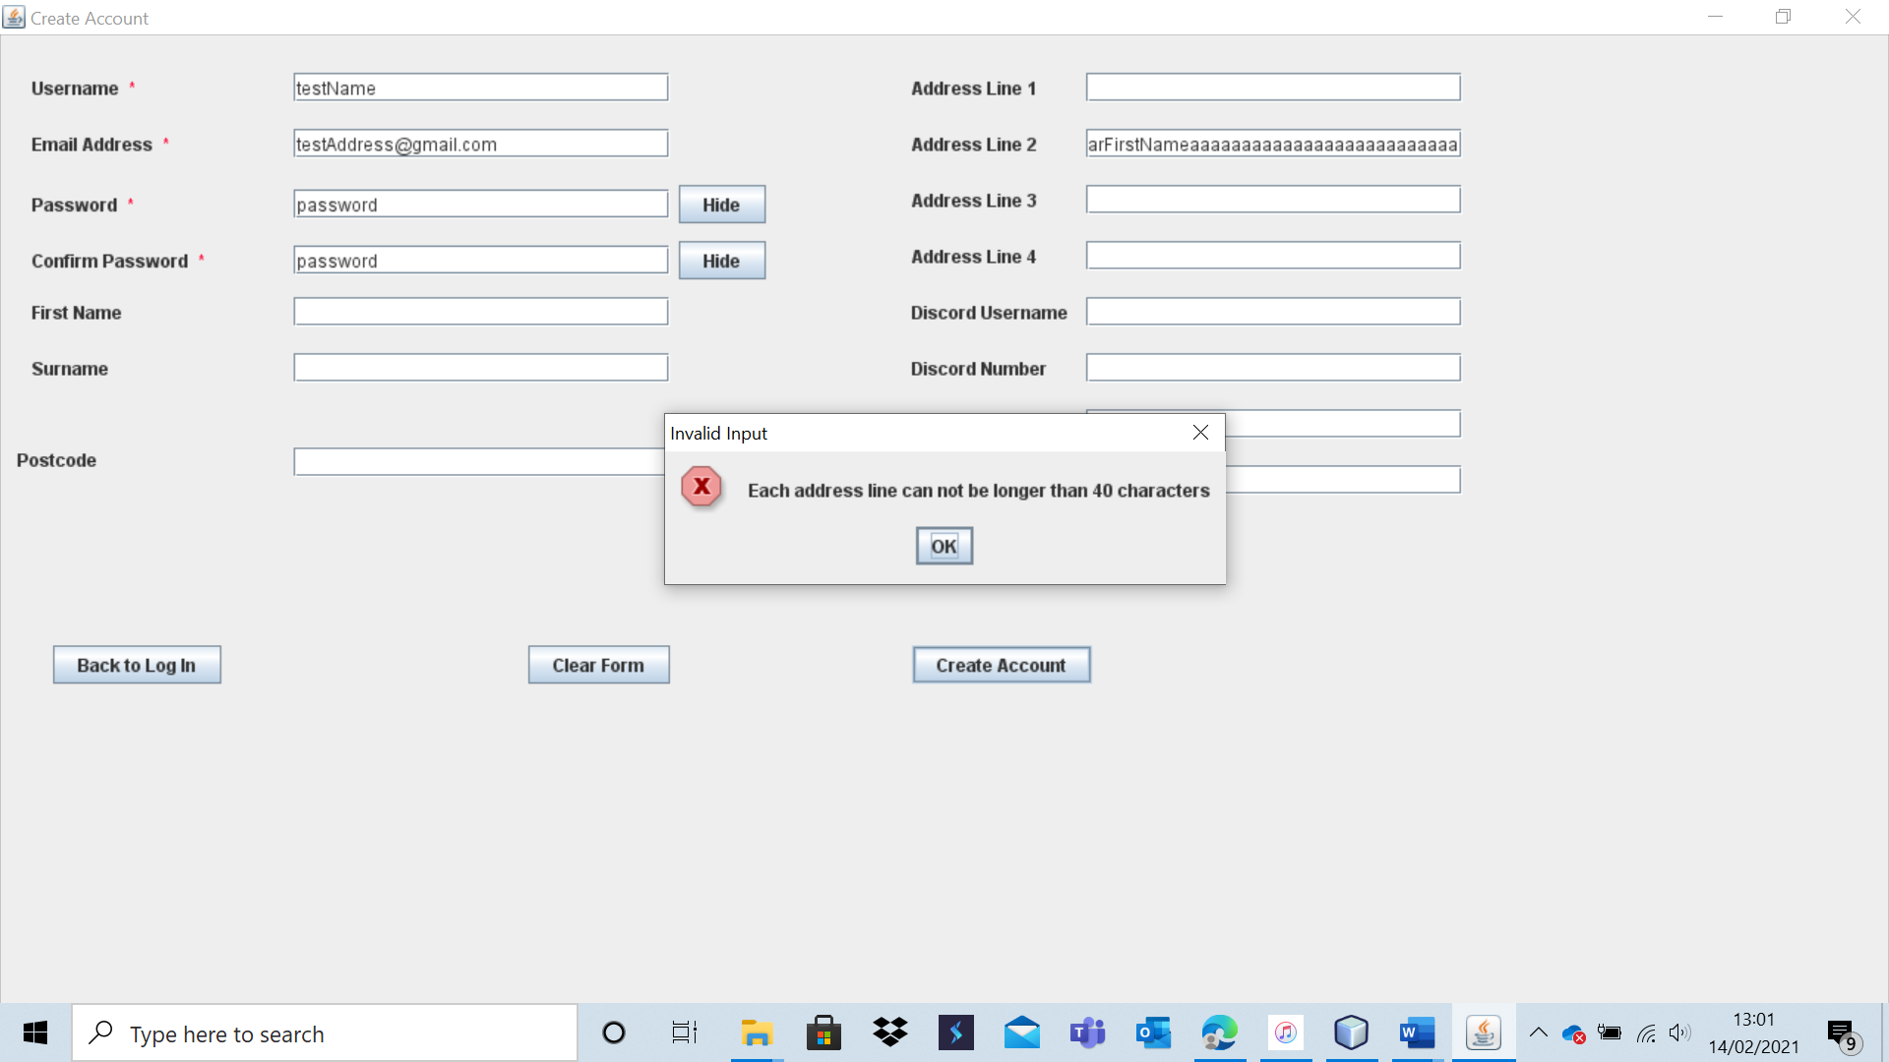

The account is not created as the address is too long.

Test 9 – A24

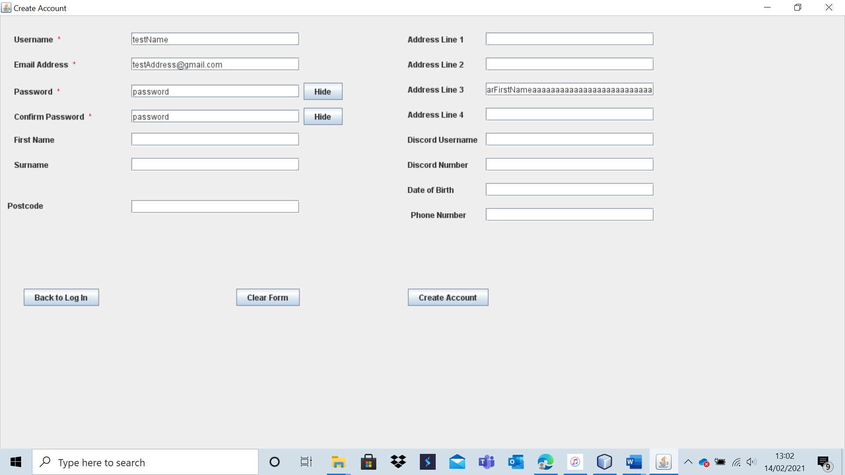

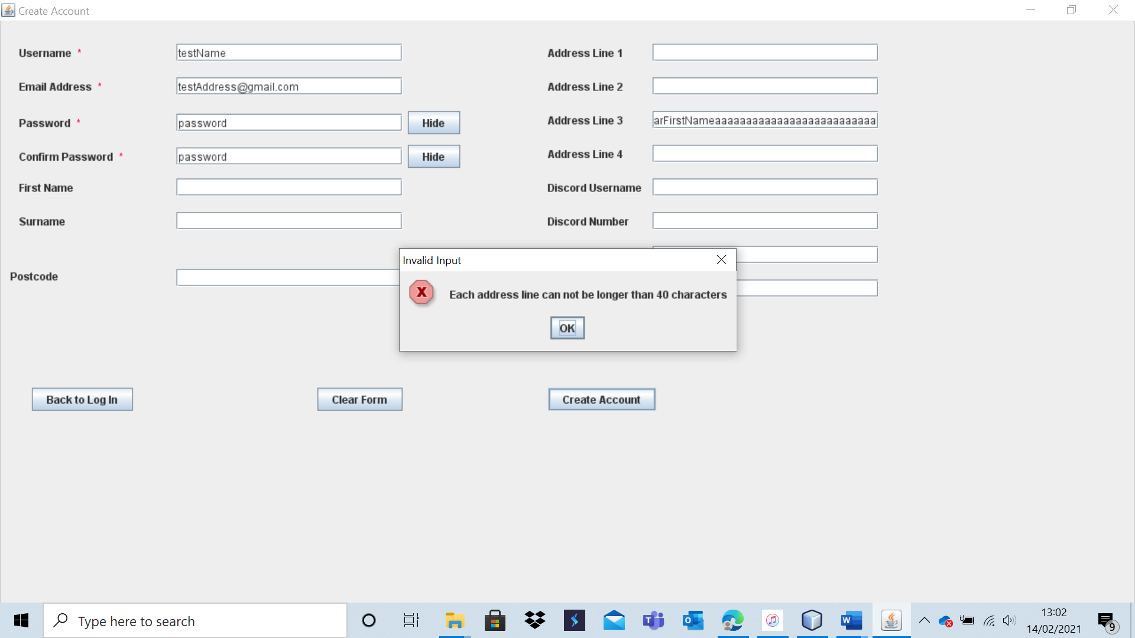

The account is not created as the address is too long.

Test 9 – A25

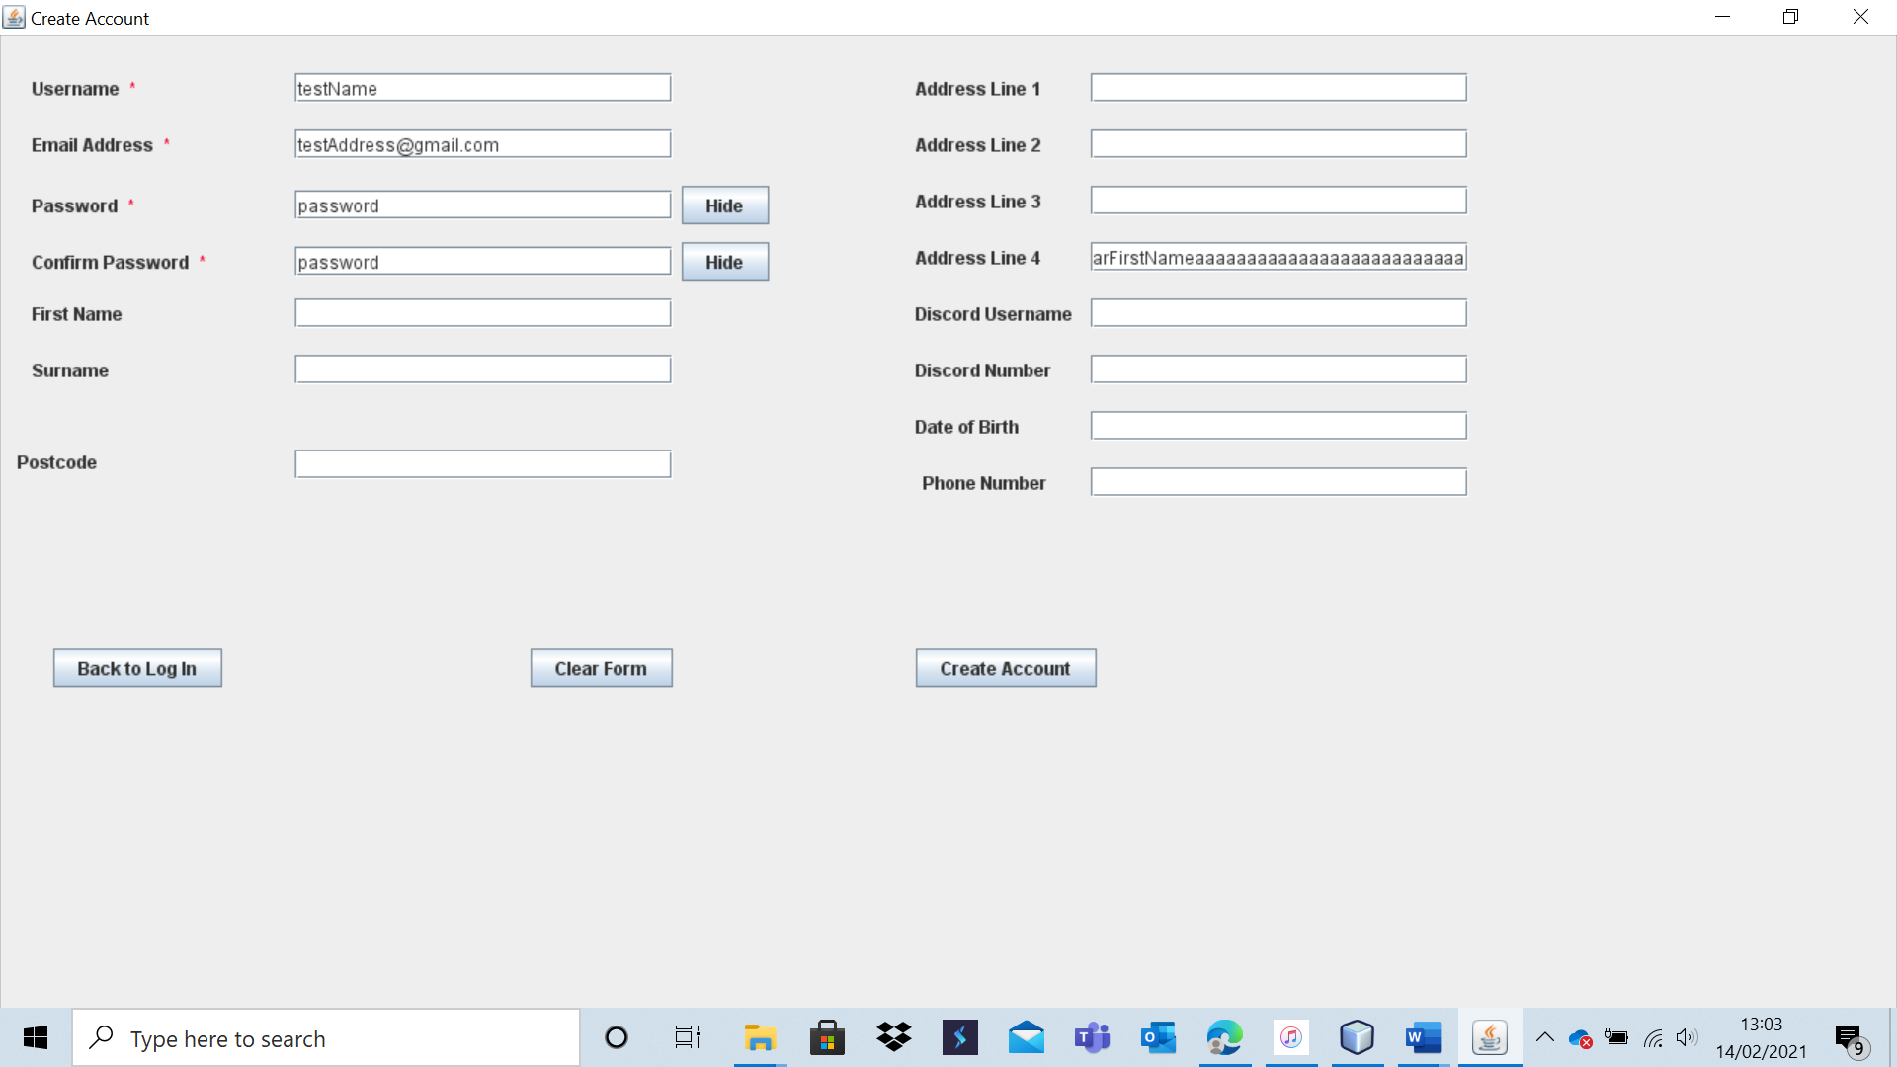

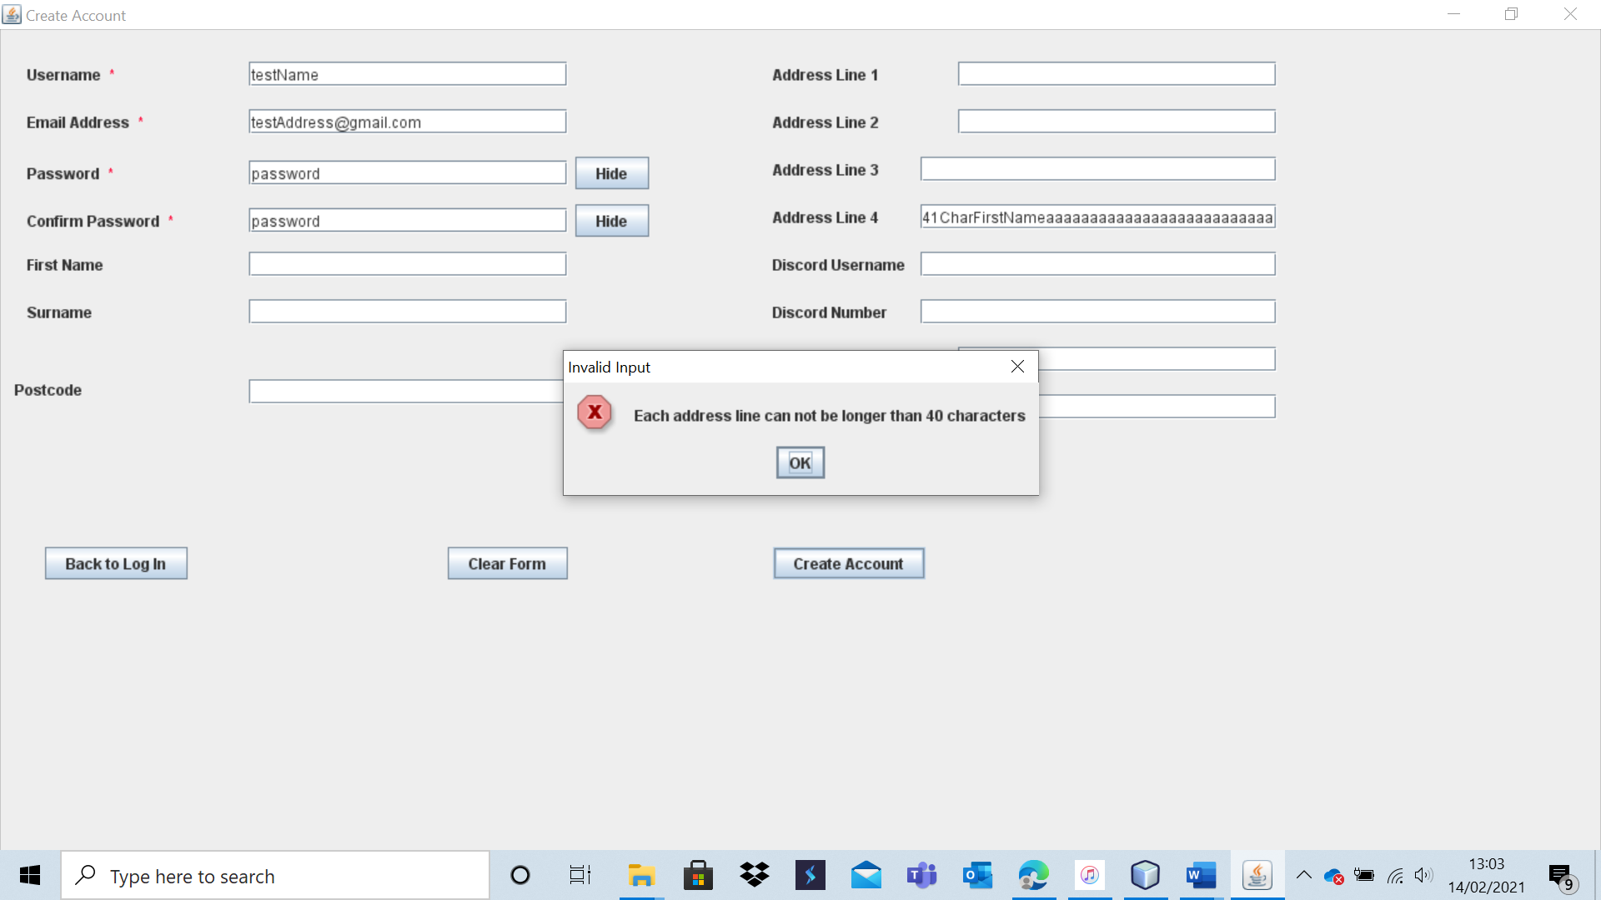

The account is not created as the address is too long.

Test 9 – A26

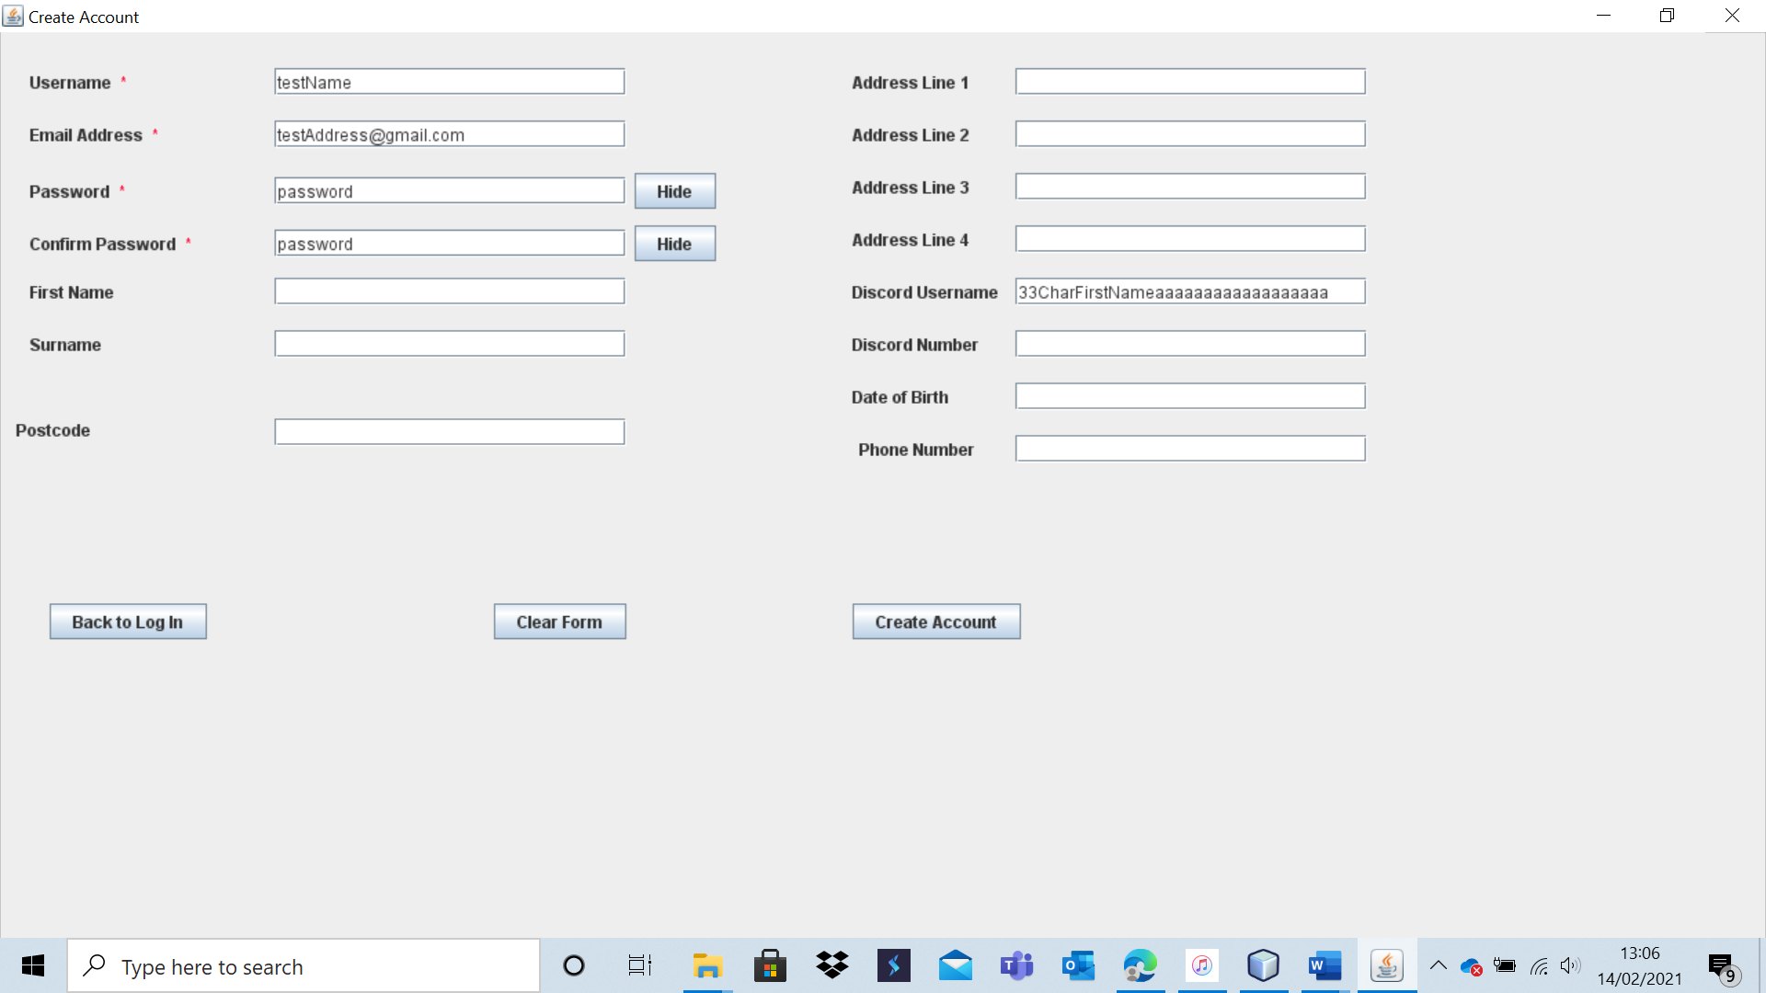

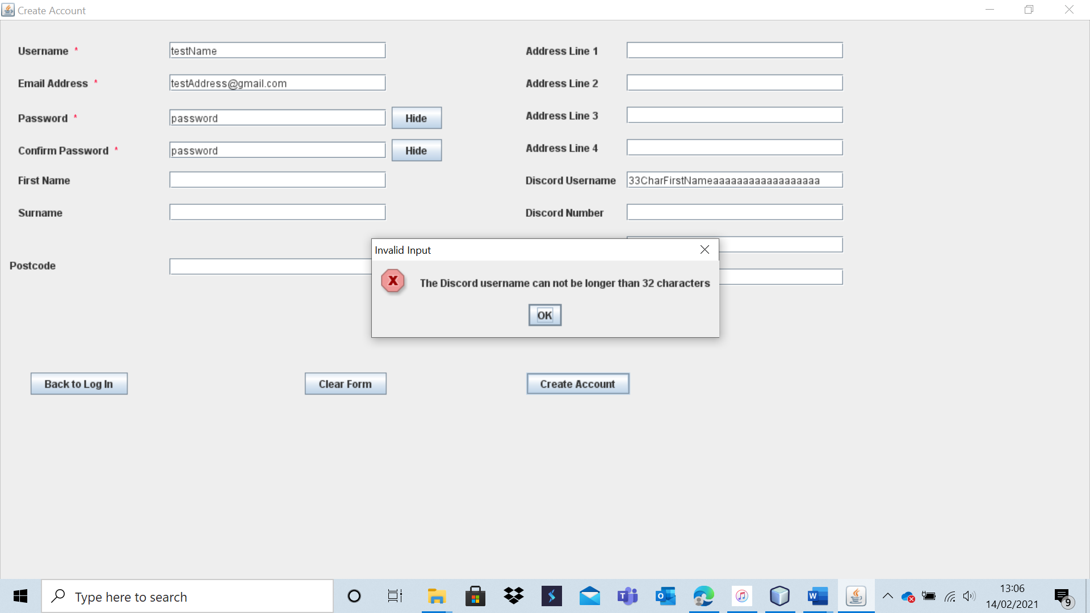

The account is not created as the Discord username entered is too long.

Test 9 – A27

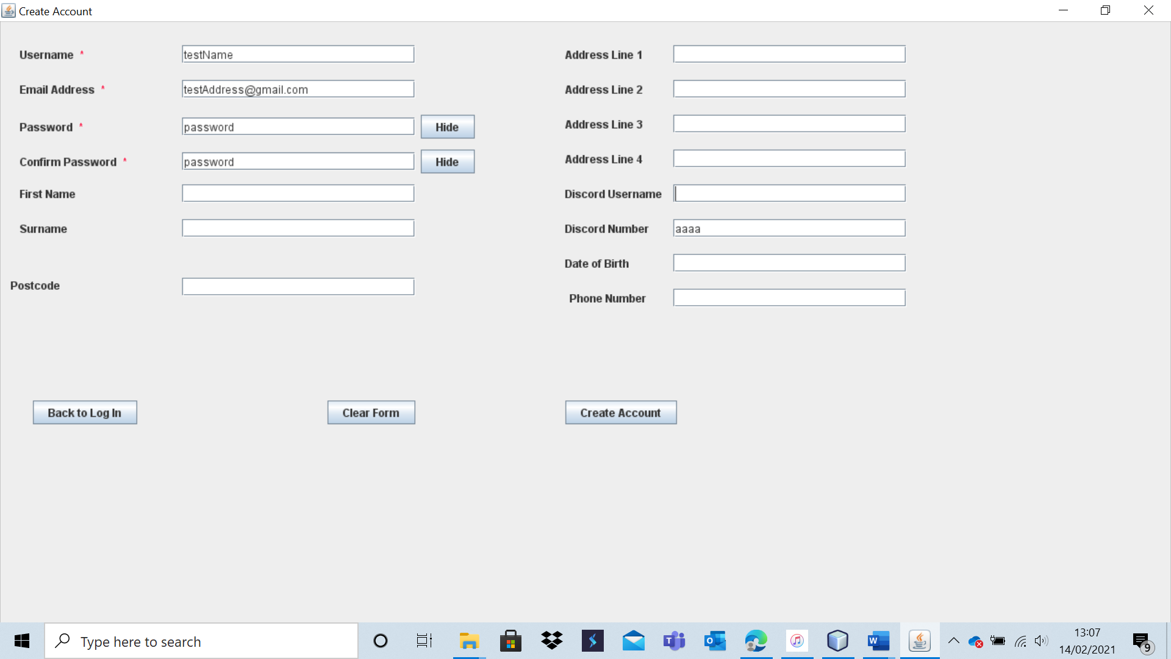

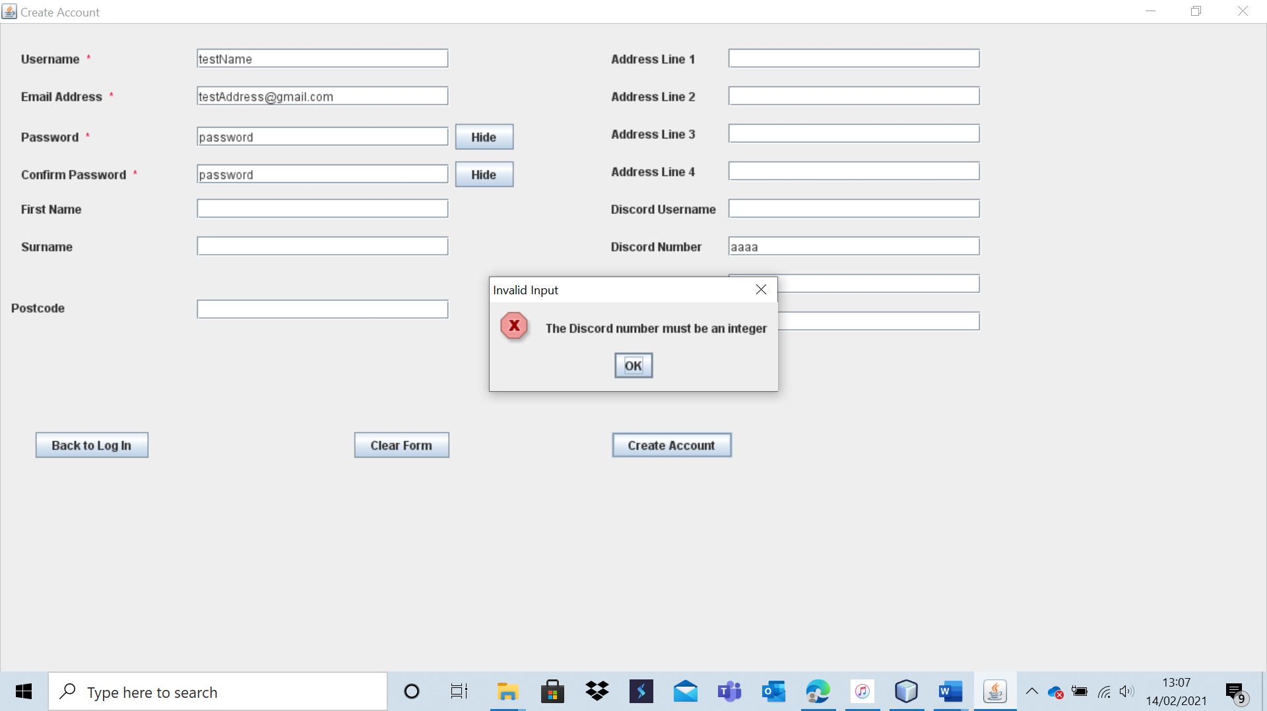

The account is not created as the Discord Number is not a number.

Test 9 – A28

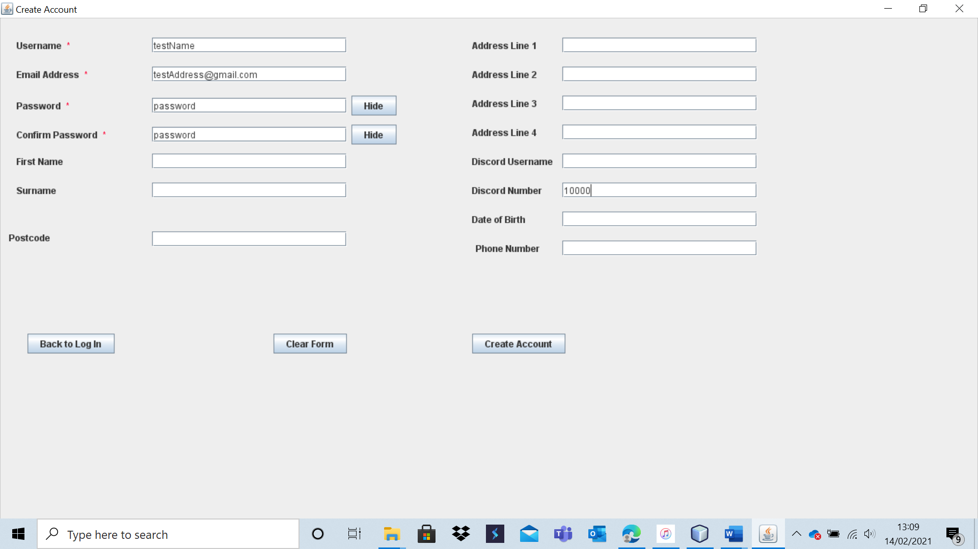

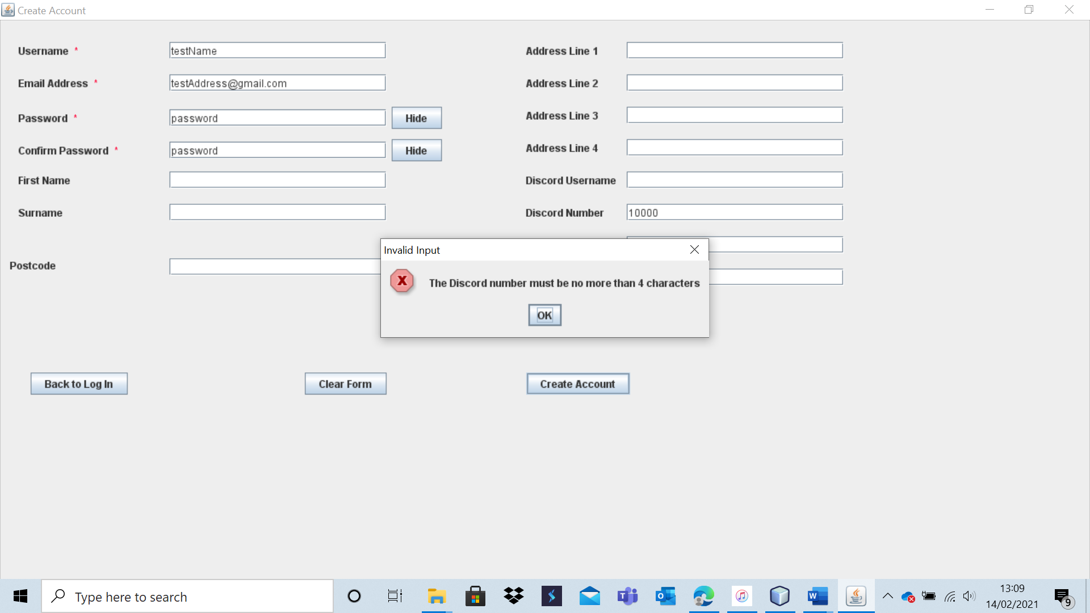

The account is not created as the Discord number cannot be 5 or more characters long.

Test 9 – A29

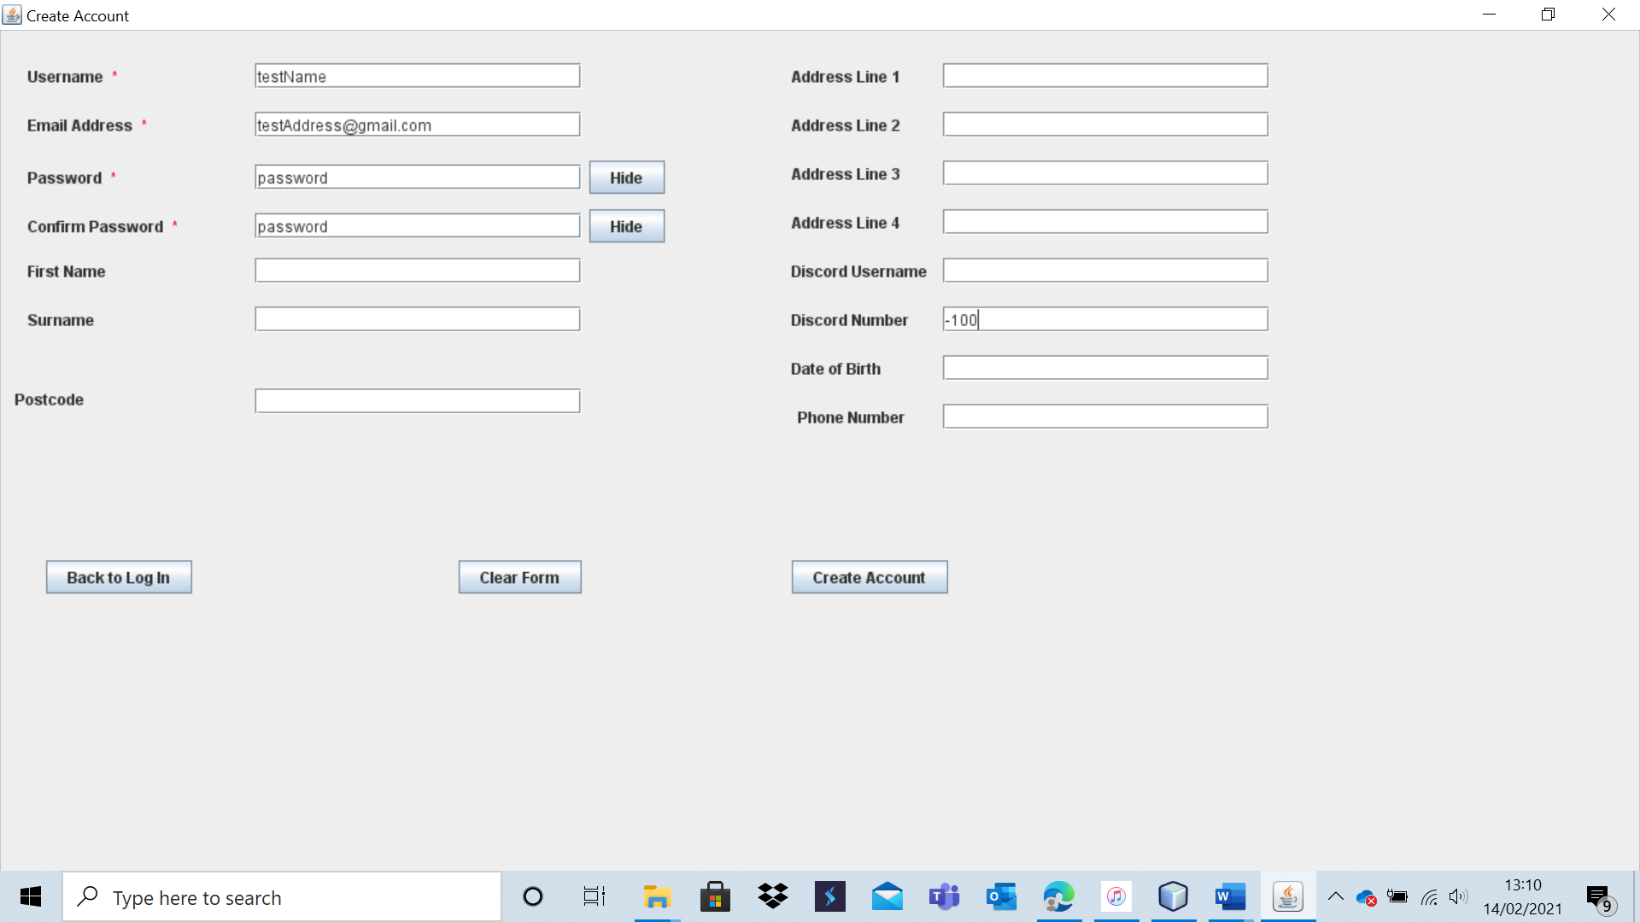

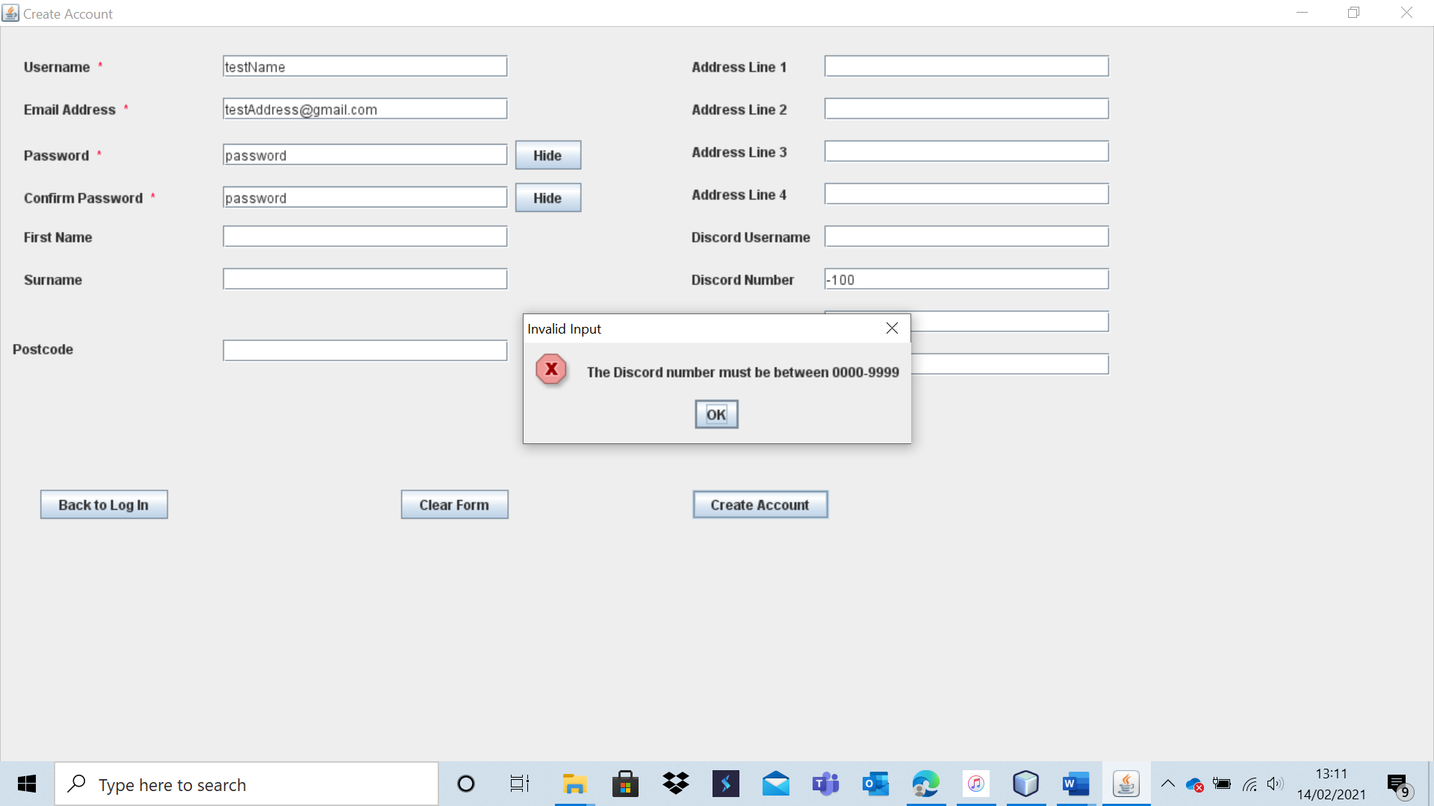

The account is not created as it fails the range check for the Discord Number.

Test 9 – A30

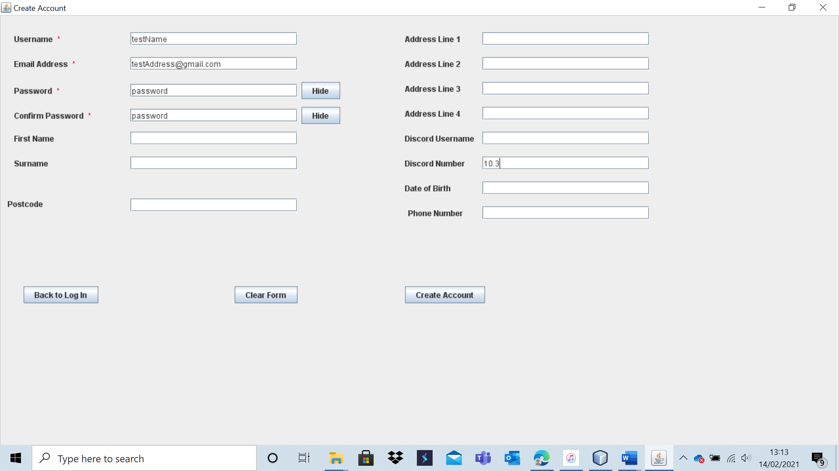

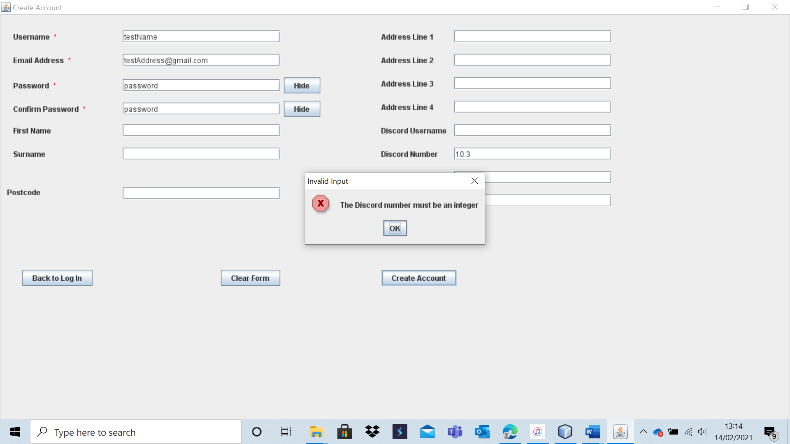

The account is not created as the number inputted is a real number, not an integer.

Test 9 – A31

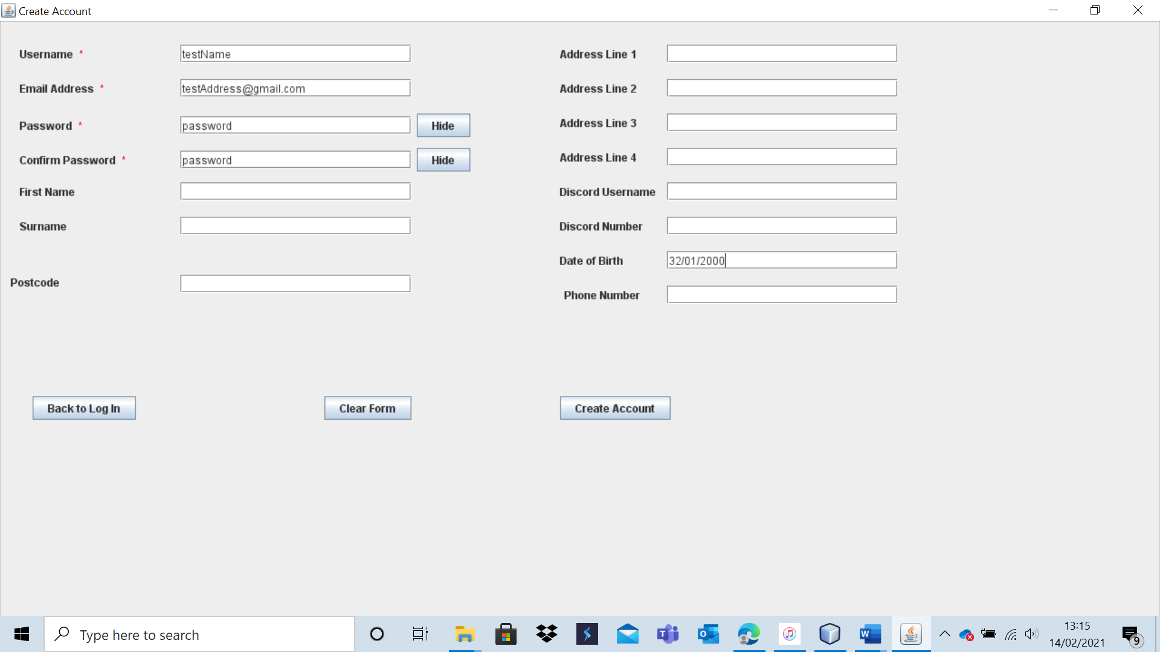

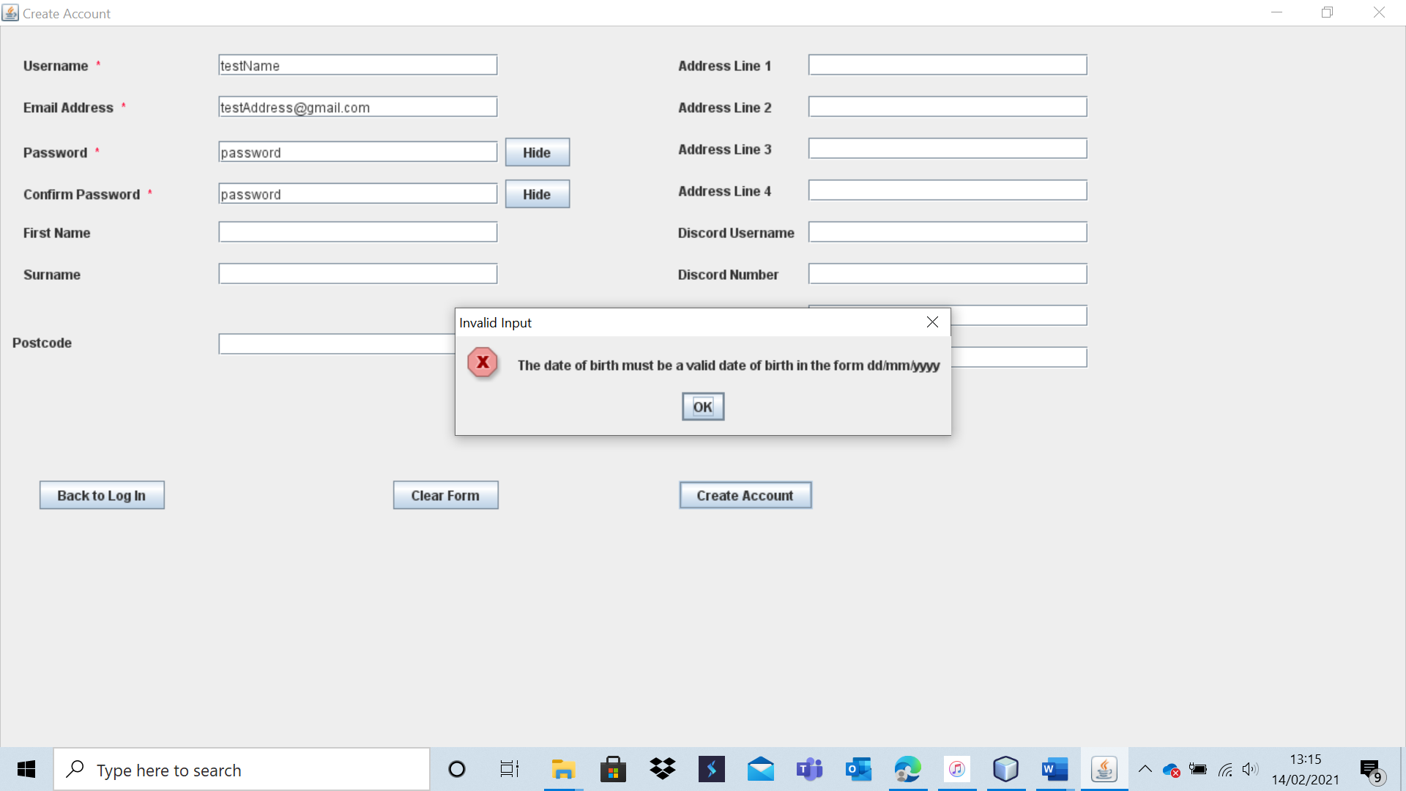

The account is not created as the date of birth is not valid.

Test 9 – A32

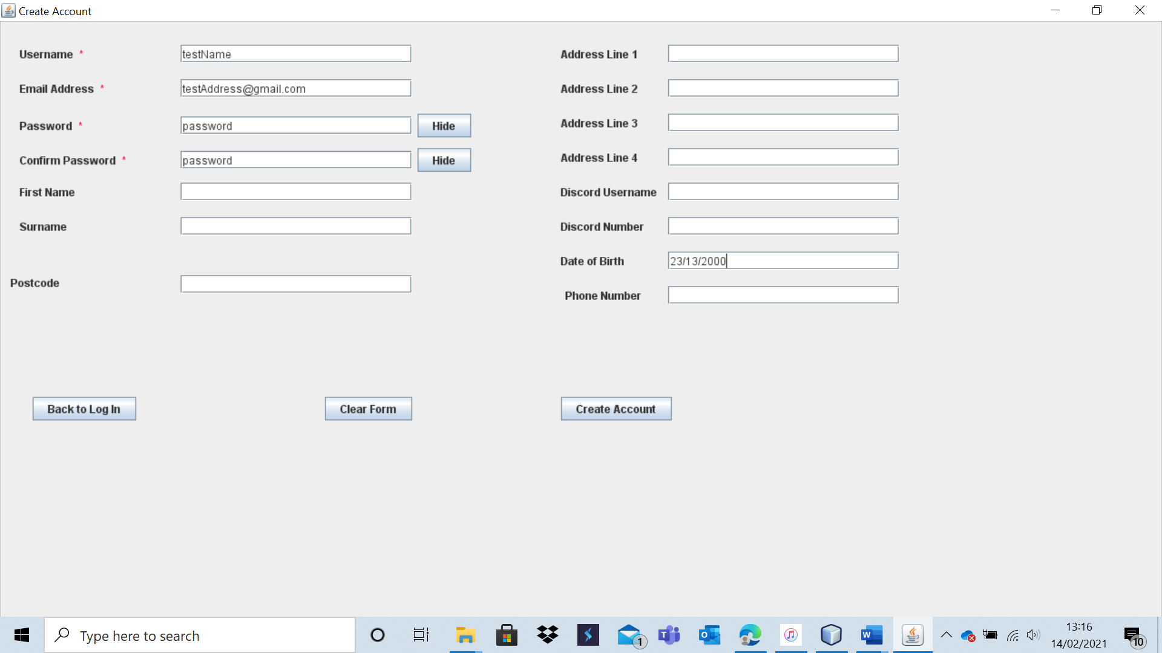

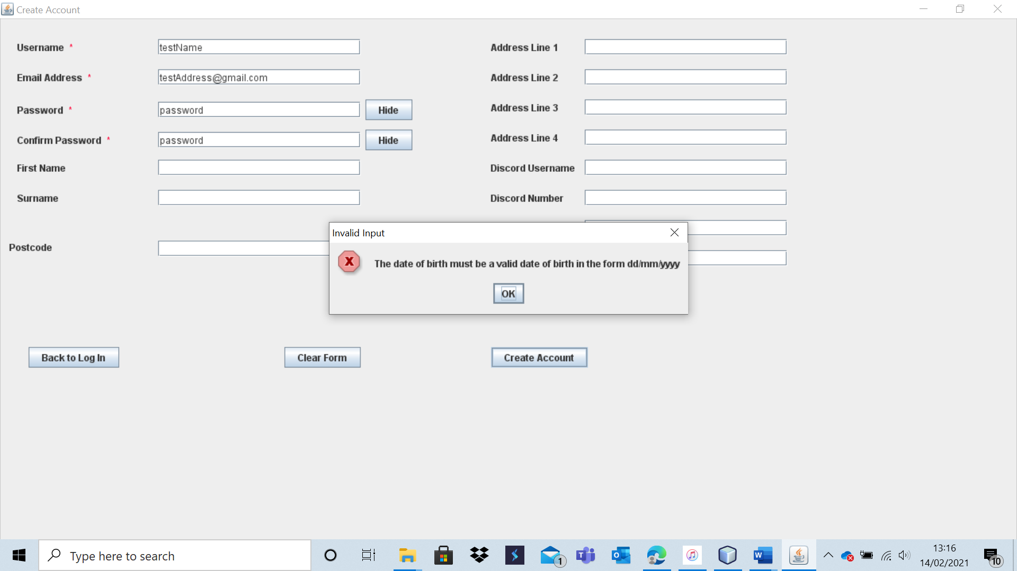

The account is not created as the date of birth entered is invalid.

Test 9 – A33

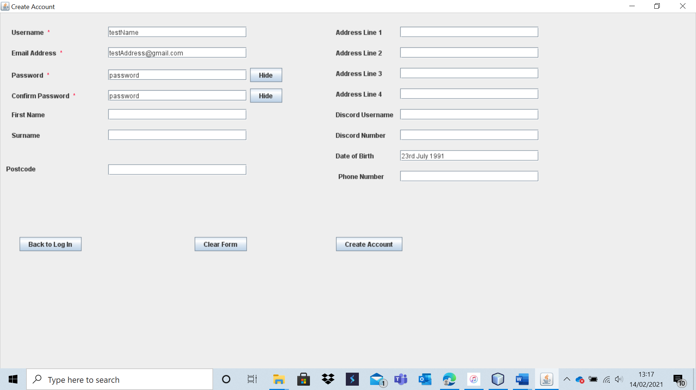

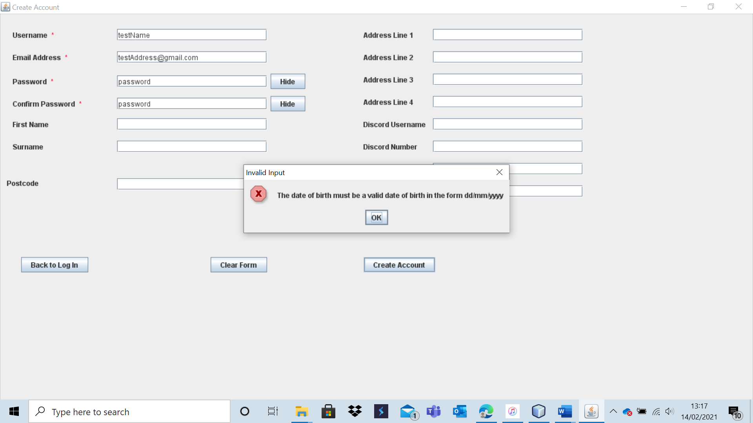

The account was not created as the date of birth was entered in the incorrect format.

Test 9 – A34

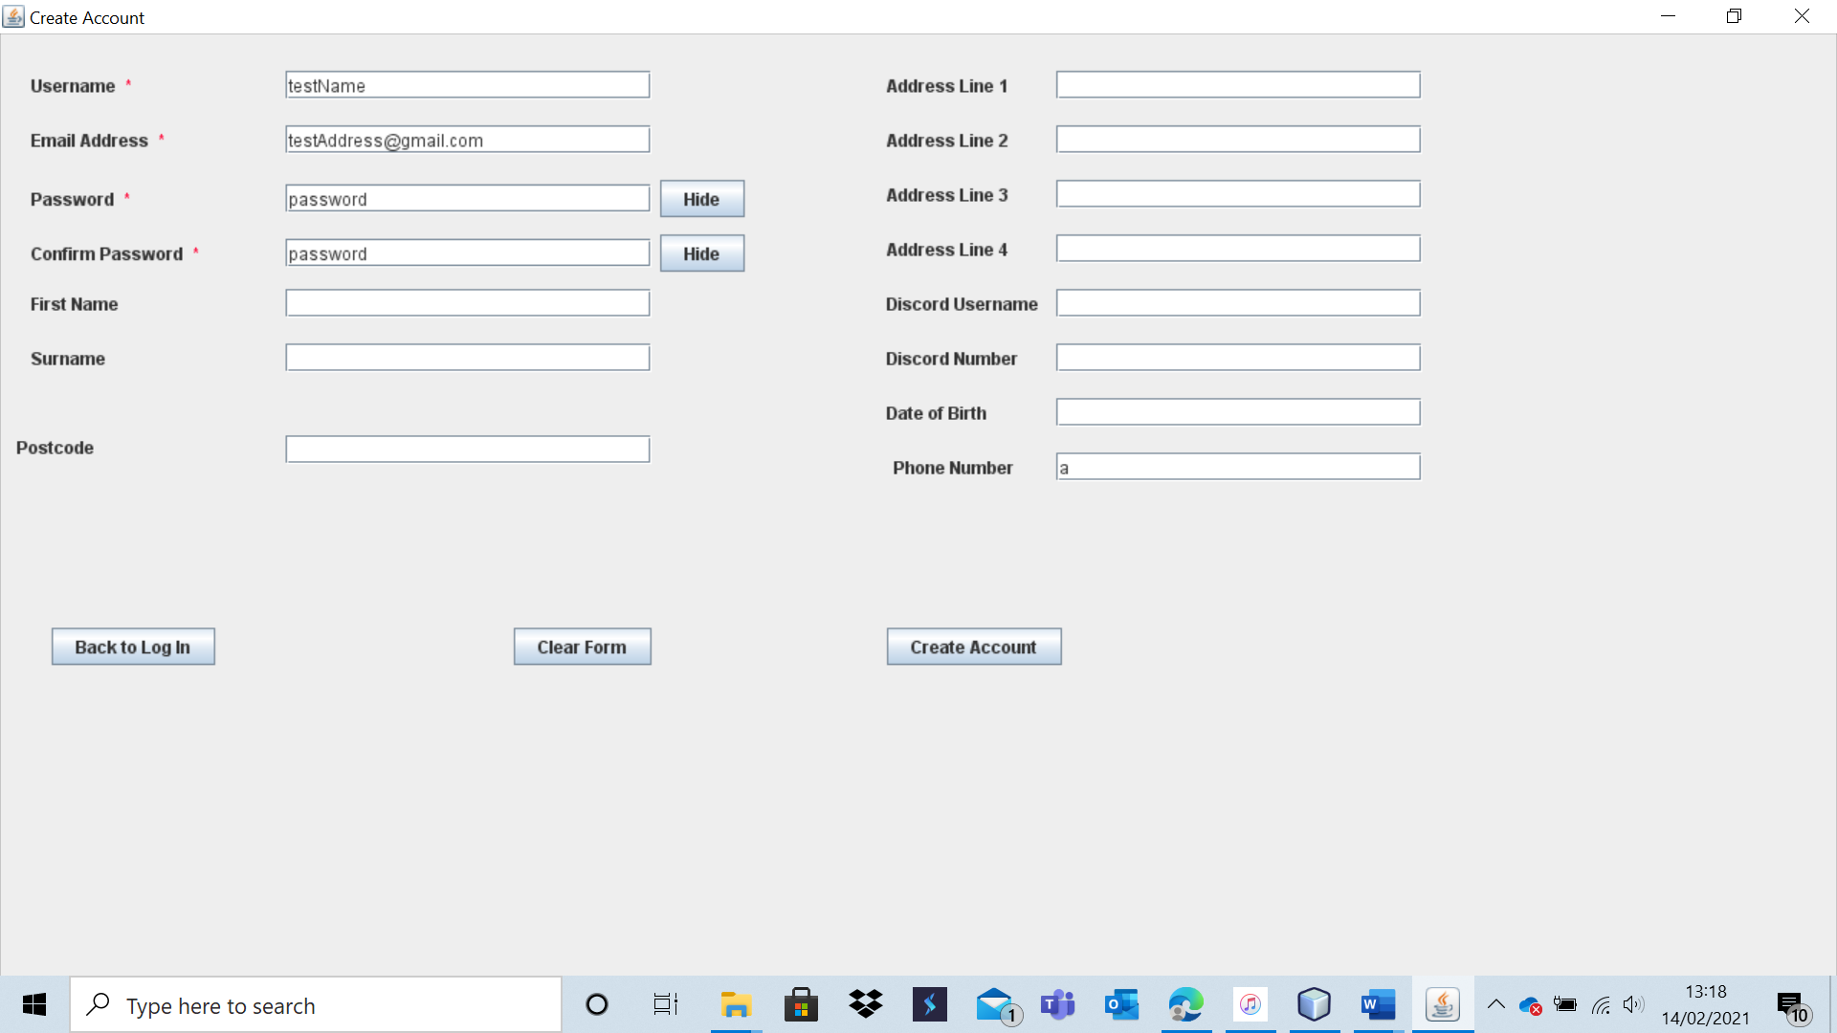

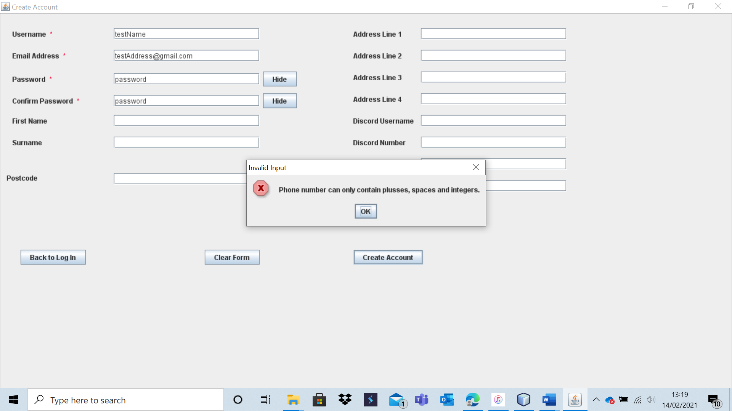

The account creation failed as an invalid phone number was entered.

Test 9 – A35

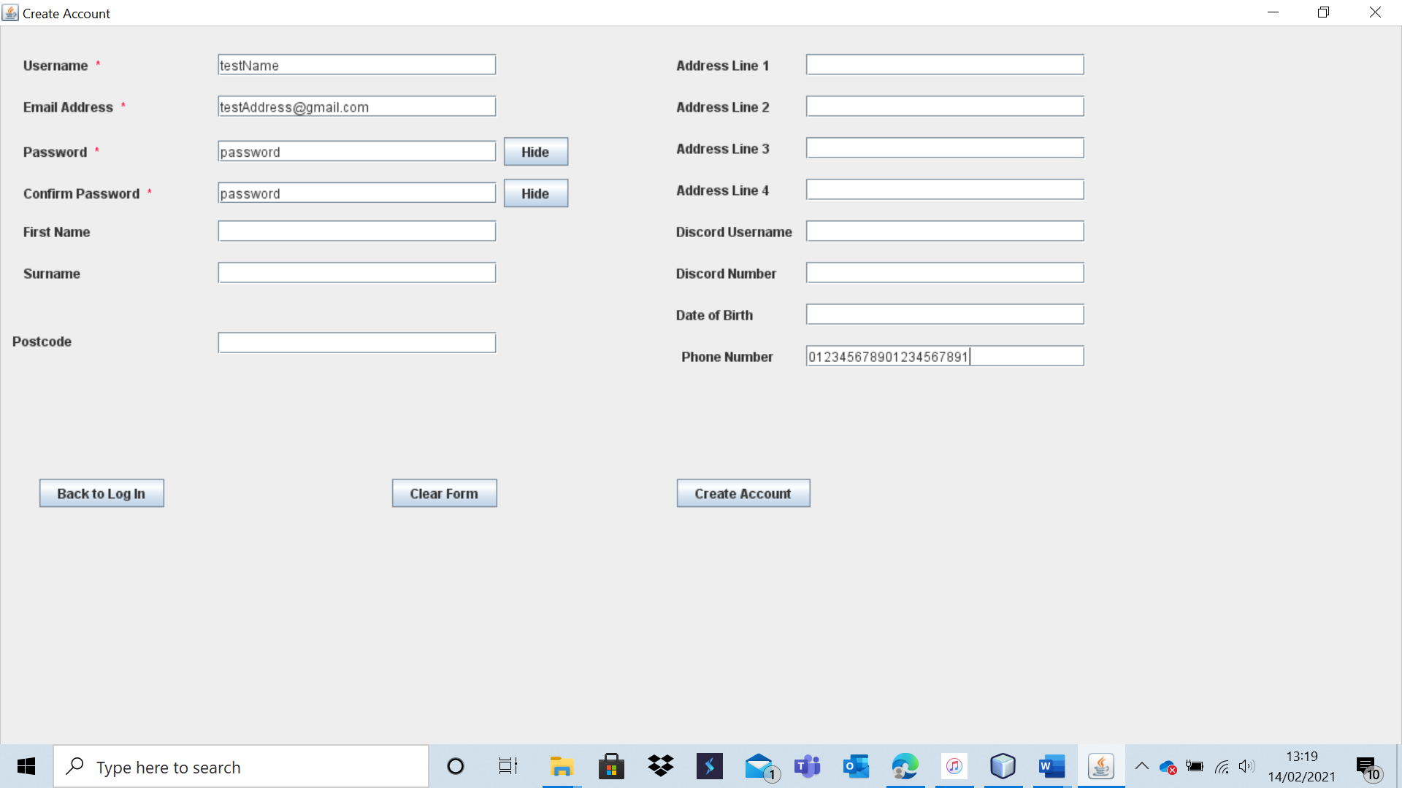

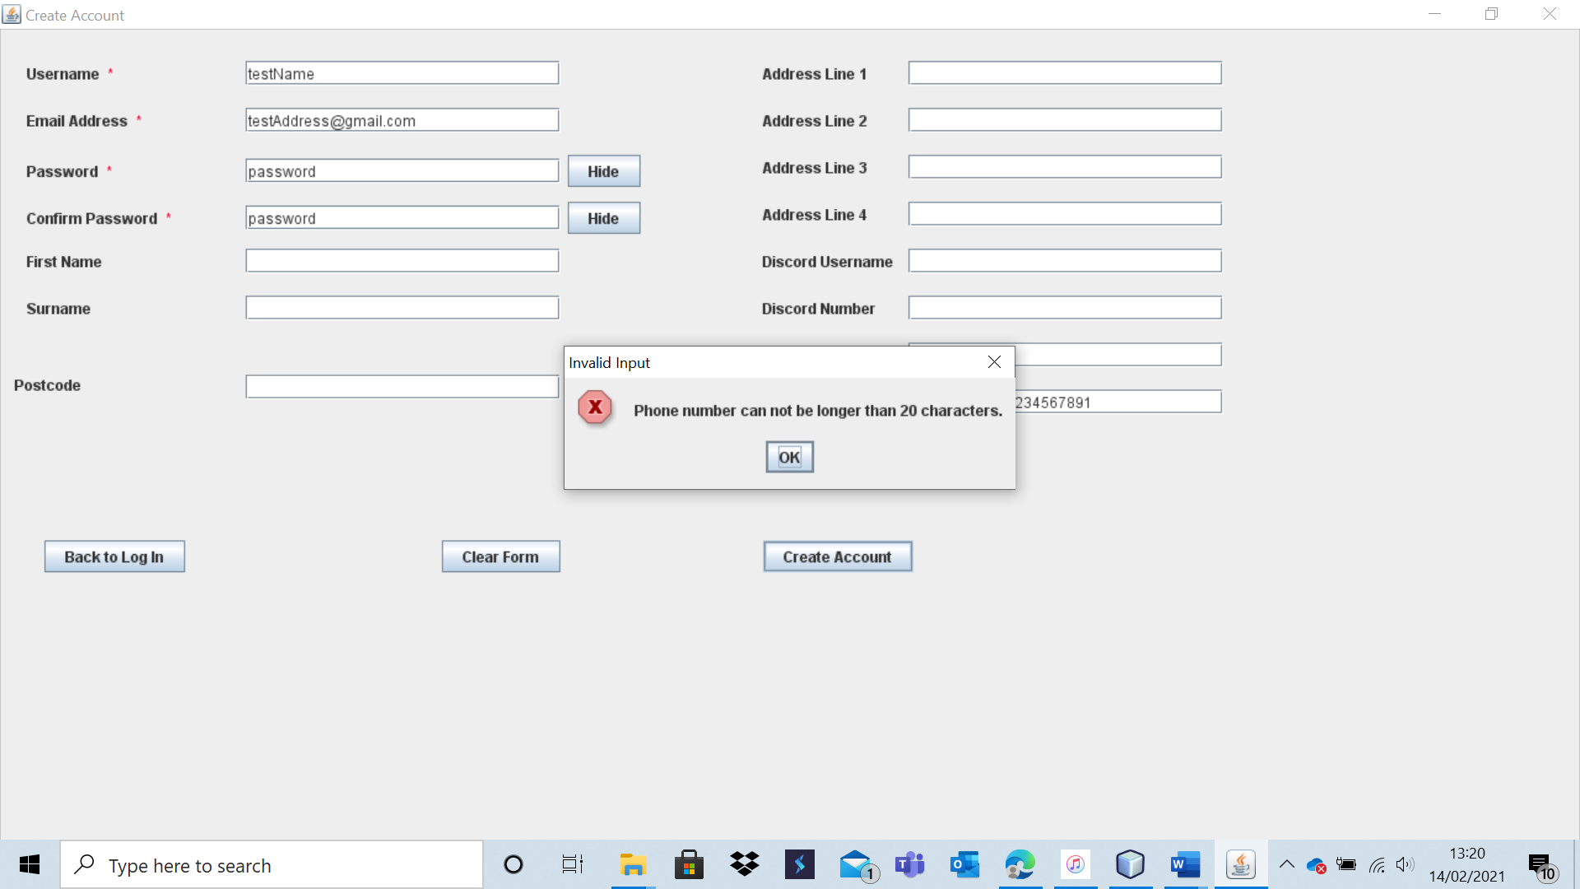

The account is not created as the phone number is too long. The system produces a specific message that makes it clear to the user why the account creation failed.

|  |  |  |  |  |  |  |
| --- | --- | --- | --- | --- | --- | --- |
| 10 | Verify that all data, including user details, is stored in the third normal form. | Ensure that data is stored as planned to minimise redundancy. | Add typical data to system (i.e., A1 and A2). | All data should be stored as planned and meet all the conditions to be in the third normal form. | 1a and 1ai. | My system stores all data in the third normal form. |

My system clearly stores all data in the third normal form as all data stored meets the relevant criteria. My design process and post-prototype refinement of design (which WJEC removed from the specification) created entity relation diagrams for the data I was to store. As I have obeyed these ERD’s (which satisfy all conditions for having data stored in the third normal form), I have clearly met this criterium. To demonstrate this, I have attached screenshots of some of my data structures which satisfy the ERD’s designed previously (which were in the third normal form).

Here is my email to username link file.

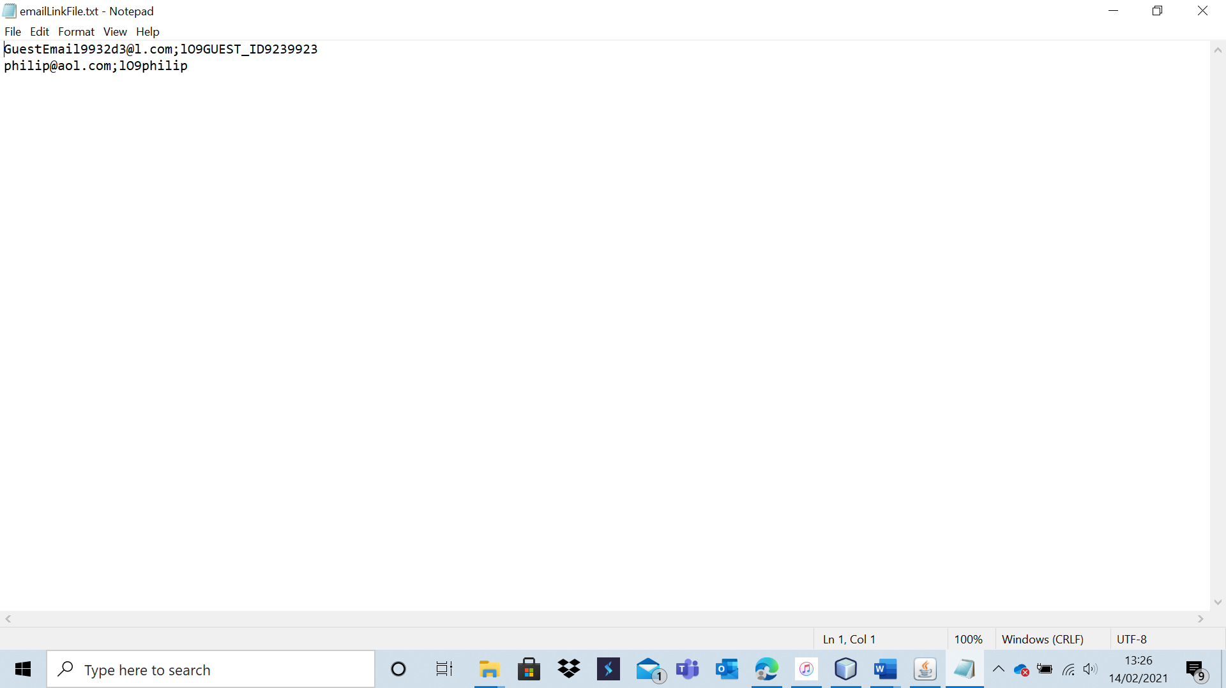

Here is my file that stores user details.

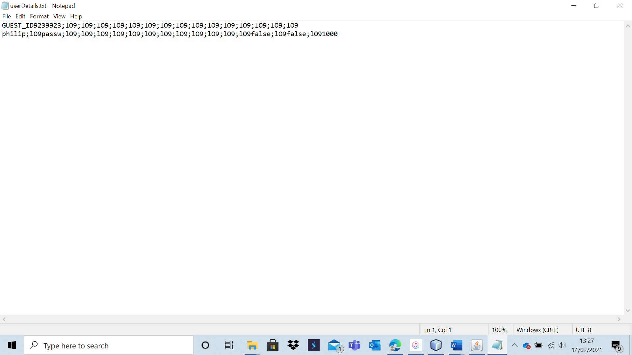

|  |  |  |  |  |  |  |
| --- | --- | --- | --- | --- | --- | --- |
| 11 | Verify that guests are able to play offline games and view the West Cross Chess Club contact details. Also verify that they cannot access other system features such as online play. | To ensure that the user access structure works as intended. |  | Log in as a guest should be possible with no user details. As a guest, one should be able to play offline games of chess against a human or computer opponent over multiple sessions. One should also be able to view the chess club contact details. The guest should not be able to access other features such as online play. | 2, 2a and2ai | As expected, one is able to log in as a guest by pressing a button. Guests are assigned a unique id which normal users cannot get. They are then able to play offline games in exactly the same fashion as a normal user. They can view the West Cross Chess Club contact details if they have an internet connection. However, they are not able to access features such as online play. This shows that the user access system works exactly as designed for guest users. |

Test 11

For this test, I pressed the “Log in As Guest” button on the log-in form to access guest mode.

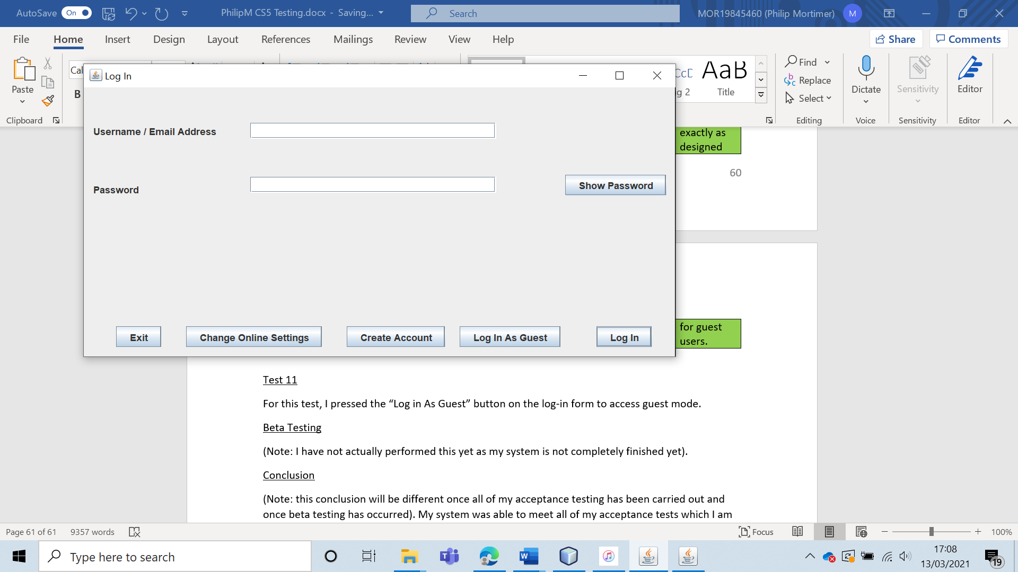

This took me to the main menu, with the system clearly displaying that I was logged in as a guest.

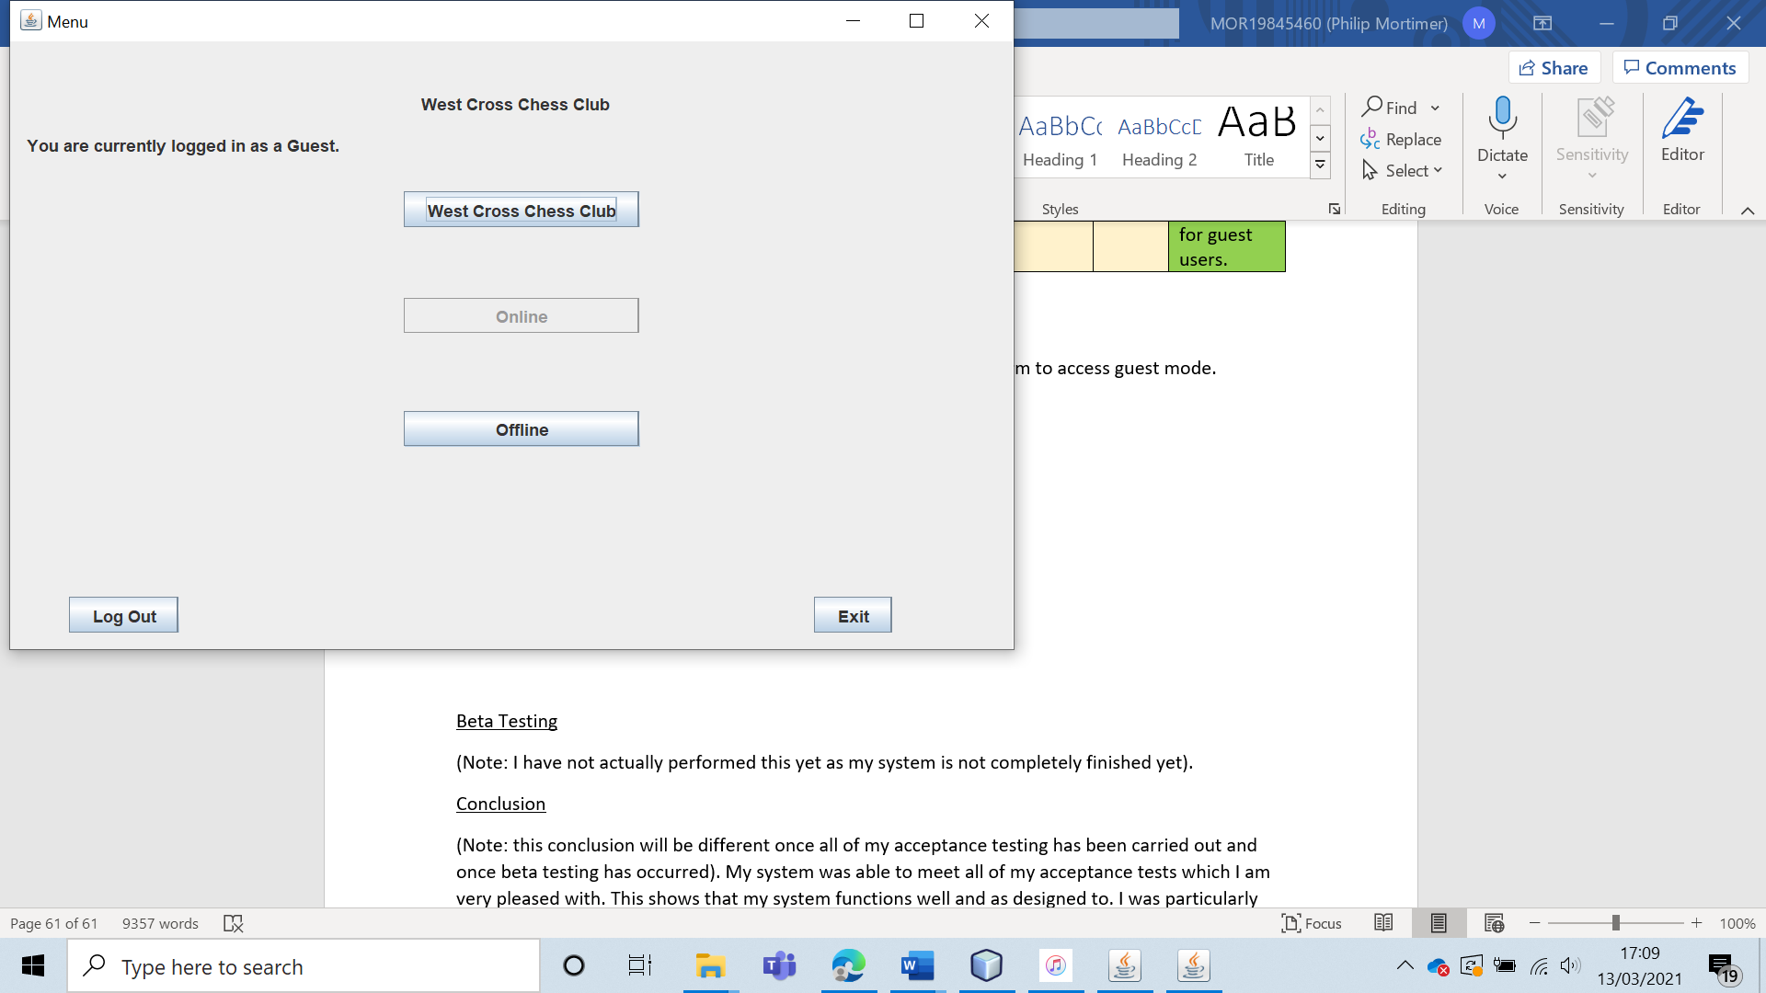

Notably, I was completely unable to even enter the online games section. This confirms that guests cannot play online games (as desired).

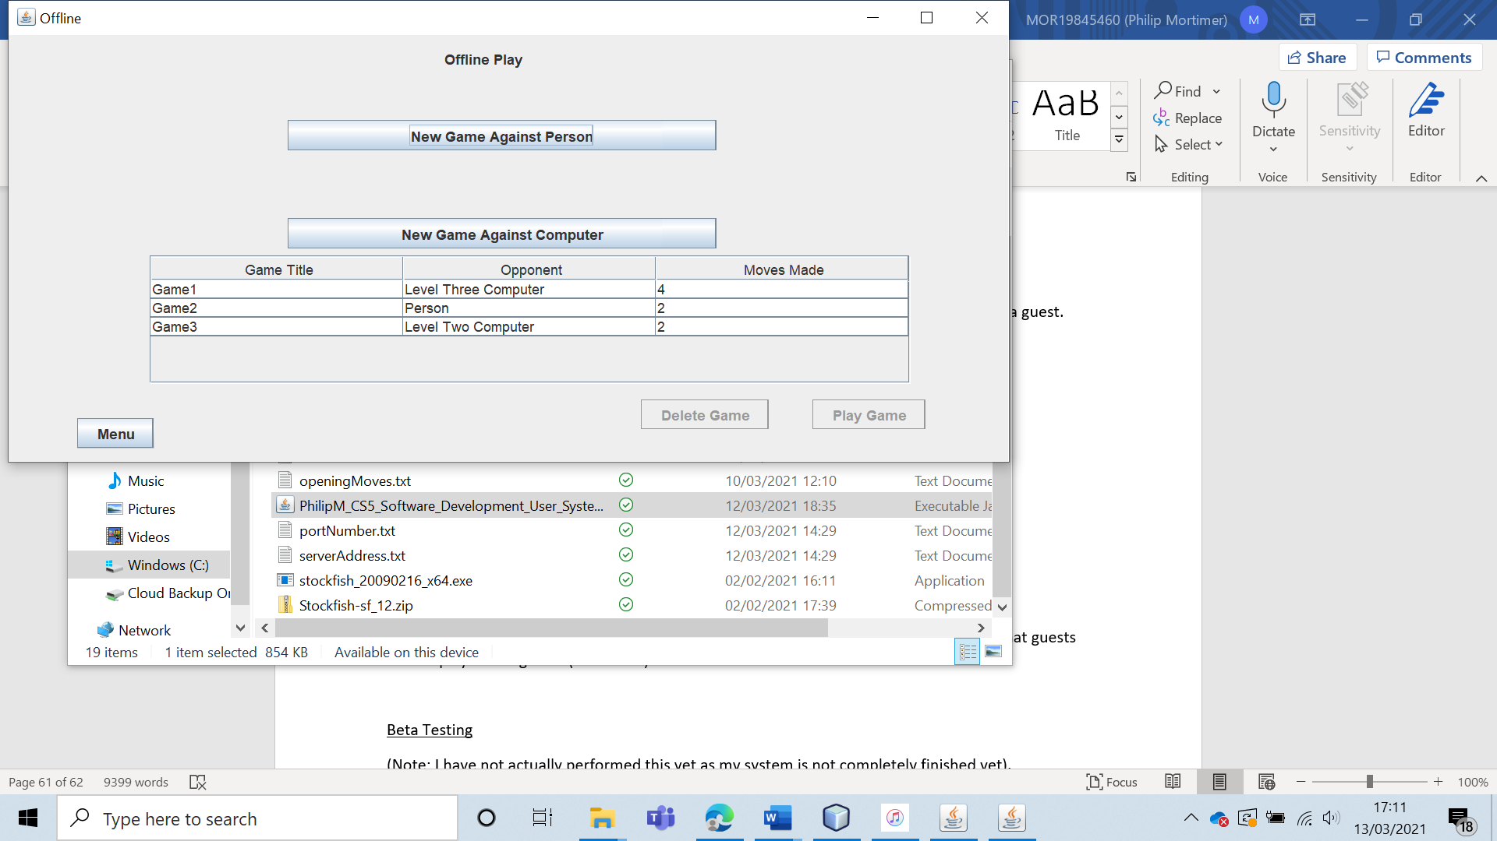

As a guest I was able to play offline chess games against computers and people over different sessions. This is exactly how I intended the system to function and is identical to the access rights to logged-in users for offline play.

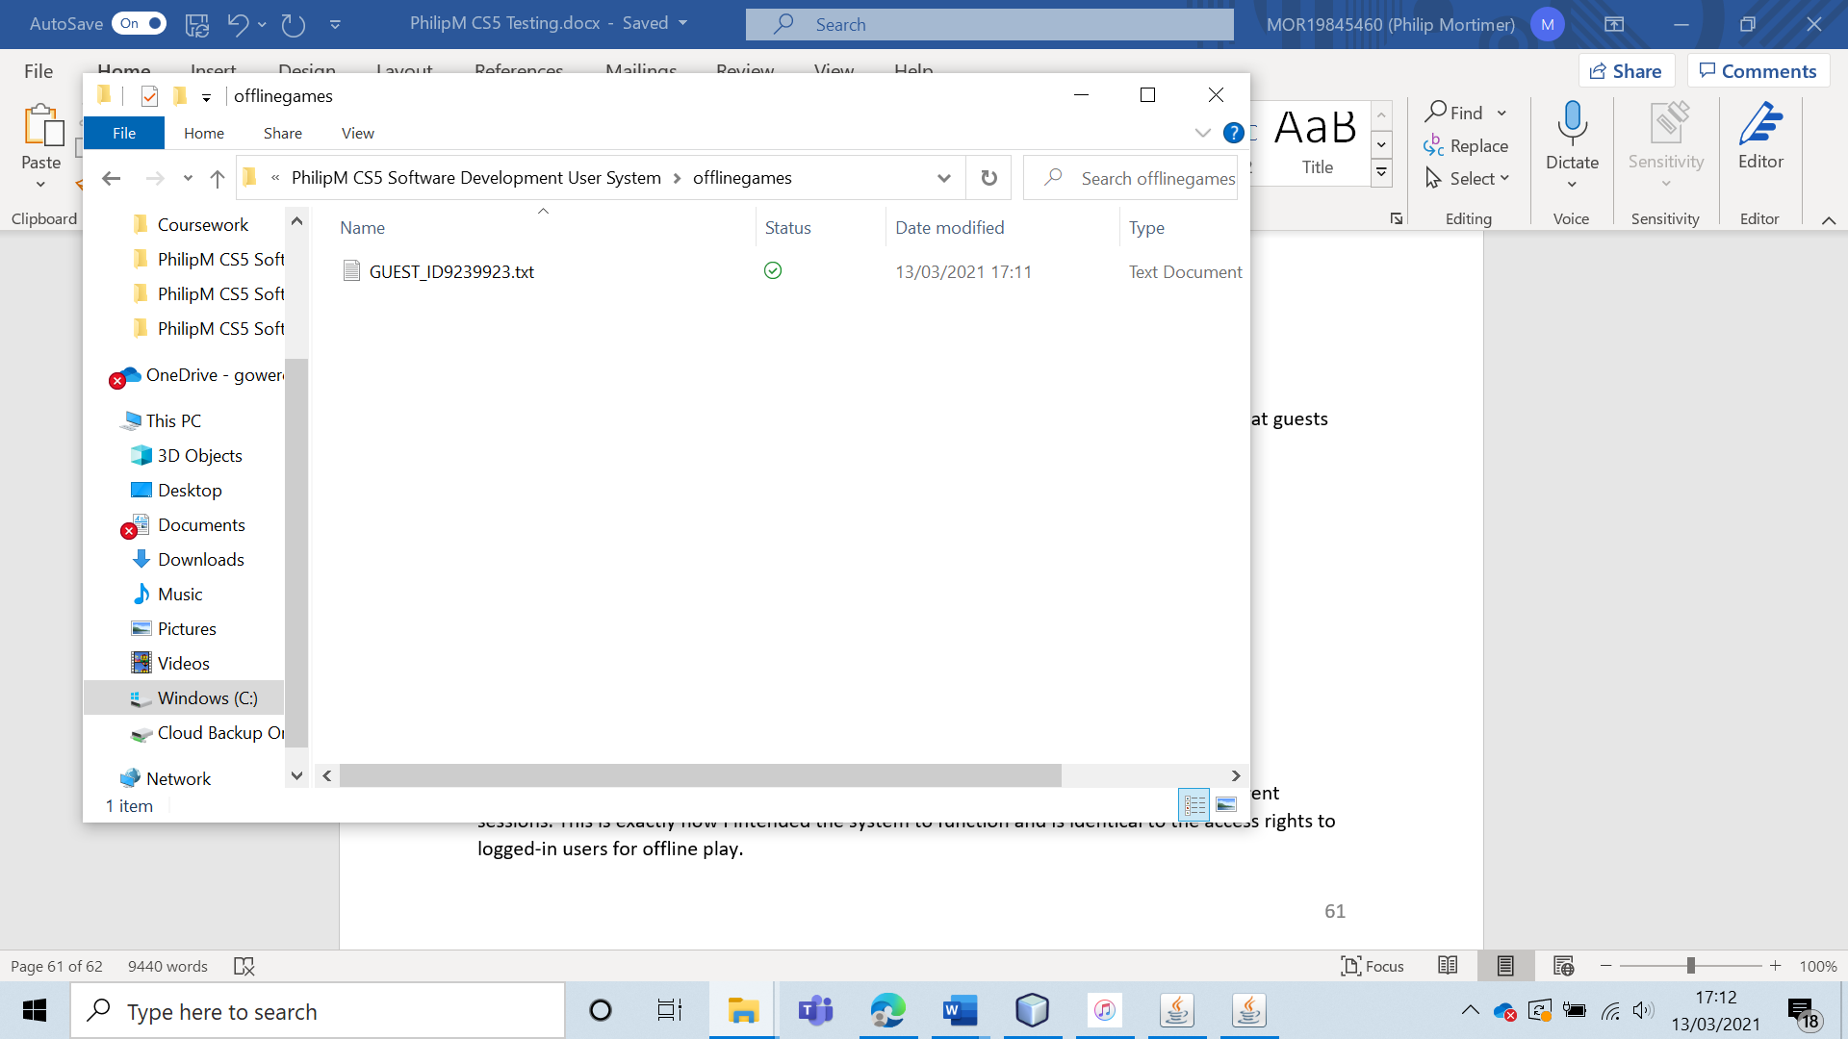

When we go into the offline games folder, we can clearly see that a folder has been specifically created for the guest. This proves that the guest is given a custom ID which allows them to play offline chess games over different sessions.

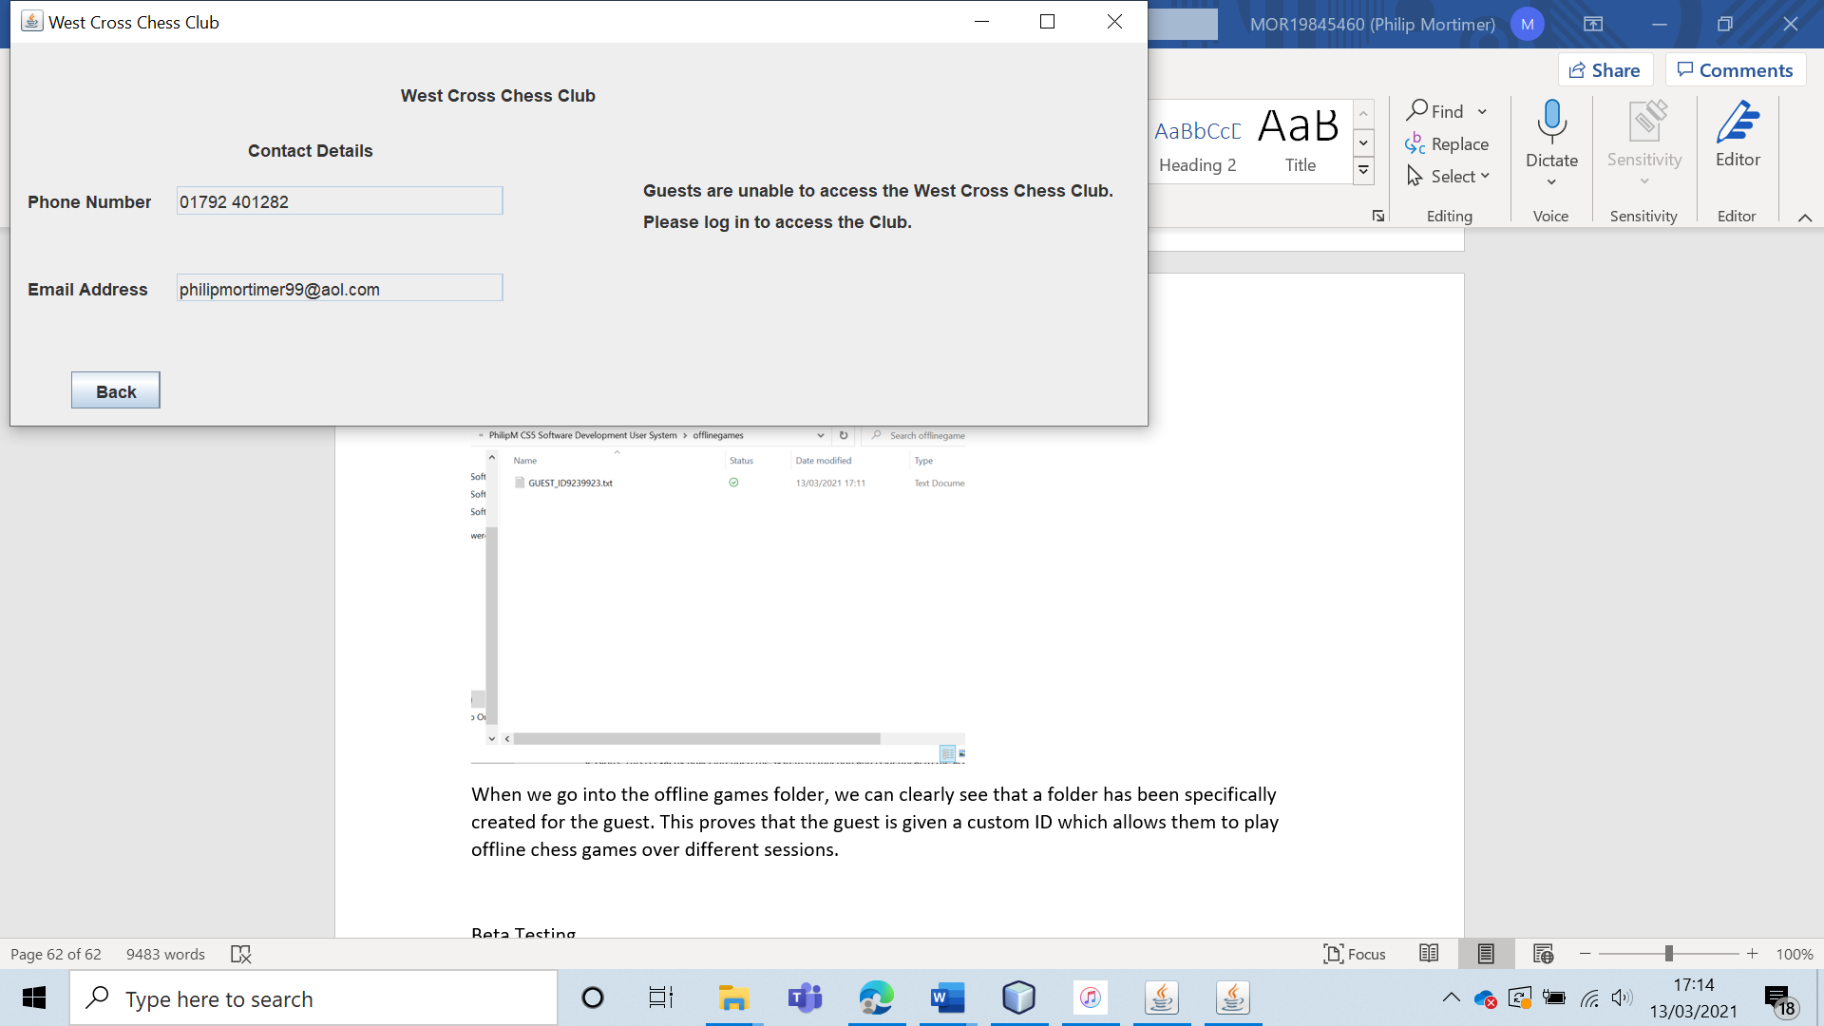

When the guest clicks on the “West Cross Chess Club” button on the main menu, they are taken to a form that displays the contact details of the chess club. The guest is told that they must log in to access the features of the chess club.

Guest users are only able to access offline games and view the chess club contact details. This is exactly what I intended and hence the user access level clearly works for guests.

|  |  |  |  |  |  |  |
| --- | --- | --- | --- | --- | --- | --- |
| 12 | Attempt to create an online game using an invalid opponent username. | To ensure that online games can only be played against real users. | Enter a username that does not exist in the user database. | The game should not be created, and an error message should be displayed to communicate that the user chosen is invalid. | 3 and 3ai. | The online game was not created, and a specific error message was displayed, telling the user that the chosen username was not found. |

Test 12

To create an online game against an invalid user, I have logged into an account with the username “philip”. I will attempt to create a game against a user with the username of “fakeUser”. There is no user called “fakeUser”.

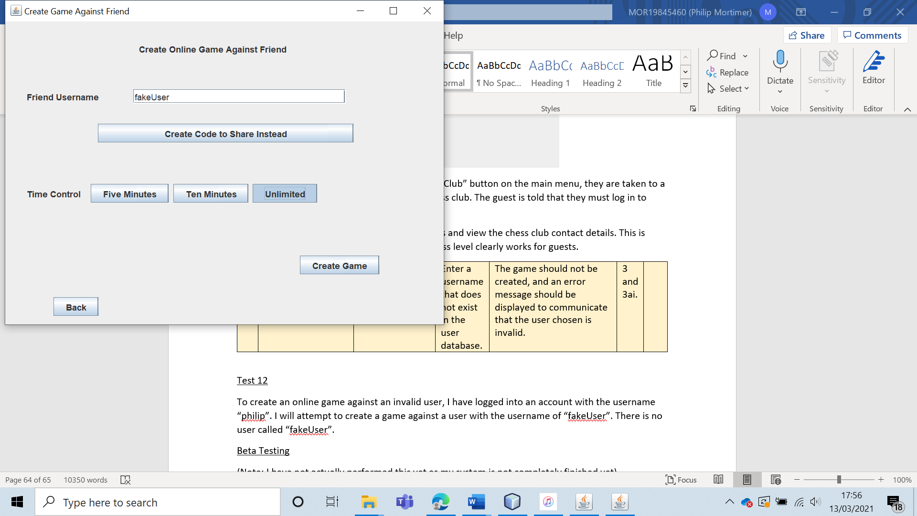

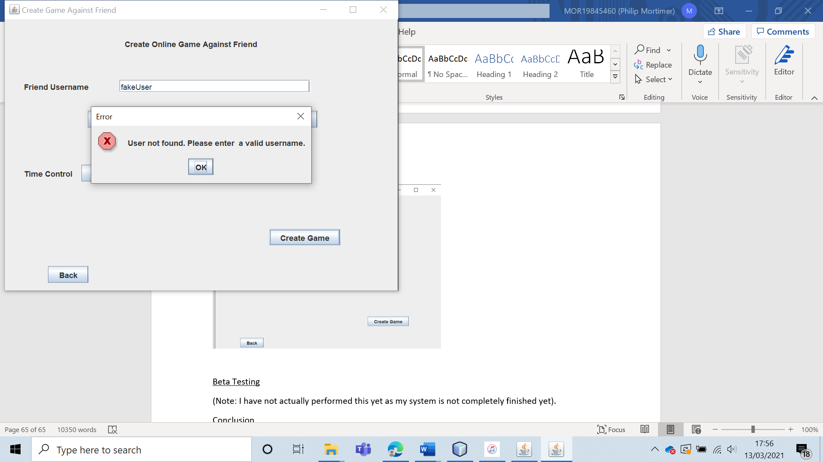

The system correctly identifies that such a user does not exist and does not create the online game of chess, as expected.

|  |  |  |  |  |  |  |
| --- | --- | --- | --- | --- | --- | --- |
| 13 | Attempt to create an online game without having selected a time control setting. | To ensure that the user has to select a time control before creating a game. |  | The game should not be created, and the user should see an error message which clearly states that a time control needs to be selected before the game can be generated. | 3, 3a and 3ai. | The online game is not created and the user is told that they need to choose a time control before the game can be made. |

Test 13

For this, I will create an online game by sharing a game code. However, I will not select a time control.

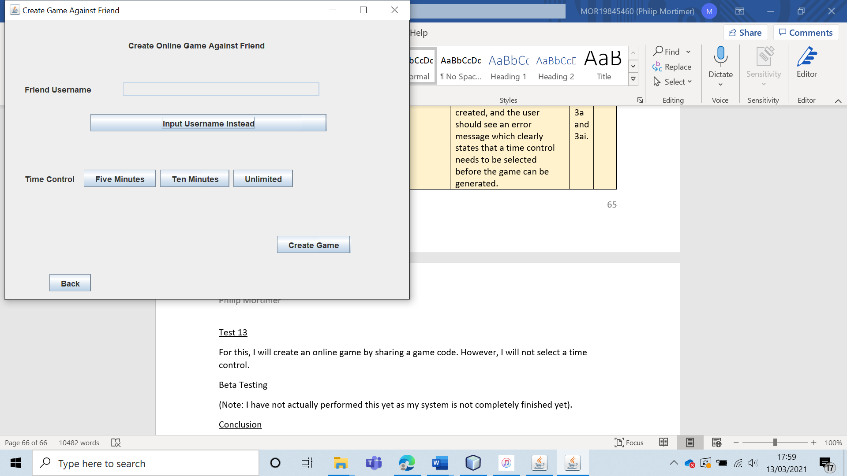

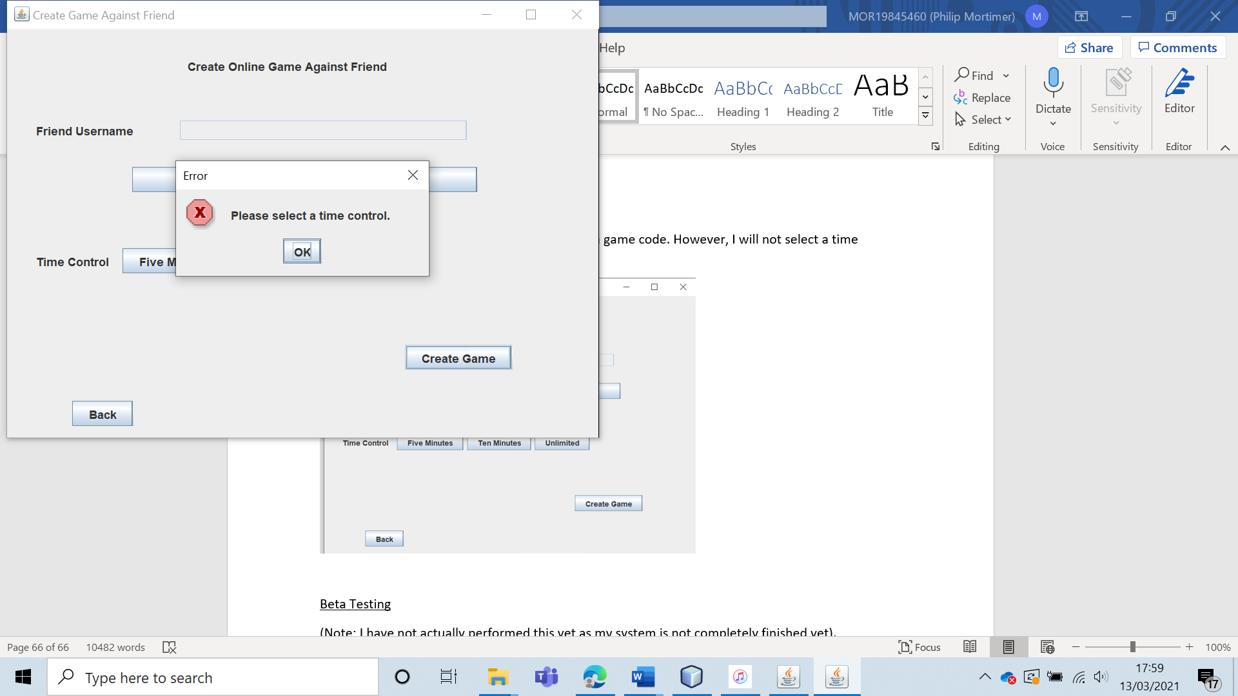

When doing this, the online game is not created, and the user is told that they must enter a time control before they can create the game.

|  |  |  |  |  |  |  |
| --- | --- | --- | --- | --- | --- | --- |
| 14 | Create an online chess game against a user by entering their username. Play the game using a five-minute time control. Let the five minutes run out to verify that the time control works. | To ensure that games against valid players can be played online. To ensure that the time control setting functions as intended. |  | The game should be created and fully playable. When one user runs out of time, both users should be notified of the game outcome. | 3, 3a and 3ai. | The chess game was created, and a normal game of chess was played using the chosen time settings. There were some minor visual bugs, but none of these had any impact on the functionality of the system. This shows that my code is robust. However, the visual bugs do detract from the user experience slightly. However, due to strong exception handling, the user experience suffers very little as the system clearly communicates what is happening. |

Test 14

For this test, I will log in to an account with the username “philip”. I will create a five-minute game of chess against a valid user called “phil”.

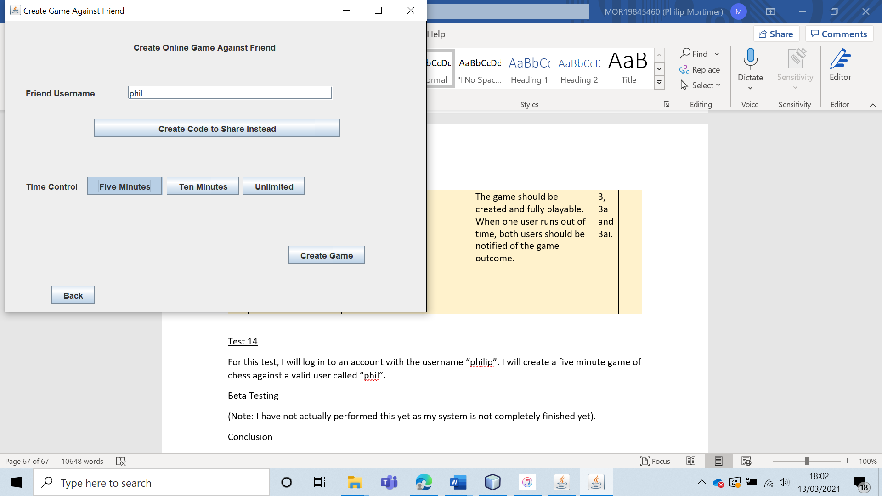

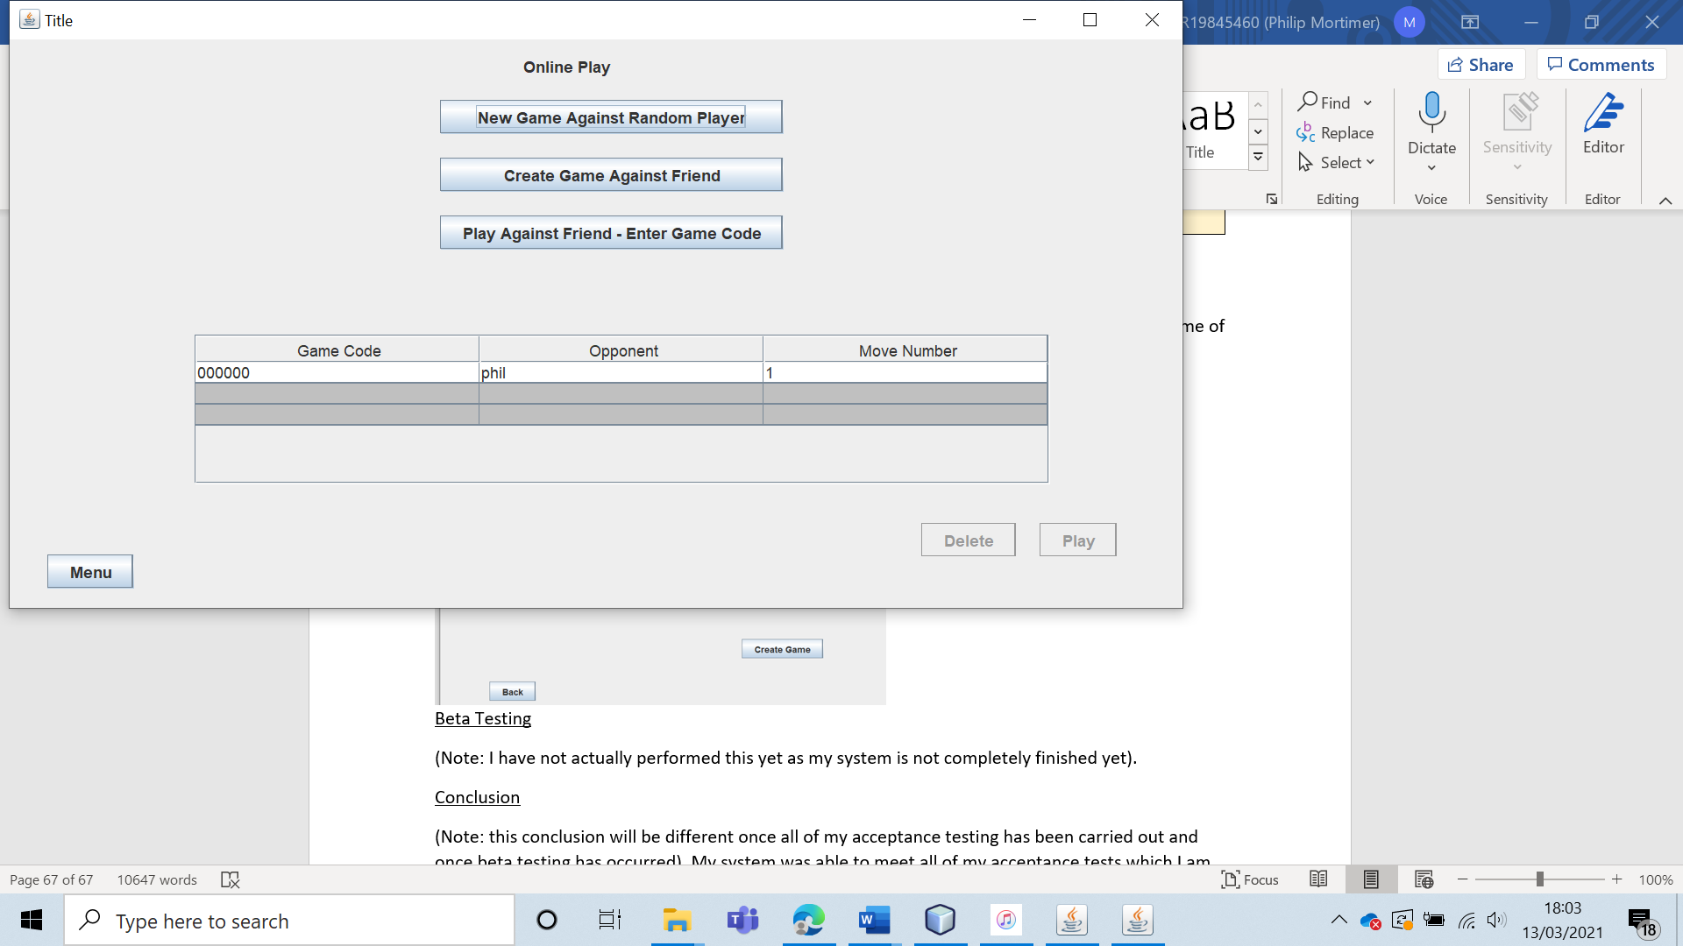

When doing this, the online game is successfully generated. Both “phil” and “philip” are able to play a normal game of chess with the correct time control.

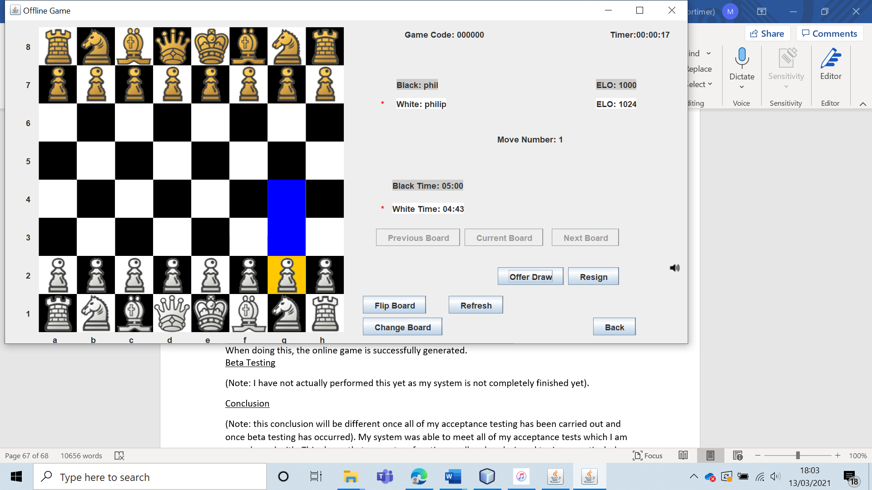

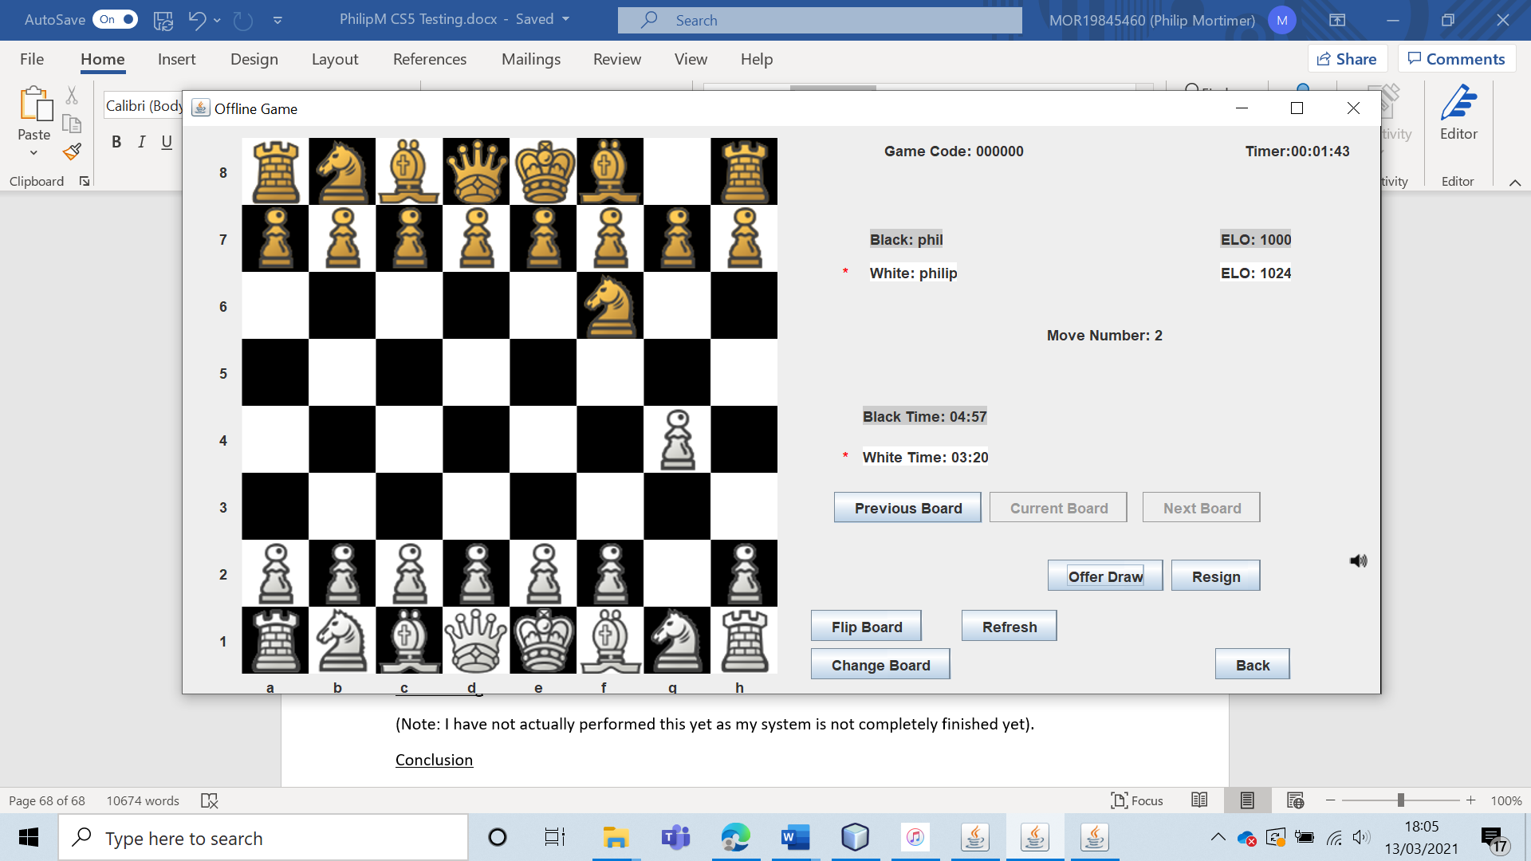

When white runs out of time, both players are notified that black has won the game. The online game is then subsequently deleted. This performs exactly as intended.

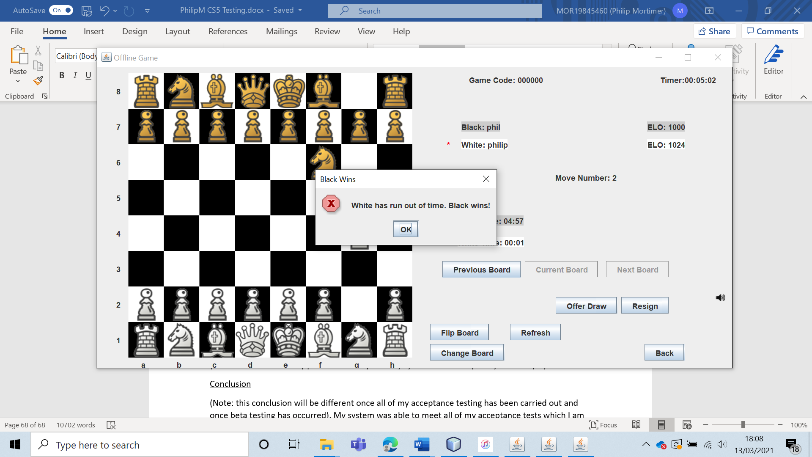

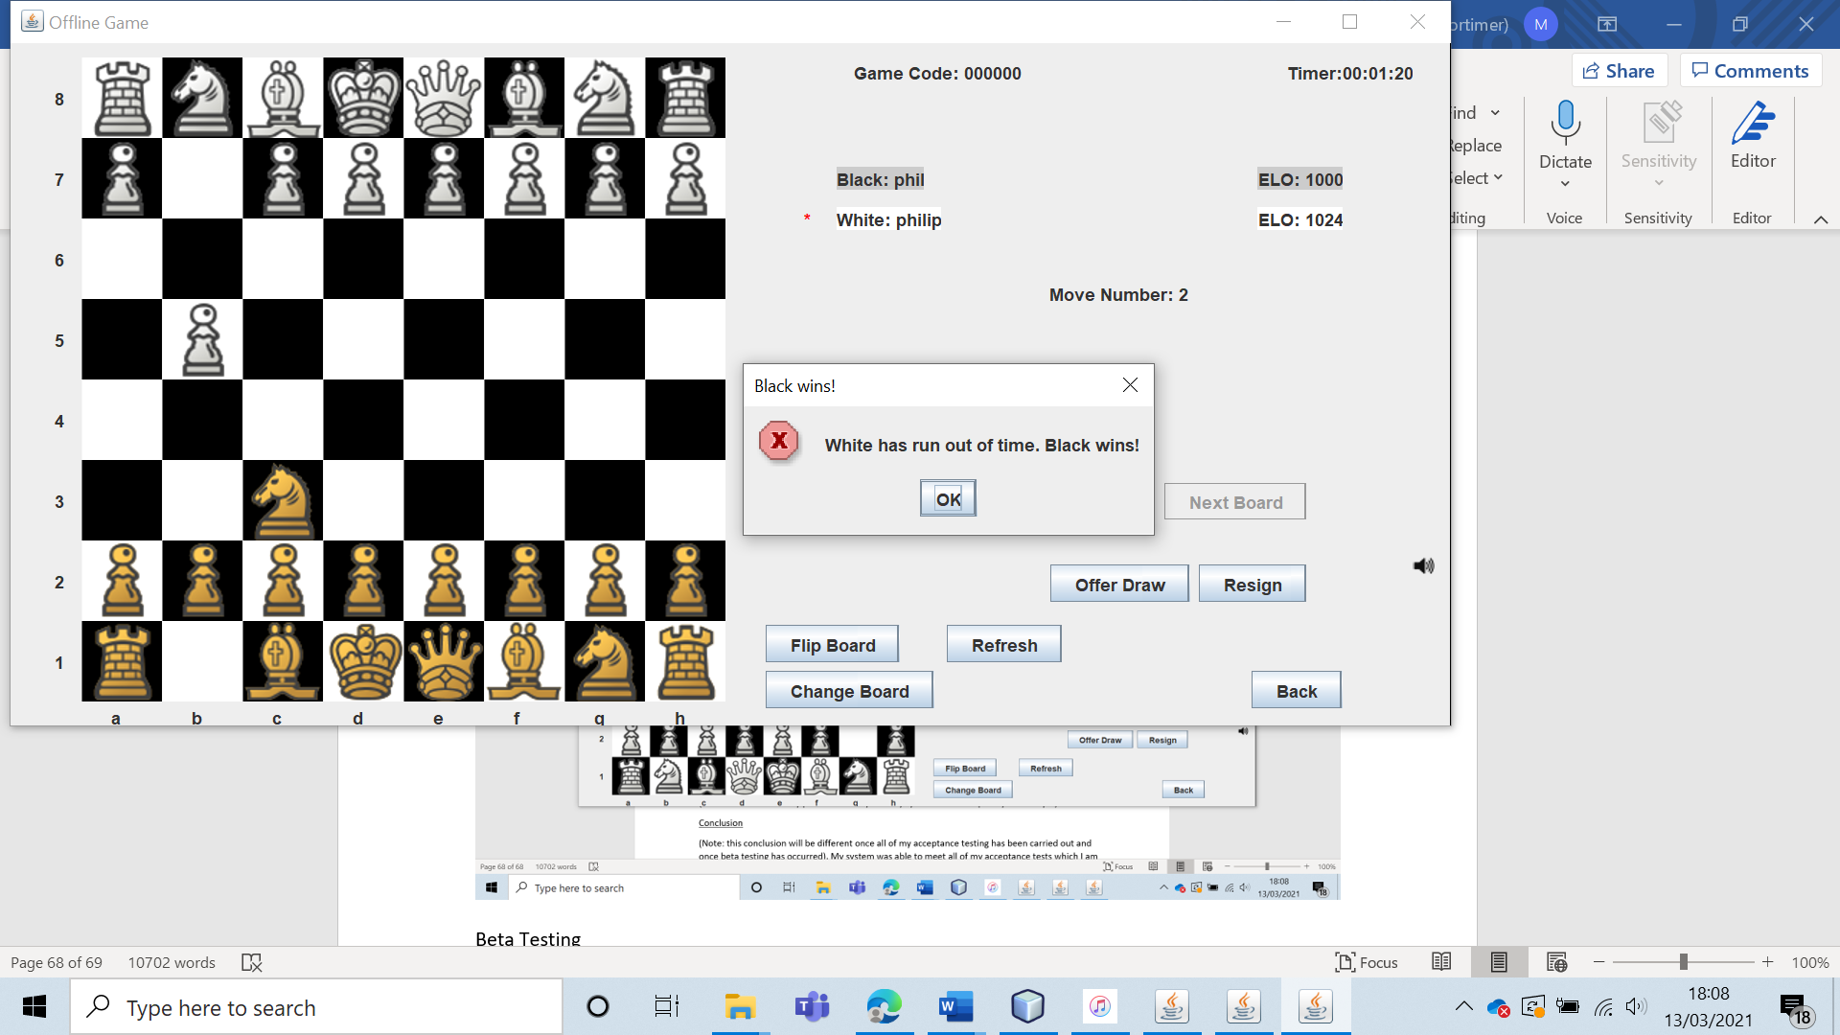

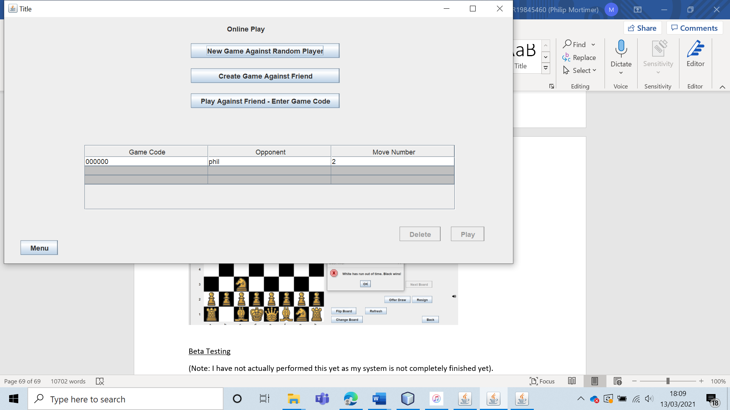

Whilst the actual feature performed exactly as expected, there were some minor visual bugs. First of all, the time never actually reaches 0 seconds as the code that exits the game is called before the timers can refresh. However, this is not a problem as it is very obvious to all involved why the game has finished (as the system says that the game is over due to time). Additionally, I found that white did not have the game deleted straight away. They were taken to the menu where it looked like they could play the game. However, upon trying to play the game, they are notified that the game is over and that they lost. This is a minor visual bug and has no actual ramifications on the function of the system. If anything, it demonstrates that my system is robust as it is able to avoid errors by preventing the user from playing games that have finished. The user is clearly told that the game was lost, so the user still knows what is happening. If I had more time, I would look to fix minor visual bugs such as this. Fortunately, the functionality of the system is not impacted by this in any manner. I also noticed; the online game form was titled “Offline Game”. I have now fixed this minor bug by altering the name of the form to “Online Game”.

Despite the minor visual bugs, the actual system performed flawlessly: allowing users to play a normal game of chess on a timer.

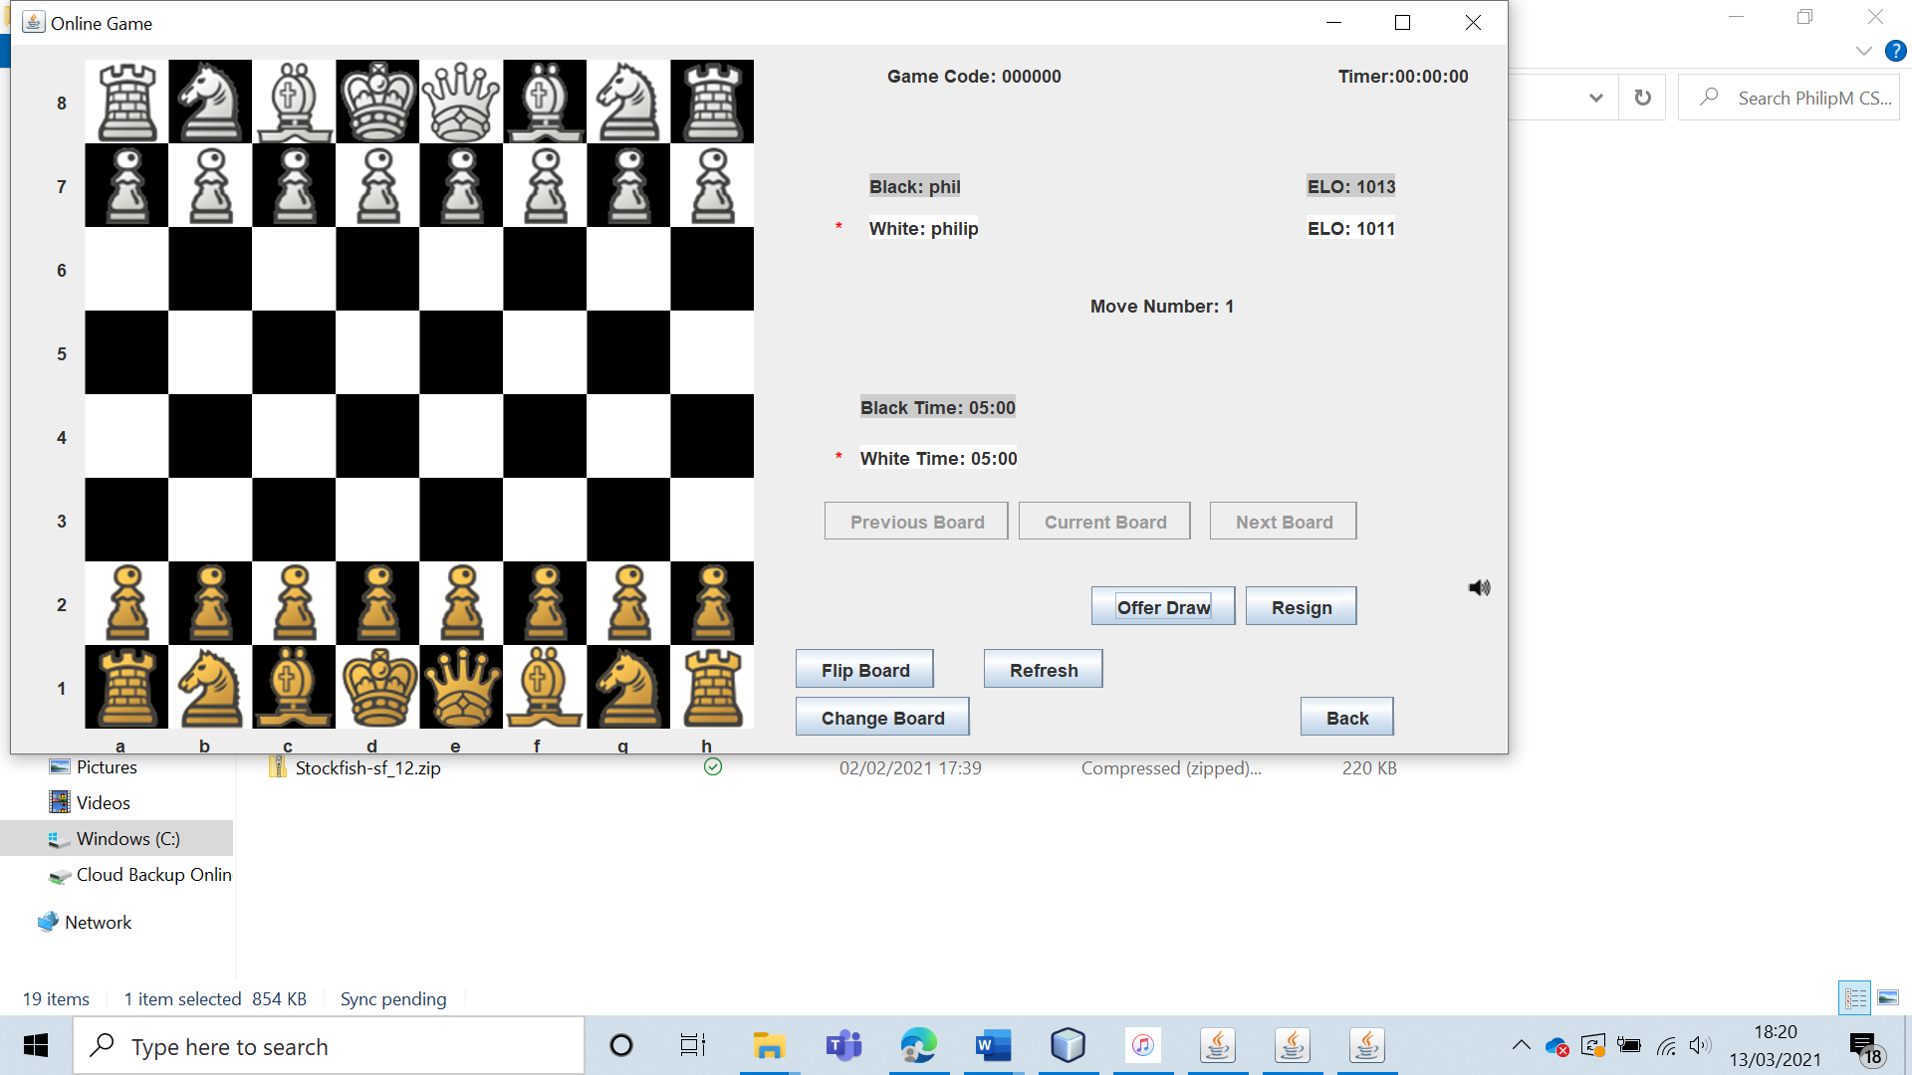

This shows that I have changed the title of the online game form to something appropriate.

|  |  |  |  |  |  |  |
| --- | --- | --- | --- | --- | --- | --- |
| 15 | Create an online chess game against a user generating a game code and sharing this. Play the game using a ten-minute time control. Let the ten minutes run out to verify that the time control works. | To ensure that the time control setting functions as intended. |  | The game should be created and fully playable. When one user runs out of time, both users should be notified of the game outcome. | 3, 3a and 3ai. | A five-minute game is created as opposed to a ten-minute game. |

Test 15

As with test 14, I created a game between “phil” and “philip”, this time using a ten-minute time control.

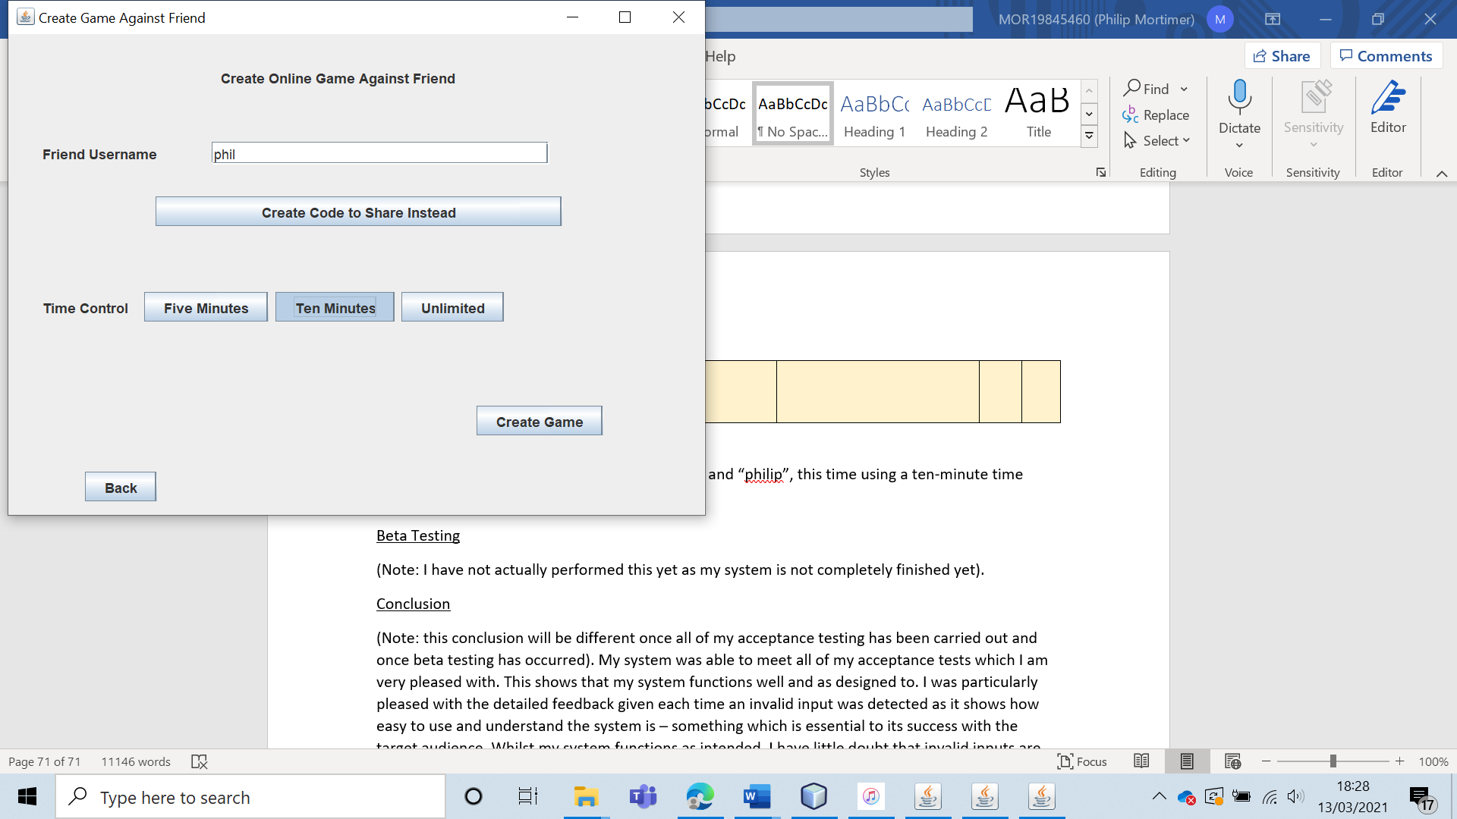

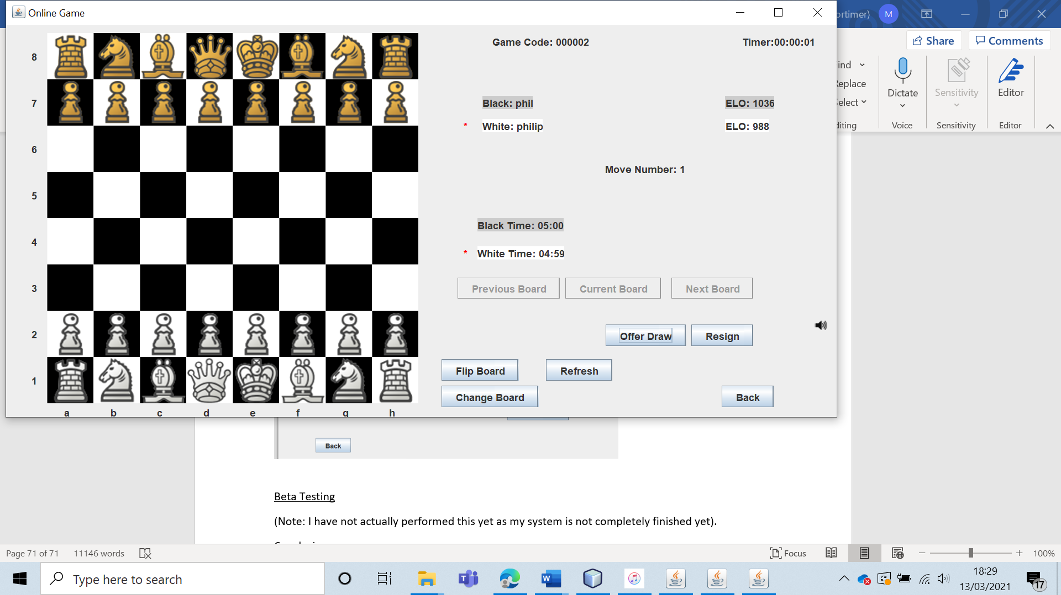

However, the game created ends up being a give minute game (when it needs to be a ten-minute game).

Upon looking at my code, I found that I hade made a very simple error. When creating a new online game, I had incorrectly calculated that 10 minutes = 500 seconds. So, I simply changed this to the correct value (600 seconds).

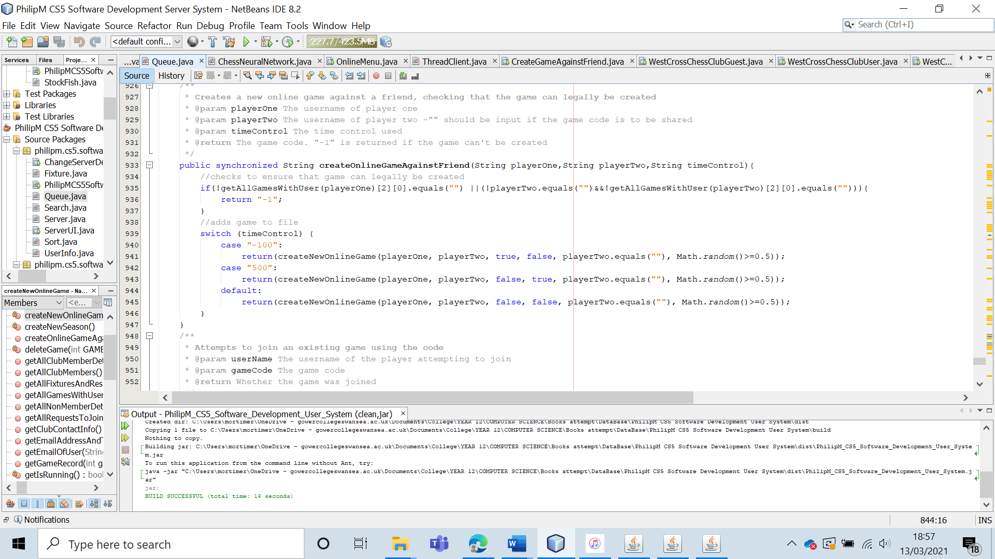

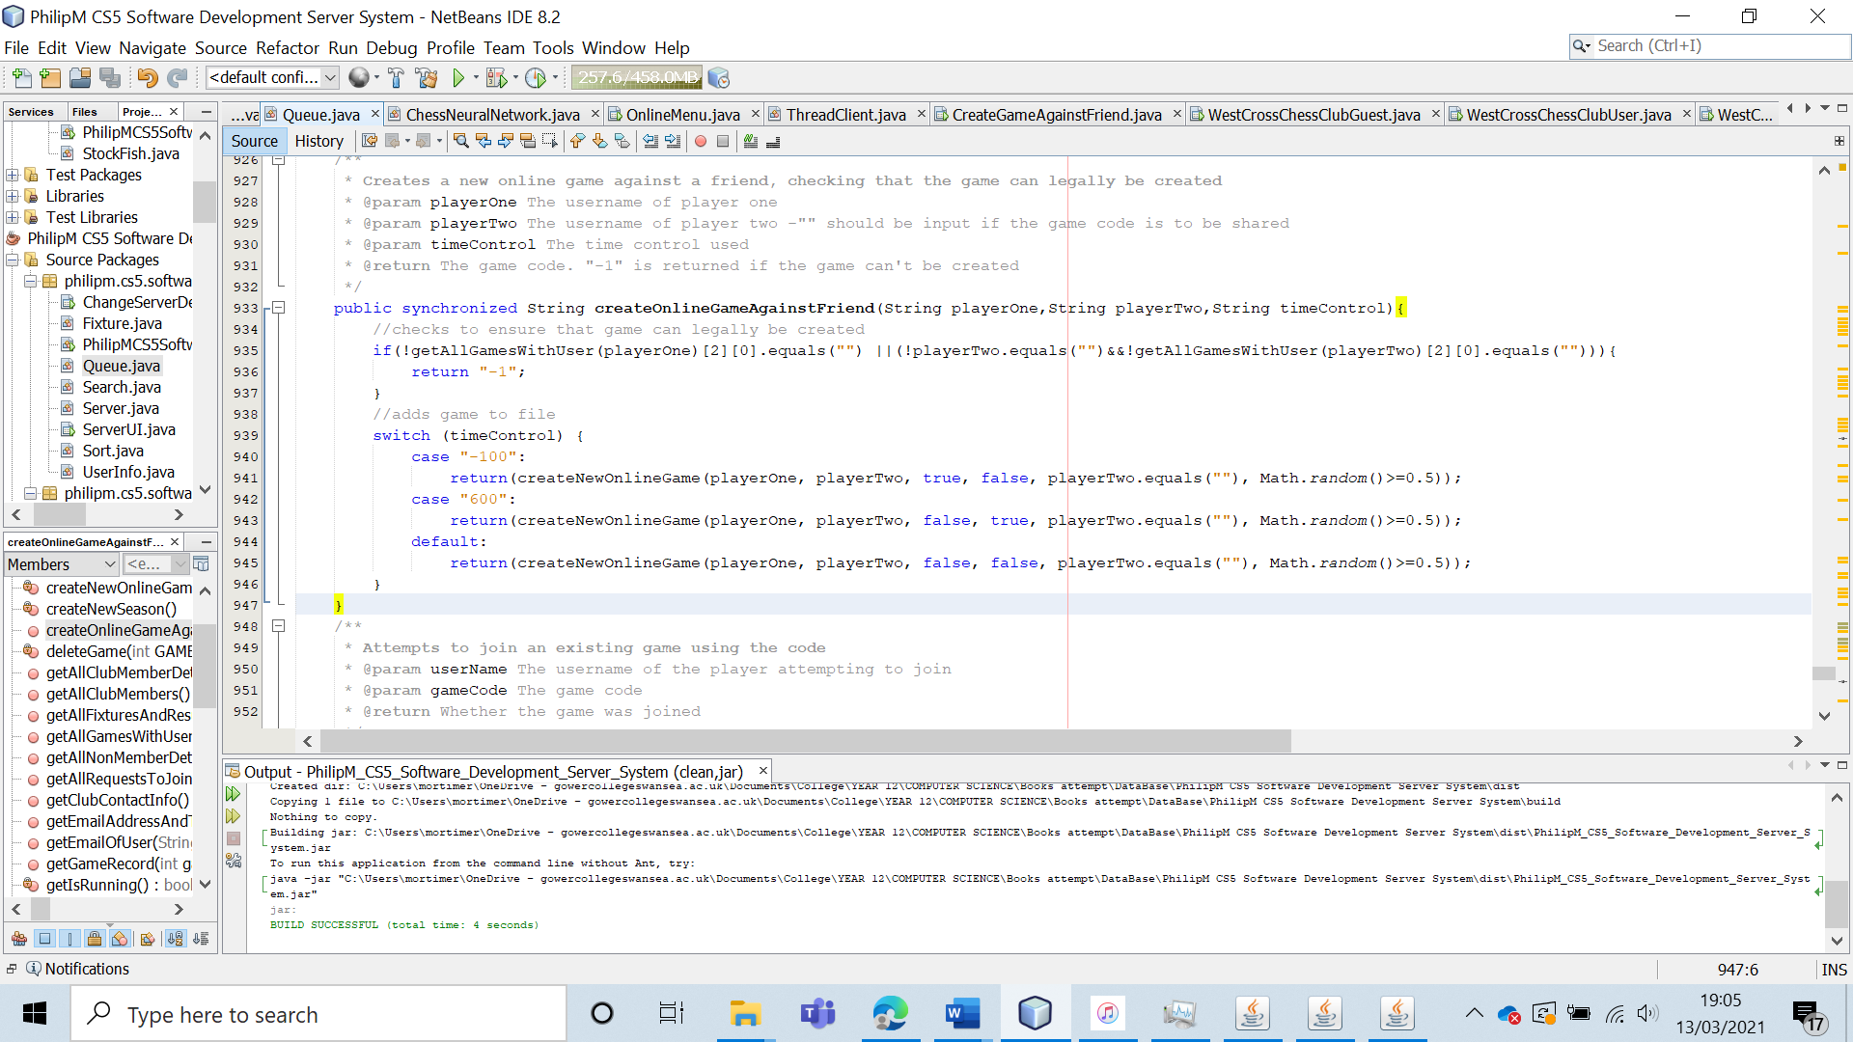

I will now re-run the test with this alteration.

|  |  |  |  |  |  |  |
| --- | --- | --- | --- | --- | --- | --- |
| 15 (Re-run) | Create an online chess game against a user generating a game code and sharing this. Play the game using a ten-minute time control. Let the ten minutes run out to verify that the time control works. | To ensure that the time control setting functions as intended. |  | The game should be created and fully playable. When one user runs out of time, both users should be notified of the game outcome. | 3, 3a and 3ai. | A ten-minute game is created. The game is a normal chess game that works perfectly. The time setting also works with the game ending once one user has spent ten minutes making moves. An appropriate message is displayed to communicate the game outcome to both players. |

Test 15 (Re-run)

I created a game as “philip” against “phil”, using a ten-minute time control.

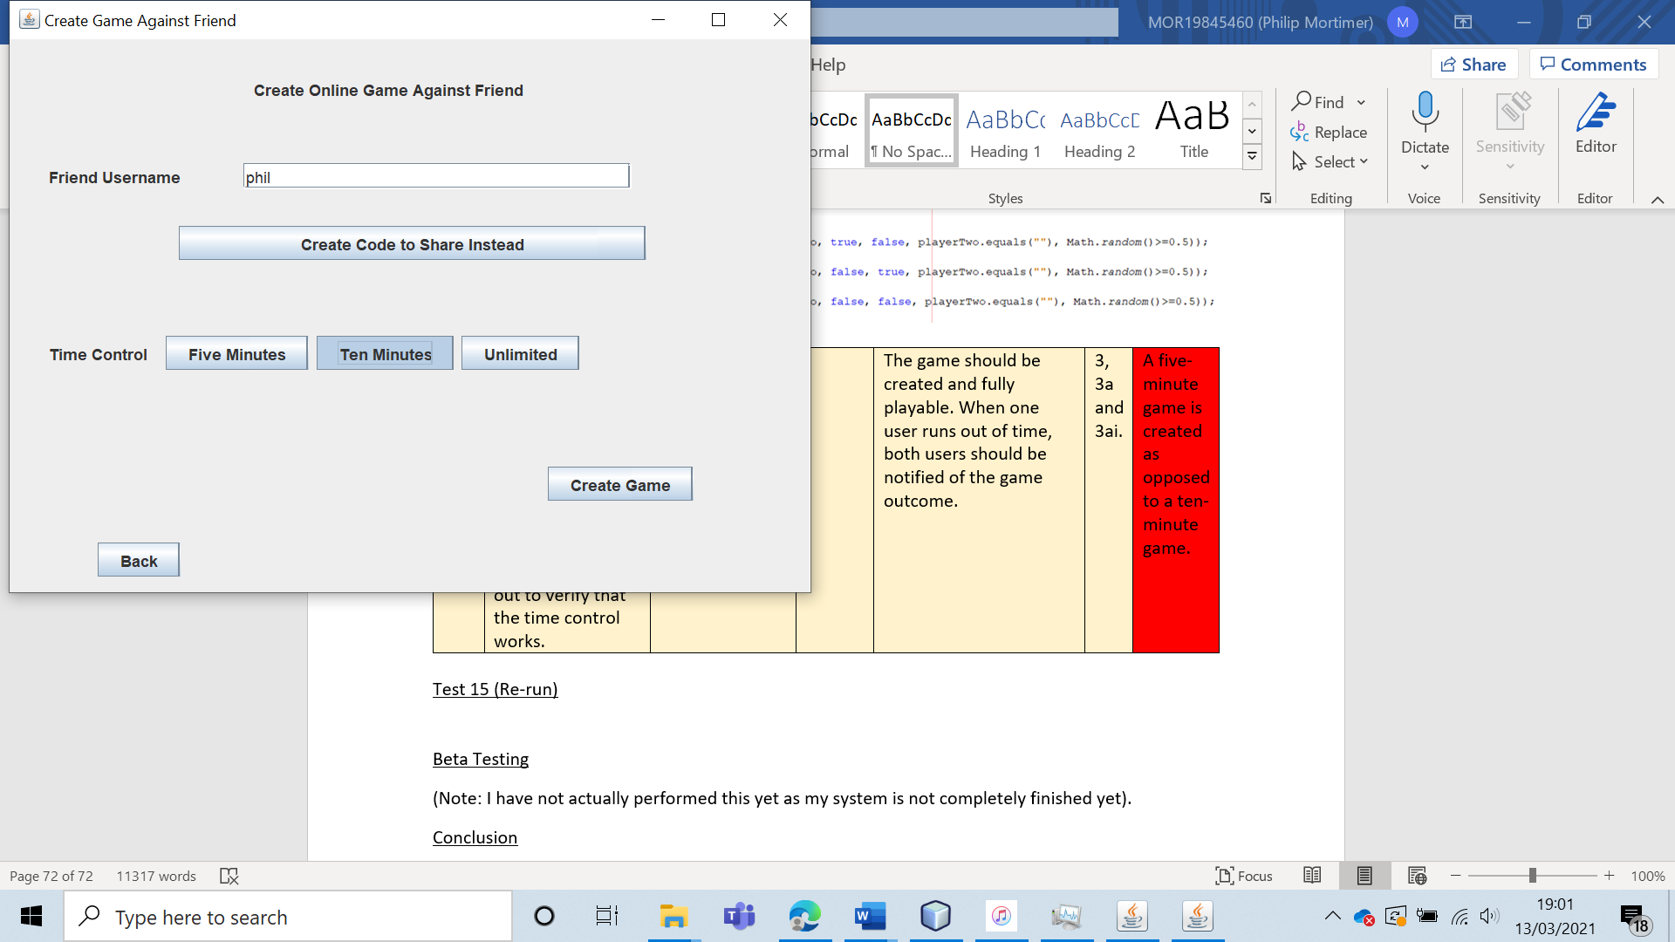

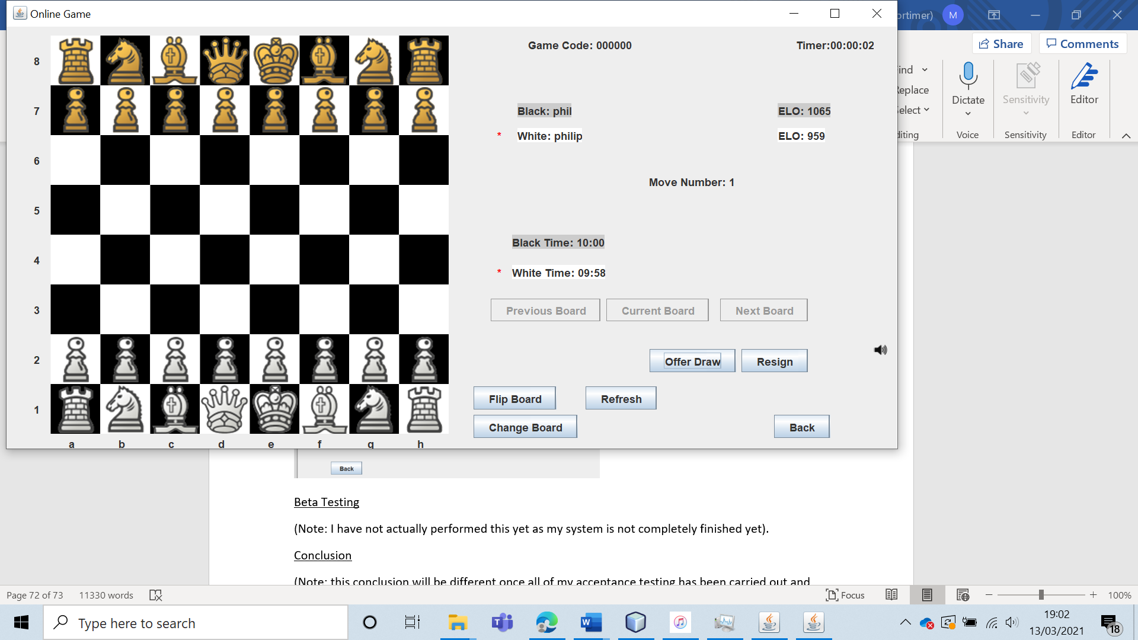

An online game is successfully created, with each player having ten minutes to play. Once more, a normal chess game is played. The time control works as desired, with the game ending after ten minutes and a message appearing which displays that one player ran out of time and the other player one.

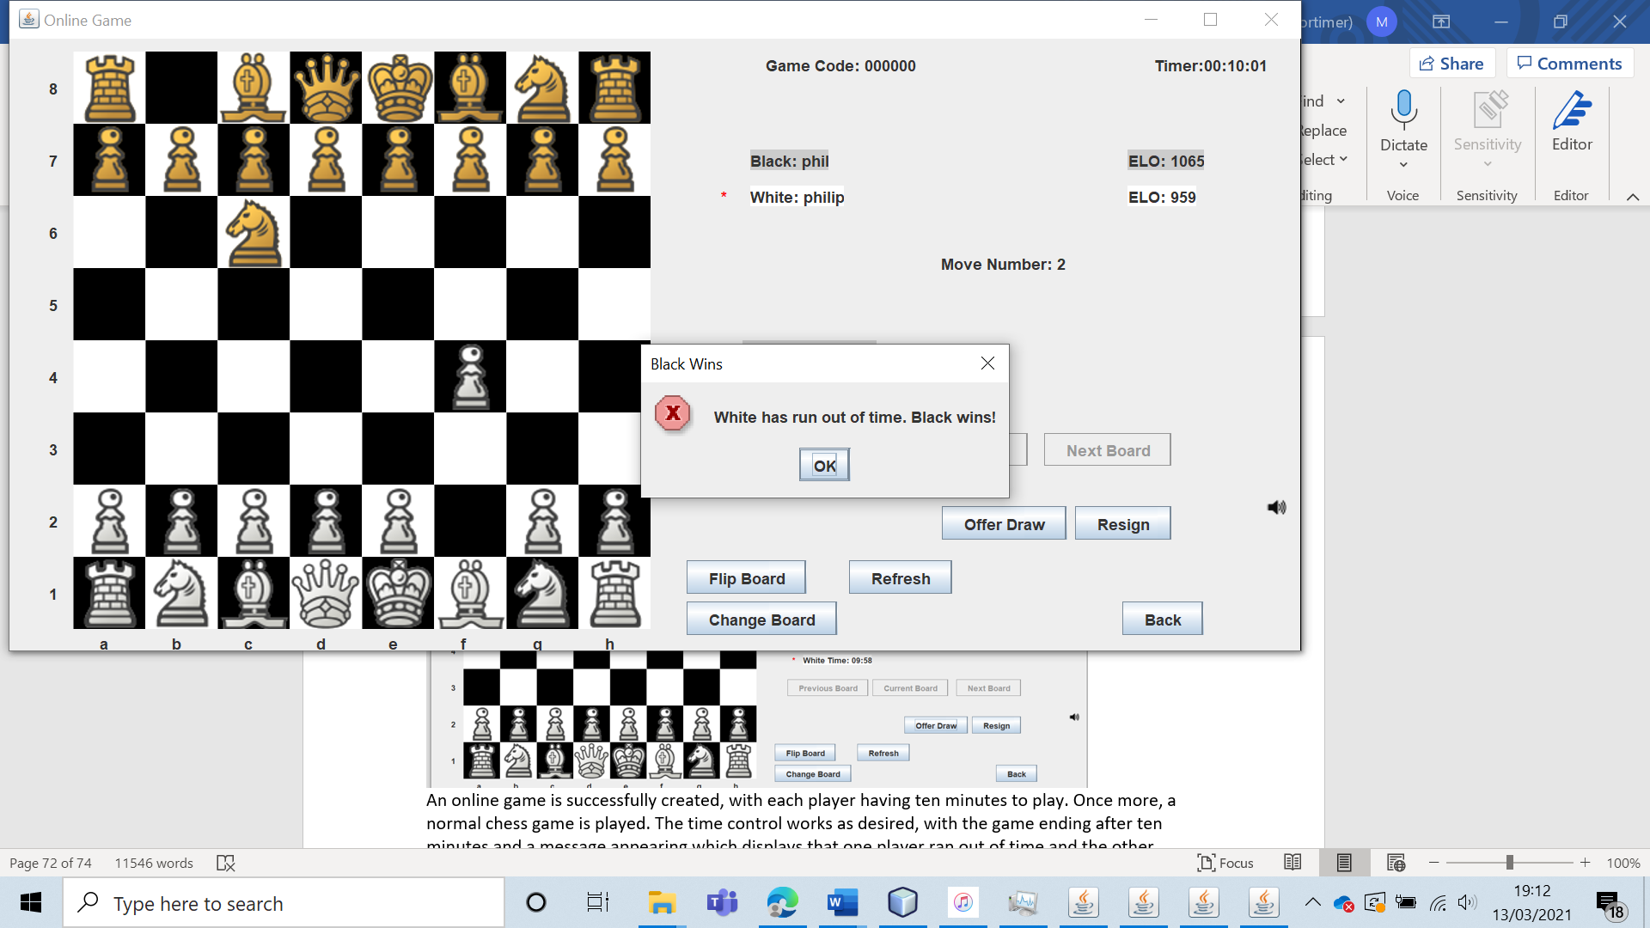

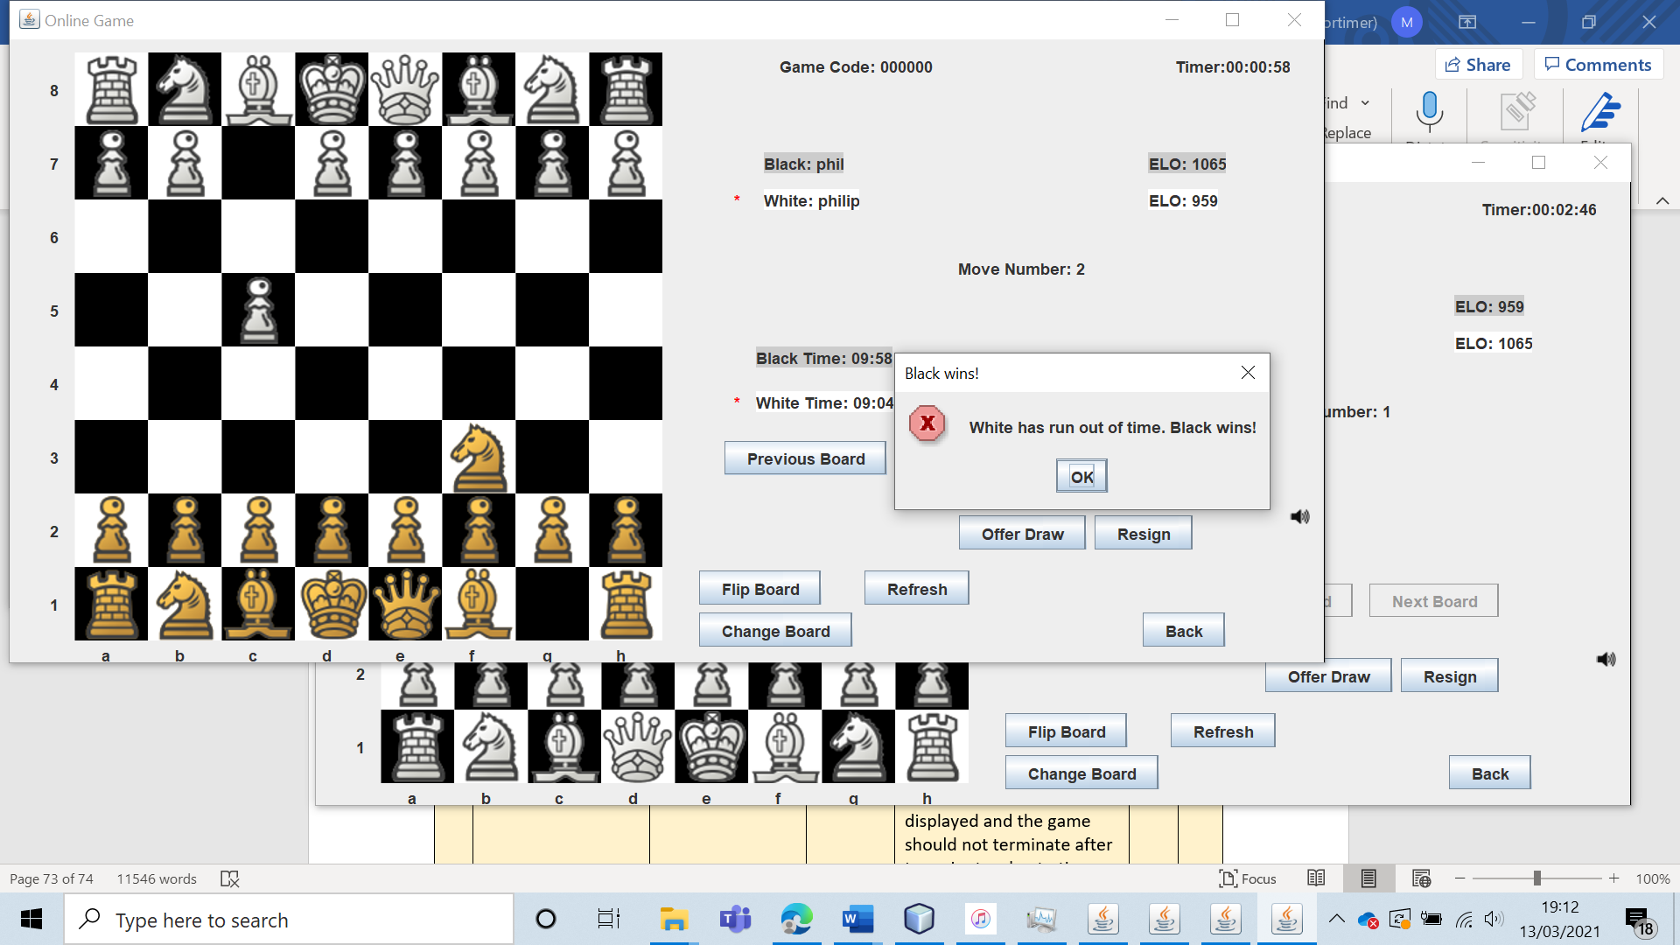

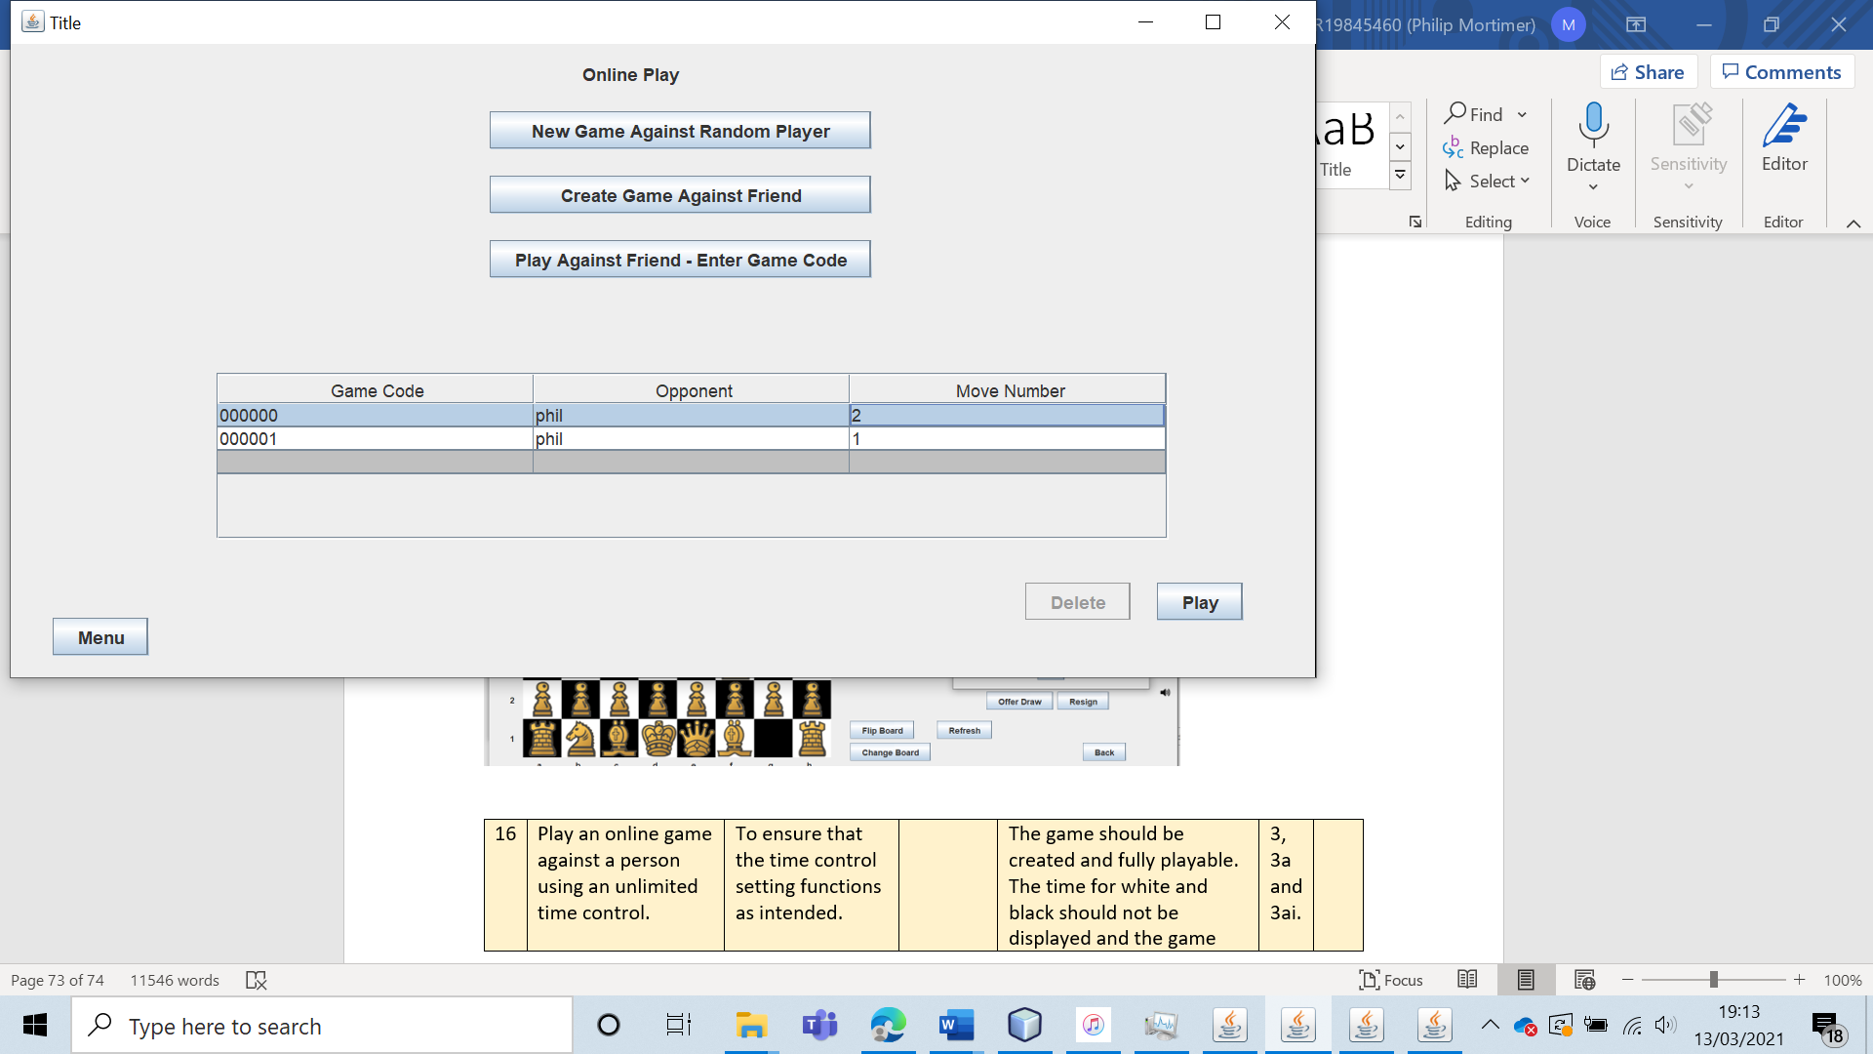

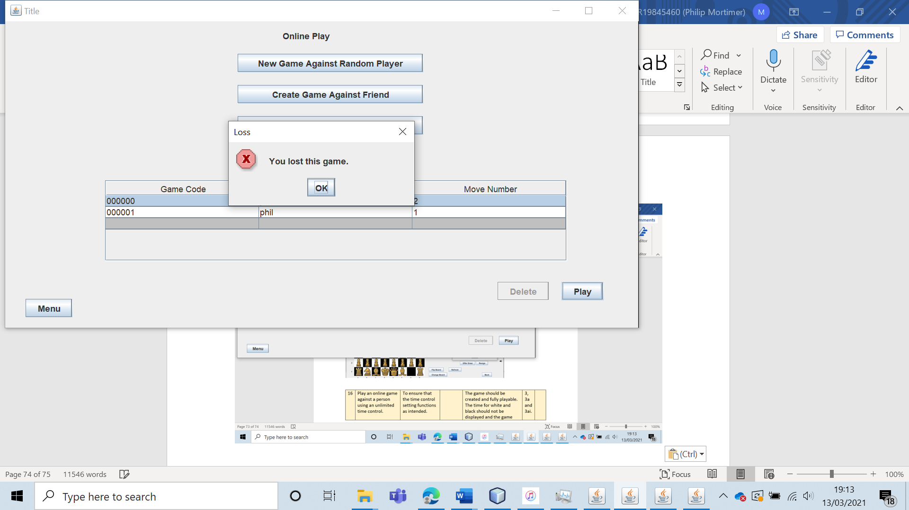

As with the five-minute time control, some small minor visual bugs occurred. Once the game was lost, it still appeared to be a playable menu. However, when clicking on the game, a message is displayed telling the user the game outcome. This is annoying but the system clearly communicates with the user what the game outcome was, leading to the bug being a minor annoyance but taking very little away from the user experience.

|  |  |  |  |  |  |  |
| --- | --- | --- | --- | --- | --- | --- |
| 16 | Play an online game against a person using an unlimited time control. | To ensure that the time control setting functions as intended. |  | The game should be created and fully playable. The time for white and black should not be displayed and the game should not terminate after ten minutes due to time. | 3, 3a and 3ai. | A game is created and the unlimited time control functions perfectly. |

Test 16

I created an online game as “phil” against “philip”.

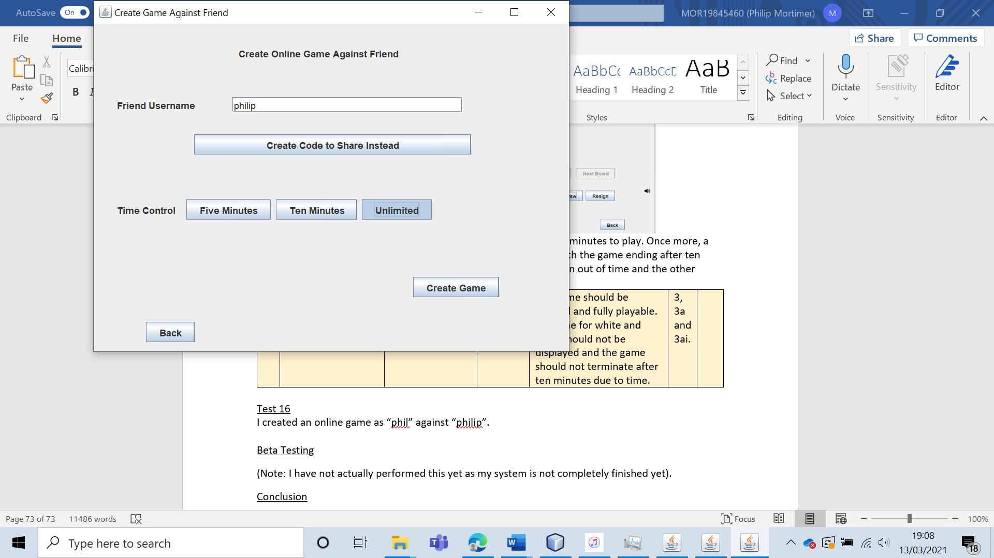

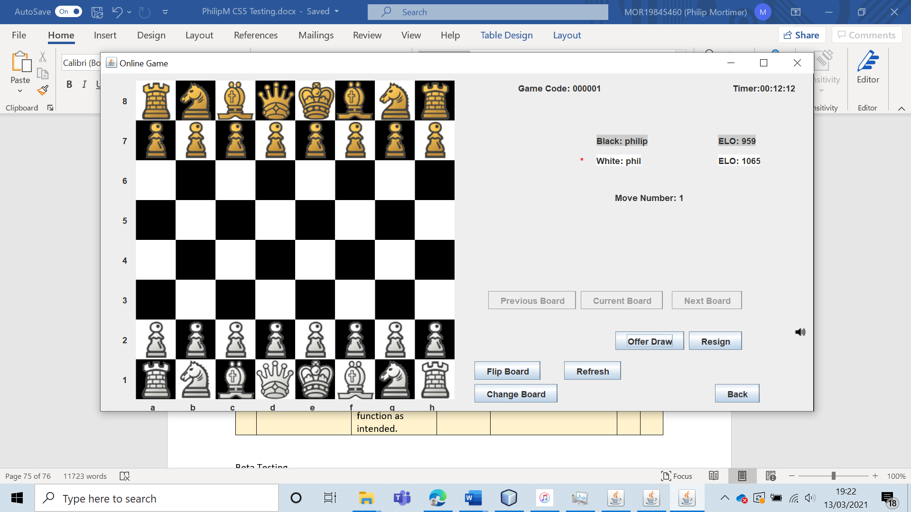

The game was successfully created and leads to a form where no timer is displayed for either user. (Although there is still a game timer). As expected, the game was a normal chess game with no time restrictions. I spent over ten minutes on one move and the game was no terminated, showing that unlimited time control functions as desired.

|  |  |  |  |  |  |  |
| --- | --- | --- | --- | --- | --- | --- |
| 17 | Attempt to create an online game against a user who is already playing three chess games. | To ensure that invalid chess games cannot be generated. This is important as the system is designed to only handle three online games being played by a user at any one time. If users were able to match with more than three players, the system would break and not function as intended. | The username of a player who is already playing three games. | The game should not be created, and the system should display a clear error message explaining why the game cannot be created. | 3 | The system provides specific error messages which explain that users can only play up to three online games at any one time. The system prevents any user from playing more than three online games at a time. |

Test 17

To test this, I will get the user “philip” to create a game against “phil”. However, “phil” is already playing three games. Therefore, the game should not be created.

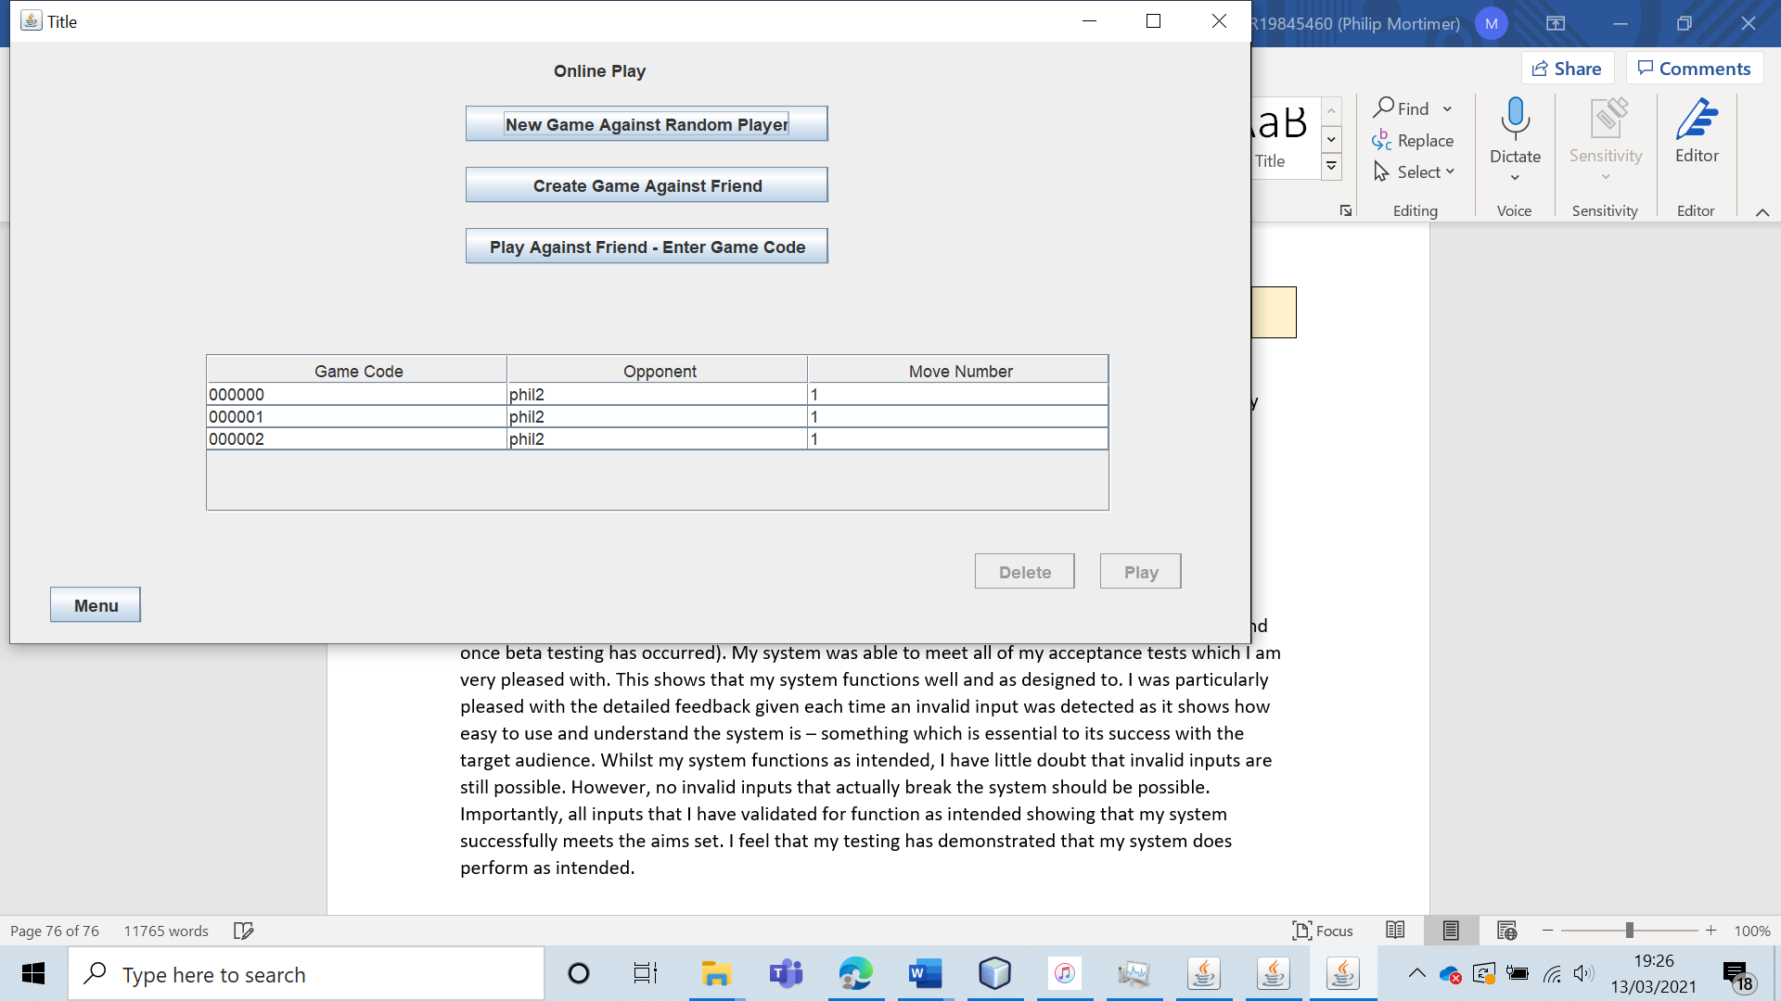 (“phil”’s games)

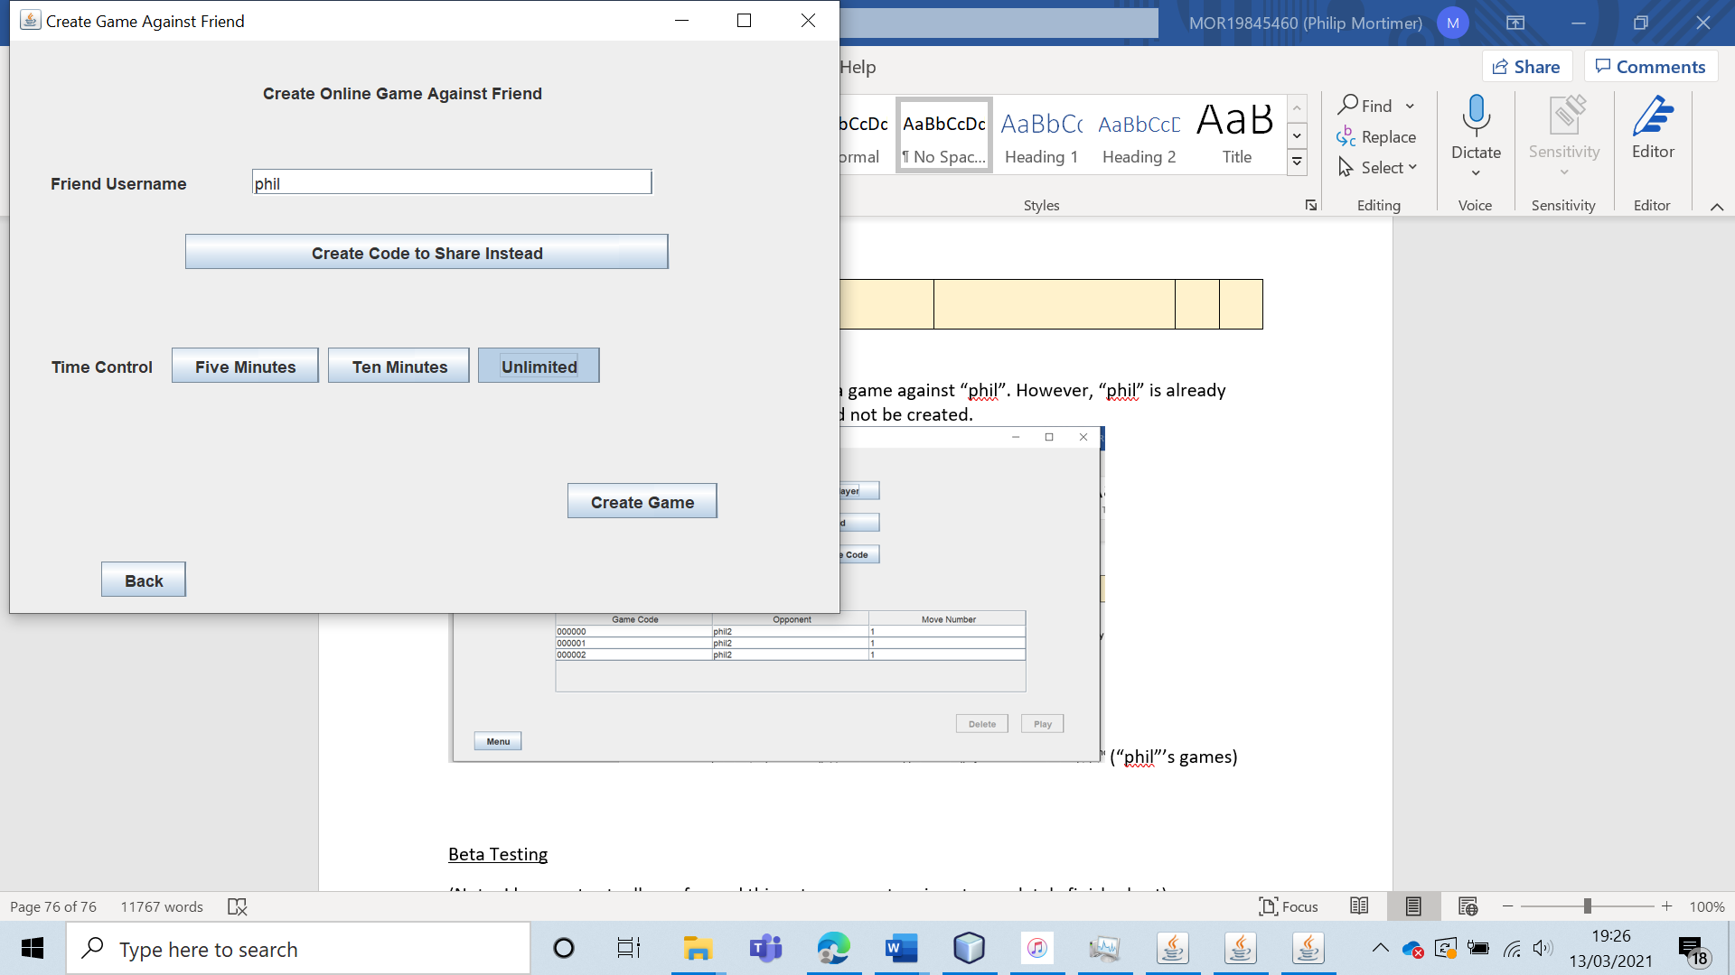

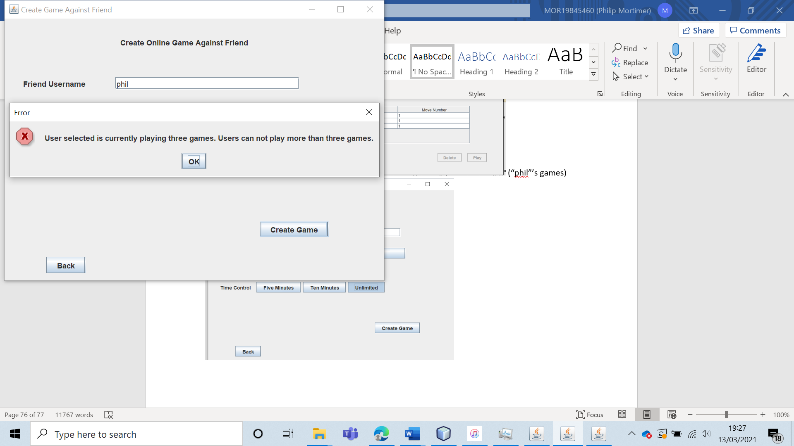

The game is not created, and the system explains that the game cannot be created because the user is already playing three games. This functions perfectly.

I will also check to ensure that “phil” (who is already playing three online games), cannot create or join any more games. To test this, I will press the buttons in the menu titled: “New Game Against Random Player”, “Create Game Against Friend” and “Play Against Friend – Enter Game Code”.

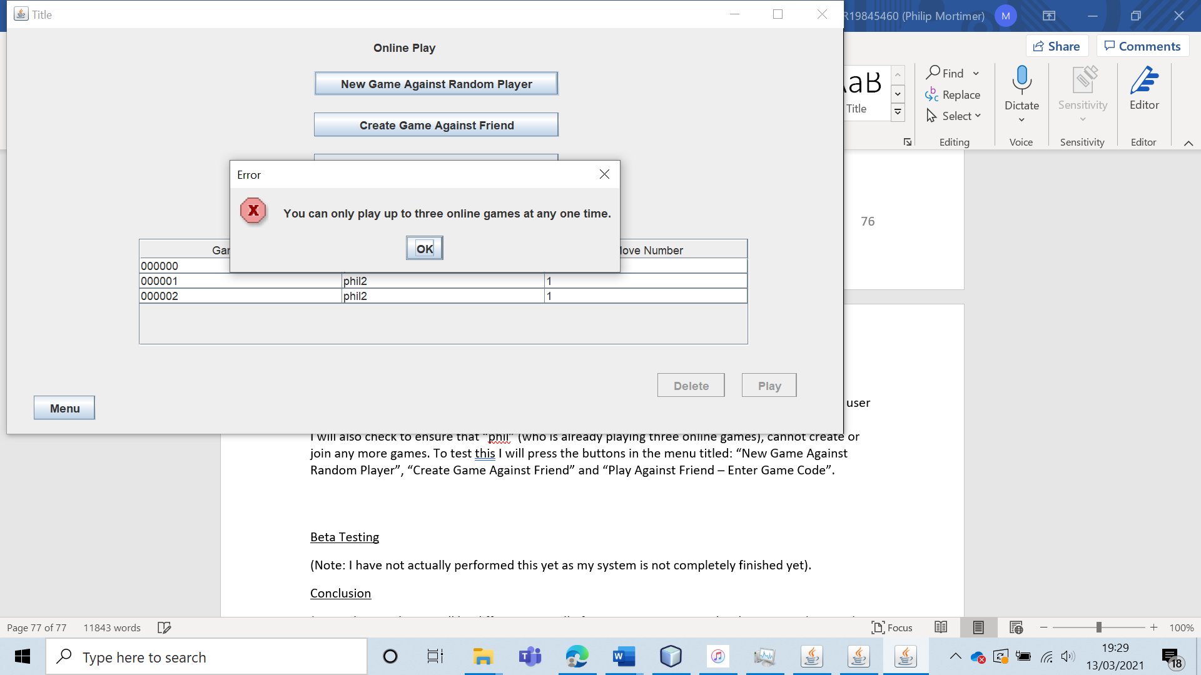

As expected, the system displays that the user can only play three online games at a time and hence prevents the user from creating or joining the games.

|  |  |  |  |  |  |  |
| --- | --- | --- | --- | --- | --- | --- |
| 18 | Play an online game by entering a game code given by another user. | To verify that the system of sharing game codes allows users to play online games with their friends. | The game code of the game. | The user should join the game and play a chess game together. | 3, 3a and 3ai. | A valid game is created, and this code is then used to join the game. The game is fully playable. |

Test 18

To test this, I created a game code to share using the account called “phil”.

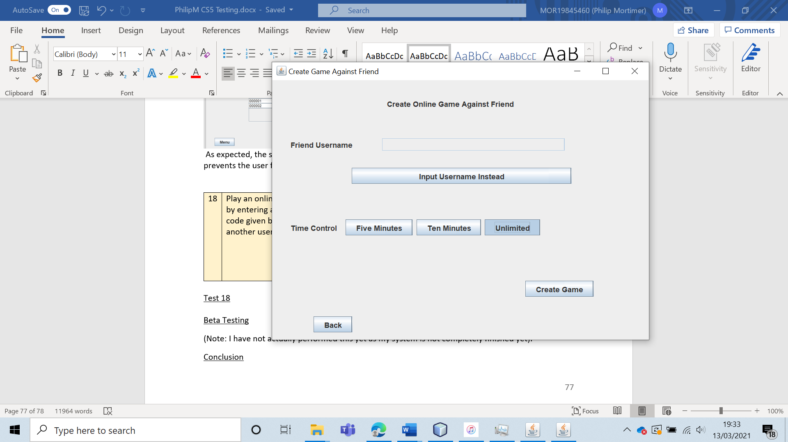

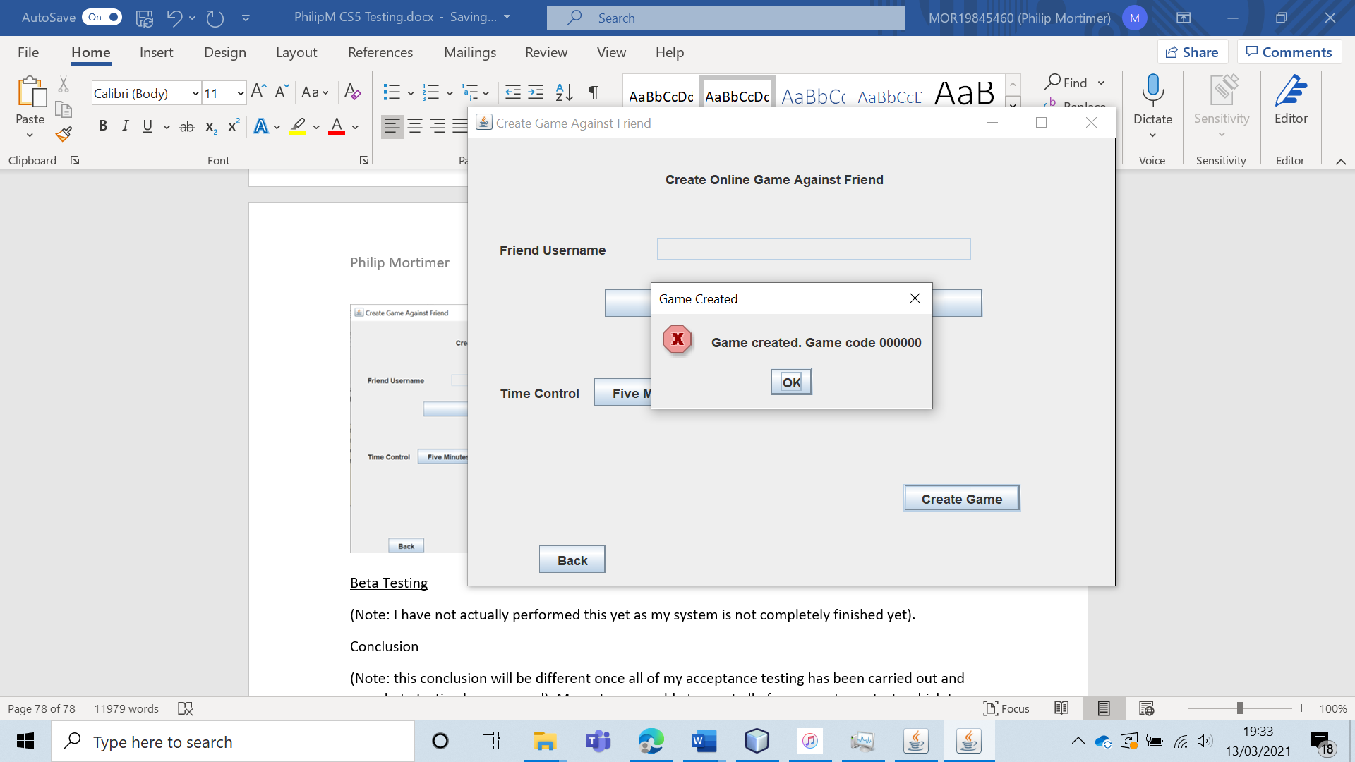

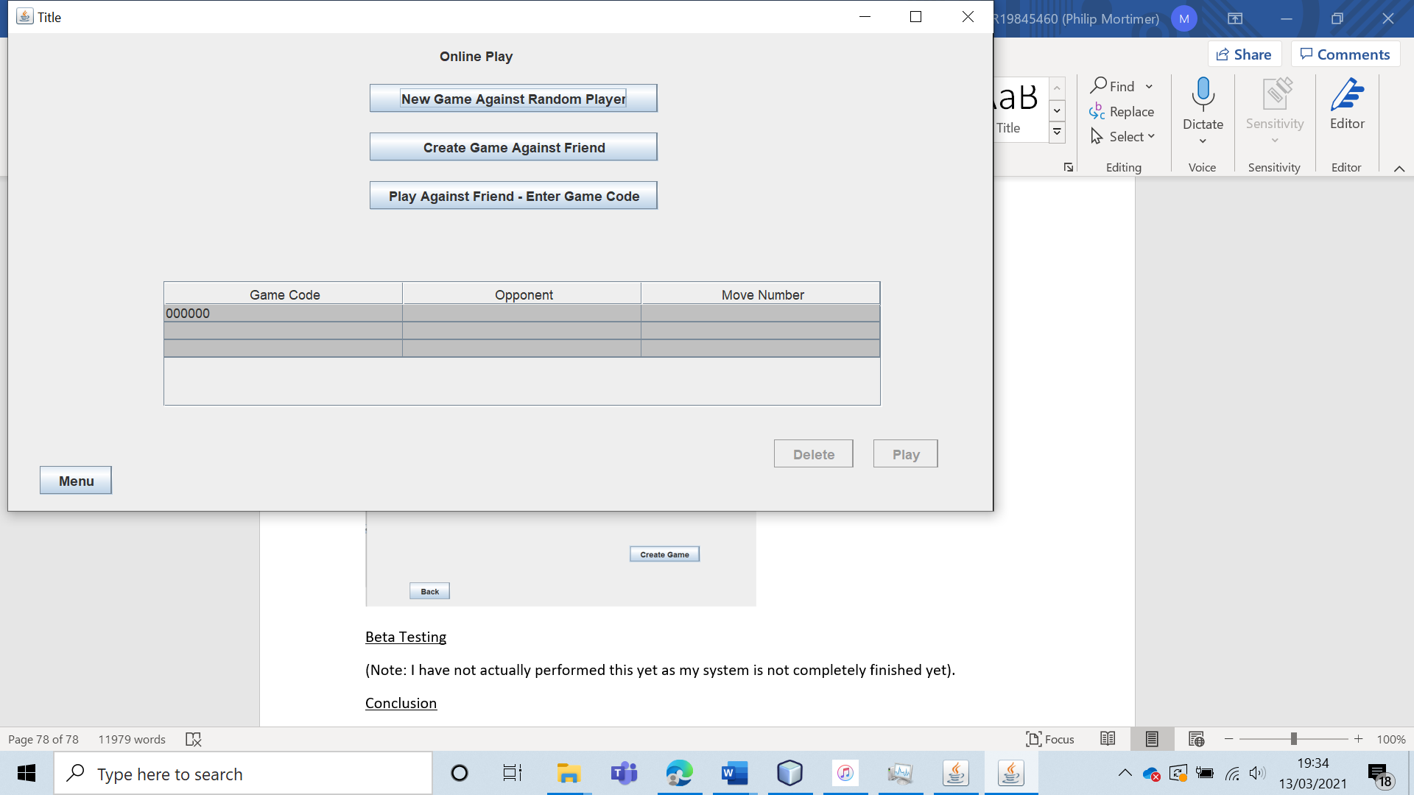

The game was created, with the game code “000000”.

I tried to join this game from the “philip” account.

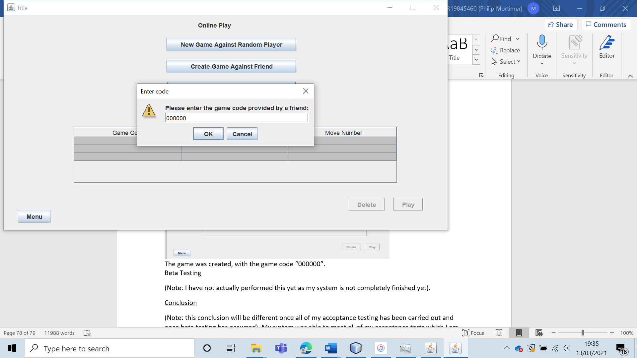

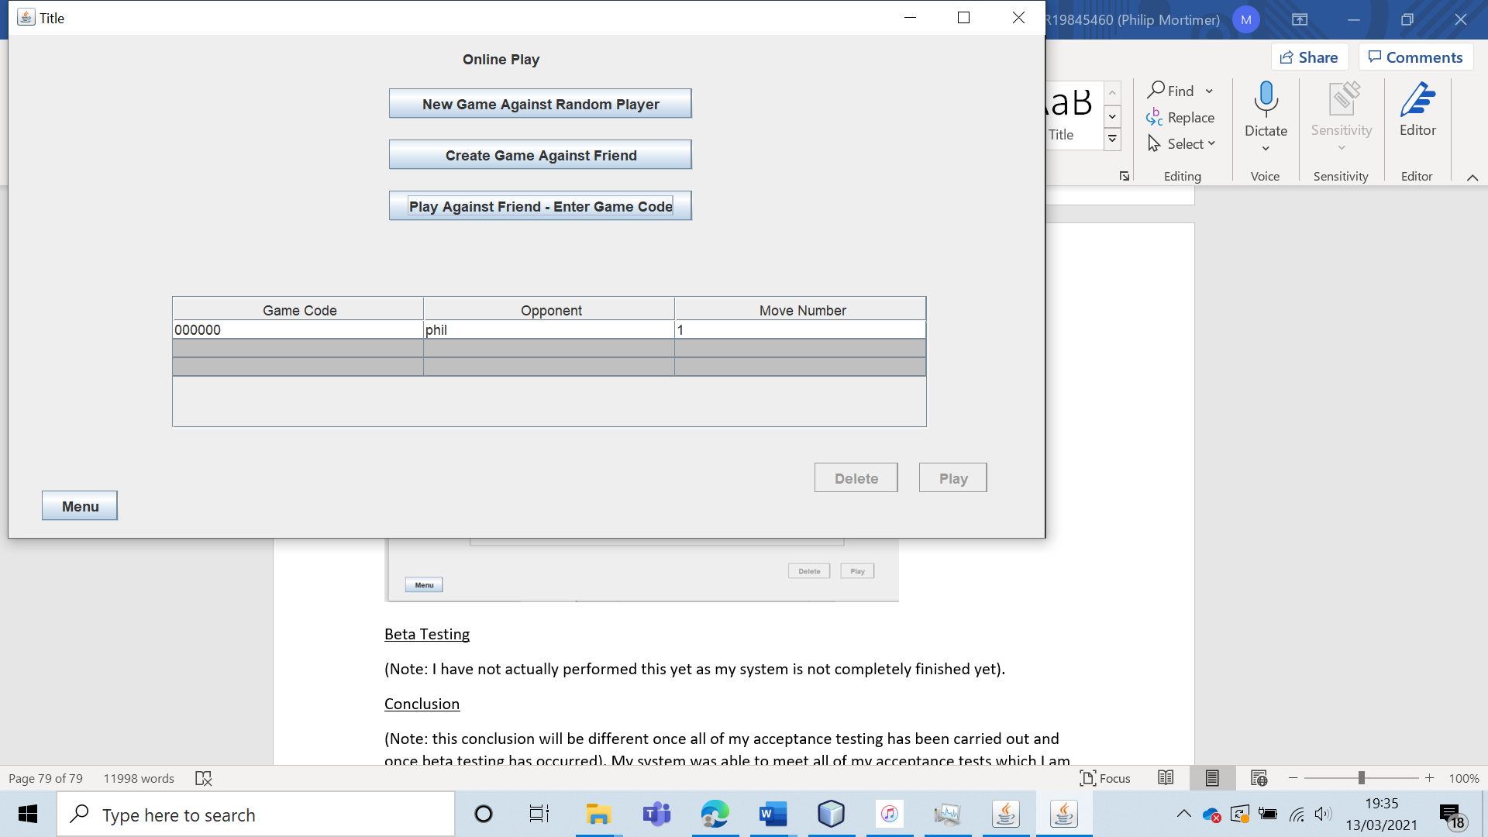

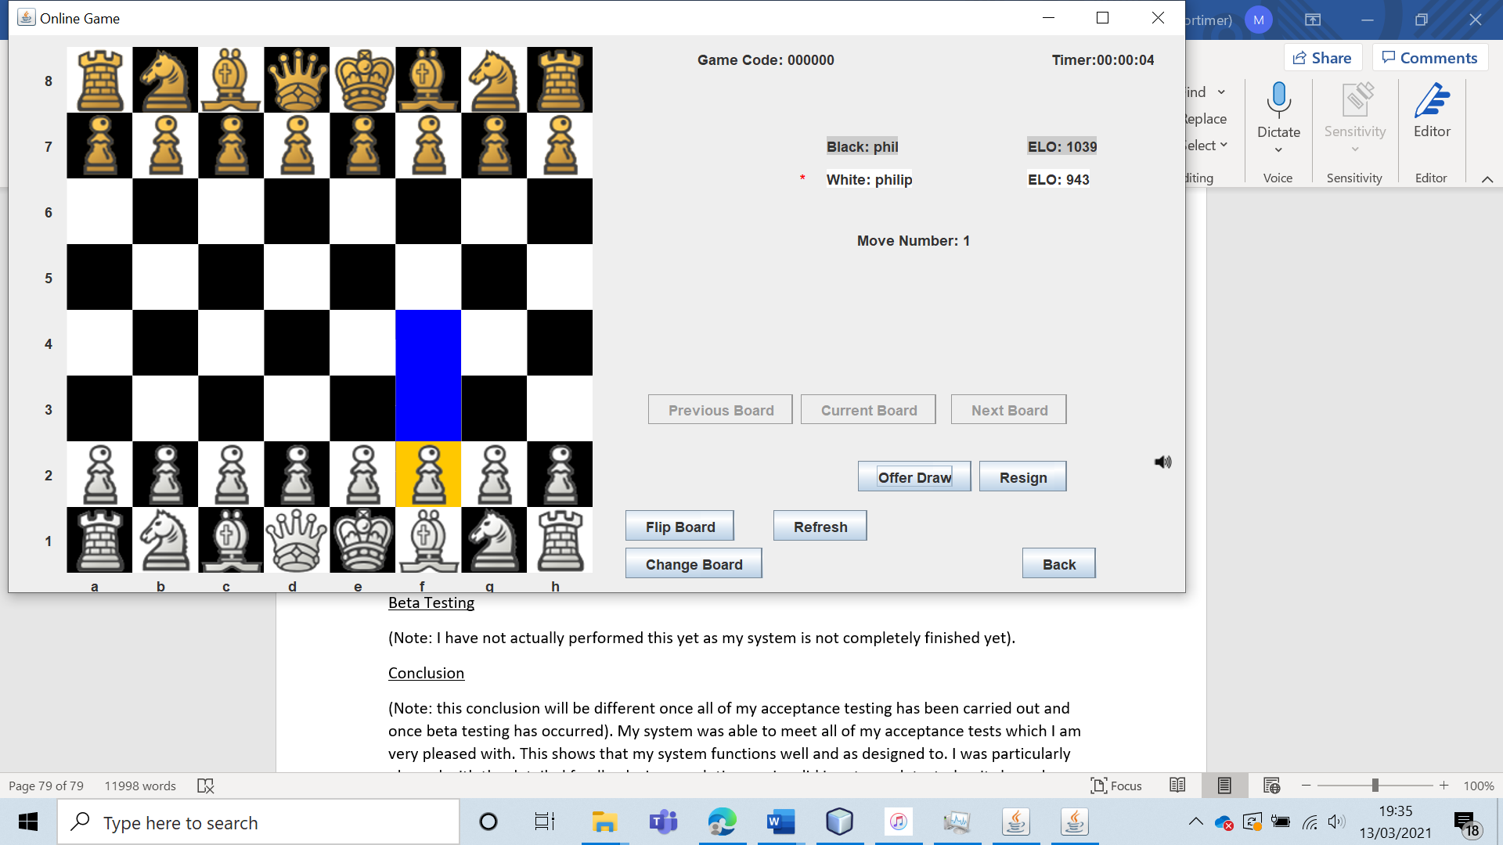

The game was then created and fully playable for both users, showing that the system passed the test.

Equally so, when using an invalid code, the game was not joined, and a clear error message was displayed.

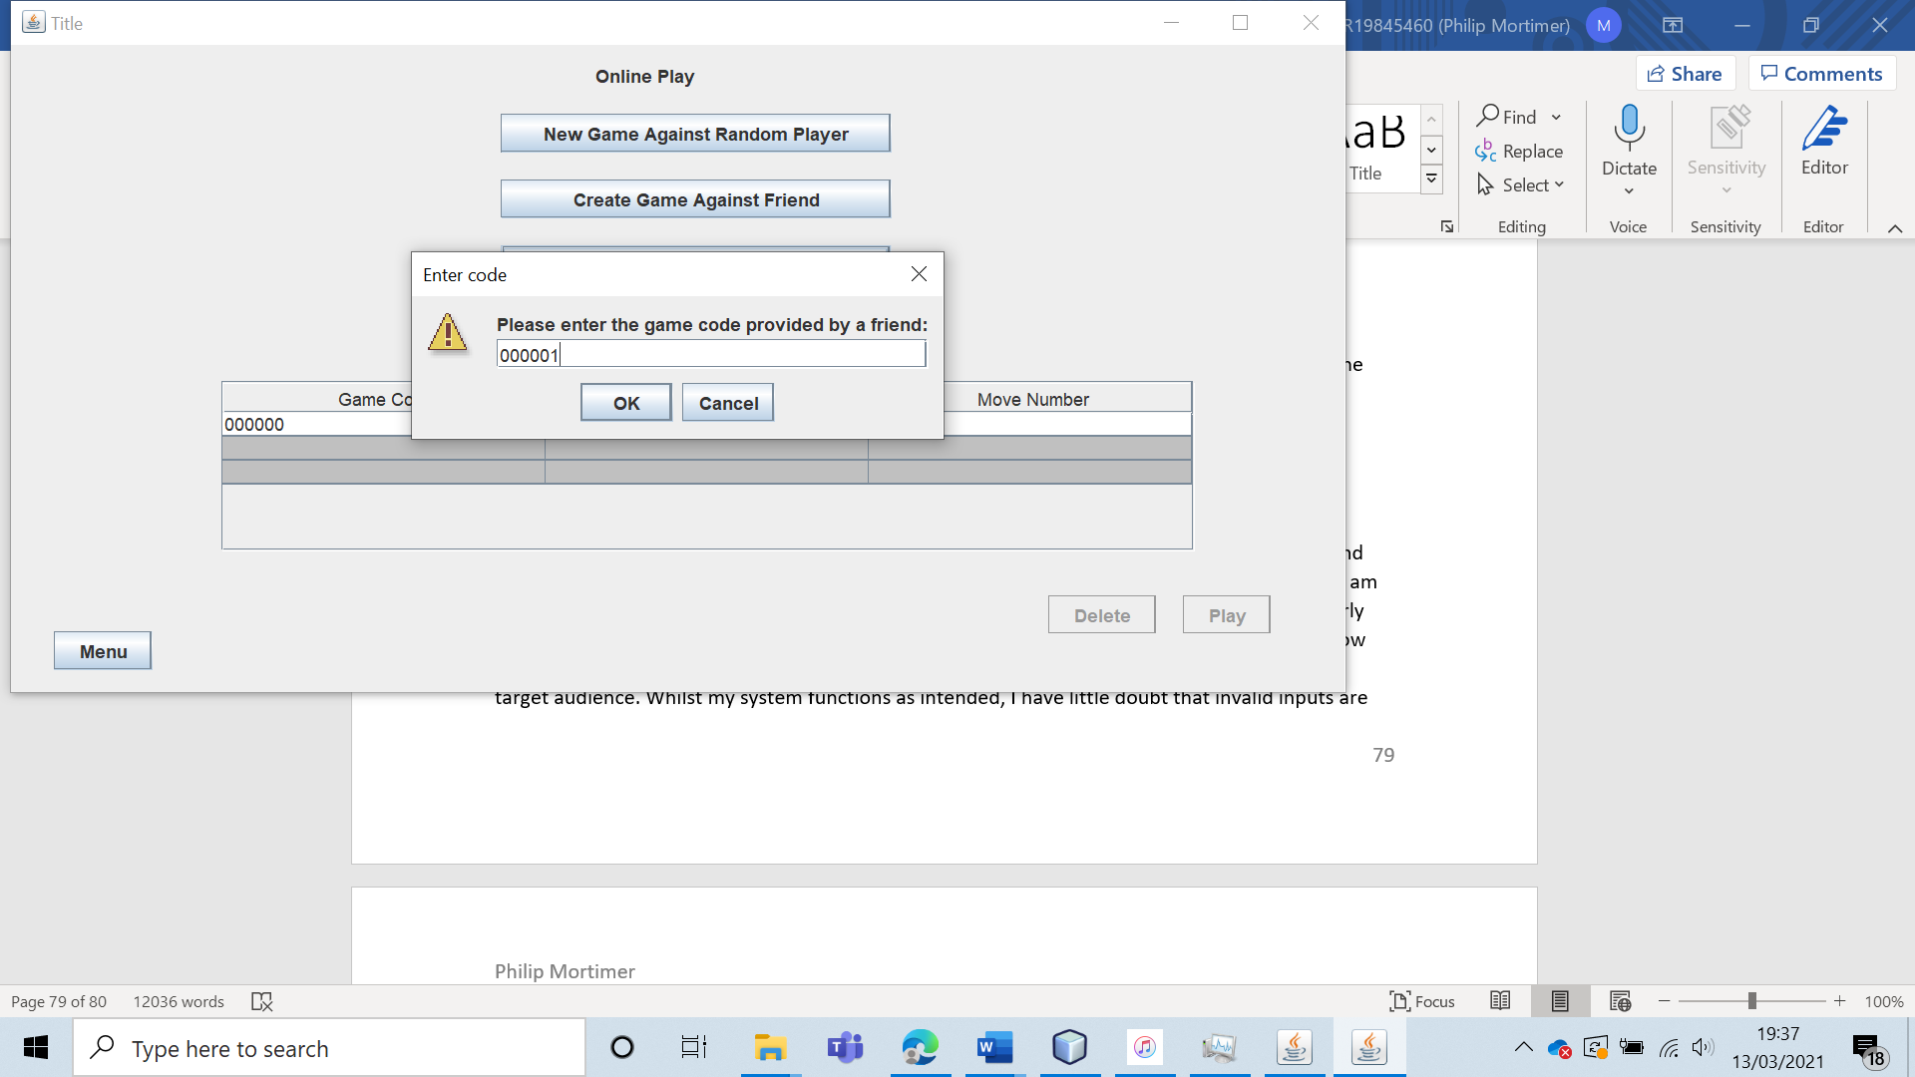

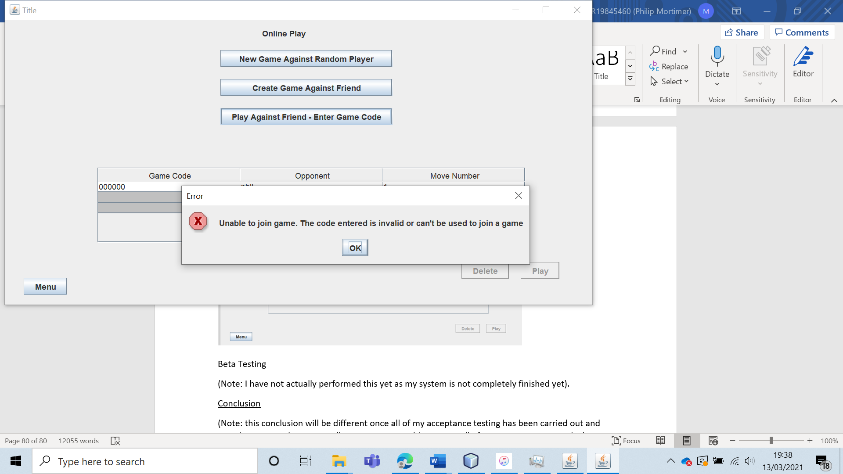

|  |  |  |  |  |  |  |
| --- | --- | --- | --- | --- | --- | --- |
| 19 | Create and play a game against a random opponent. | To verify that online games can both be created and accepted. |  | If no random online requests exist, a new one should be displayed. If one does exist, this game should be joined, and the two players will start a chess game. | 3b and 3bi. | Both joining and creating a game against a random opponent work perfectly and lead to a fully playable online chess match. |

Test 19

To do this, I will attempt to create a random game with the user “phil”. I will then attempt to join this game using the user “philip”. Both of these actions are done by pressing “New Game Against Random Player”.

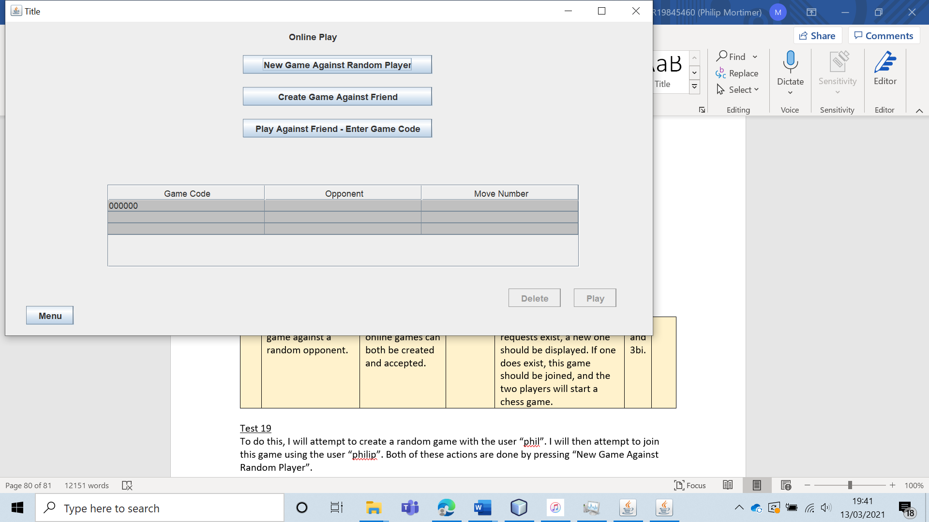

The game is successfully created by “phil”. The game is not yet playable as no one has also requested to play a game against a random player. “philip” will now do that.

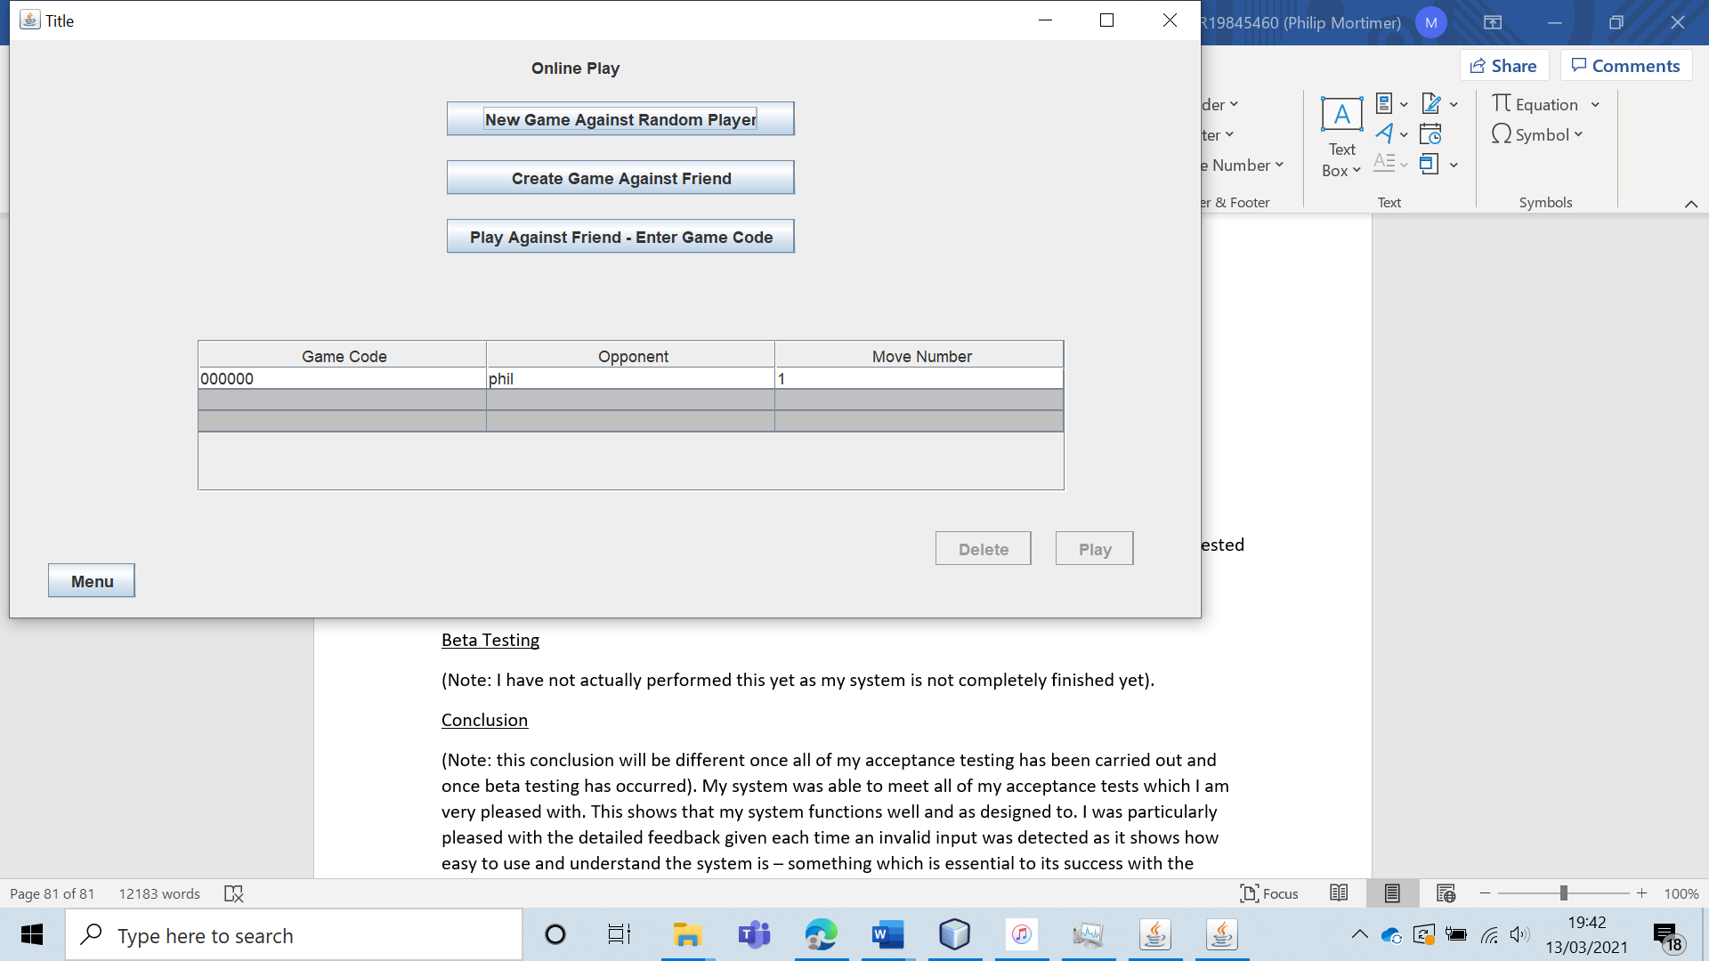

When “philip” presses the button, the game becomes playable and both users can now play an online chess game (as intended).

|  |  |  |  |  |  |  |
| --- | --- | --- | --- | --- | --- | --- |
| 20 | Offer a draw to an opponent and have them accept the offer (in an online game). | To verify that online chess functions as intended. |  | The user should be able to offer a draw. The opponent will be able to accept or decline this offer. If they accept the offer, the game will end and be marked as a draw. | 3 | The draw feature works perfectly, with users being able to offer and withdraw draw offers. The opponent can then choose to accept or decline this offer. If they accept, the game is deleted and both users are told that the game was drawn. |

Test 20

To do this, I will have user “phil” play against user “philip”.

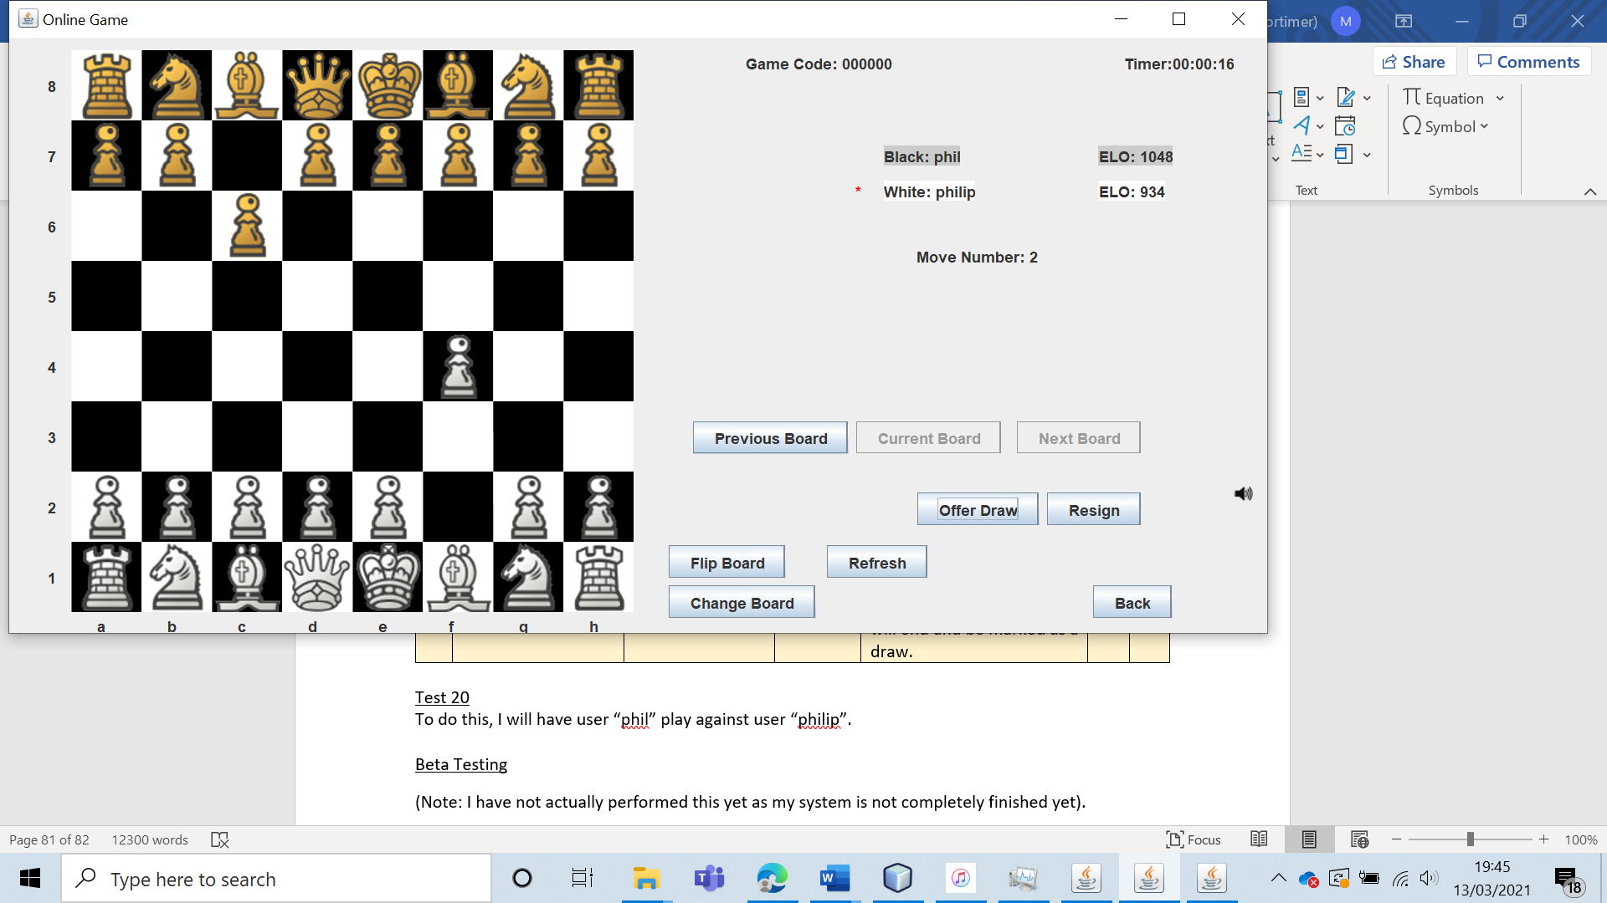

I will have “philip” offer a draw to “phil”.

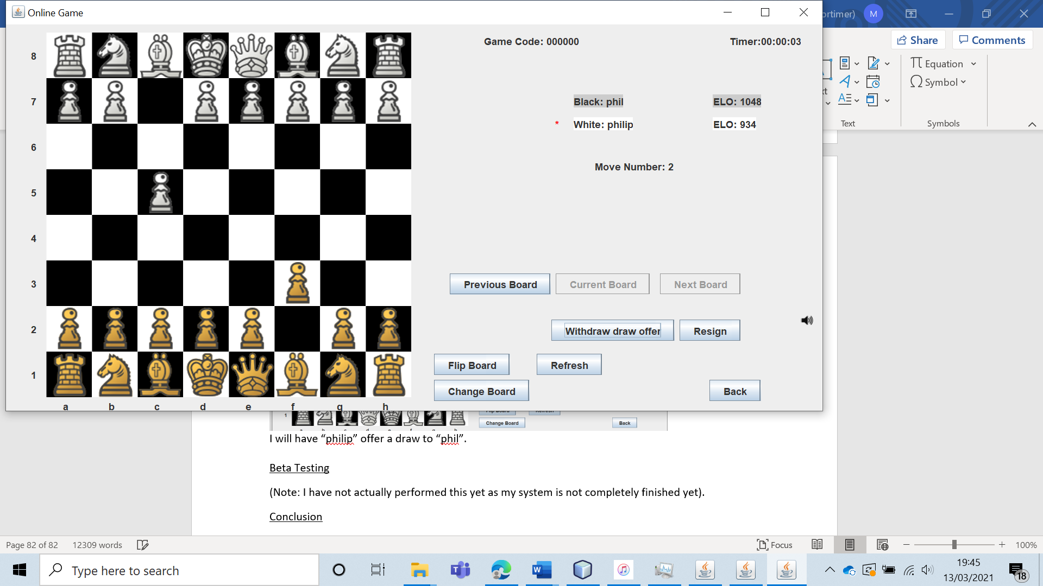

The draw offer is received, and the offer is presented to withdraw the draw offer.

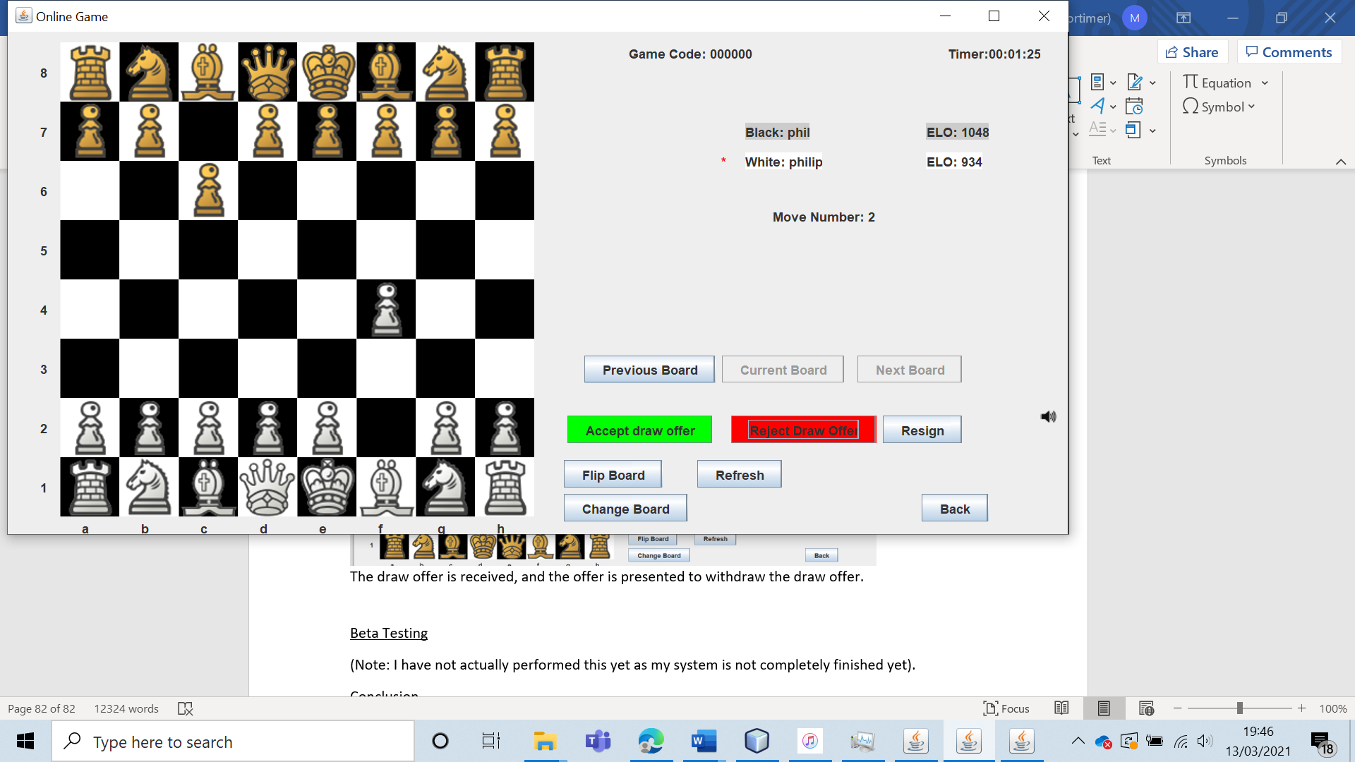

If “phil” accepts the offer, the game is deleted and both users are told the game was a draw.

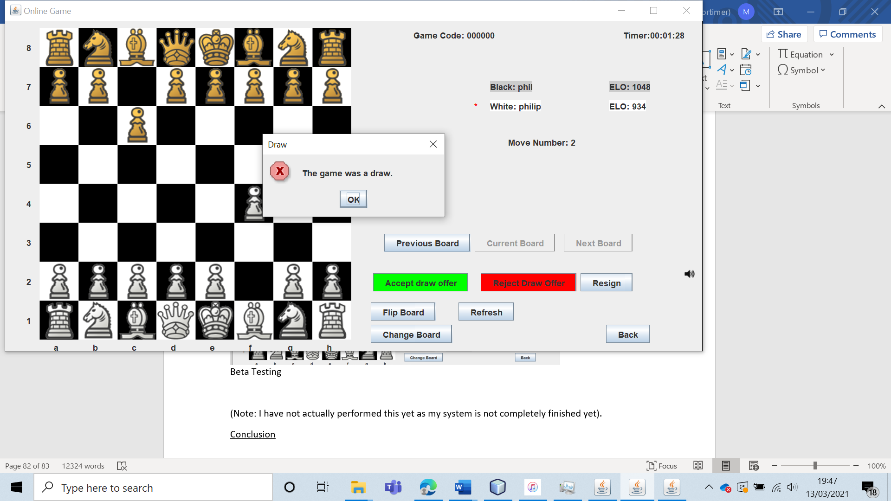

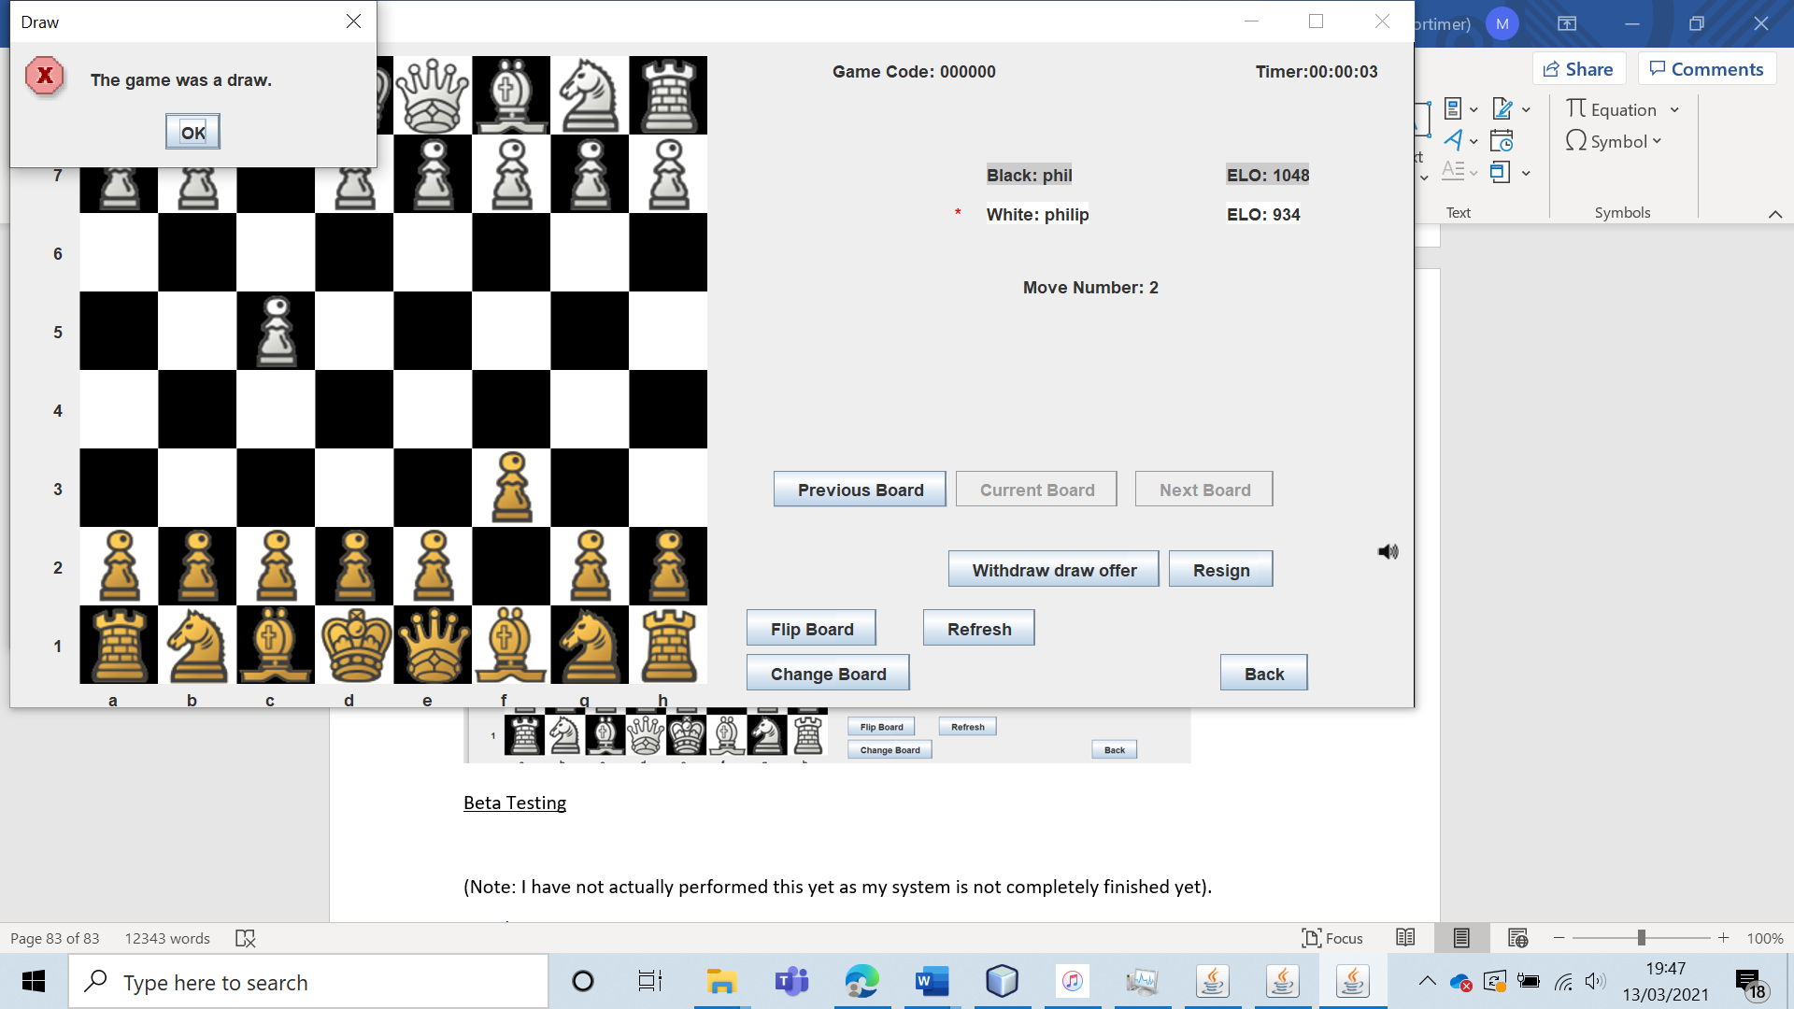

This draw feature works perfectly, and no visual bugs occurred (suggesting that the small visual bugs encountered earlier where due to how the timer was being handled).

|  |  |  |  |  |  |  |
| --- | --- | --- | --- | --- | --- | --- |
| 21 | Resign in an online game. | To verify that online chess functions as intended. |  | The user should be able to resign. Both users will be notified of the game outcome and taken back to a menu. | 3 | The user resigns and the correct game results is displayed to both users. |

Test 21

To test this, I had user “phil” play against “philip”.

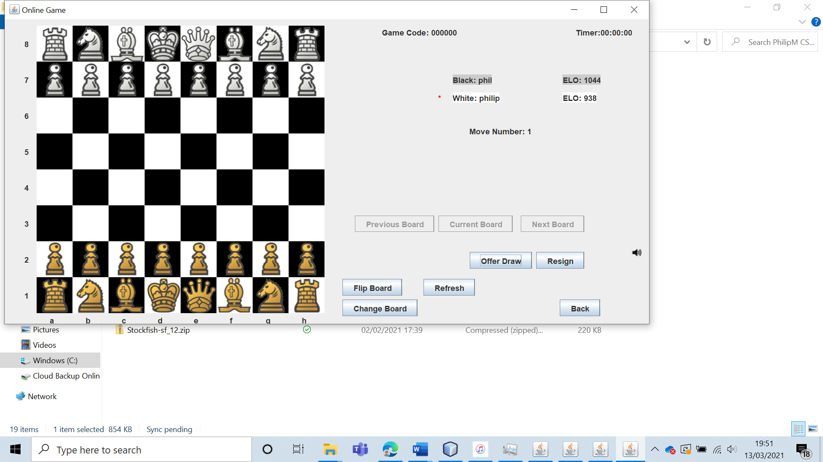

“phil” then resigned. After confirming that he did wish to resign, both users were told the game outcome correctly.

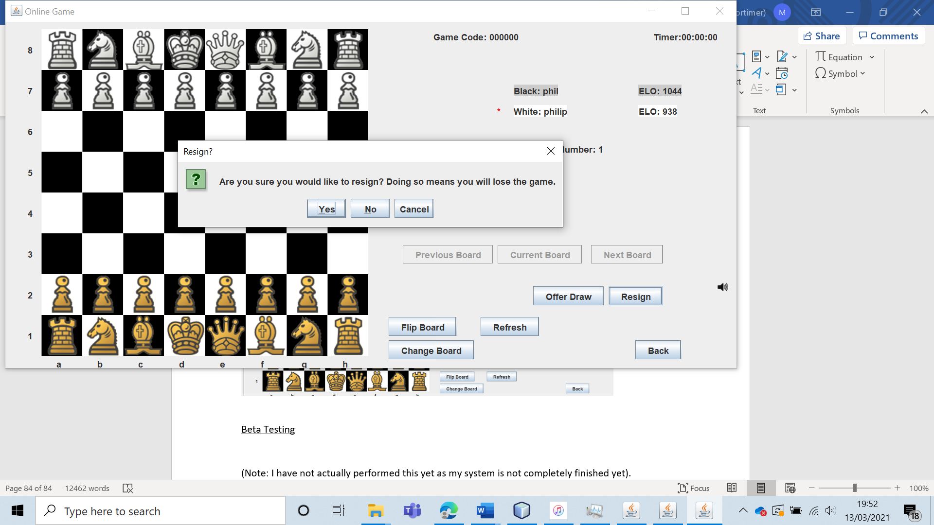

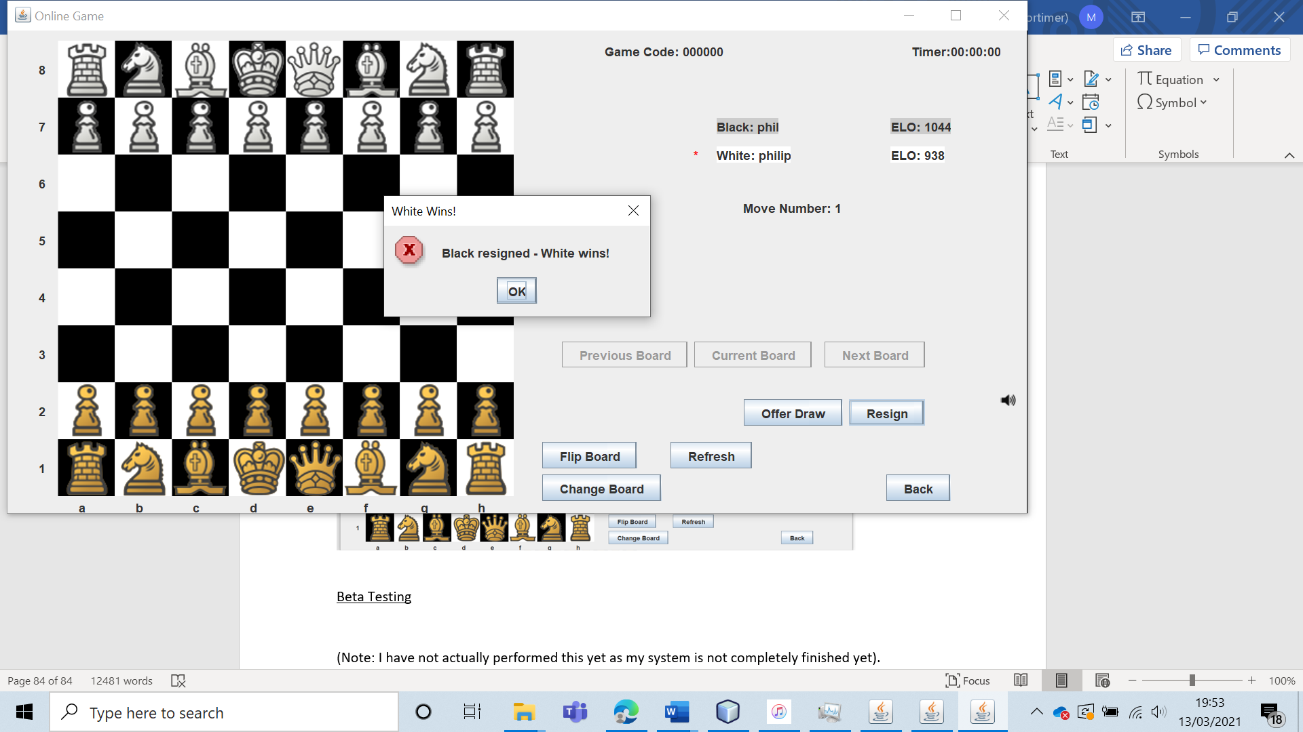

Hence, the ability to resign clearly functions as designed.

|  |  |  |  |  |  |  |
| --- | --- | --- | --- | --- | --- | --- |
| 22 | Play and end an online game by checkmate or stalemate. | To verify that online chess functions as intended. |  | The game of chess should play exactly the same as offline chess and meet all of the rules of chess. | 3 | The system handles all natural terminal board states and displays the appropriate game result to both users. |

Test 22

I played a game against two users and performed checkmate.

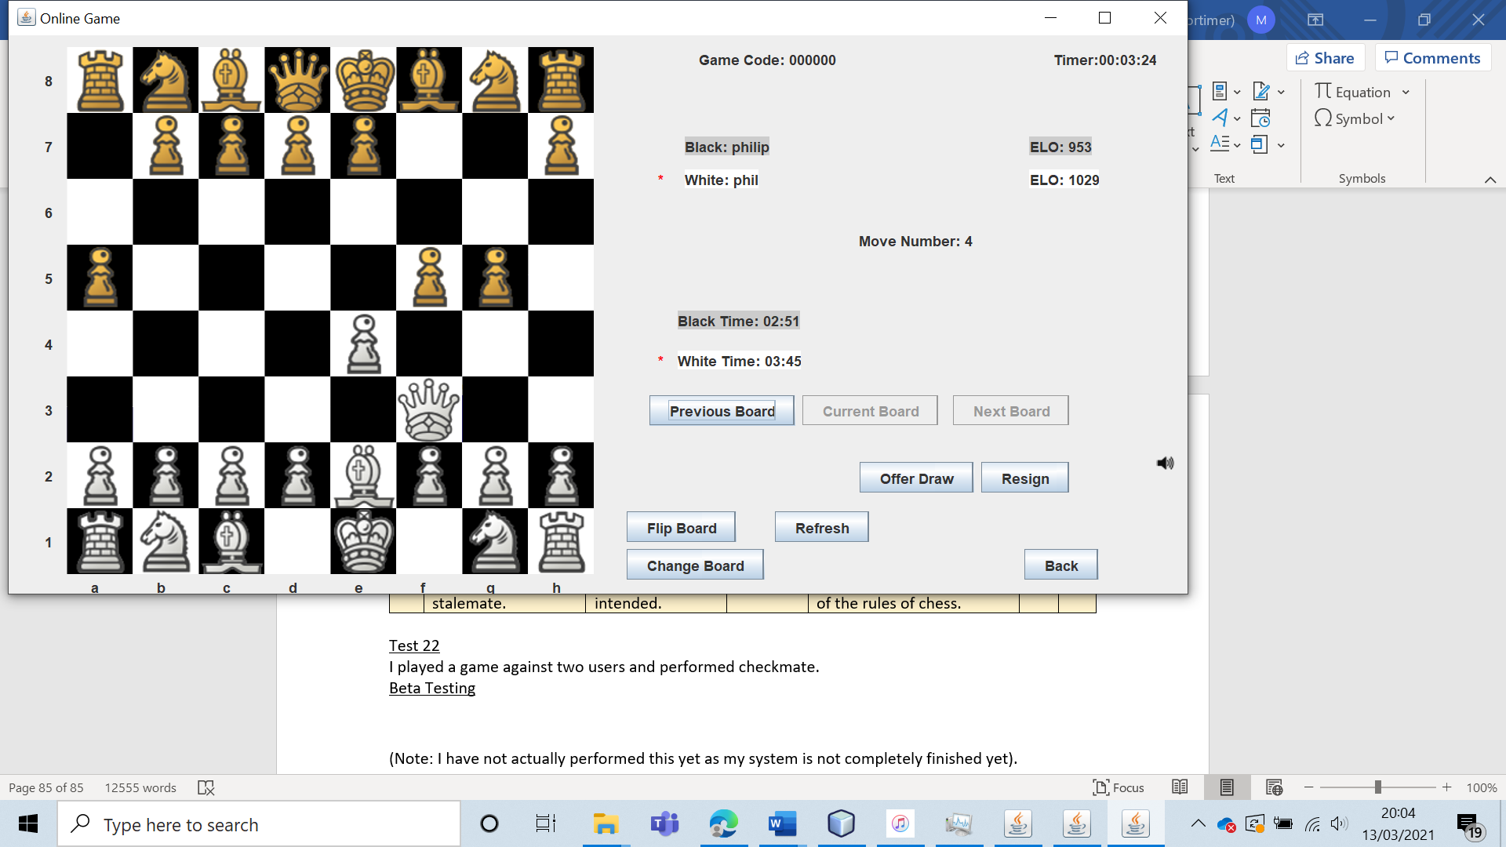

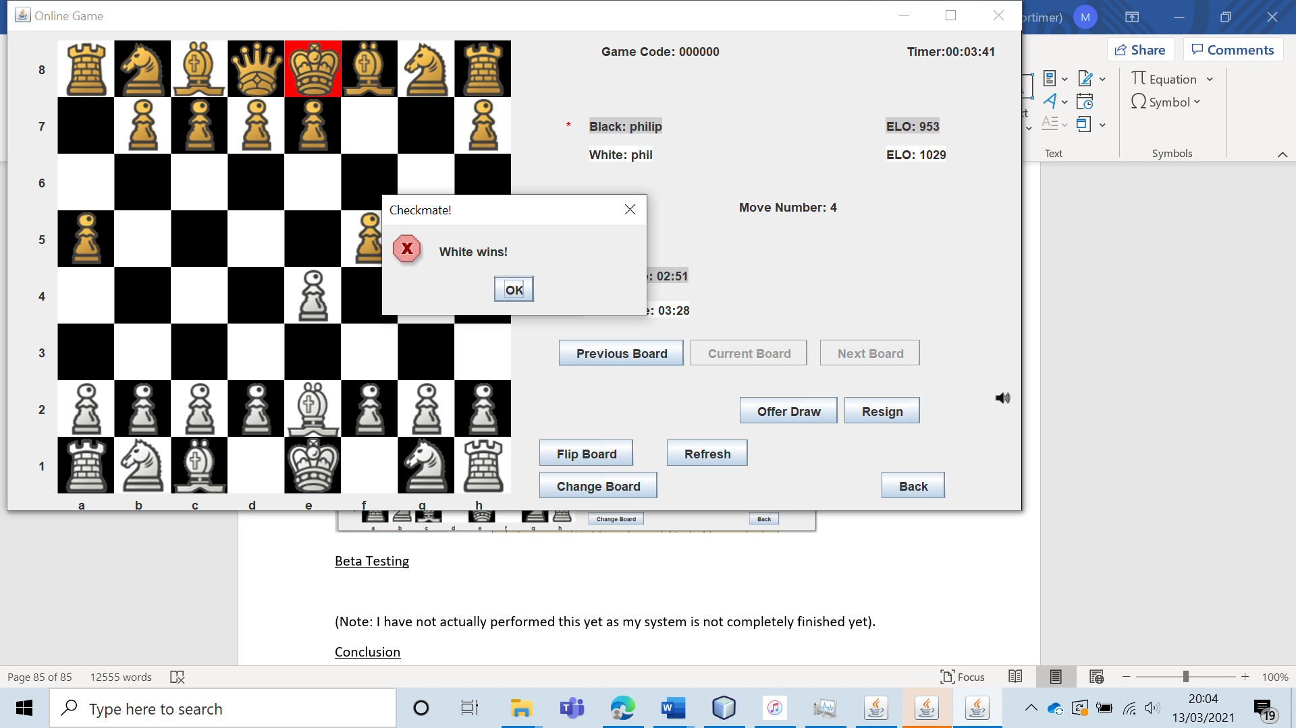

As expected, both users receive a message displaying the game outcome and the game is deleted from the online games file.

I also played fifty moves from both sides without any captures or pawns advancing (to draw the game of chess under the fifty-move rule).

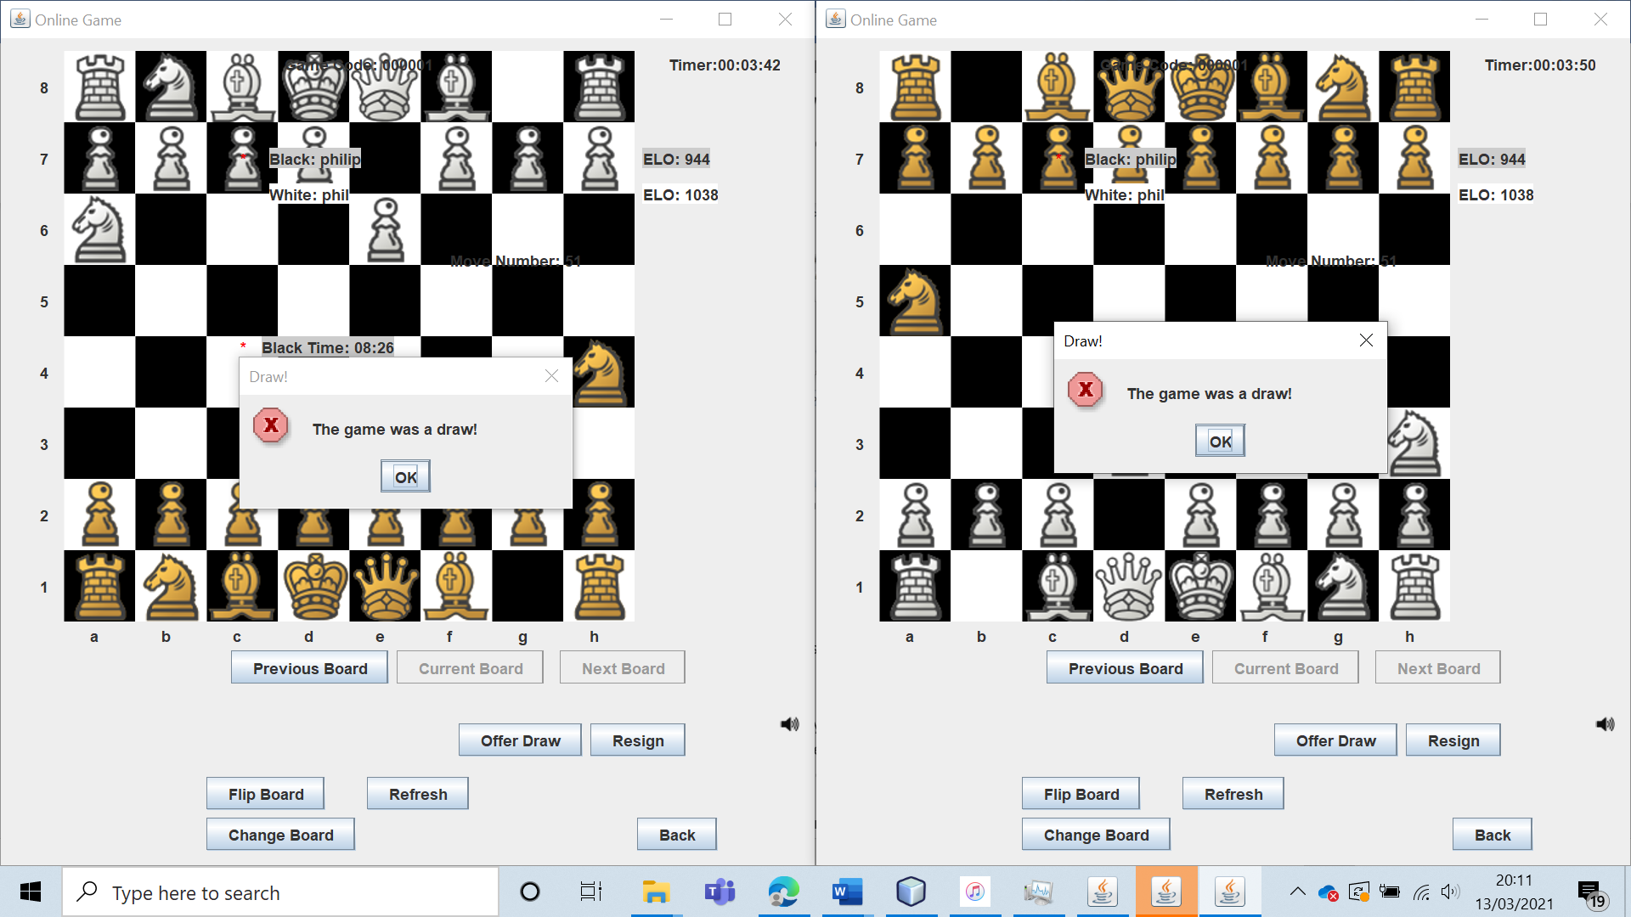

As expected, the game was deleted and both users were told that the game was drawn.

Hence, my system performs exactly as expected.

|  |  |  |  |  |  |  |
| --- | --- | --- | --- | --- | --- | --- |
| 23 | Attempt to create and play three offline chess games over multiple sessions | To verify that users can play three offline games simultaneously, over multiple play sessions. |  | The three chess games should be created. These games should be playable regardless of whether the user closes and restarts the application. | 4a and 4ai. | I was able to create three offline chess games and play them over multiple sessions. |

Test 23

I created three offline chess games as a guest.

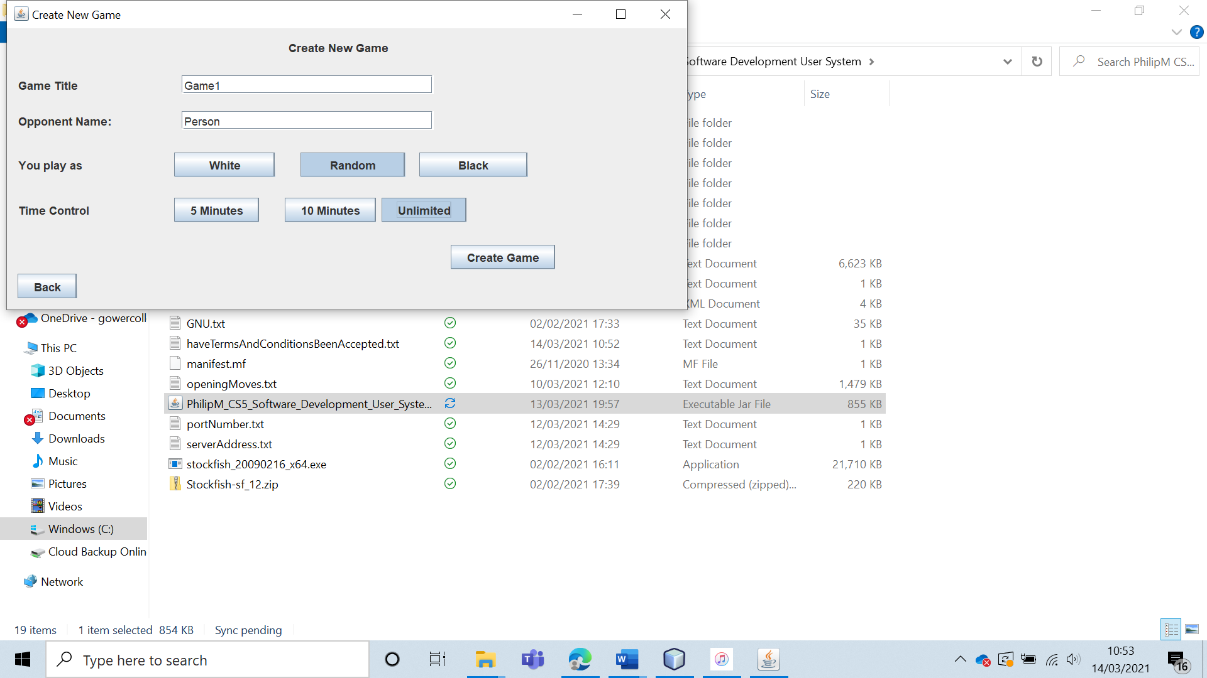

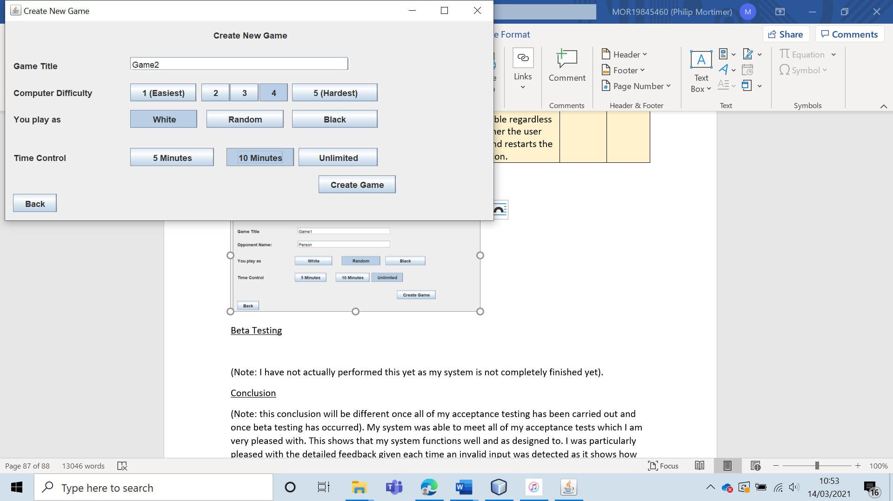

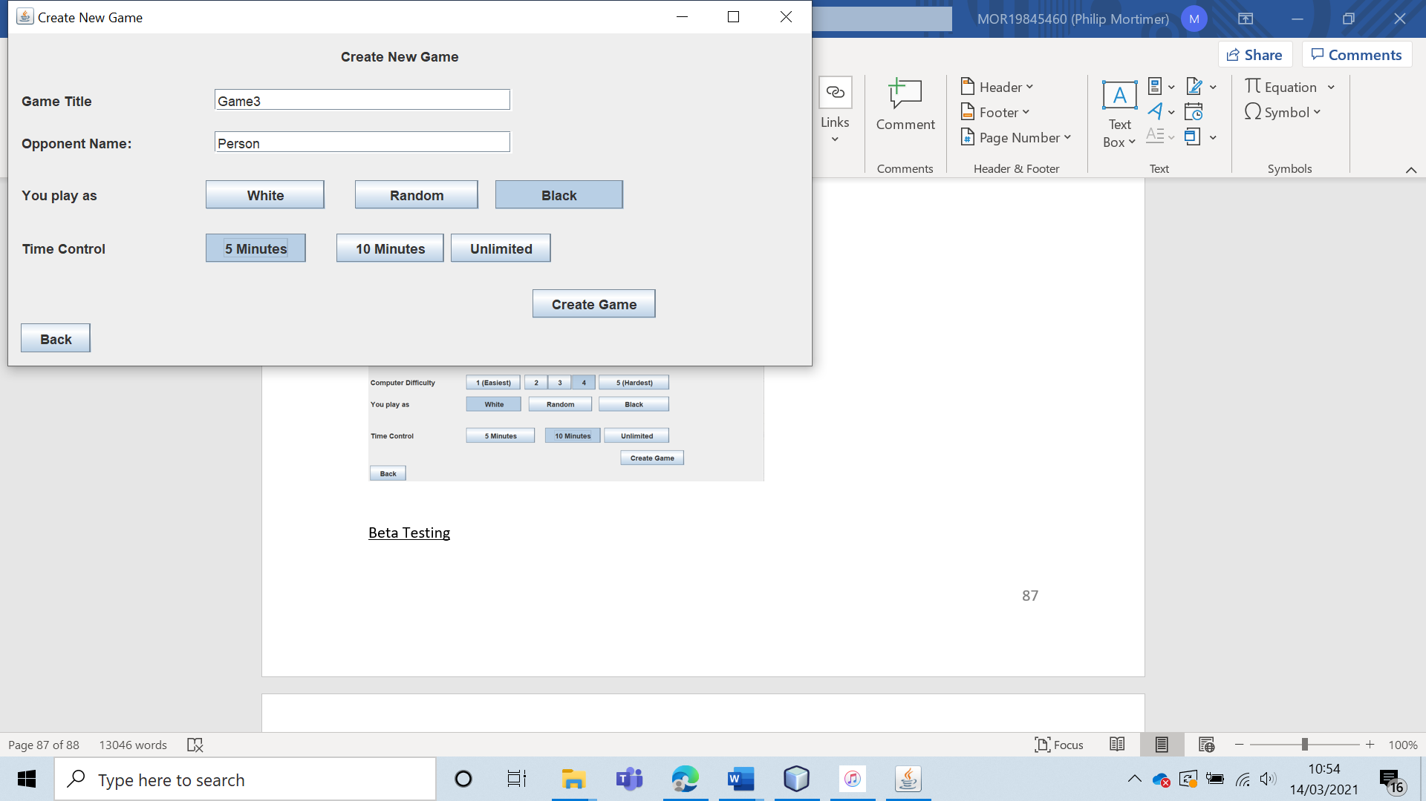

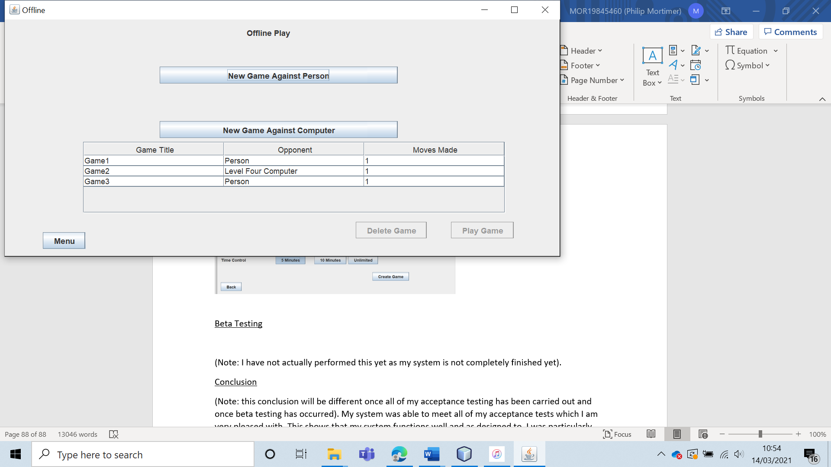

All of the games were created and playable over multiple sessions.

|  |  |  |  |  |  |  |
| --- | --- | --- | --- | --- | --- | --- |
| 24 | Play an offline chess game against a human opponent | To check that person versus person play is supported and works as intended. |  | The chess game should be created and playable by the two people. | 4 | The offline chess game was created successfully and playable. |

Test 24

I created an offline chess game against a human opponent.

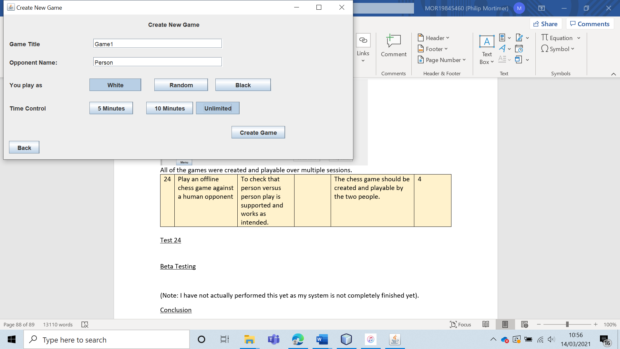

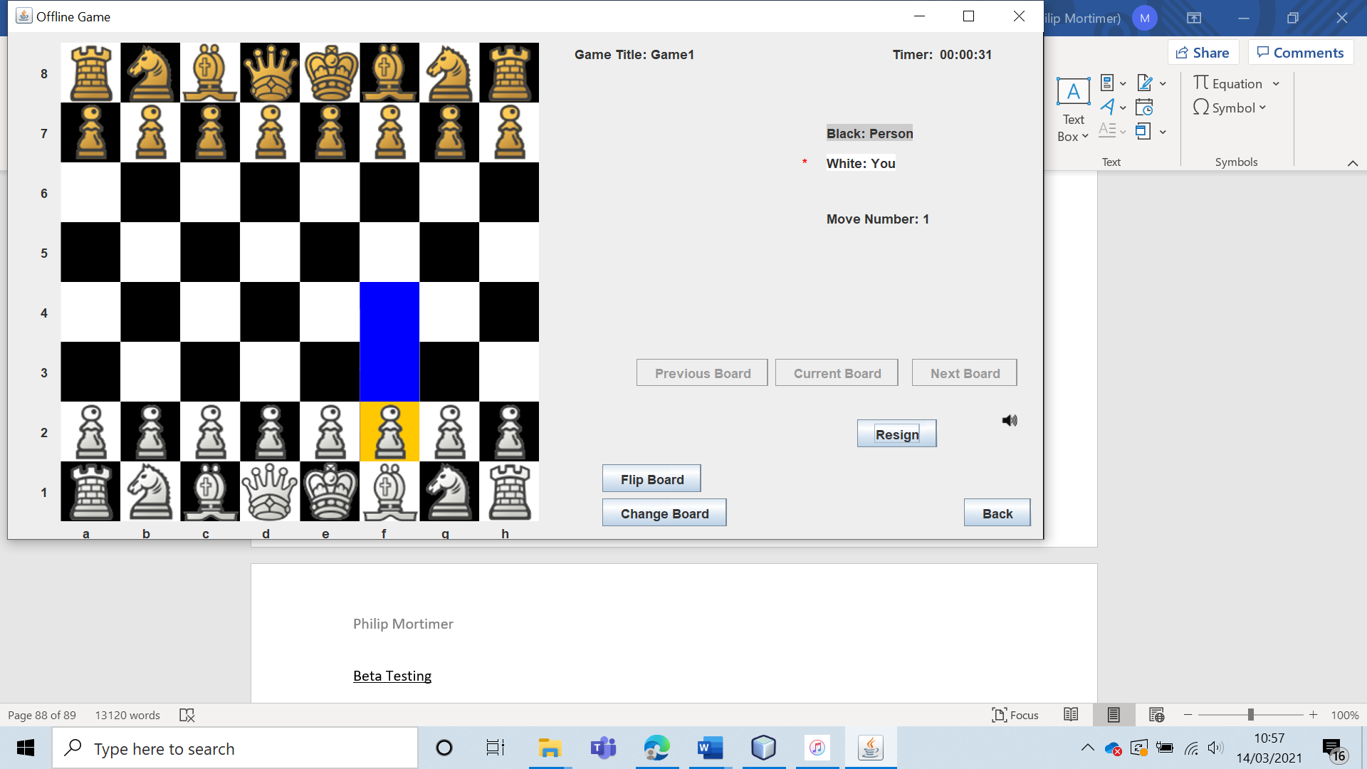

The game was fully playable and functioned exactly as expected, with both colour able to make moves using mouse inputs.

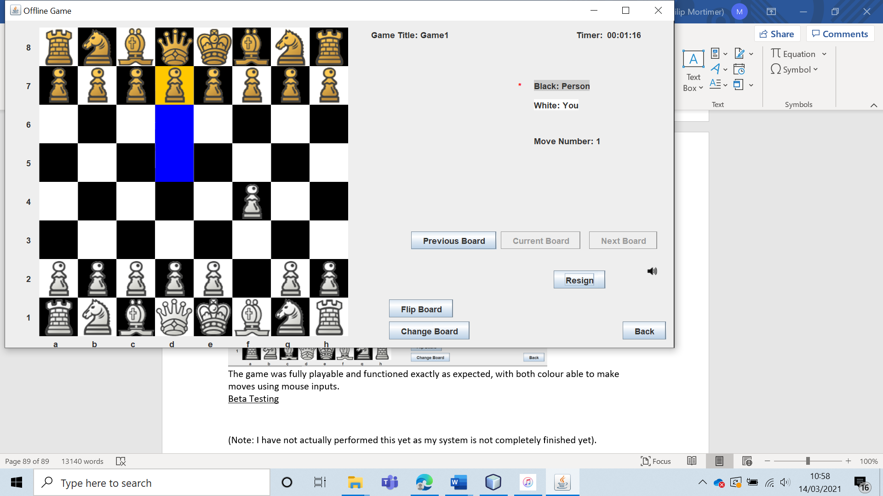

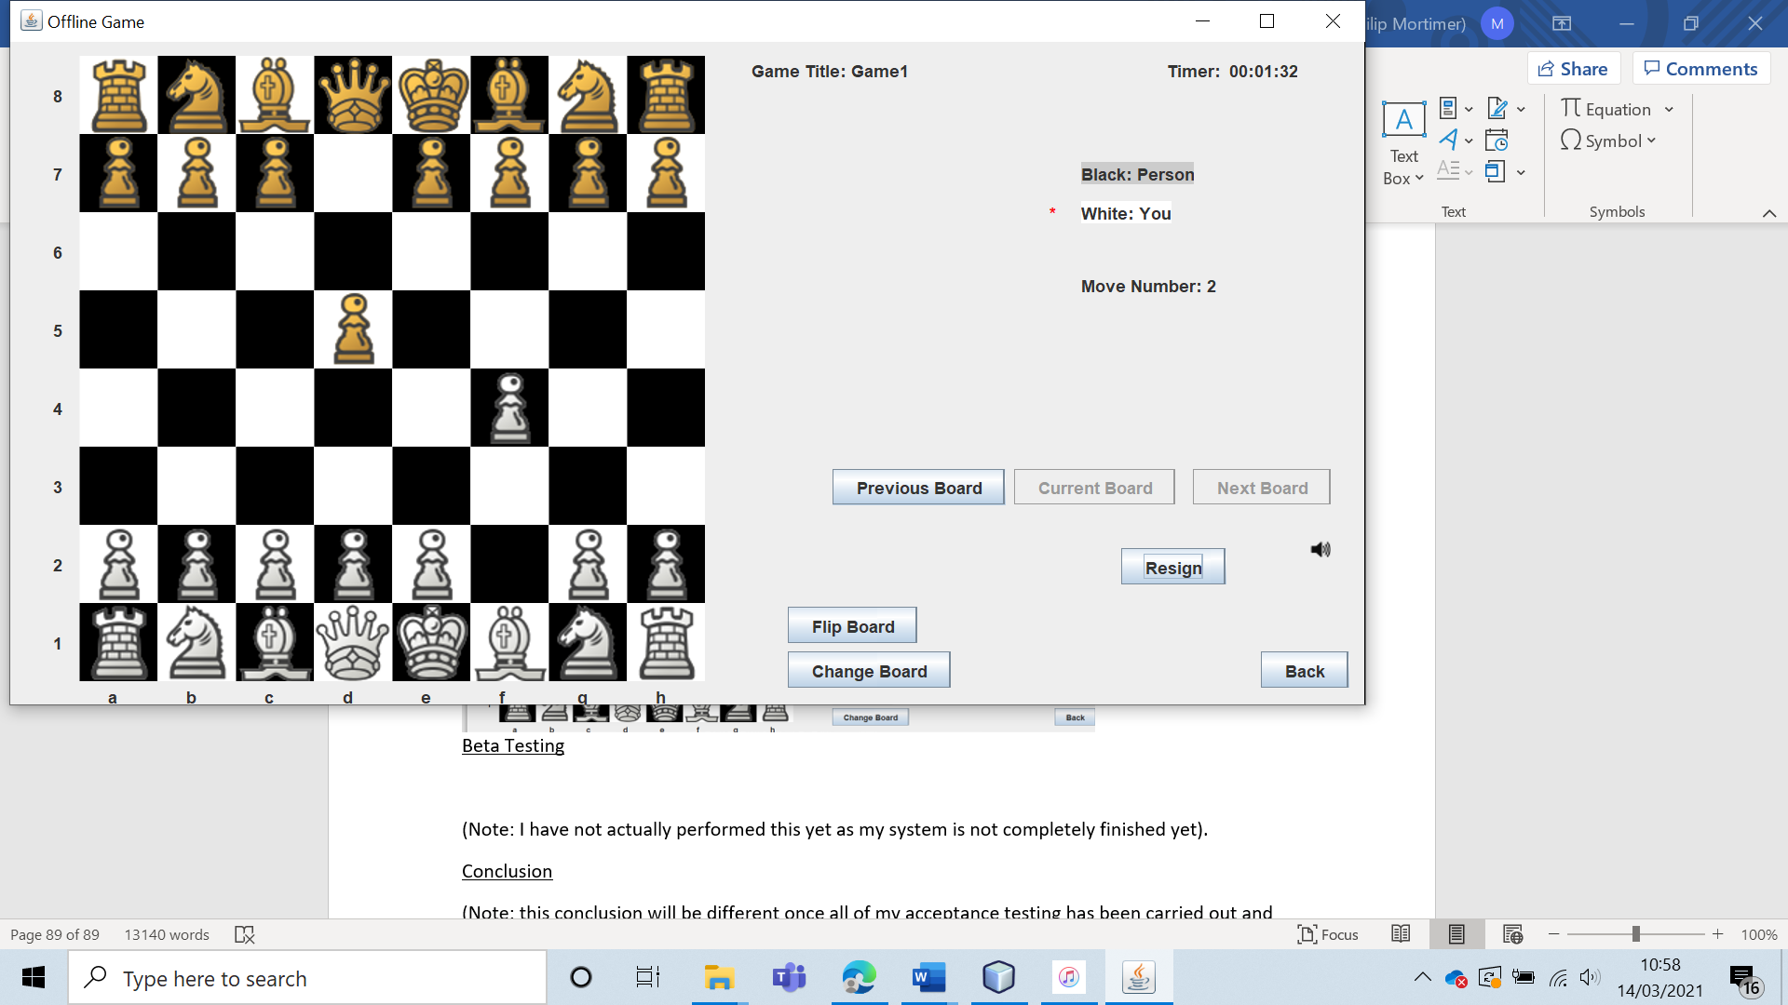

|  |  |  |  |  |  |  |
| --- | --- | --- | --- | --- | --- | --- |
| 25 | Create three offline games and then attempt to create another offline game. | To ensure that users can only play up to three offline games at a time. |  | The fourth offline game should not be created, and the system should display a message explaining that only three offline games can be played at a time. | 4a | The fourth offline game was not created, and the user was told that they could only play up to three offline games at a time. |

Test 25

I created three offline games:

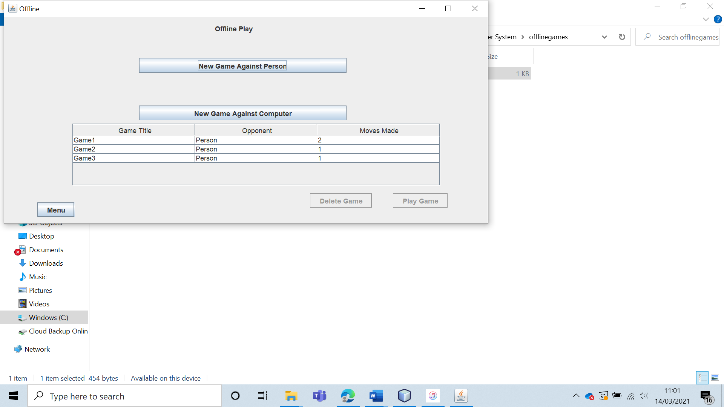

Then when I pressed “New Game Against Person”, I was given a message explaining that I could only play up to three offline games at a time. The same occurred when pressing “New Game Against Computer”.

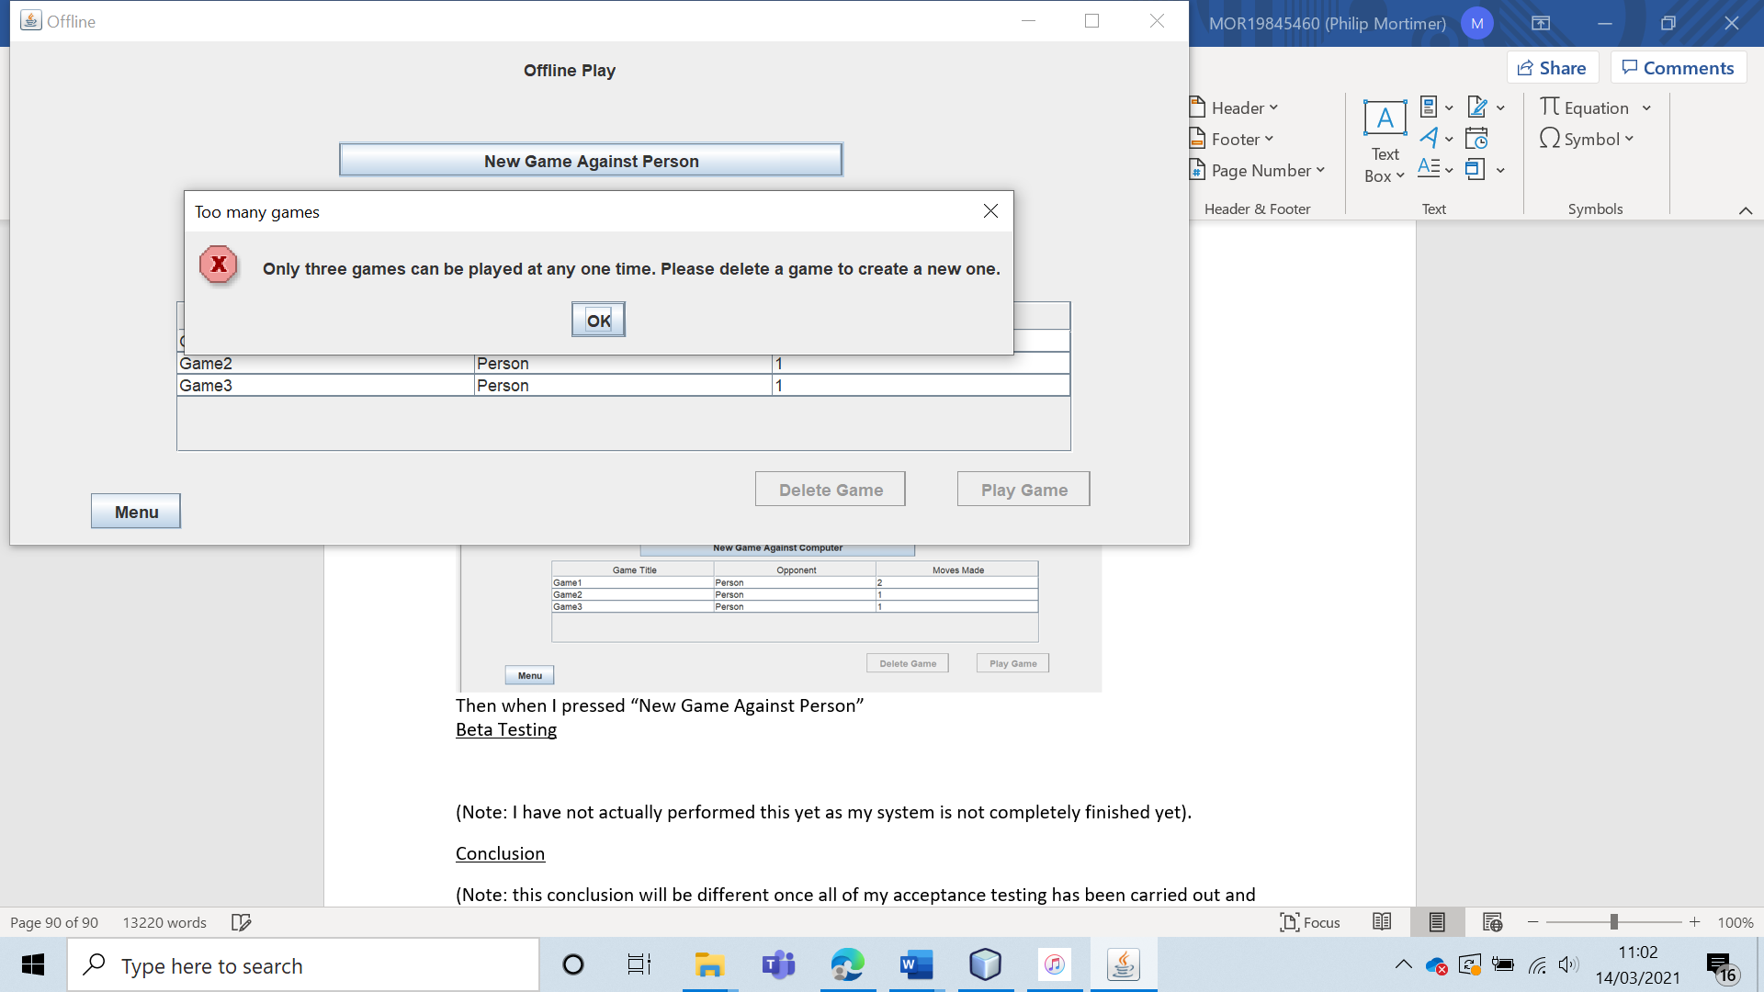

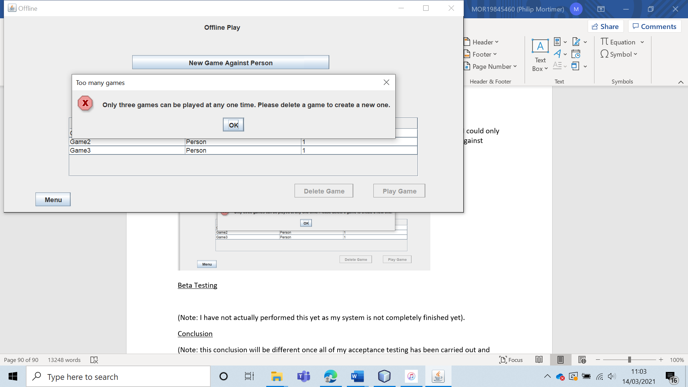

|  |  |  |  |  |  |  |
| --- | --- | --- | --- | --- | --- | --- |
| 26 | Create and play offline chess games using all three-time control settings. | To verify that various offline game settings can be selected and that they all function as desired. |  | The games should be created without any difficulty and the time control should work as expected (i.e., each player is given five minutes, ten minutes or unlimited time to make their moves). | 4b, 4bi and 6ai. | As expected, each game was created with the appropriate time-control. The time control functioned as intended, with users losing if they ran out of move time. Additionally, the unlimited time-control setting did in fact give both players unlimited move time. |

Test 26

First, I created a game with a five-minute time control.

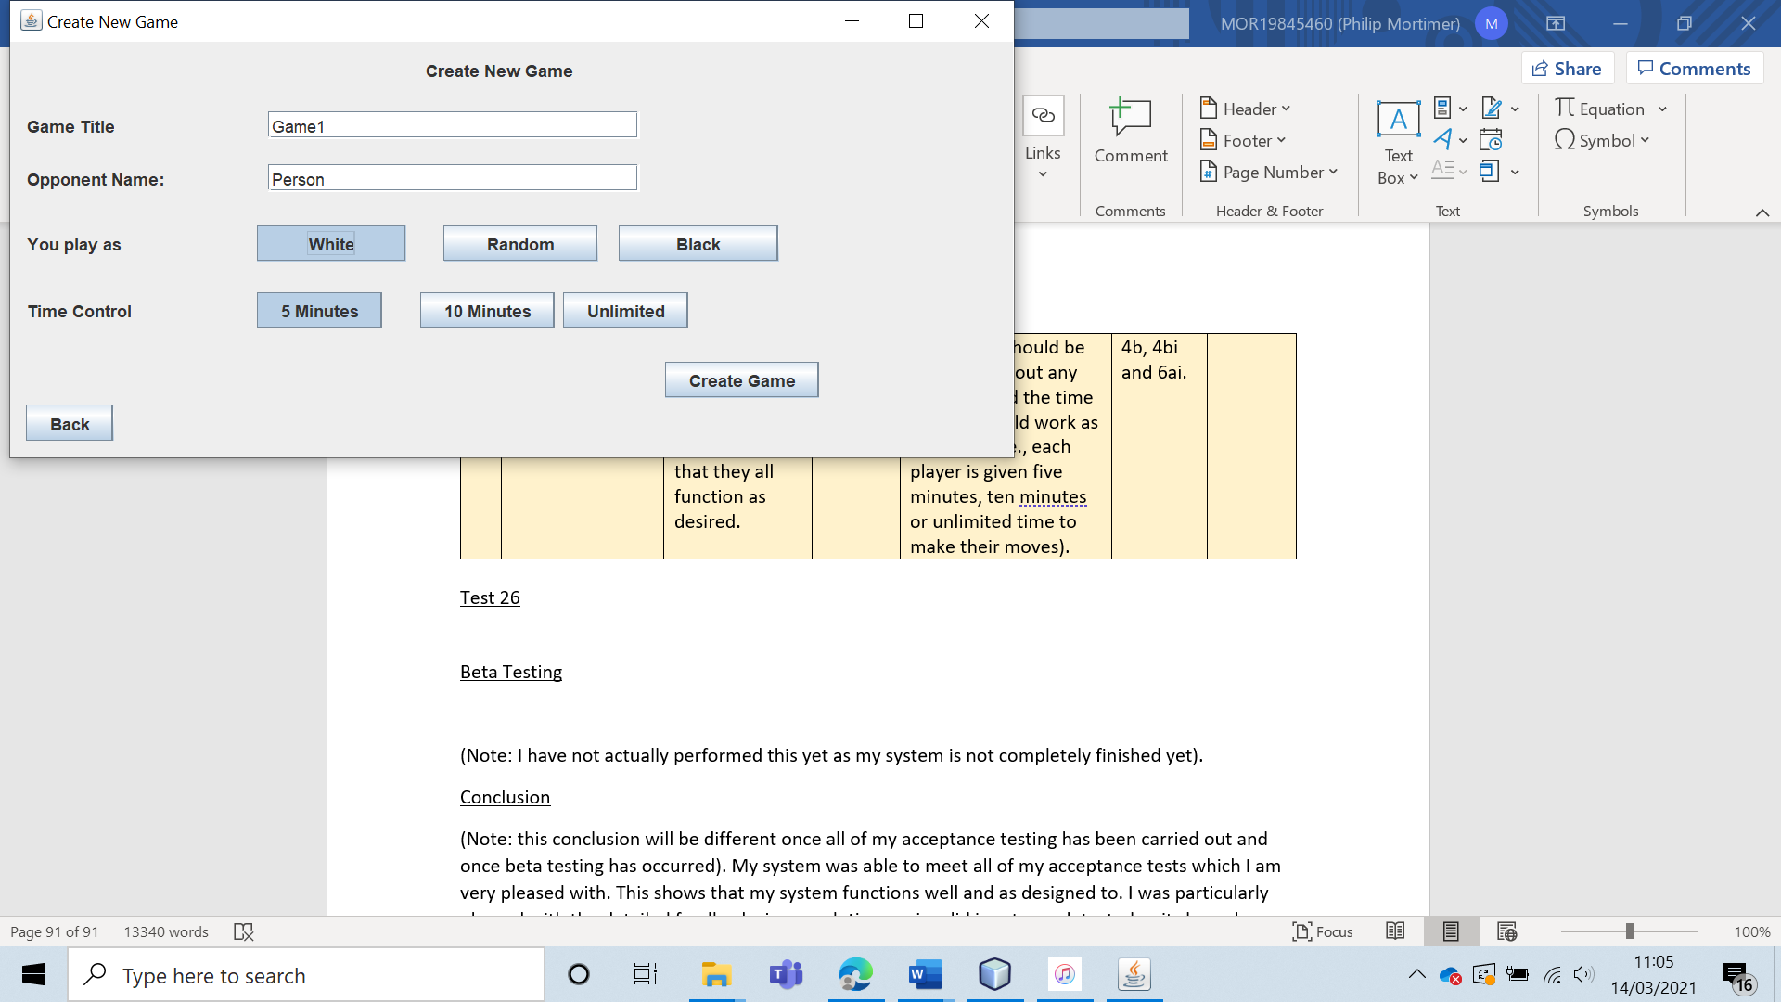

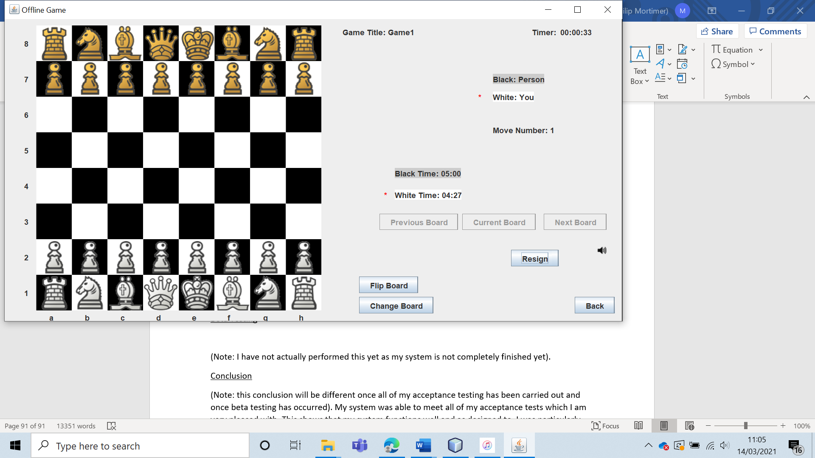

As expected, when one player ran out of time, the game results was displayed, and the user was taken back to the offline menu. The game was deleted from the offline game file.

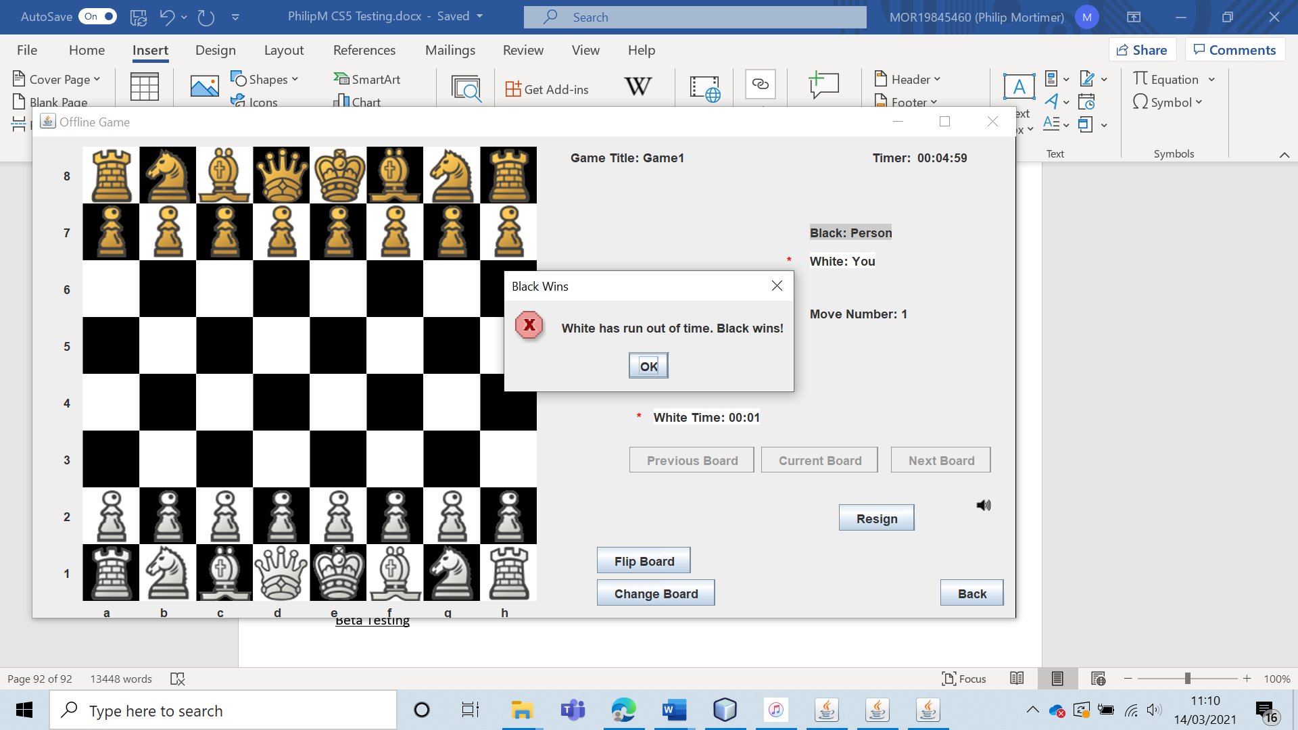

I then created a game using a ten-minute time control.

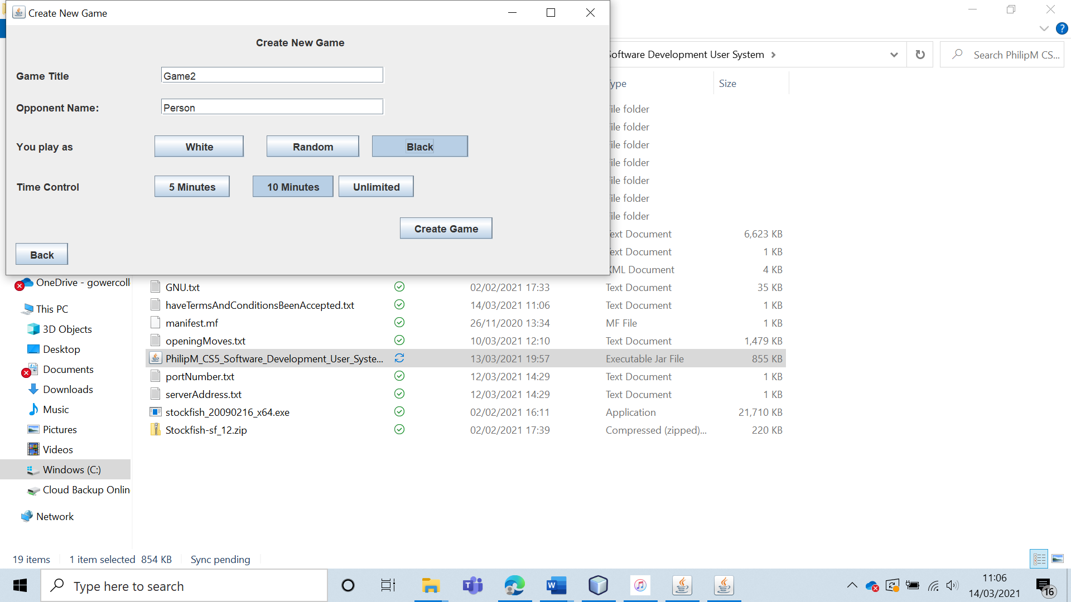

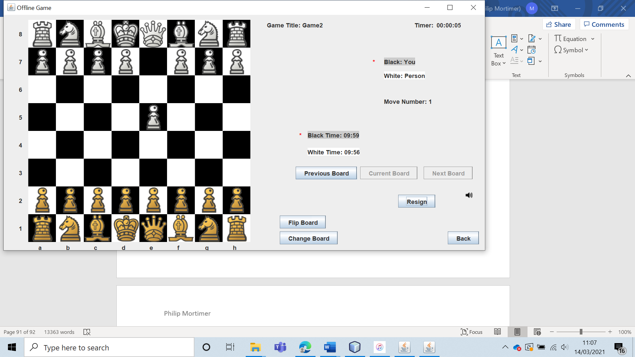

As expected, when one player ran out of time, the game results was displayed, and the user was taken back to the offline menu. The game was deleted from the offline game file.

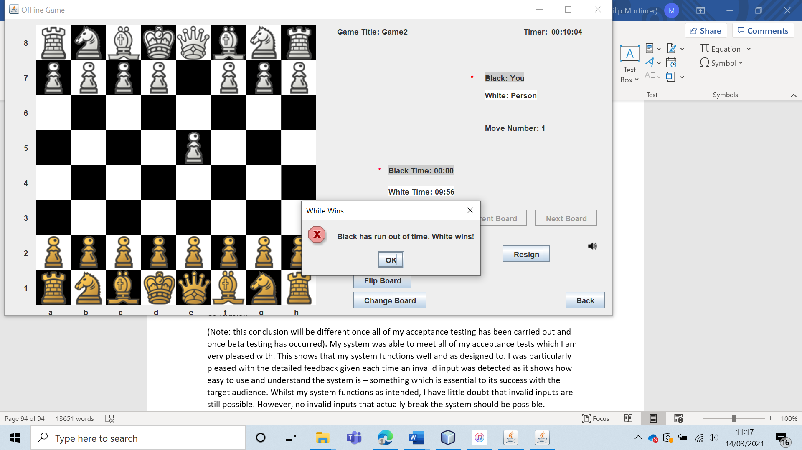

I then created a game with unlimited time.

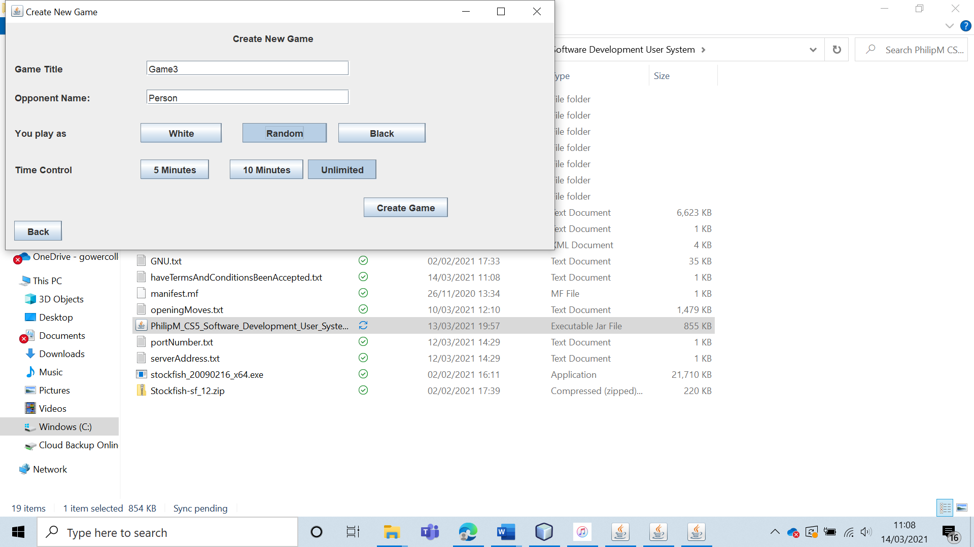

As expected, even after ten minutes, no player ran out of time. Additionally, no timers were displayed to indicate the individual amount of time each player had spent making moves.

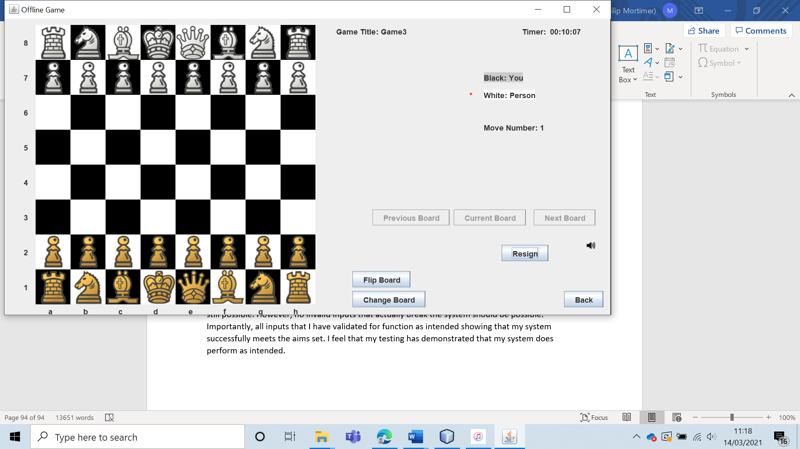

|  |  |  |  |  |  |  |
| --- | --- | --- | --- | --- | --- | --- |
| 27 | Play an offline game of chess and verify that all of the rules of chess are obeyed. | To ensure that the game of chess actually functions. |  | The game should work and obey all of the rules of chess. | 4 | All of the chess games I have played have adhered perfectly to the rules of chess. Hence, the system does pass the test. It is important to note that it is physically impossible to test all possible board states. Therefore, it is still possible that my system does not work perfectly. However, I have found no mistakes and hence my system definitely works very well. |

Test 27

Having played countless offline games, I can confirm that all the rules of chess are obeyed by the system. Obviously, I cannot test every single possible board state, but I can say with confidence that the game functions as intended.

The pawn functions as intended, being able to move one or two squares at the start.

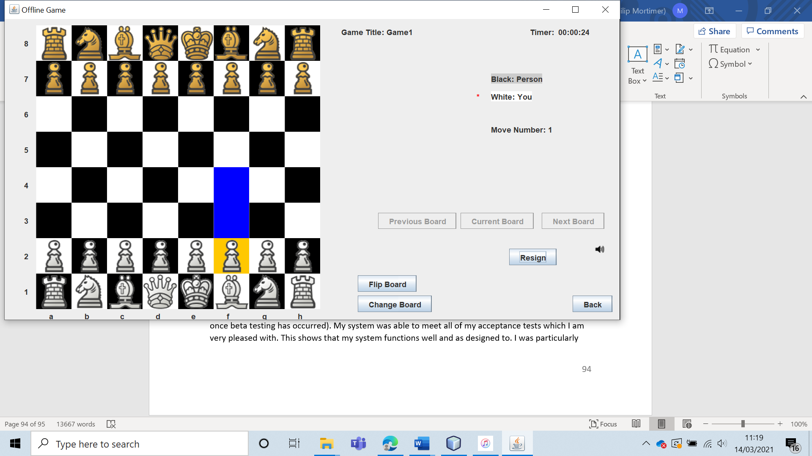

From that point on, the pawn can only move one square.

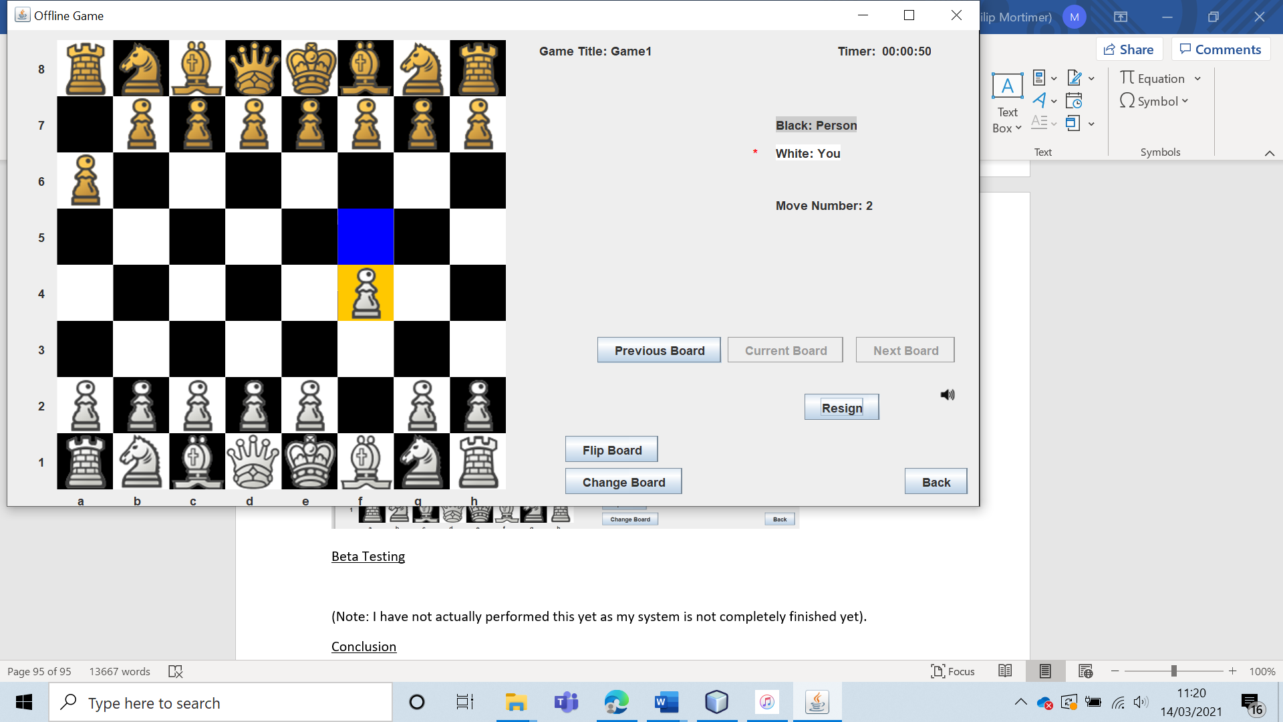  
The pawn is able to make captures by en passant.

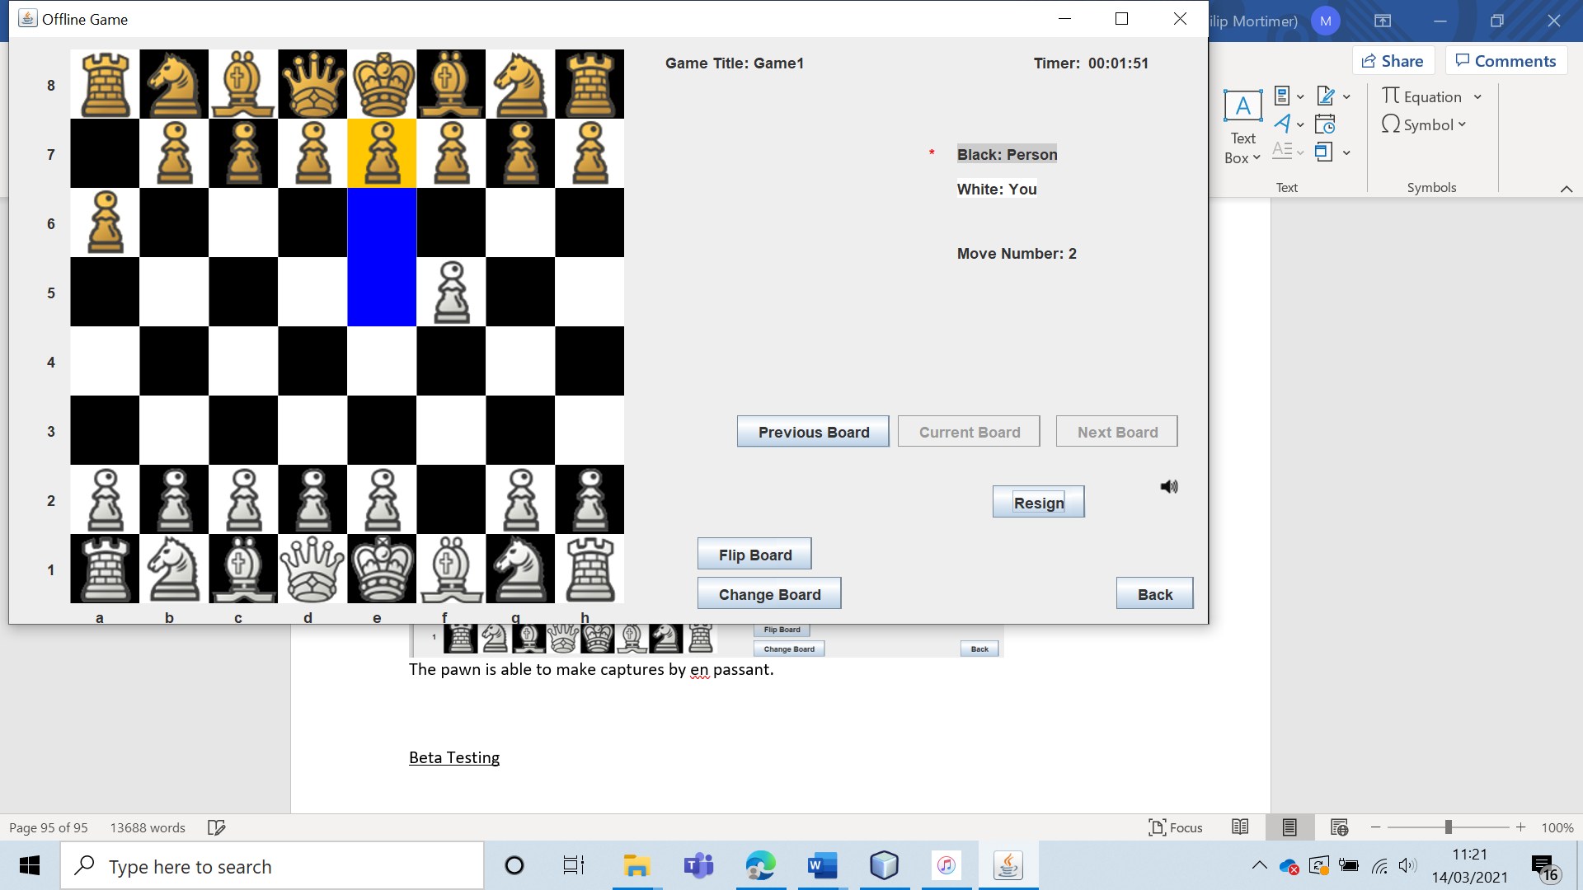

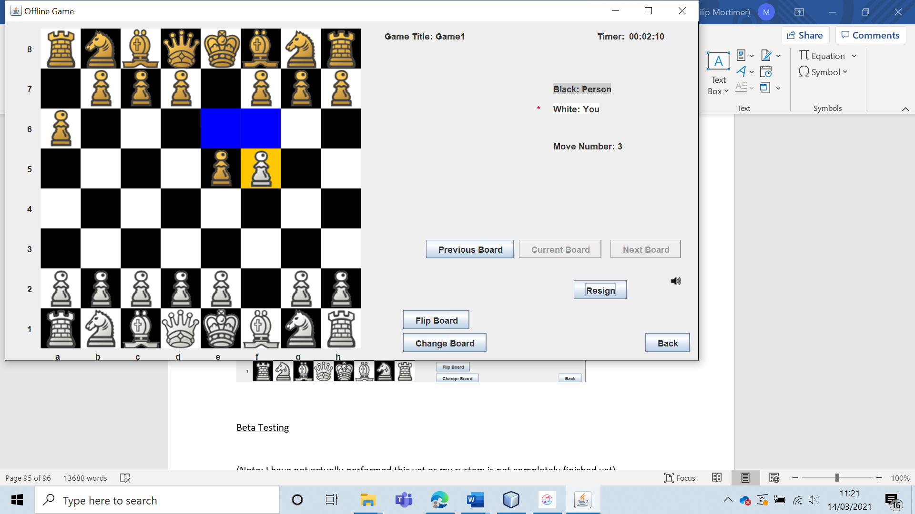

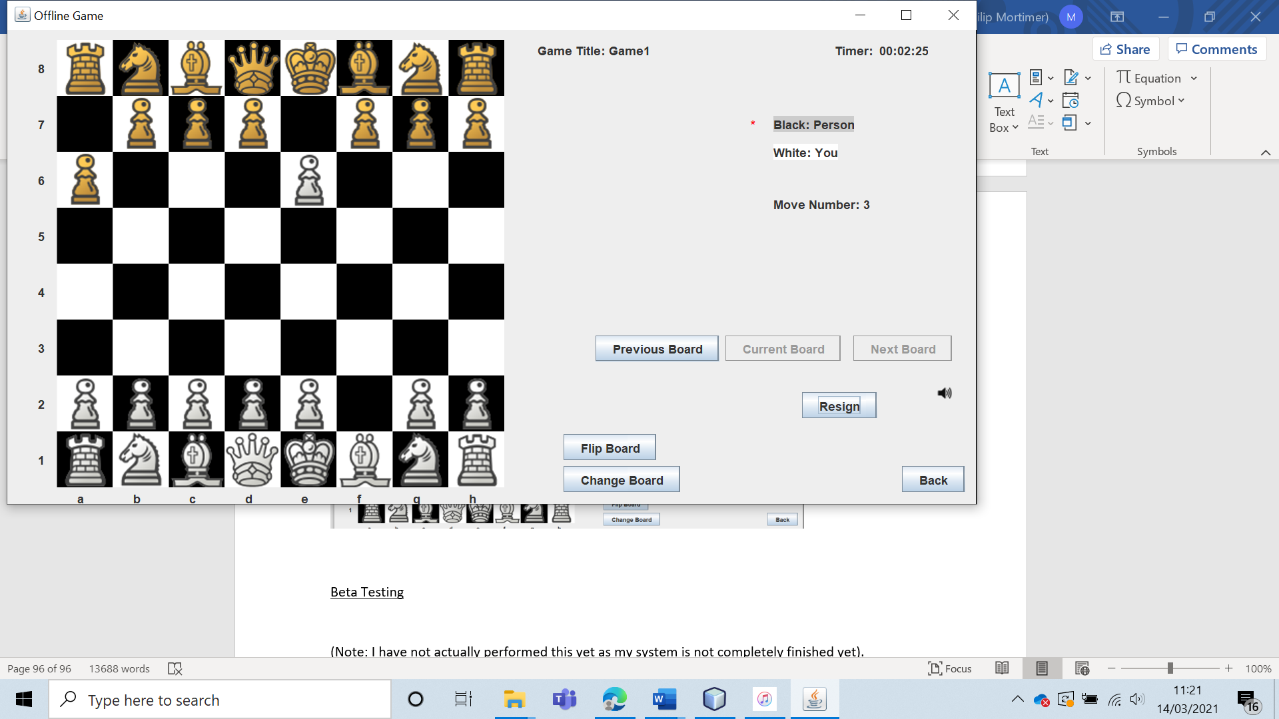

The pawn is also able to make normal captures.

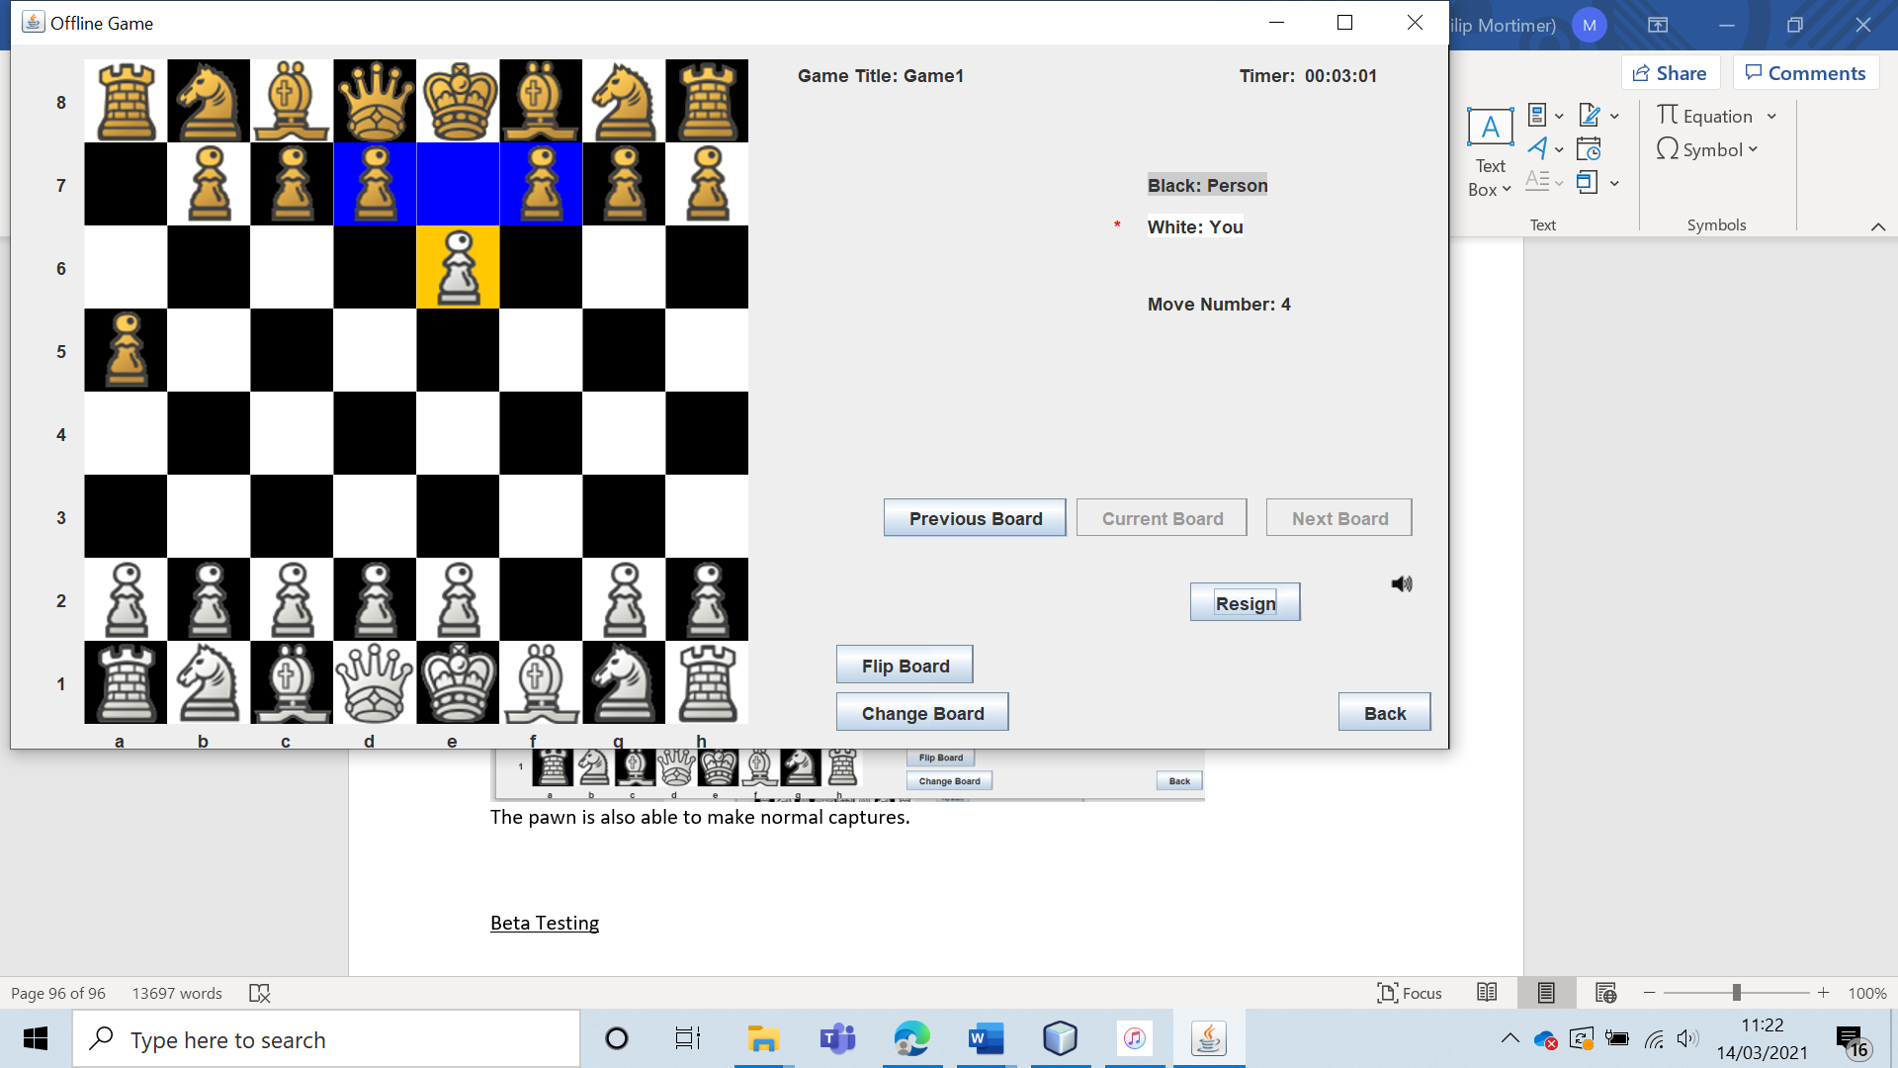

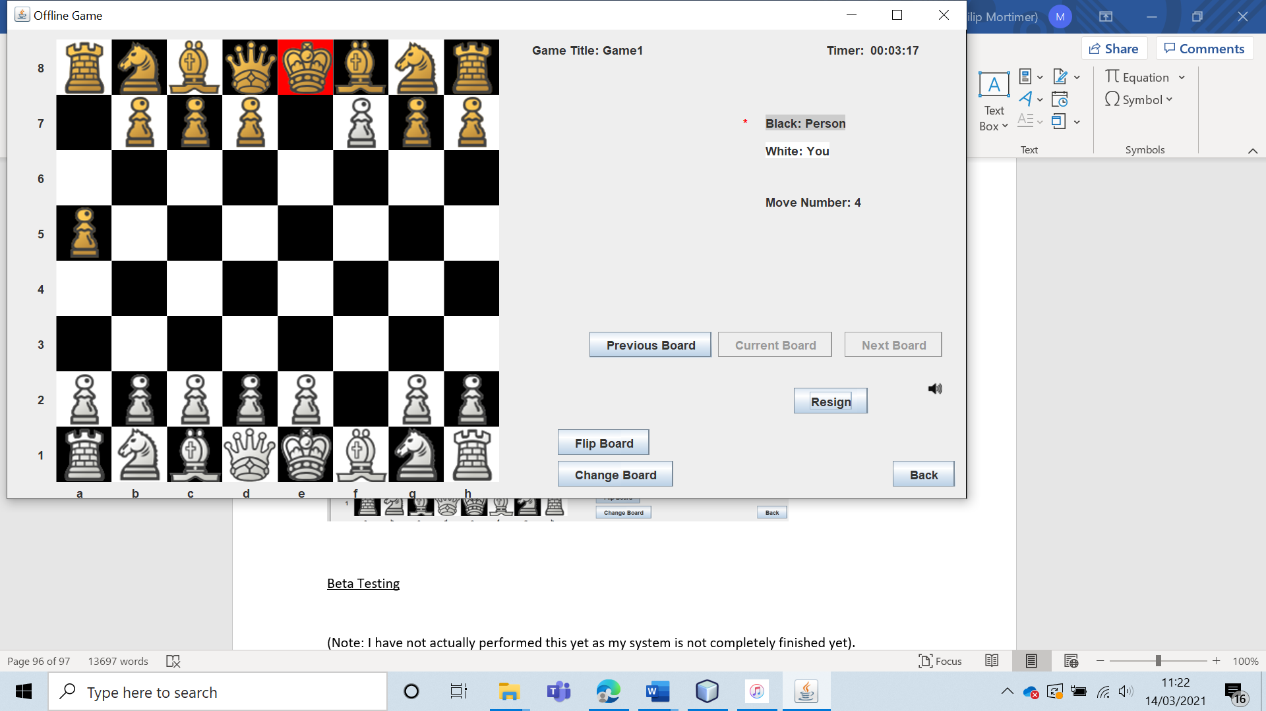

This board state also proves that the game is able to handle check, as the king is the only piece that is able to move. The pawn can also be promoted.

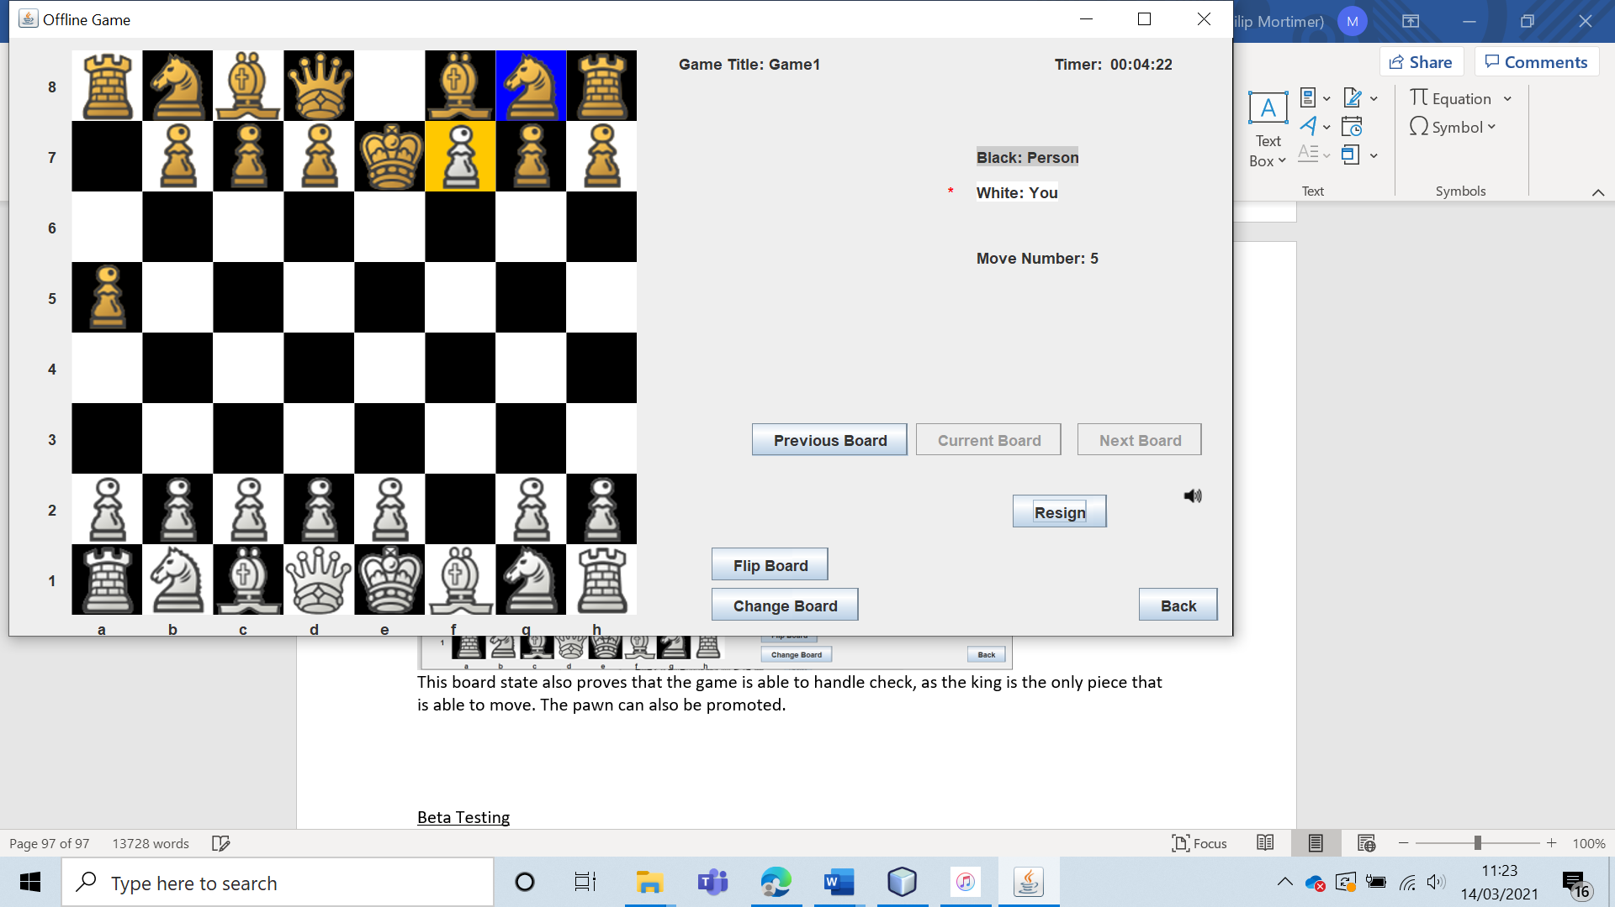

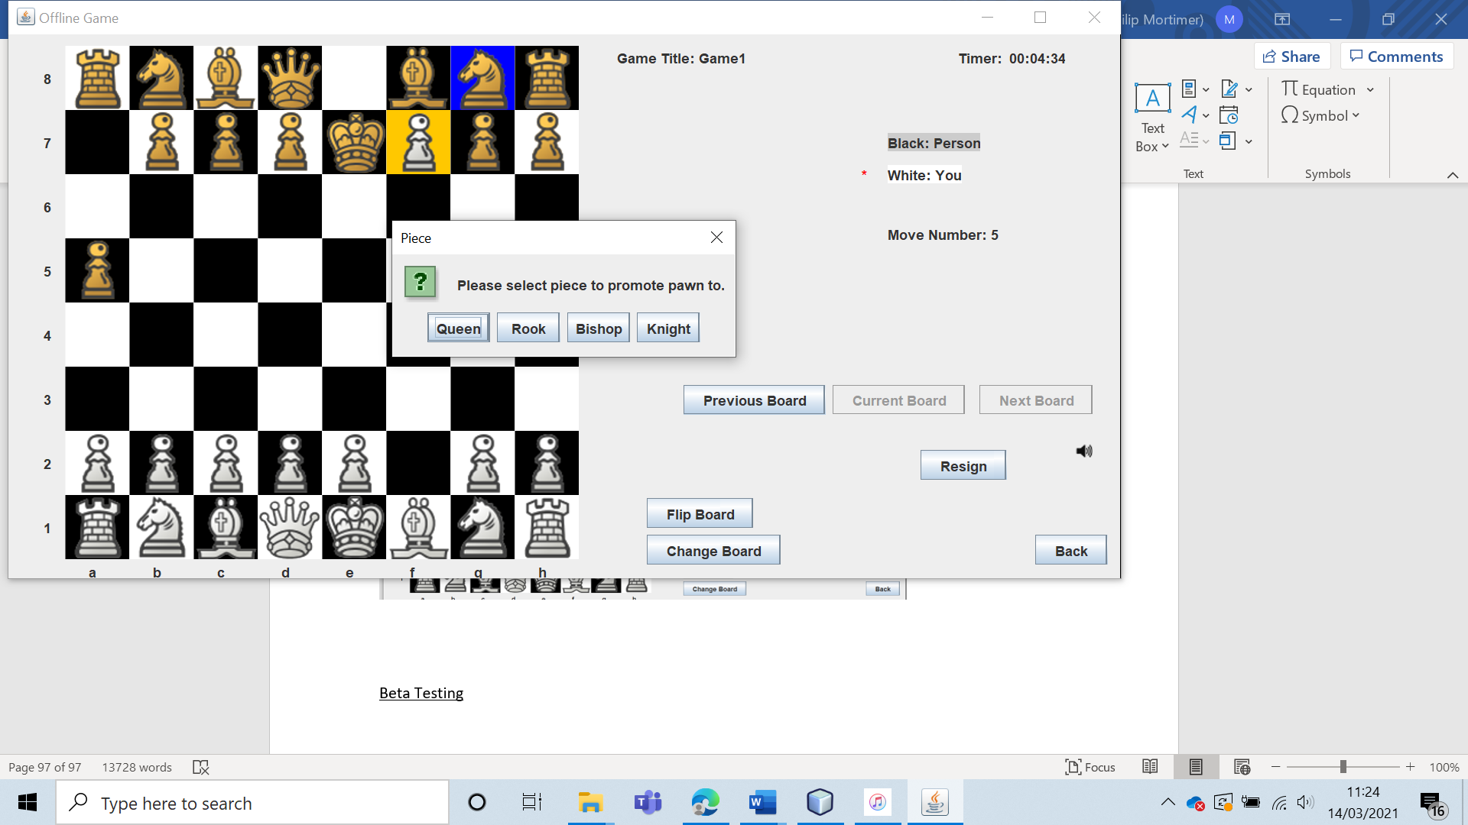

The player is then able to choose which piece they wish to promote the pawn too.

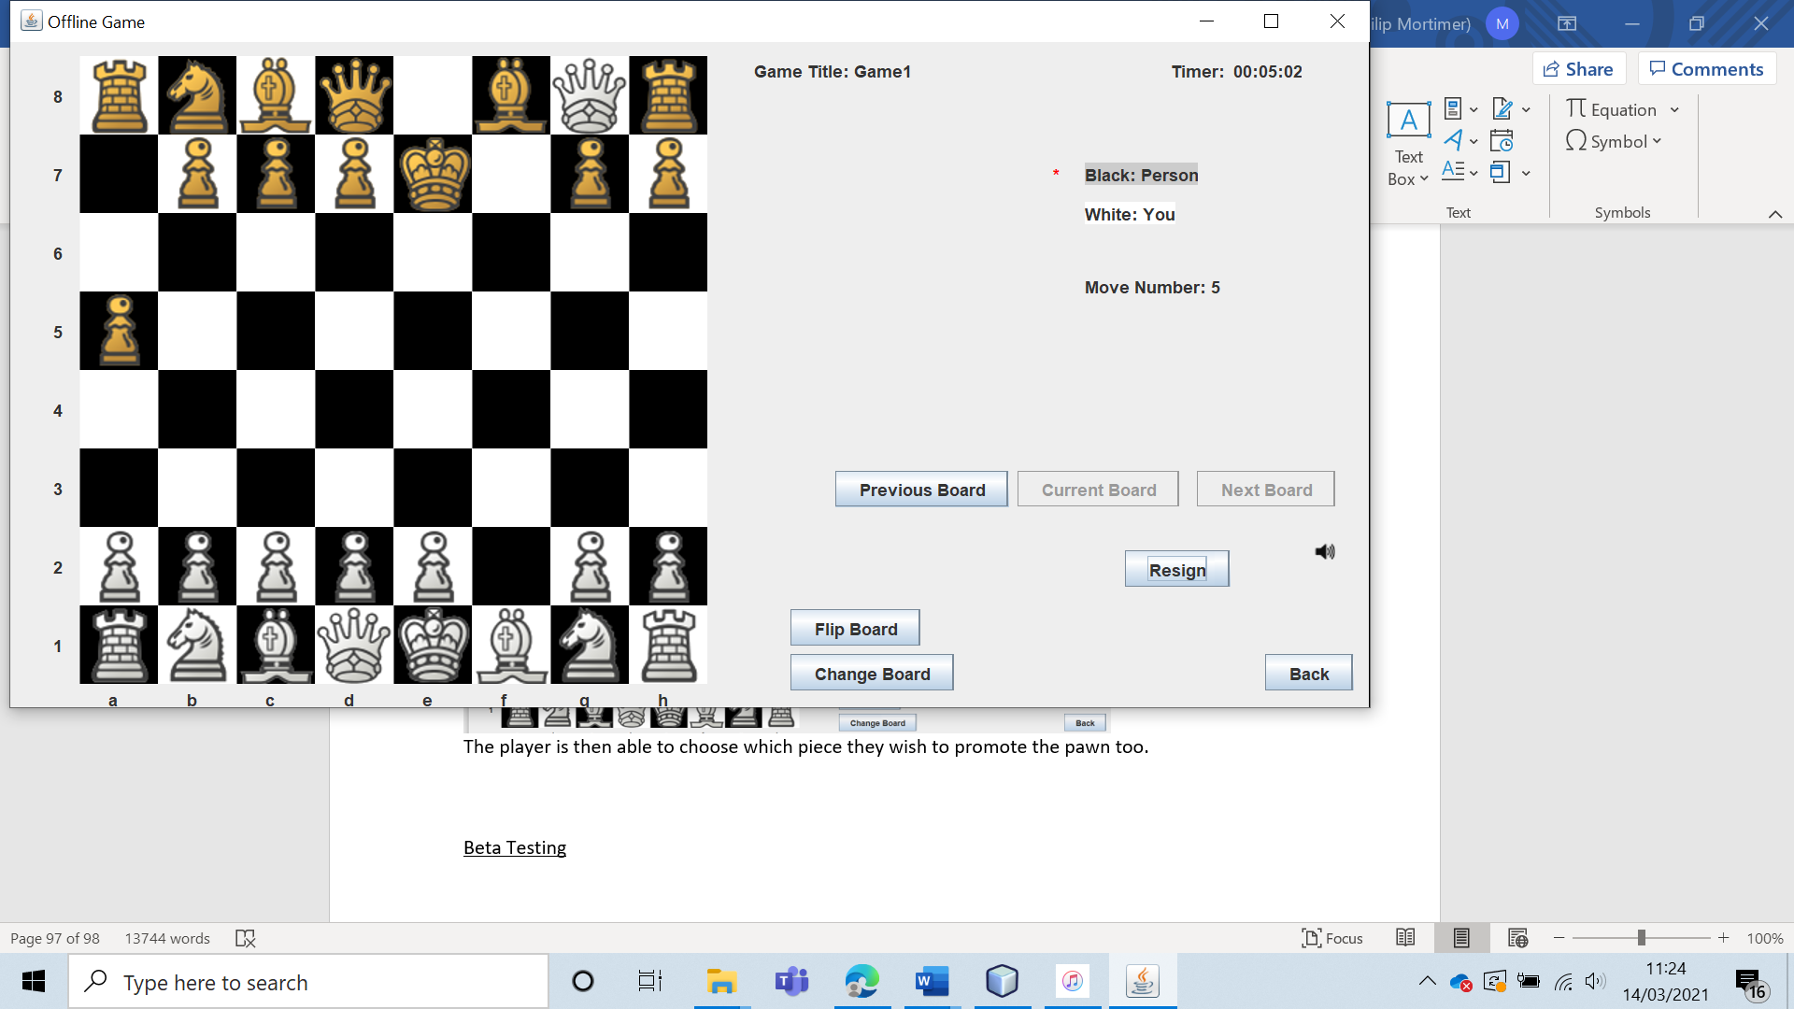

This clearly demonstrates that the pawn functions exactly as it should.

The knight also functions correctly, with the correct moves always being highlighted.

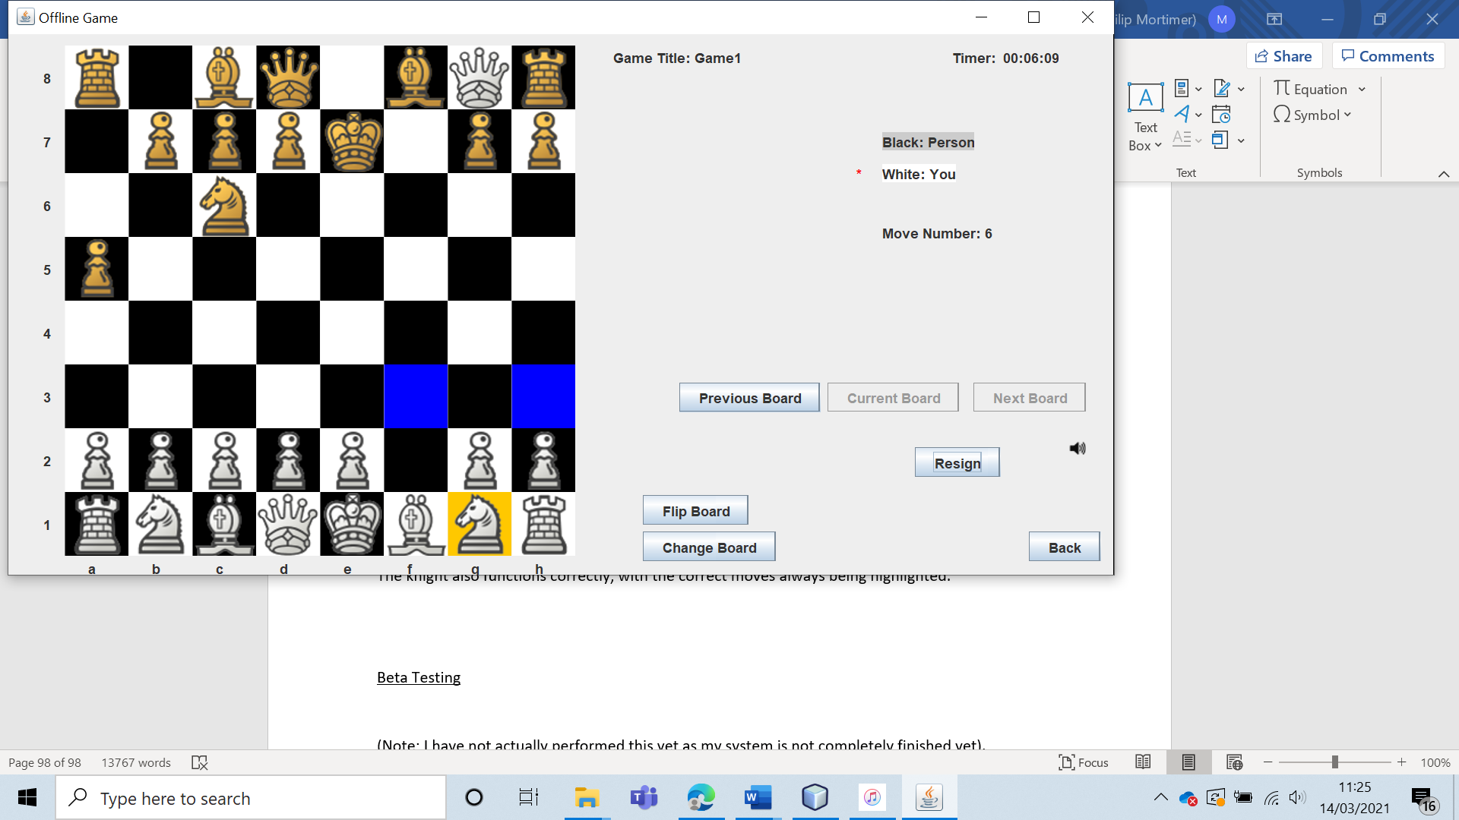

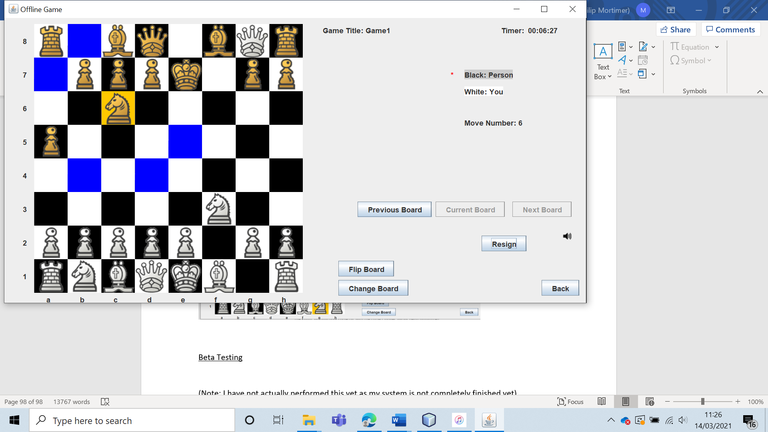

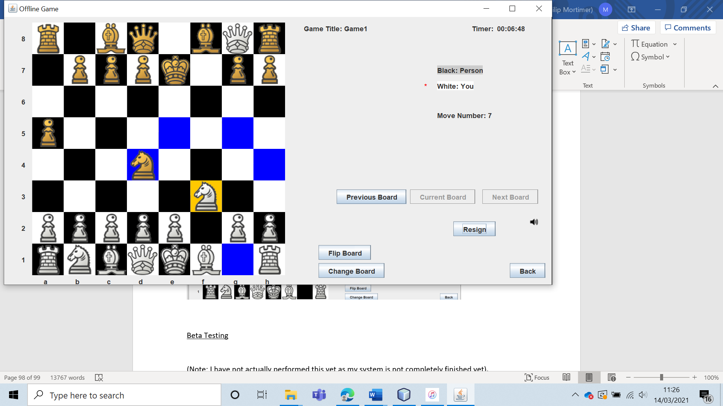

The bishop also functions, with only diagonal squares being highlighted.

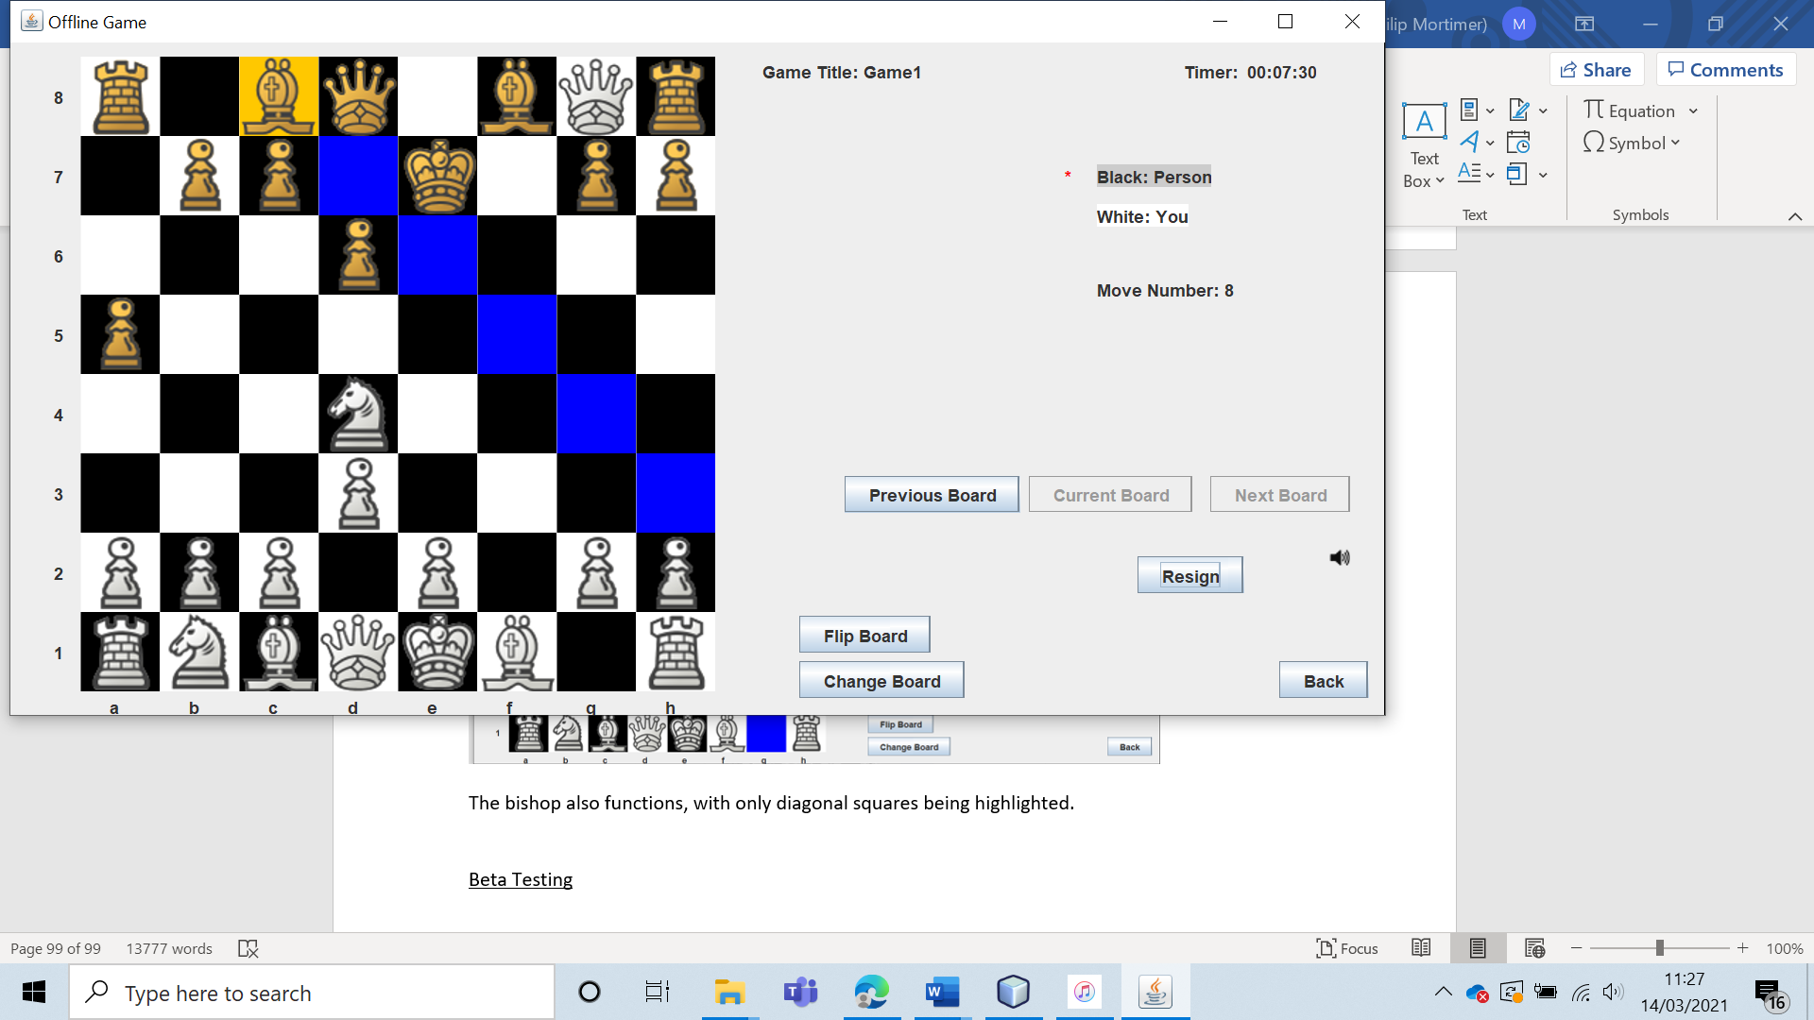

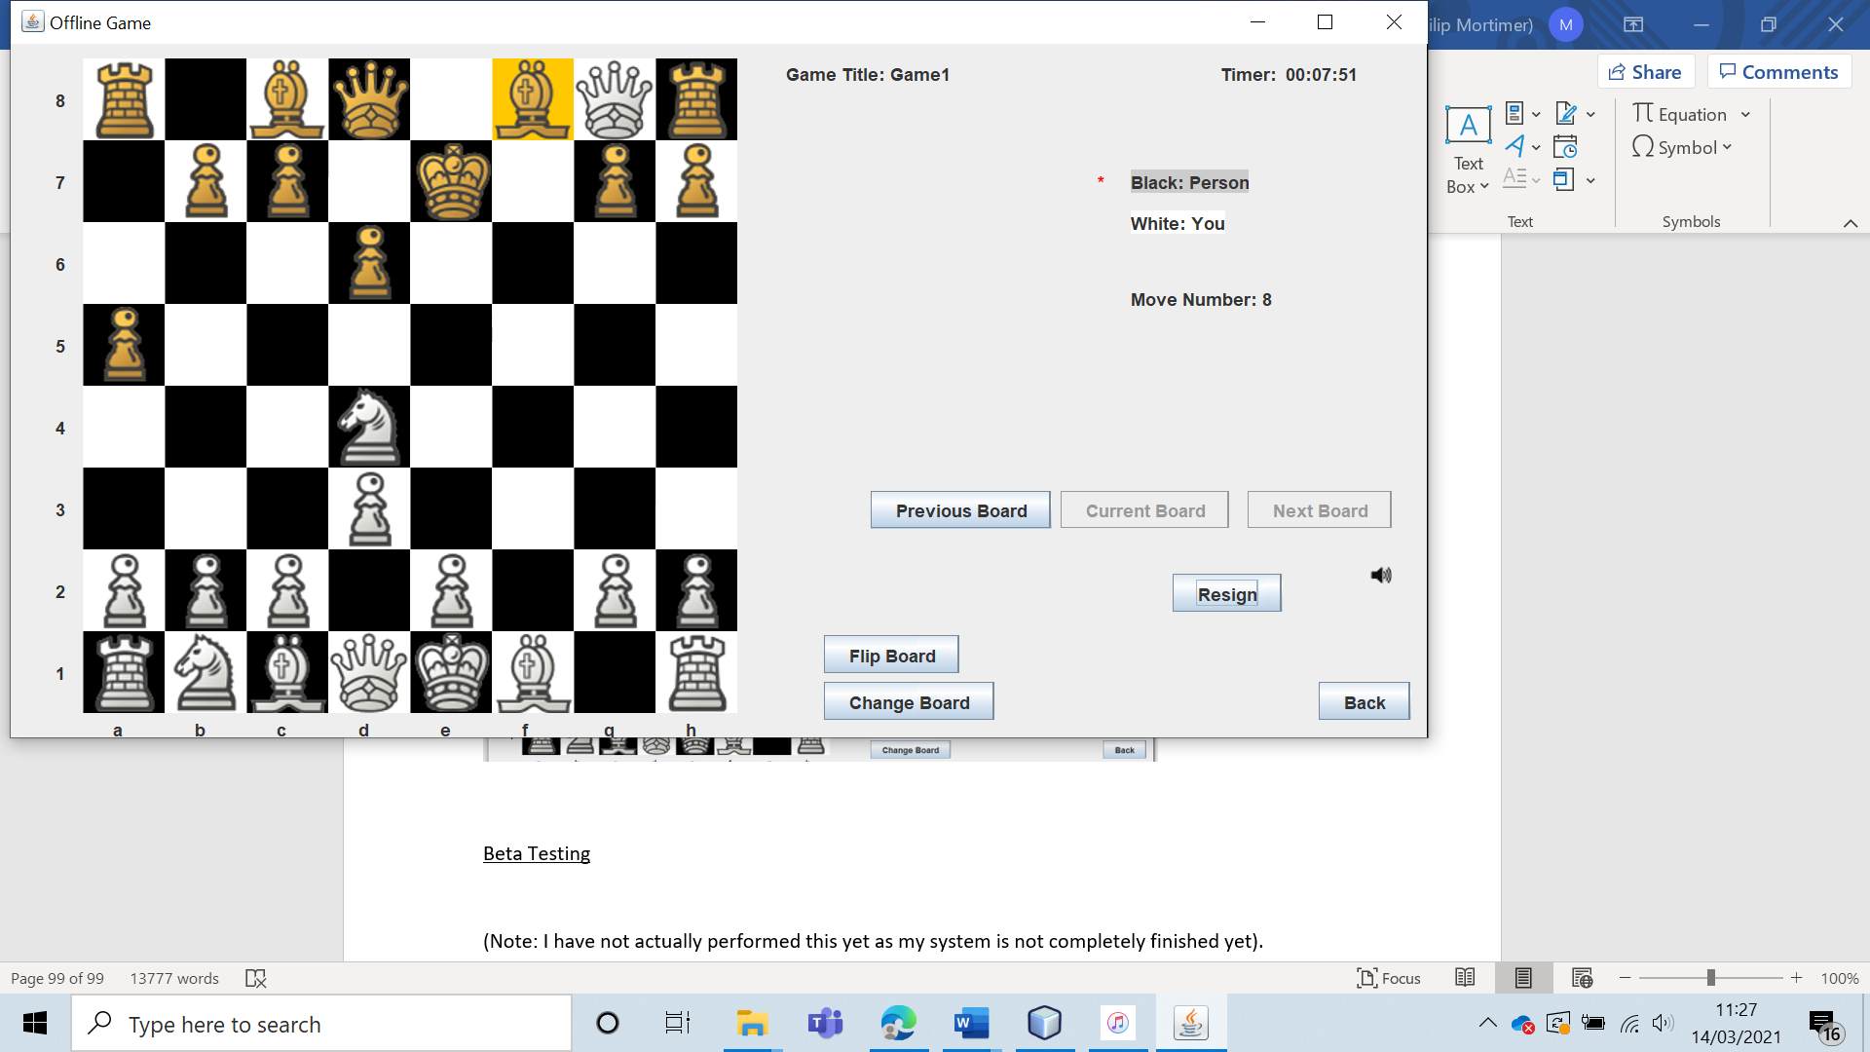

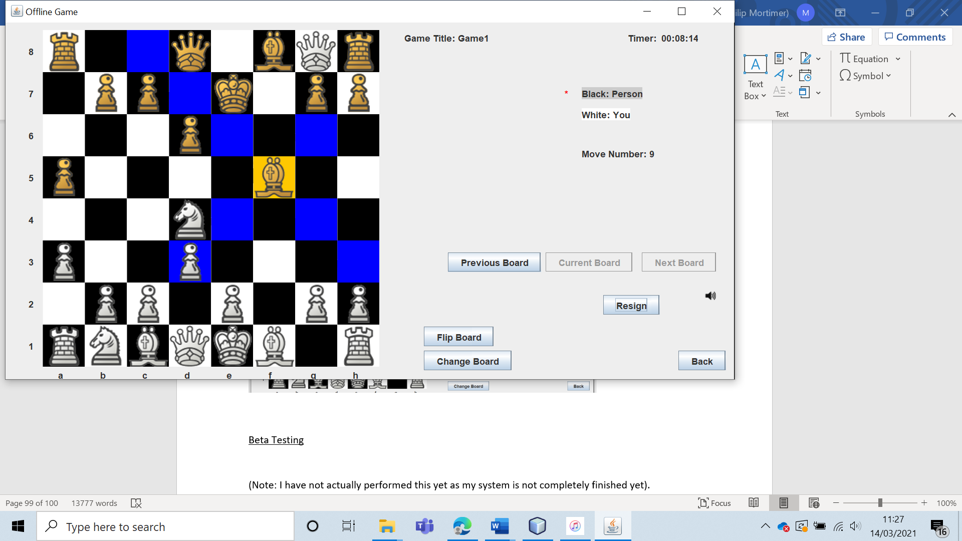

The rook moves as intended, only being able to move vertically or horizontally.

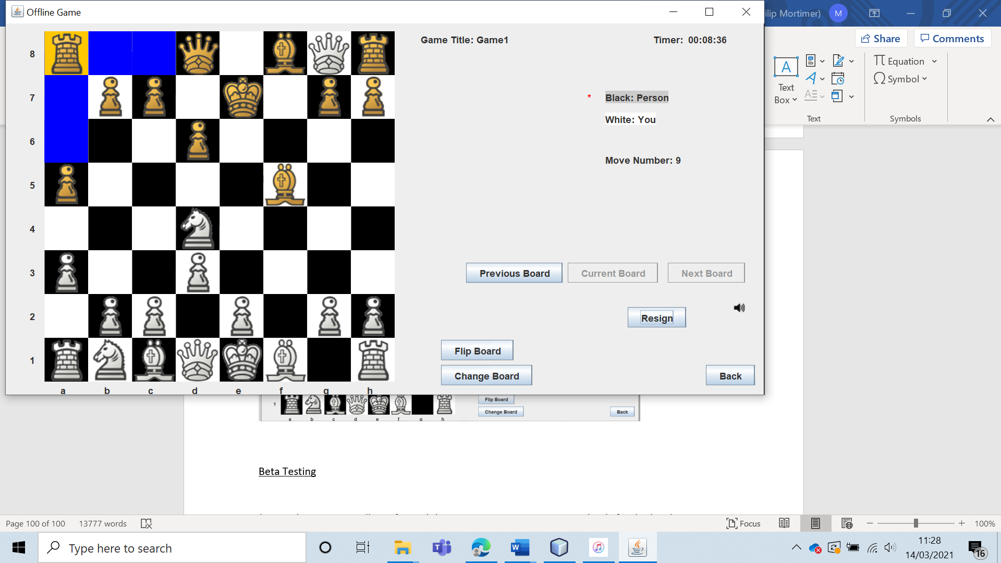

The queen moves as desired, being able to move like a rook and bishop combined.

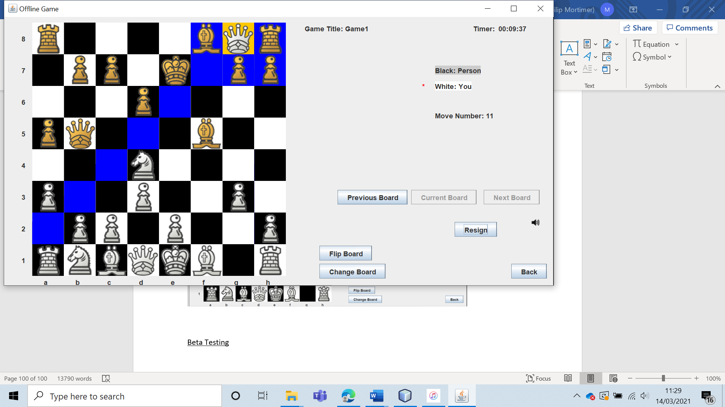

The king works, only being able to move one block in any direction.

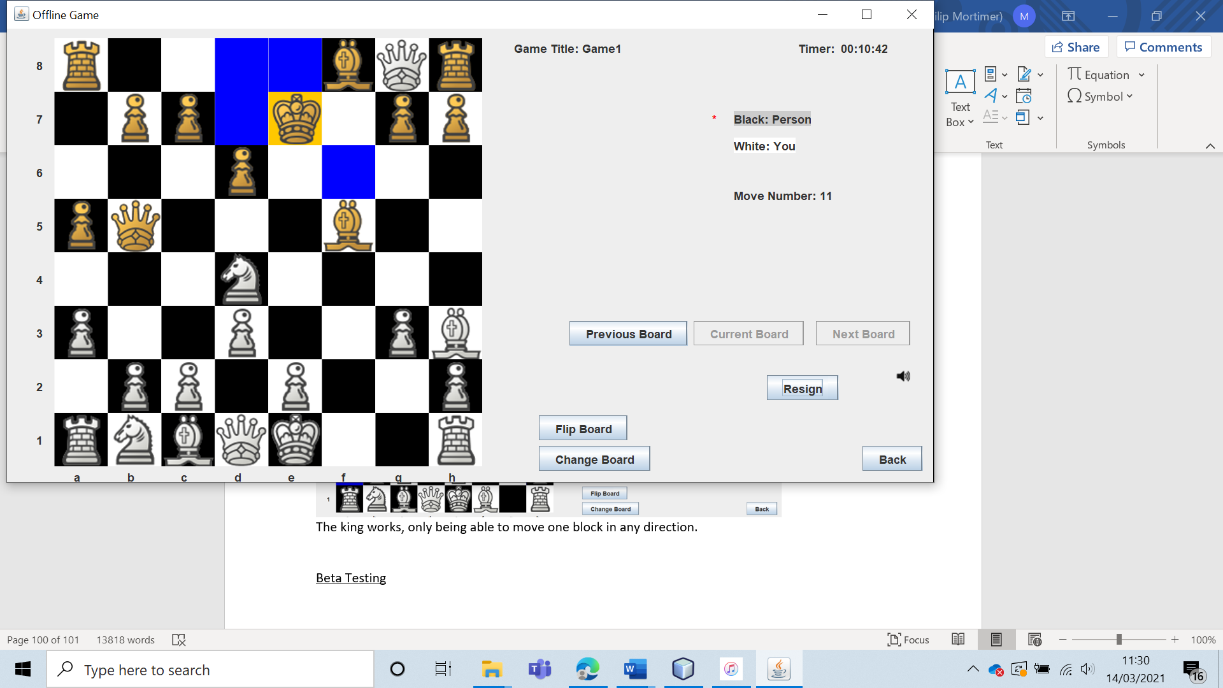

The king can also castle.

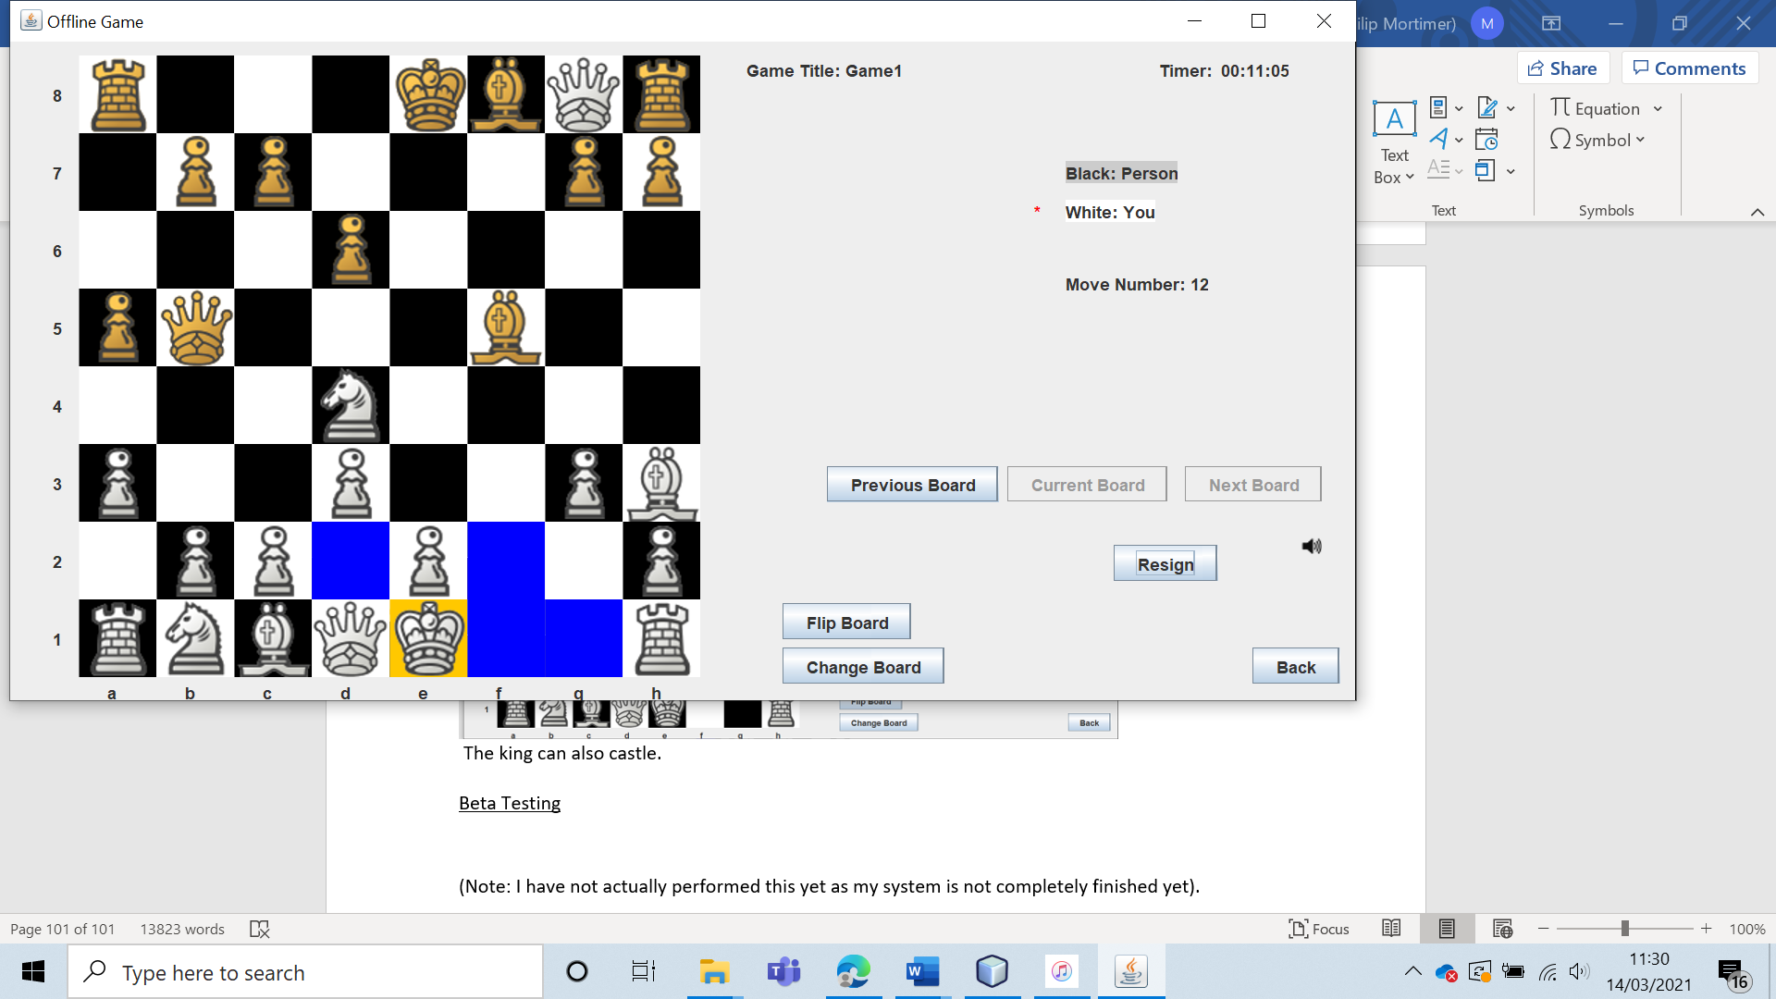

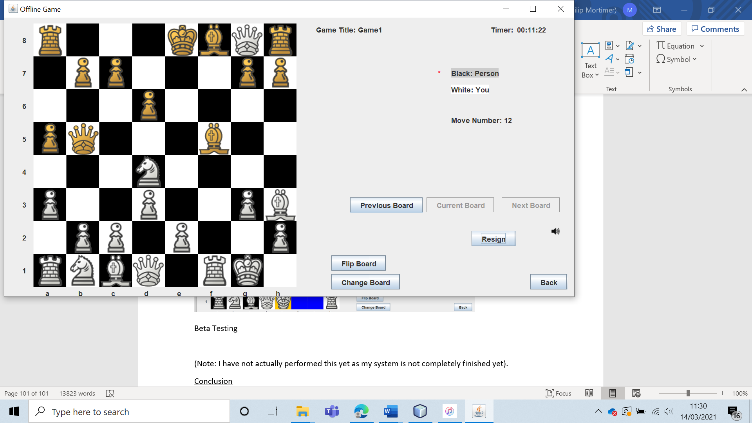

And finally, the concept of checkmate works.

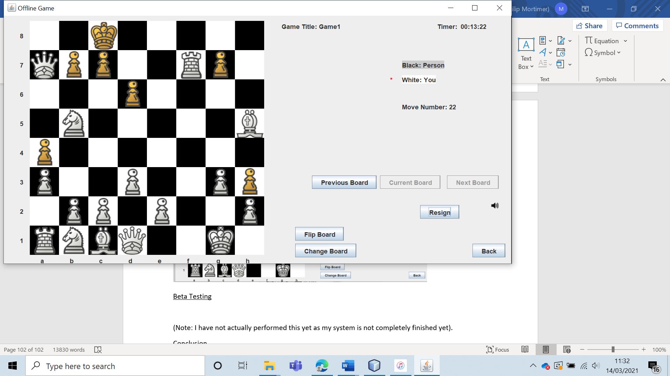

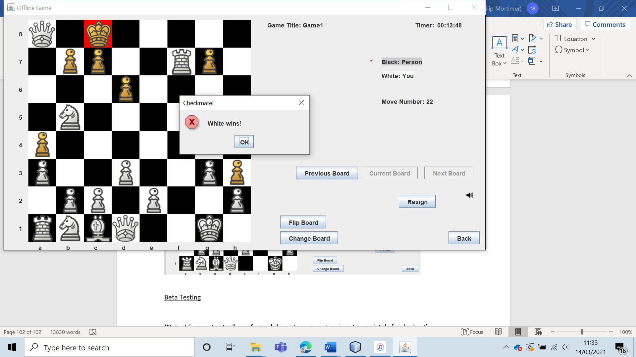

|  |  |  |  |  |  |  |
| --- | --- | --- | --- | --- | --- | --- |
| 28 | Create an offline chess game and verify that it is given a unique game id. | To ensure that each offline game record is unique. |  | The game should be created and given the chosen / assigned unique id. | 4b | The game’s were created as expected. |

Test 28

To test this, I pressed create game and used the autogenerated game title.

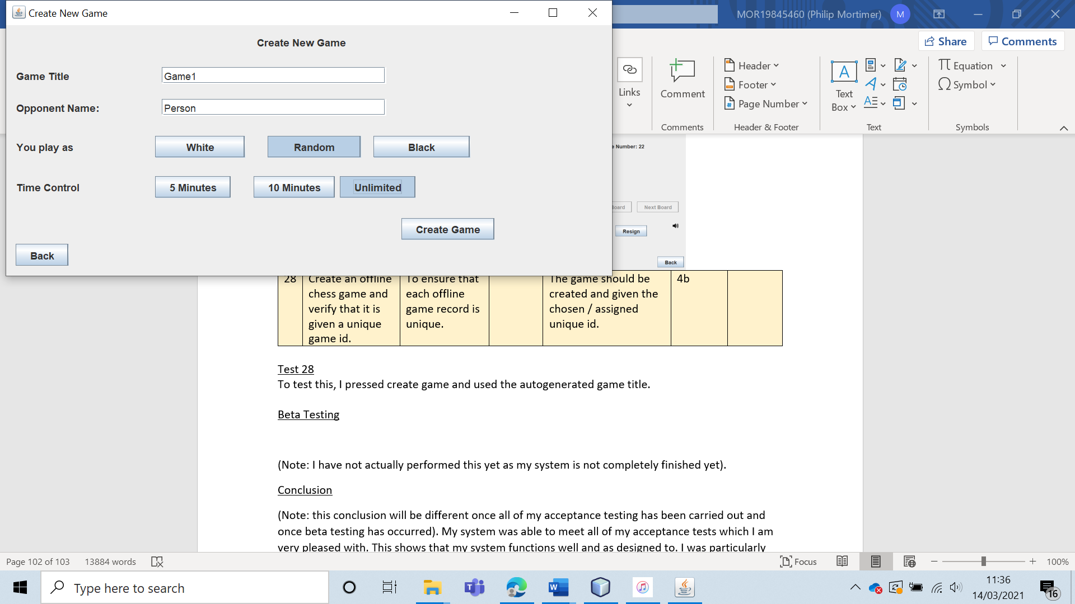

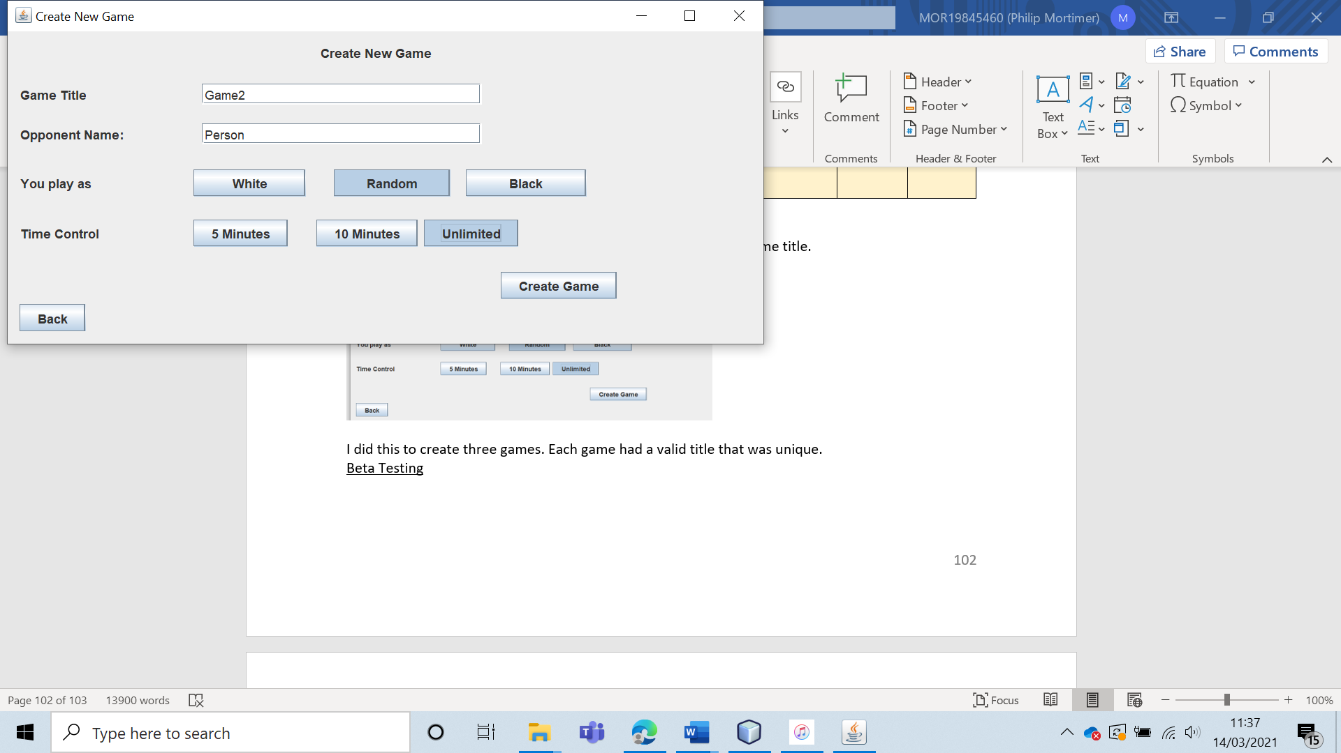

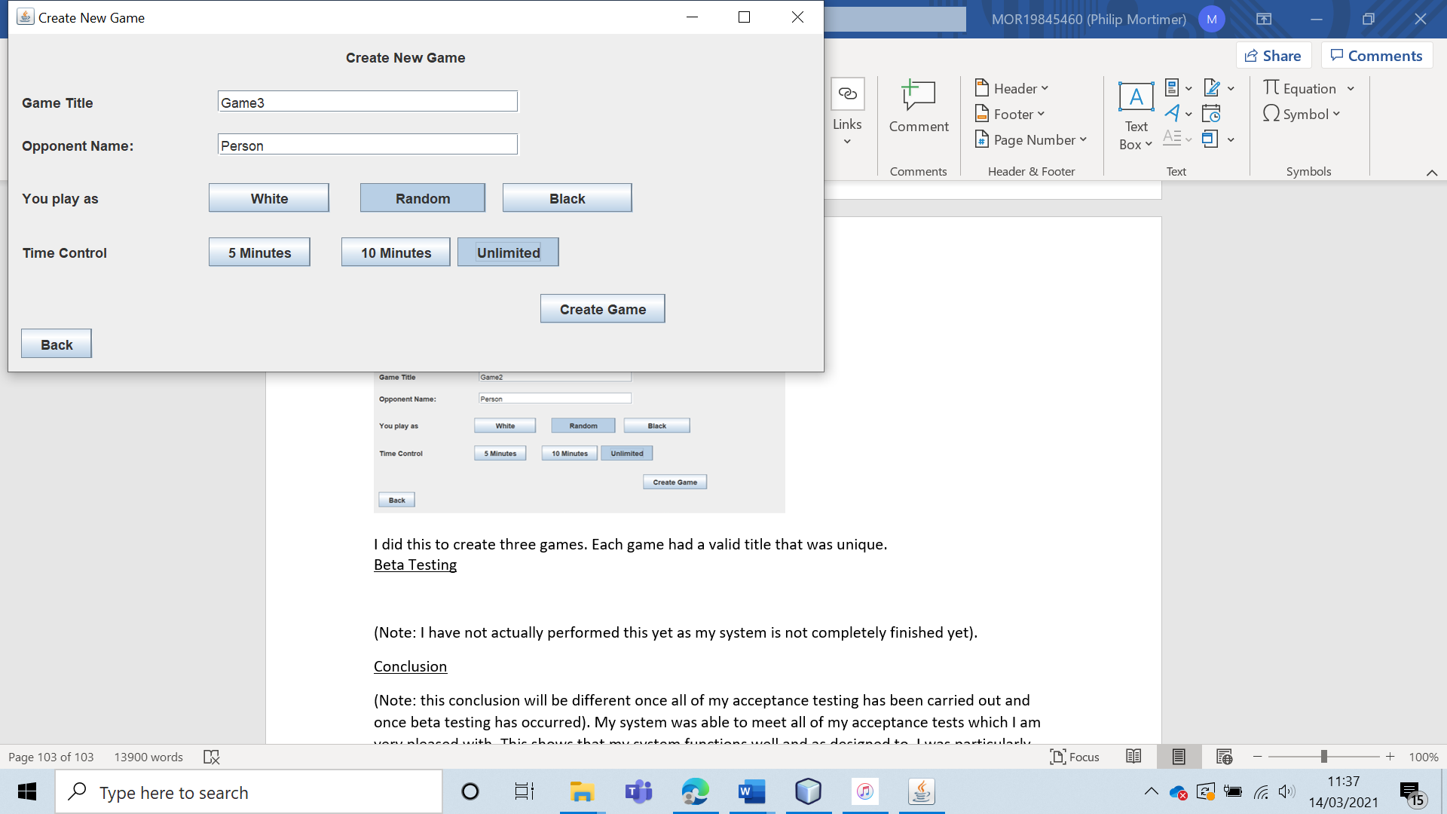

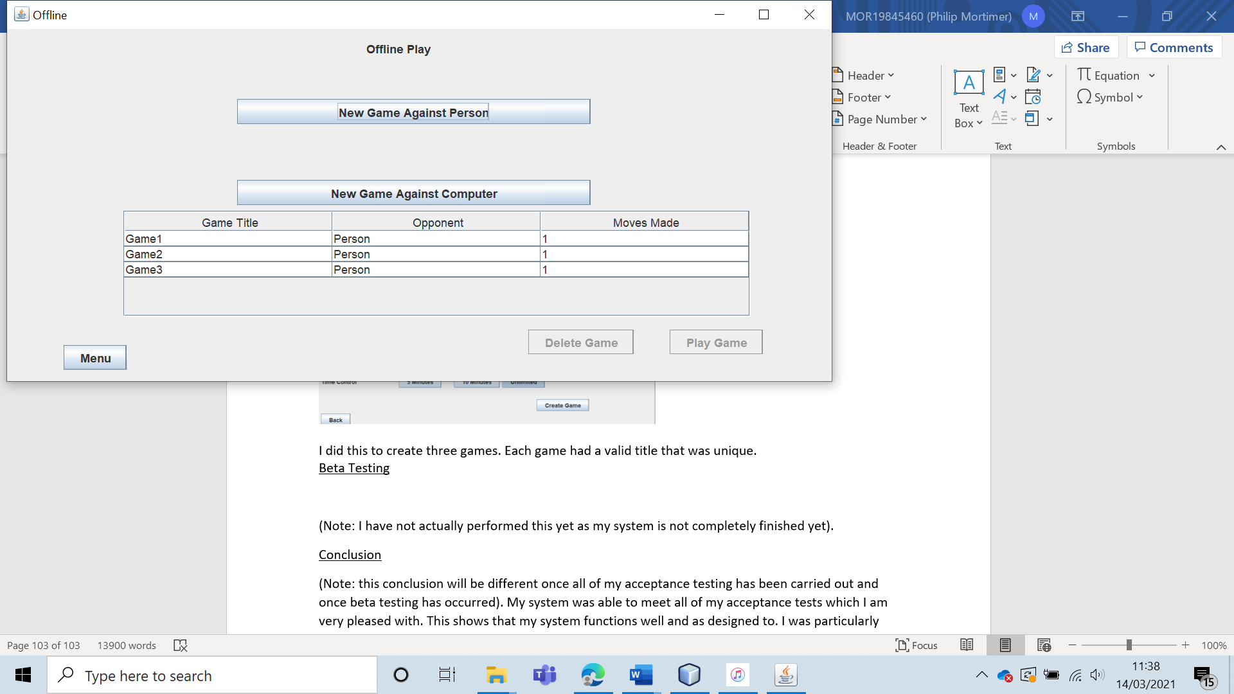

I did this to create three games. Each game had a valid title that was unique. This also worked when I created my own game title.

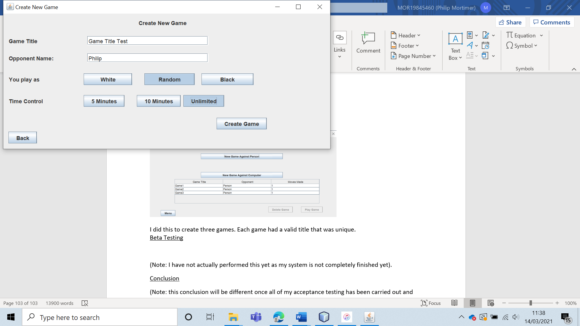

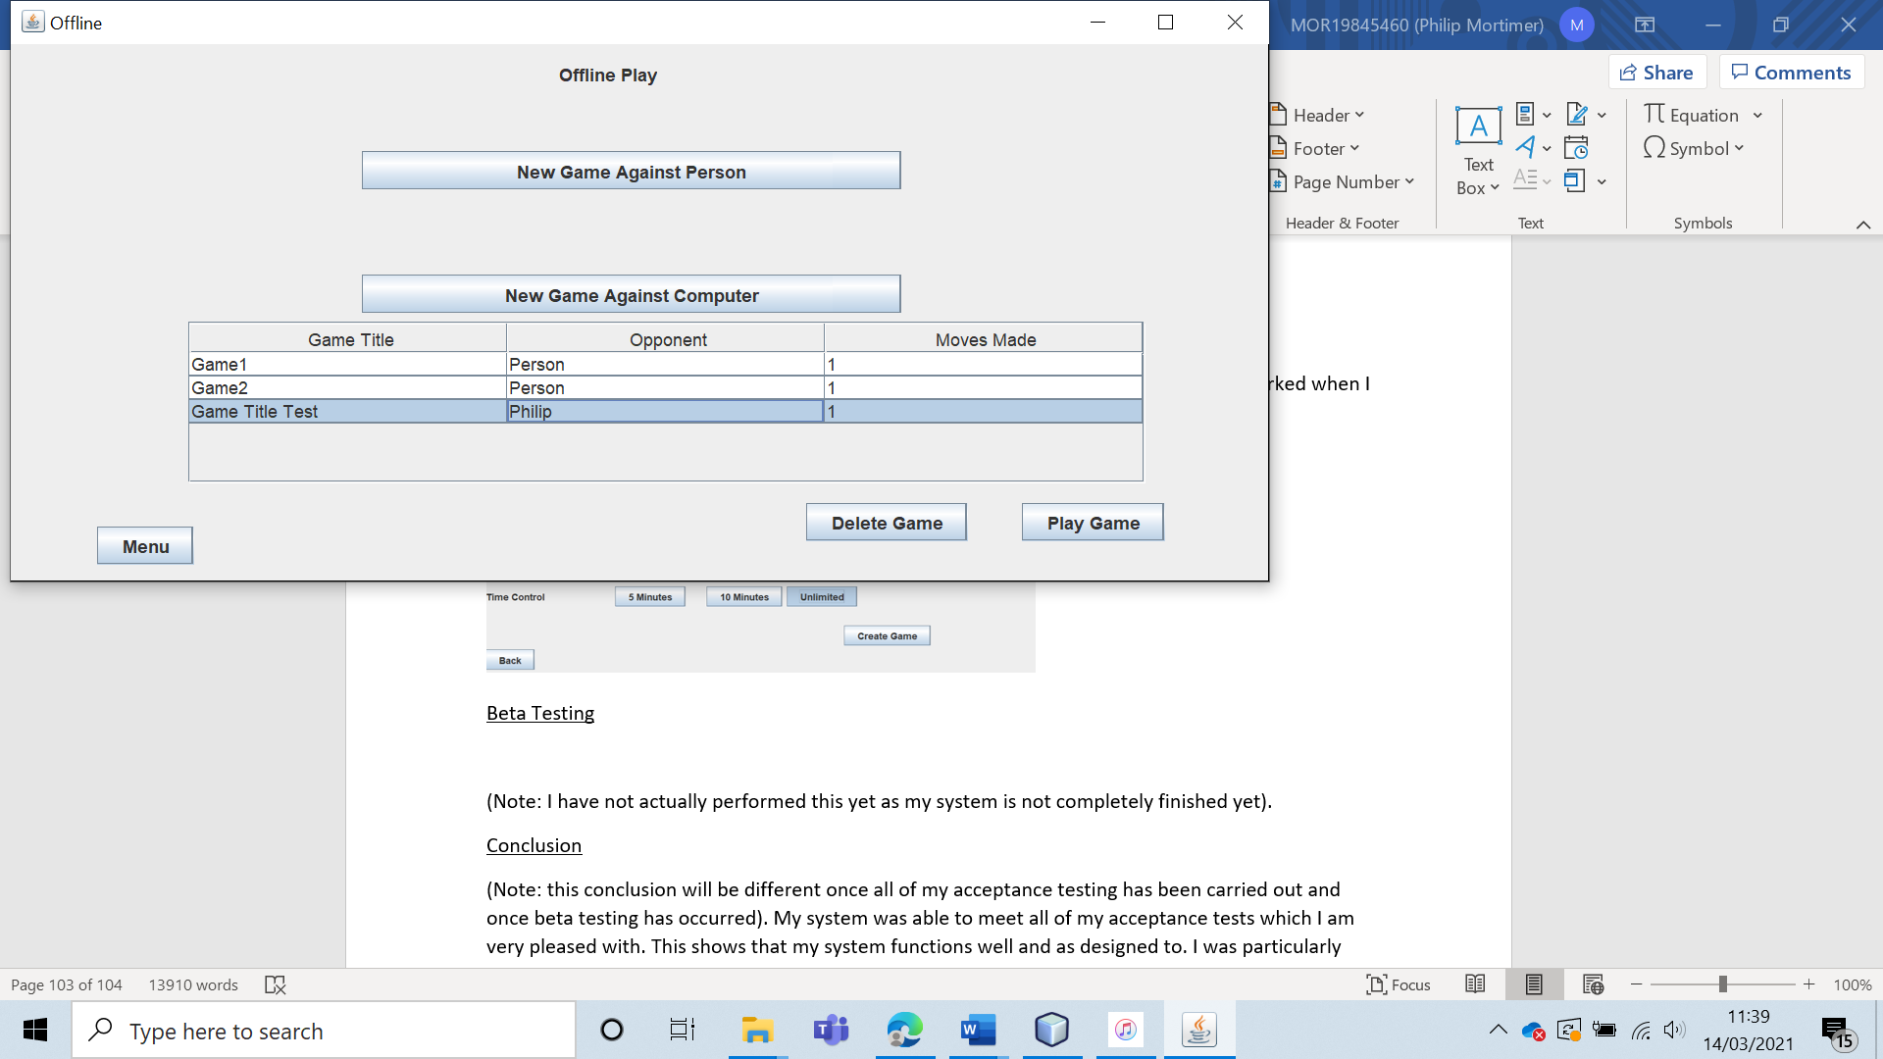

Clearly, the generation of games with valid game titles works.

|  |  |  |  |  |  |  |
| --- | --- | --- | --- | --- | --- | --- |
| 29 | Attempt to create an offline chess game with a game id that is already in use. | To ensure that each offline game record is unique. |  | The game should not be created, and a message should be displayed explaining that the chosen game id is already taken. | 4b | The offline game is not created and the user is told that they must select a game title that is not already currently in use. |

Test 29

To test this, I created a game with the title “Game Title”.

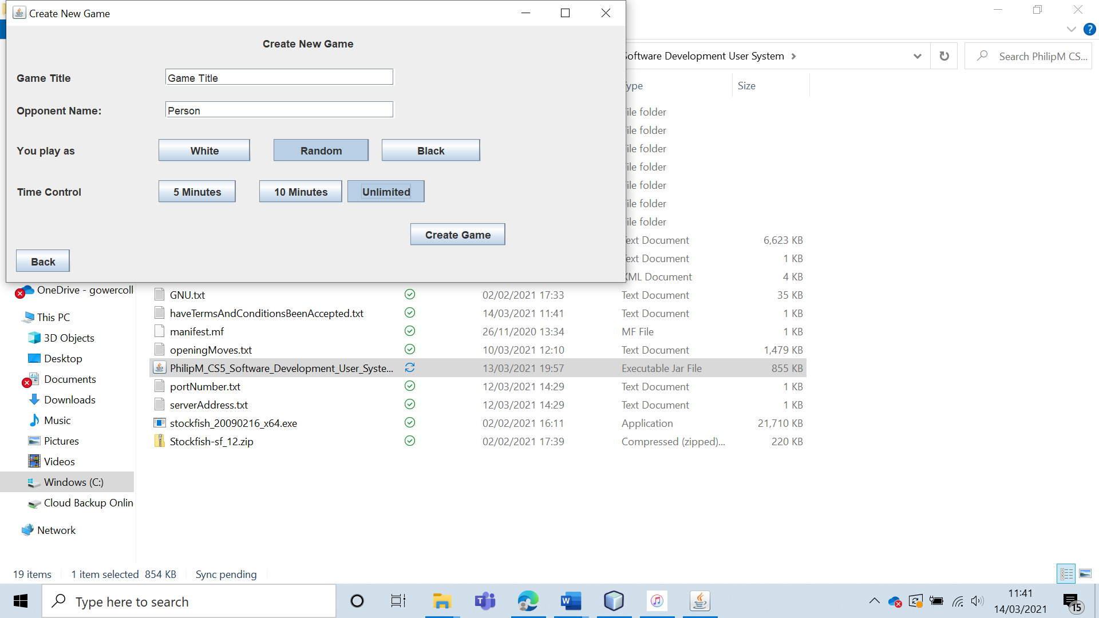

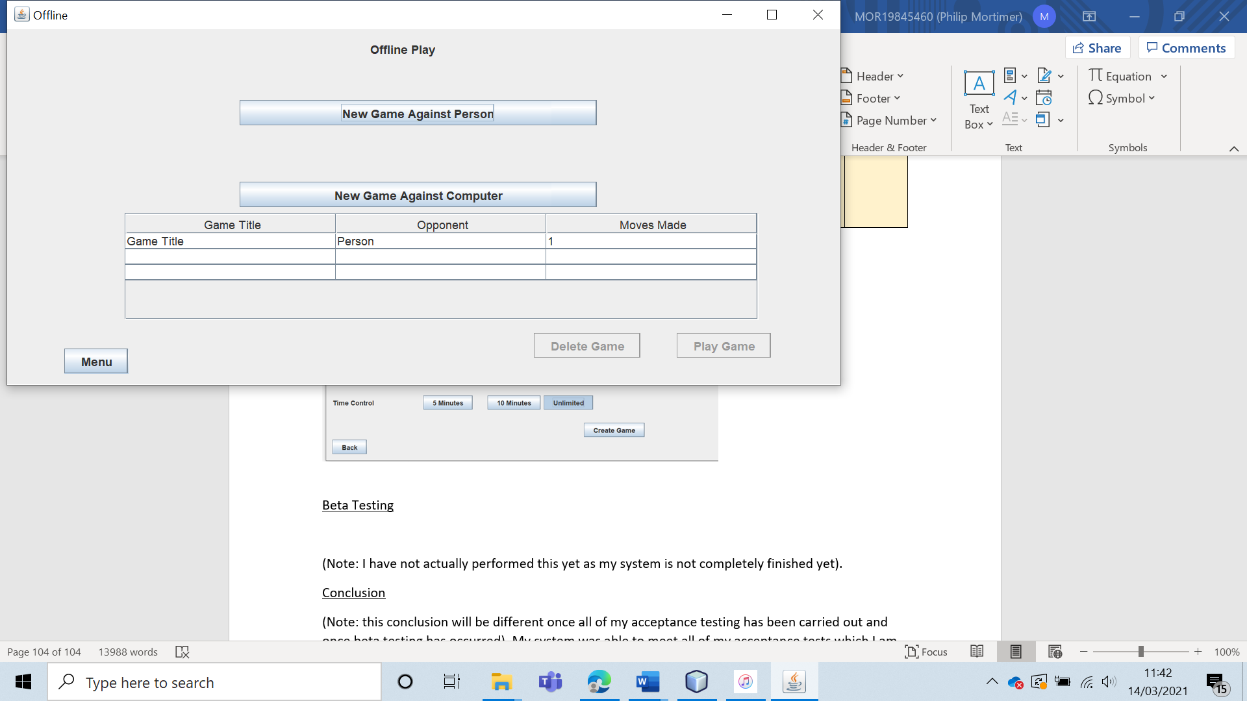

Then, I attempted to create a new offline game with the title “Game Title”.

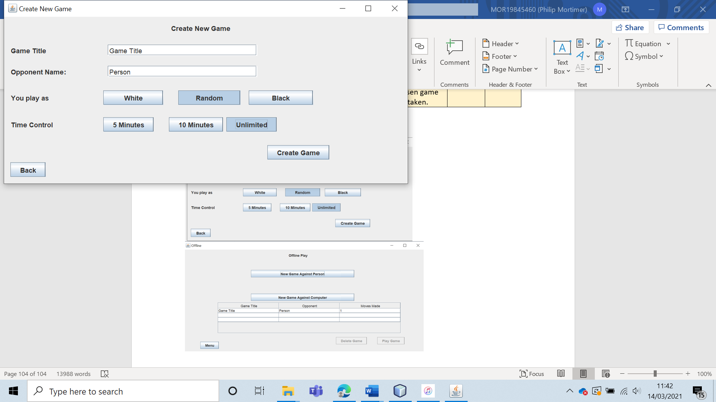

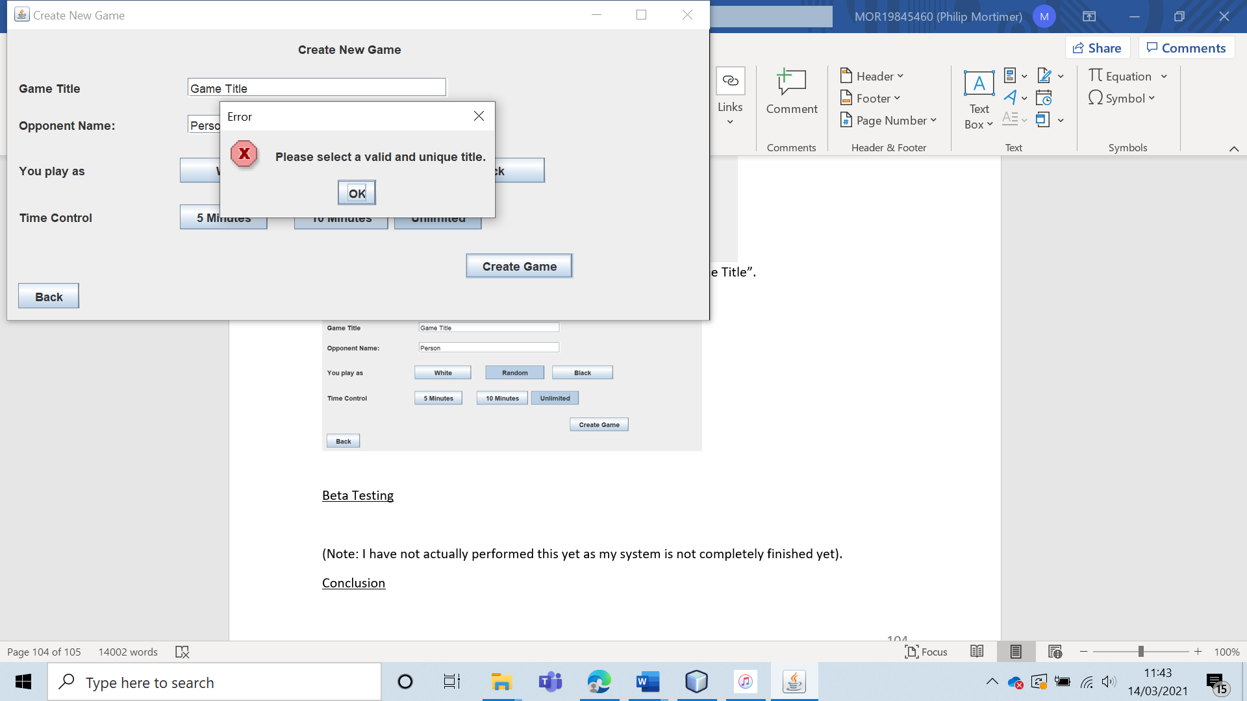

The game is not created, and the user is told that they must use a unique game title.

|  |  |  |  |  |  |  |
| --- | --- | --- | --- | --- | --- | --- |
| 30 | Play games against each of the 5 computer levels. I will then verify that they each play the game differently. | To ensure that the five computer difficulty settings are in fact unique. |  | Each of the five computers should play differently at certain board states. | 5 and 5ai. | In some board states, different moves are played by different computer settings. This proves that the chess opponents are all unique algorithms. |

Test 30

To verify that the five difficulty settings are different algorithms, I played the same opening move against all five computers. Namely, pawn to f3. In these test runs, I am white, and the computer is black.

First, against the level one computer.

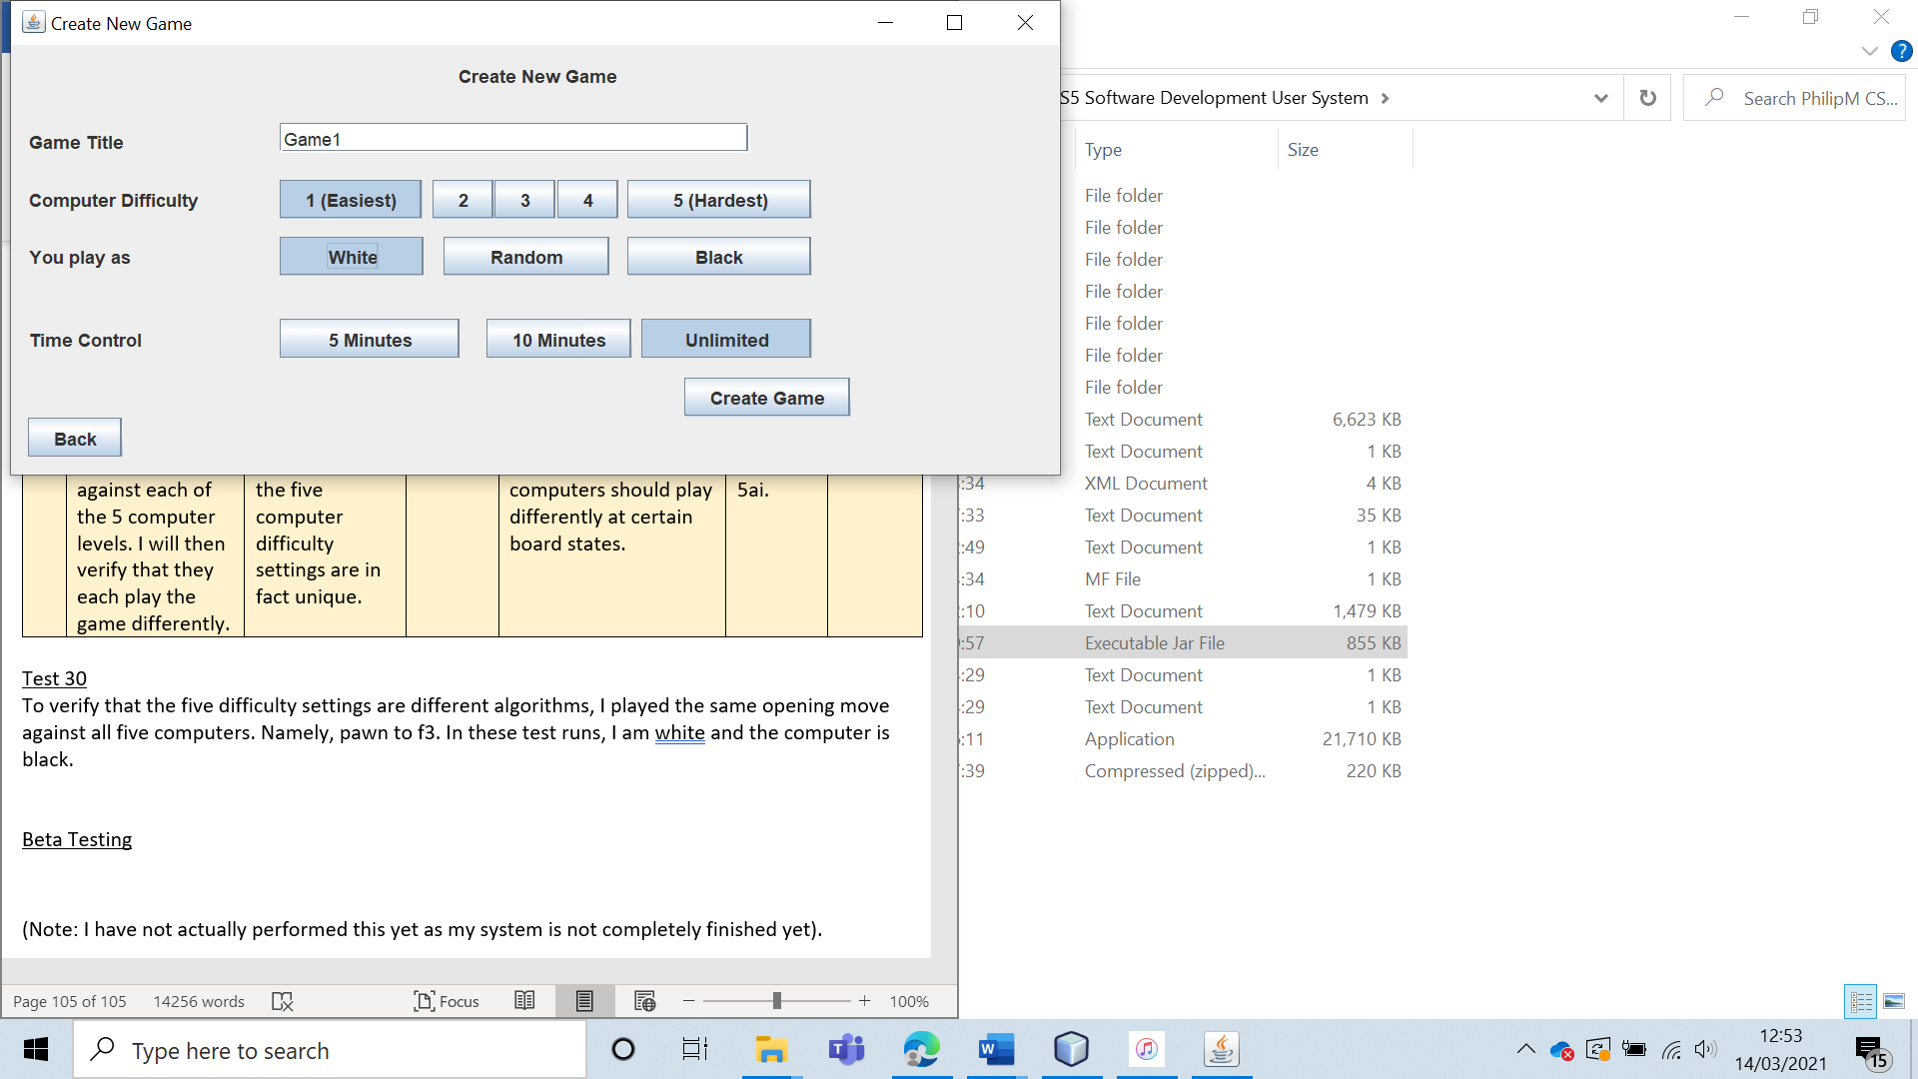

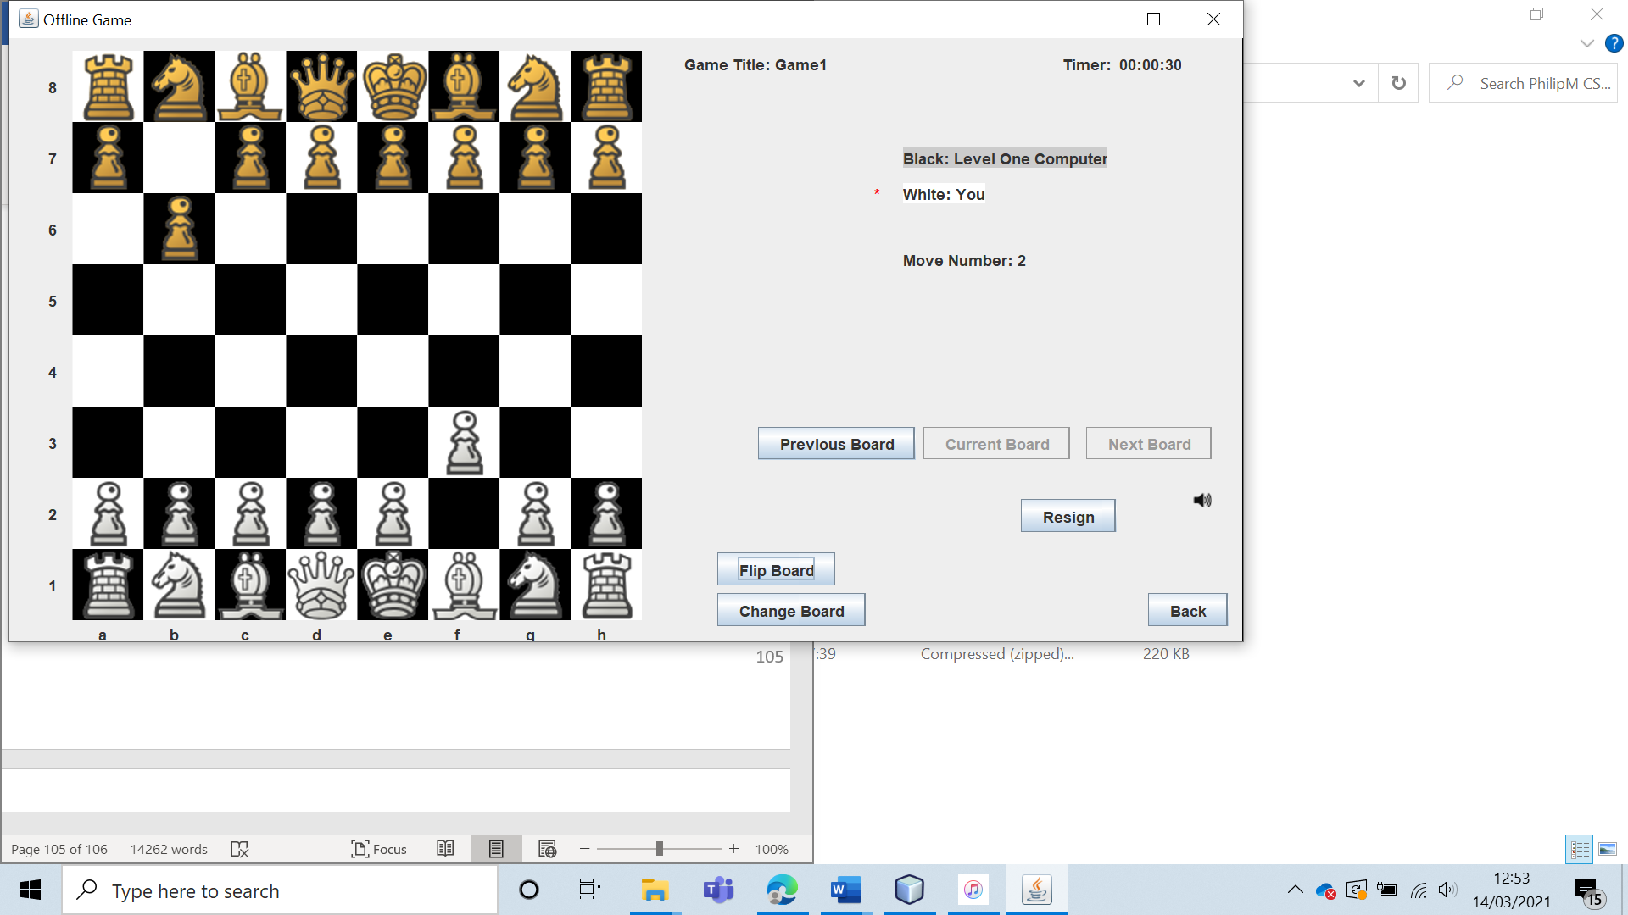

Then, against the level two computer.

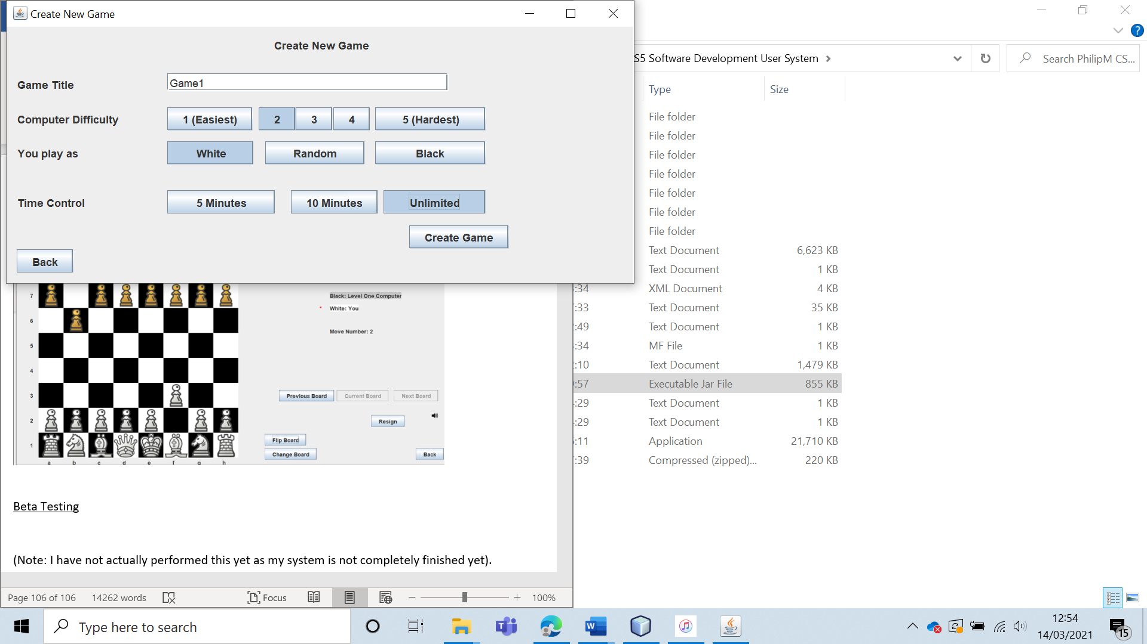

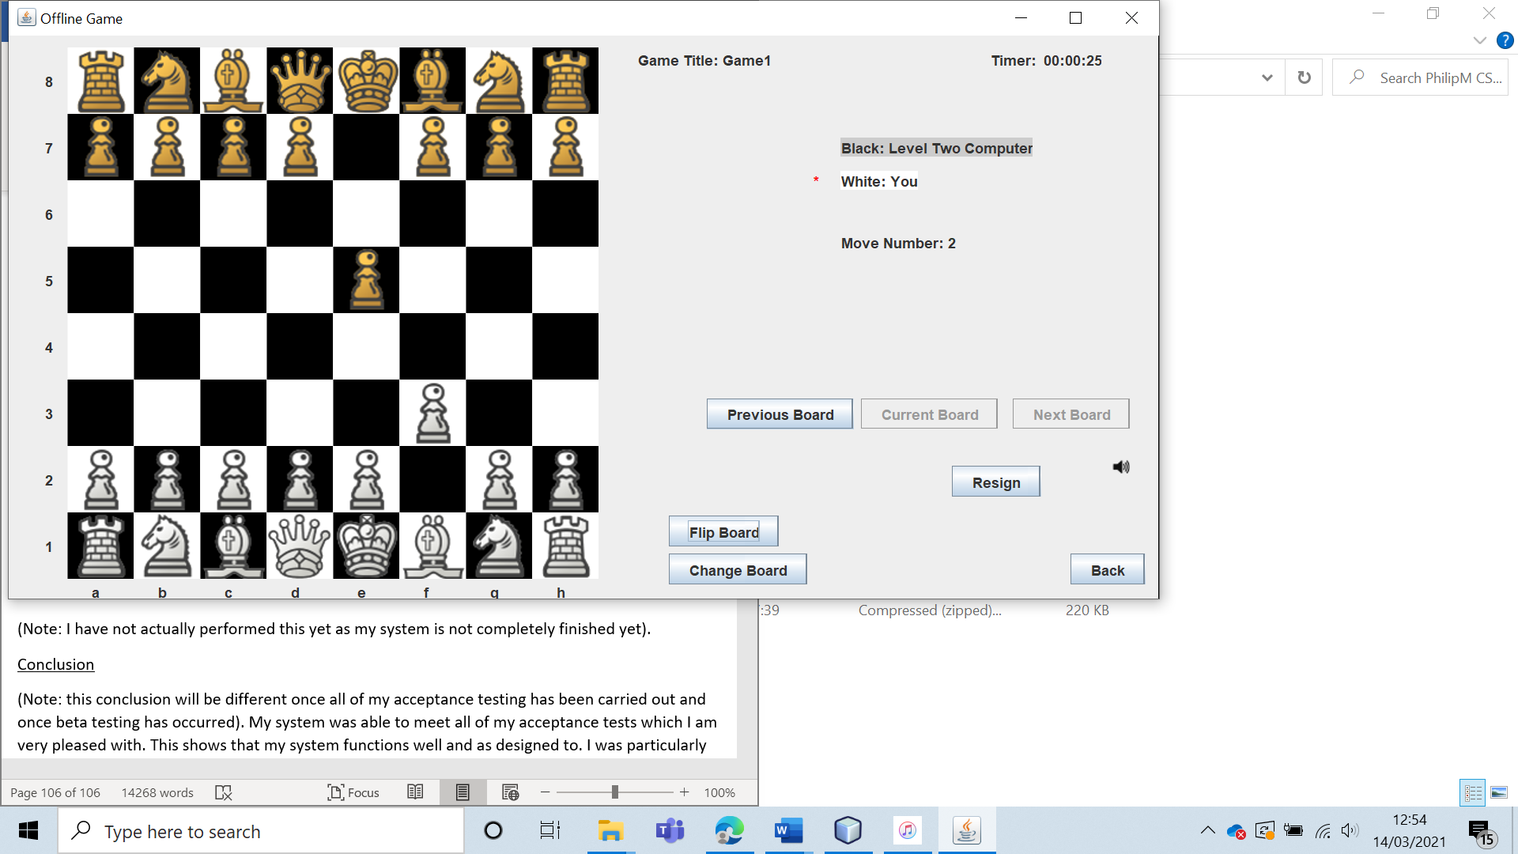

Then against the level 3 computer.

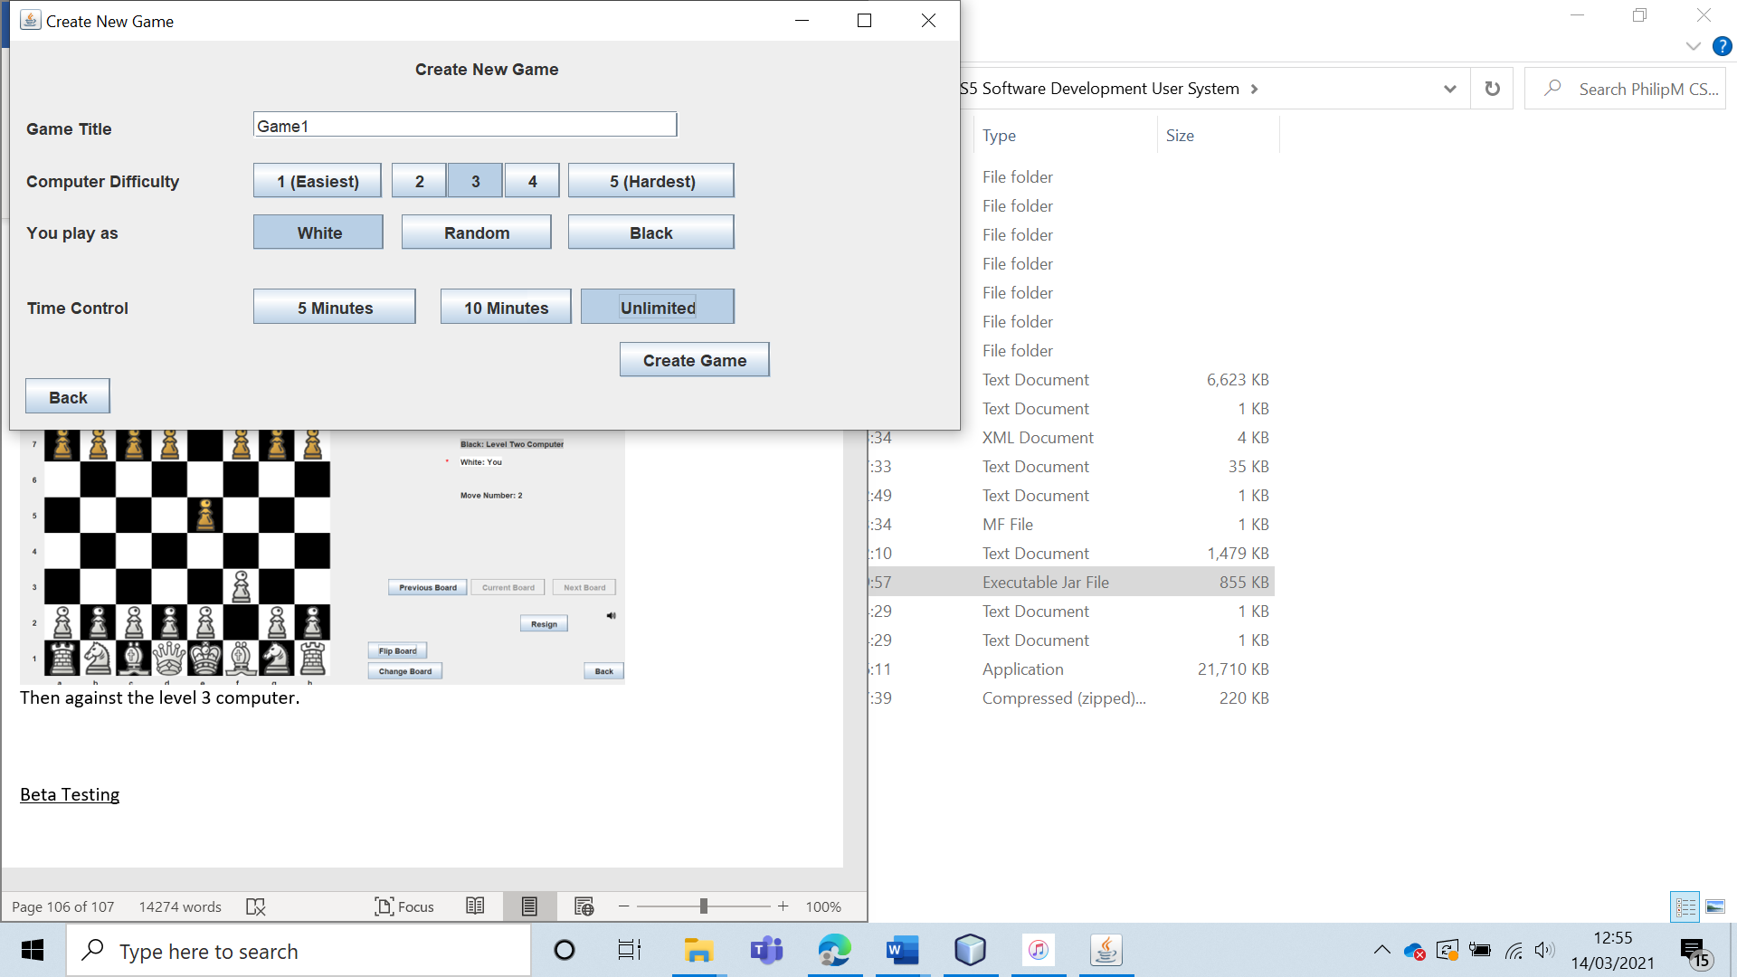

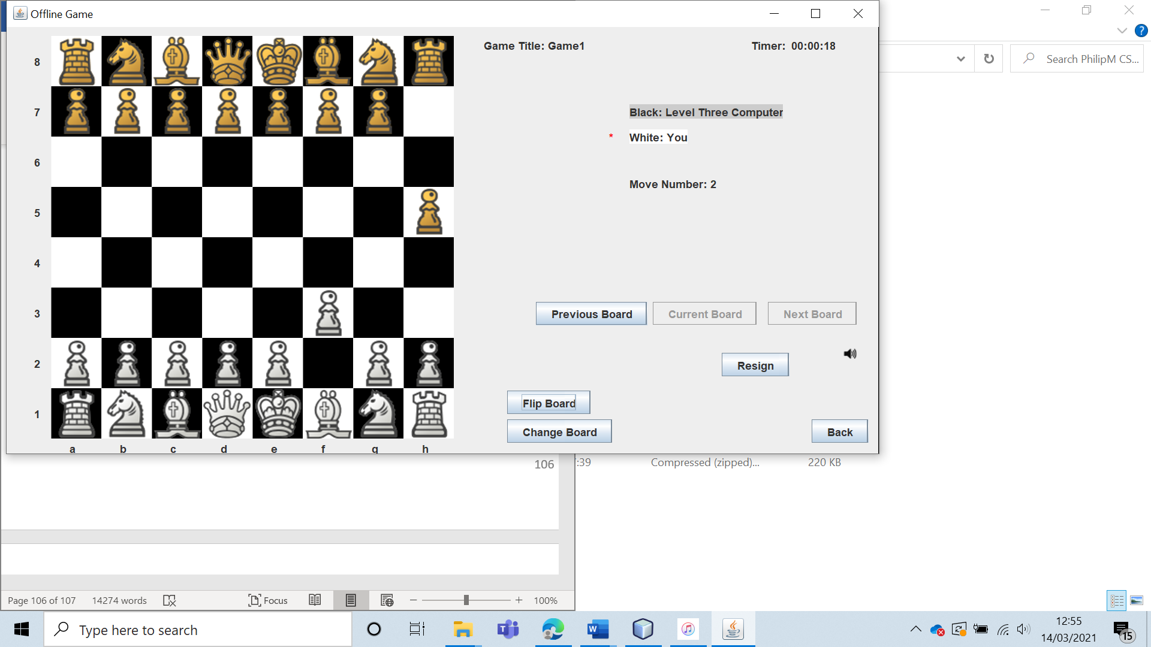

Then against the level four computer.

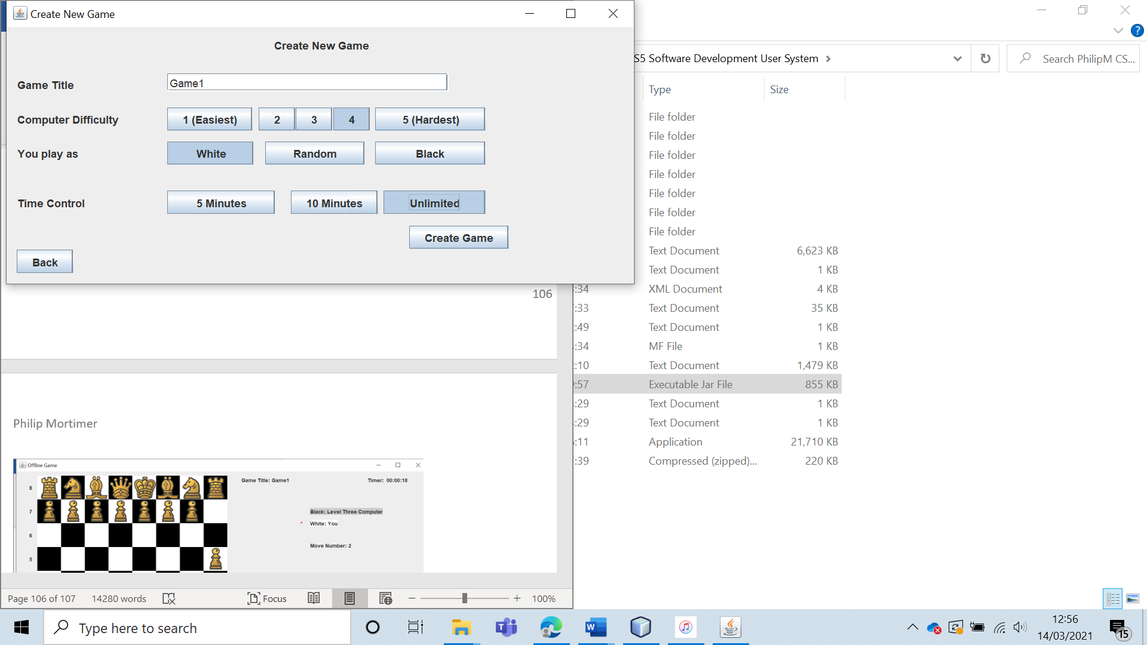

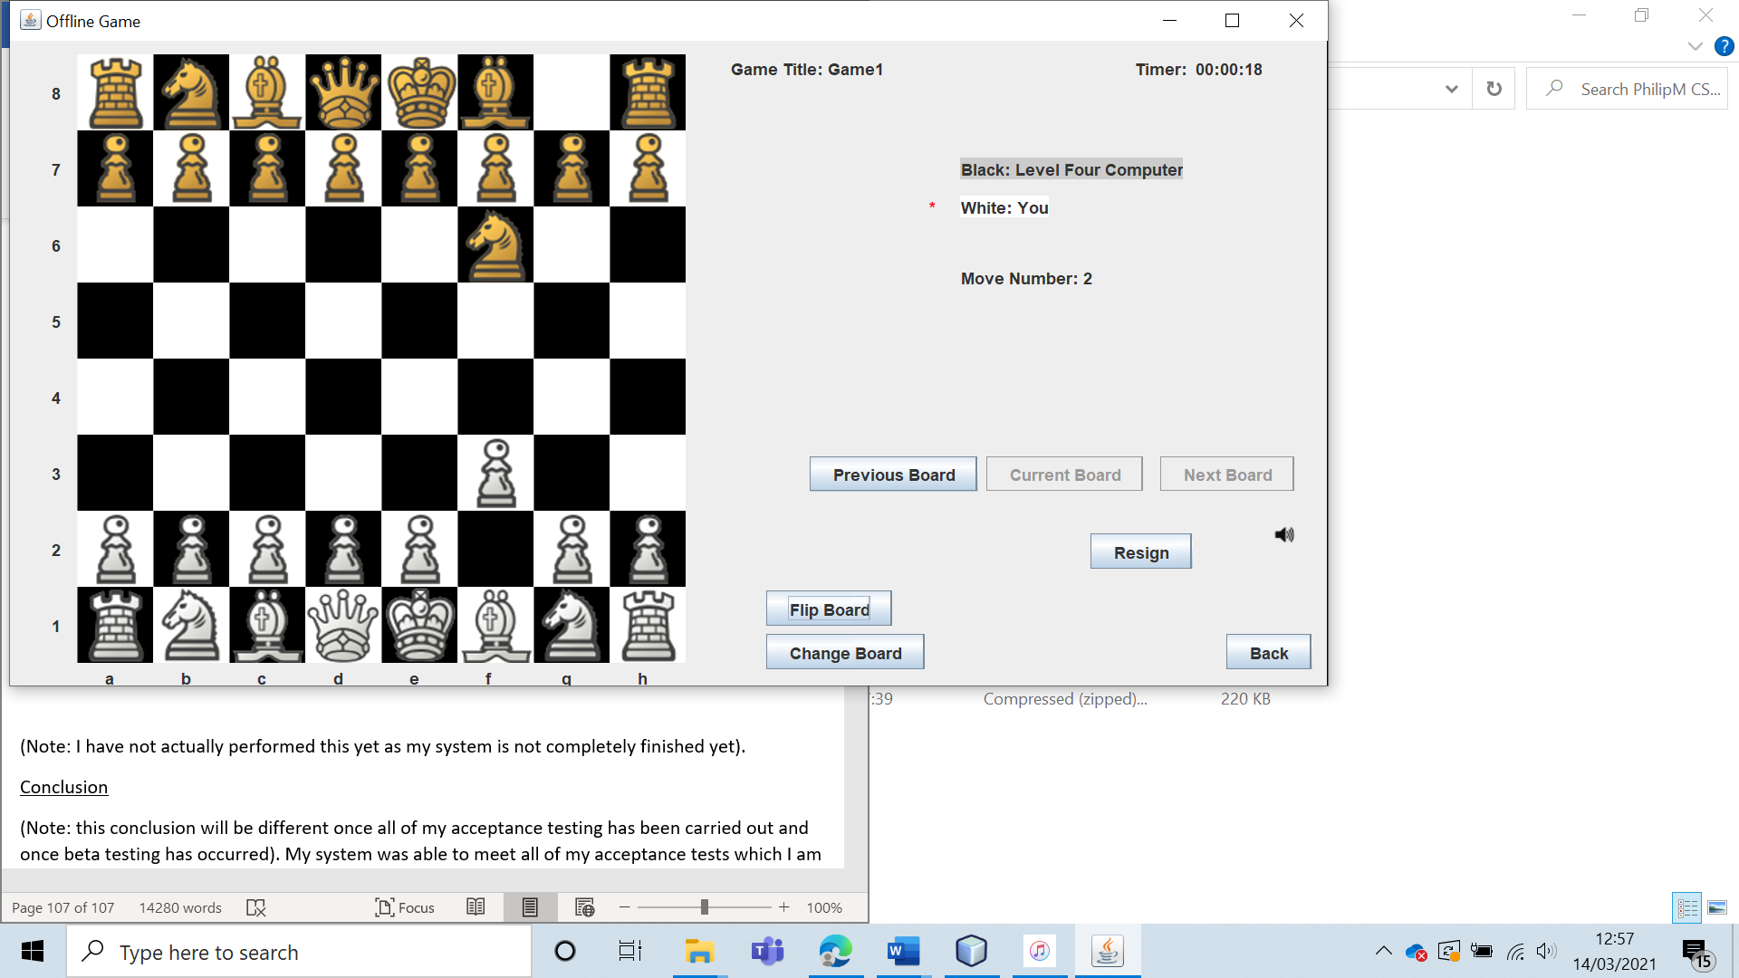

Then against the level five computer.

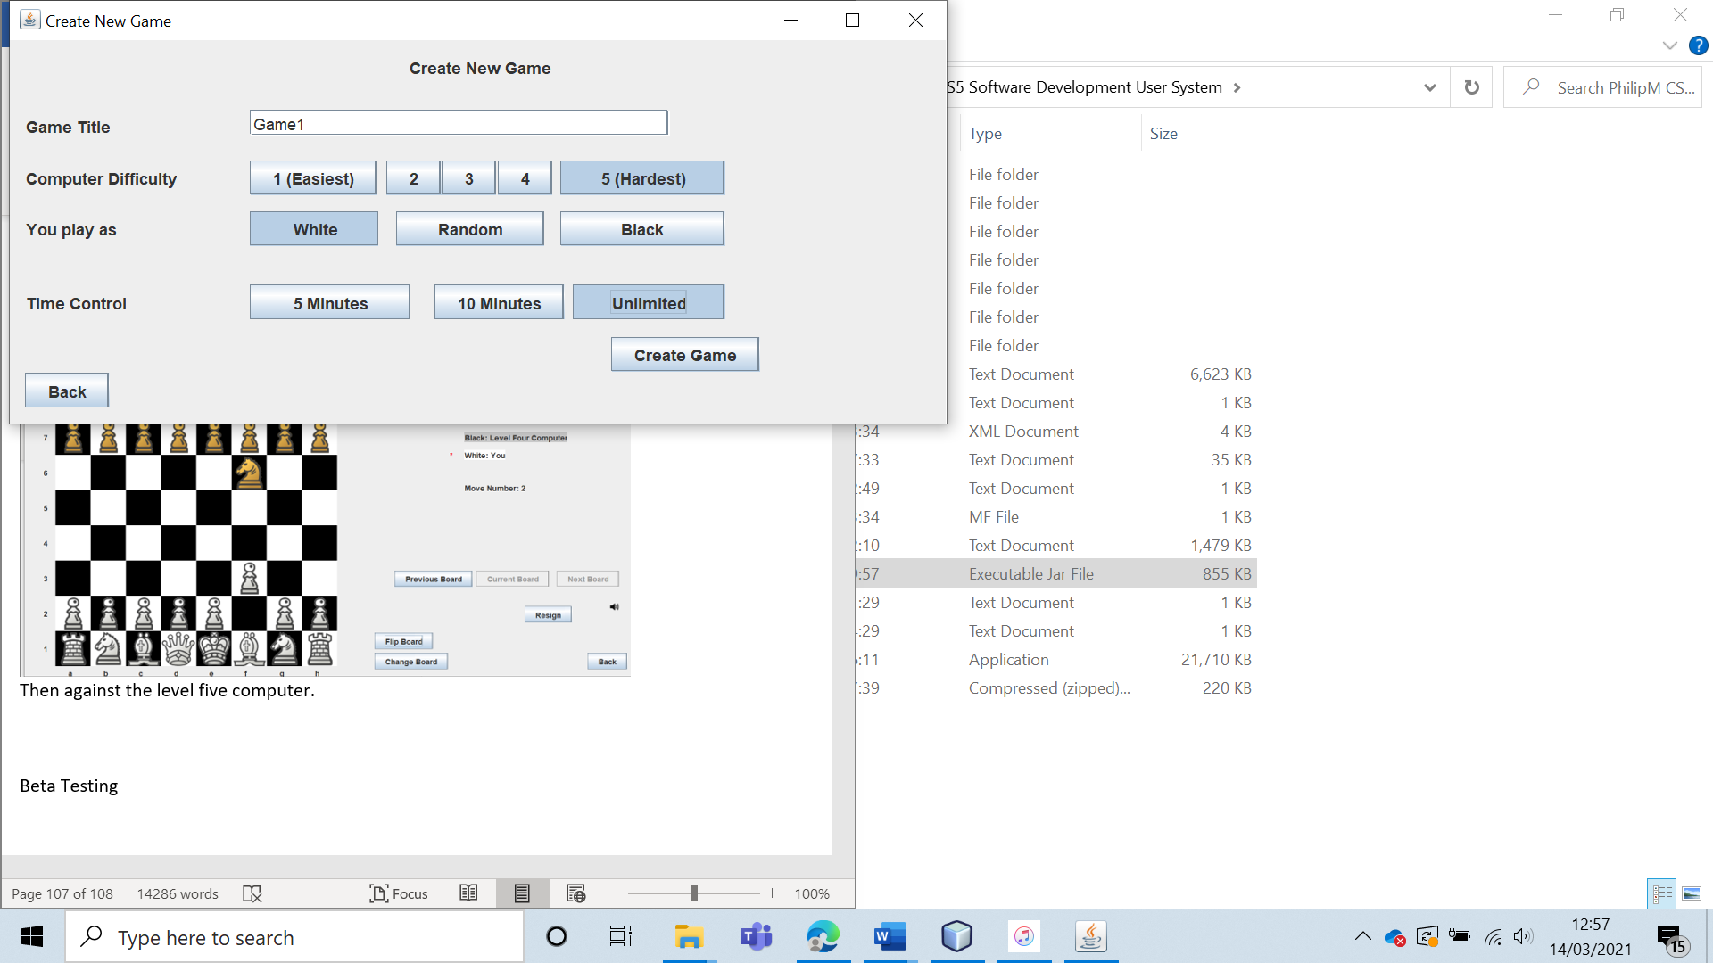

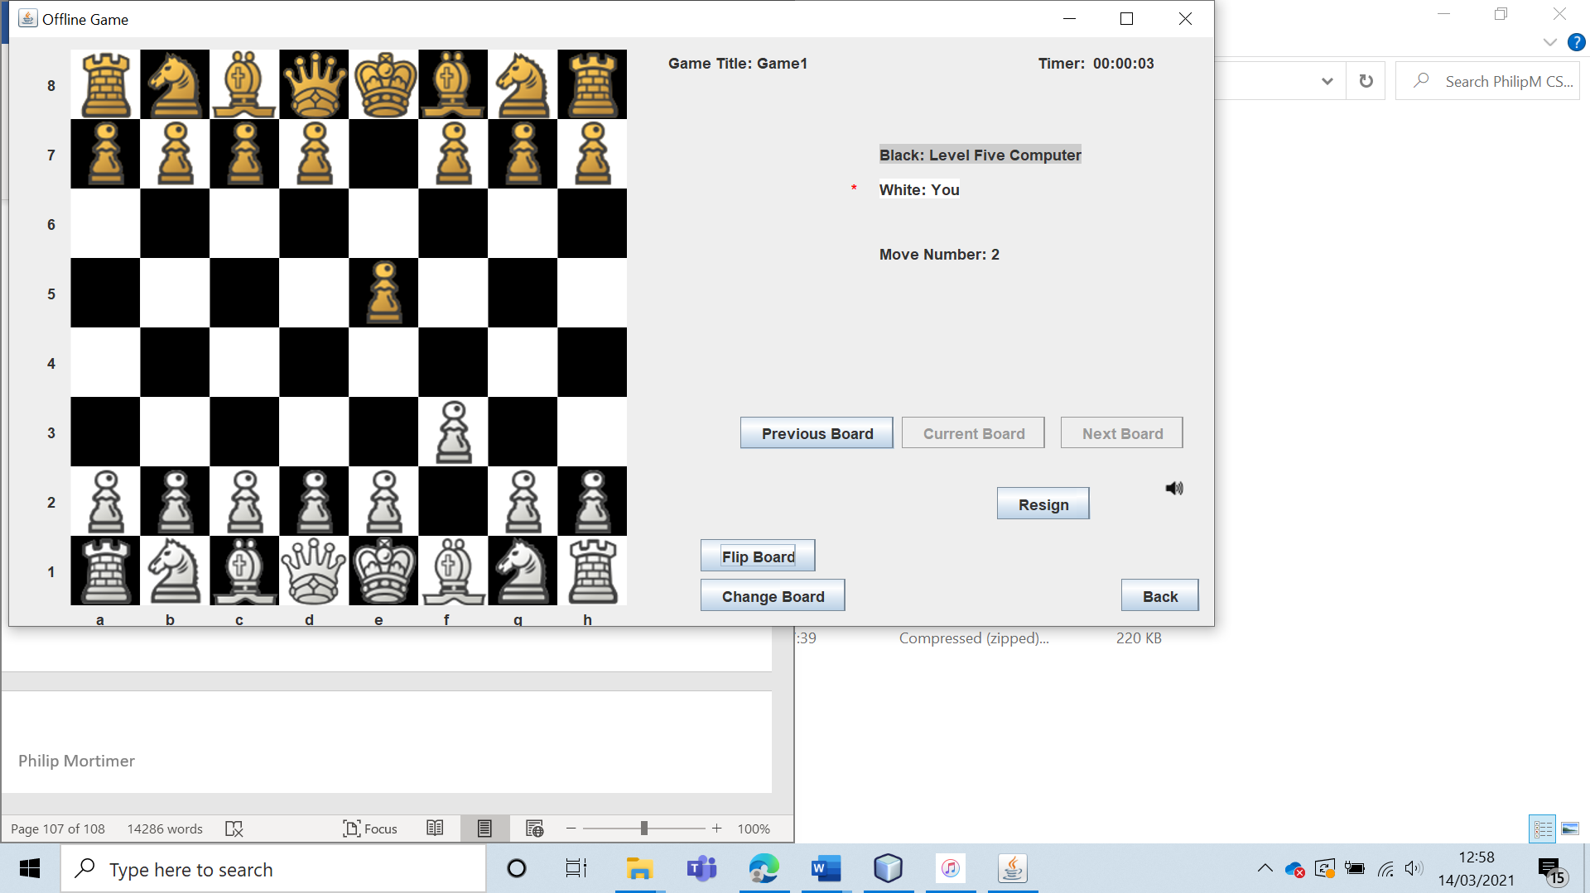

As you can see, each computer does in fact play a different move showing that they are five distinct and different algorithms.

|  |  |  |  |  |  |  |
| --- | --- | --- | --- | --- | --- | --- |
| 31 | Have all of the computers play chess games against each other. | To establish that they are all different algorithms and that that they are ranked in order of difficulty. |  | On average, the stronger computer should beat the computer that is ranked as weaker. | 5a and 5ai. | All the computers played each other, and the stronger computer never lost to the weaker computer, as expected. This shows that the difficulty settings are correctly ranked. Although, it was noted that the computer opponents were vulnerable to getting stuck in a loop of playing the same sequence of moves. This led to draws where one side was winning by a lot. |

Test 31

To test this, I had every computer play each other twice (once as black and once as white). I then put the results into a table. I did not play computers of the same difficulty against each other. I then assigned a score. A win is worth one point, a draw 0.5 points and a loss zero points. Hence the game can be represented by opponentColumn – opponentRow. E.g., 2-0 represents that opponentColumn won both games. Opponent column is the opponent represented in the column. Fields where the computer believed to be stronger won overall are highlighted green.

|  |  |  |  |  |  |  |
| --- | --- | --- | --- | --- | --- | --- |
|  | Opponent Column | | | | | |
| Opponent Row |  | 1 | 2 | 3 | 4 | 5 |
| 1 | - | 2-0 | 2-0 | 2-0 | 2-0 |
| 2 | 0-2 | - | 2-0 | 2-0 | 2-0 |
| 3 | 0-2 | 0-2 | - | 1.5-0.5 | 2-0 |
| 4 | 0-2 | 0-2 | 0.5-1.5 | - | 2-0 |
| 5 | 0-2 | 0-2 | 0-2 | 0-2 | - |

As expected, the ranking system was very accurate with no computer of a perceived lower difficulty level beating a computer of a higher difficulty level. The most interesting results was when the level 3 and 4 computers drew. This game was interesting as the level 4 computer had a significant piece advantage and a position that was very clearly going to result in a win for the level 4 computer. However, as the minimax search is deterministic, the level 4 computer was stuck in a cycle with the level 4 computer of two moves. When putting the board into the world’s best chess engine, Stockfish, the system finds that there is a guaranteed checkmate for the level four computer opponent in 9 moves.

Let $f_{4}\left(S_{t}\right)= S_{t+1} and f_{3}\left(S_{t}\right)= S_{t+1}$

Where f(S) represents a computer move given a board state, S. Essentially this says that the computer opponent when given a certain board state will always return some determined state $S_{t+1}$

Let $S_{a}$ be a board state when it is the level four’s computer to move. In this game, we had

$$f_{4}\left(S_{a}\right)= S_{a+1}$$

$$f_{3}\left(S_{a+1}\right)= S_{a}$$

So, we had a situation where the level four computer was clearly winning but was caught in an endless loop and hence was unable to win the game. If I were to spend more time on the system, adding incentives to negate this is something that I would look to do.

Despite this, the results were crystal clear: the computers were definitely ranked correctly in order of difficulty. I was particularly pleased with the range of difficulty, with level 1 and two being suitable opponents for beginners, 3 and 4 being good opponents for mid ranged players and level 5 being suitable for highly advanced players.

|  |  |  |  |  |  |  |
| --- | --- | --- | --- | --- | --- | --- |
| 32 | Create all possible types of offline games (using different time control settings and who plays as what colour). | To establish that all offline games can be created and played as intended. | All possible combinations of computer difficultly, which colour pieces the user plays as and time-control. | All games should be generated and playable with the correct ruleset and computer setting. | 6, 6a and 6 ai. | All possible games are generated correctly, and function exactly as intended. |

Test 32

To do this I will create all possible offline games against a human opponent and verify if they function as intended.

I will do this using the form to create a game against an offline person:

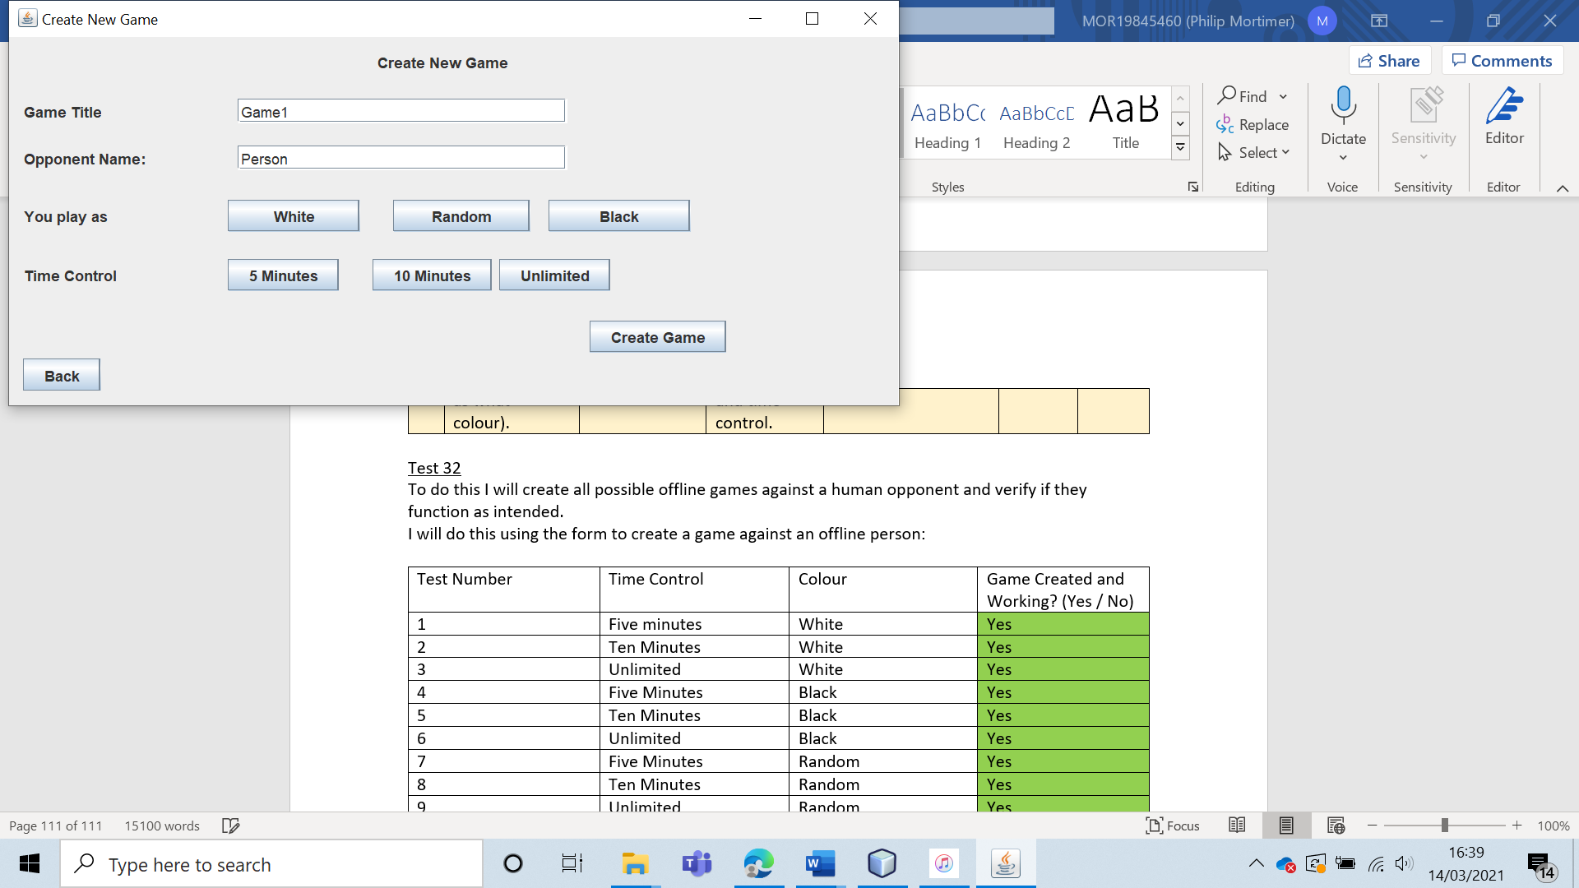

|  |  |  |  |
| --- | --- | --- | --- |
| Test Number | Time Control | Colour | Game Created and Working? (Yes / No) |
| 1 | Five minutes | White | Yes |
| 2 | Ten Minutes | White | Yes |
| 3 | Unlimited | White | Yes |
| 4 | Five Minutes | Black | Yes |
| 5 | Ten Minutes | Black | Yes |
| 6 | Unlimited | Black | Yes |
| 7 | Five Minutes | Random | Yes |
| 8 | Ten Minutes | Random | Yes |
| 9 | Unlimited | Random | Yes |

All of the games against a person were successfully created and played. The function that randomly assigns colour also functioned, with roughly half of games leading to the user being white. To verify this, I used the random function 20 times and recorder the colour the user was assigned to.

|  |  |
| --- | --- |
| Test Number | Colour Selected |
| 1 | White |
| 2 | Black |
| 3 | White |
| 4 | White |
| 5 | White |
| 6 | White |
| 7 | Black |
| 8 | White |
| 9 | Black |
| 10 | White |
| 11 | Black |
| 12 | Black |
| 14 | White |
| 15 | Black |
| 16 | Black |
| 17 | White |
| 18 | Black |
| 19 | White |
| 20 | Black |

So, in the sample of 20, 9/20 games were black, and 11/20 games were black. Clearly this indicates that the random function works. I verified this by copying the code for the colour generator and running it one billion times. The result was that the 50.0000854% of games where white (and the rest were black).

Next, I verified that the games against a computer opponent were all generated correctly and playable. To avoid creating 45 games and testing each one, I only tested that each computer setting was loaded. This is justified as the systems that generate the piece colour and time control are completely independent form the system that generates the computer level. As the two aforementioned systems have already been tested, I only need to test the computer difficulty settings. The generation of all computer levels worked perfectly:

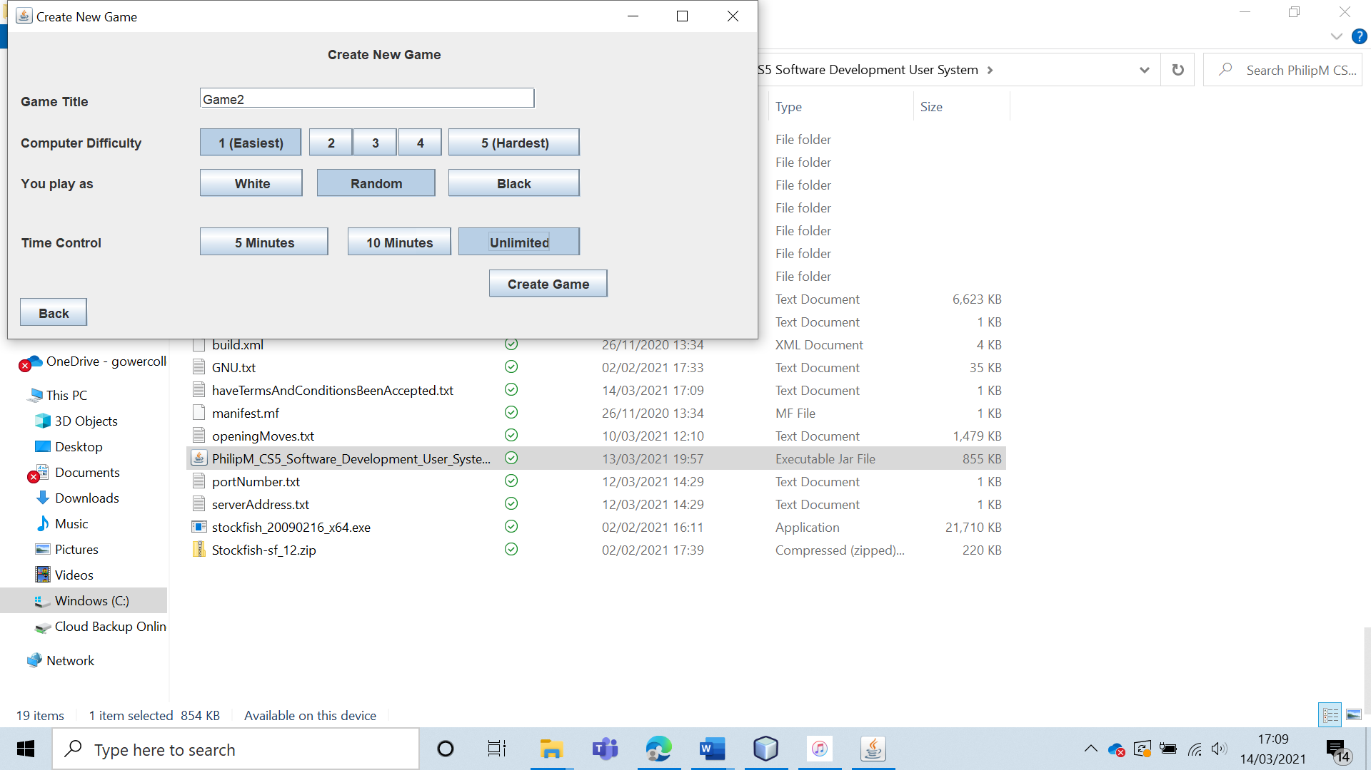

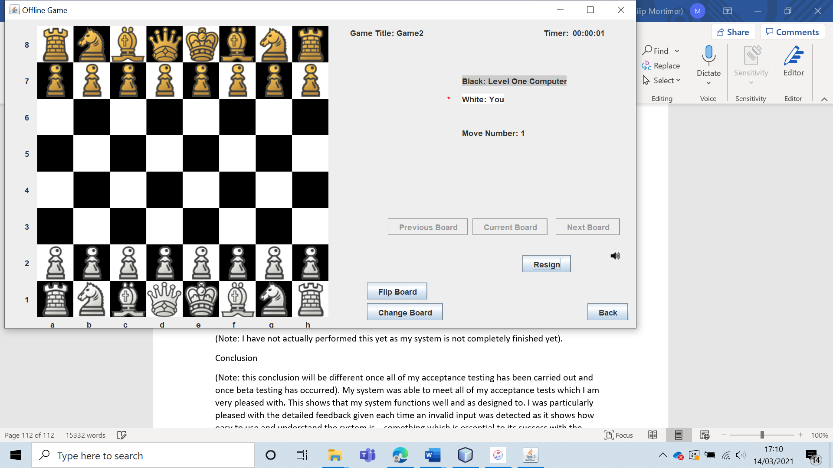

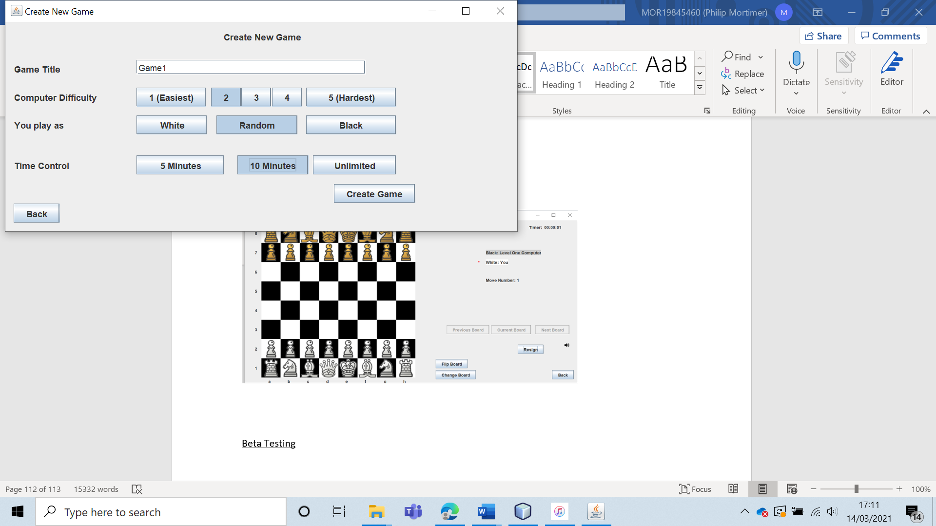

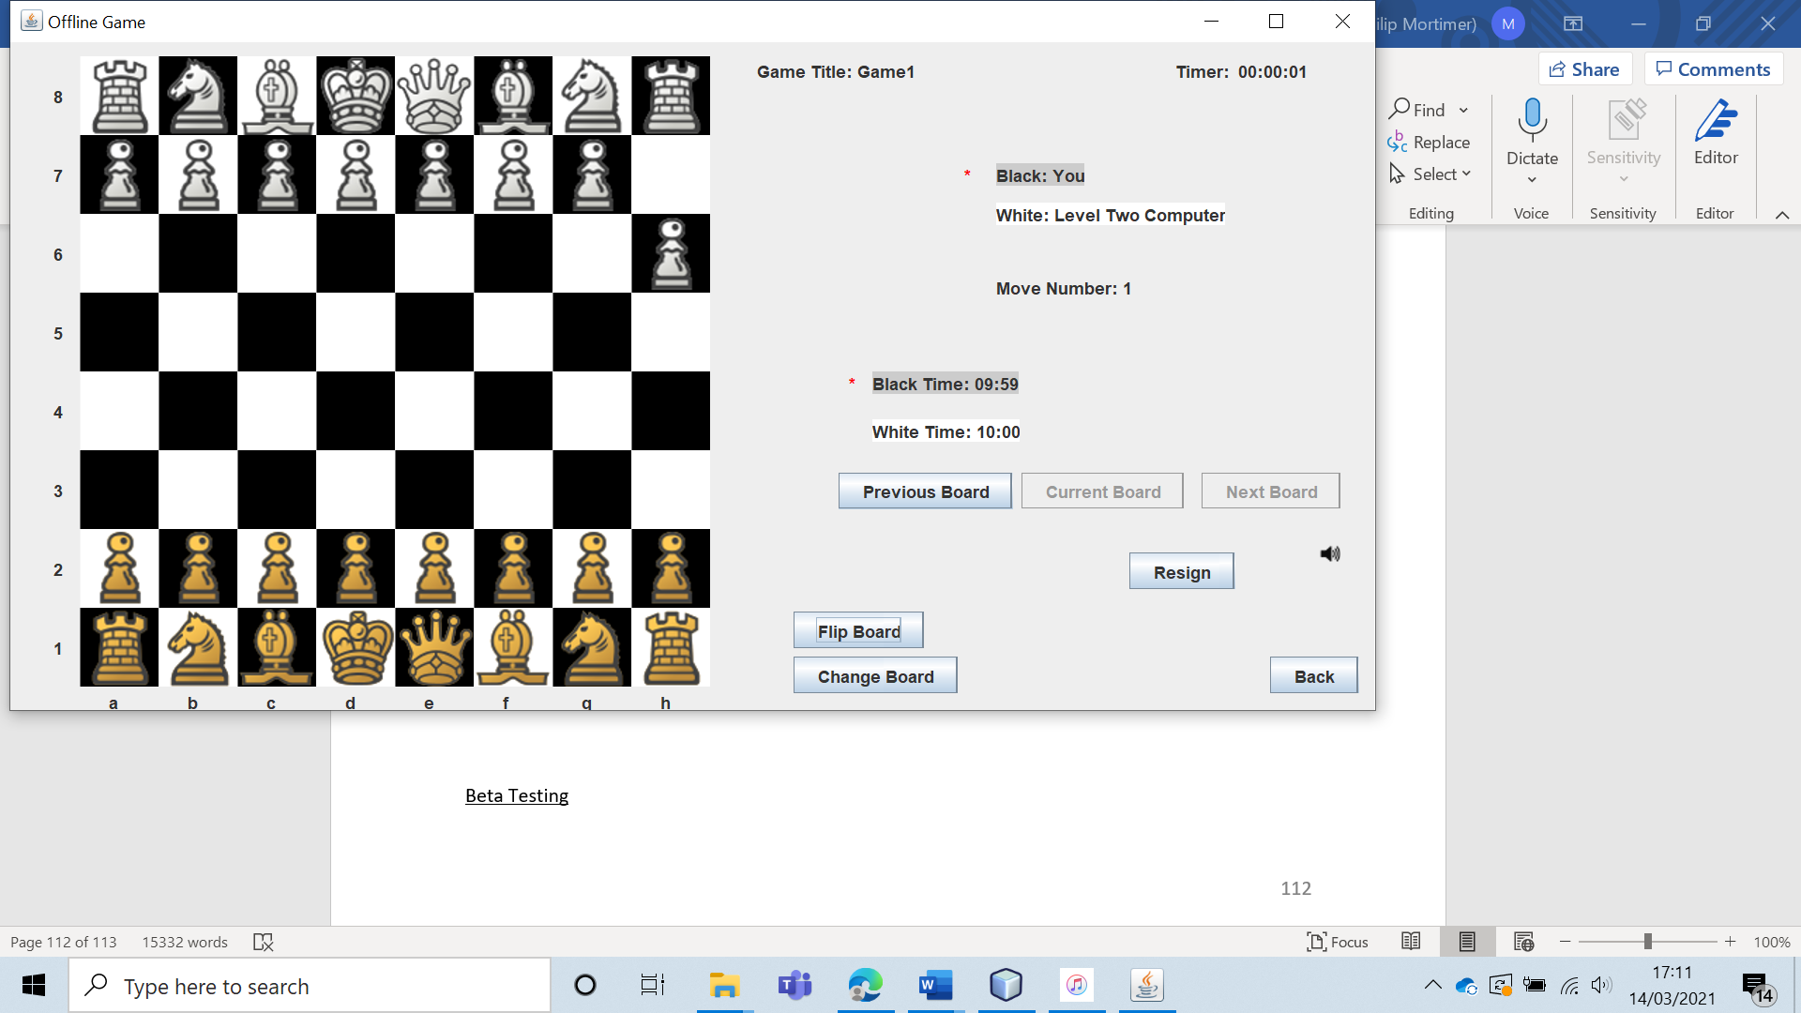

(I did generate the remaining games, but the result was as expected so I have not included the screenshots for the sake of brevity).

|  |  |  |  |  |  |  |
| --- | --- | --- | --- | --- | --- | --- |
| 33 | Have the club leader view the user details of all members of the chess club. | To ensure that the club leader can see all the relevant user info of members of the club. |  | The leader should be able to see all known user info on members of the club, other than their password. | 7a and 7ai. | All of the user information is correctly loaded onto the form and visible. |

Test 33

To do this, I logged in as the leader and went to the “Member Details” section of the system.

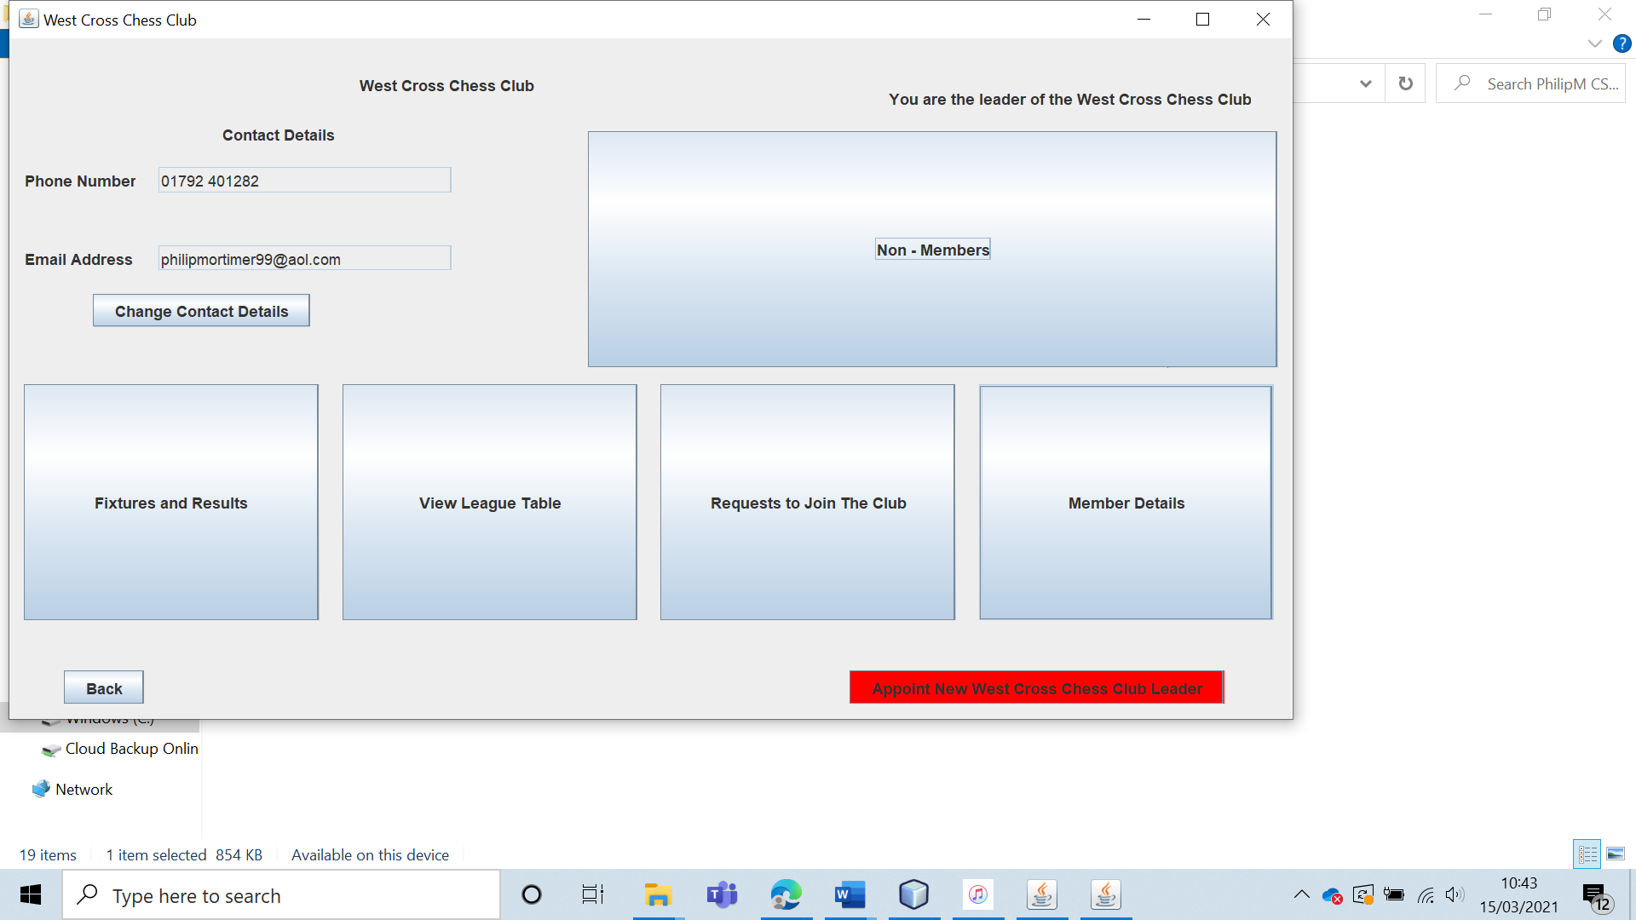

In this section, I am clearly able to view the user information of all three club members.

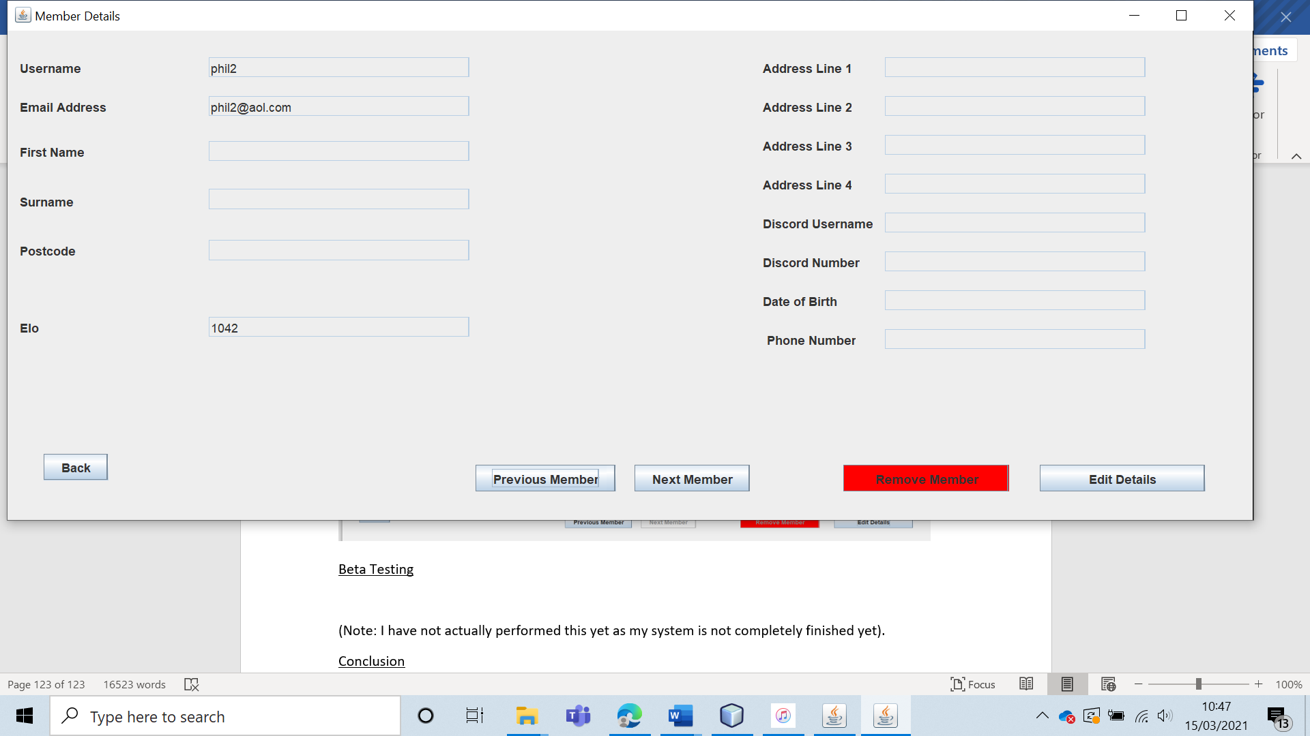

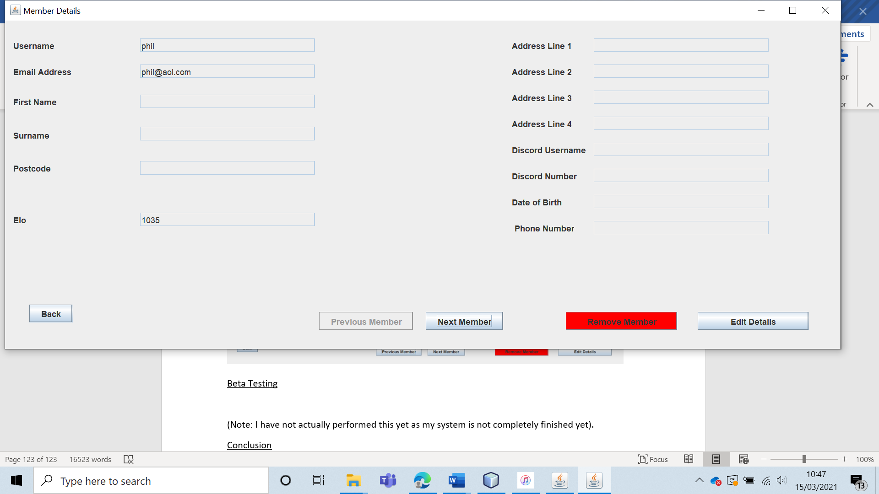

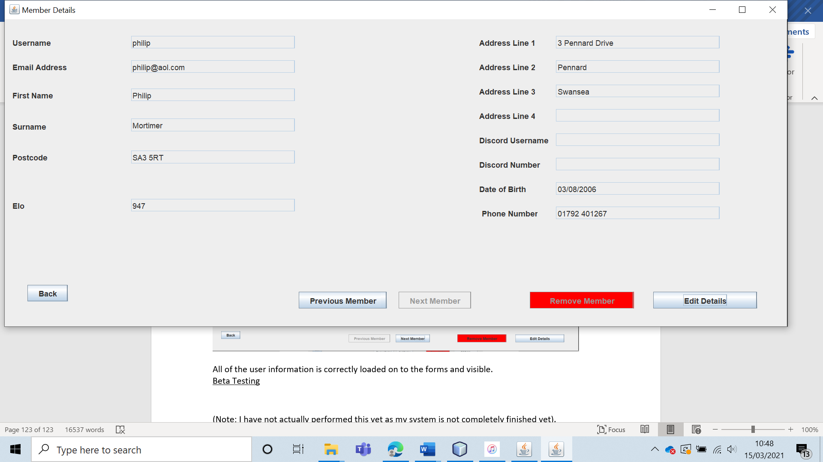

All of the user information is correctly loaded on to the forms and visible.

|  |  |  |  |  |  |  |
| --- | --- | --- | --- | --- | --- | --- |
| 34 | Have the club leader remove a club member from the club and check to see if it worked. | To ensure that the leader is able to remove members from the West Cross Chess Club. |  | The member should be removed from the club. This means that the user should show up in the non-member section. | 7, 7a and 7ai. | The user was removed from the club successfully. |

Test 34

To test this, I removed “phil2” from the club.

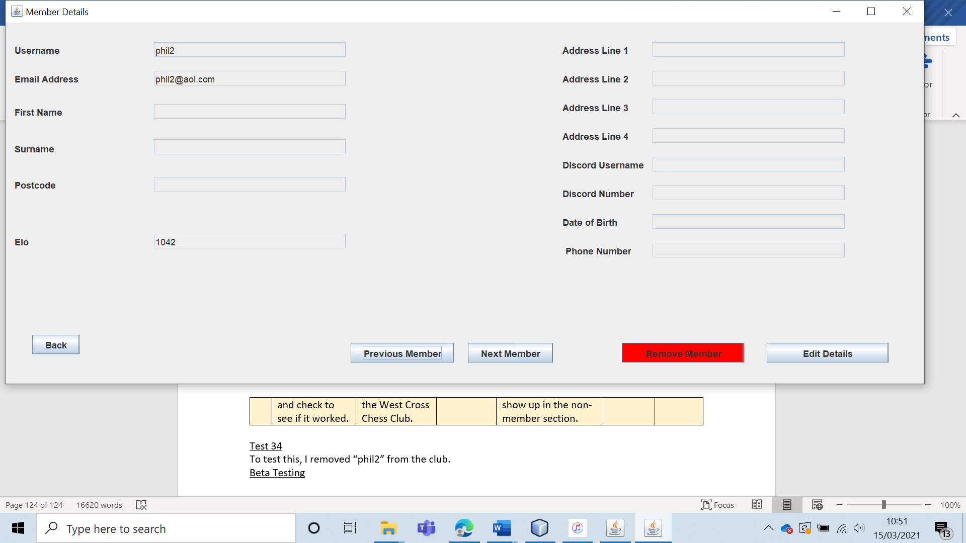

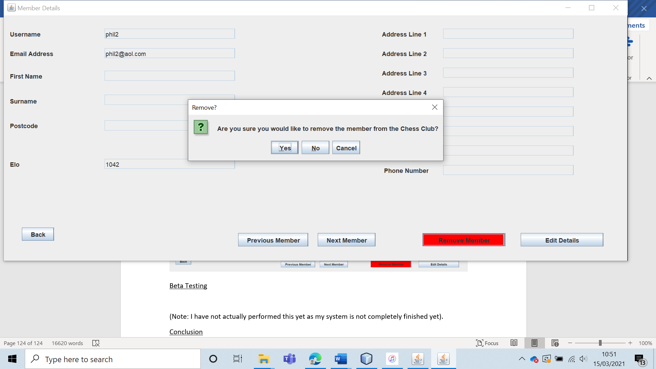

When this is done, “phil2” is non longer visible in the member’s section. However, “phil2” is now visible in the non-member’s section, confirming that the user has been removed from the club.

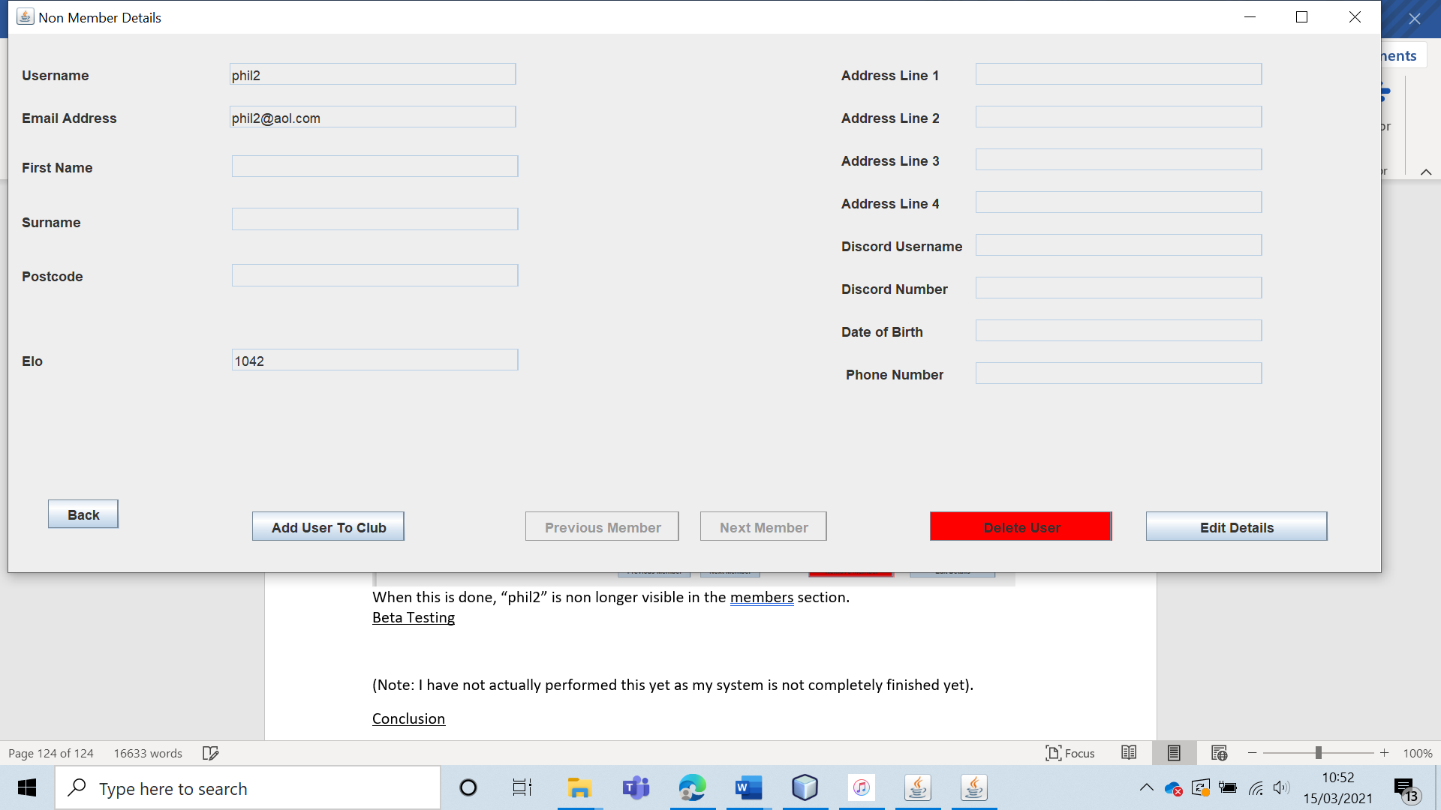

|  |  |  |  |  |  |  |
| --- | --- | --- | --- | --- | --- | --- |
| 35 | Have the club leader add a member to the club and see if it works. | To ensure that the leader is able to add users to the West Cross Chess Club. |  | The added user should appear in the member details section of the application. | 7, 7a and 7ai. | The user was successfully added to the club. |

Test 35

For this I added the non-member “phil2” to the club.

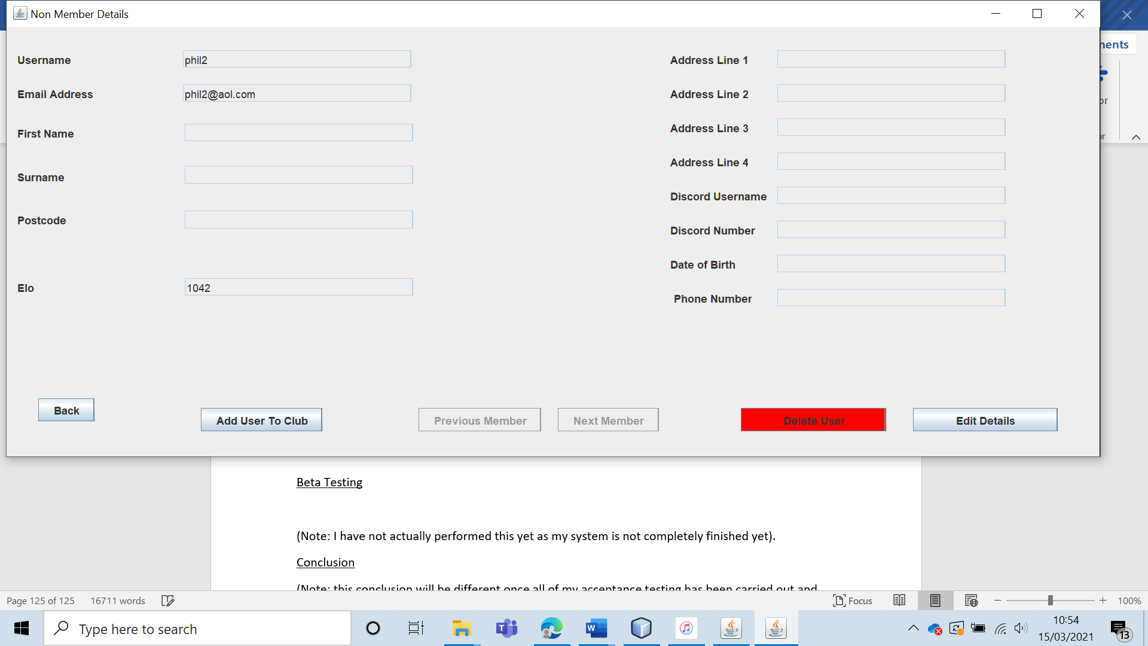

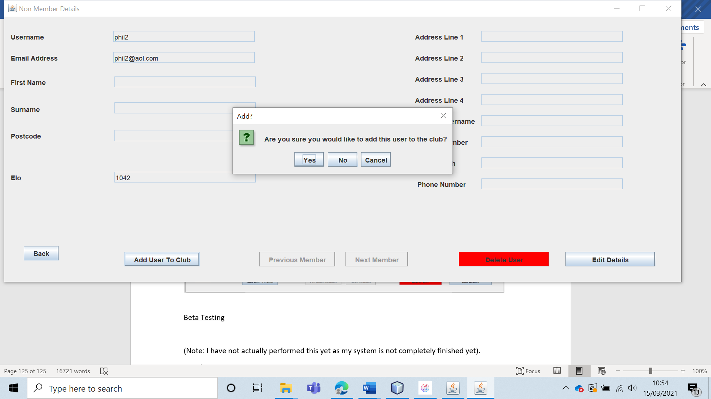

The user was successfully added to the club as the could no longer be seen in the non-member section and could be seen in the member section.

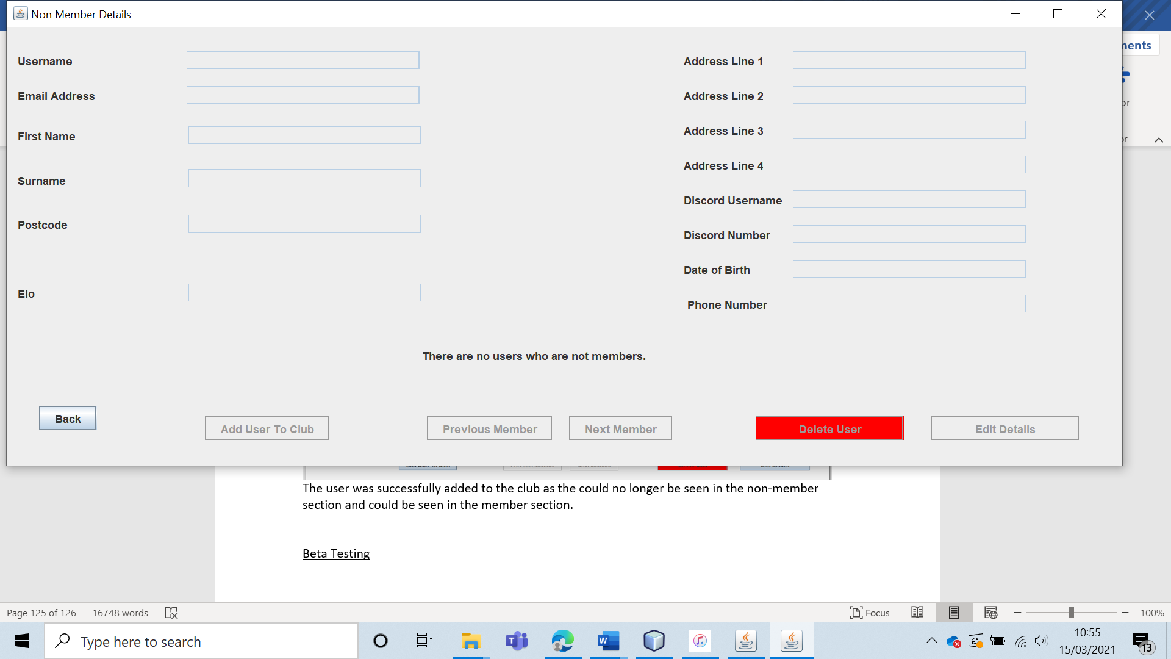

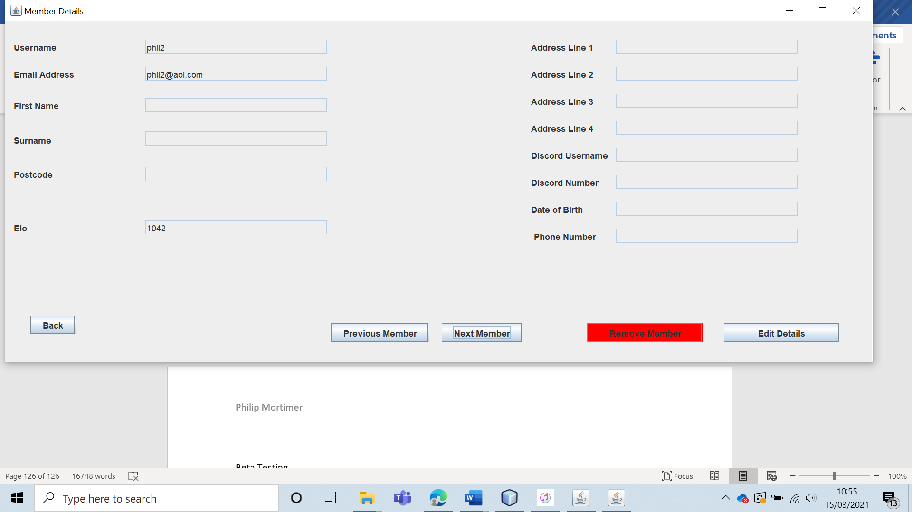

|  |  |  |  |  |  |  |
| --- | --- | --- | --- | --- | --- | --- |
| 36 | Get the club leader to try and remove themselves from the club (invalid input). | To ensure that the club leader cannot remove themselves from the club without selecting a replacement leader. |  | The system should not allow the leader to remove themselves without selecting a replacement. | 7 | The leader cannot remove themselves from the club from the member details section. |

Test 36

To test this, I attempted to remove the account “philip” (the current club leader in my system) in the member details section. I was unable to do so as the button was disabled.

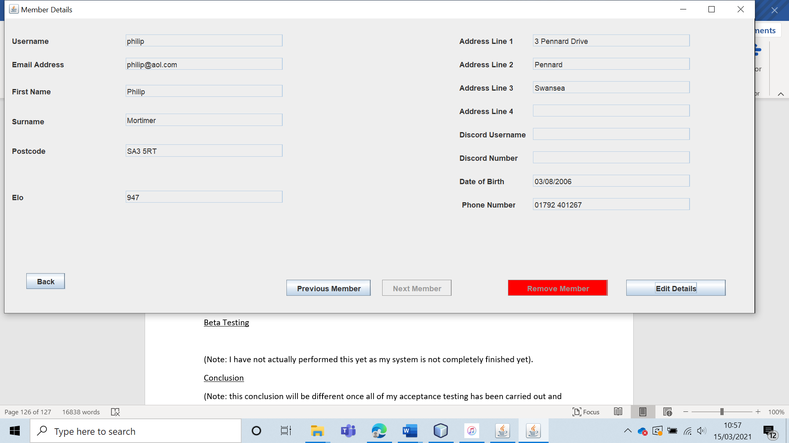

|  |  |  |  |  |  |  |
| --- | --- | --- | --- | --- | --- | --- |
| 37 | Have the club leader edit a club member’s user information. | Edit member info with typical data to verify that the server correctly stores the updated info. | C1 and C2 | The new user information should be stored in the server. When going to view member details, the updated user information should be displayed. | 7, 7a and 7ai. | The validation functioned as expected, but the saving of details did not function correctly. The discord username was saved as the discord number. |

Test 37 (C1)

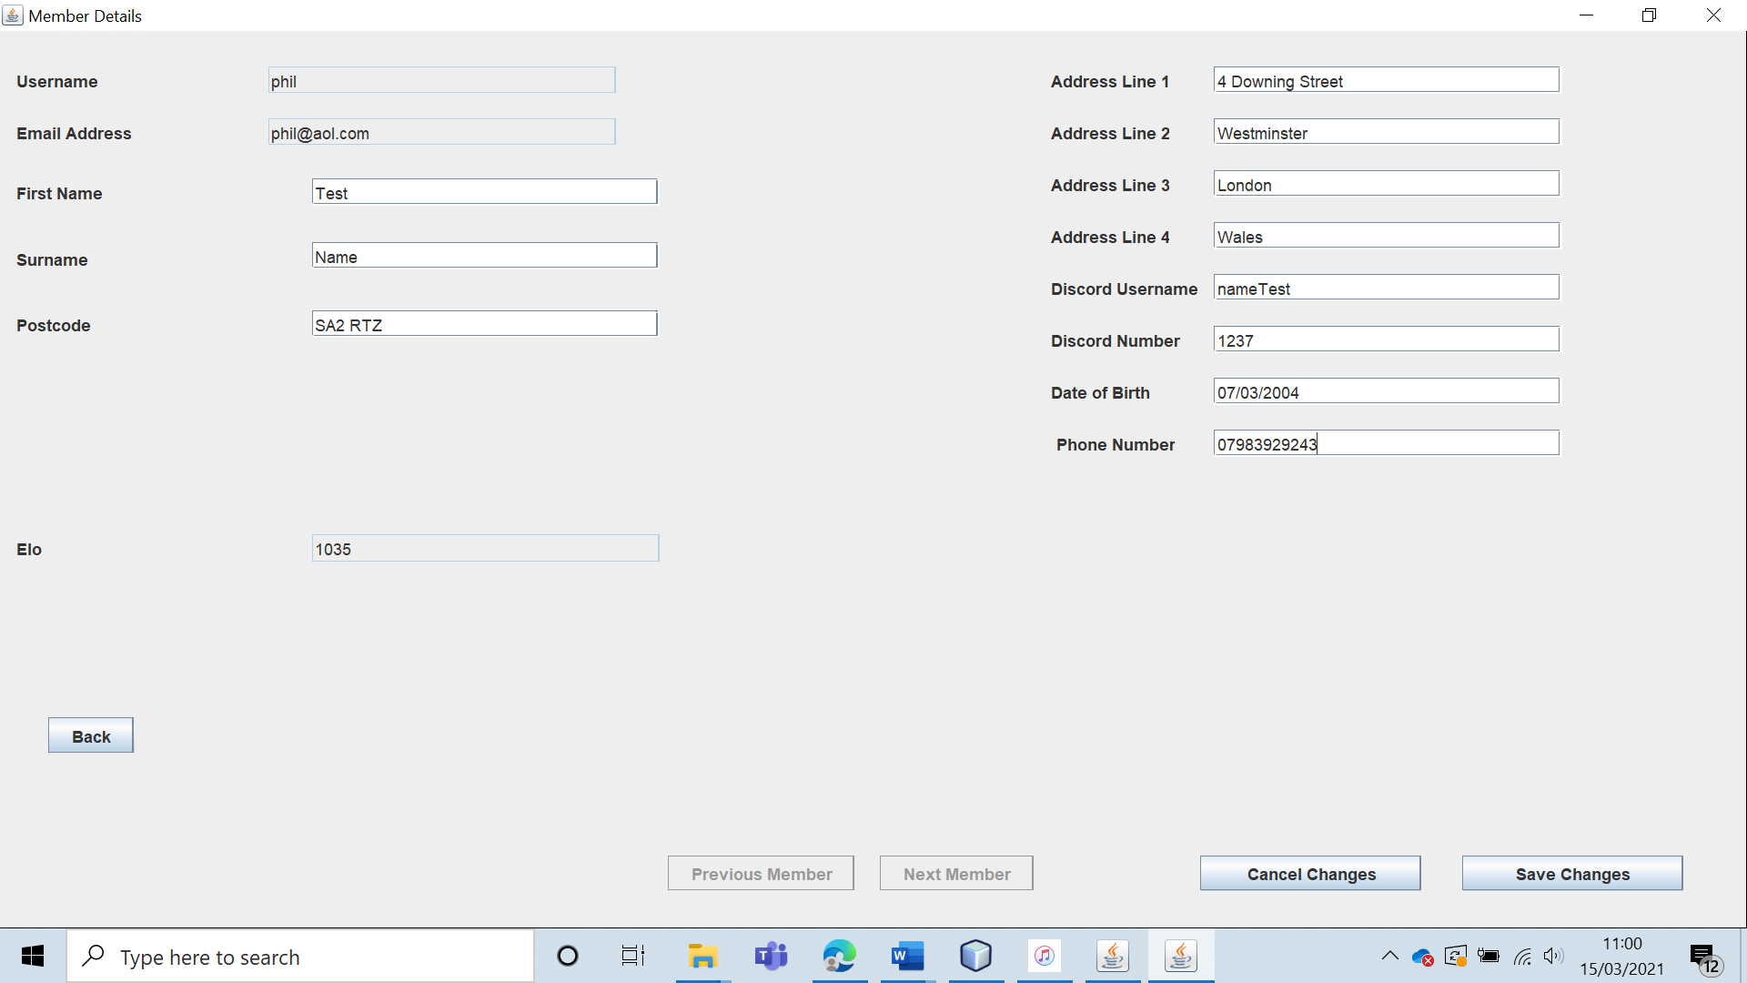

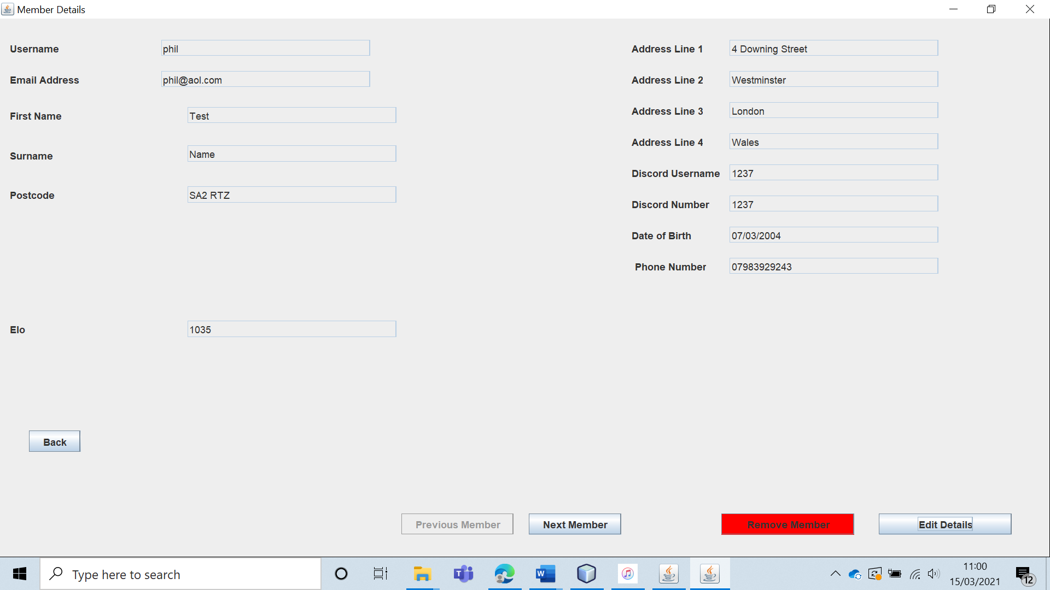

The validation worked as expected. The data was altered and saved to the server. There was however an error, the Discord name was incorrectly saved as matching the Discord number.

This is because I have an error in my code where the discord number is stored as opposed to the username.

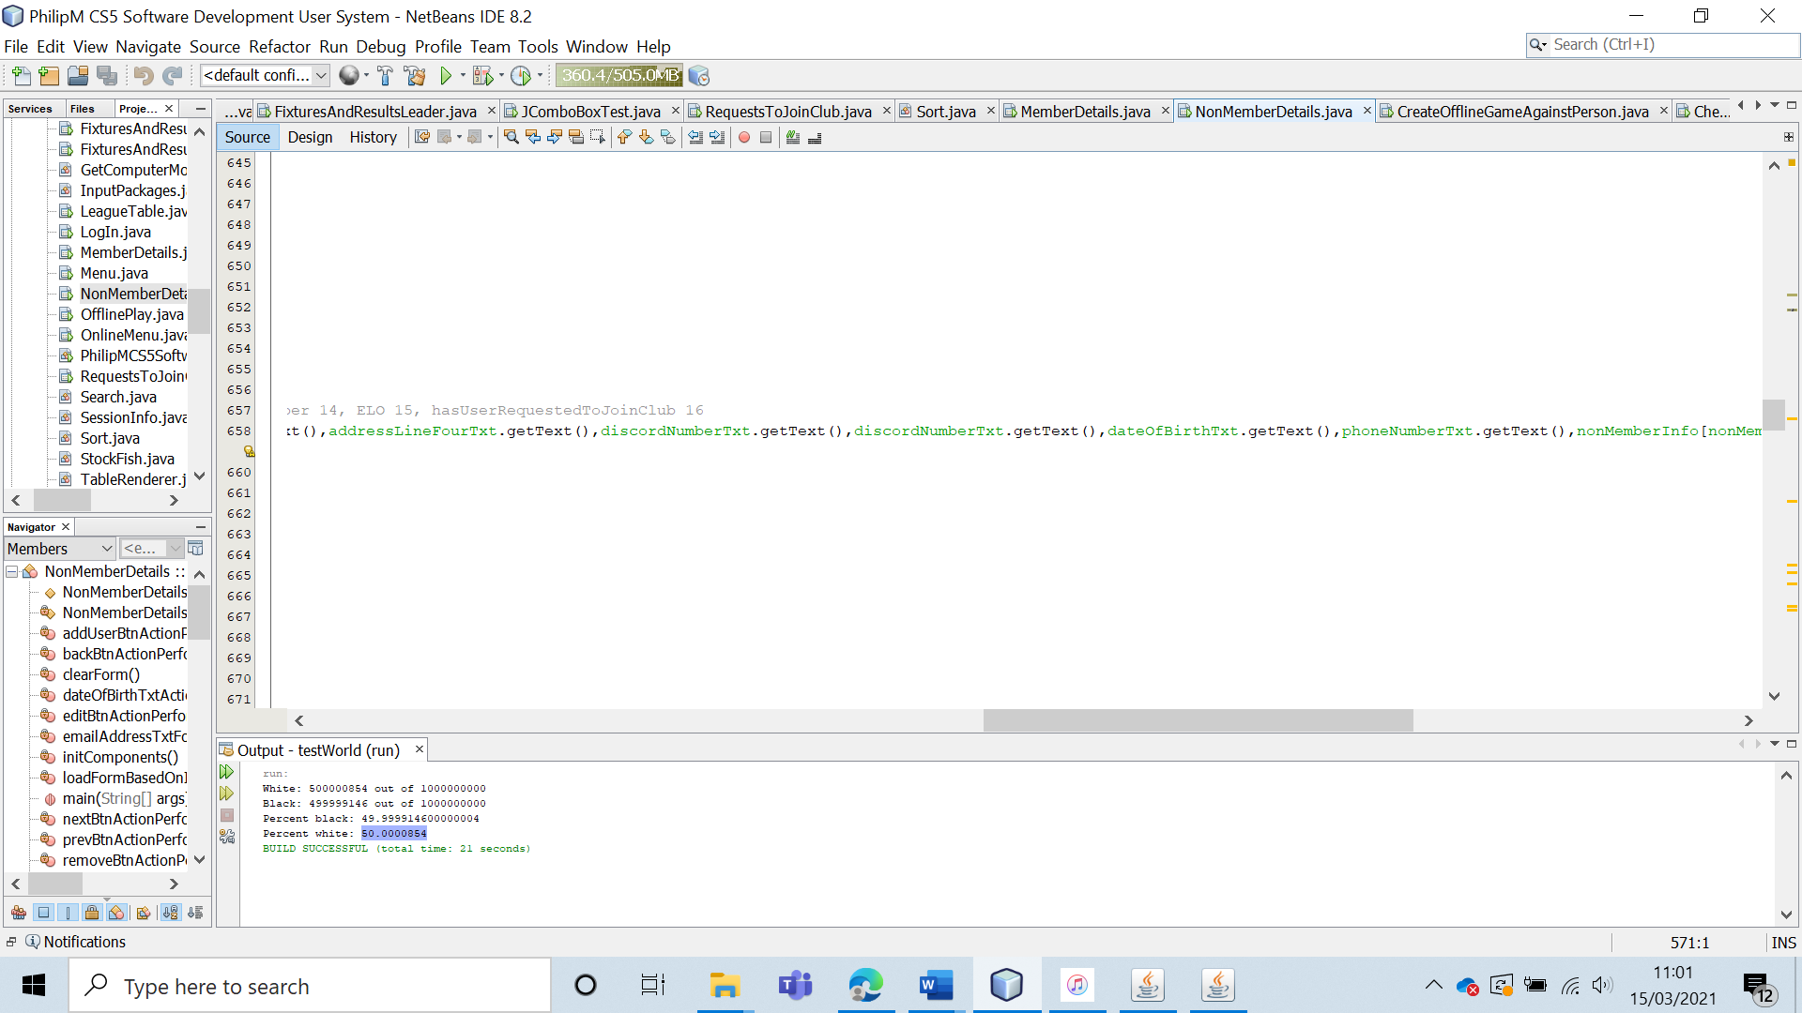

I have hopefully fixed this error in both my Member details and non-member details form by replacing the first “discordNumberTxt.getText()” with “discordUsernameTxt.getText()”.

|  |  |  |  |  |  |  |
| --- | --- | --- | --- | --- | --- | --- |
| 37 | Have the club leader edit a club member’s user information. | Edit member info with typical data to verify that the server correctly stores the updated info. | C1 and C2 | The new user information should be stored in the server. When going to view member details, the updated user information should be displayed. | 7, 7a and 7ai. | All of the user information was saved correctly with no validation errors occurring. |

Test 37 (C1) (Re-run)

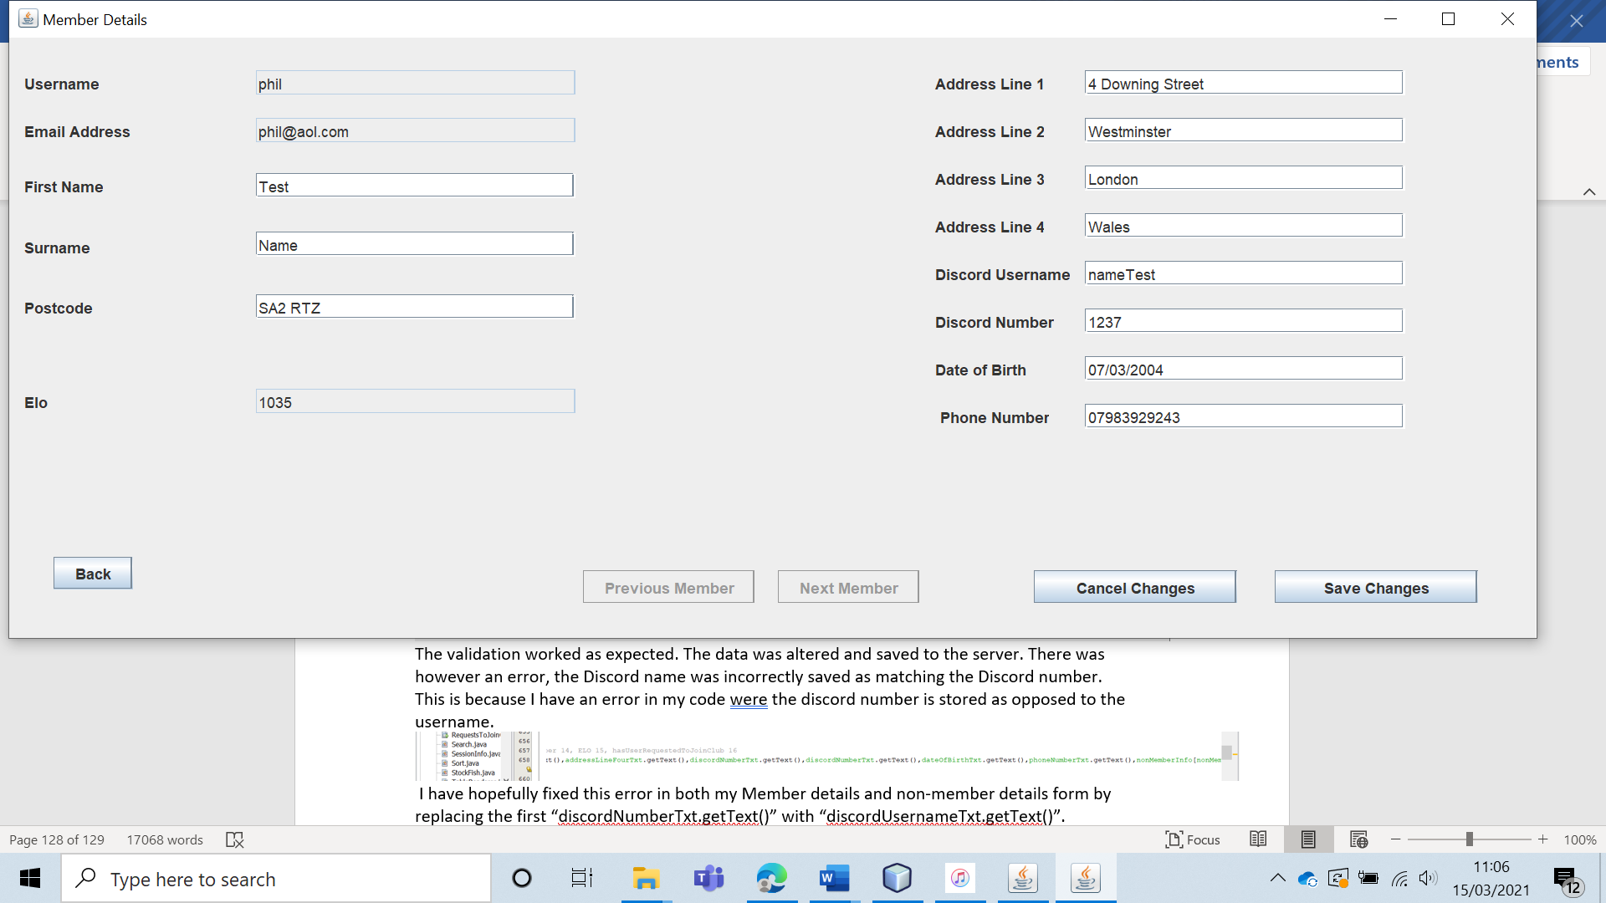

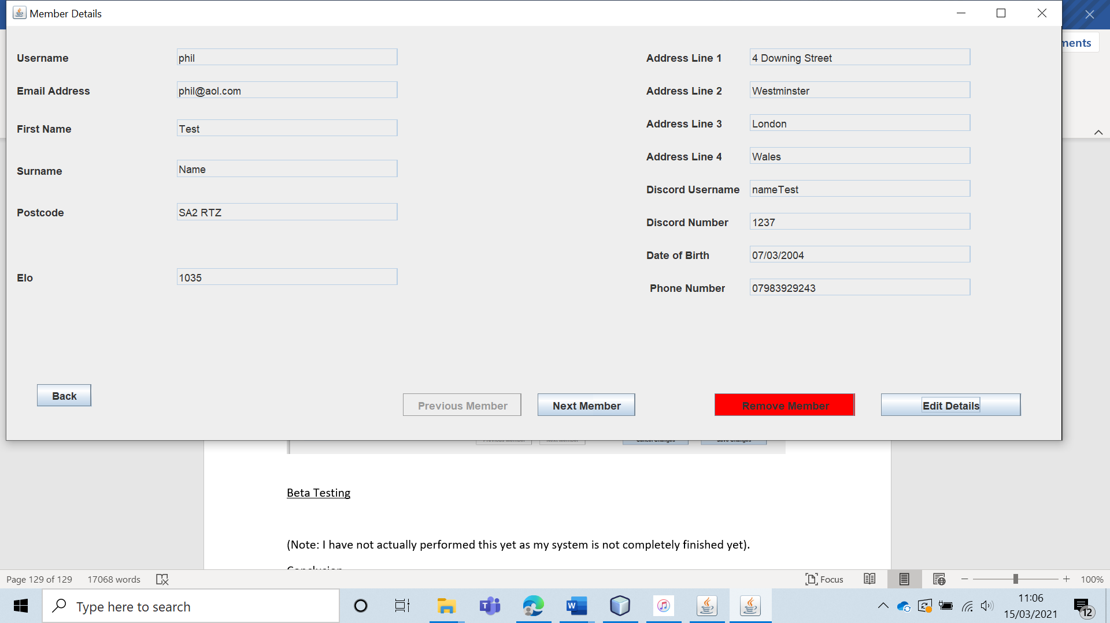

The system threw no validation errors and saved all of the information correctly this time.

Test 37 (C2)

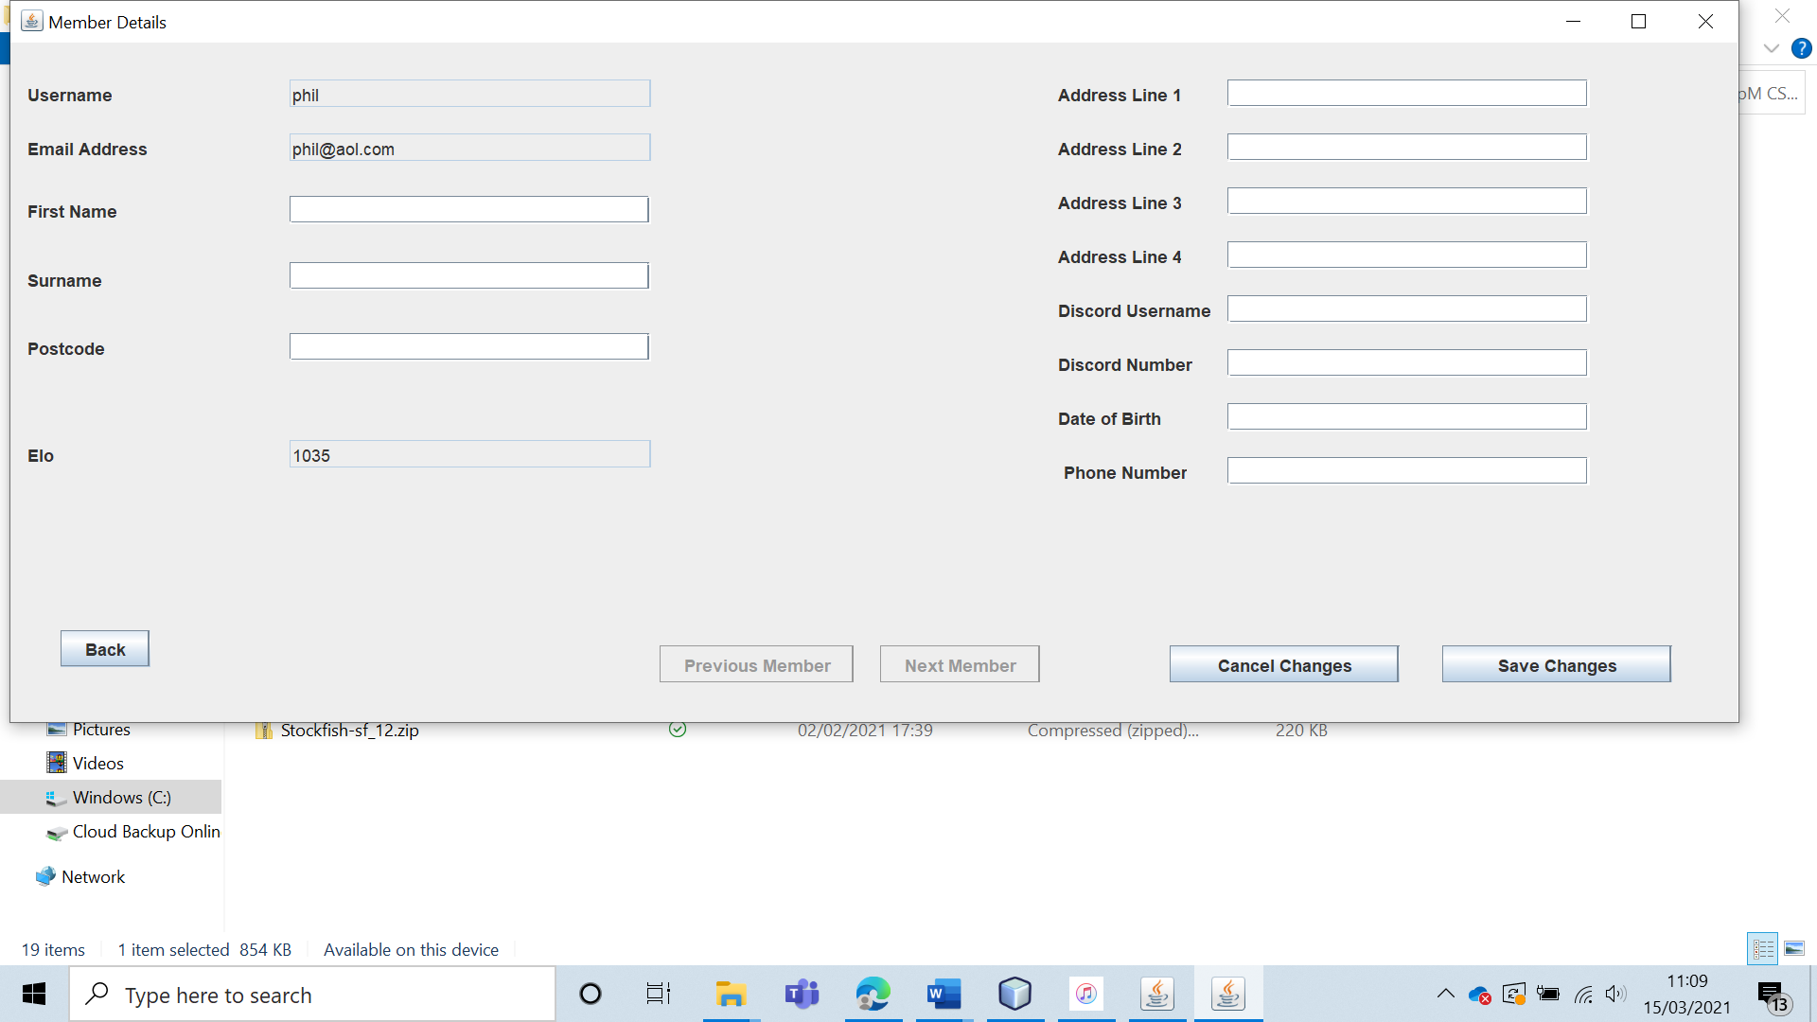

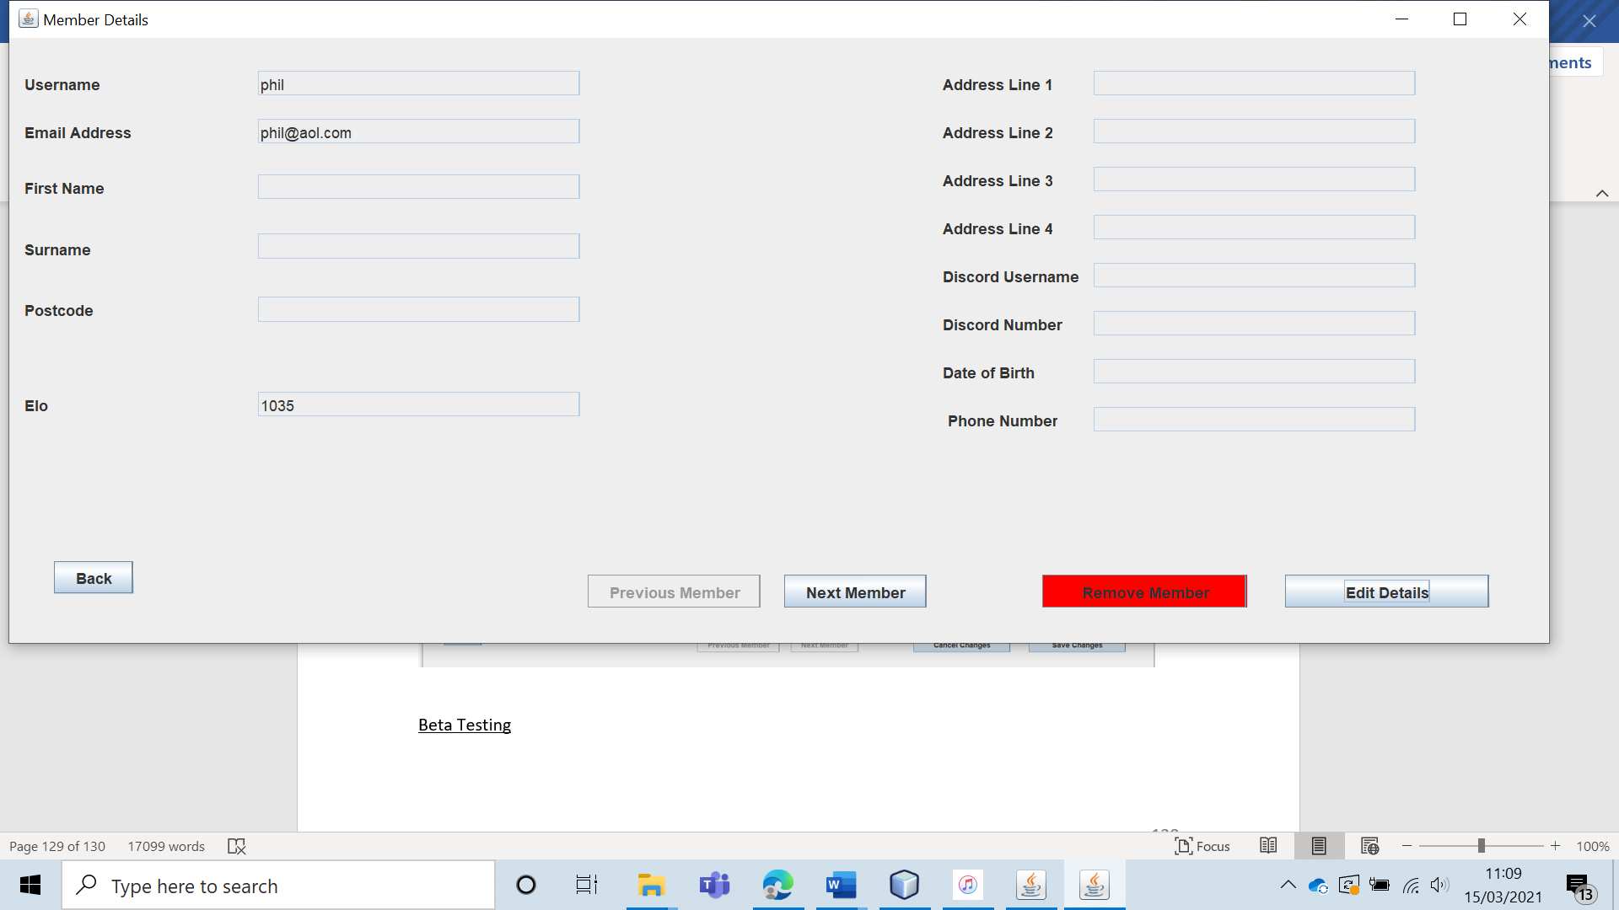

All of the information was correctly edited and saved.

|  |  |  |  |  |  |  |
| --- | --- | --- | --- | --- | --- | --- |
| 38 | Have the leader view the details of non-club members. | To ensure that the club leader can view the user info of non-members. |  | The information of all non-club members should be displayed. | 7b and 7bi. | The leader is able to view the user information. |

Test 38

The leader is able to view the user information of all non-members in the “Non-Members” section of the system.

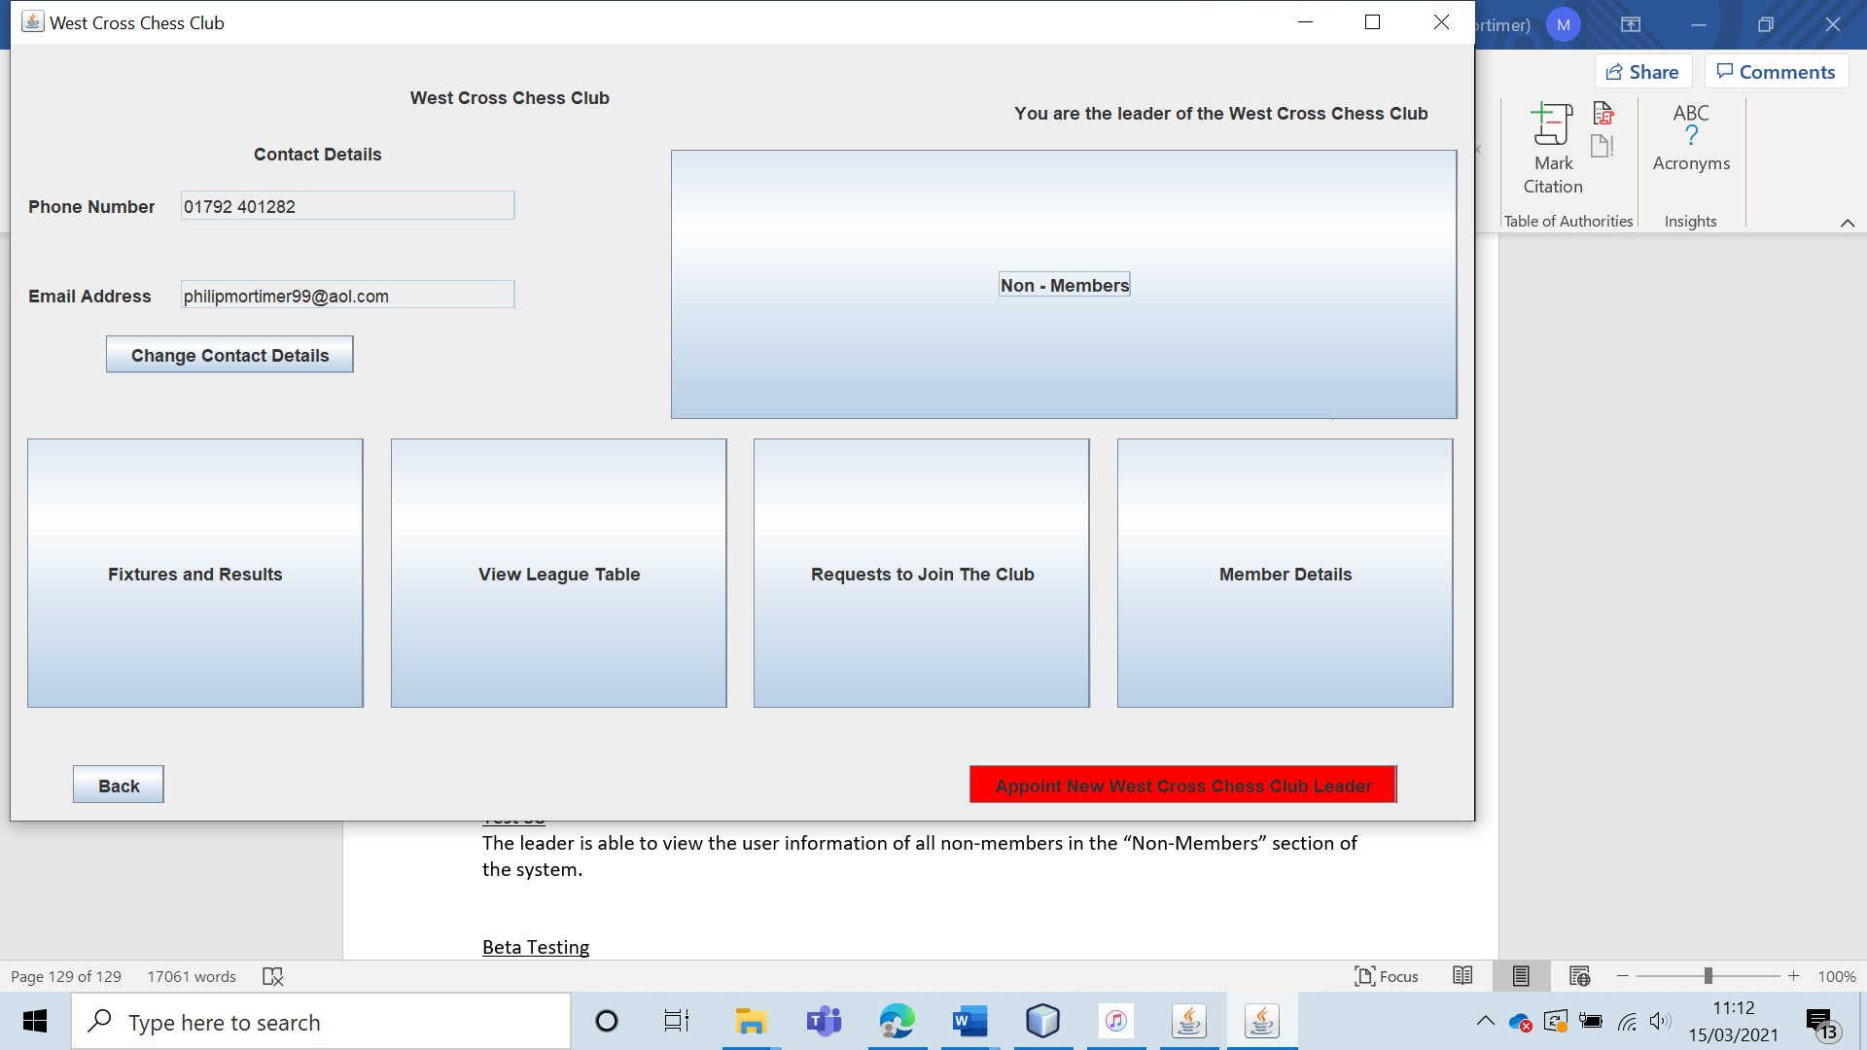

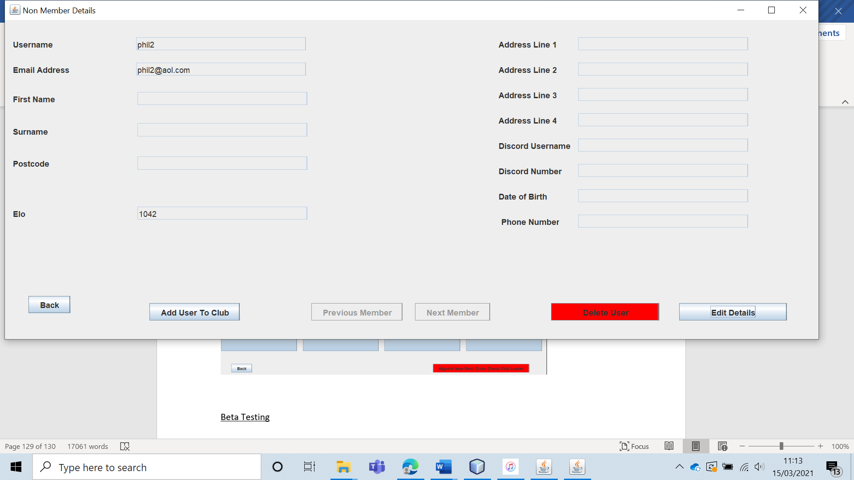

The leader is able to view all of the user information which is correctly displayed.

|  |  |  |  |  |  |  |
| --- | --- | --- | --- | --- | --- | --- |
| 39 | Have the leader edit the details of a non-club member. (Typical Data) | To ensure that non-club member information can be altered. | C1 and C2 | The information should be changed and saved. These new details should be visible when the user is viewed by the leader. | 7b and 7bi. | The edited values are correctly saved. |

Test 39 (C1)

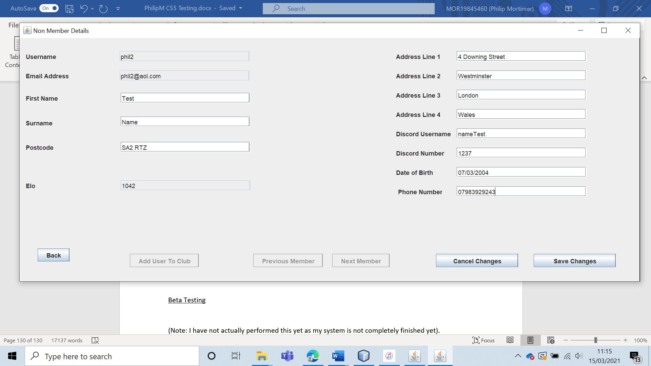

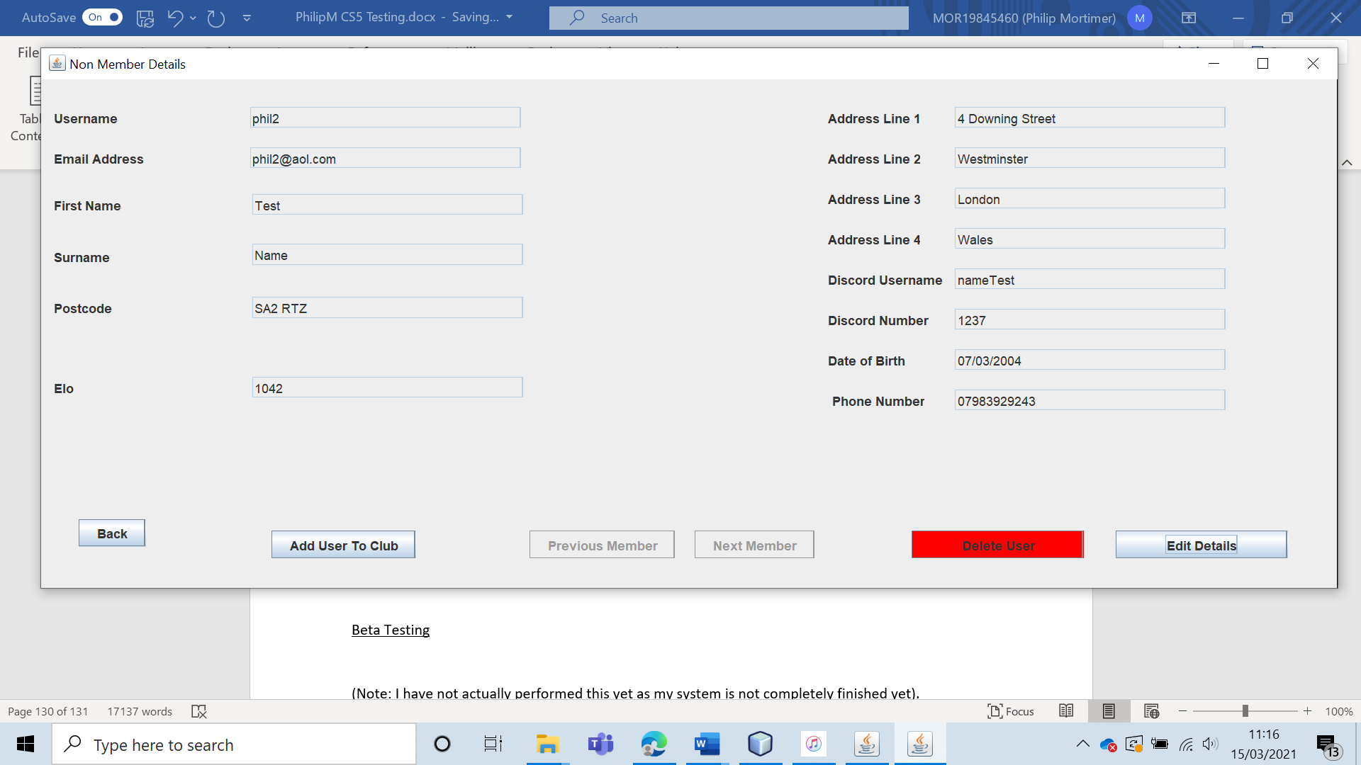

The edited values are correctly saved.

Test 39 (C2)

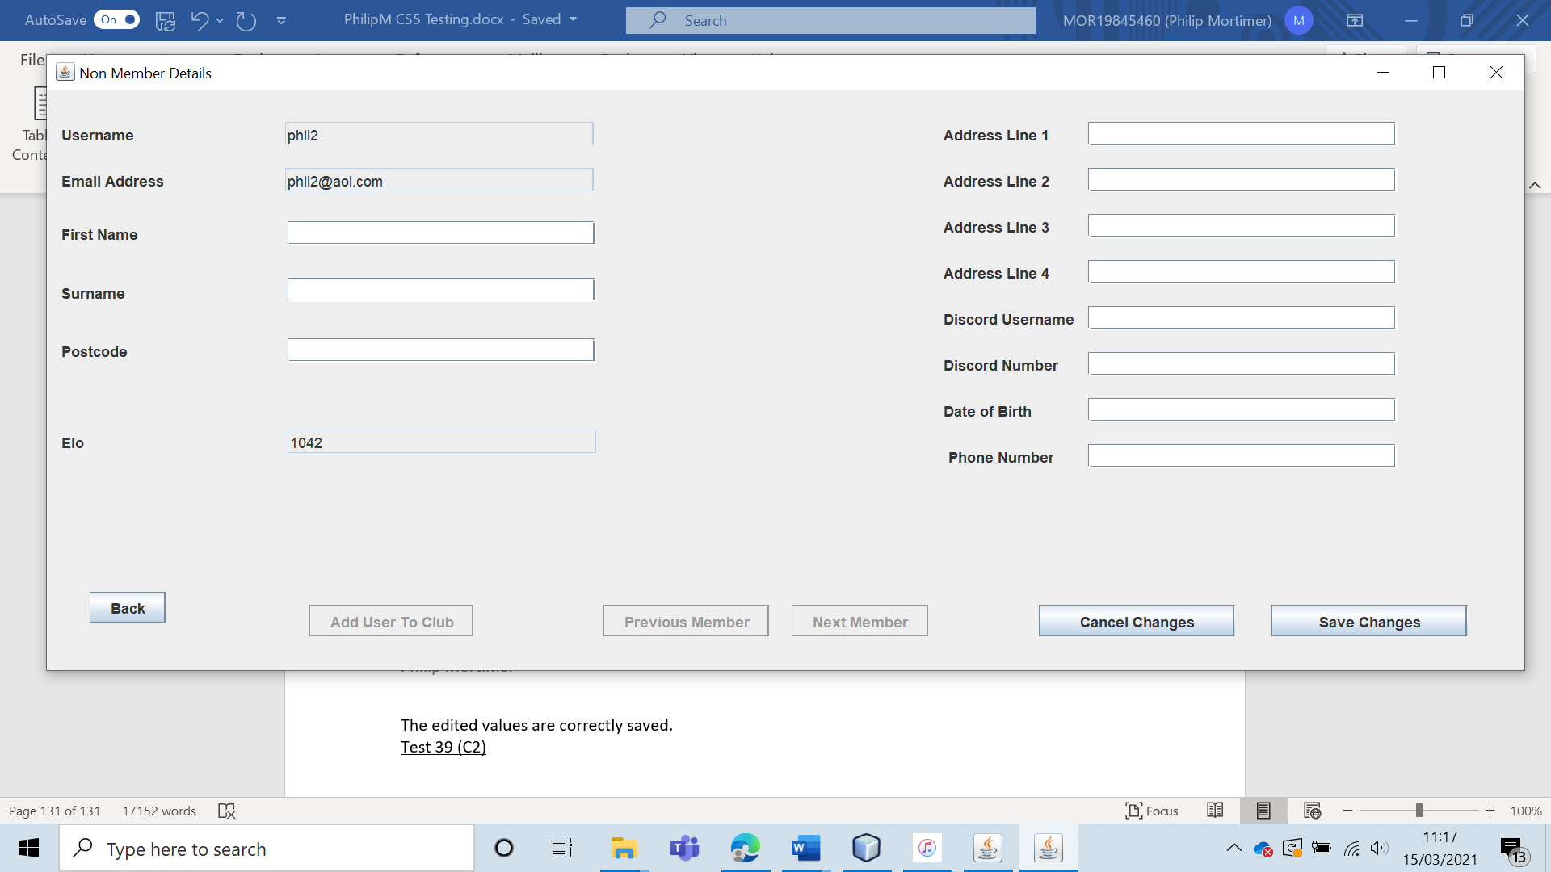

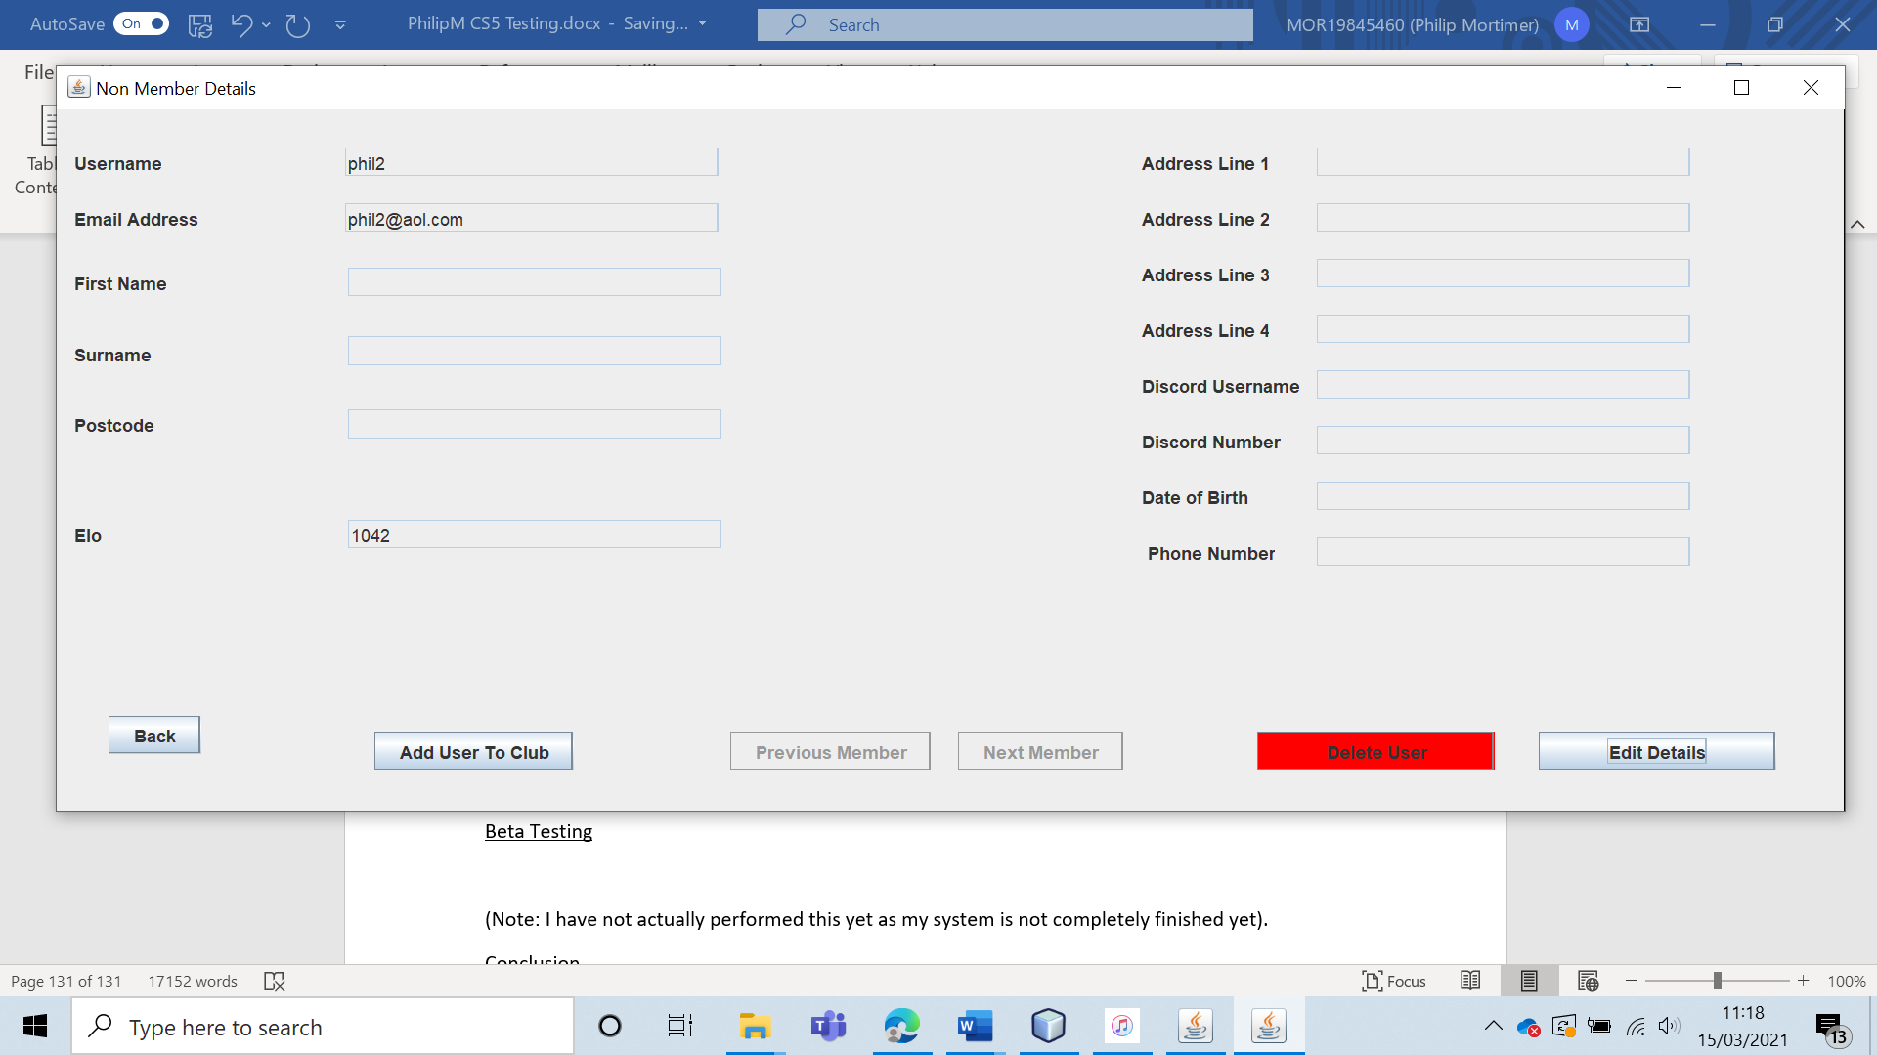

The edited values are correctly saved.

|  |  |  |  |  |  |  |
| --- | --- | --- | --- | --- | --- | --- |
| 40 | Have the user delete a non-member from the entire system. | To ensure that non-members can be removed from the system completely. |  | The user should be removed from the entire system. | 7b and 7bi. | The user record is deleted from the system. However, the wrong email record is deleted from the system. |

The selected user is deleted from the user file. However, the wrong email address is deleted from the file. This leads to a non-deleted user having their email address deleted. The code that deletes the email address use the index of the record for the user file to delete the index for the email file.

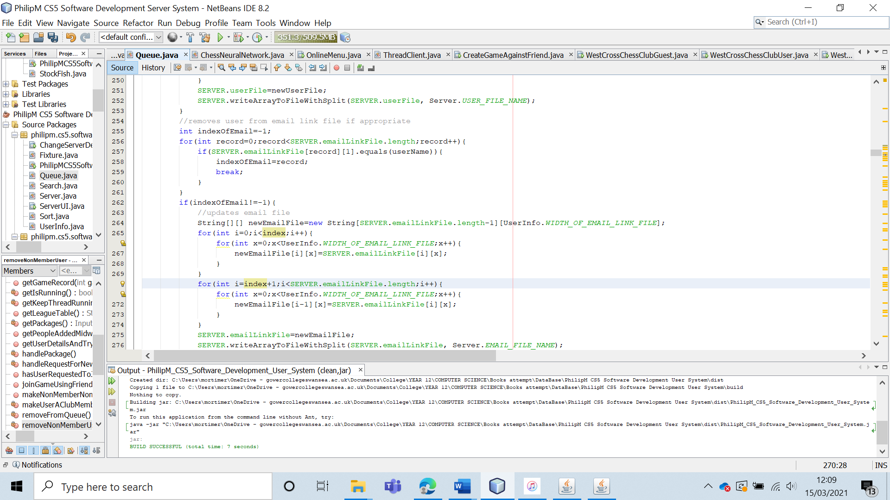

The variable used in the two loops should be “indexOfEmail”.

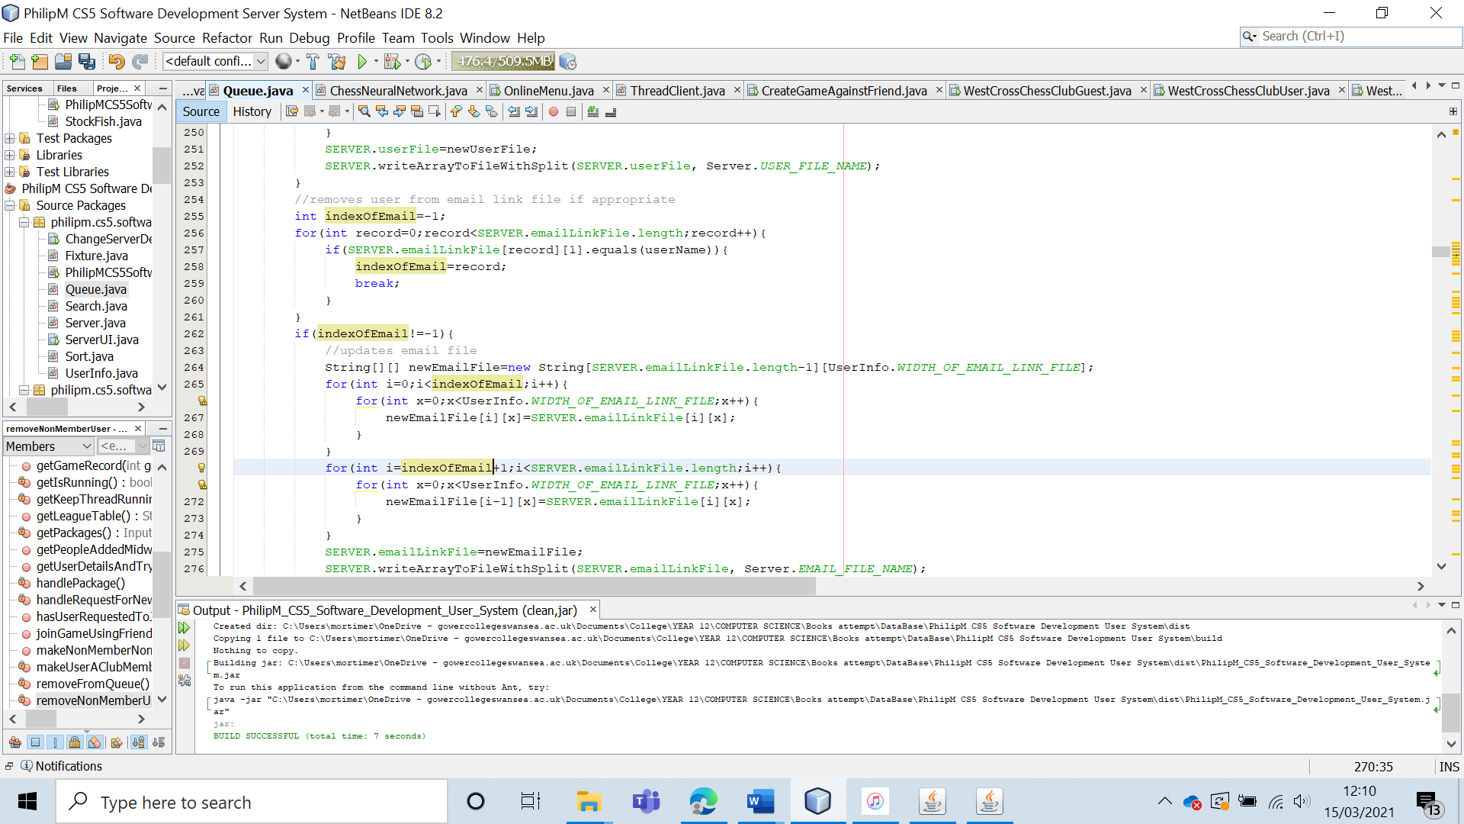

Test 40

|  |  |  |  |  |  |  |
| --- | --- | --- | --- | --- | --- | --- |
| 40 | Have the user delete a non-member from the entire system. | To ensure that non-members can be removed from the system completely. |  | The user should be removed from the entire system. | 7b and 7bi. | The user is correctly deleted from the entire system. |

Test 40 (Re-run).

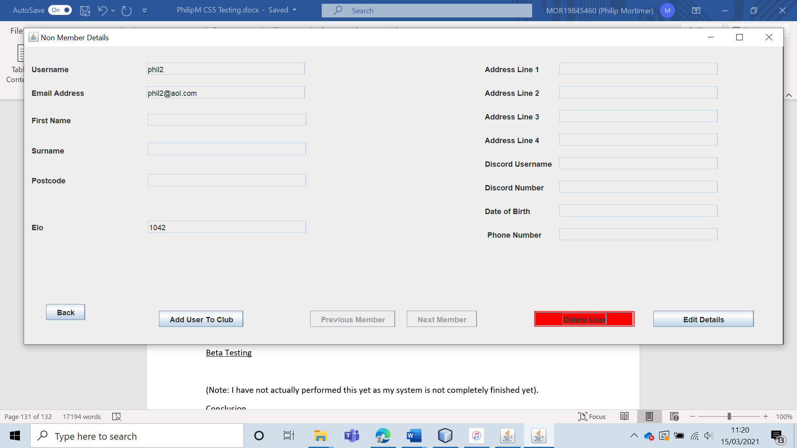

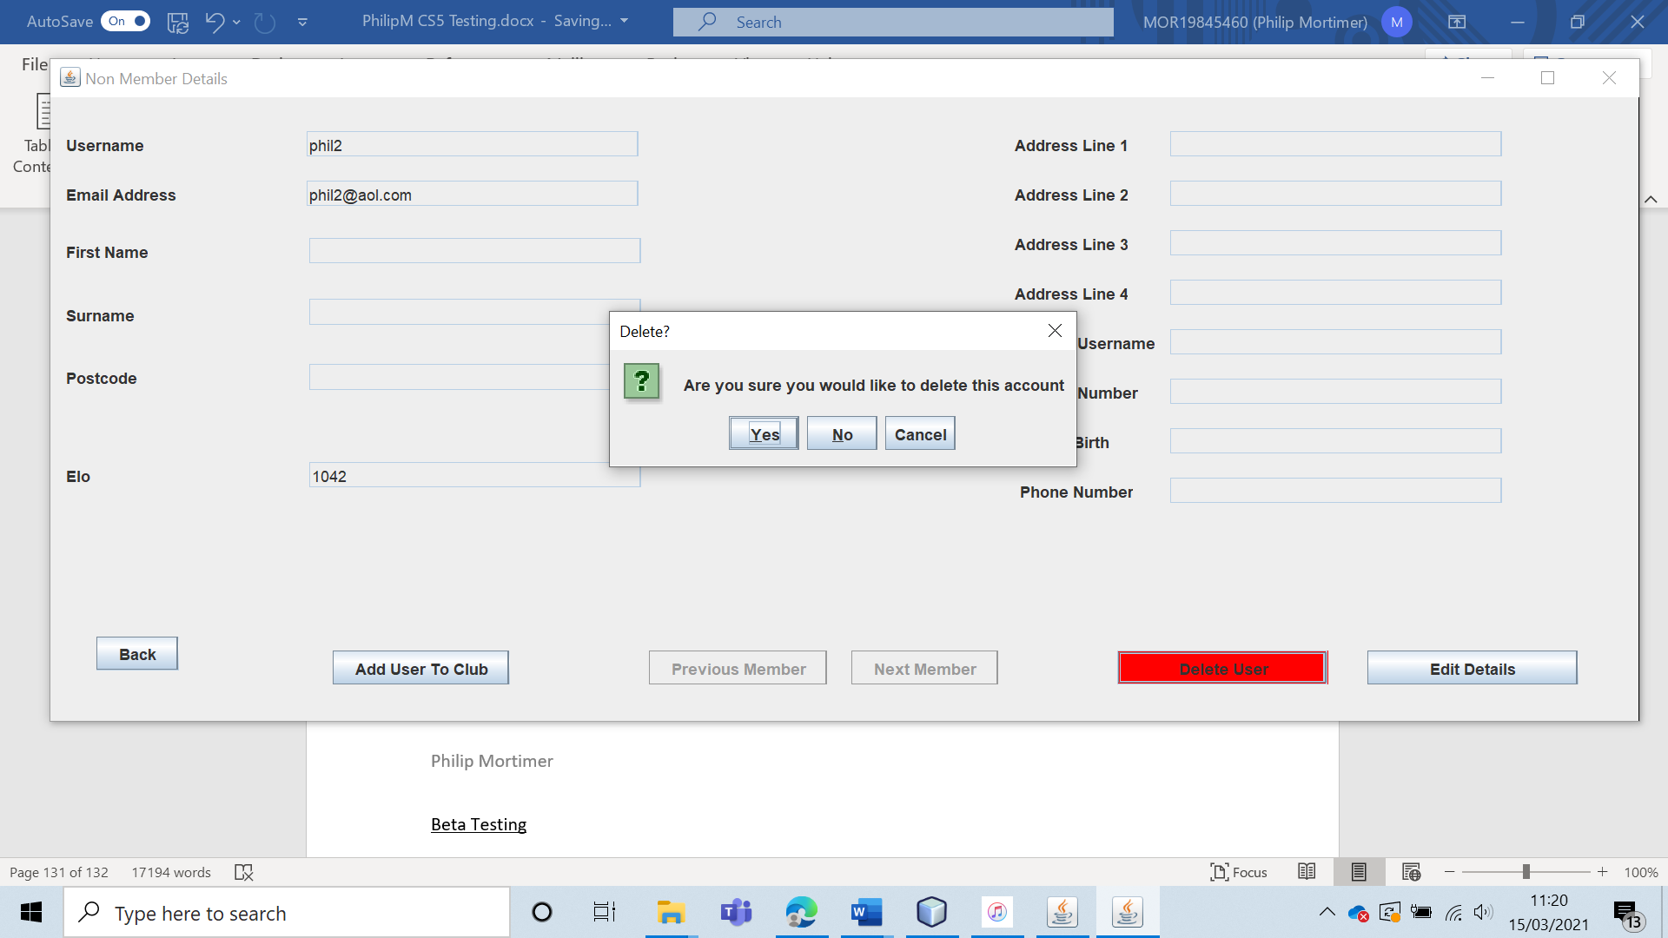

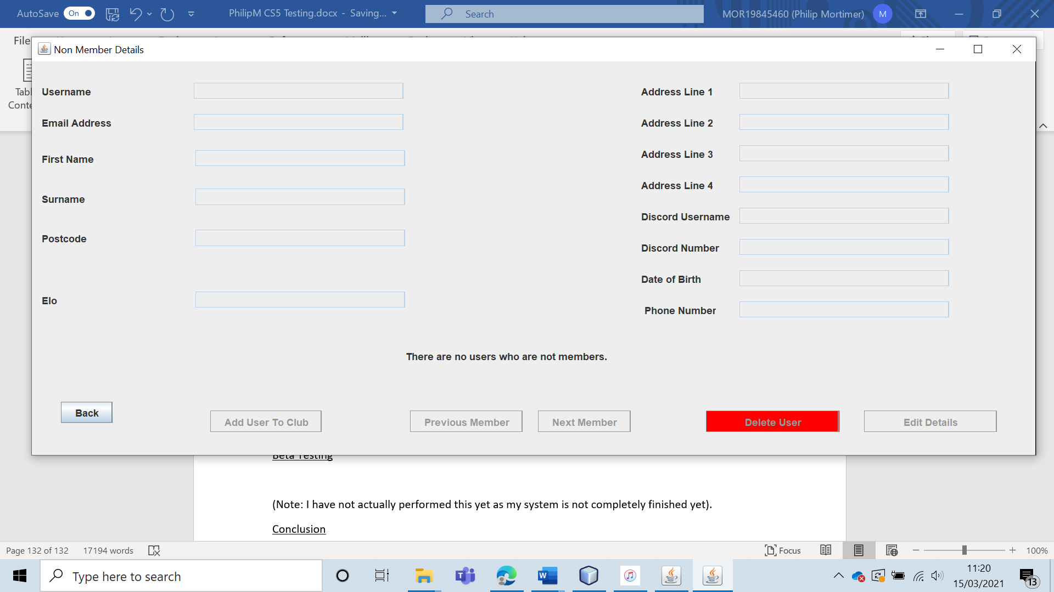

The user is deleted from the entire system; hence the test has succeeded. This time, the correct email address is deleted from the system.

|  |  |  |  |  |  |  |
| --- | --- | --- | --- | --- | --- | --- |
| 41 | Validate the edited user data for both the non-member and member forms. (Extreme Data) | To ensure that all edited data is valid. These validation rules should be the same as those when creating an account. | C3 and C4 | The information should be altered to the new values. | 7, 7a, 7ai, 7b and 7bi. | All of the data is saved correctly, as expected. |

Test 41 (C3) (Member Form)

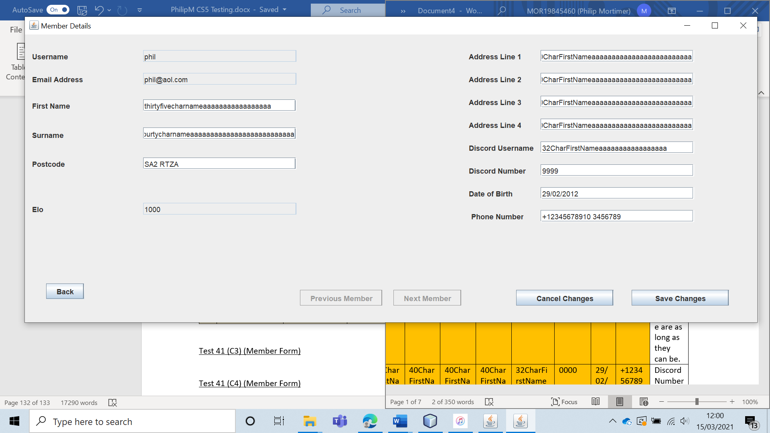

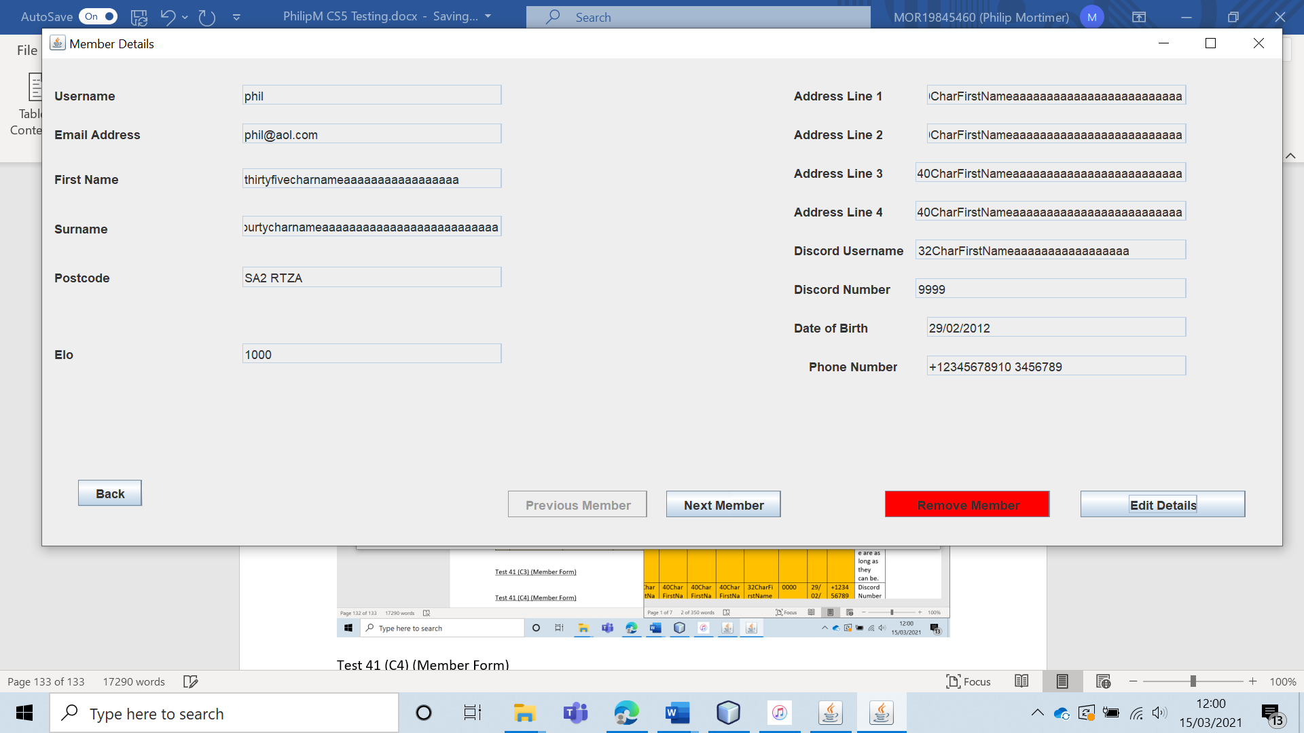

The edited data is saved correctly.

Test 41 (C4) (Member Form)

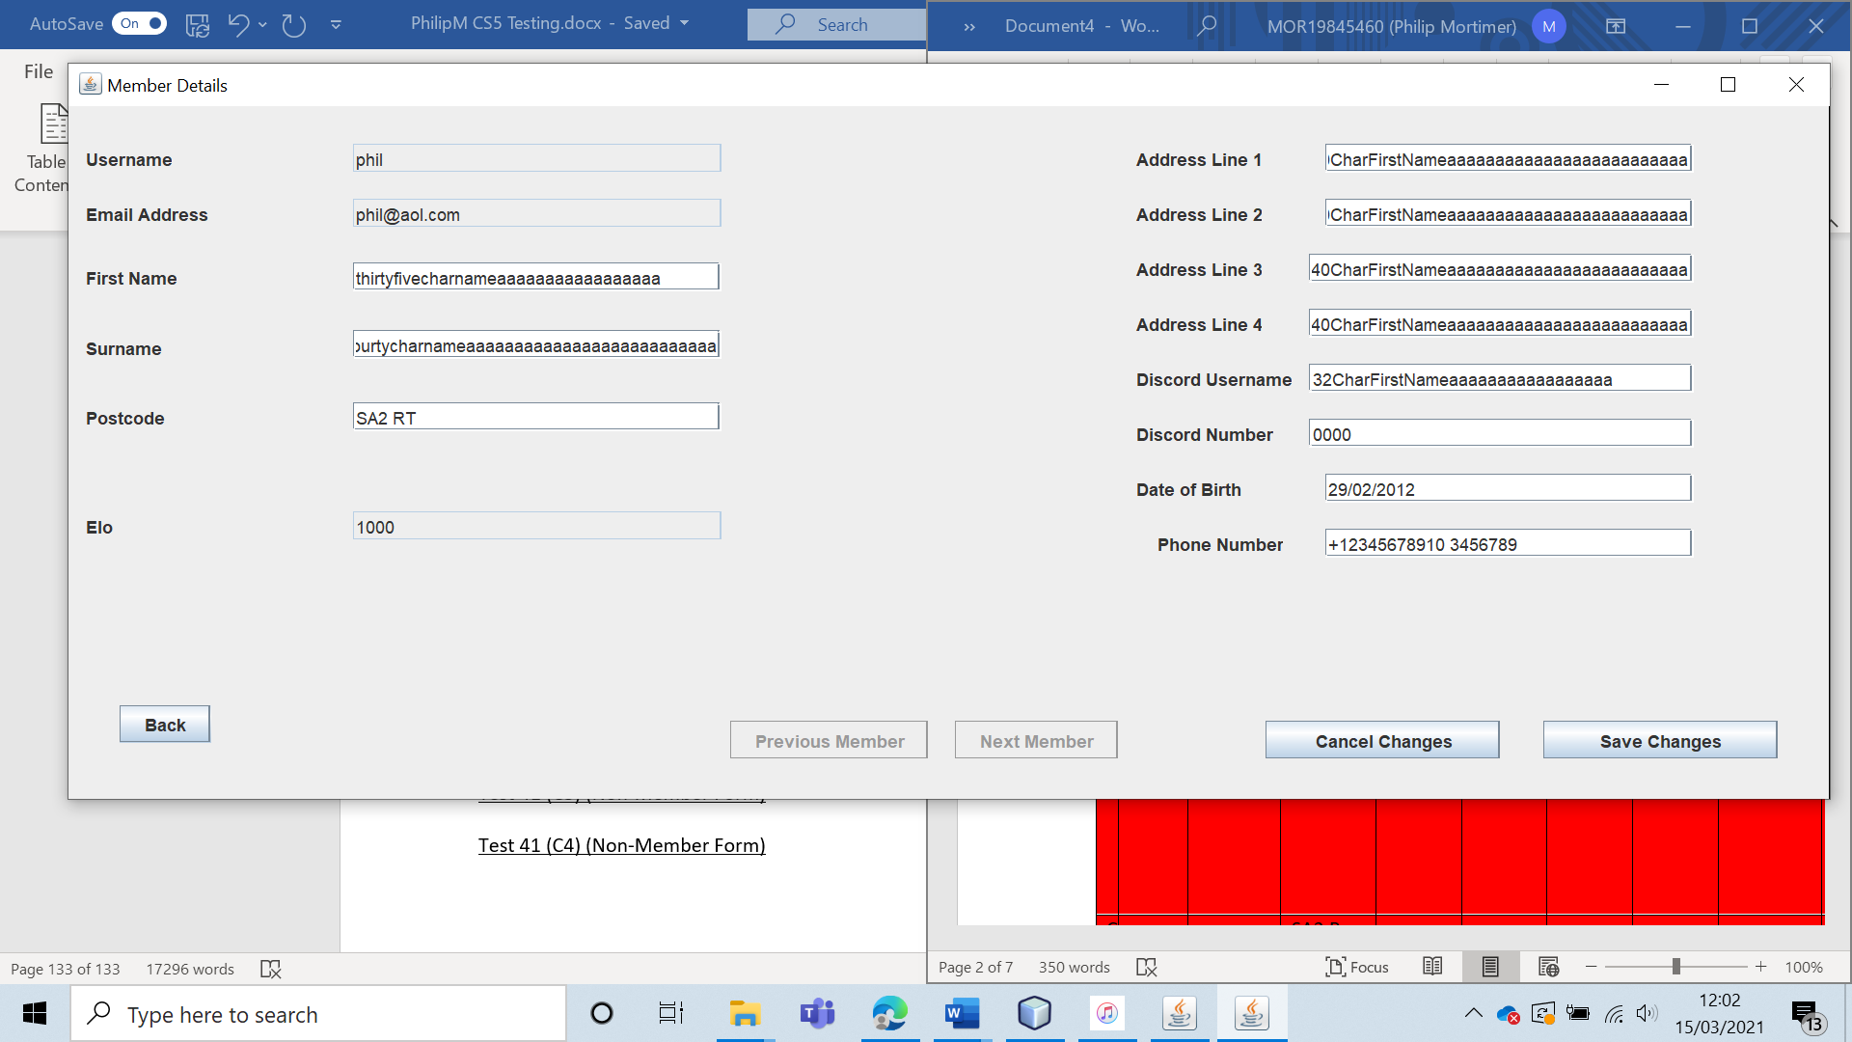

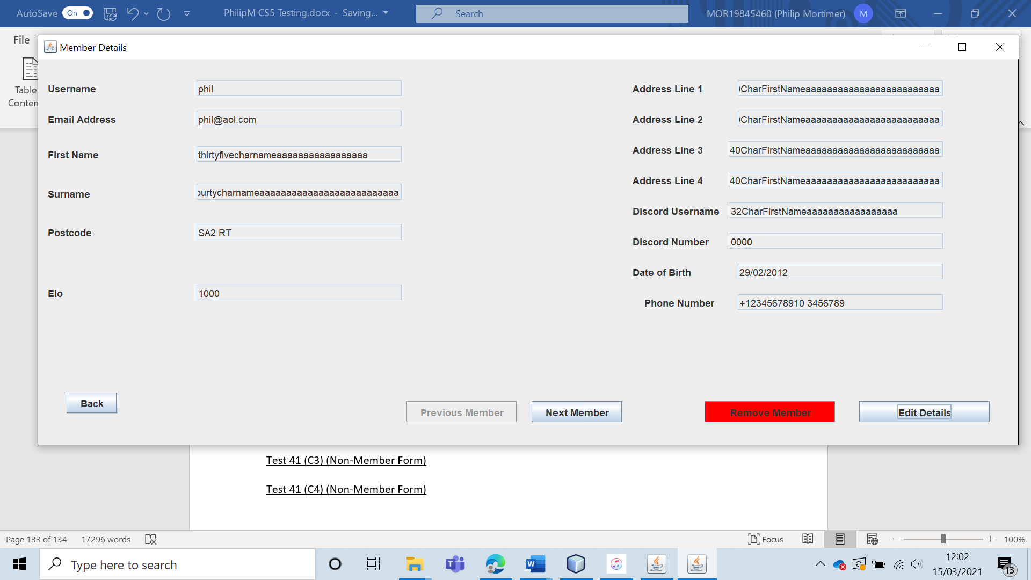

The data was correctly saved.

Test 41 (C3) (Non-Member Form)

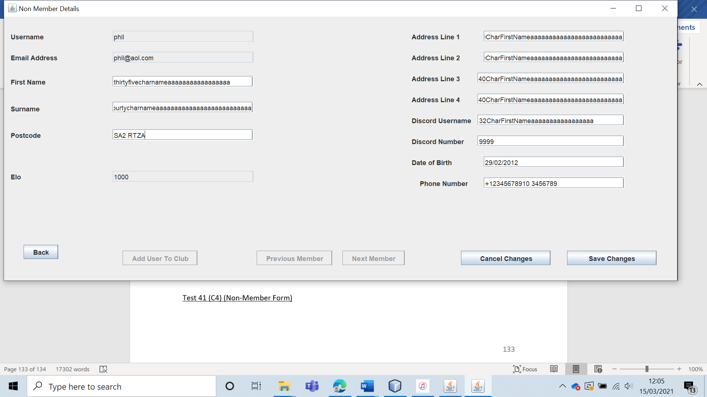

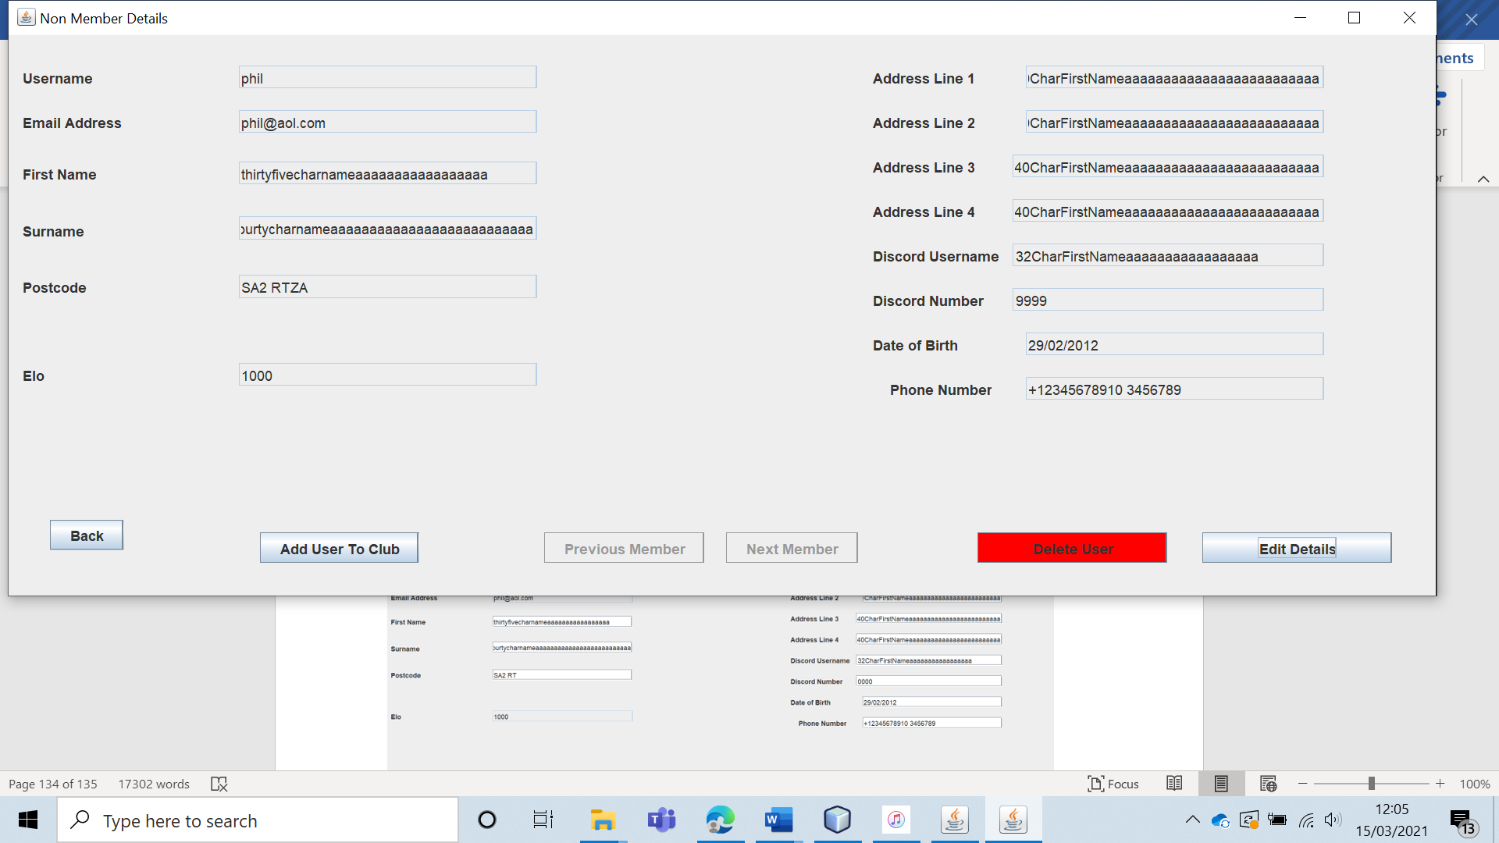

The data is saved correctly.

Test 41 (C4) (Non-Member Form)

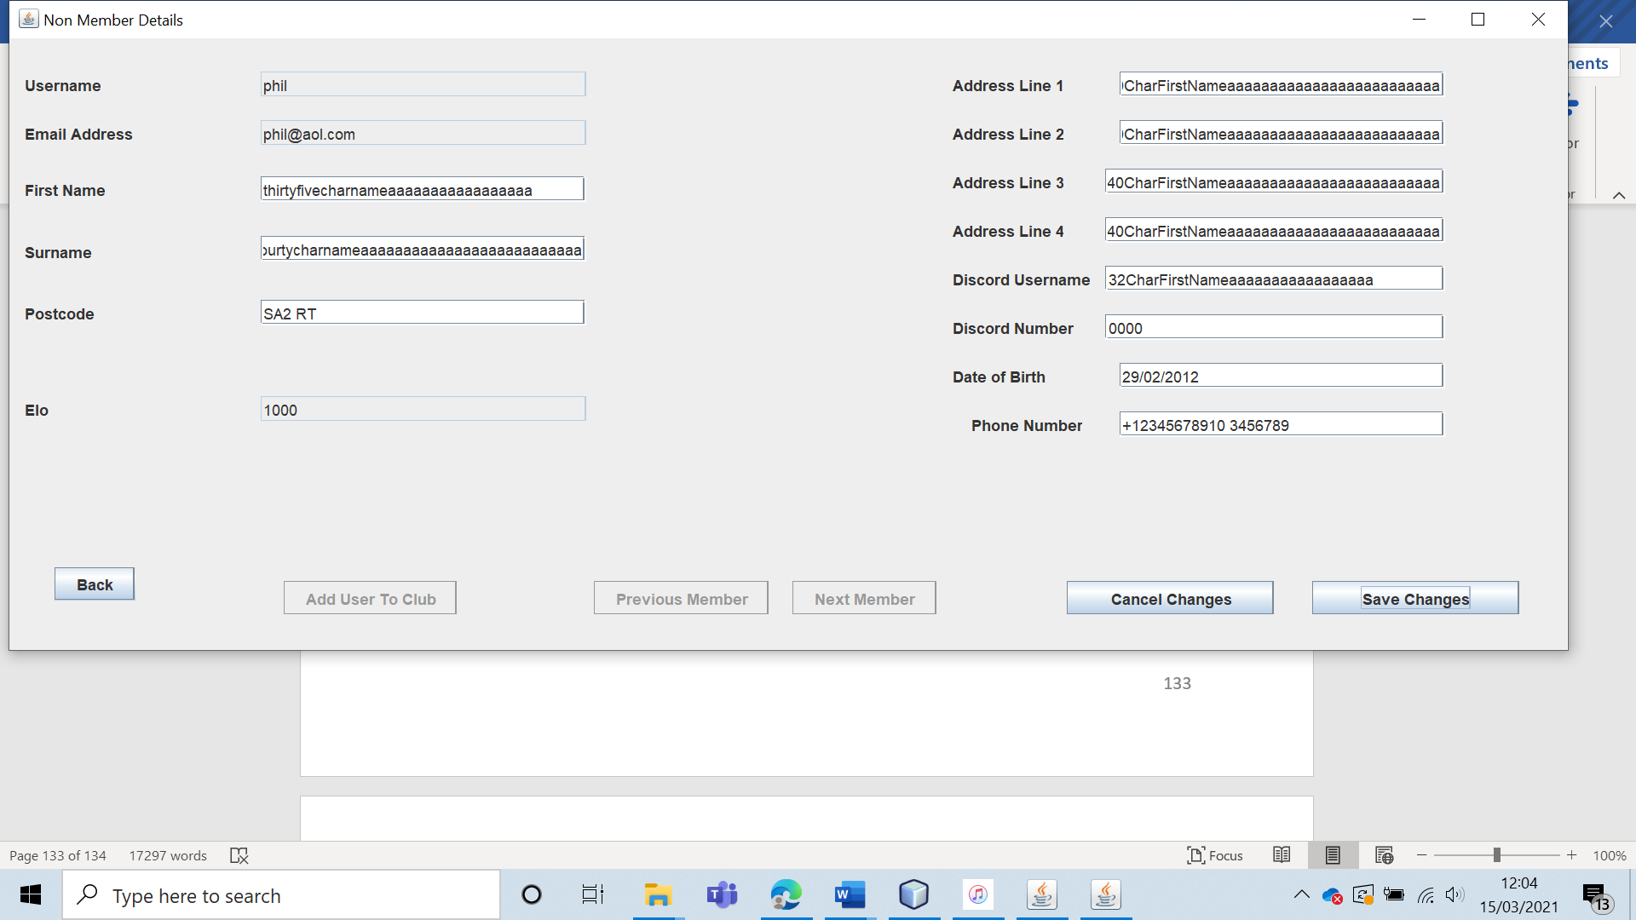

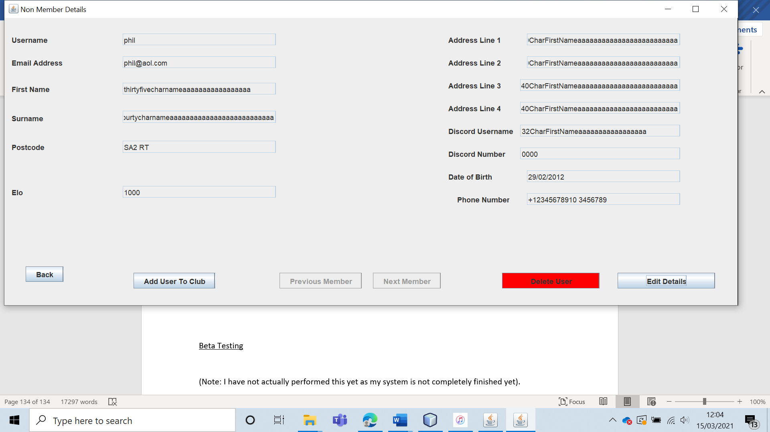

The data is saved correctly.

|  |  |  |  |  |  |  |
| --- | --- | --- | --- | --- | --- | --- |
| 42 | Validate the edited user data for both the non-member and member forms. (Invalid Data) | To ensure that all edited data is valid. These validation rules should be the same as those when creating an account. | C5 – C23 | The changes should not be accepted, and an appropriate error message should be displayed. | 7, 7a, 7ai, 7b and 7bi. | All invalid data items were not accepted by either form. A clear and specific error message was displayed telling the user exactly and unambiguously why the input they made was invalid. |

Test 42 (Info)

For test 42, I will include screenshots of the test being carried out. I will not comment on the individual tests unless the test is failed (or an error occurs). If there is no comment, one can assume that the validation has worked, and an appropriate error message has been displayed that tells the leader why the specific input was invalid.

Test 42 (C5) (Member Form)

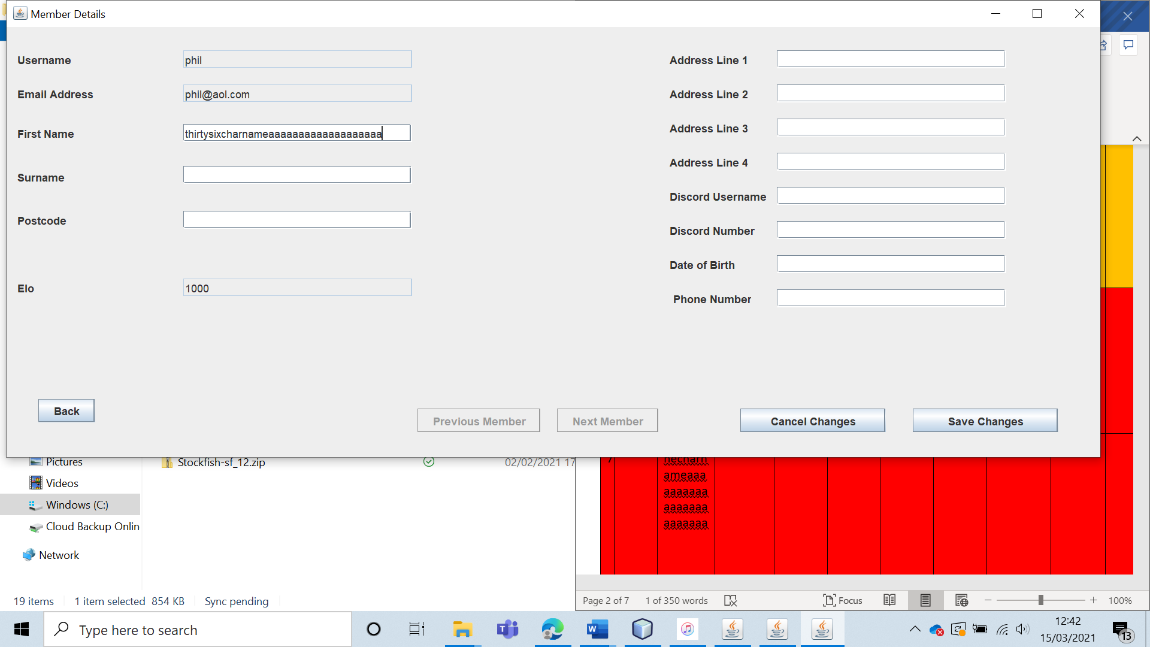

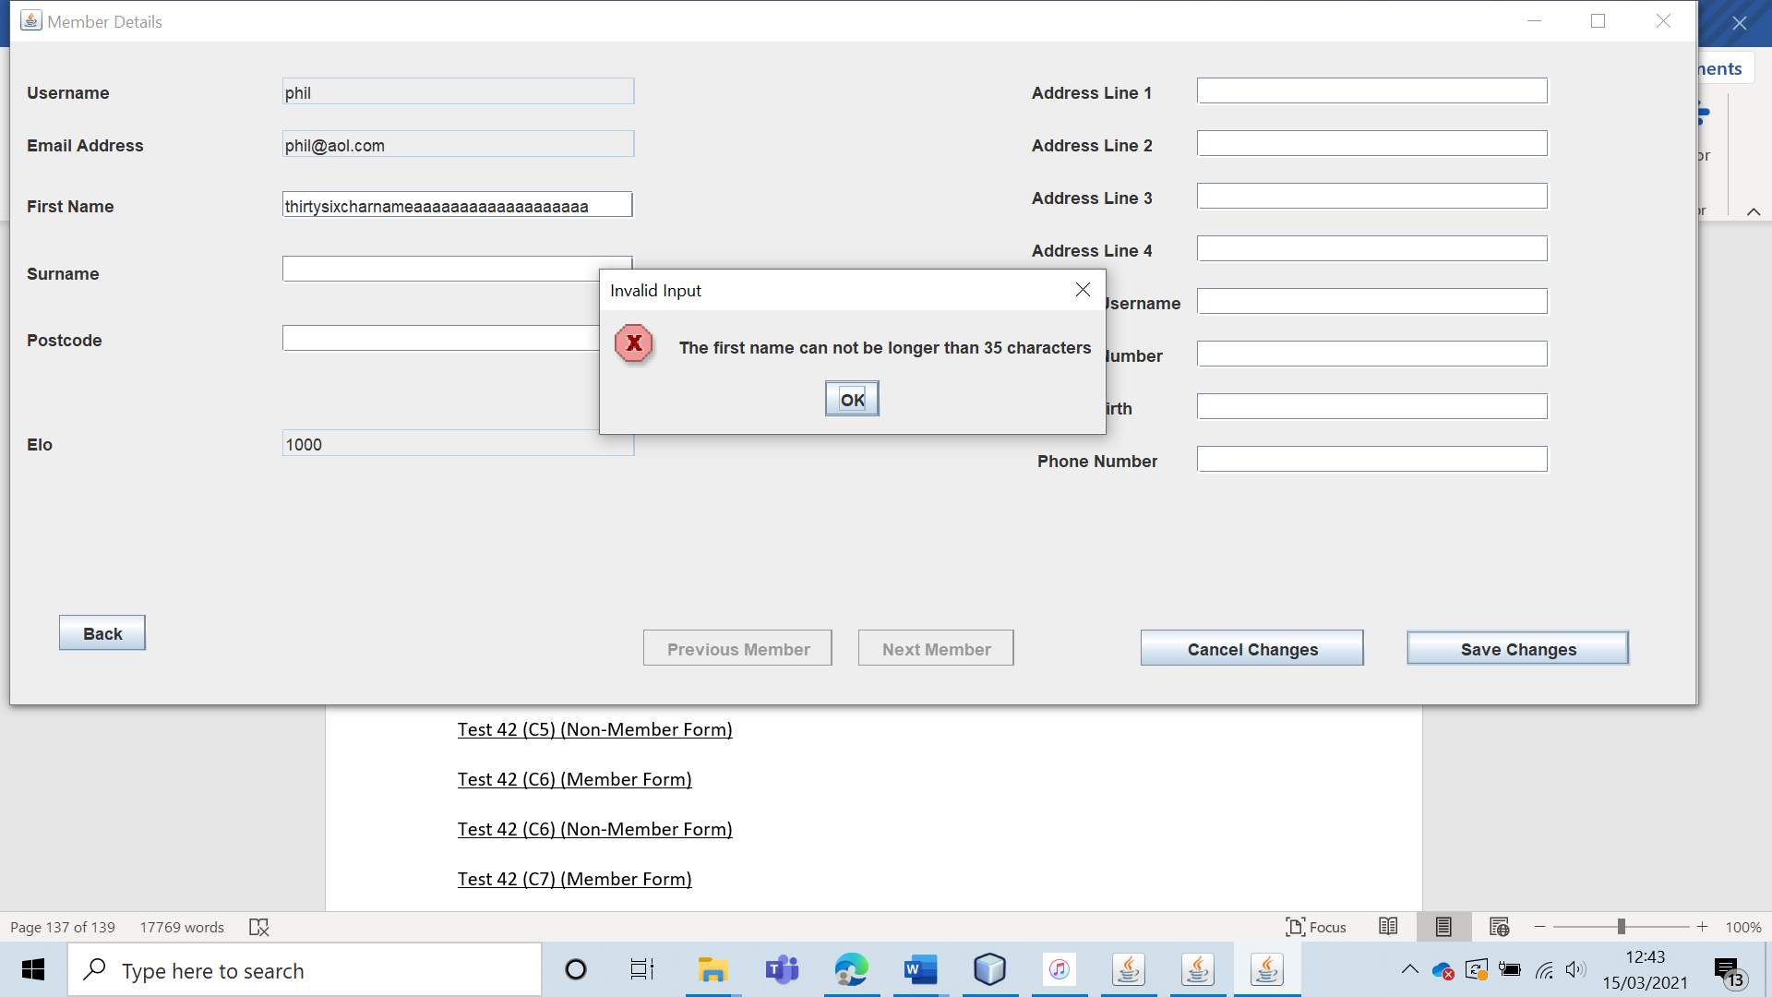

Test 42 (C5) (Non-Member Form)

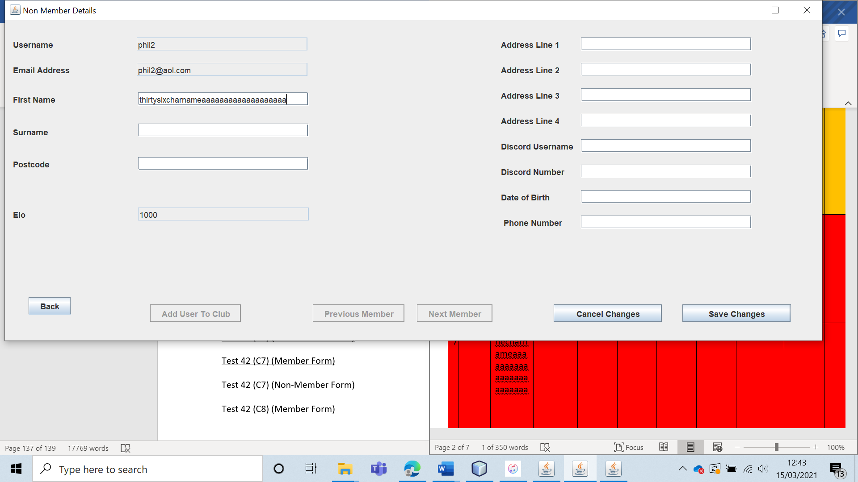

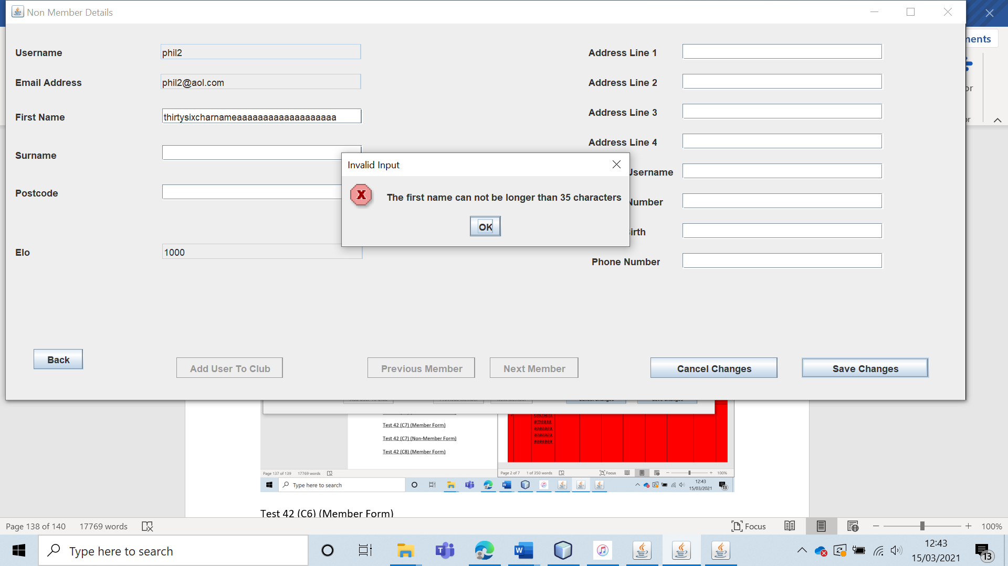

Test 42 (C6) (Member Form)

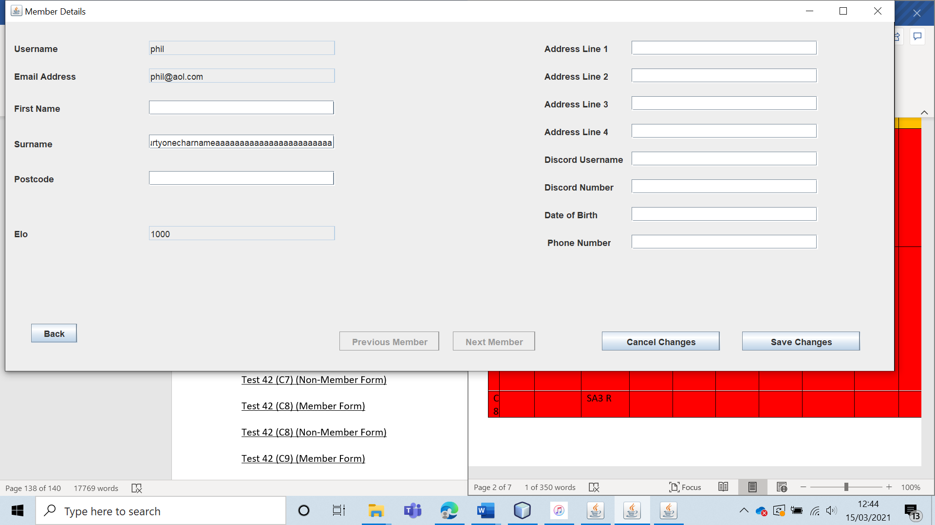

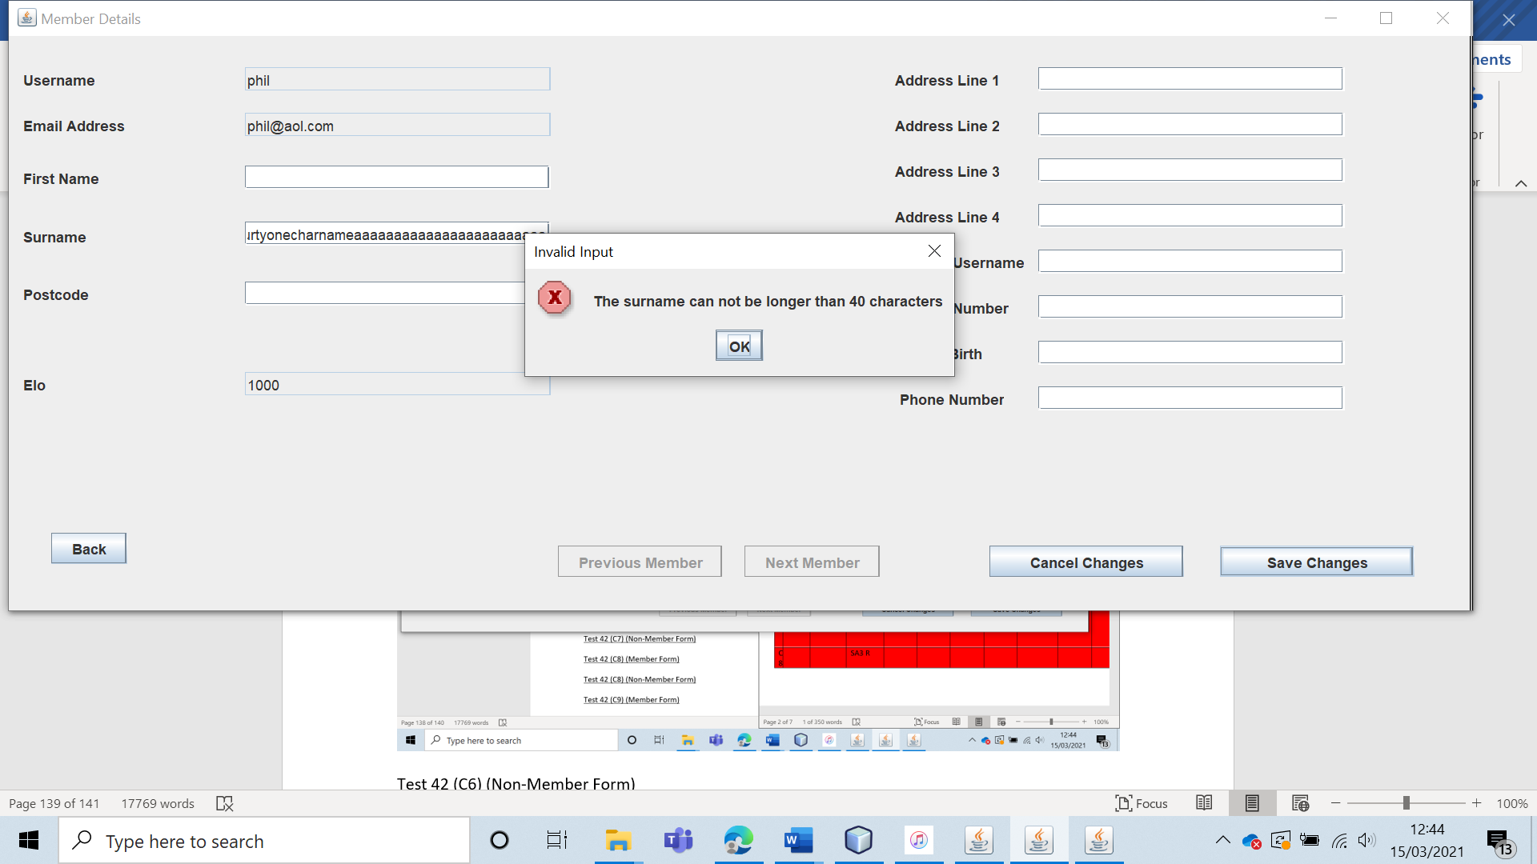

Test 42 (C6) (Non-Member Form)

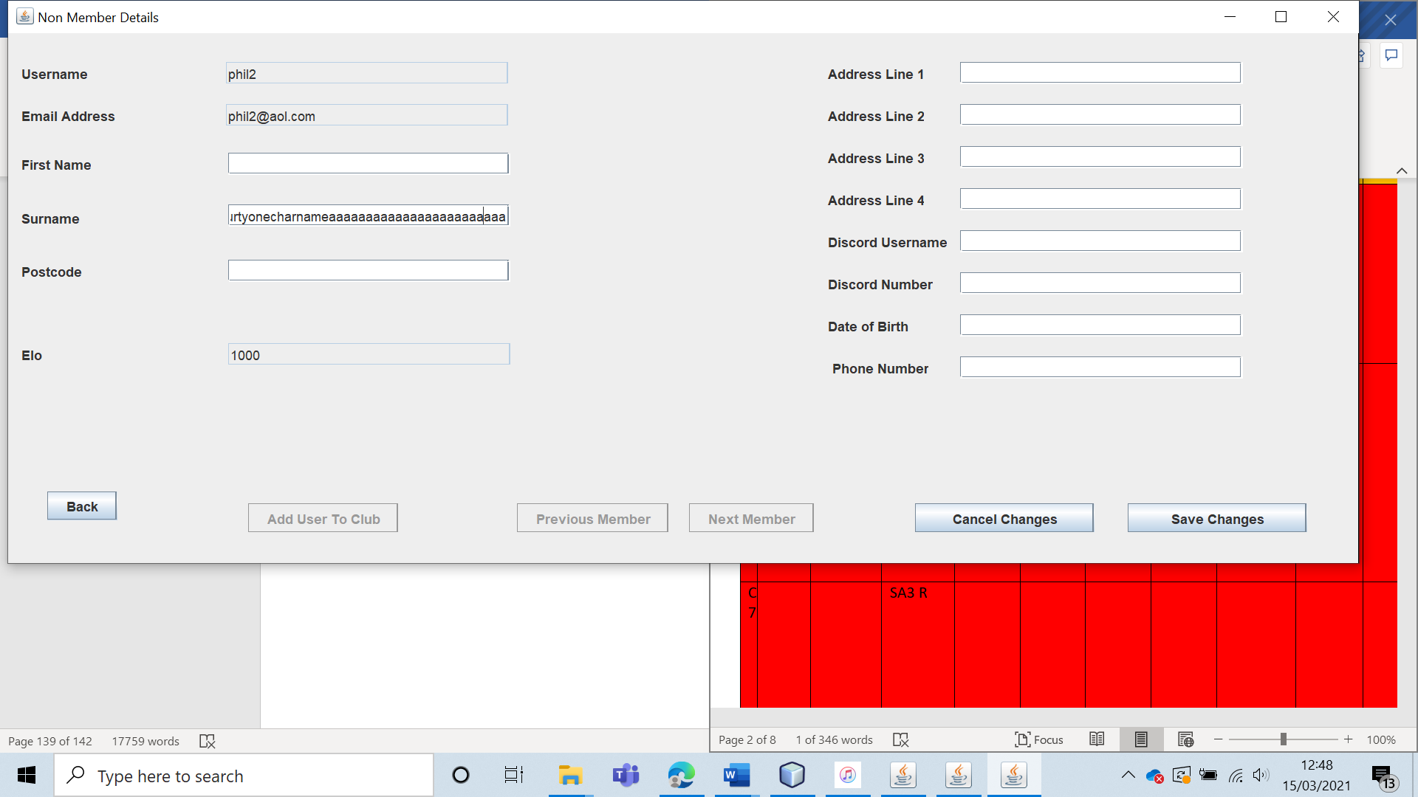

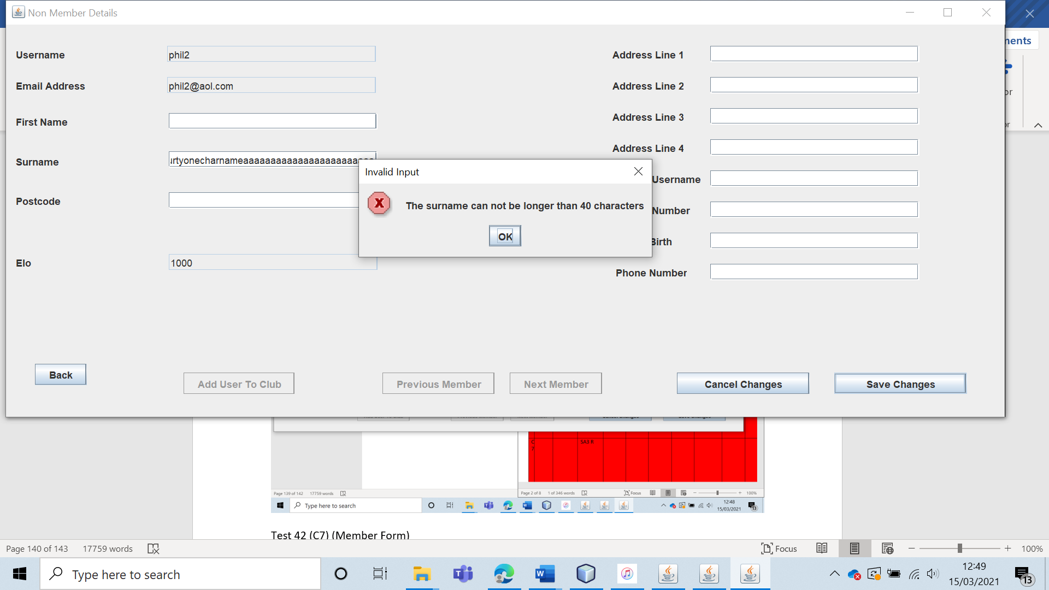

Test 42 (C7) (Member Form)

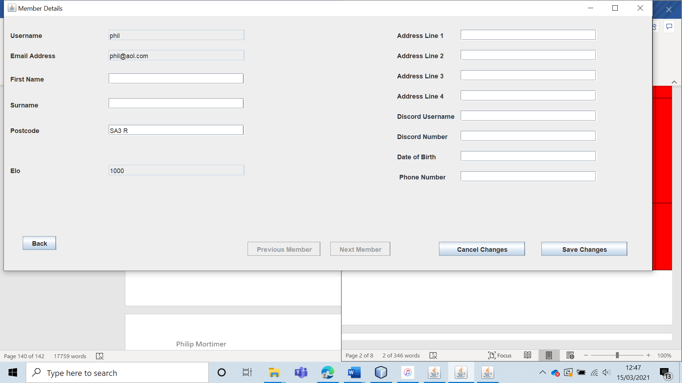

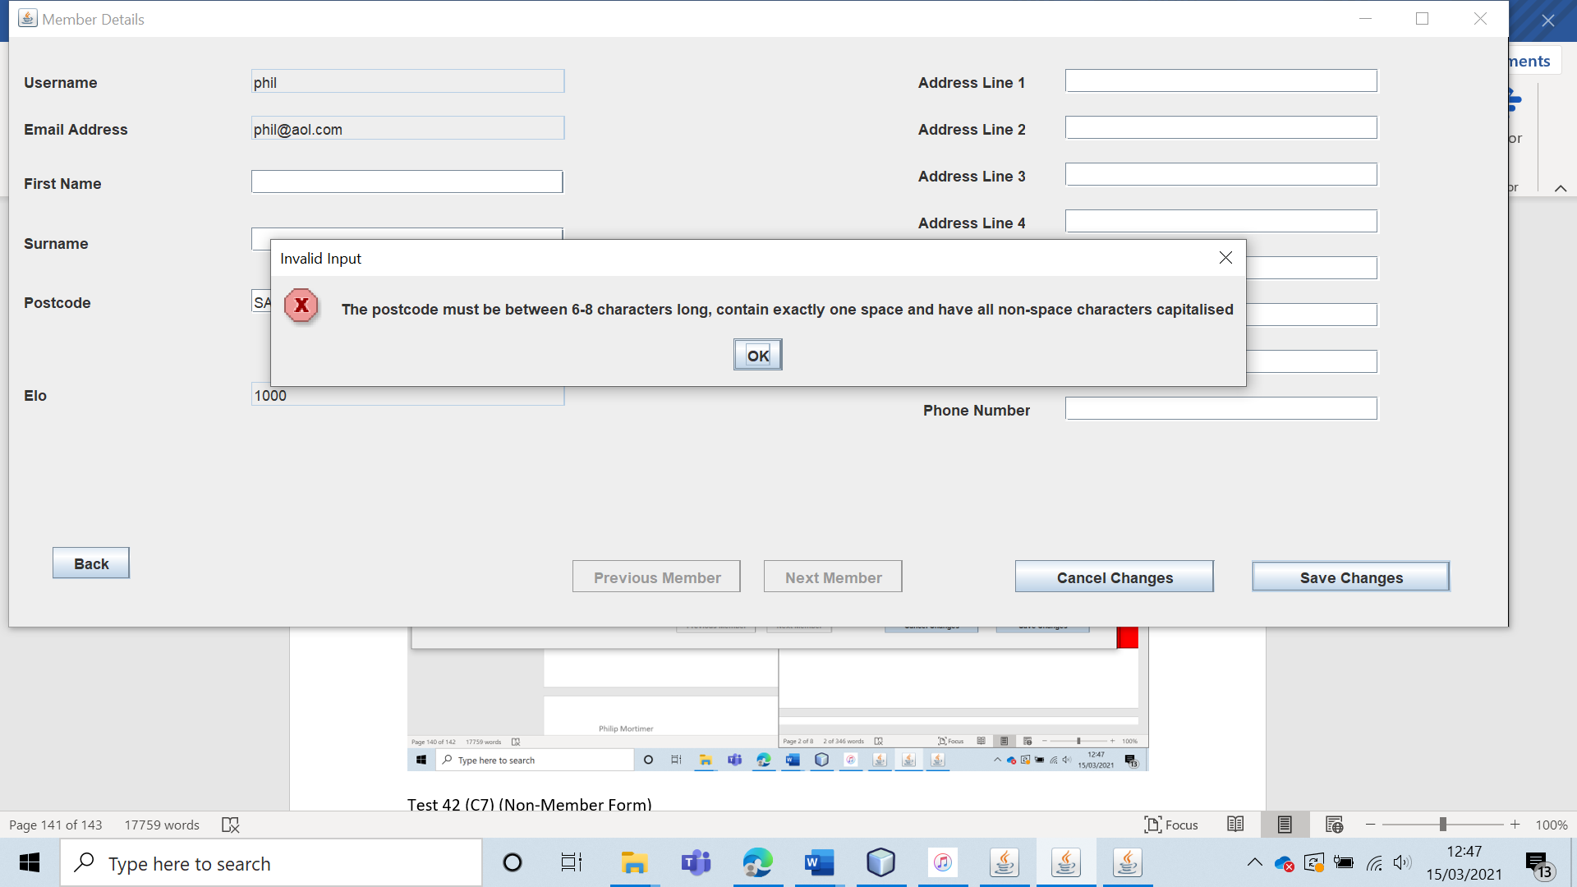

Test 42 (C7) (Non-Member Form)

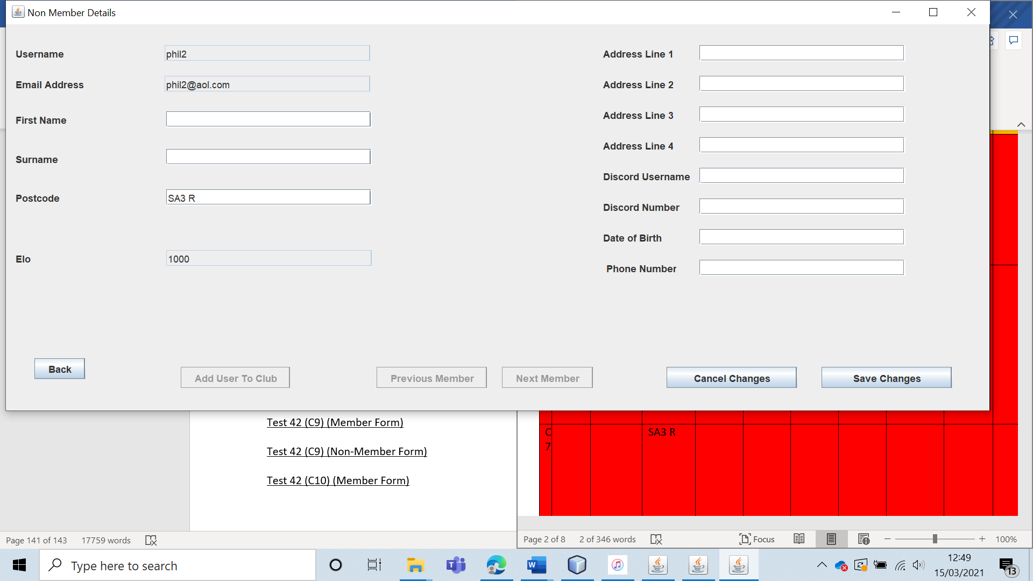

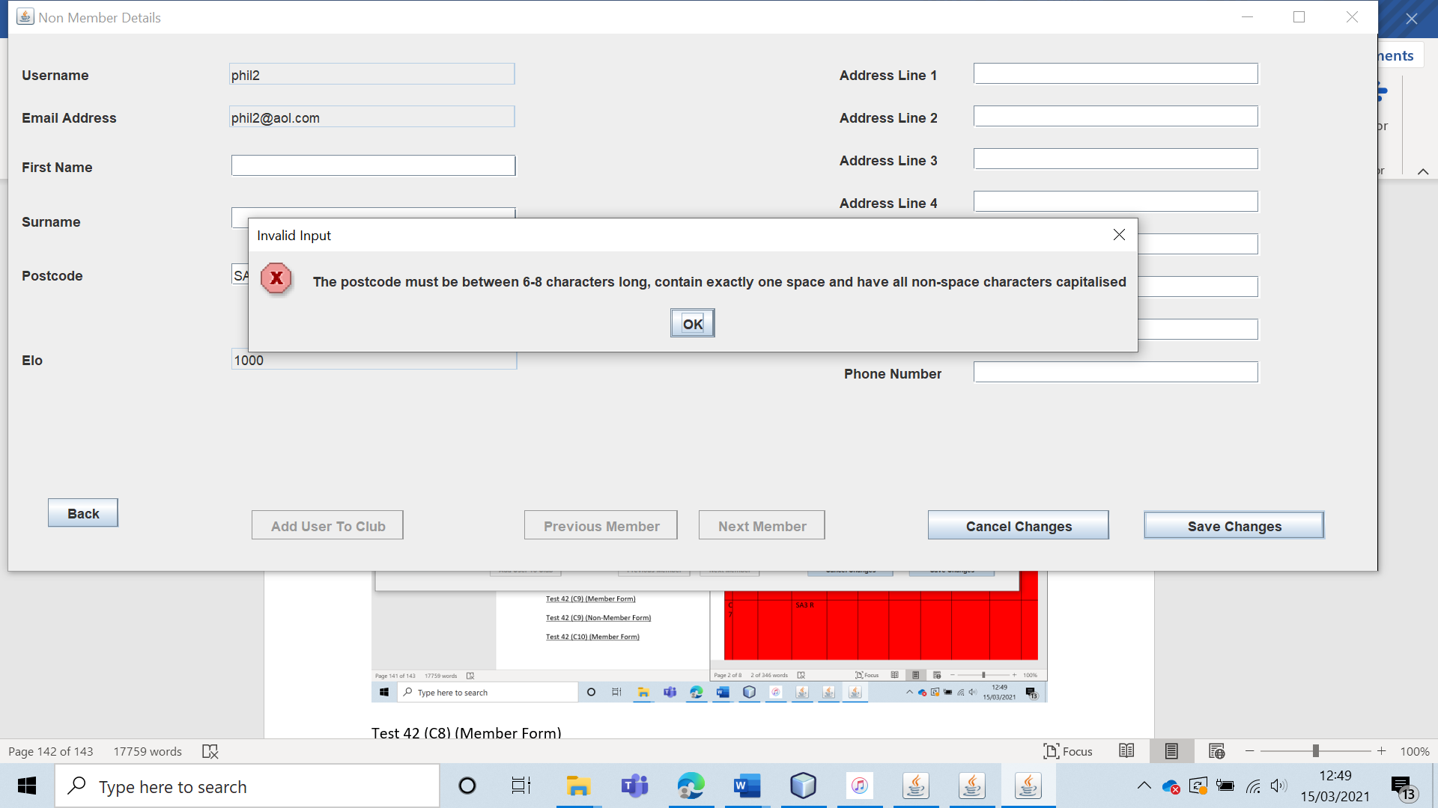

Test 42 (C8) (Member Form)

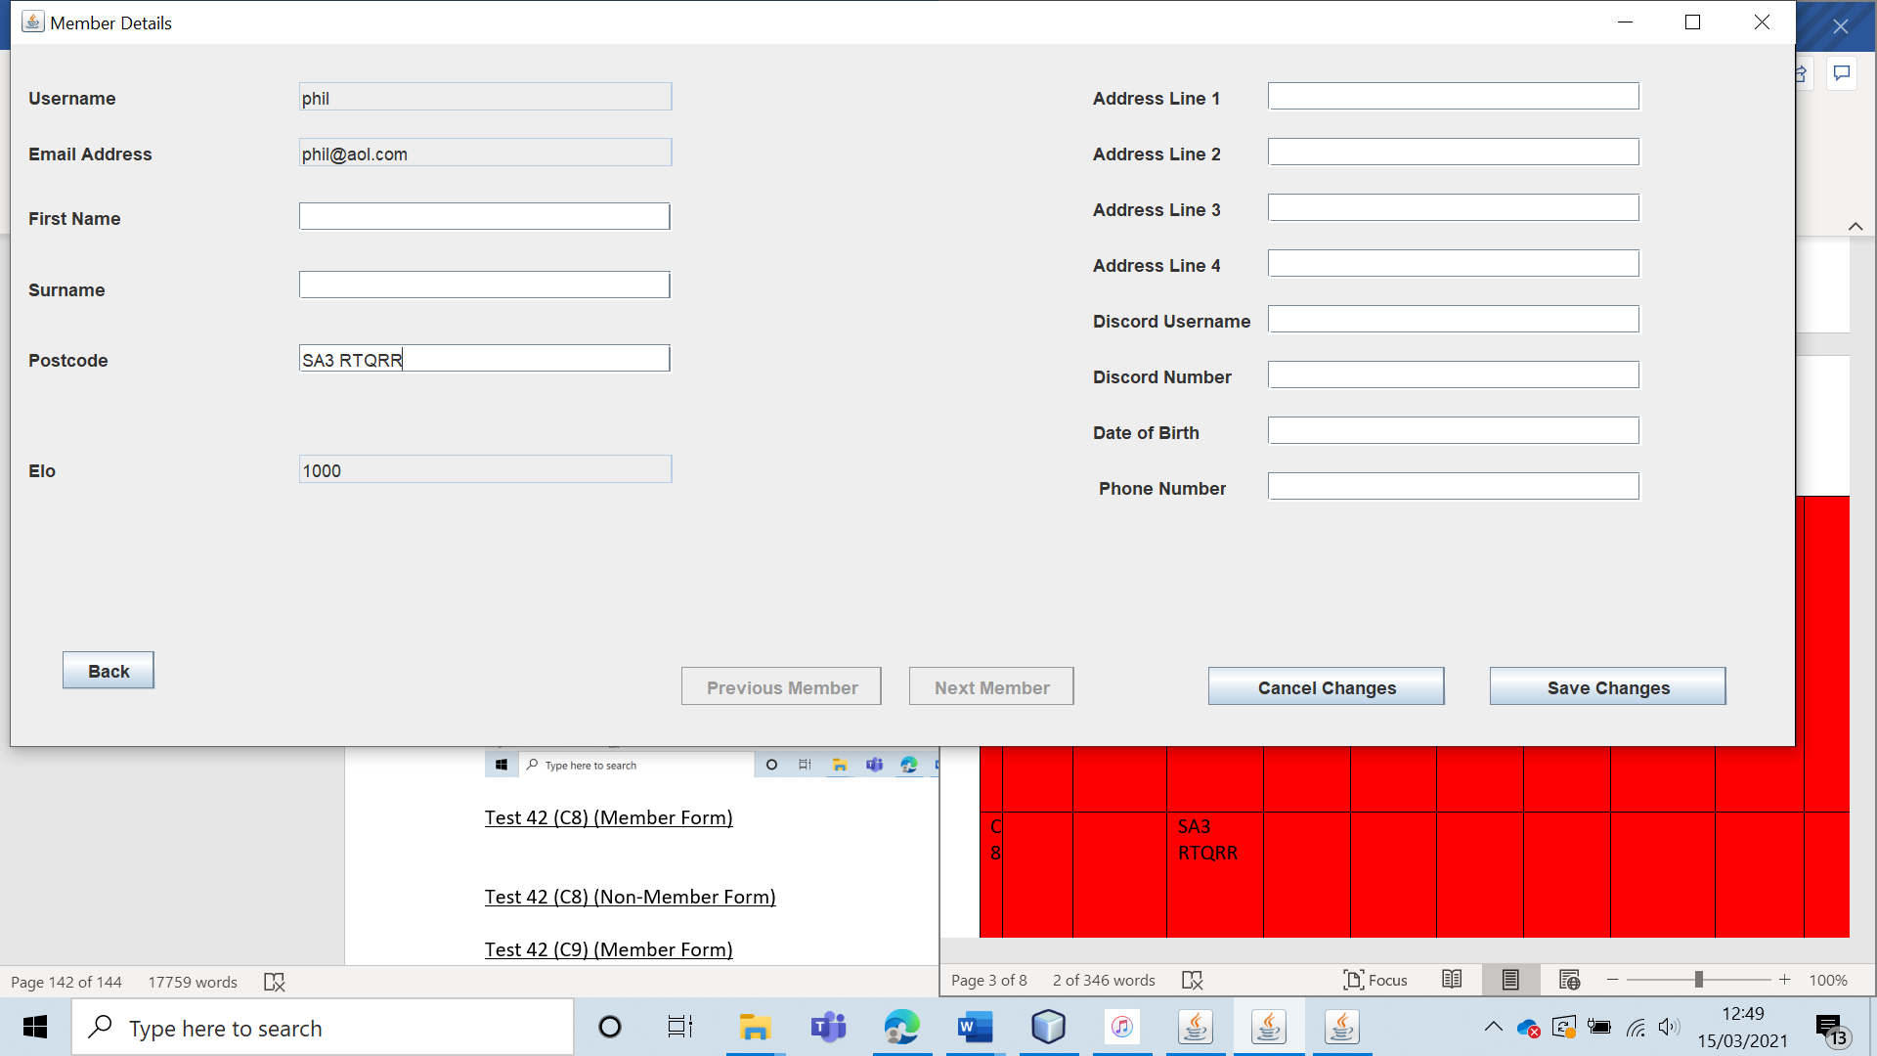 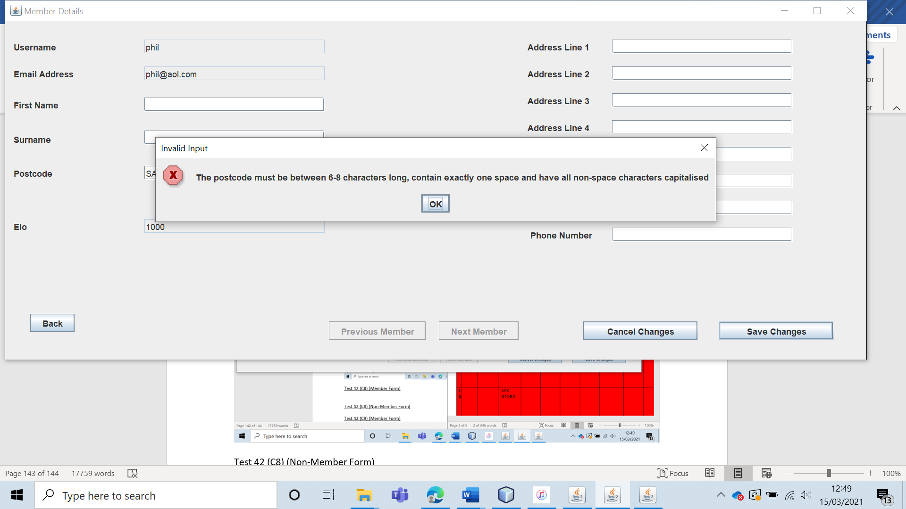

Test 42 (C8) (Non-Member Form)

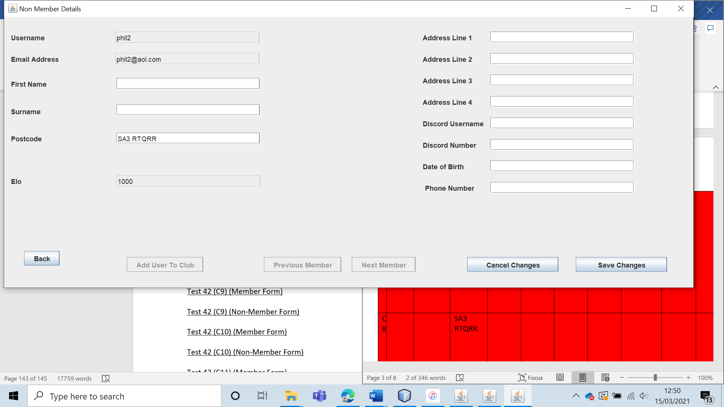 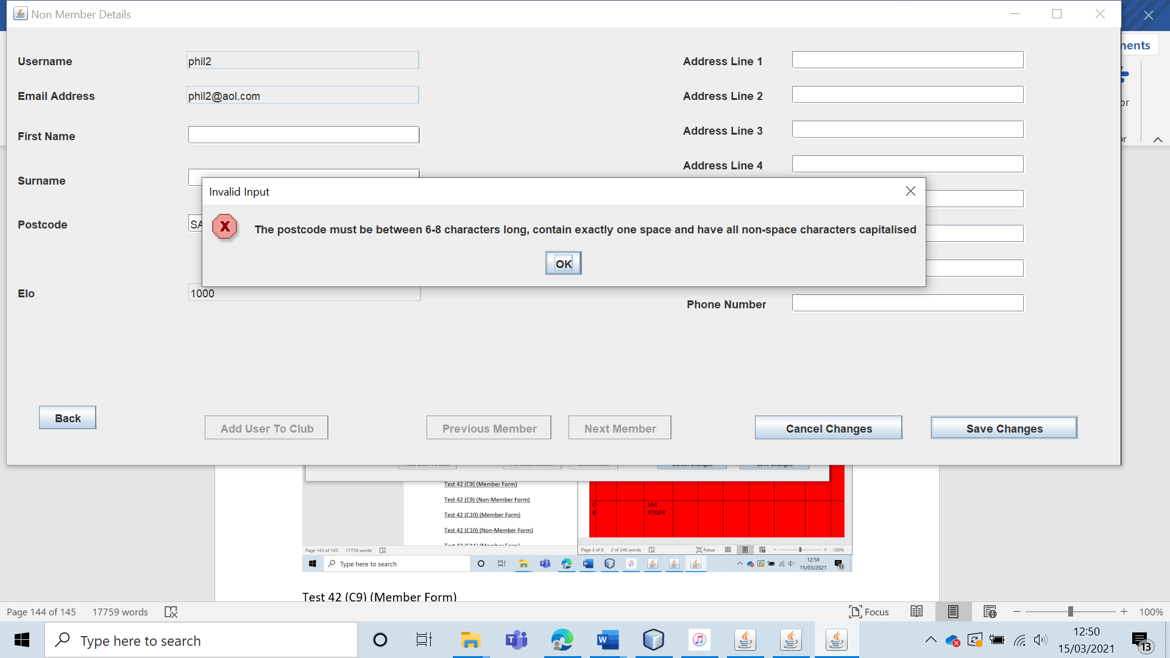

Test 42 (C9) (Member Form) 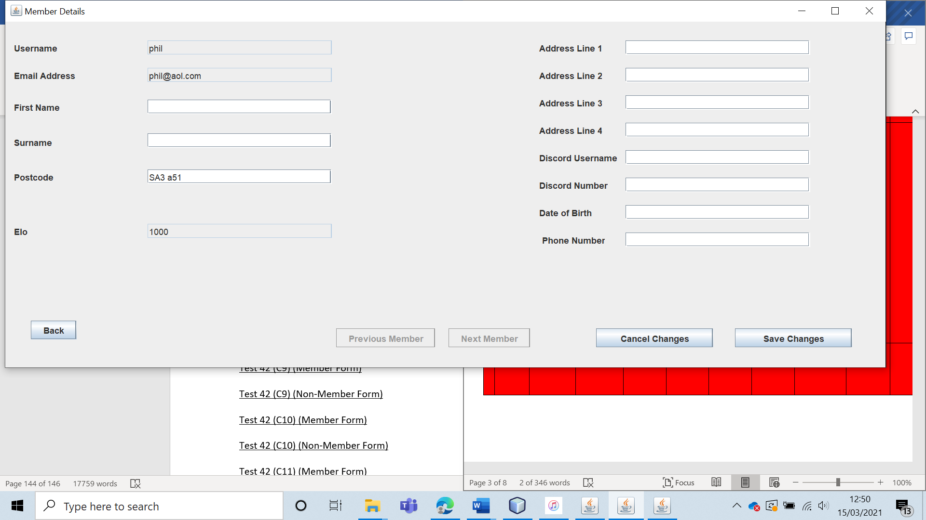 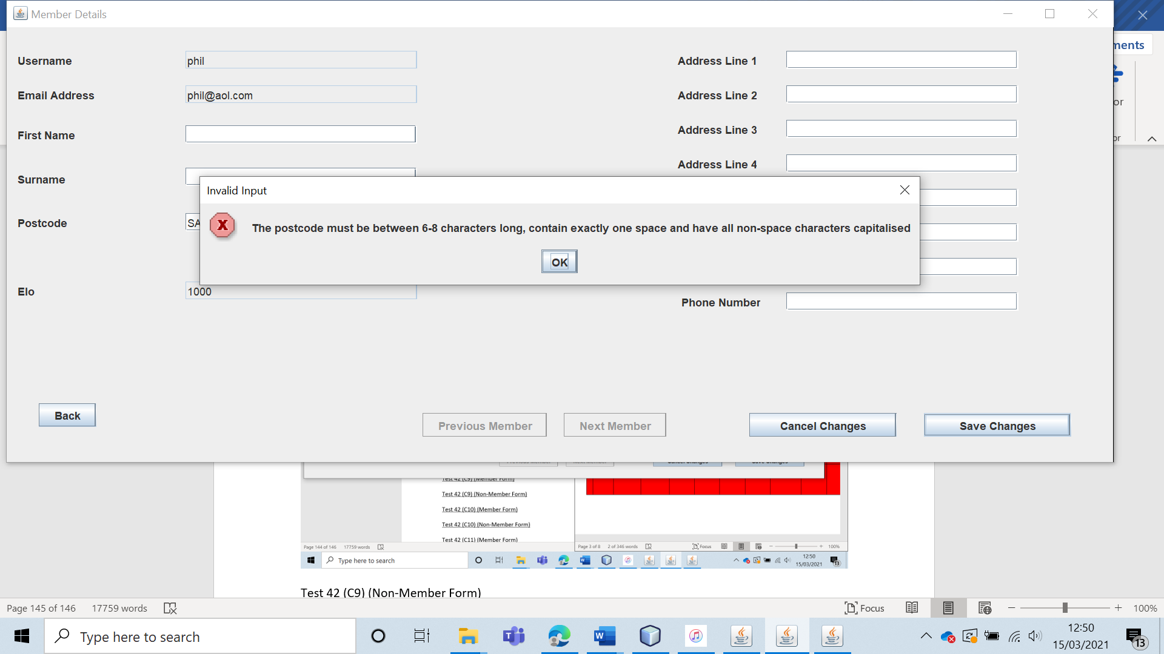

Test 42 (C9) (Non-Member Form) 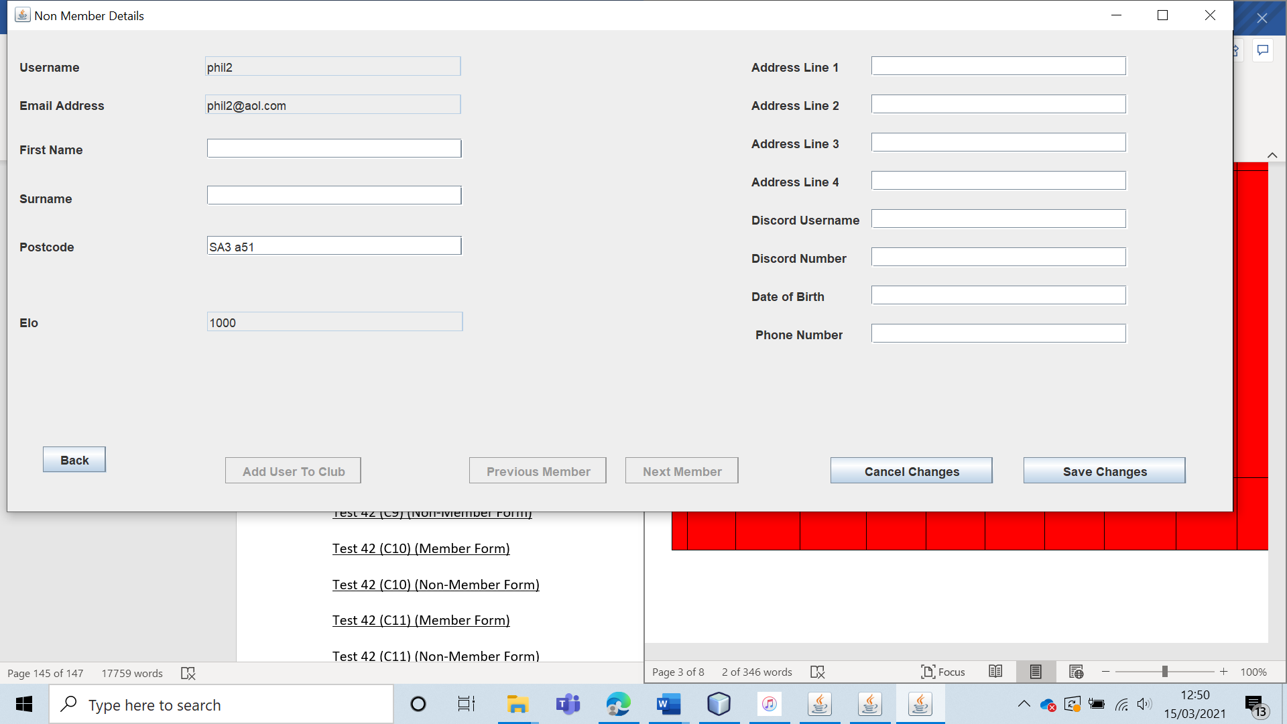 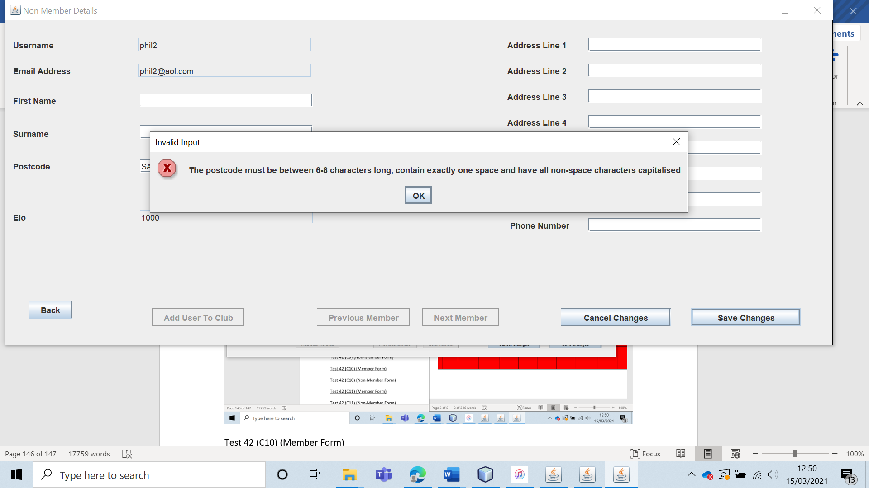

Test 42 (C10) (Member Form) 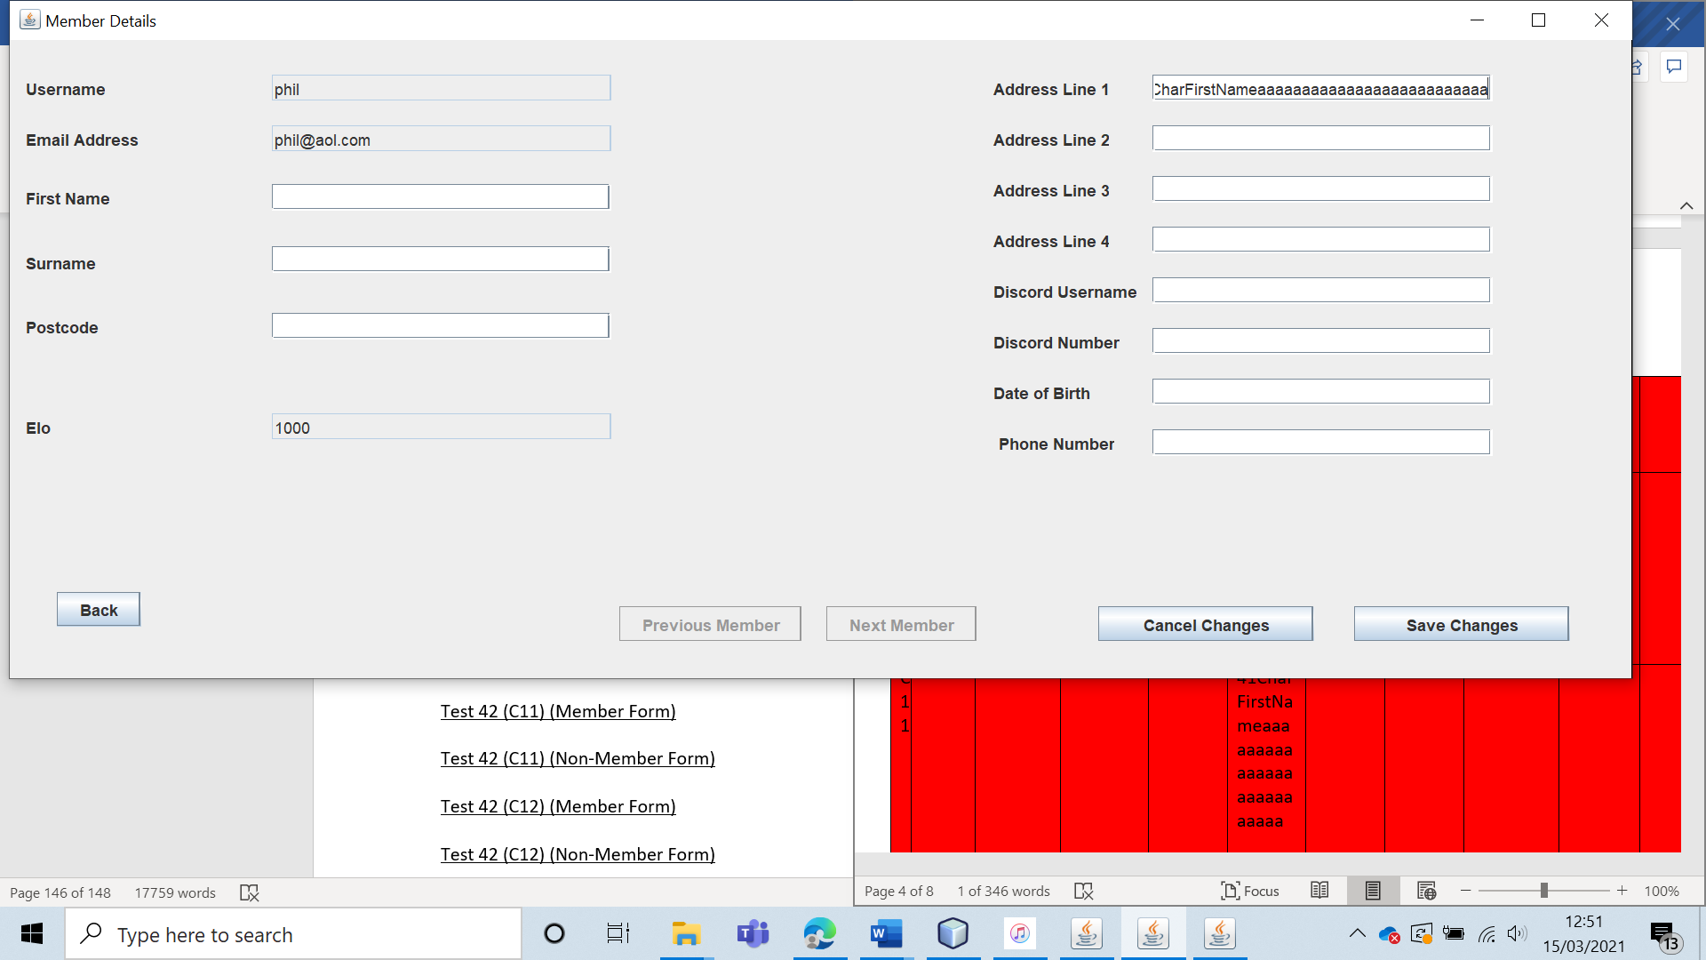

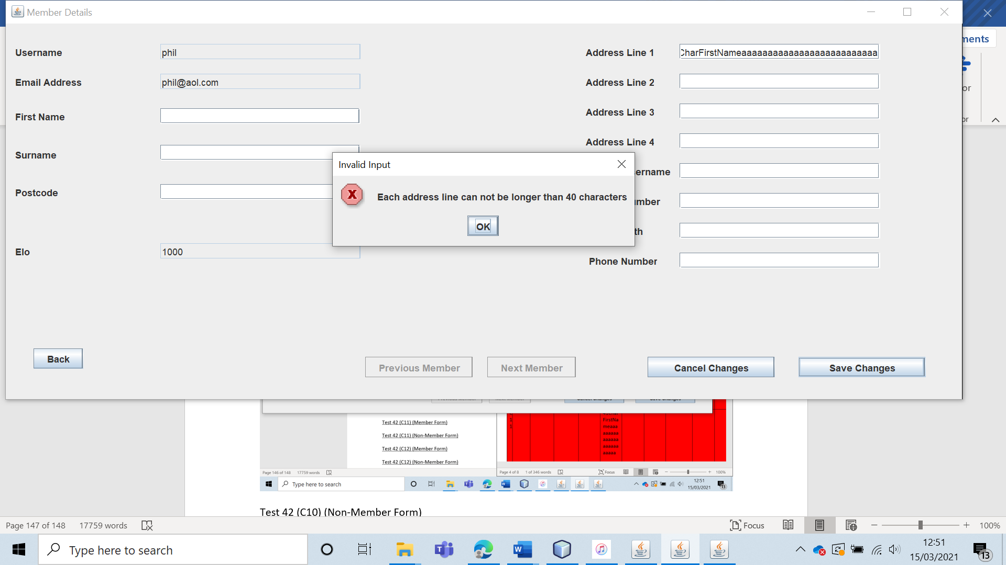

Test 42 (C10) (Non-Member Form) 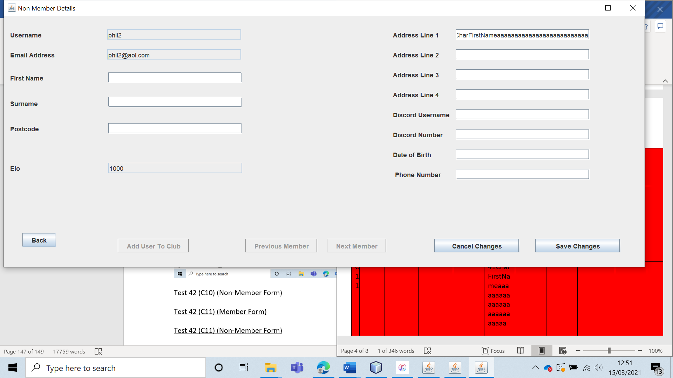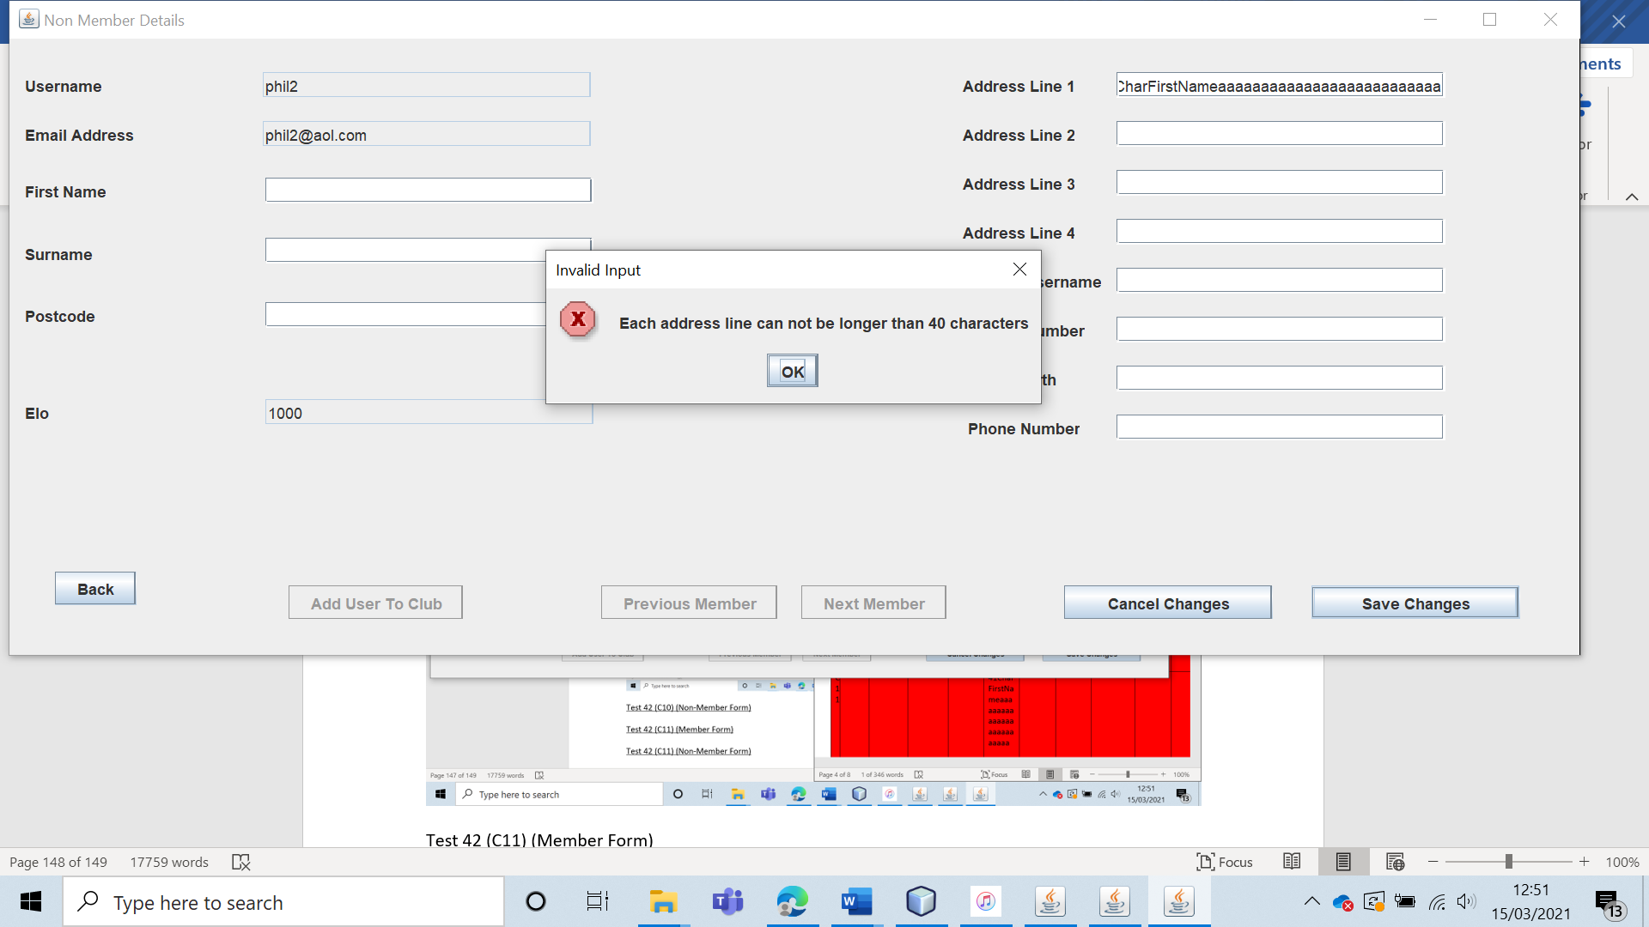

Test 42 (C11) (Member Form) 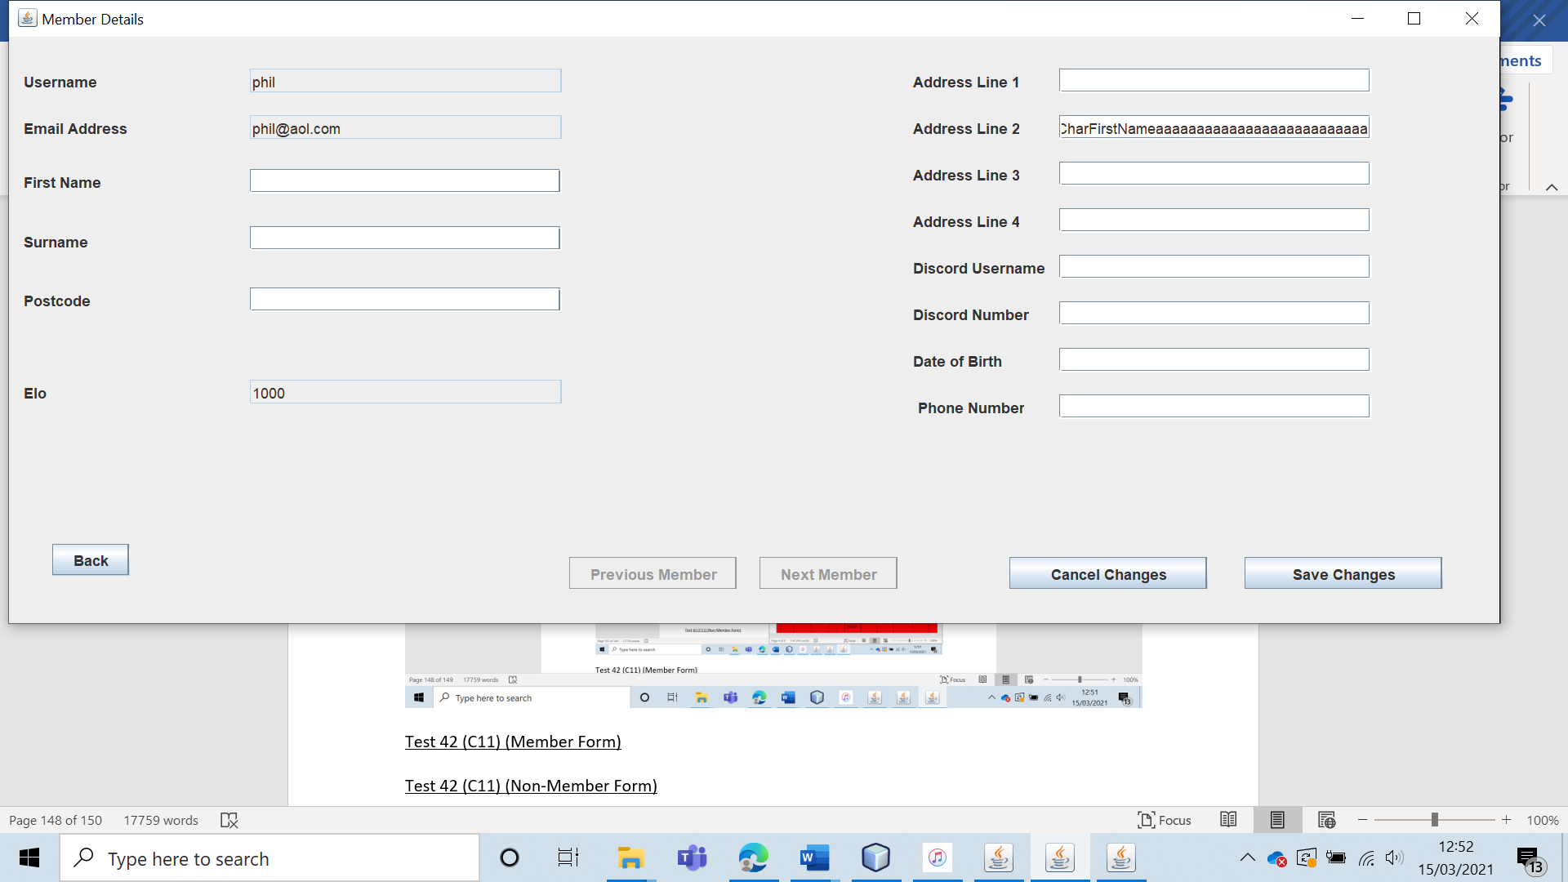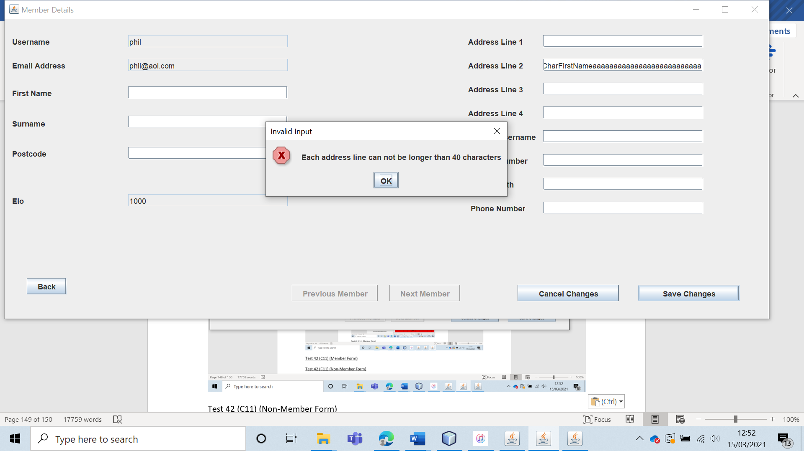

Test 42 (C11) (Non-Member Form) 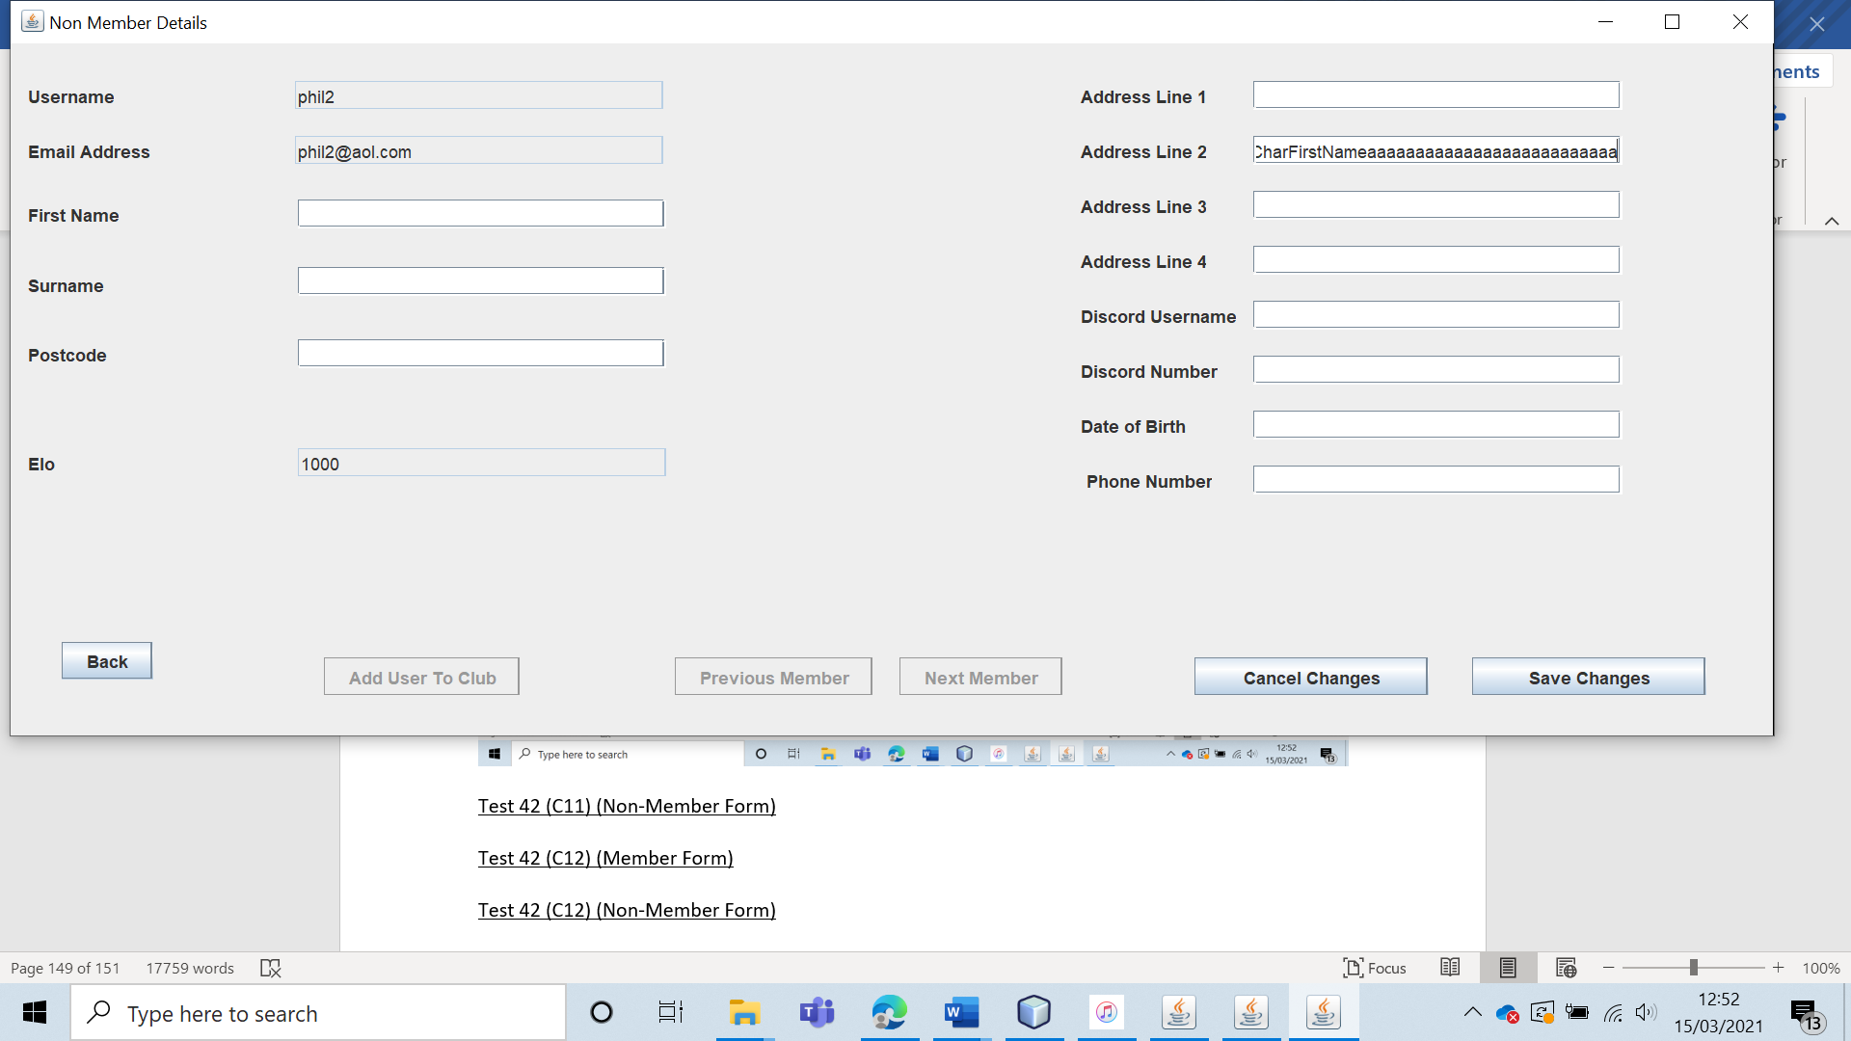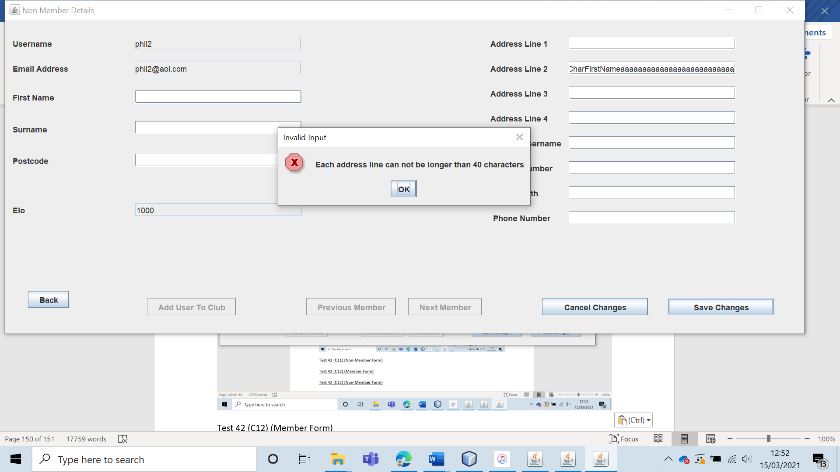

Test 42 (C12) (Member Form)

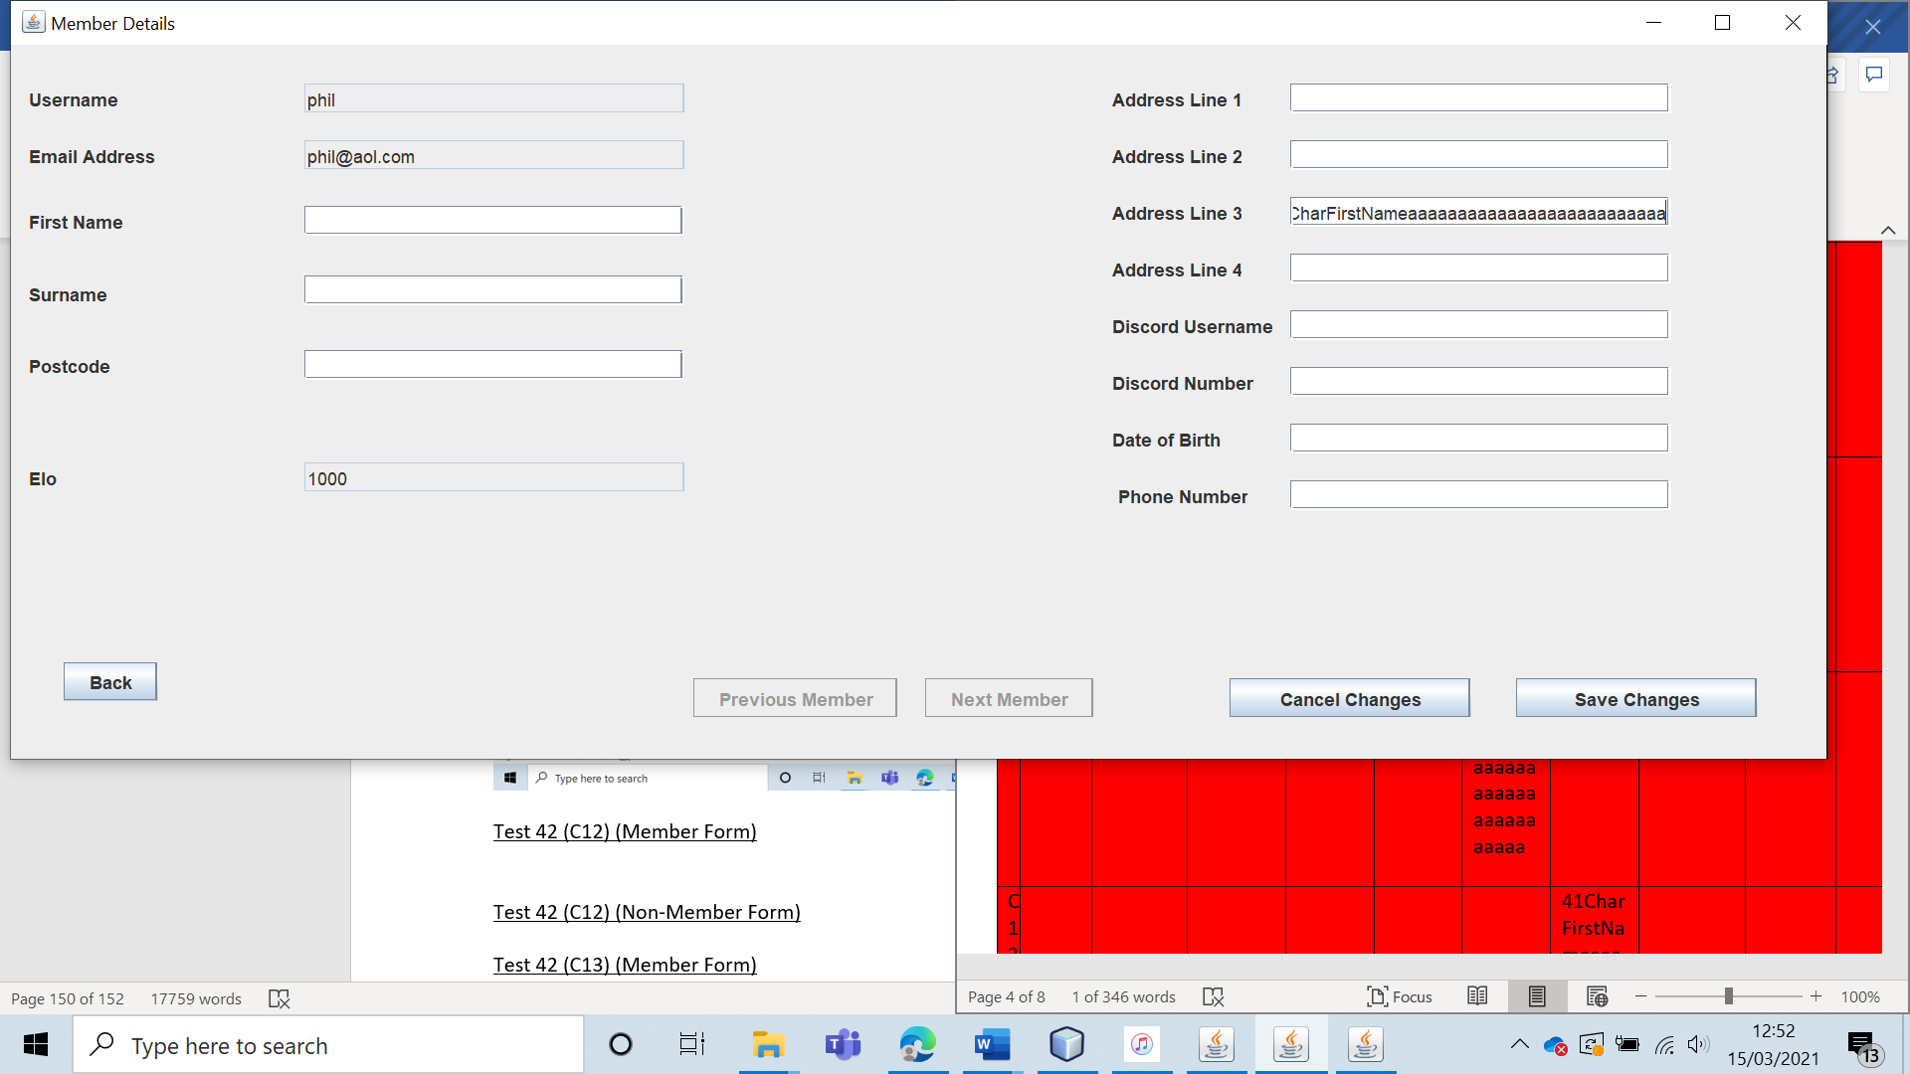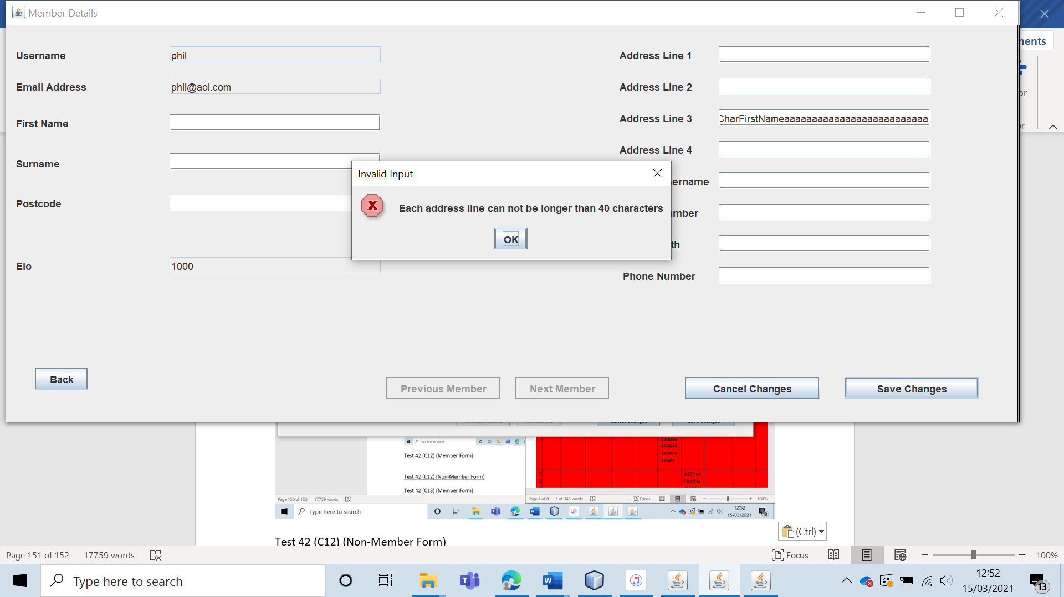

Test 42 (C12) (Non-Member Form) 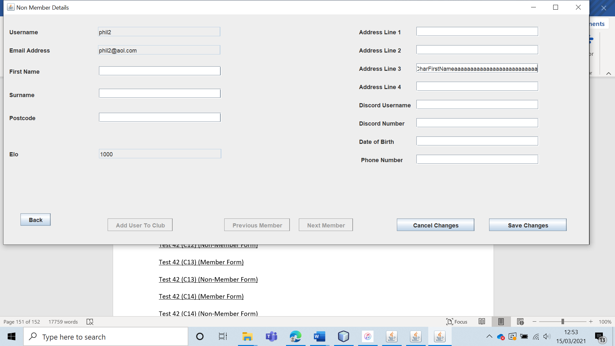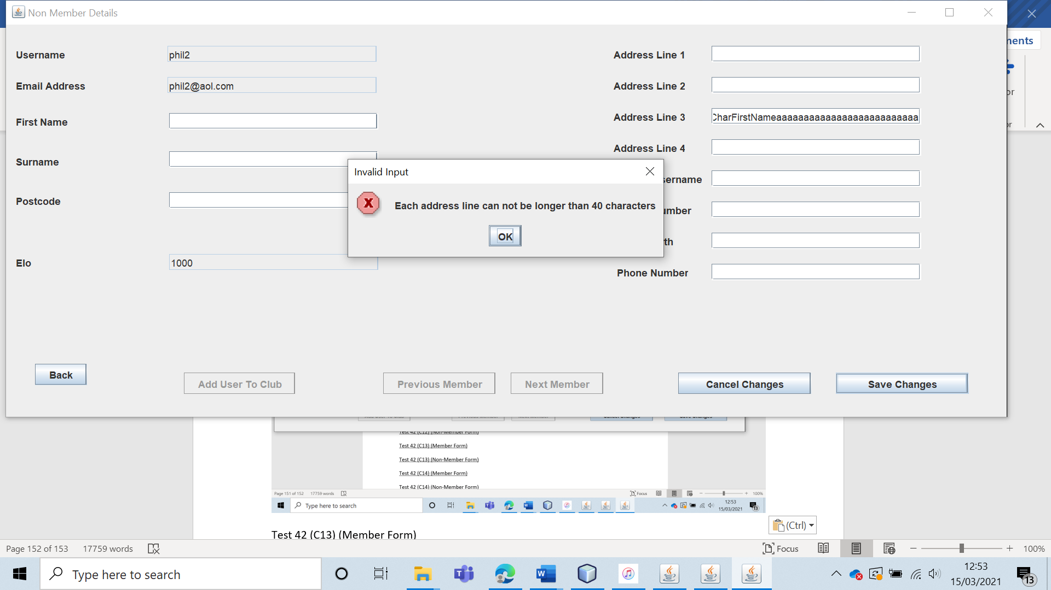

Test 42 (C13) (Member Form) 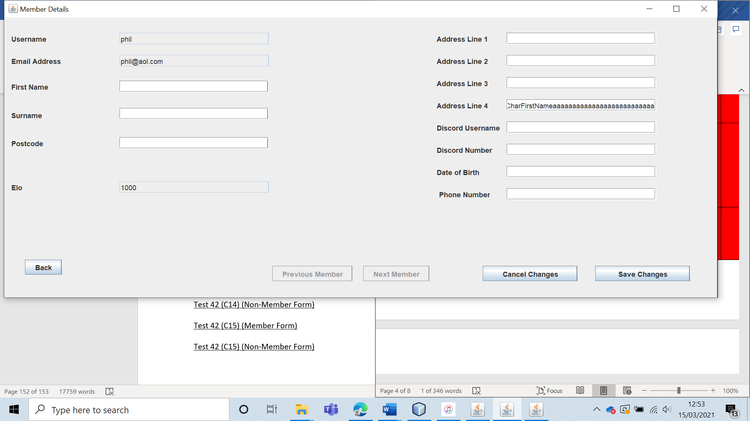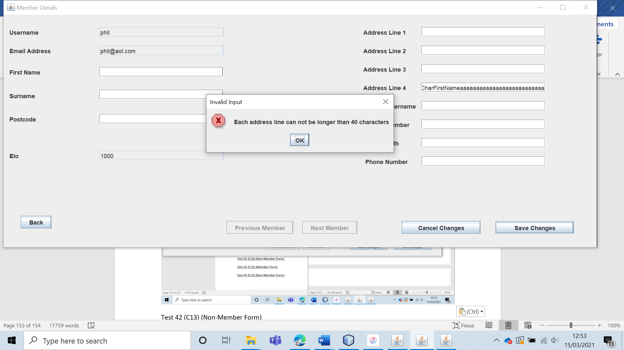

Test 42 (C13) (Non-Member Form) 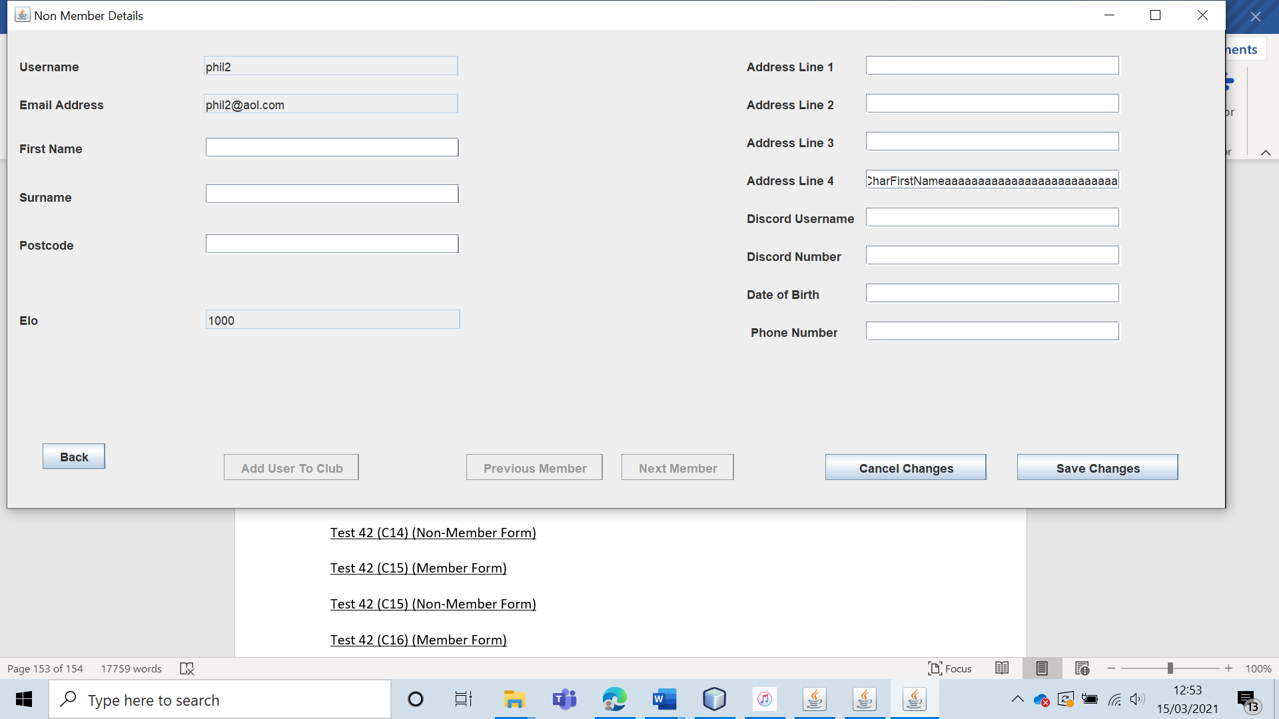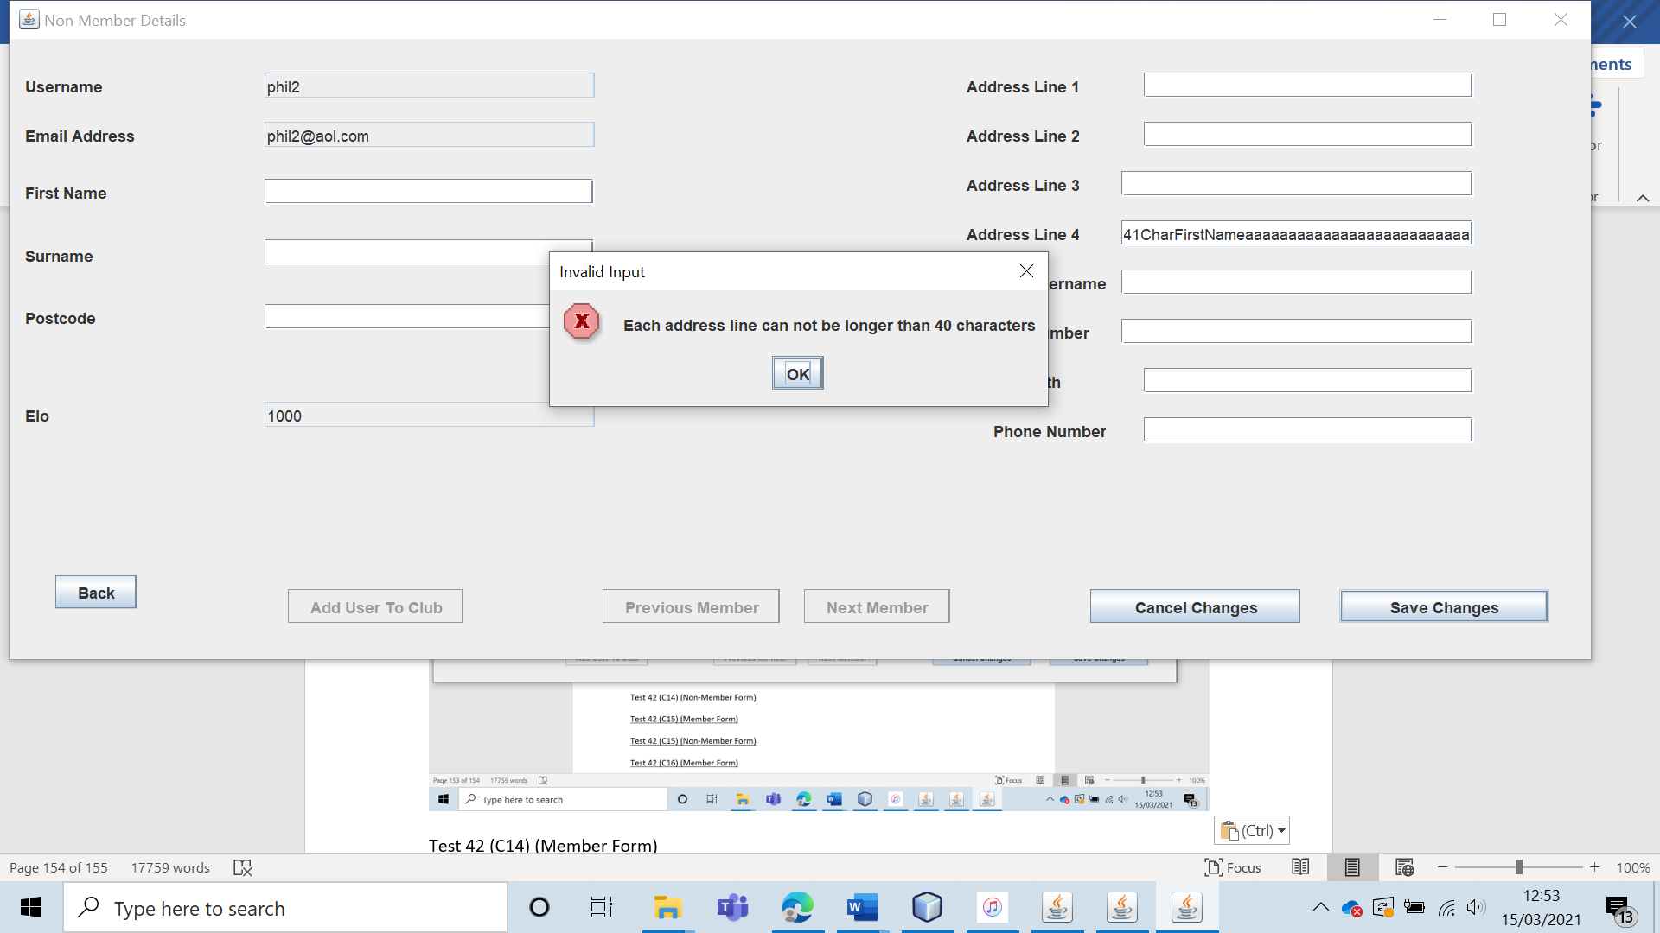

Test 42 (C14) (Member Form)

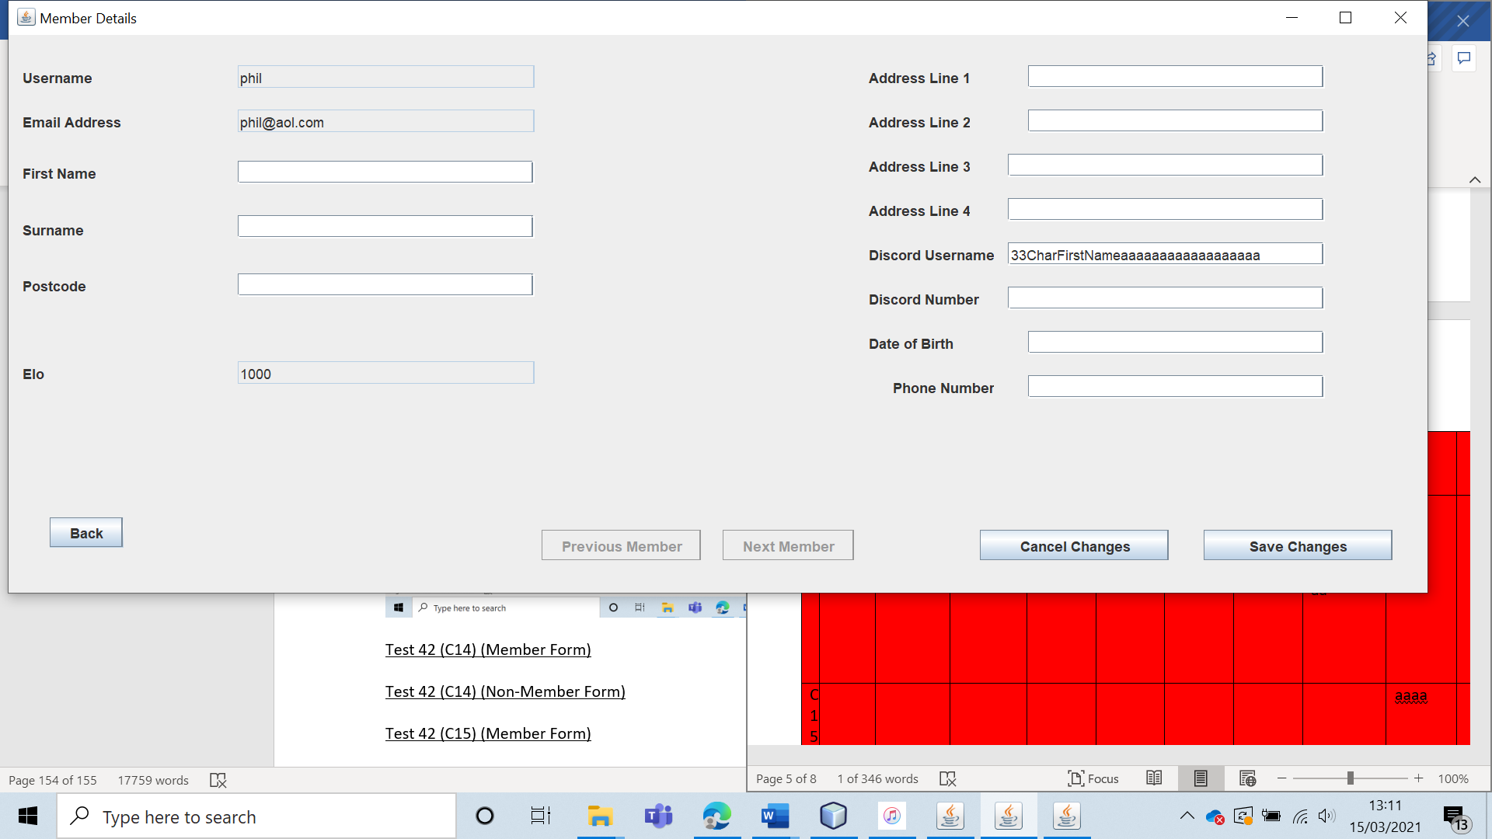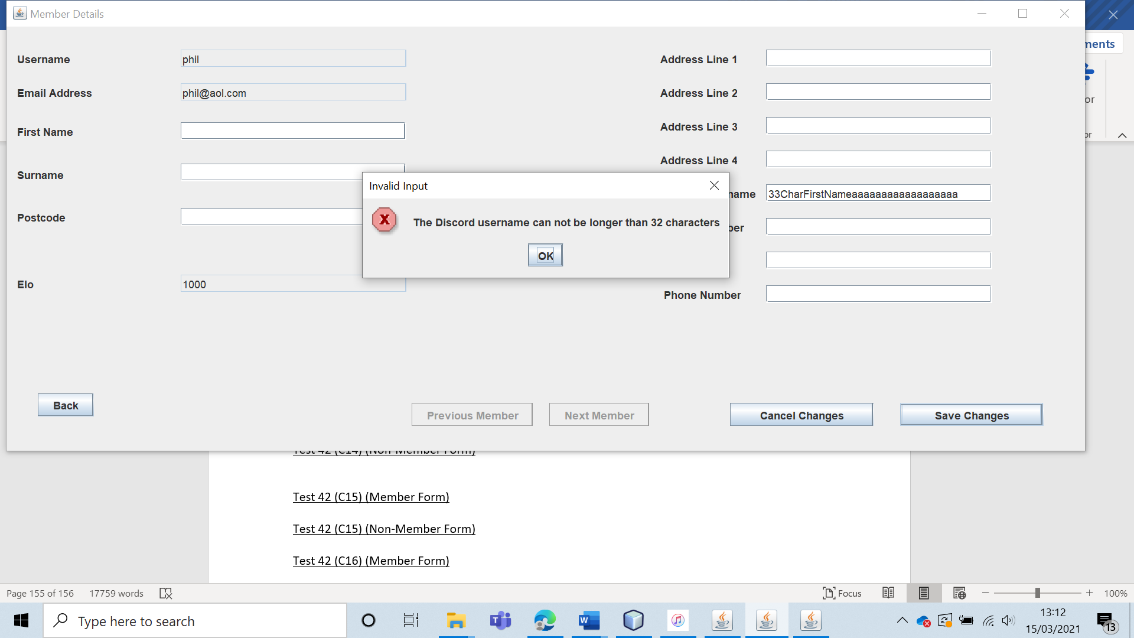

Test 42 (C14) (Non-Member Form)

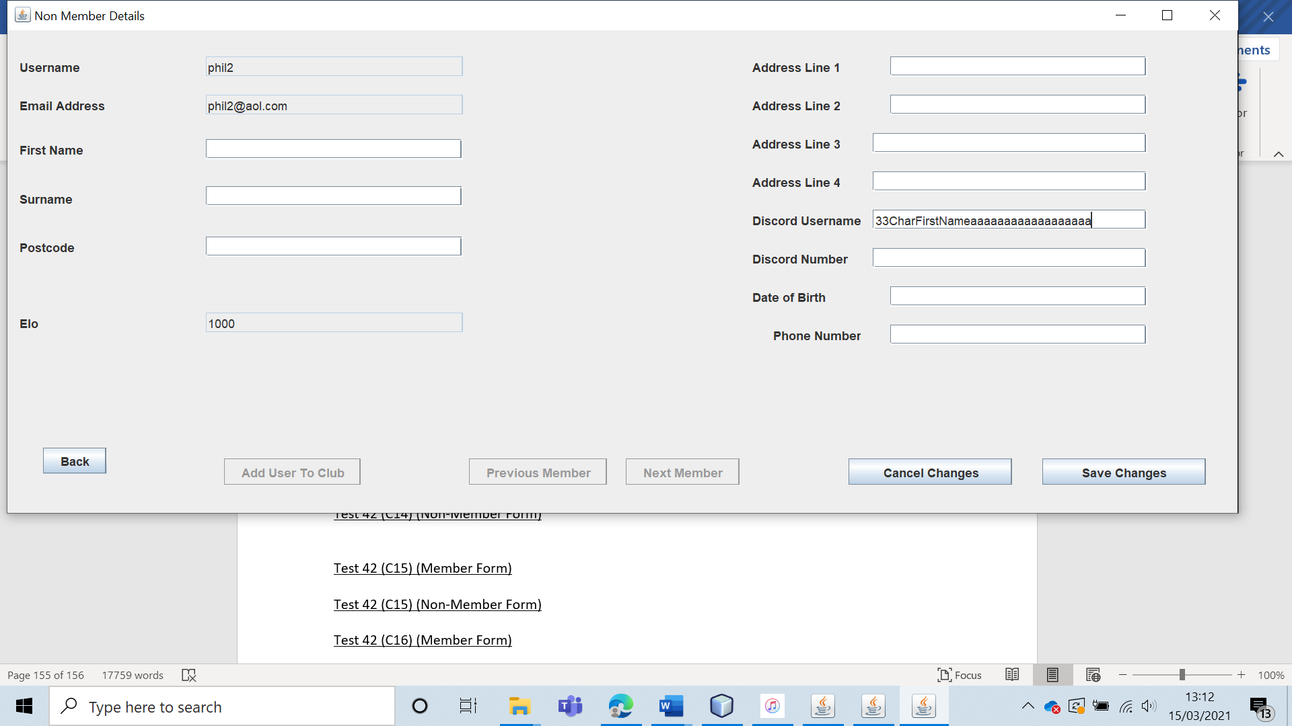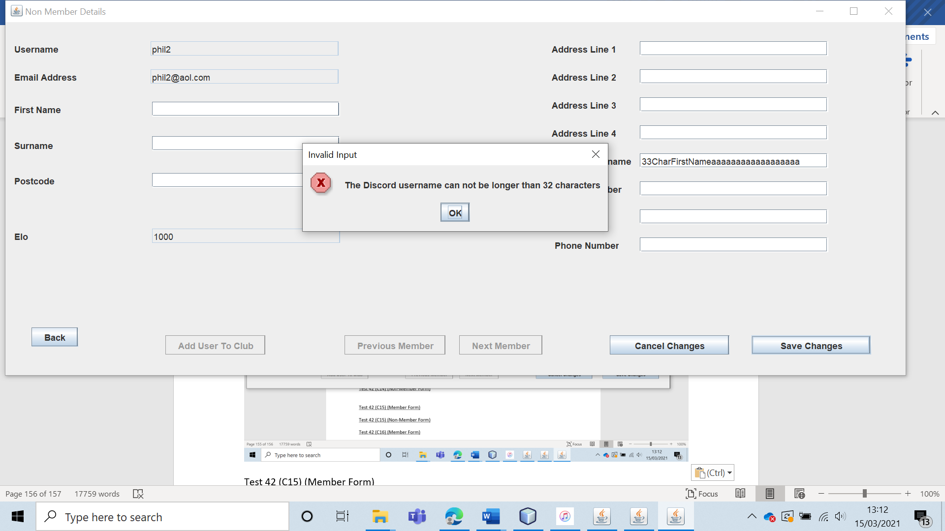

Test 42 (C15) (Member Form)

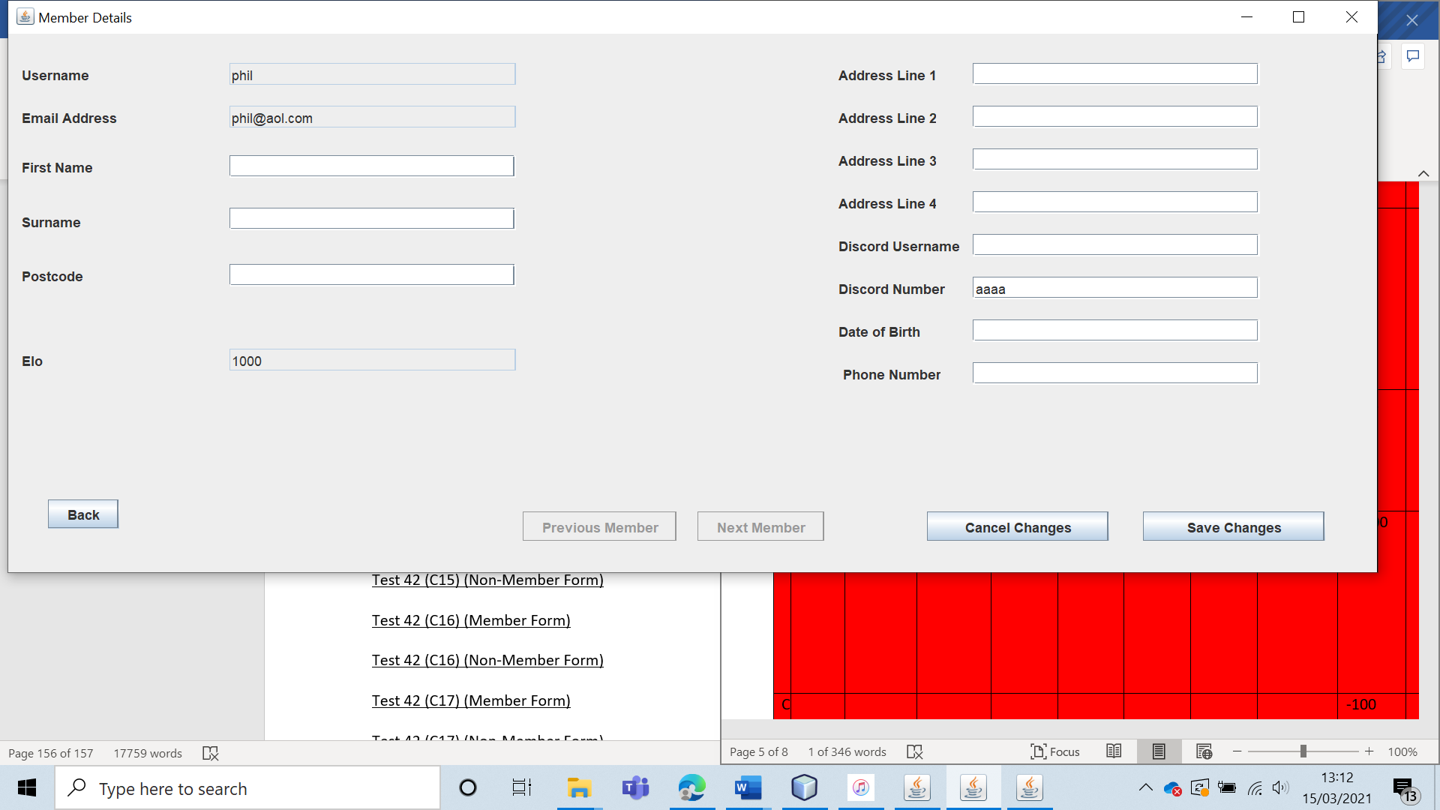 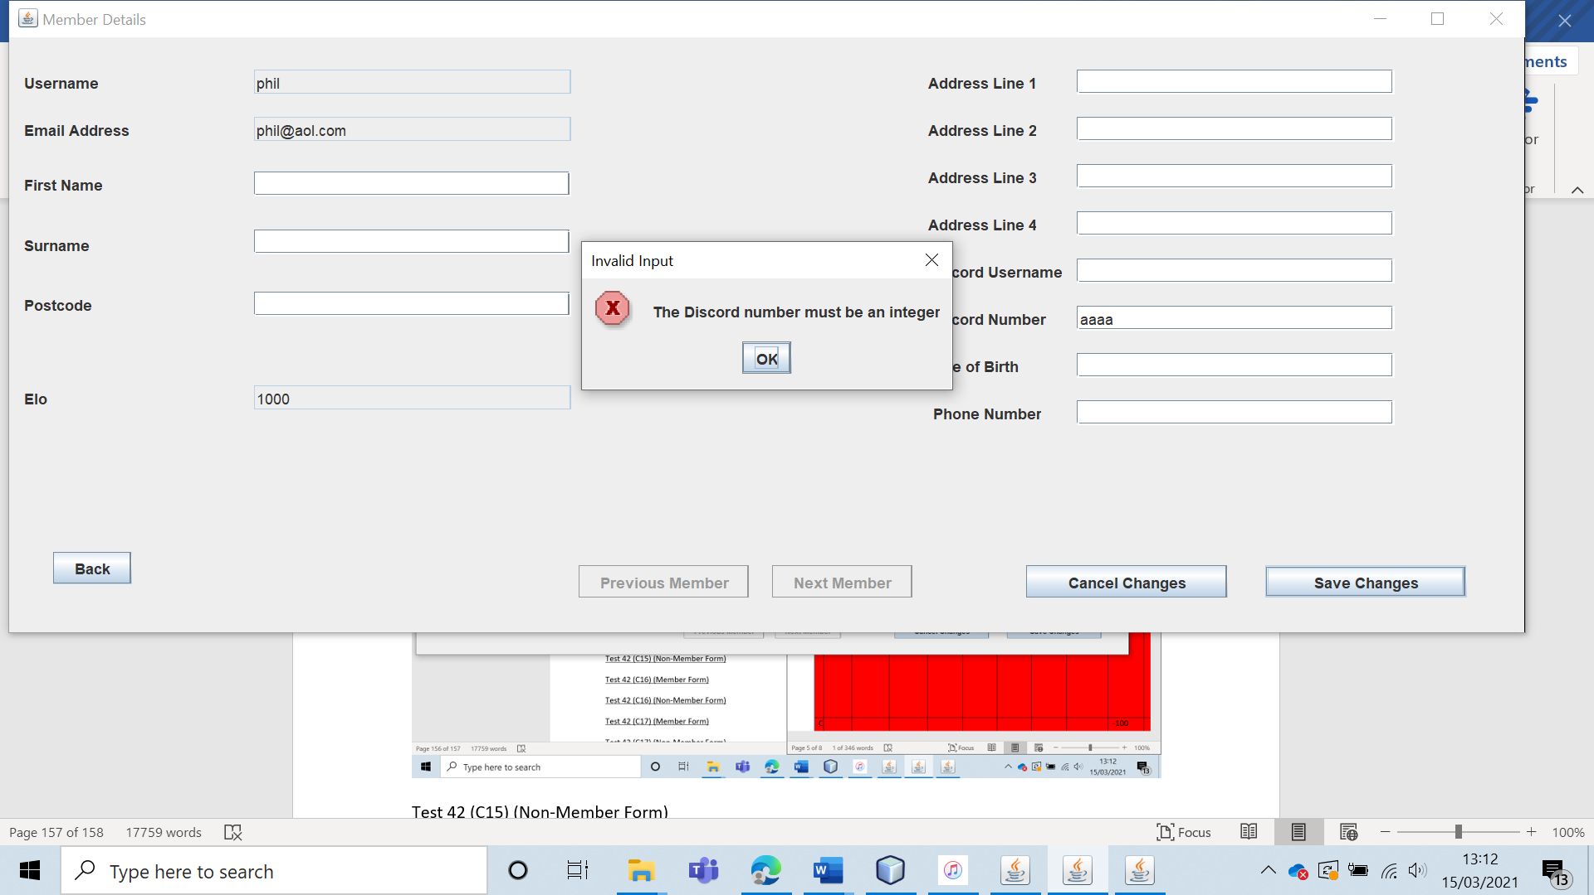

Test 42 (C15) (Non-Member Form) 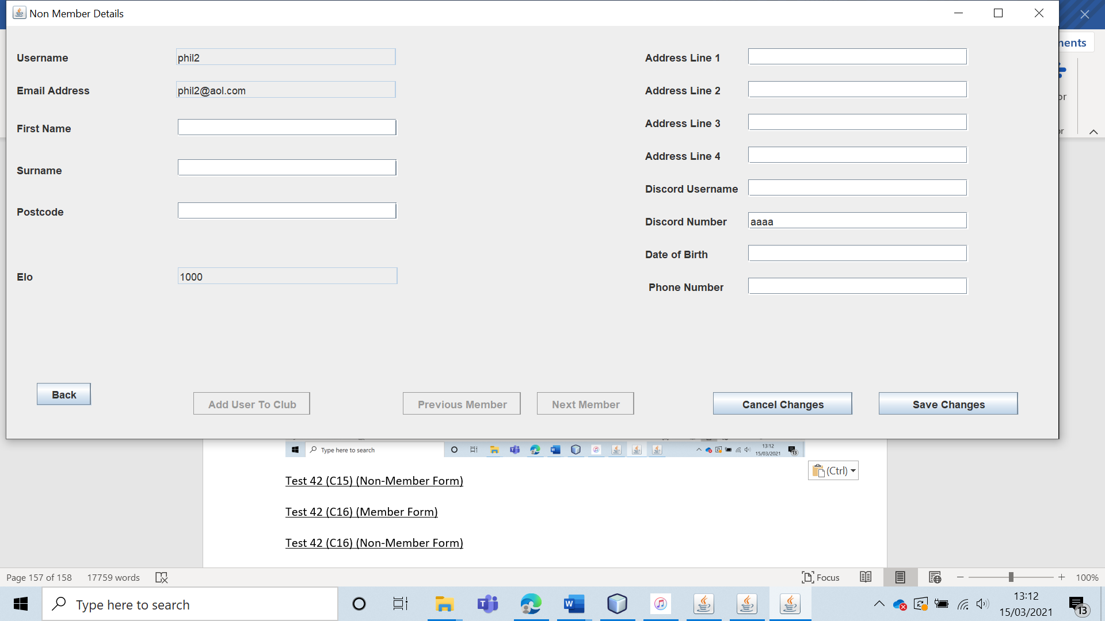 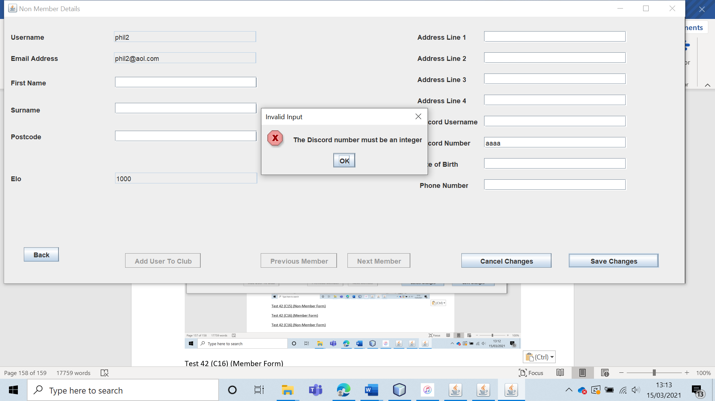

Test 42 (C16) (Member Form) 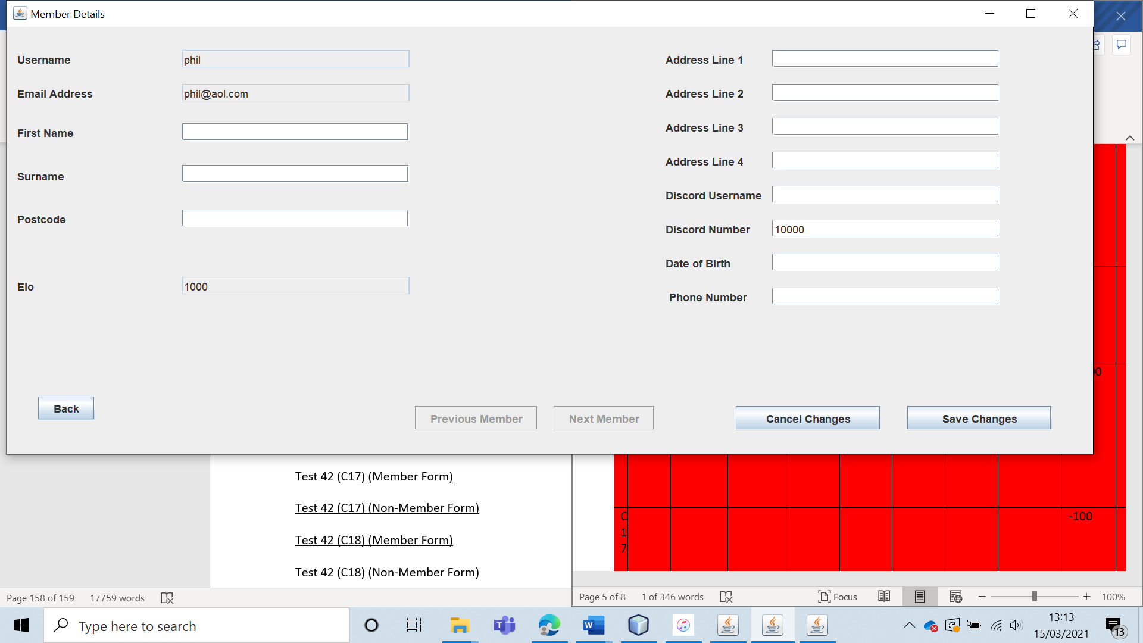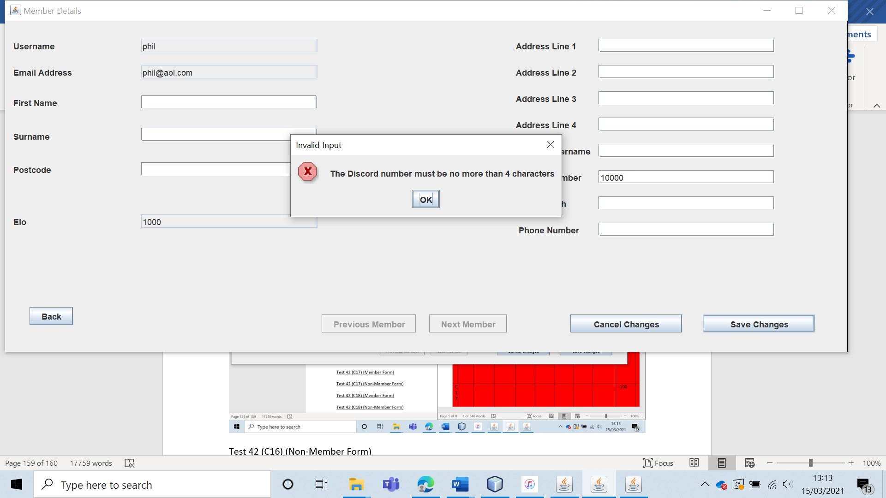

Test 42 (C16) (Non-Member Form) 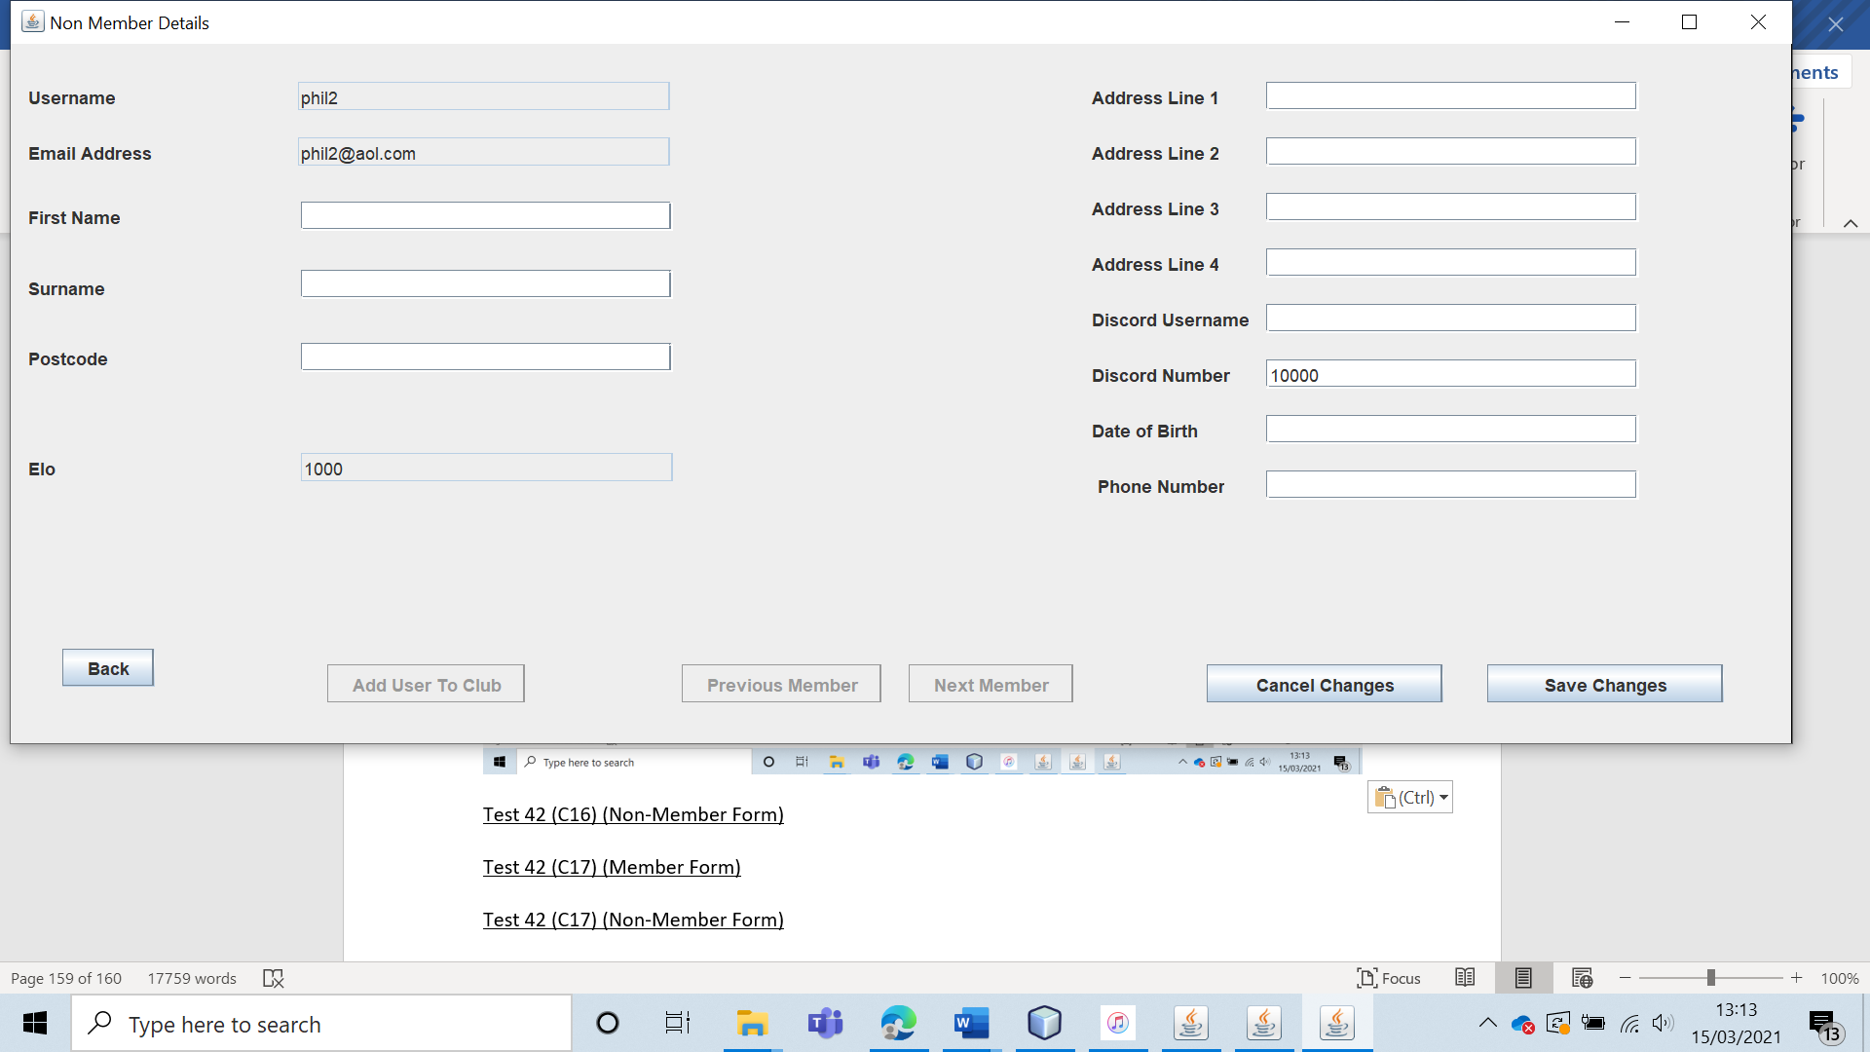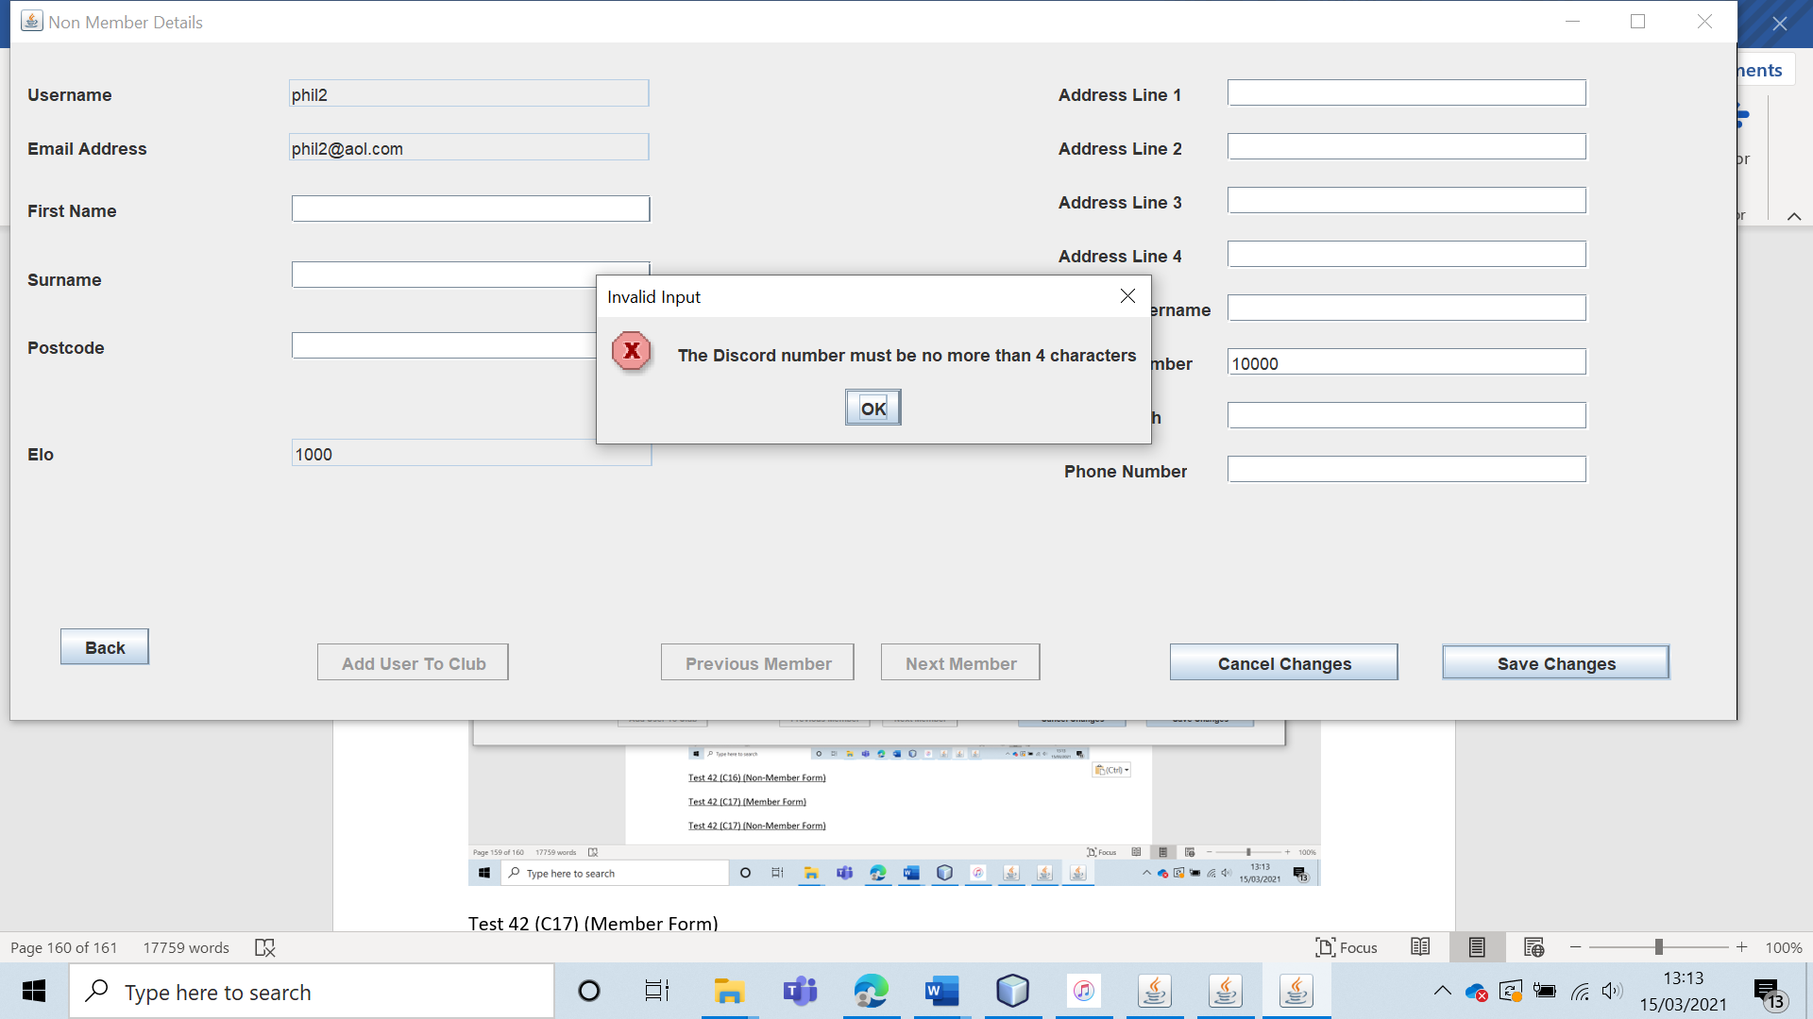

Test 42 (C17) (Member Form)

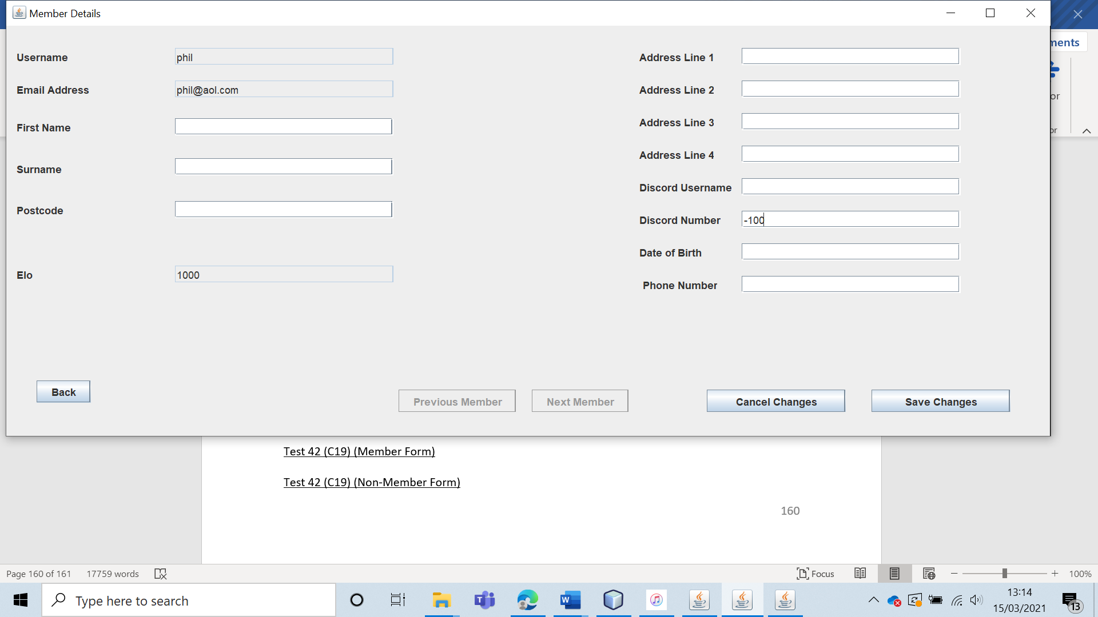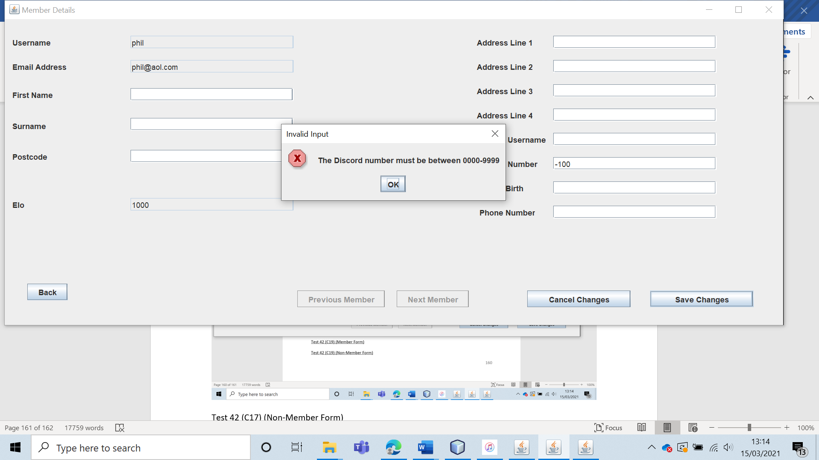

Test 42 (C17) (Non-Member Form)

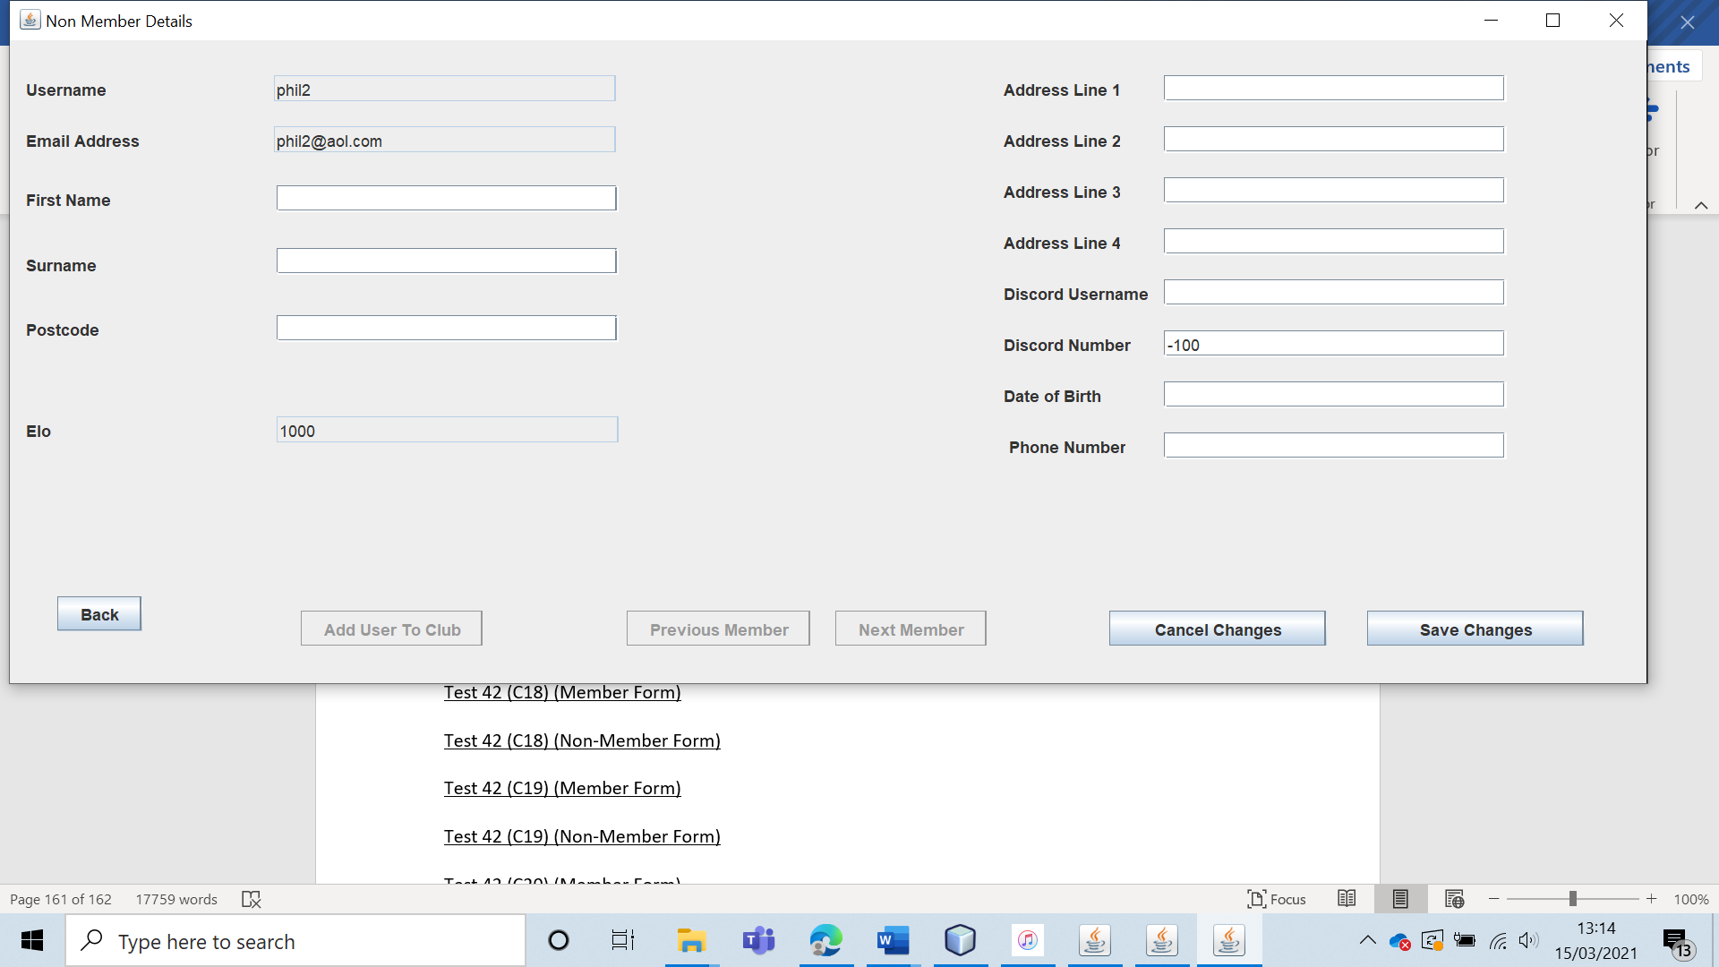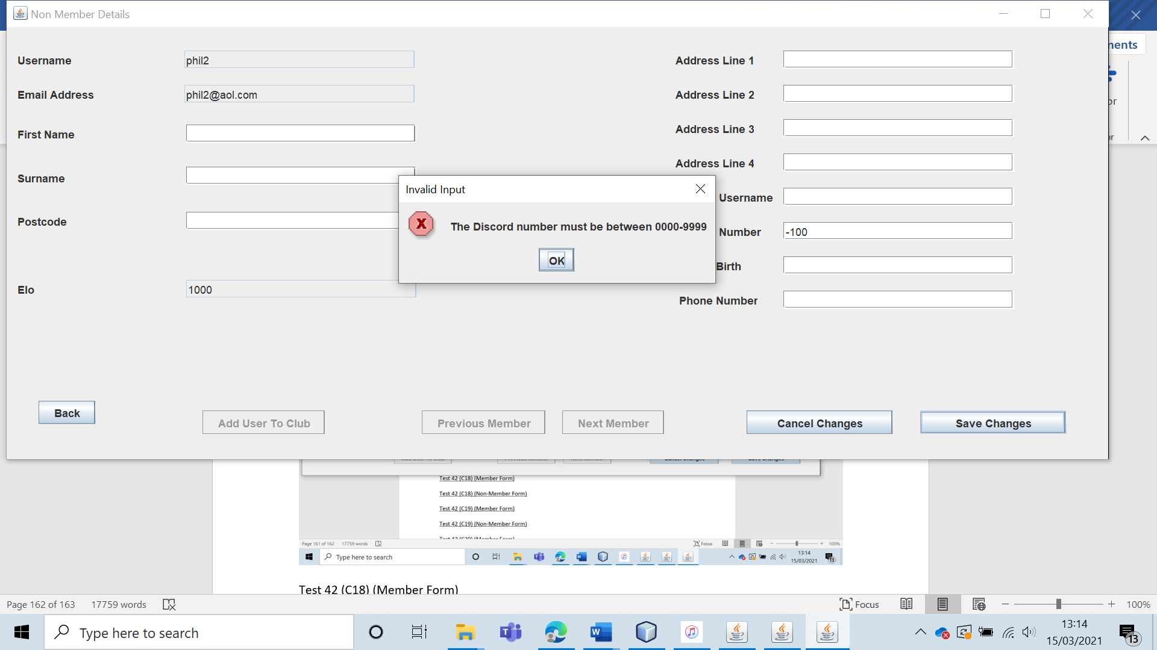

Test 42 (C18) (Member Form)

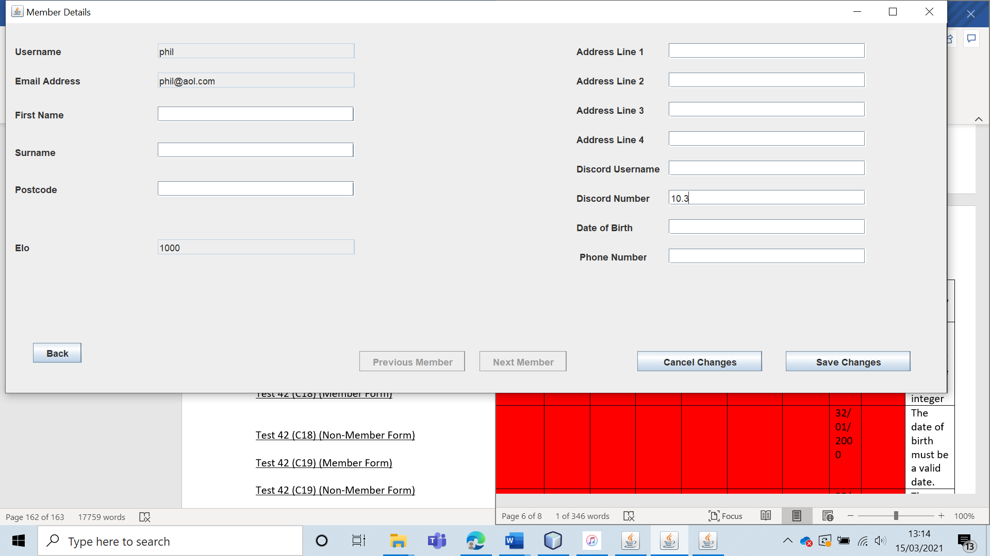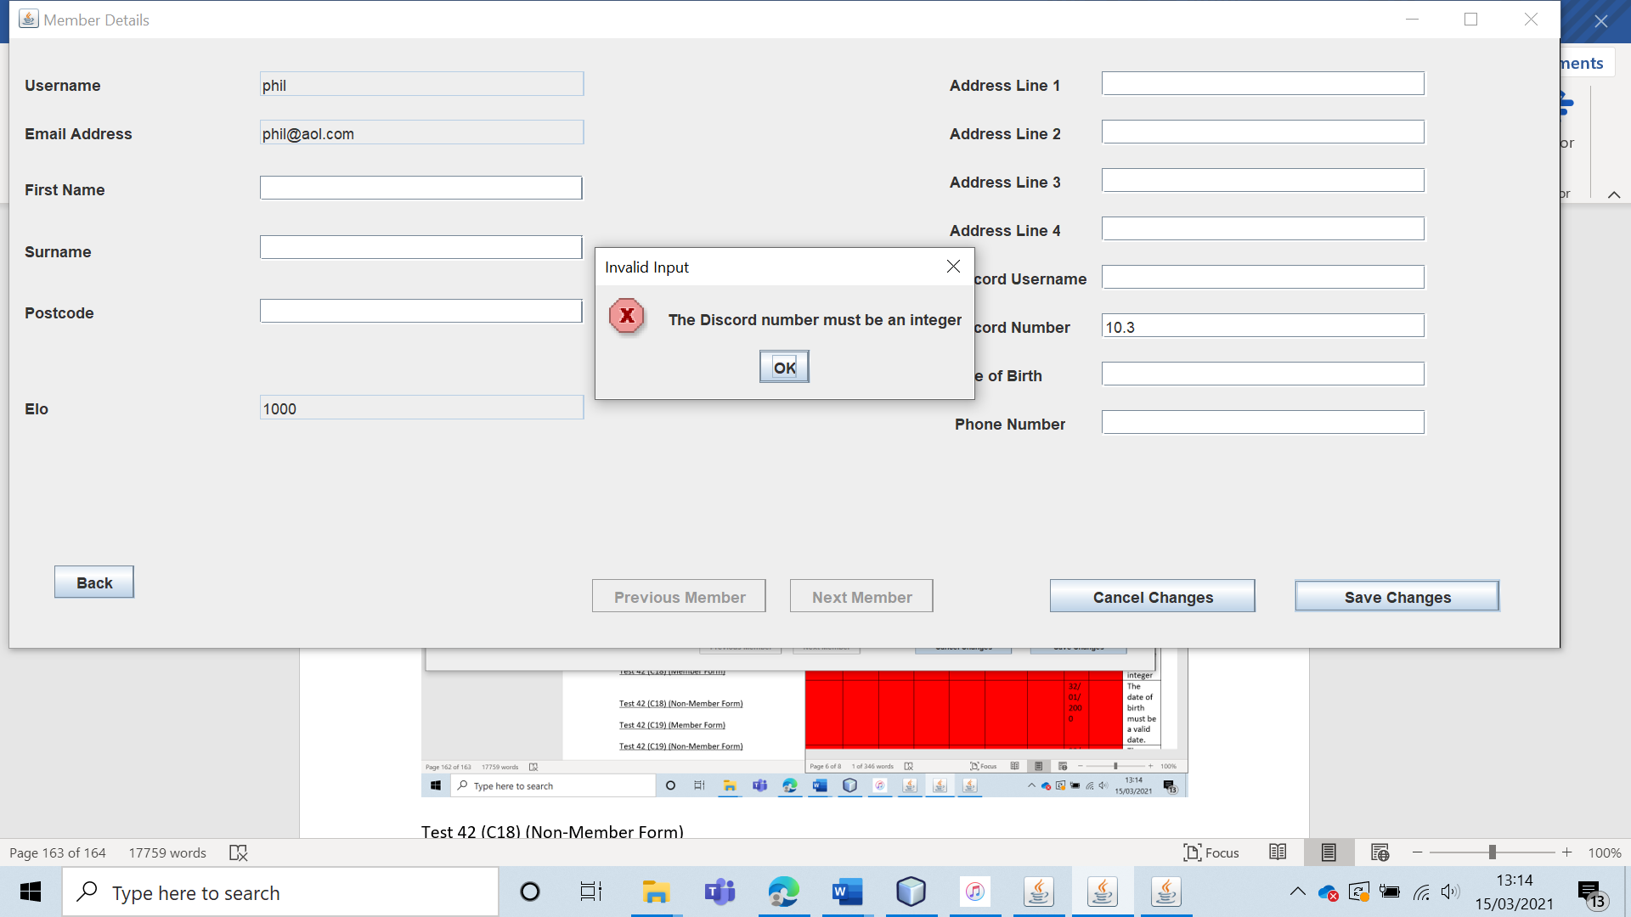

Test 42 (C18) (Non-Member Form)

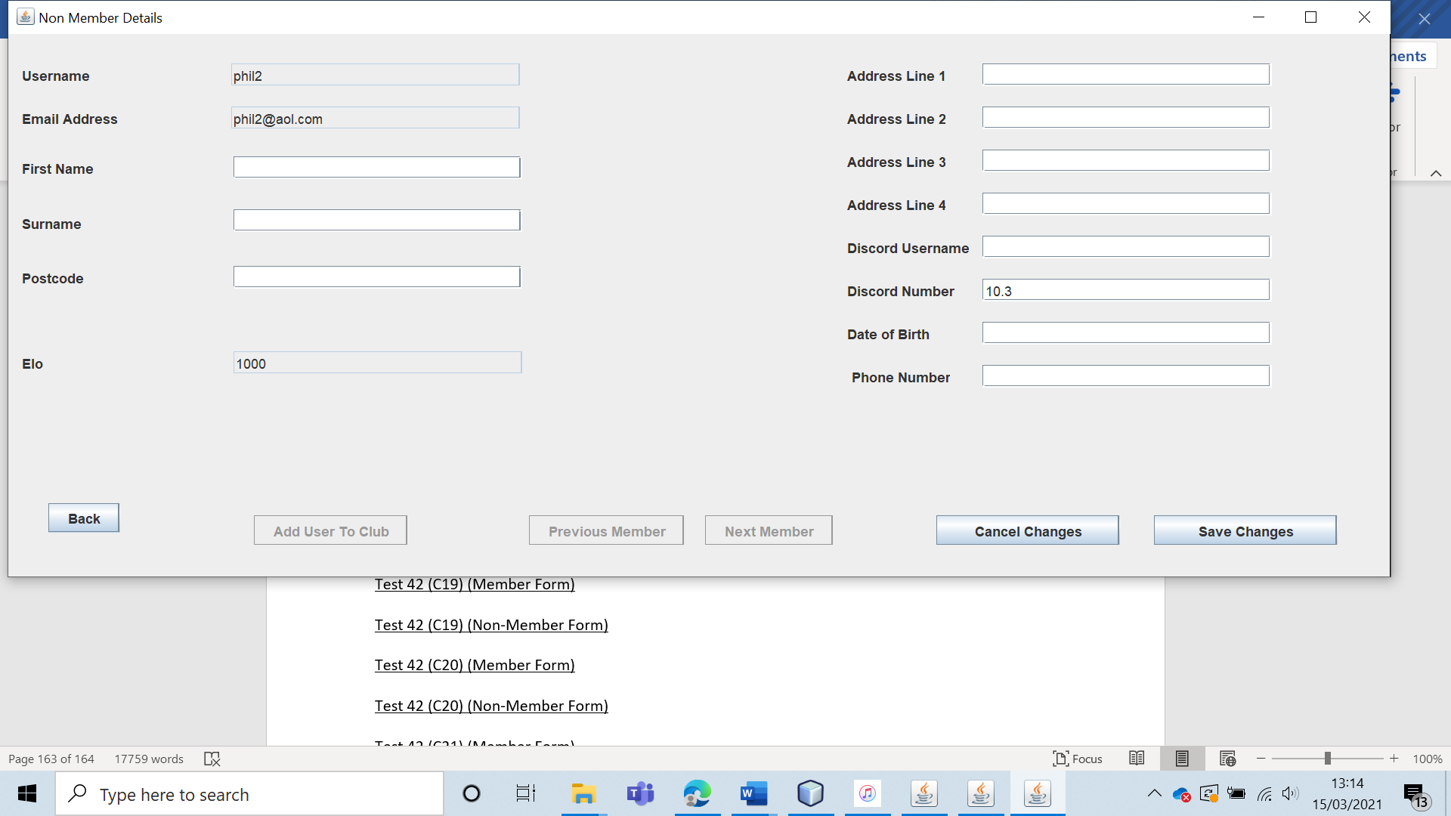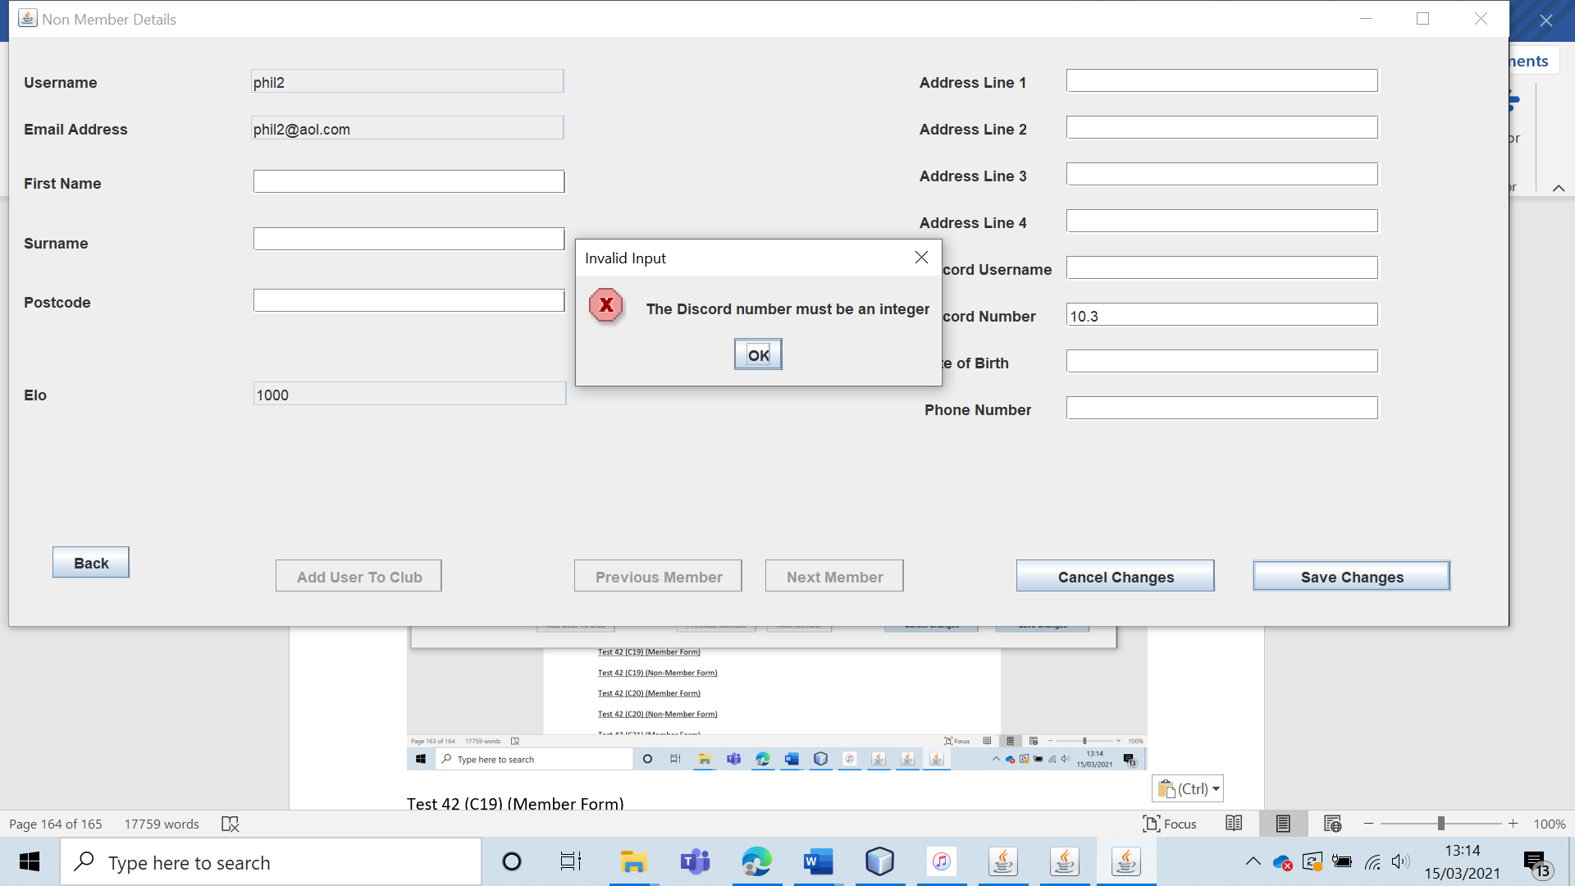

Test 42 (C19) (Member Form)

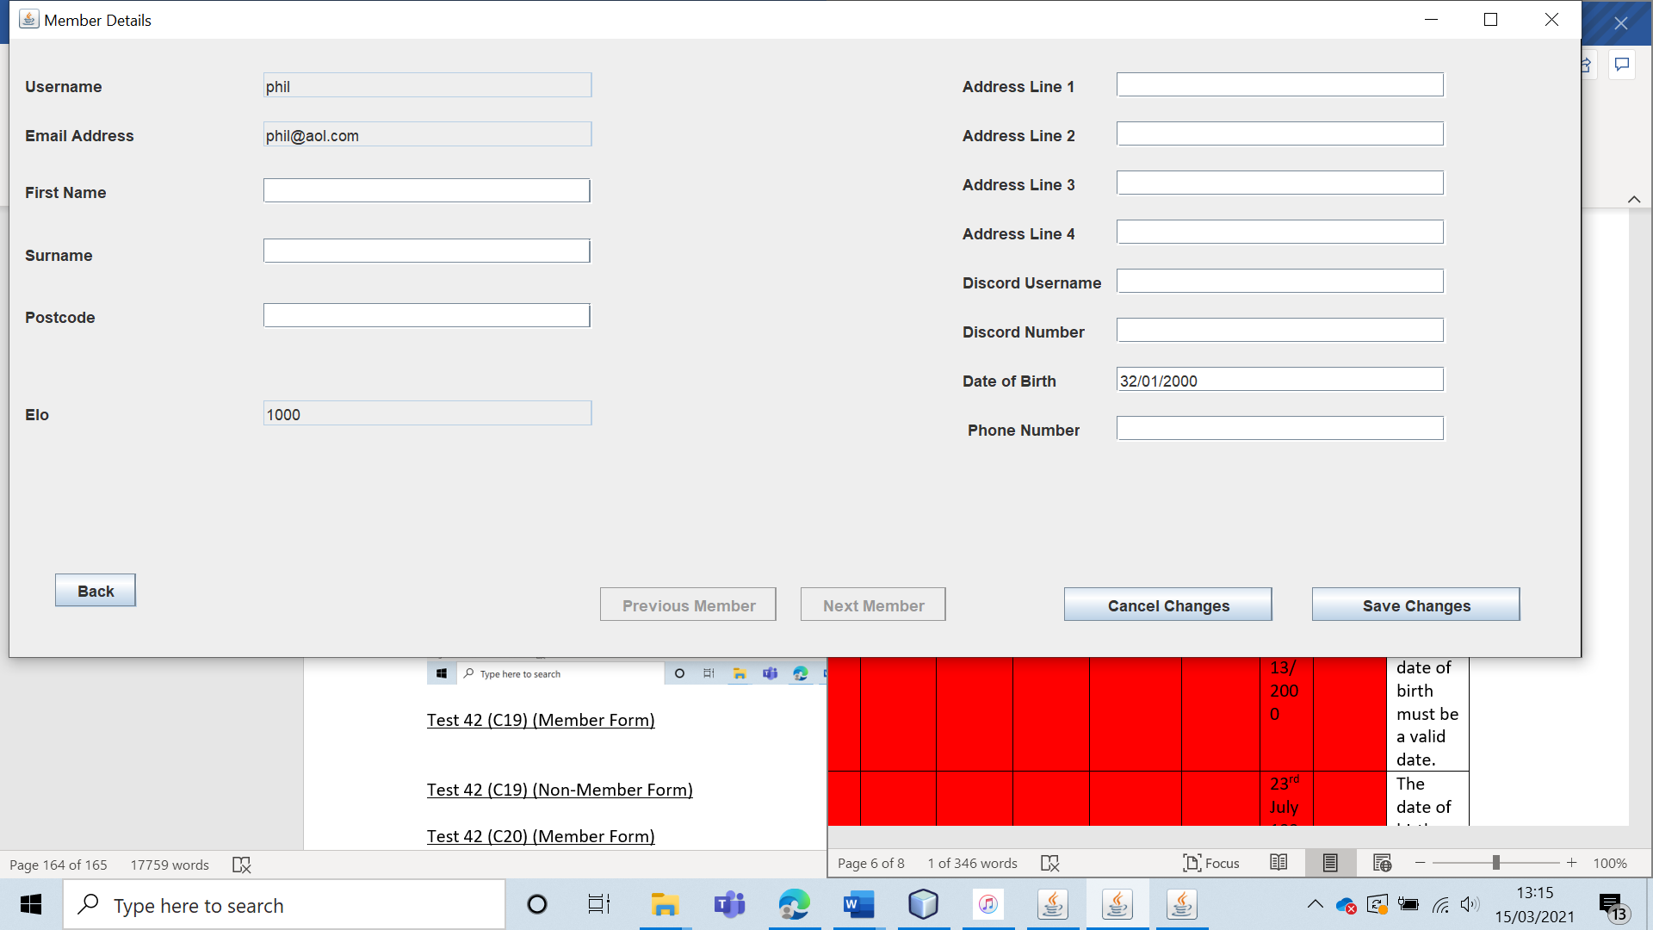

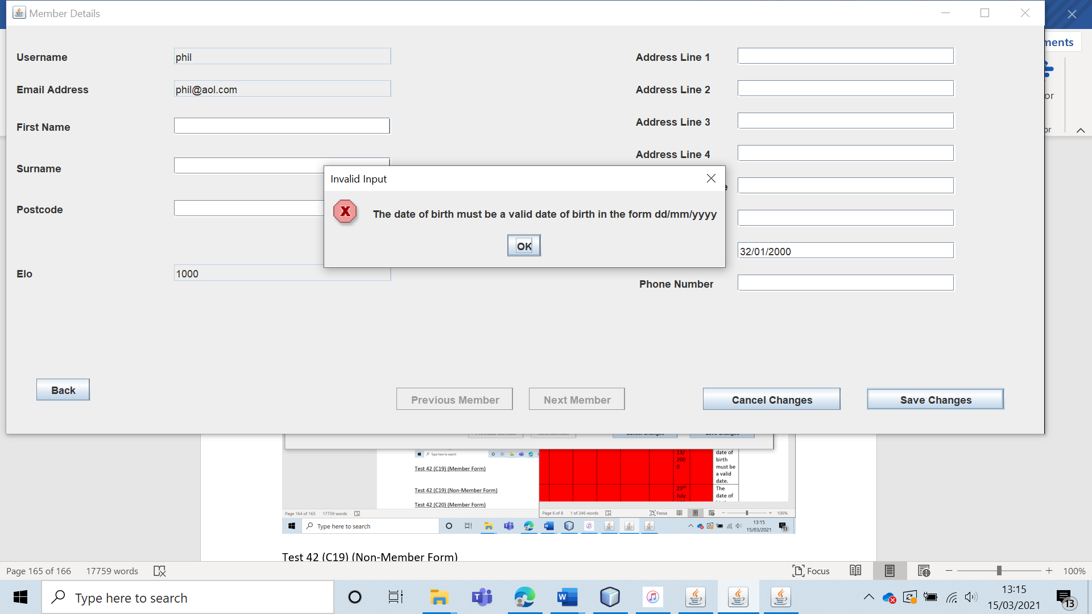

Test 42 (C19) (Non-Member Form)

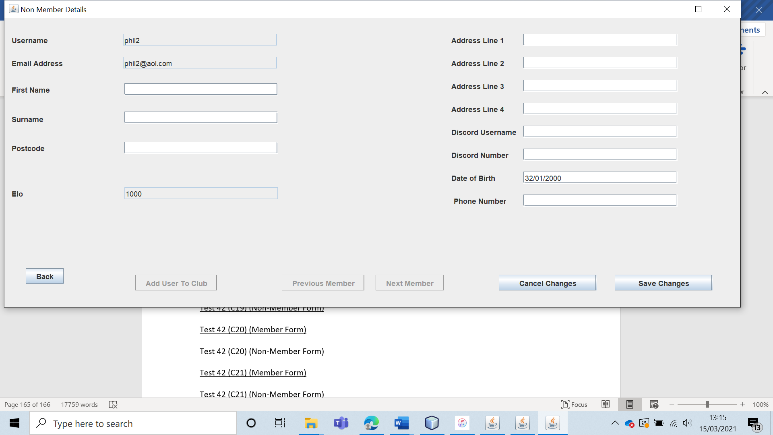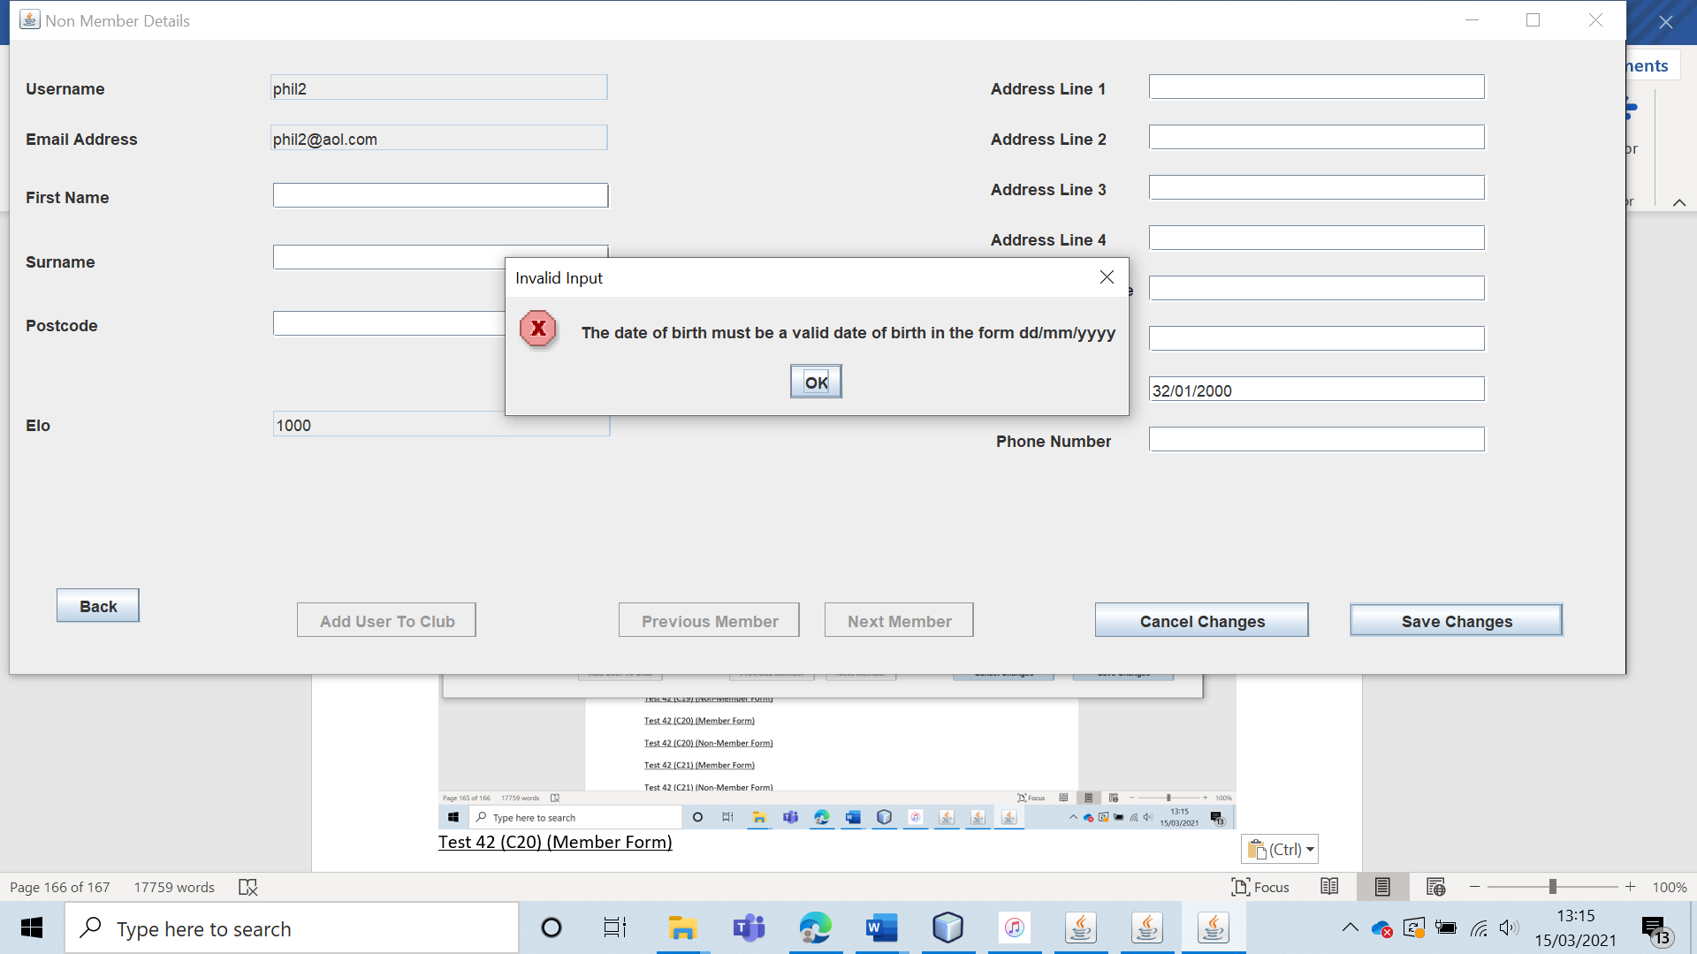

Test 42 (C20) (Member Form) 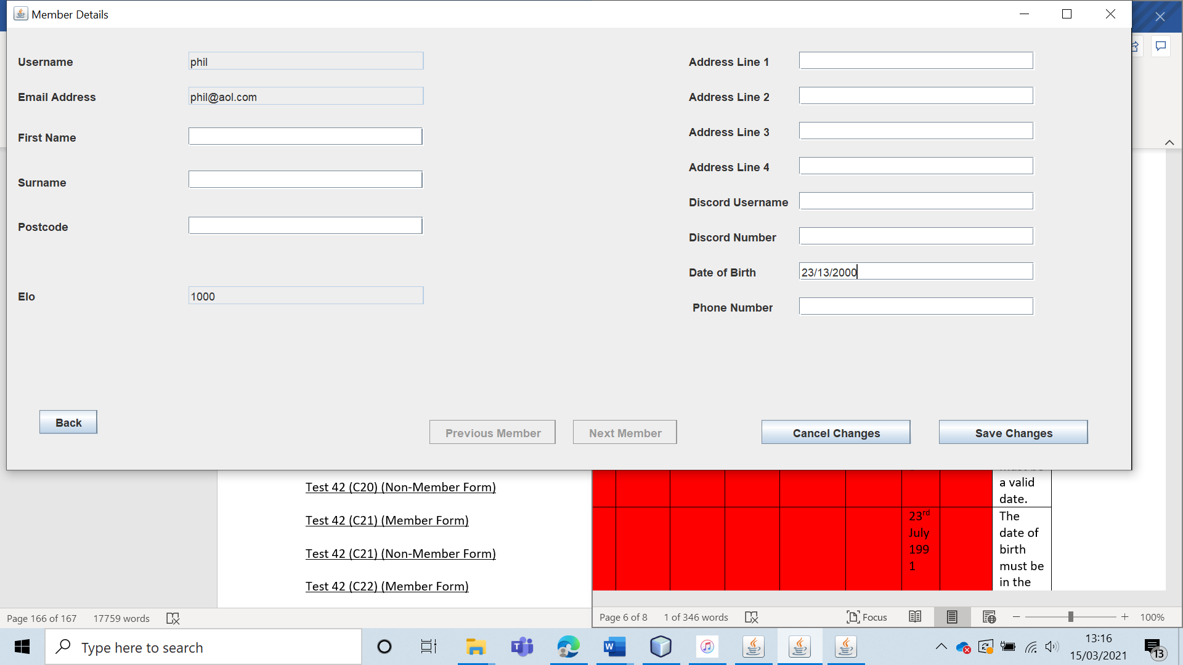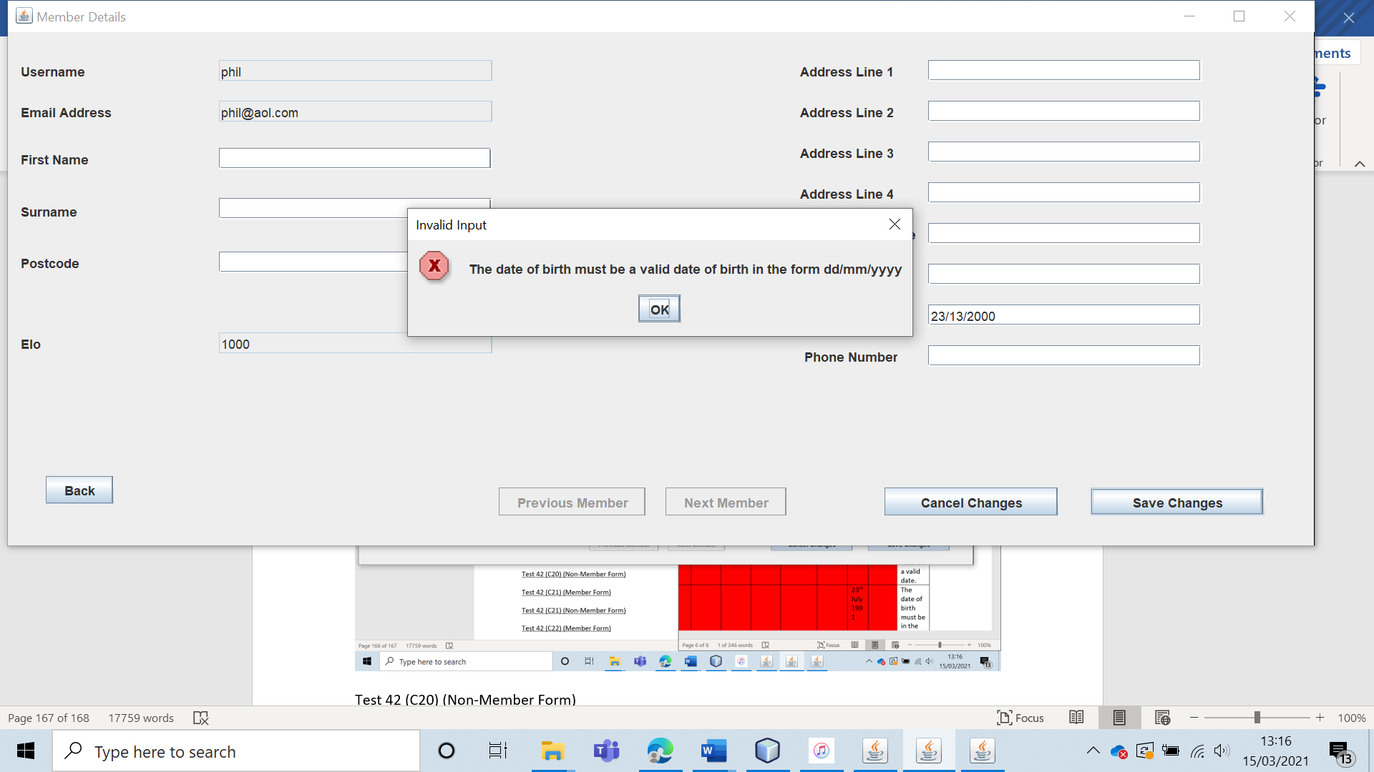

Test 42 (C20) (Non-Member Form) 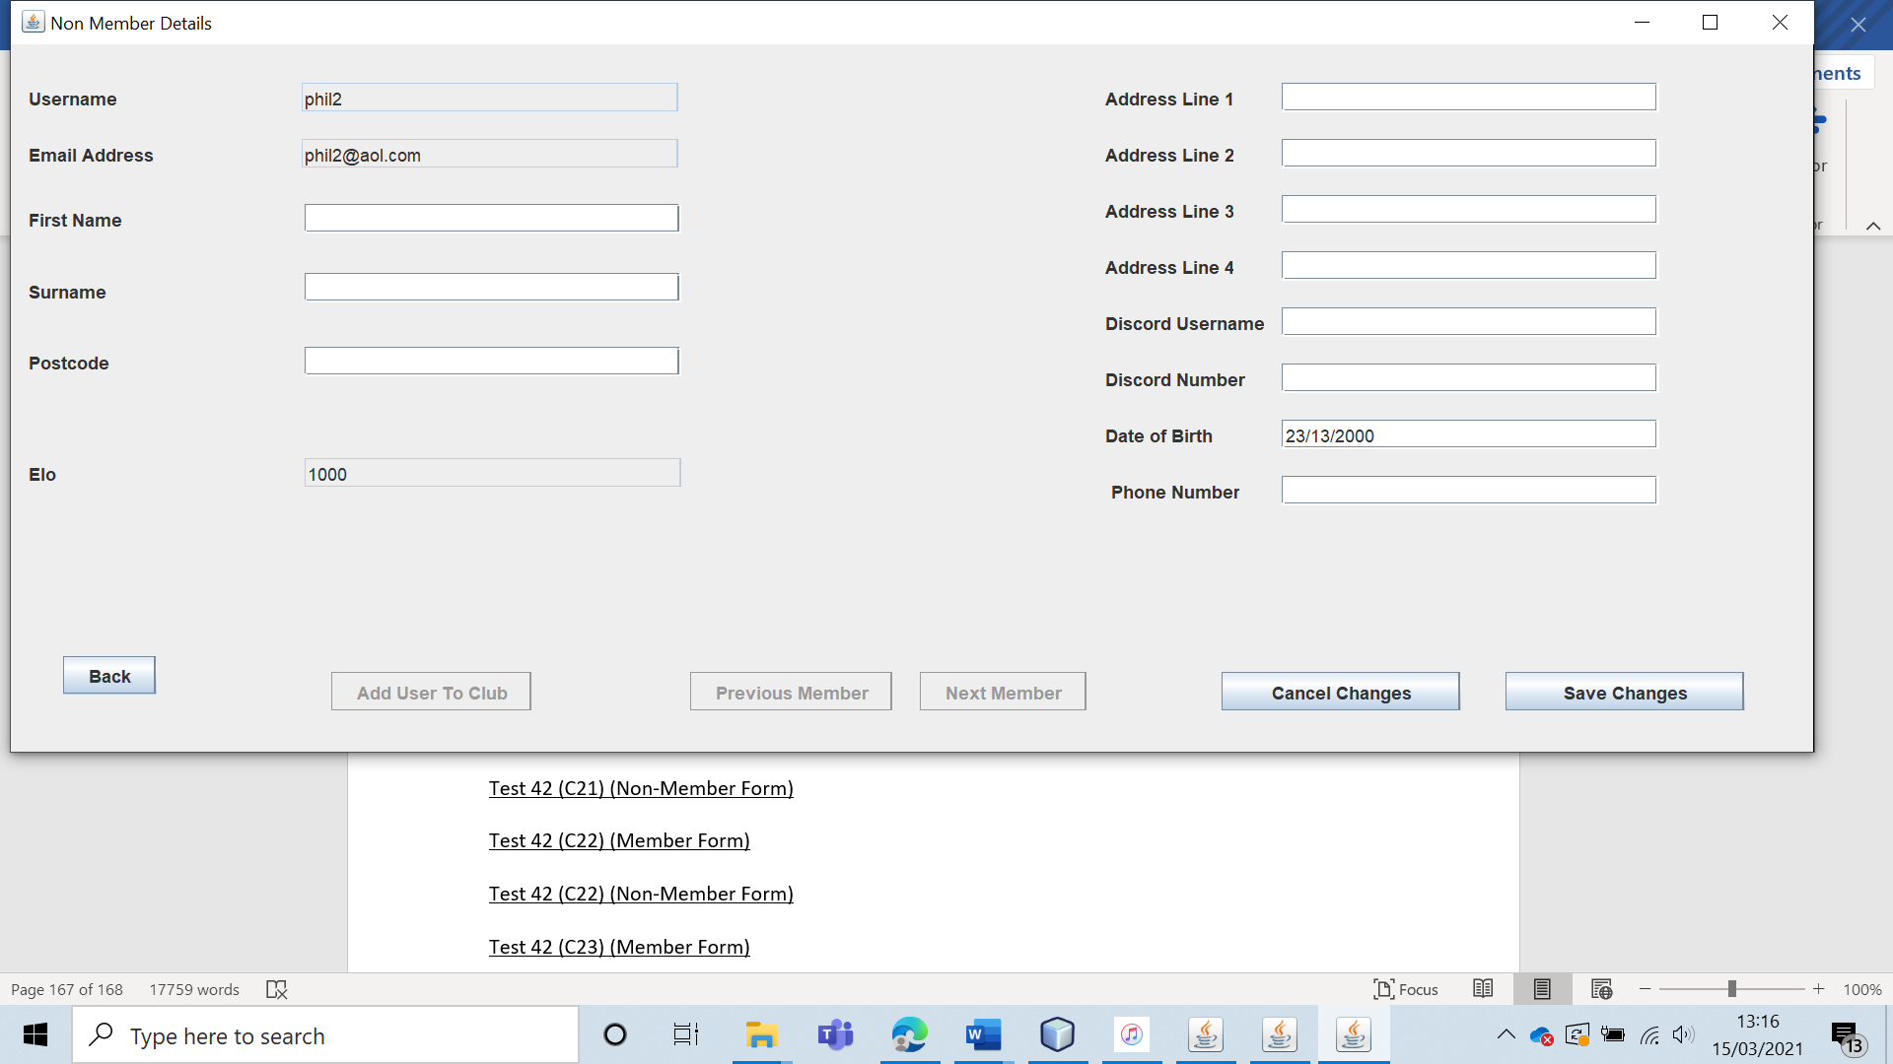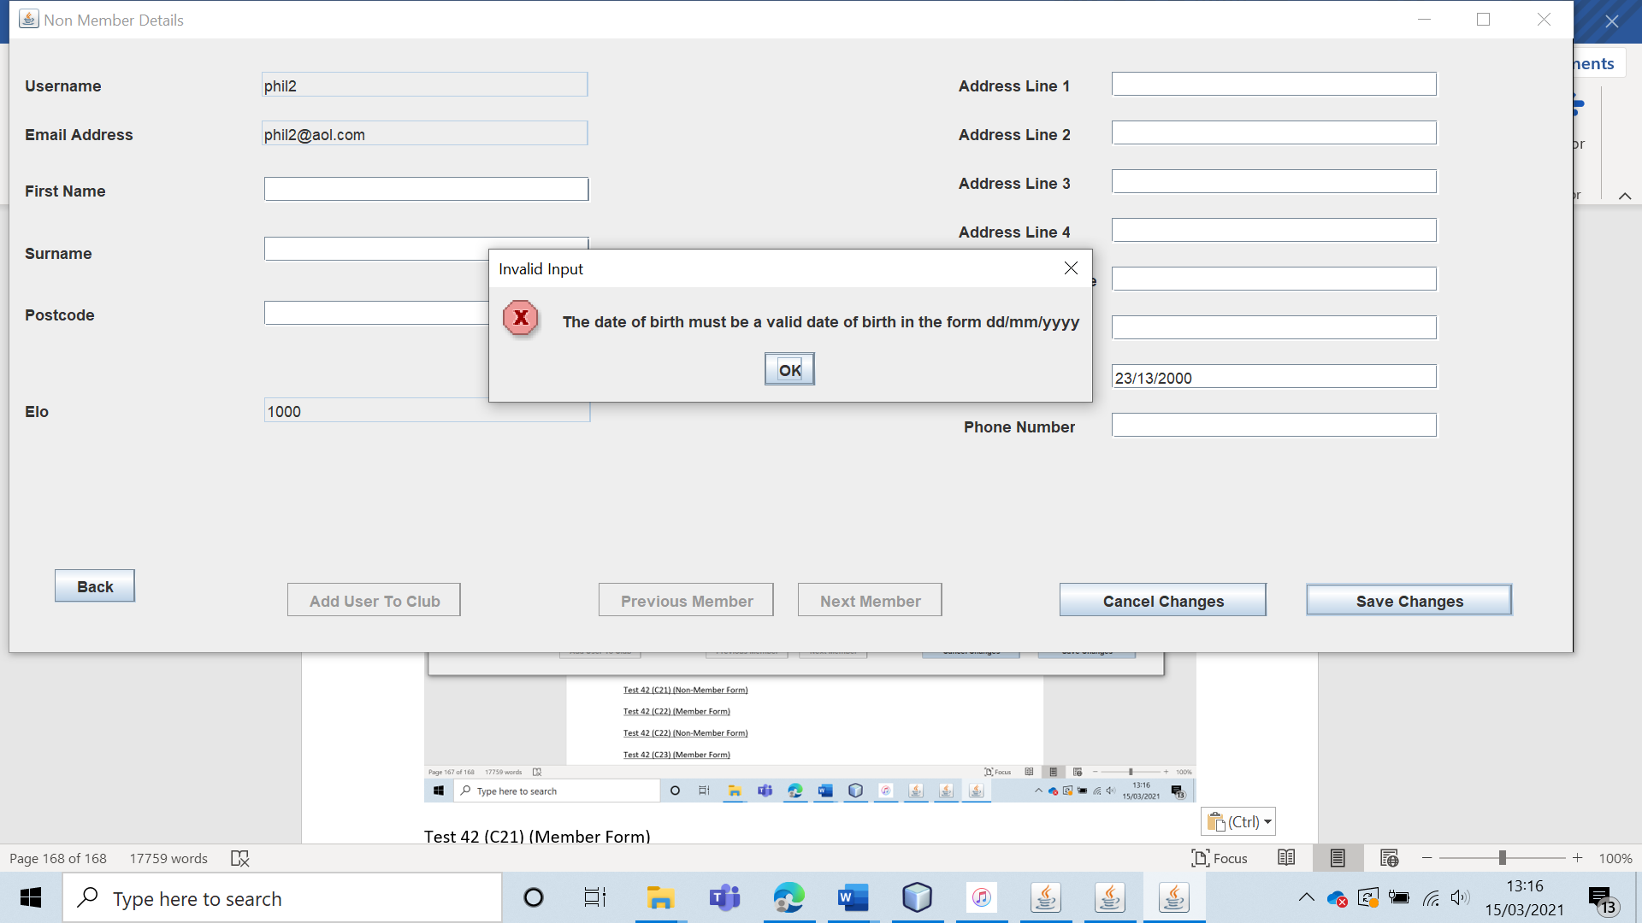

Test 42 (C21) (Member Form) 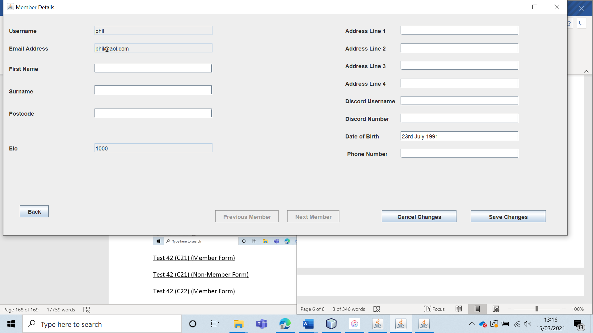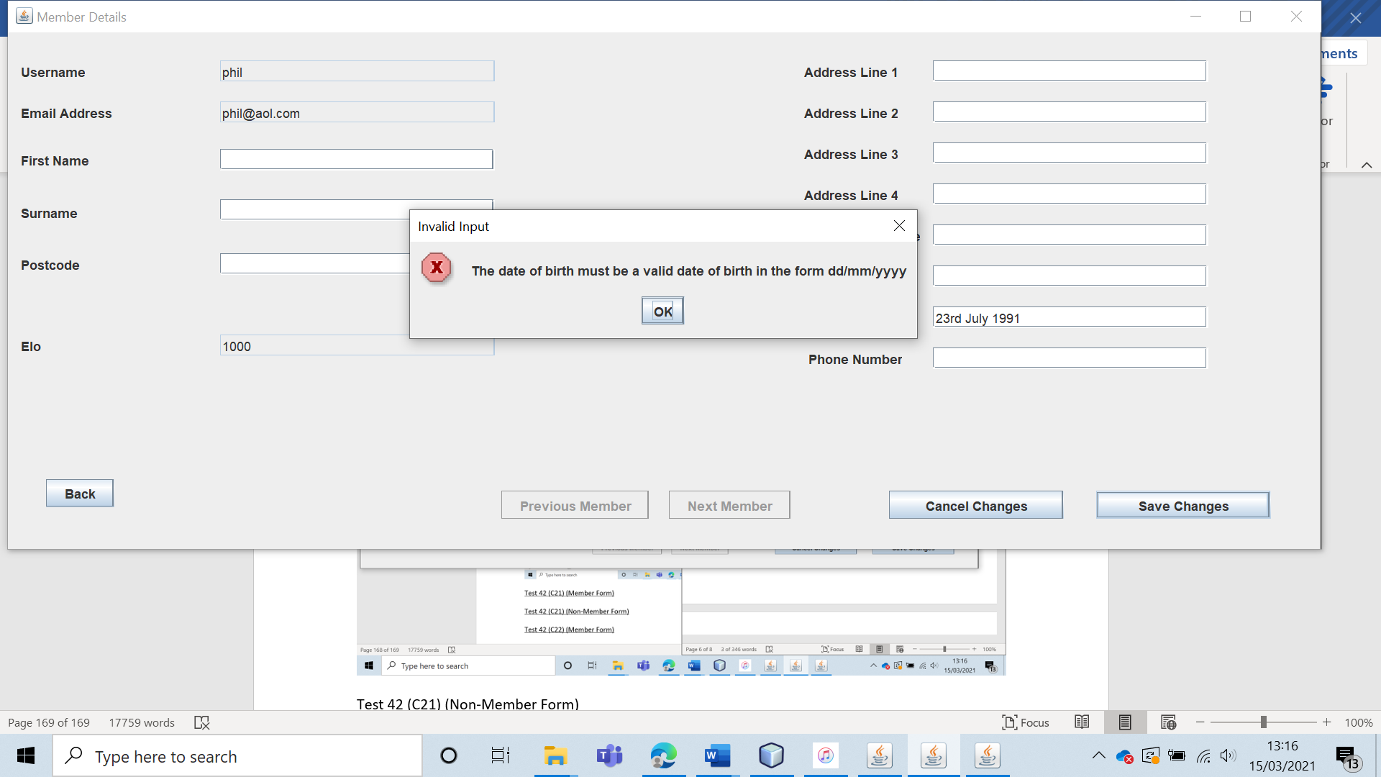

Test 42 (C21) (Non-Member Form)

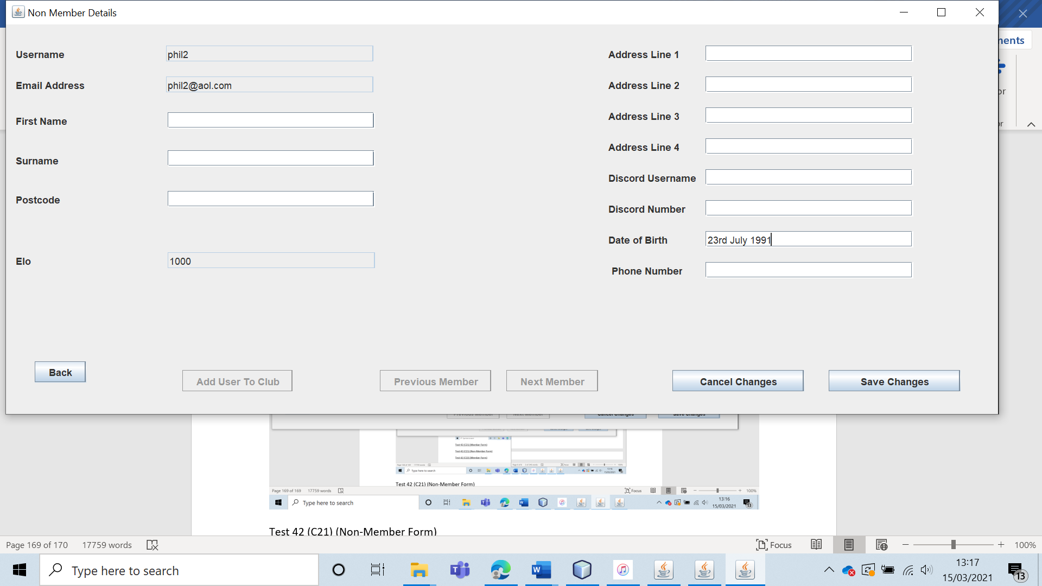

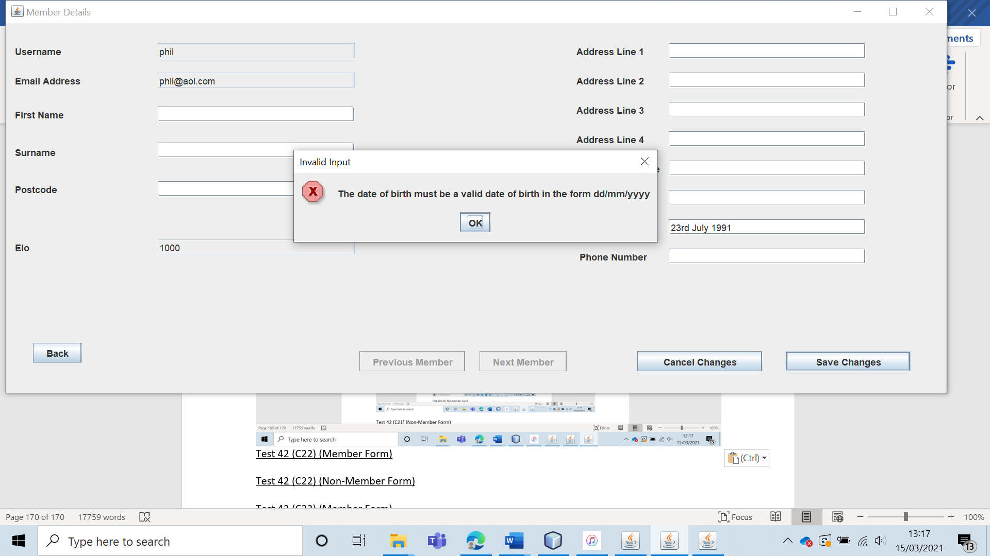

Test 42 (C22) (Member Form)

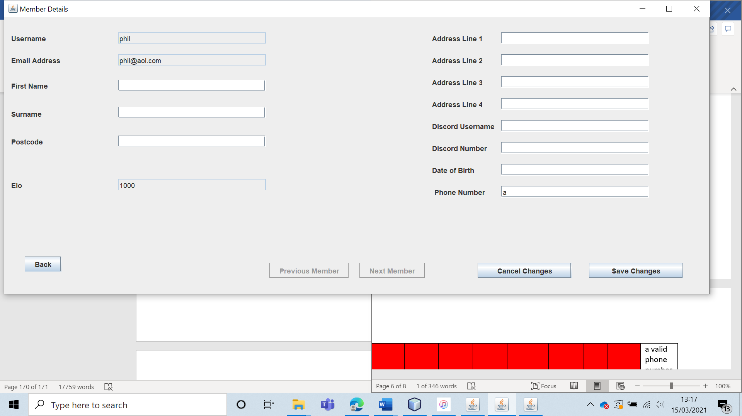

Test 42 (C22) (Non-Member Form)

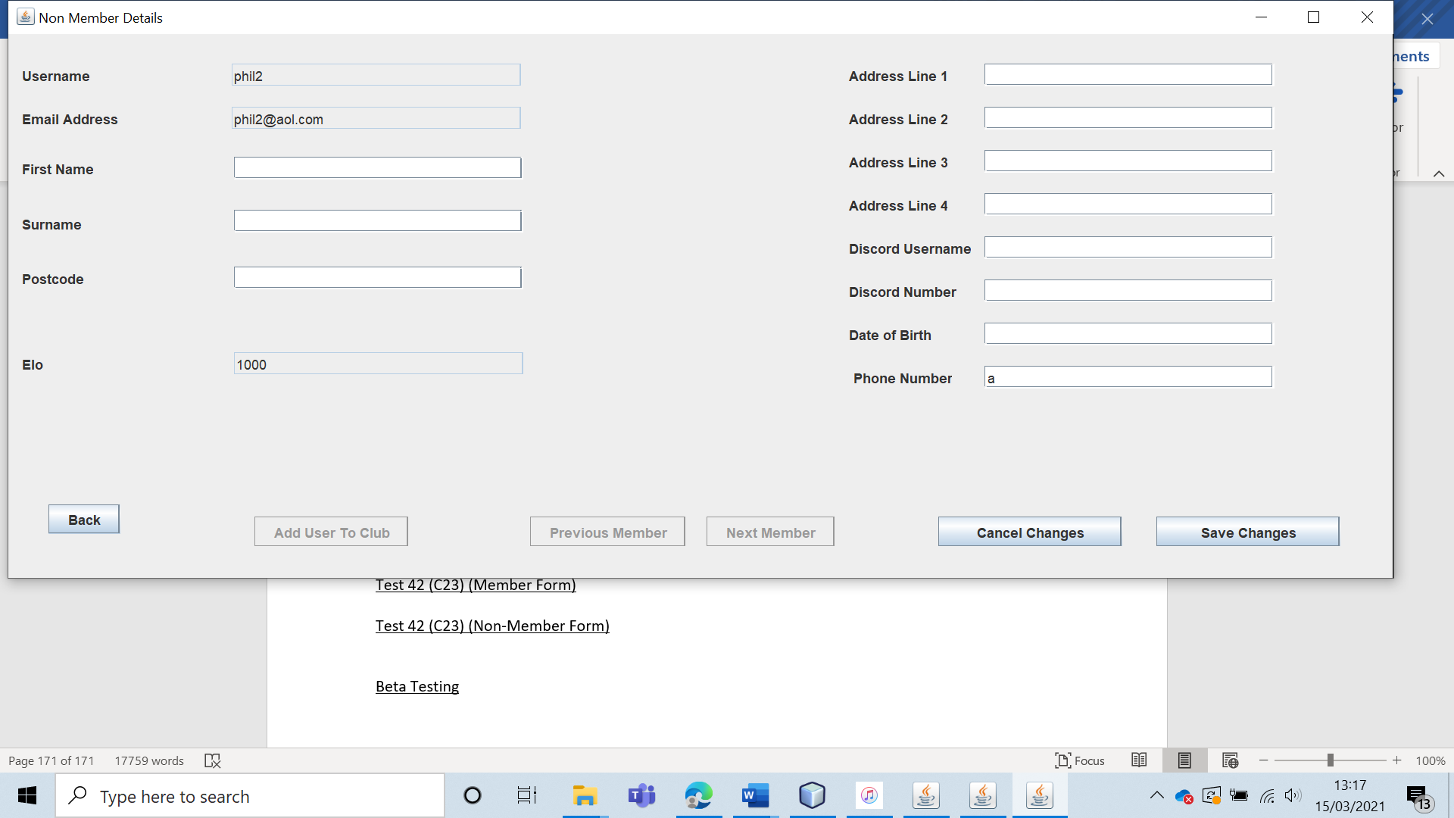 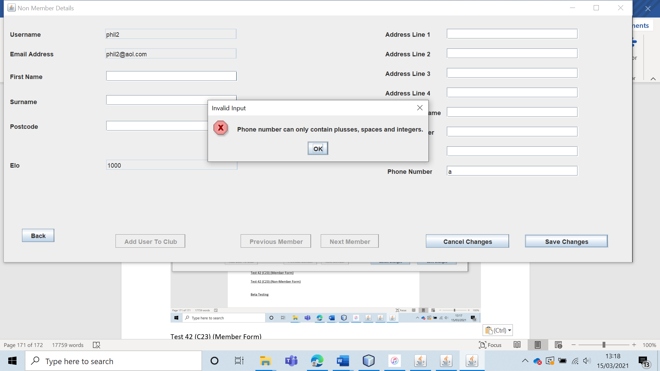

Test 42 (C23) (Member Form)

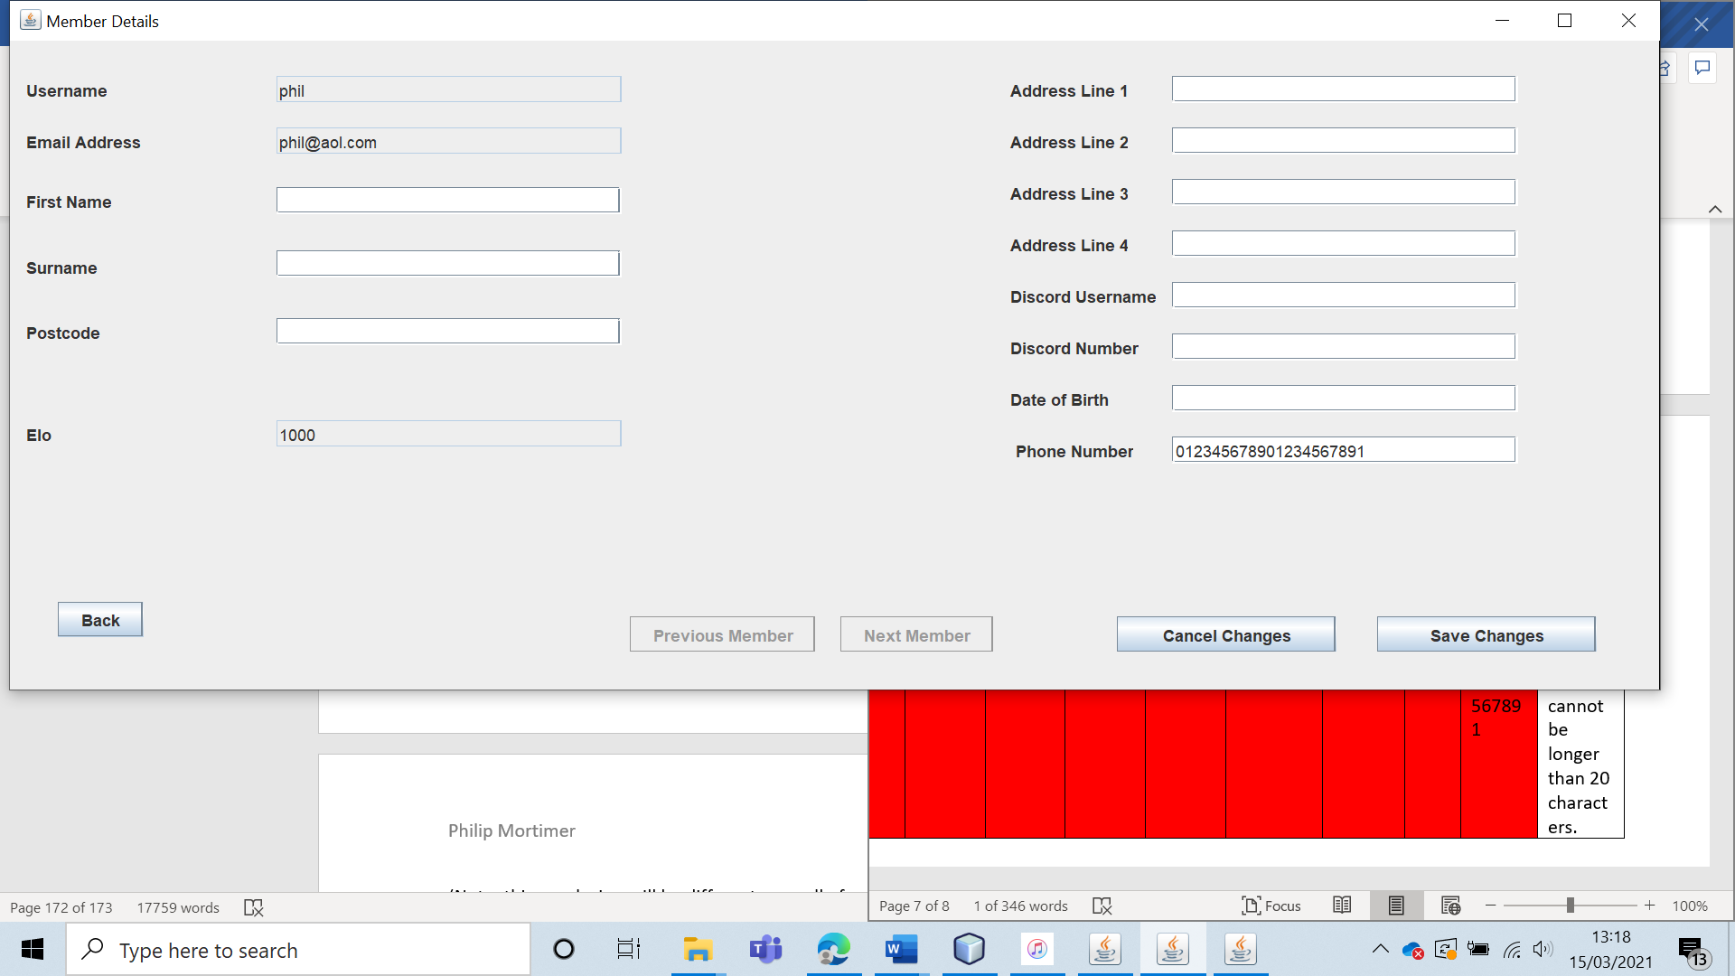



Test 42 (C23) (Non-Member Form)

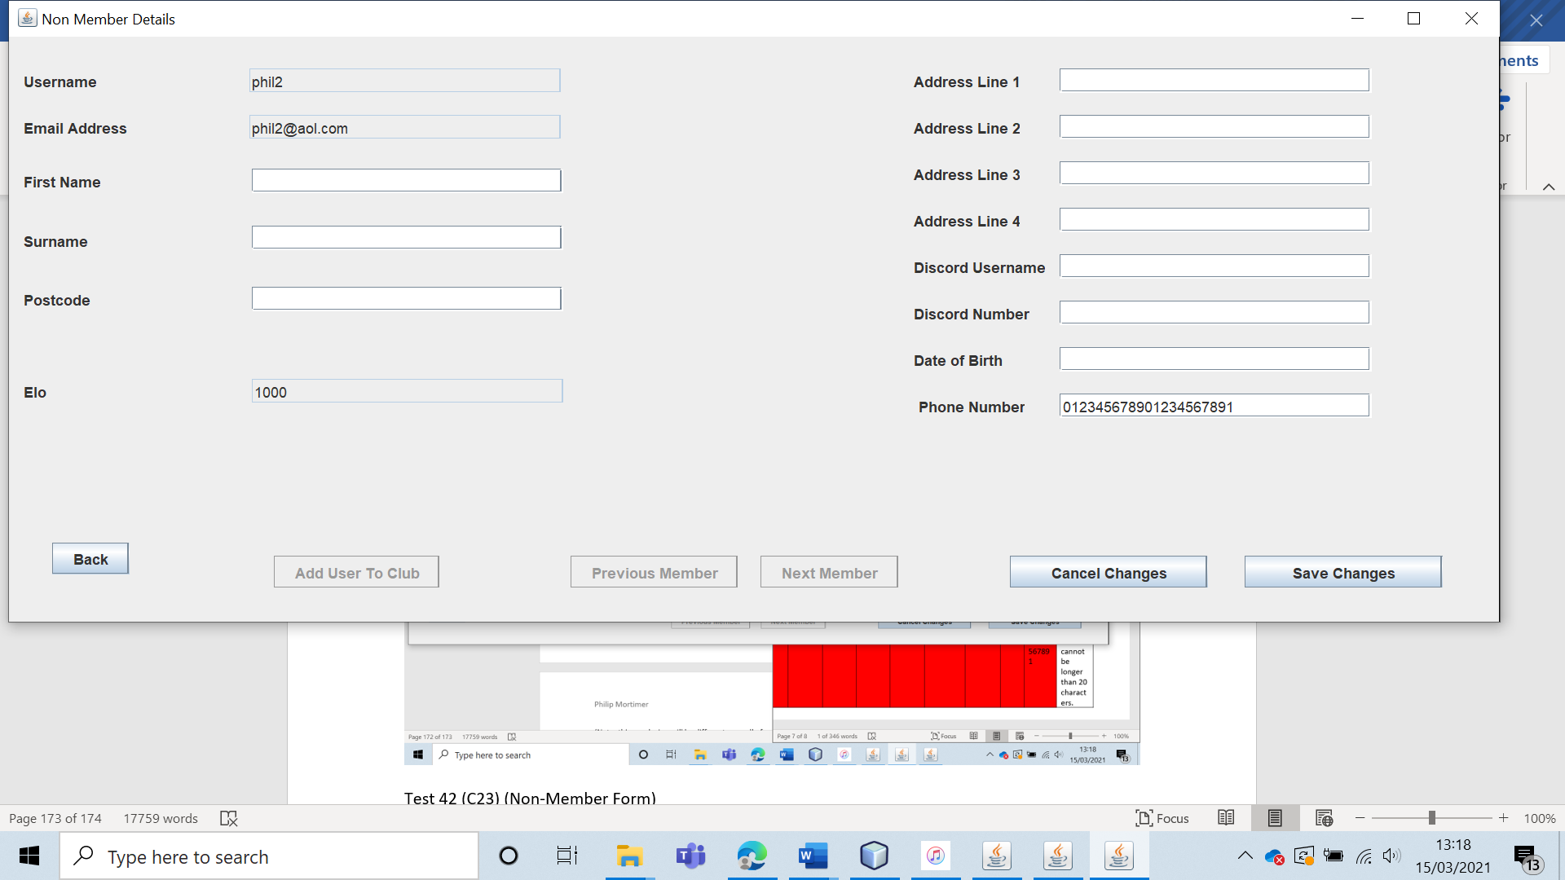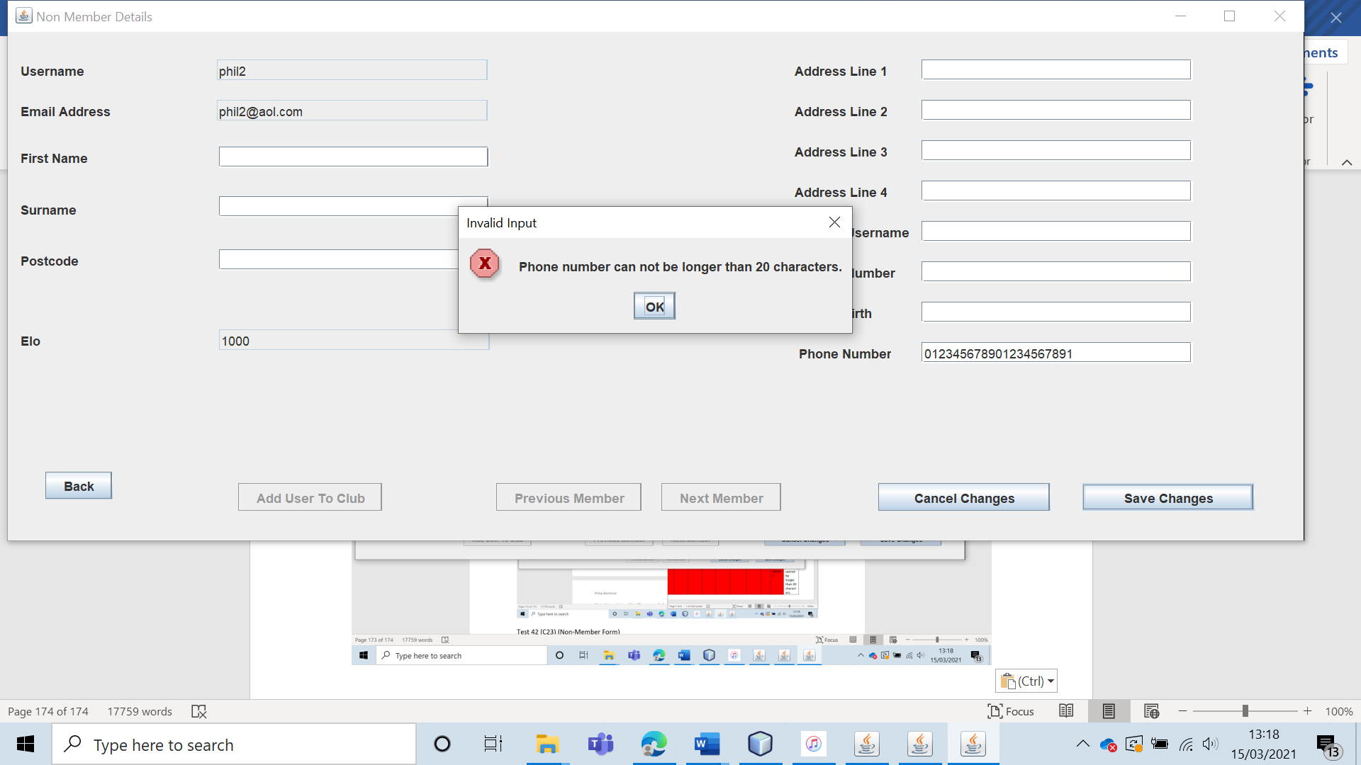

|  |  |  |  |  |  |  |
| --- | --- | --- | --- | --- | --- | --- |
| 43 | Have a non-member user send a request to join the club and verify that it actually shows up. | To ensure that users can request to join the West Cross Chess Club and that these requests actually work. |  | The request should be stored to the server and visible to the club leader. | 8, 8a and 8ai. | The request to join the club is sent and is visible to the leader. |

Test 43

For this test, I will have the non-member “phil2” request to join the club.

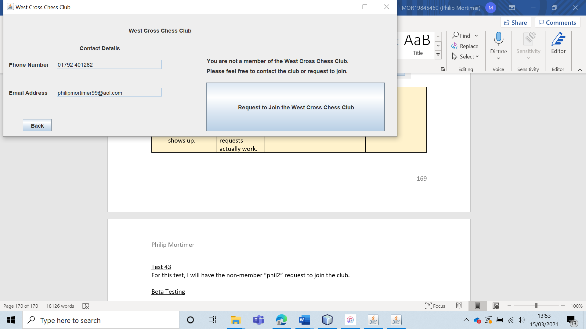

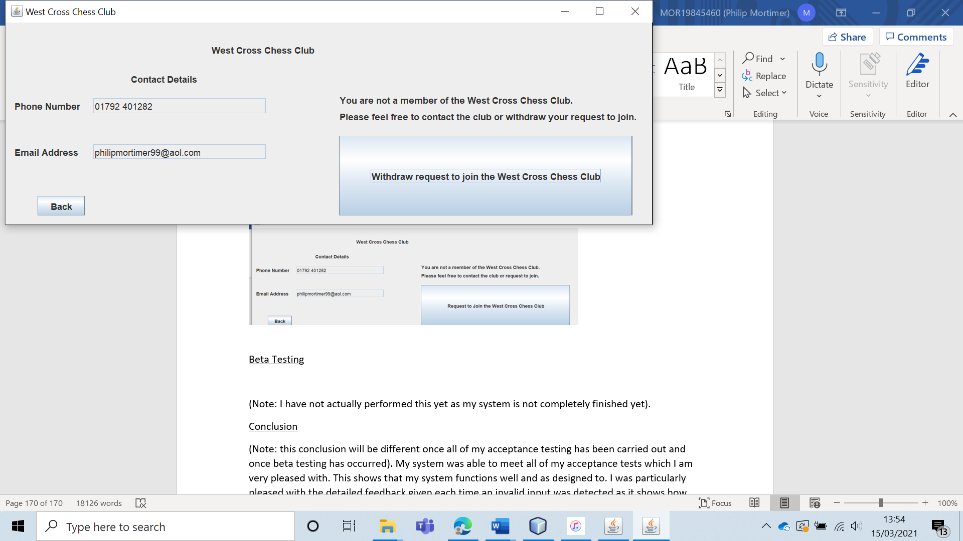

Then I logged into the leader account and went into the “Request to Join The Club”.

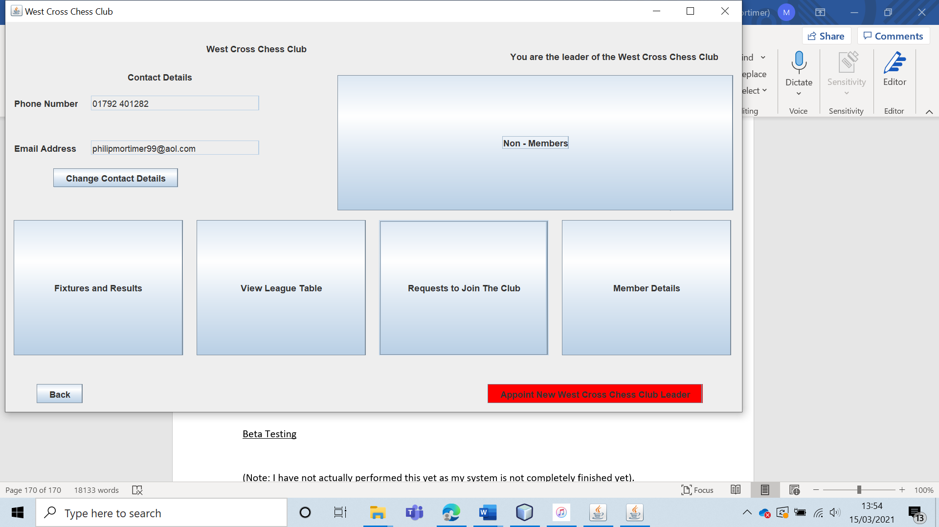

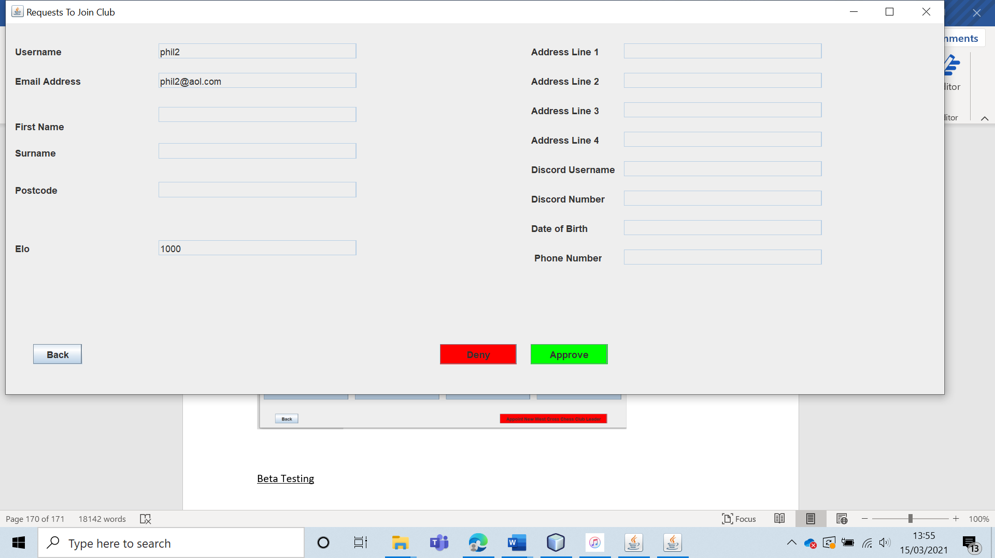

And sure enough, the request to join the club showed up. Whilst the system passes the test, I would note that the leader has no way of knowing whether there any requests to join the club without going into the requests section. It would be more intuitive if there were some sort of indication that requests had been made before entering the form. This is a potential future improvement I would make to the system. Despite this, the system is completely functional and passes the test.

|  |  |  |  |  |  |  |
| --- | --- | --- | --- | --- | --- | --- |
| 44 | Have a non-member user withdraw a request to join the club and verify that the request is actually withdrawn. | To verify that users can withdraw requests to join the club. |  | The request should be withdrawn. The user should no longer show up in the section storing requests to join the club. | 8 | The request is successfully withdrawn. |

Test 44

For this test, I have had the user “phil2” send a request to join the club. I will now get “phil2” to withdraw the request.

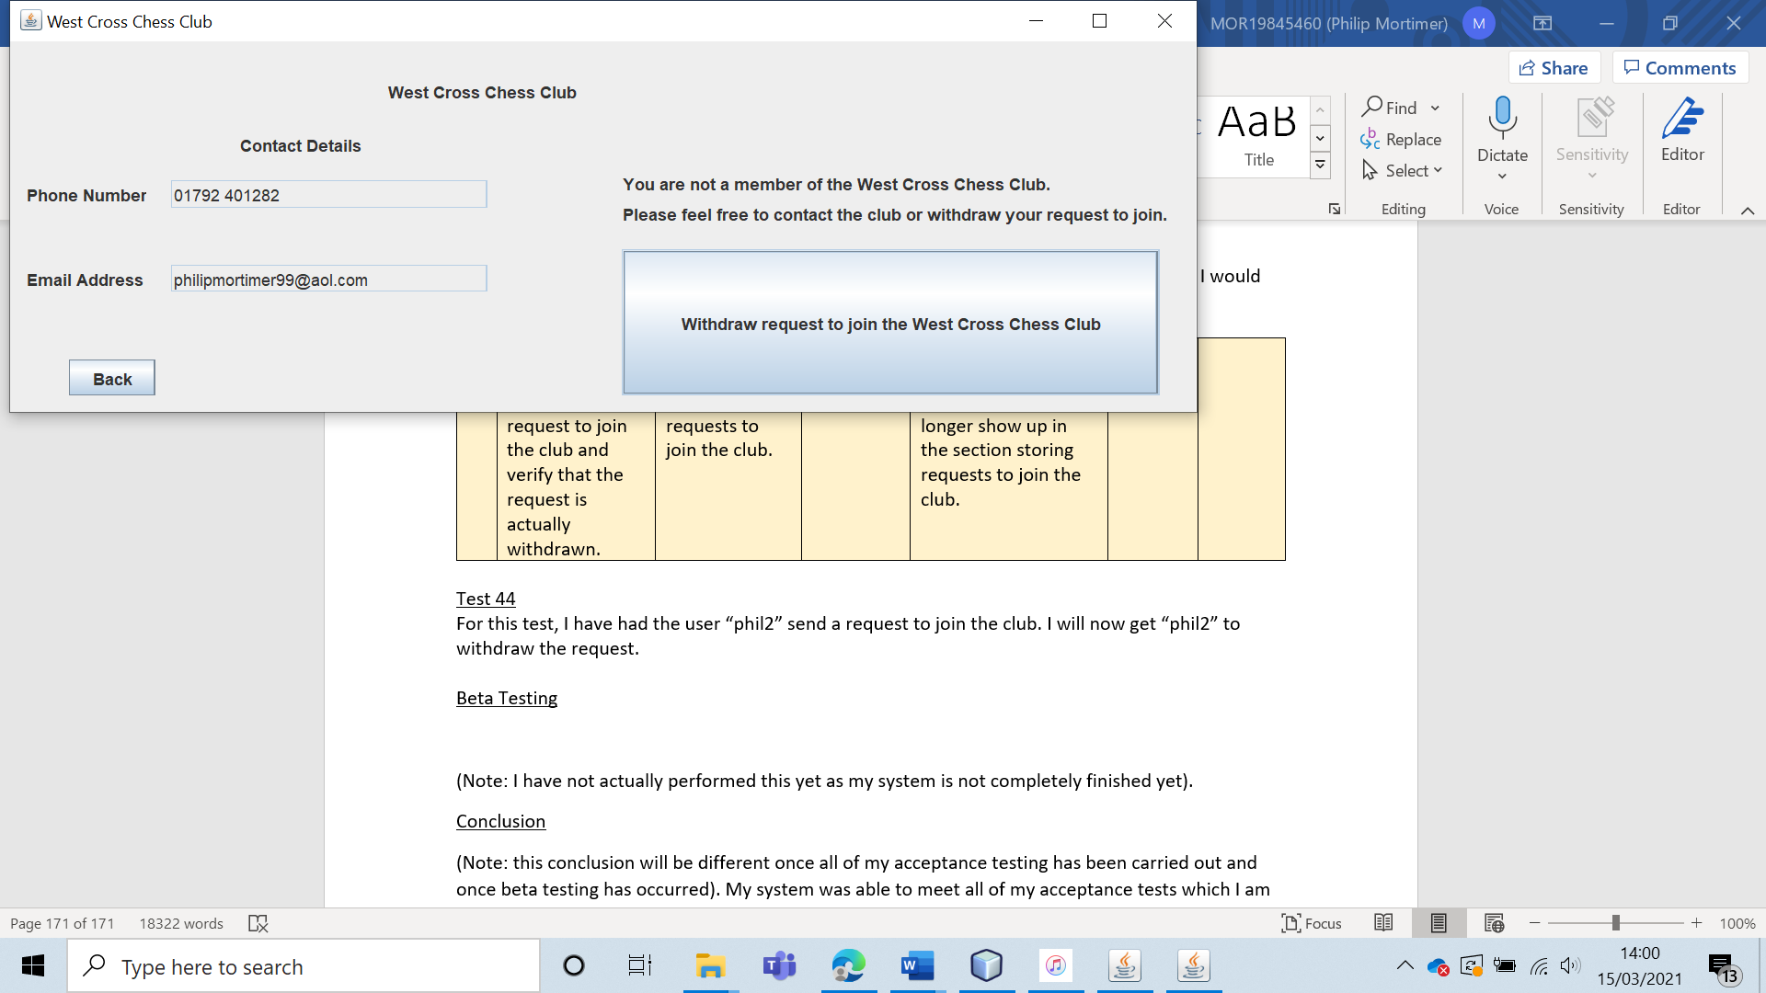

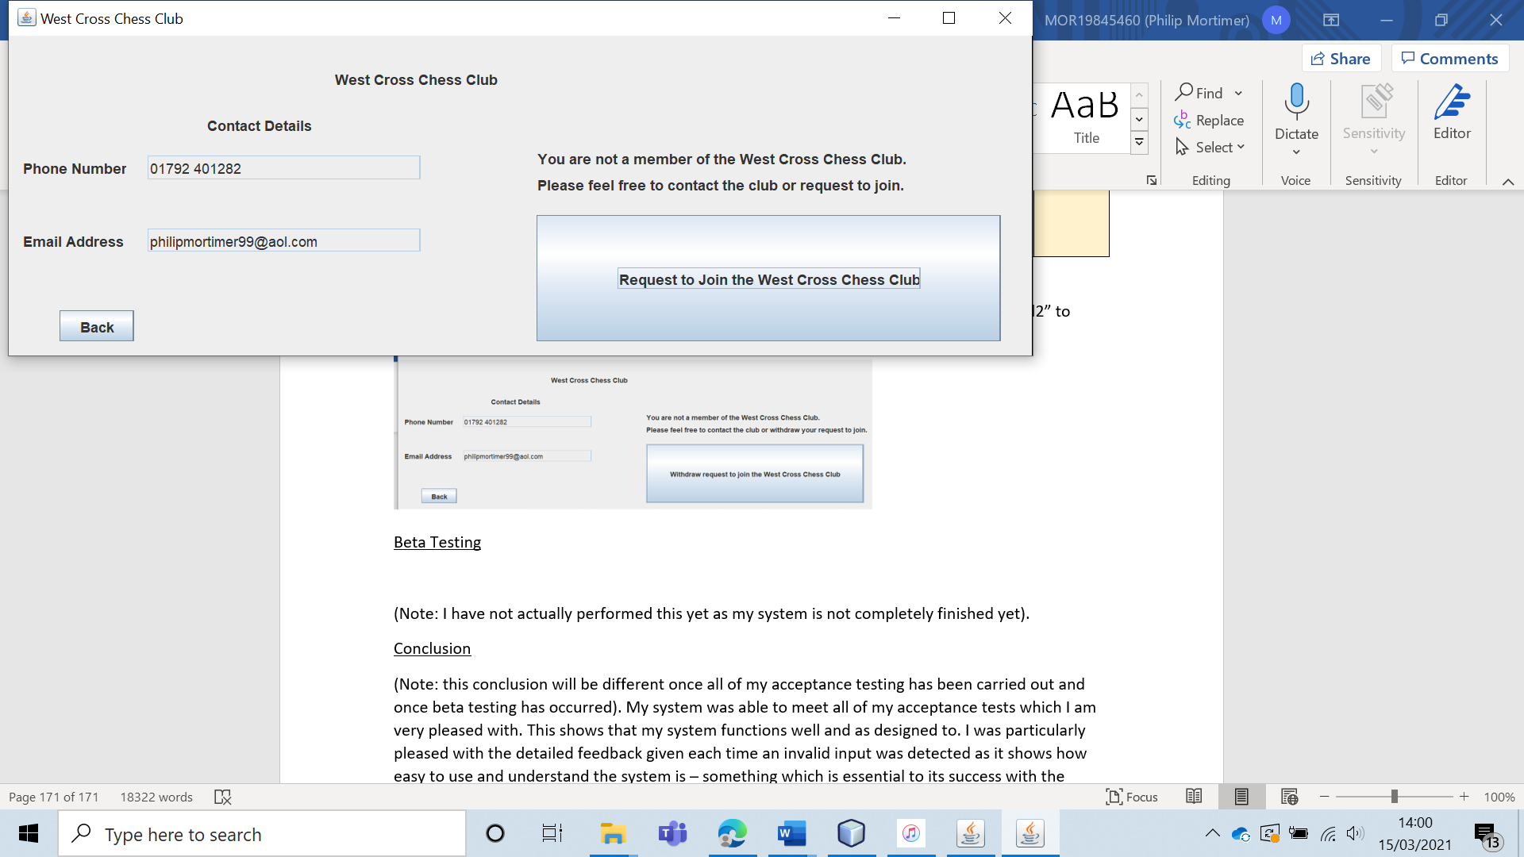

The request has been withdrawn by “phil2”. The request no longer shows up either to the leader or to the user, showing that the test was successful.

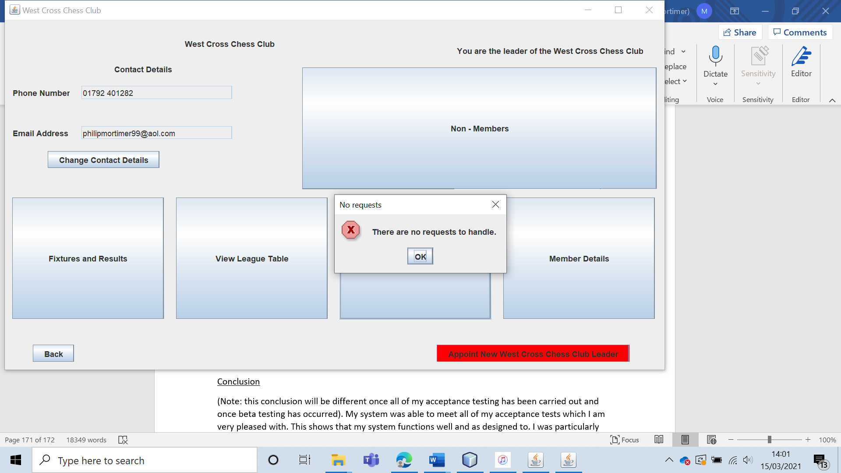

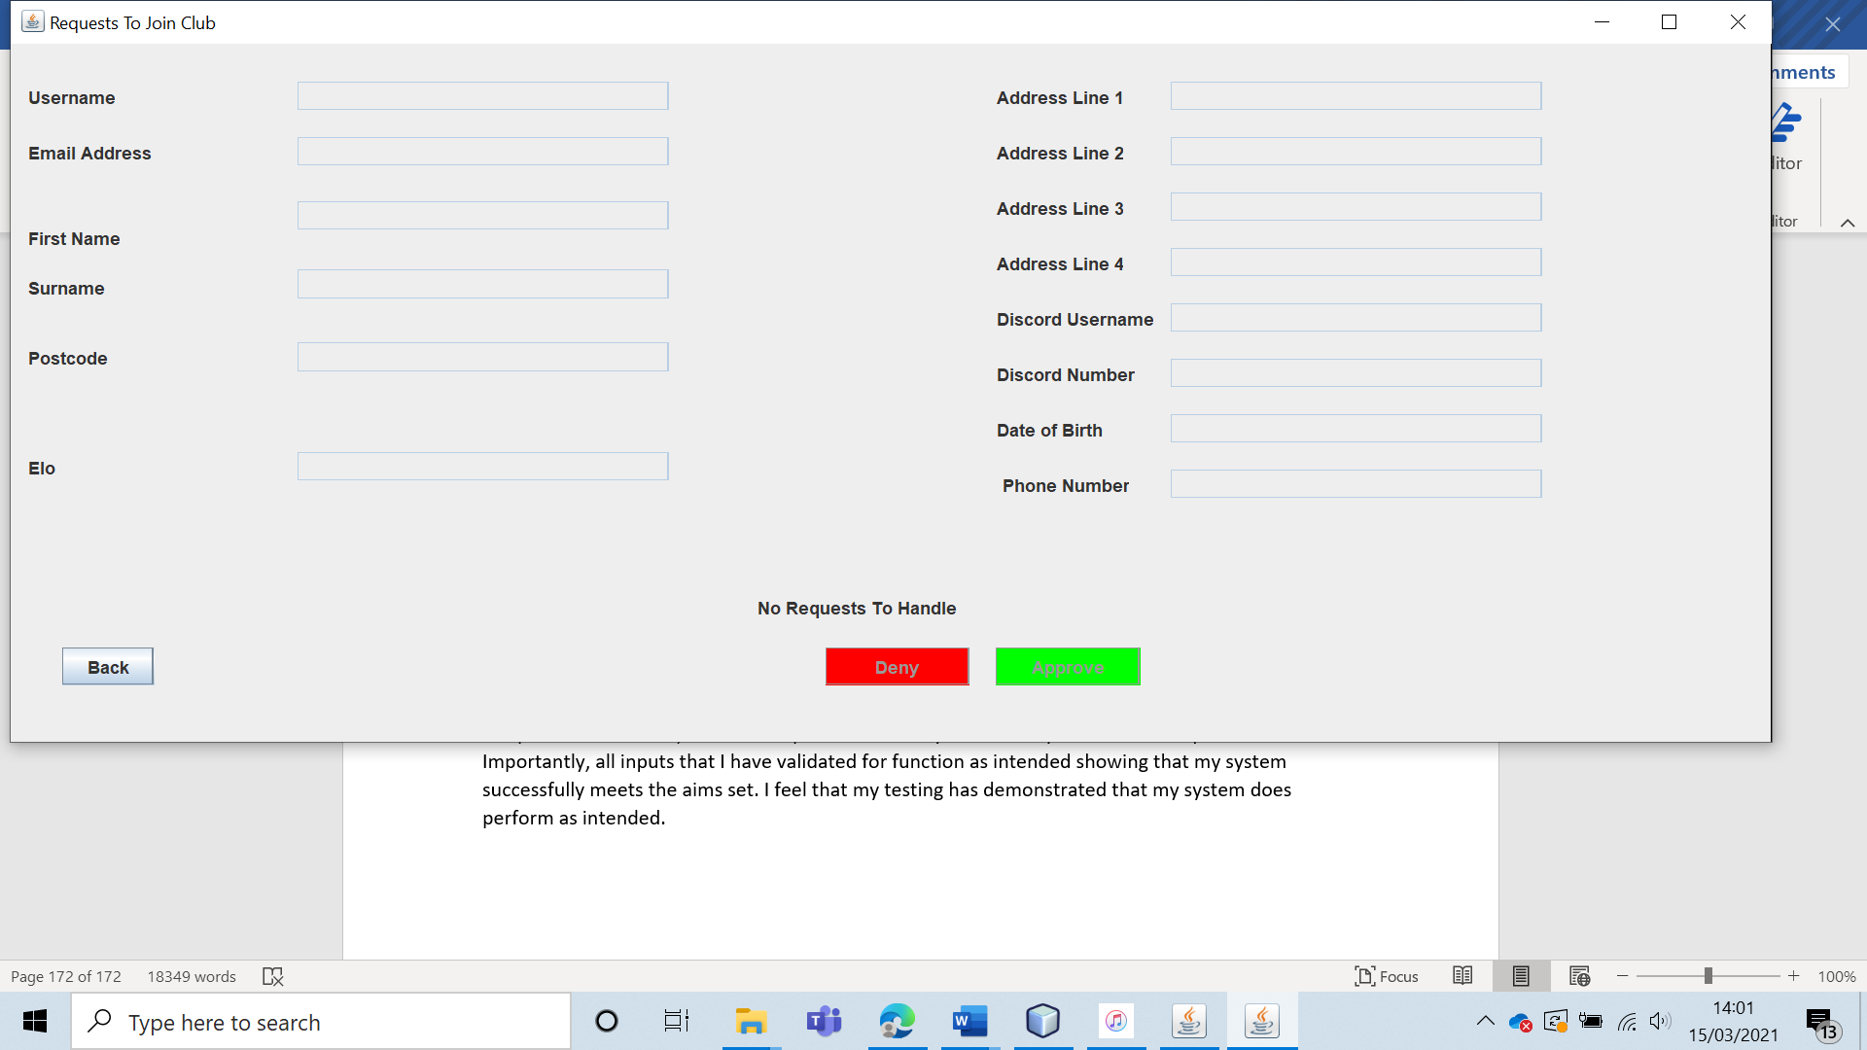

|  |  |  |  |  |  |  |
| --- | --- | --- | --- | --- | --- | --- |
| 45 | Have the club leader accept a request to join the club and verify that the user becomes a member of the club. | To ensure that requests to join the club can actually be accepted. |  | The user should become a part of the West Cross Chess Club. | 8, 8a and 8ai. | The request is accepted and the user is added to the club. |

Test 45

To test this, I had the club leader accept “phil2”’s request to join the club.

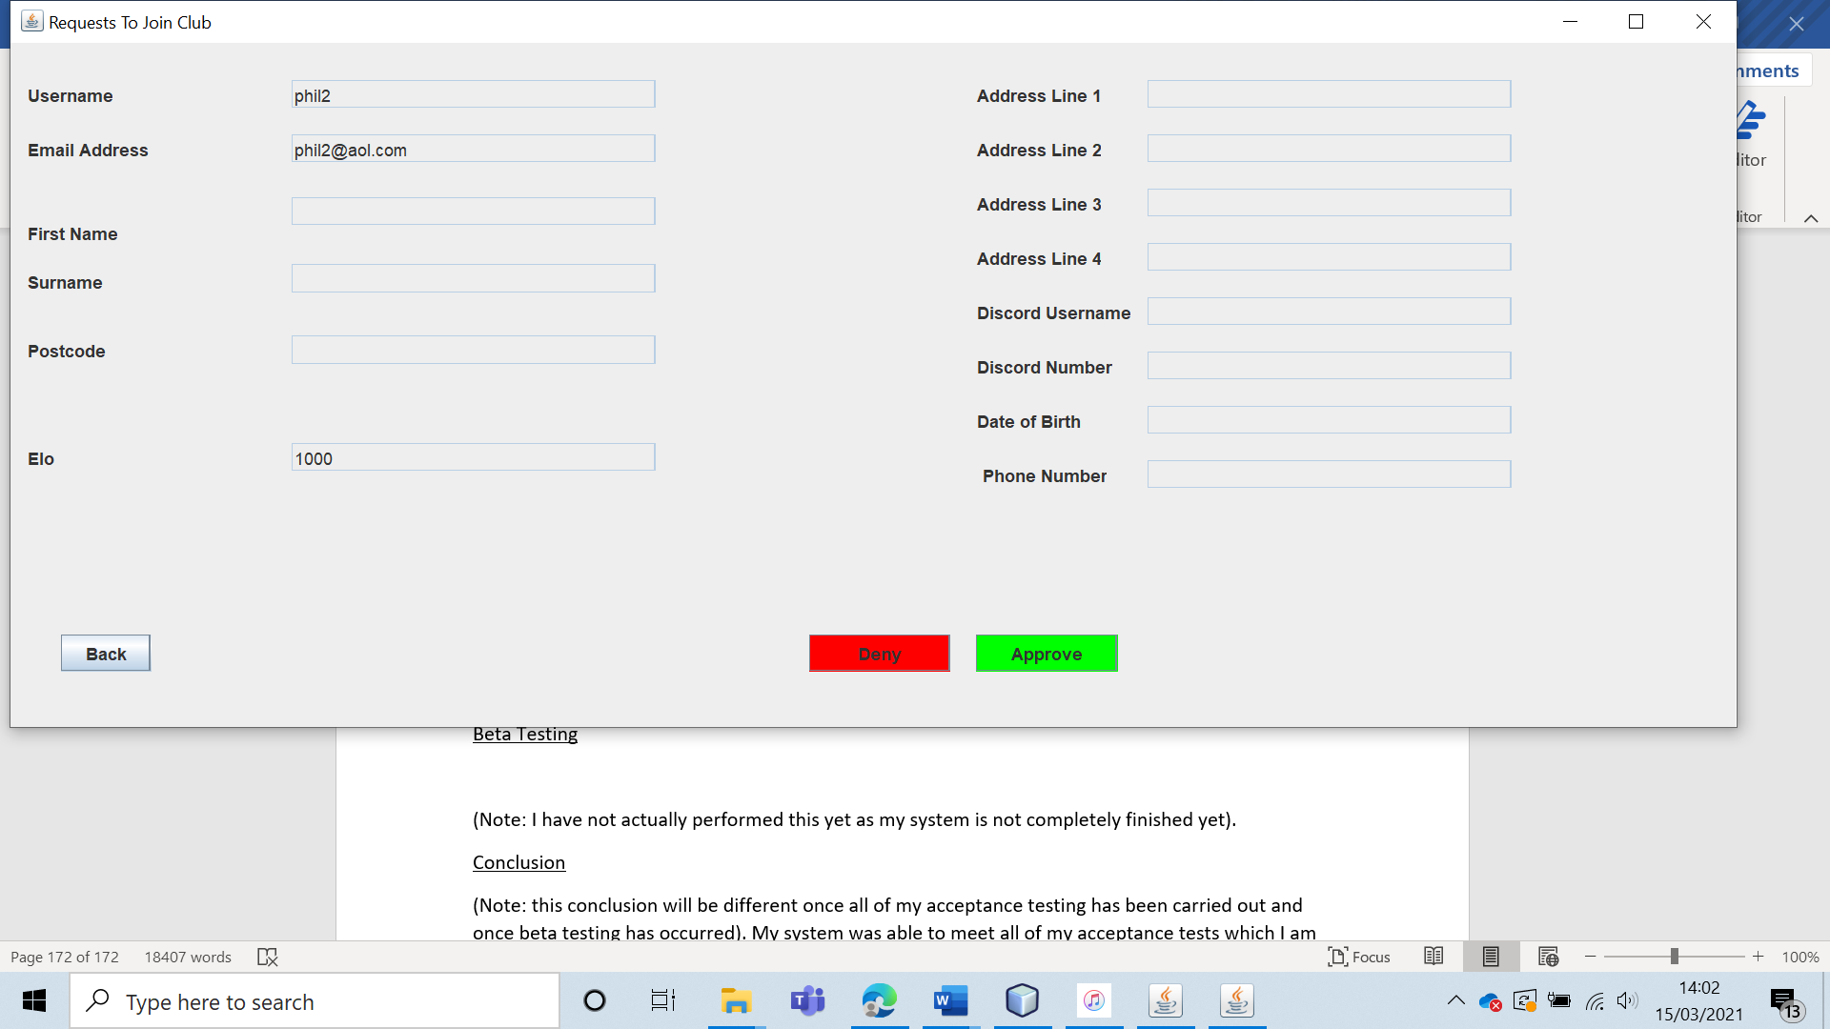

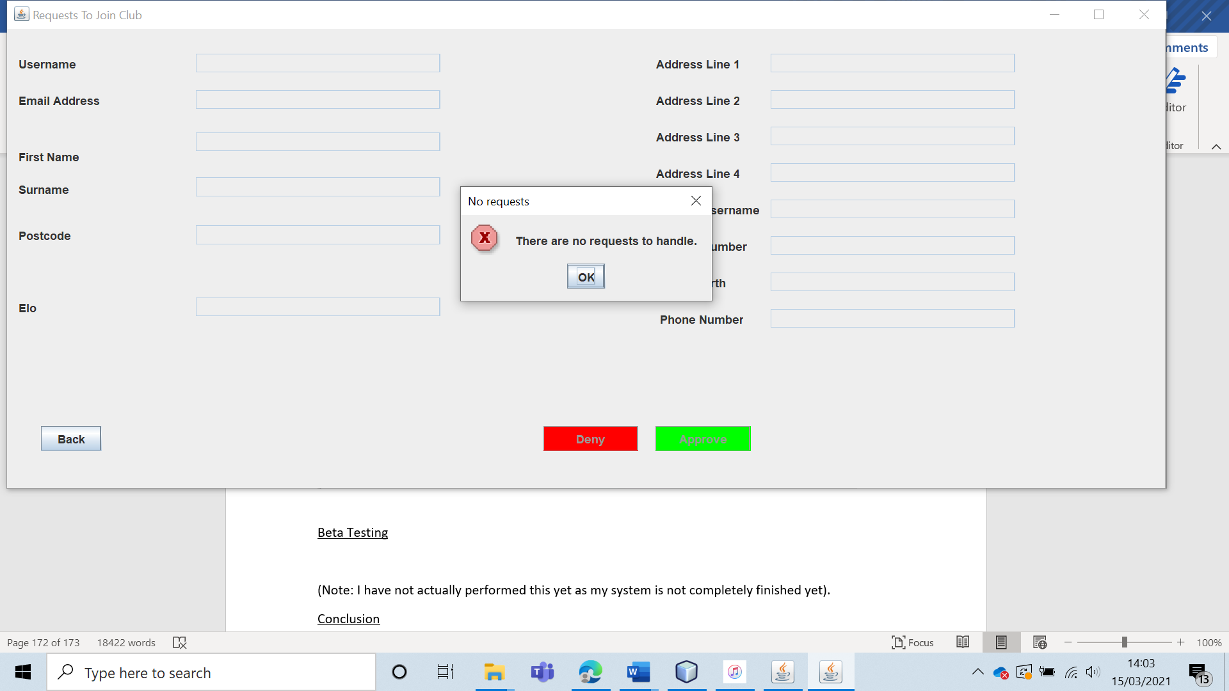

And the user “phil2” no shows up when the leader views the details of members of the chess club, showing that the request has been accepted.

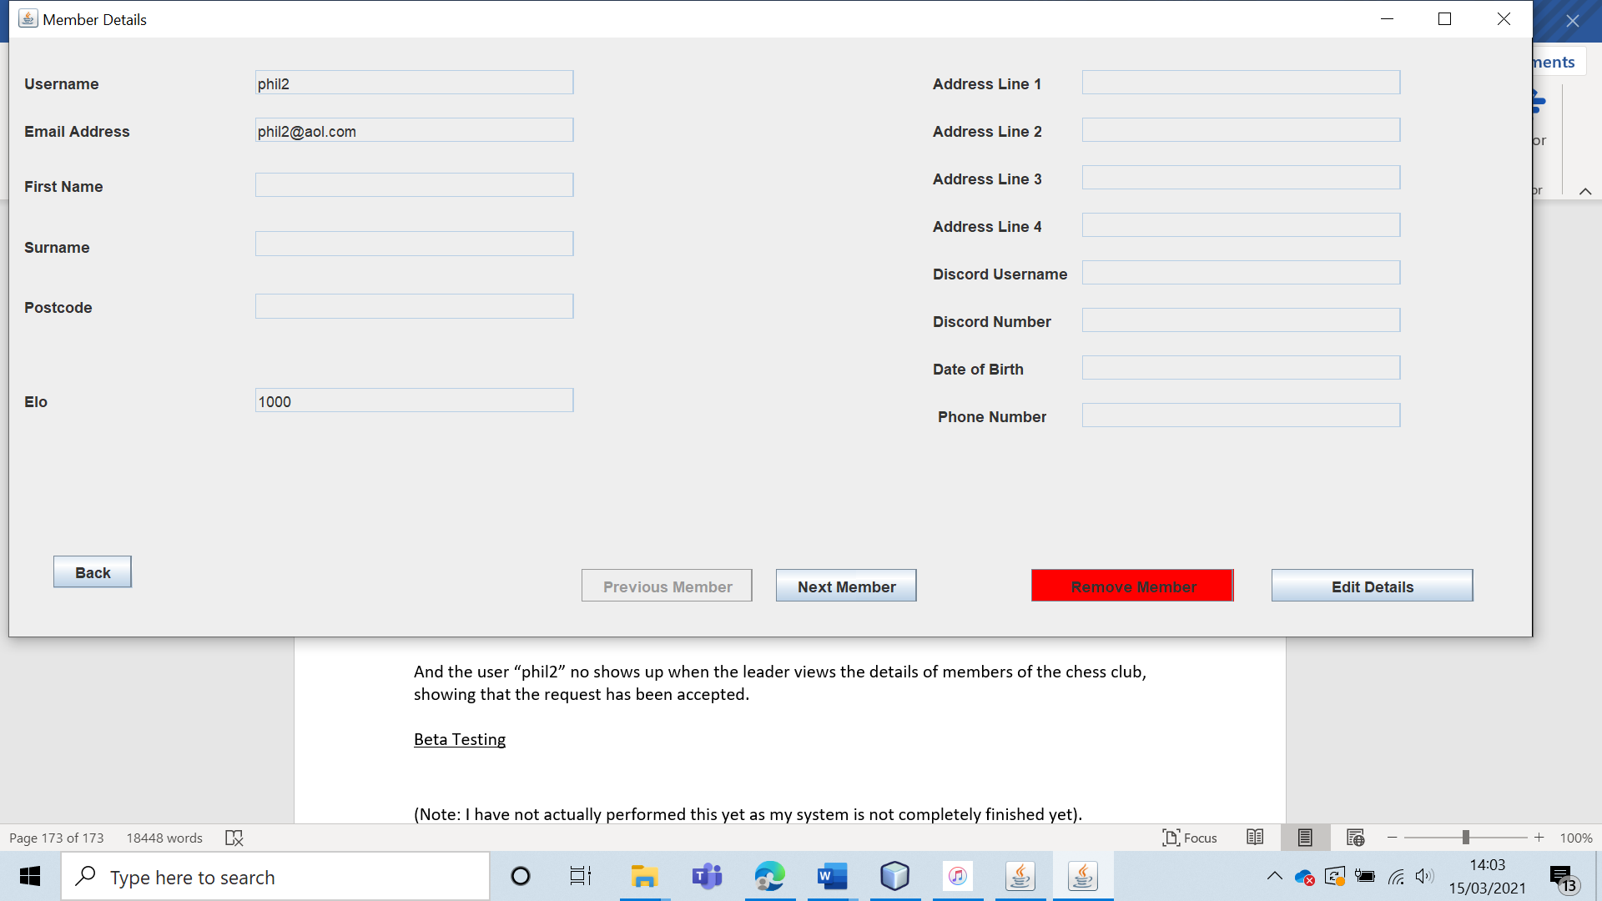

|  |  |  |  |  |  |  |
| --- | --- | --- | --- | --- | --- | --- |
| 46 | Have the club leader deny a request to join the club and verify that the user does not become a part of the club. | To ensure that requests to join the club can be turned down. |  | The user should not become a part of the club and should be removed from the group of people who have requested to join the club. | 8, 8a and 8ai. | The request is declined and the user does not become a club member. |

Test 46

To test this, I had the user “phil2” request to join the club. Then, I had the leader deny the request to join.

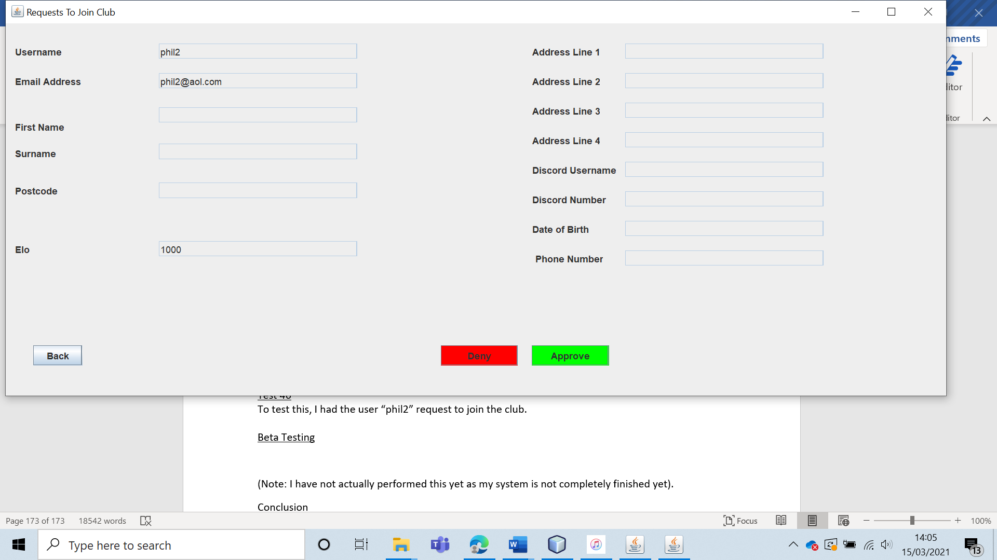

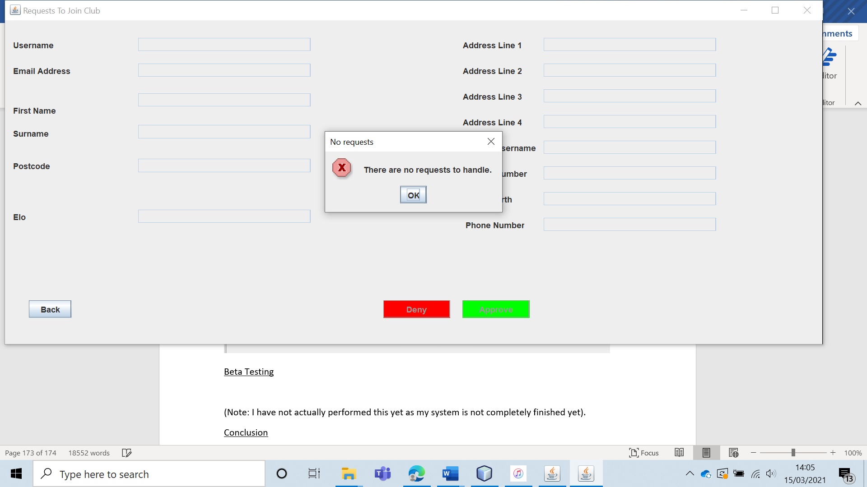

And as expected, the user “phil2” appears in the Non-member details section but does not appear in the member section. This shows that the request has been denied.

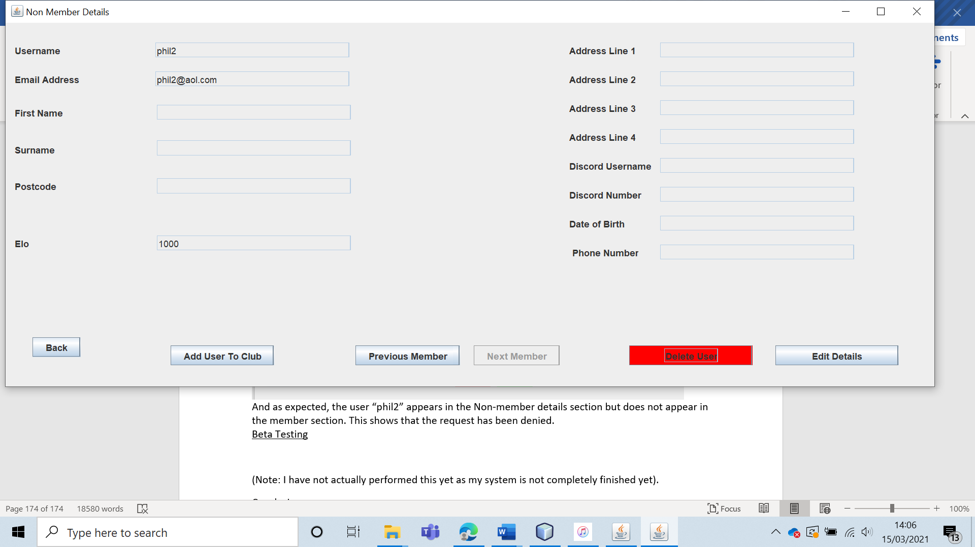

|  |  |  |  |  |  |  |
| --- | --- | --- | --- | --- | --- | --- |
| 47 | Verify the fixture generation algorithm by having the system generate the season’s fixtures when the club has: 1,2,3 and 4 members. | To ensure that the fixture generation algorithm works. |  | When there is one member, no fixtures should be generated. Otherwise, each user should play each other exactly twice. The users should also swap colour so for each pair of fixtures, userA is white in one game against userB and then userA is black in the other game against userB. | 9, 9a and 9ai. | The fixture generation functions in each of the test cases. |

Test 47

To test this, I generated the fixtures for the club when the club had 1,2,3 and 4 members.

When there is only one member, no fixtures are generated (as one person is not enough to have a league).

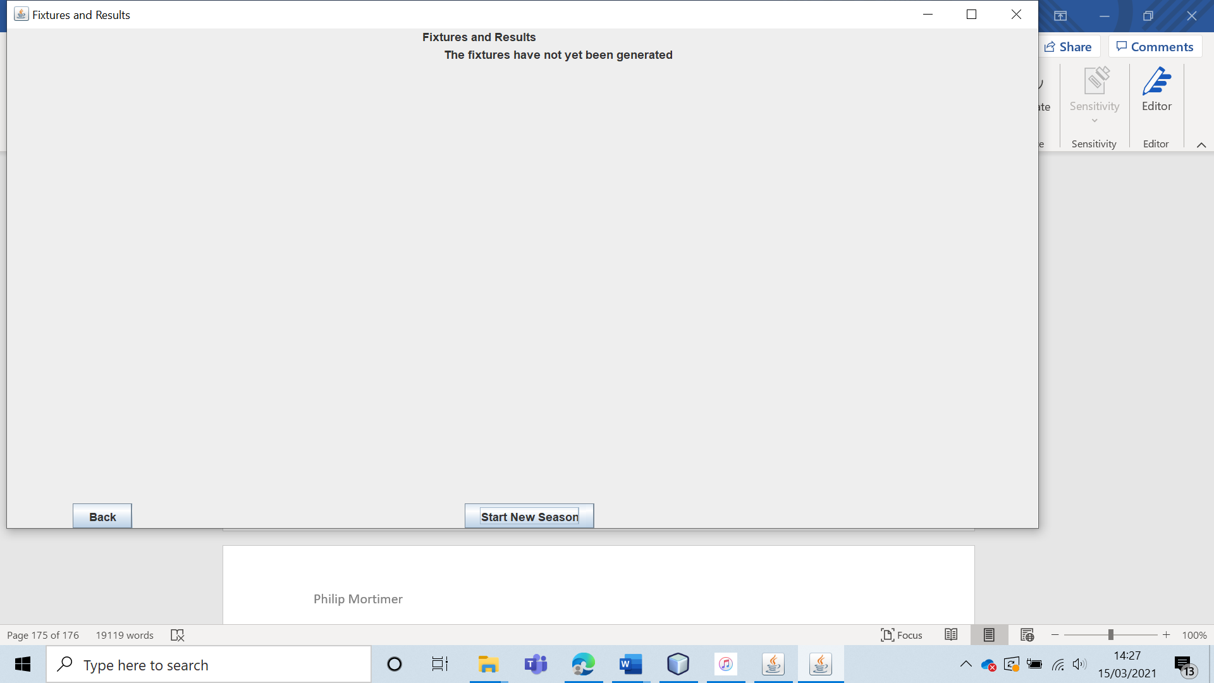

When the fixtures are generated with two players, the algorithm functions as intended. With both users playing each other twice (swapping colours).

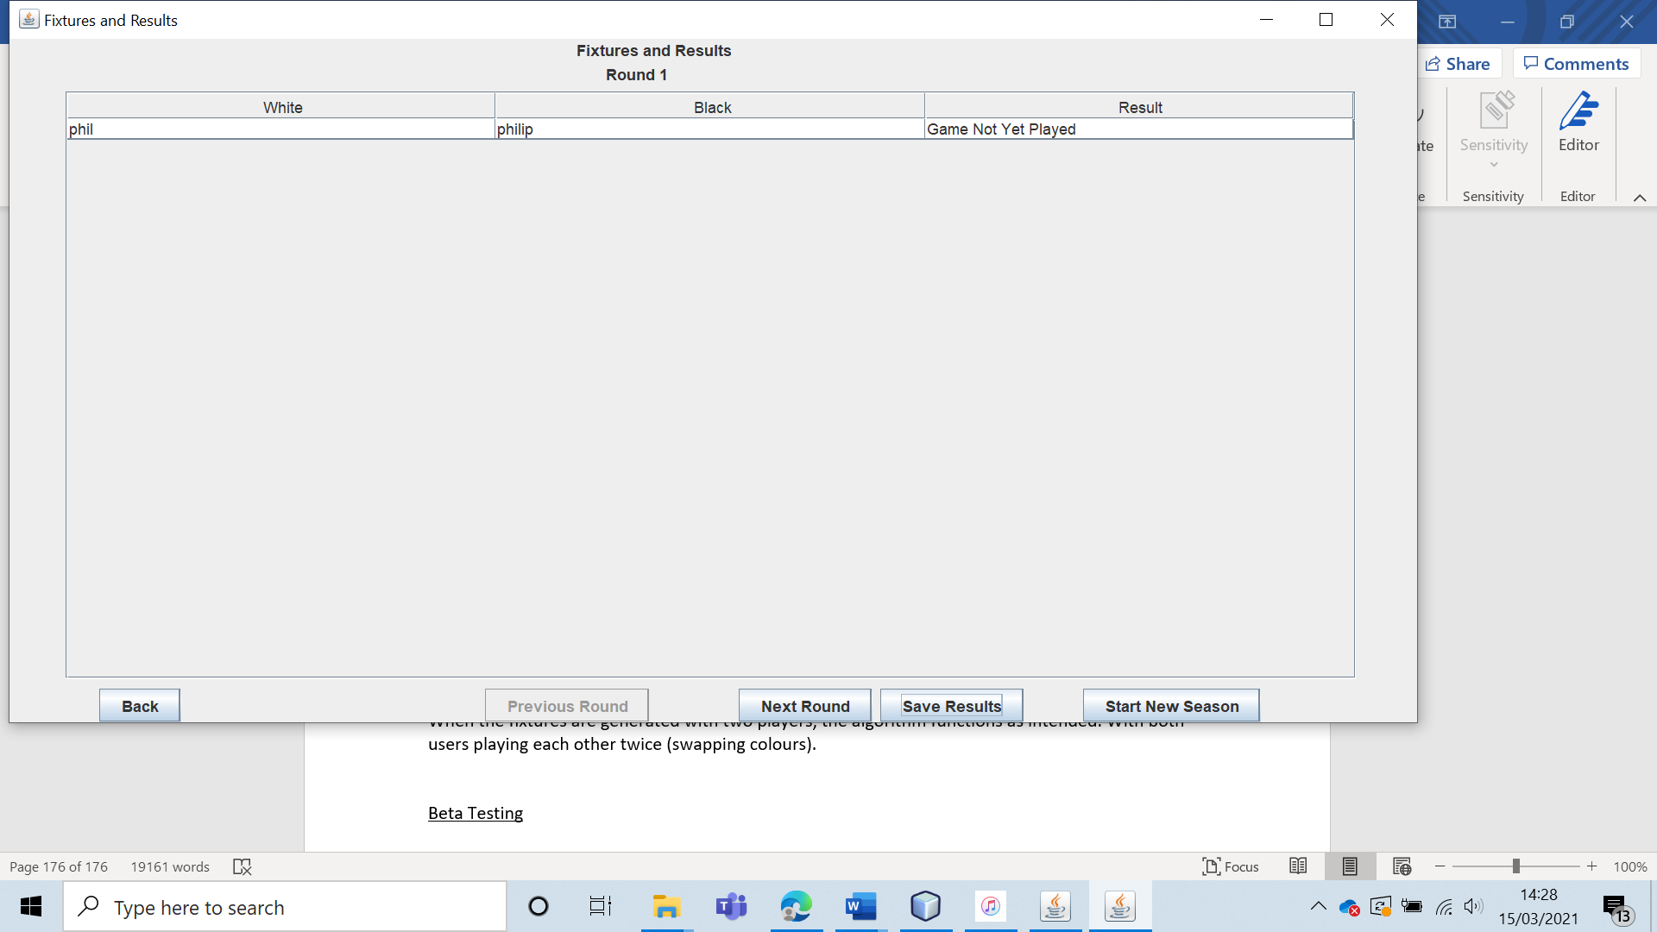

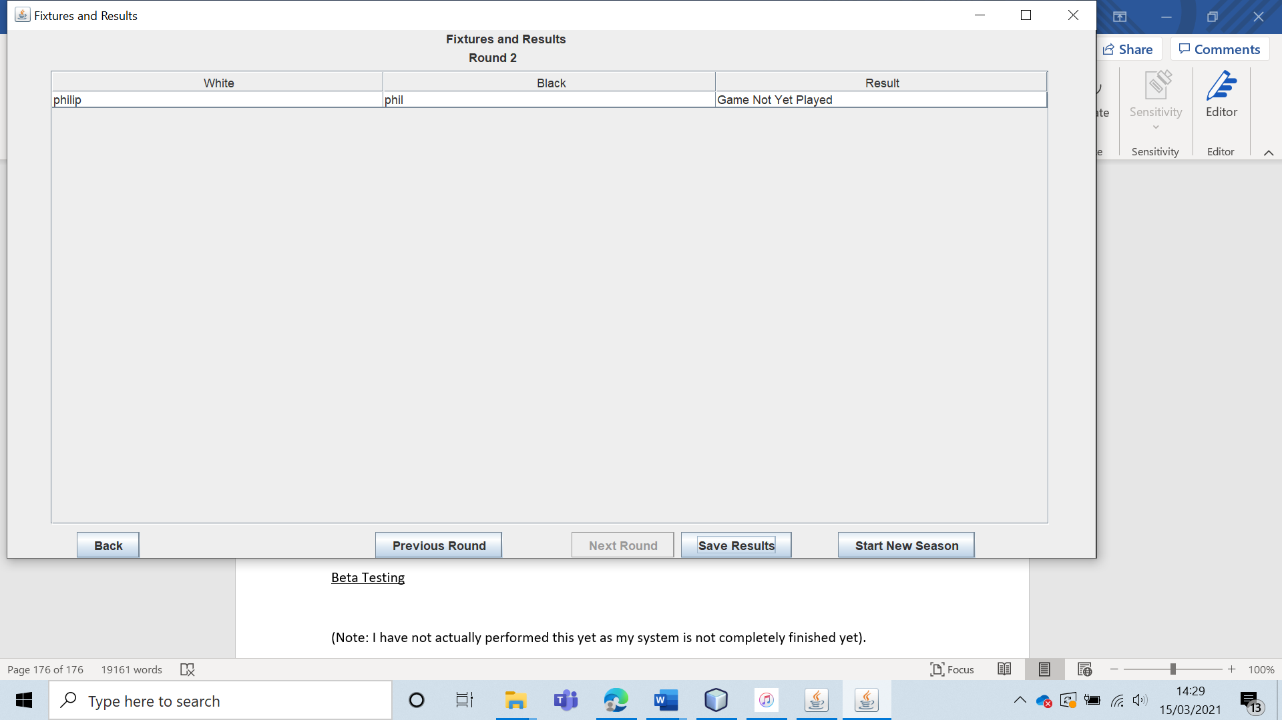

The algorithm also works with 3 members as each member players every member exactly twice: once as black and once as white. The system handles the odd number of players by adding in a bye round every week.

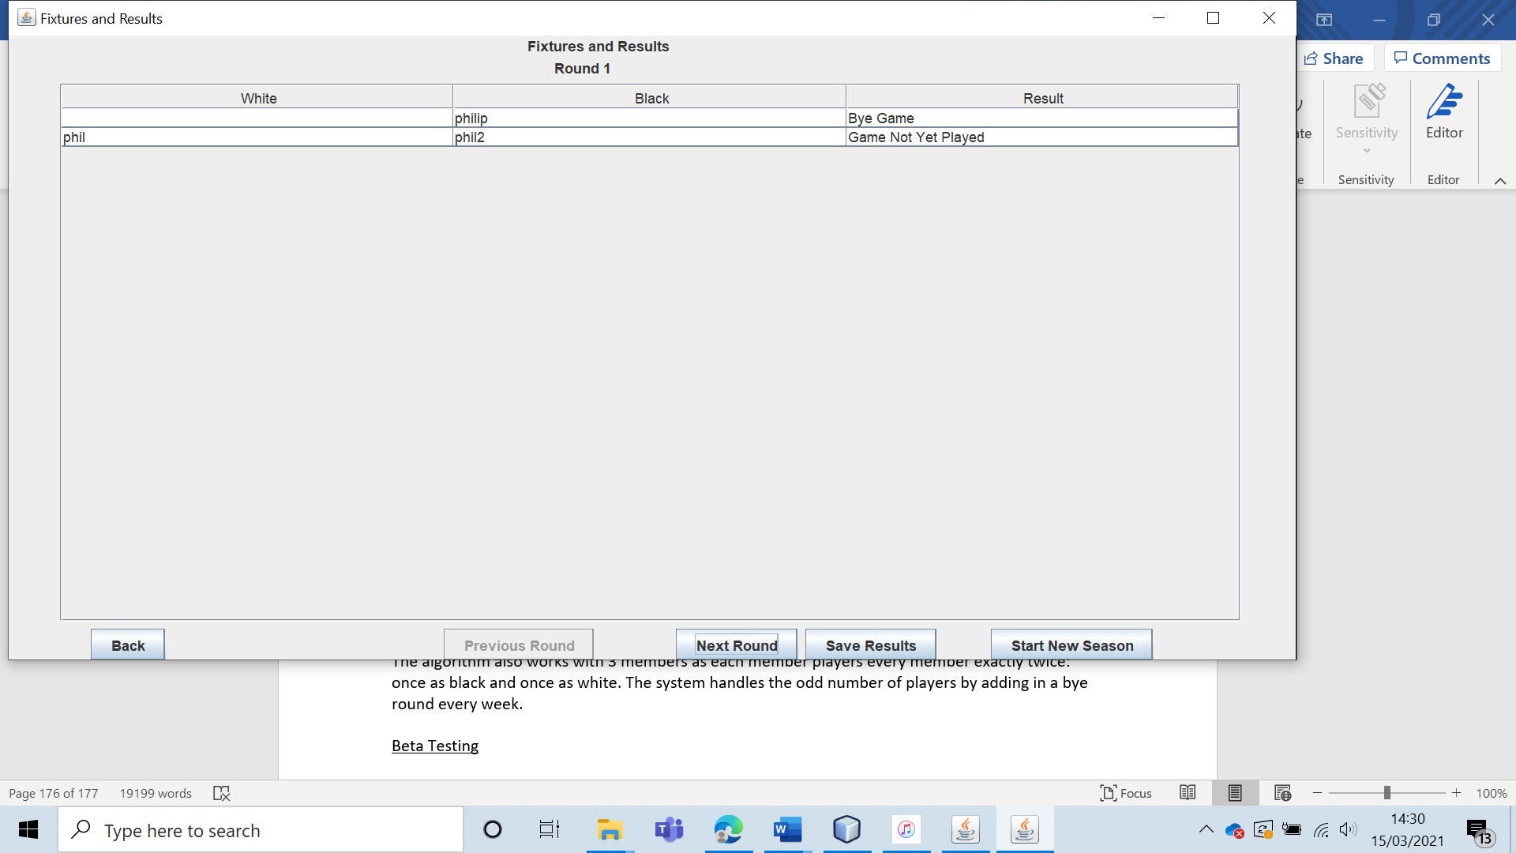

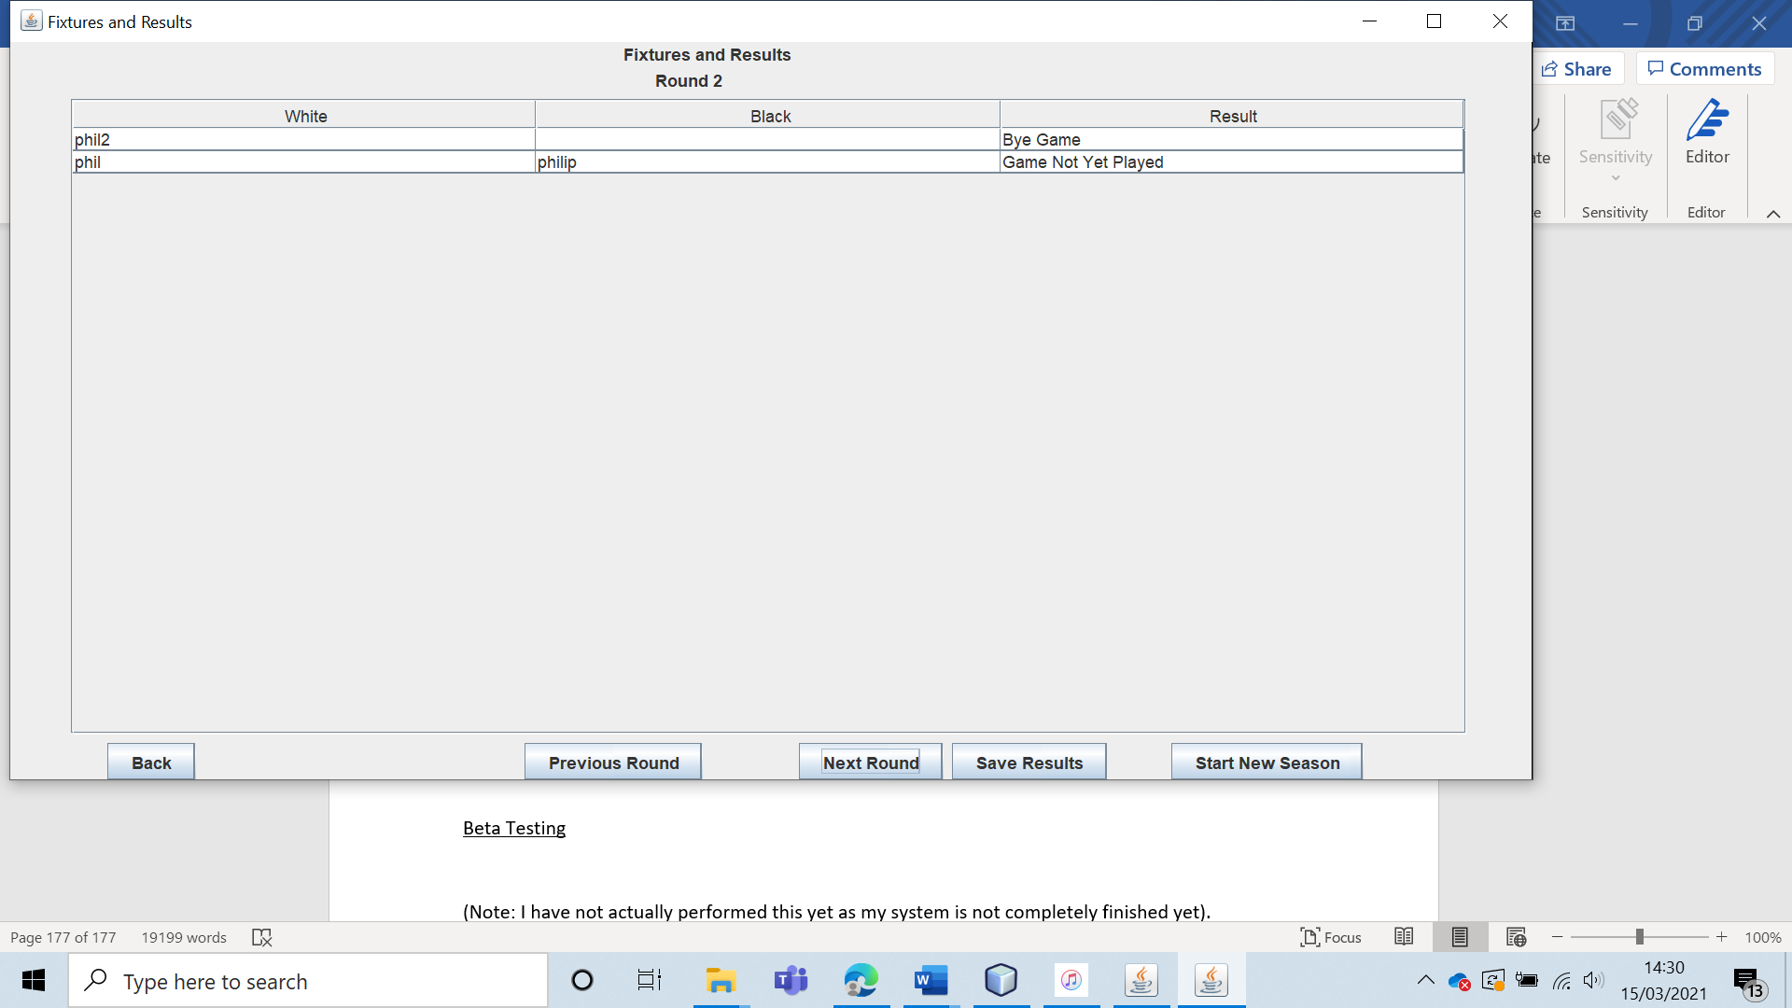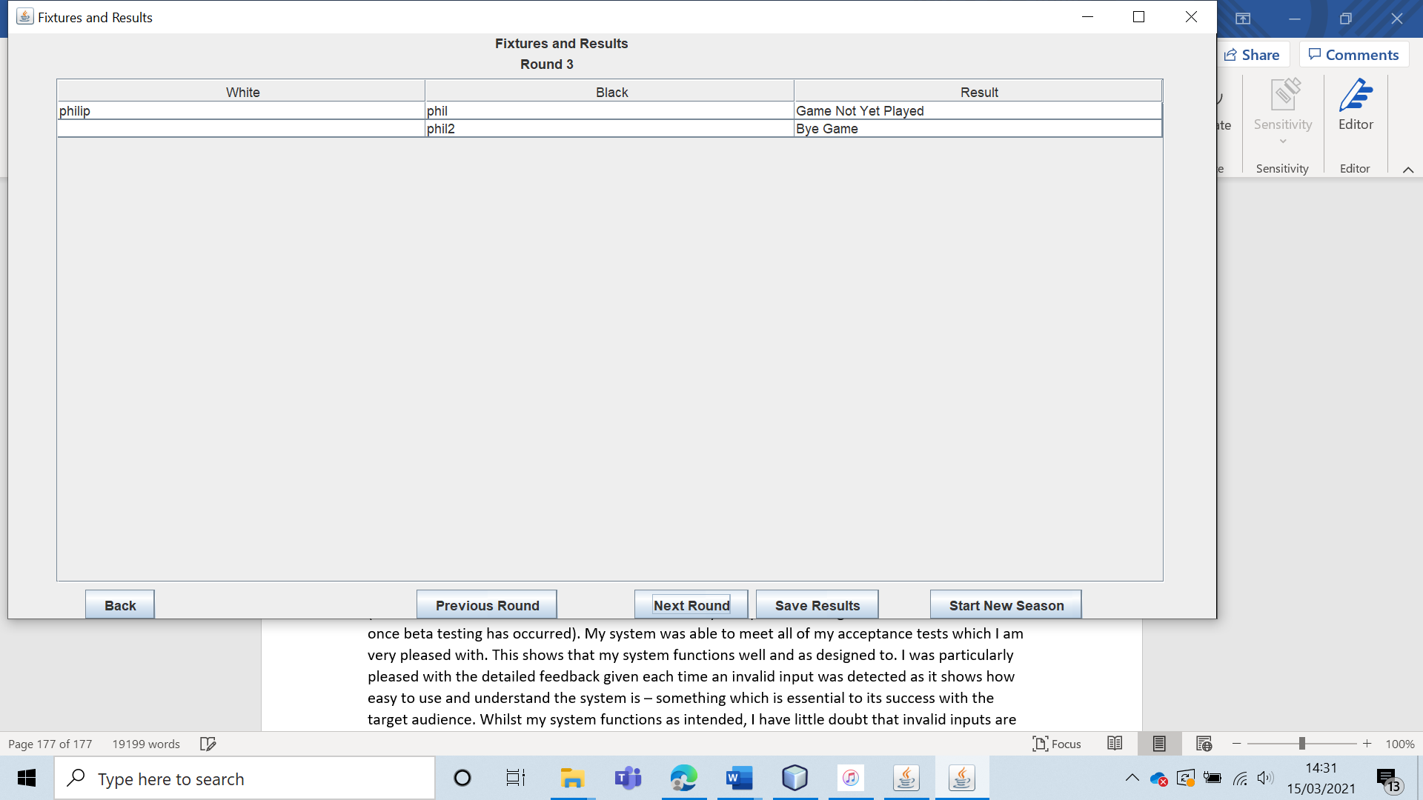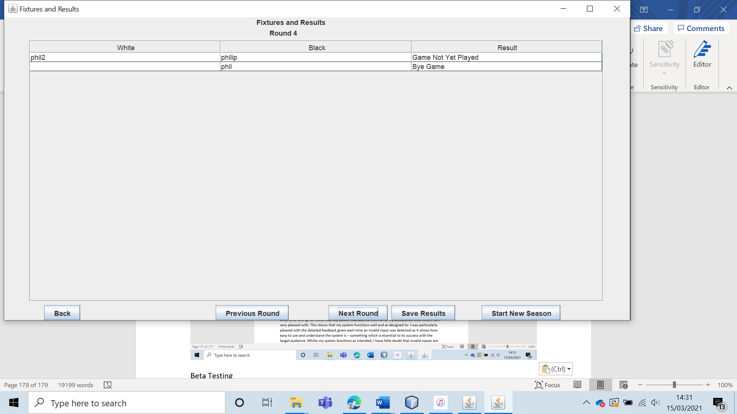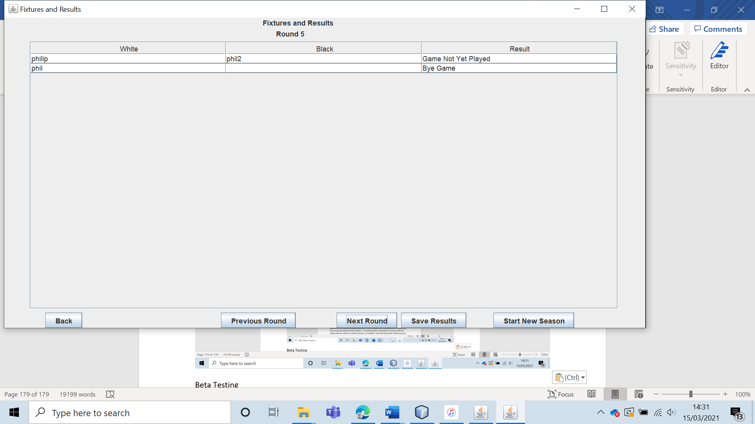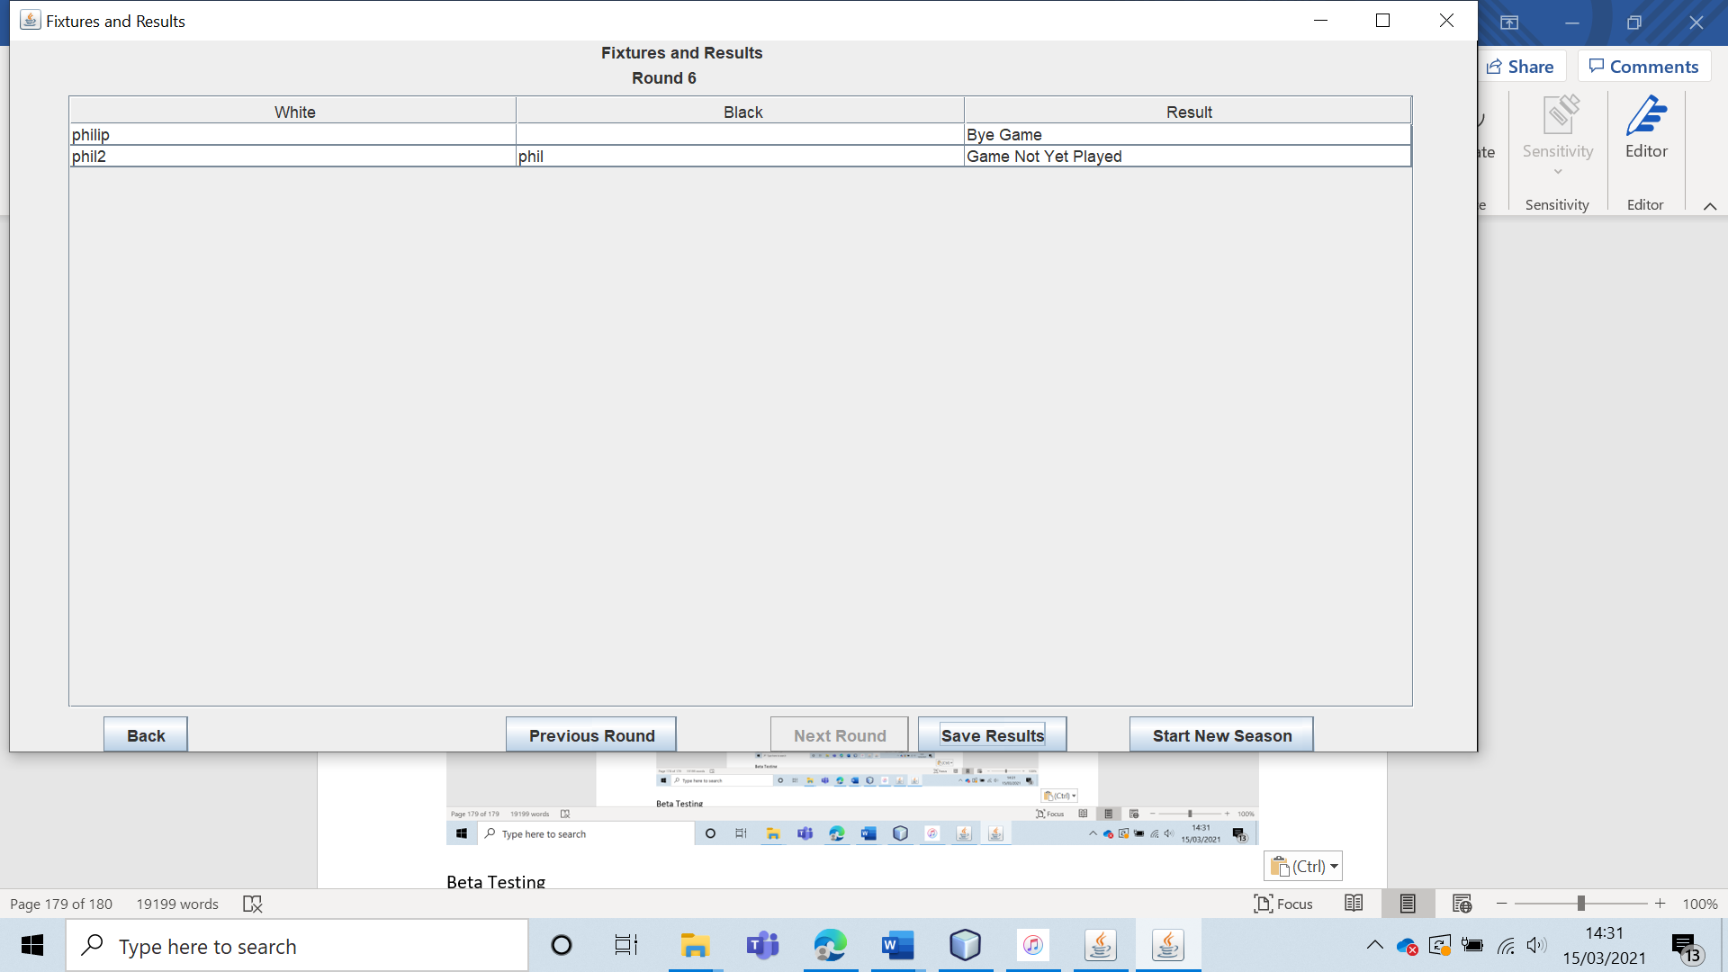

The algorithm also satisfies the problem constraints with 4 members.

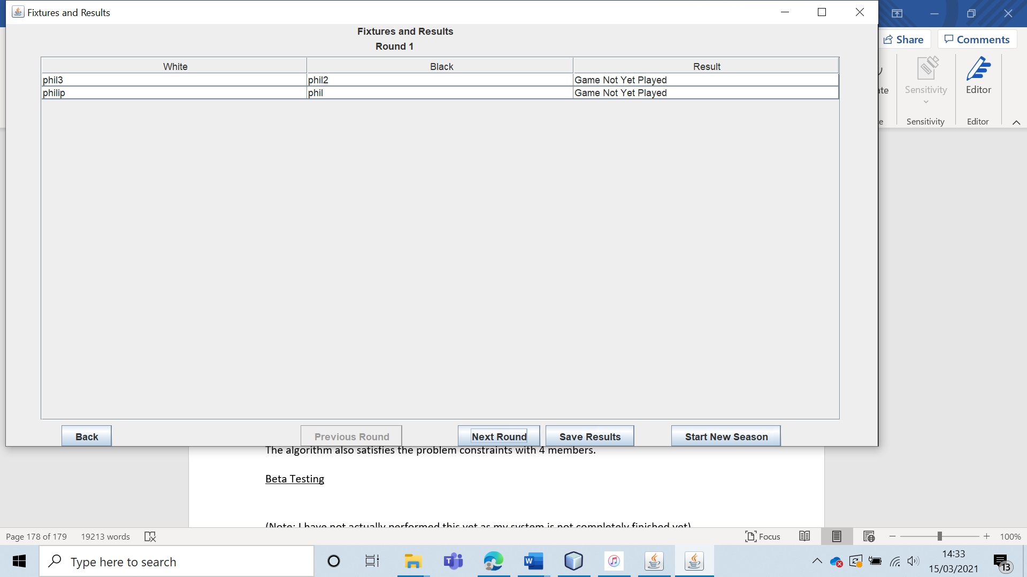

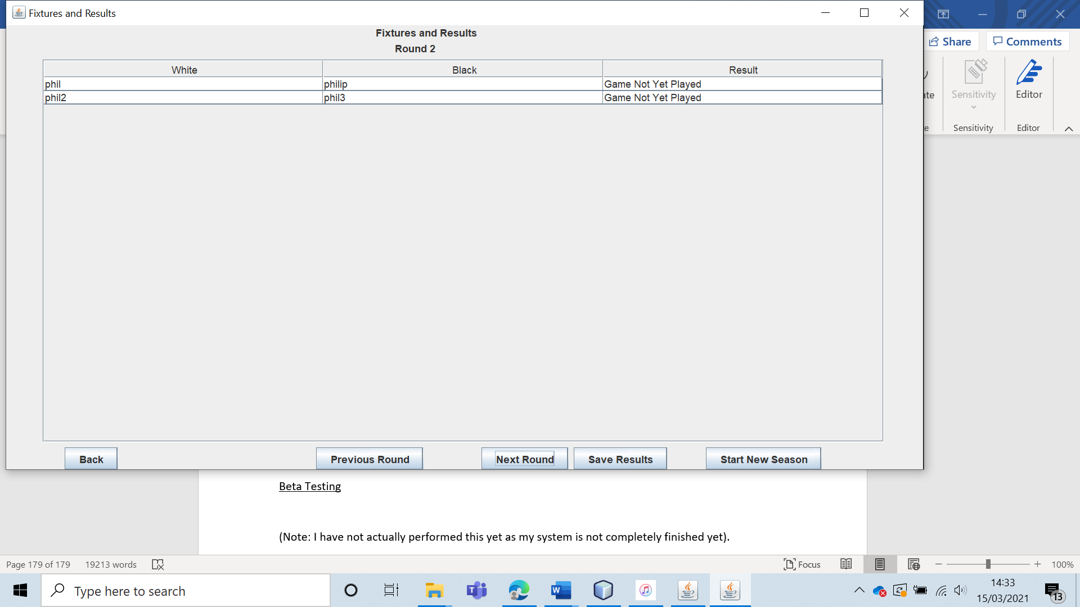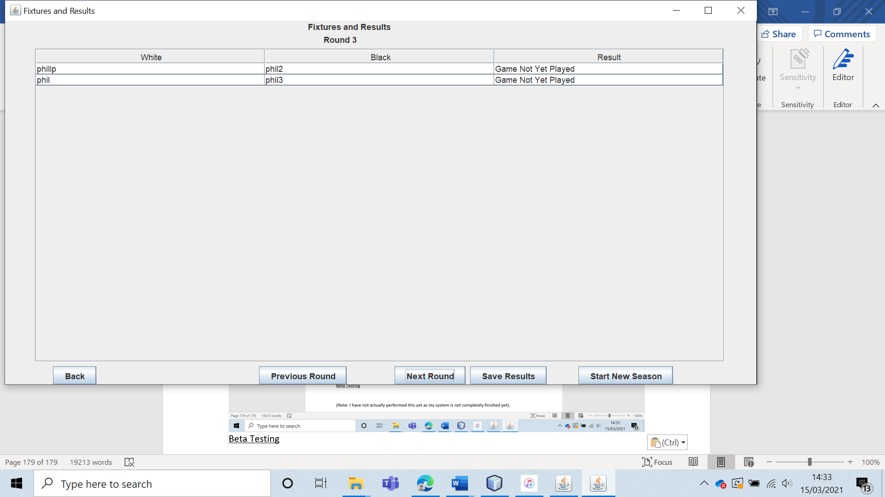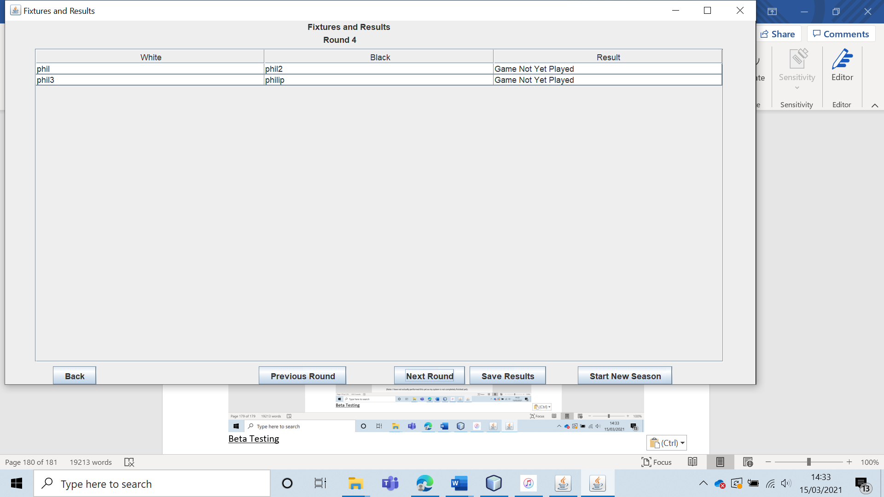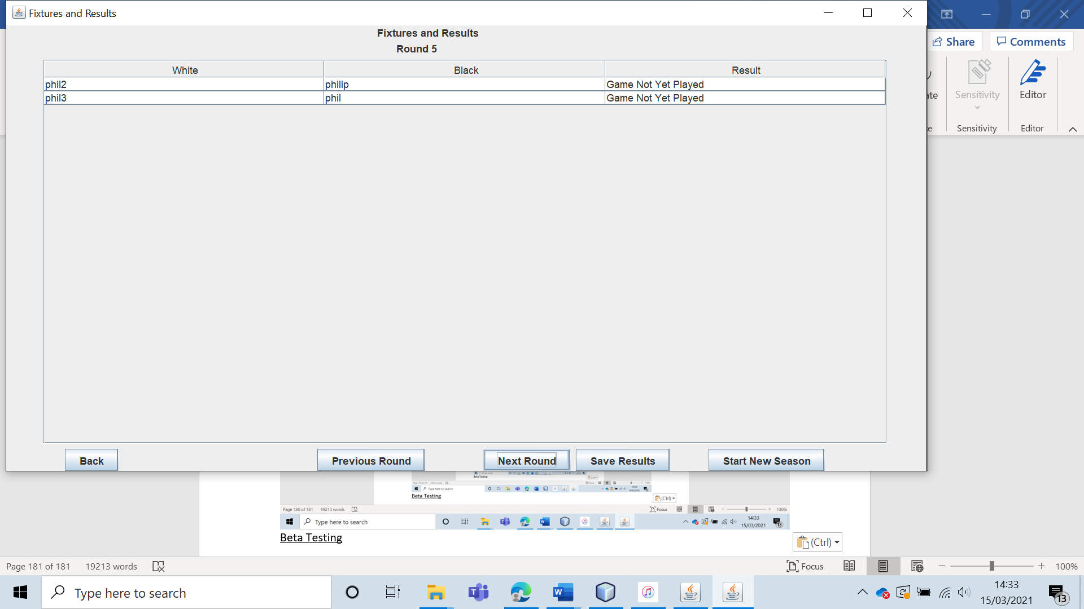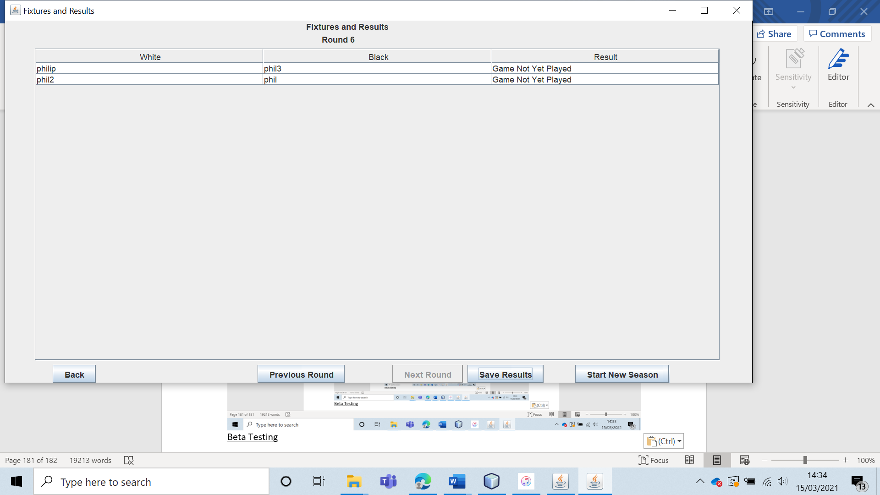

|  |  |  |  |  |  |  |
| --- | --- | --- | --- | --- | --- | --- |
| 48 | Have a user leave the club after a set of fixtures have been generated. | To ensure that the fixture generation algorithm works. |  | All games with the user that has left in them should be replaced with bye games. | 9, 9a and 9ai. | All games with the user that left were replaced with bye games as expected. |

Test 48

To test this, I had a user leave when games had been generated for four members.

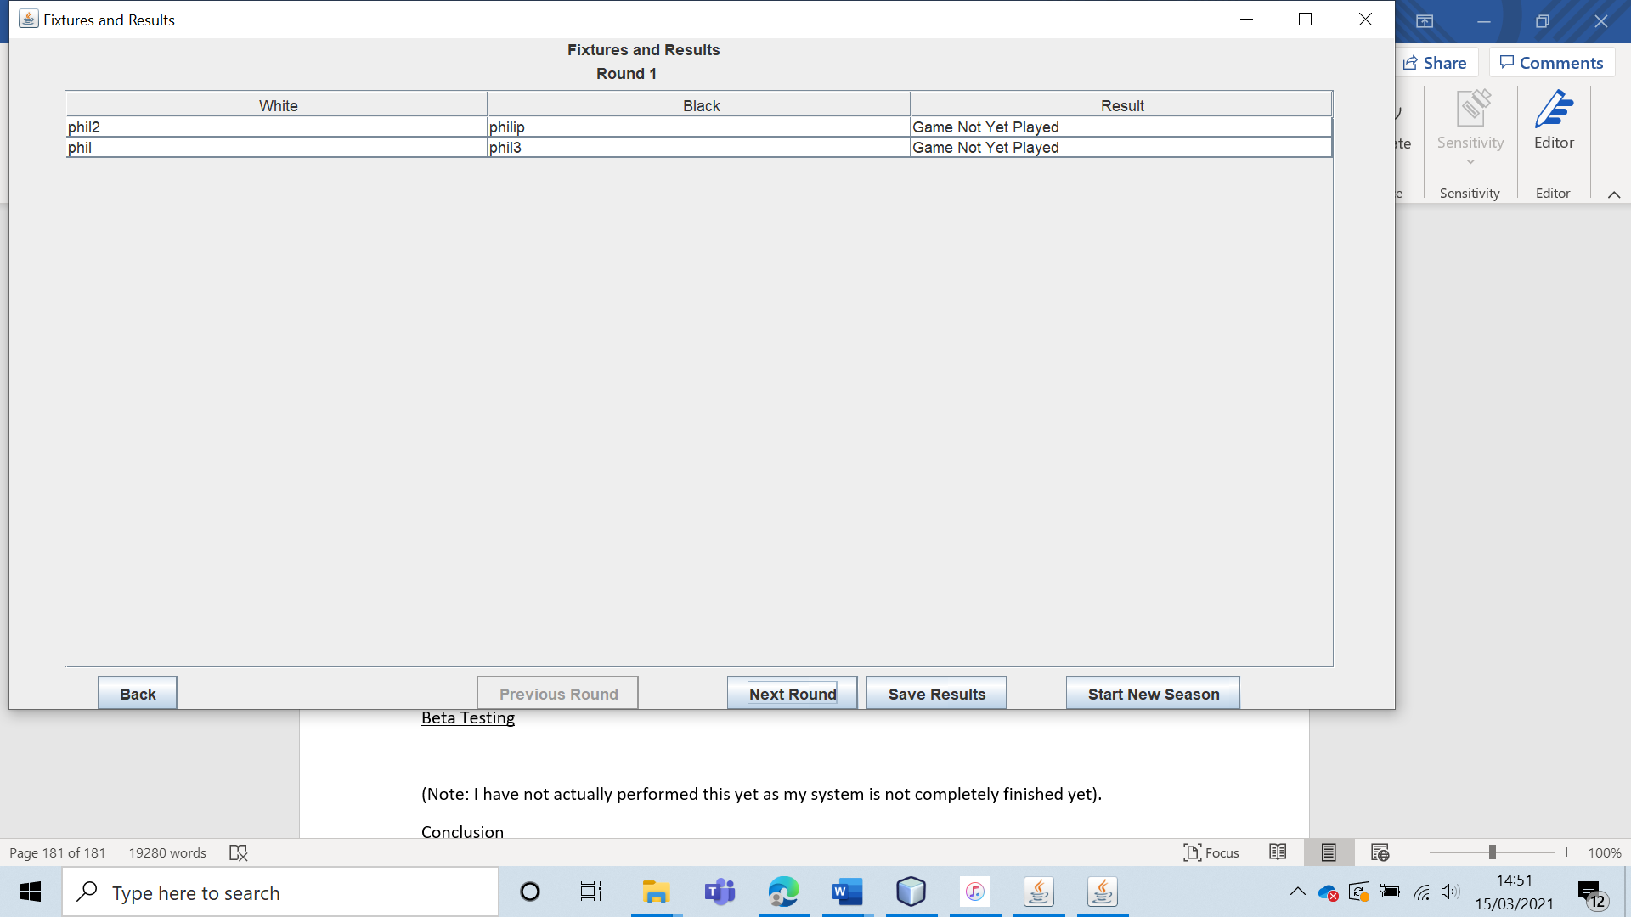

When a user left, all of their games were replaced with bye games.

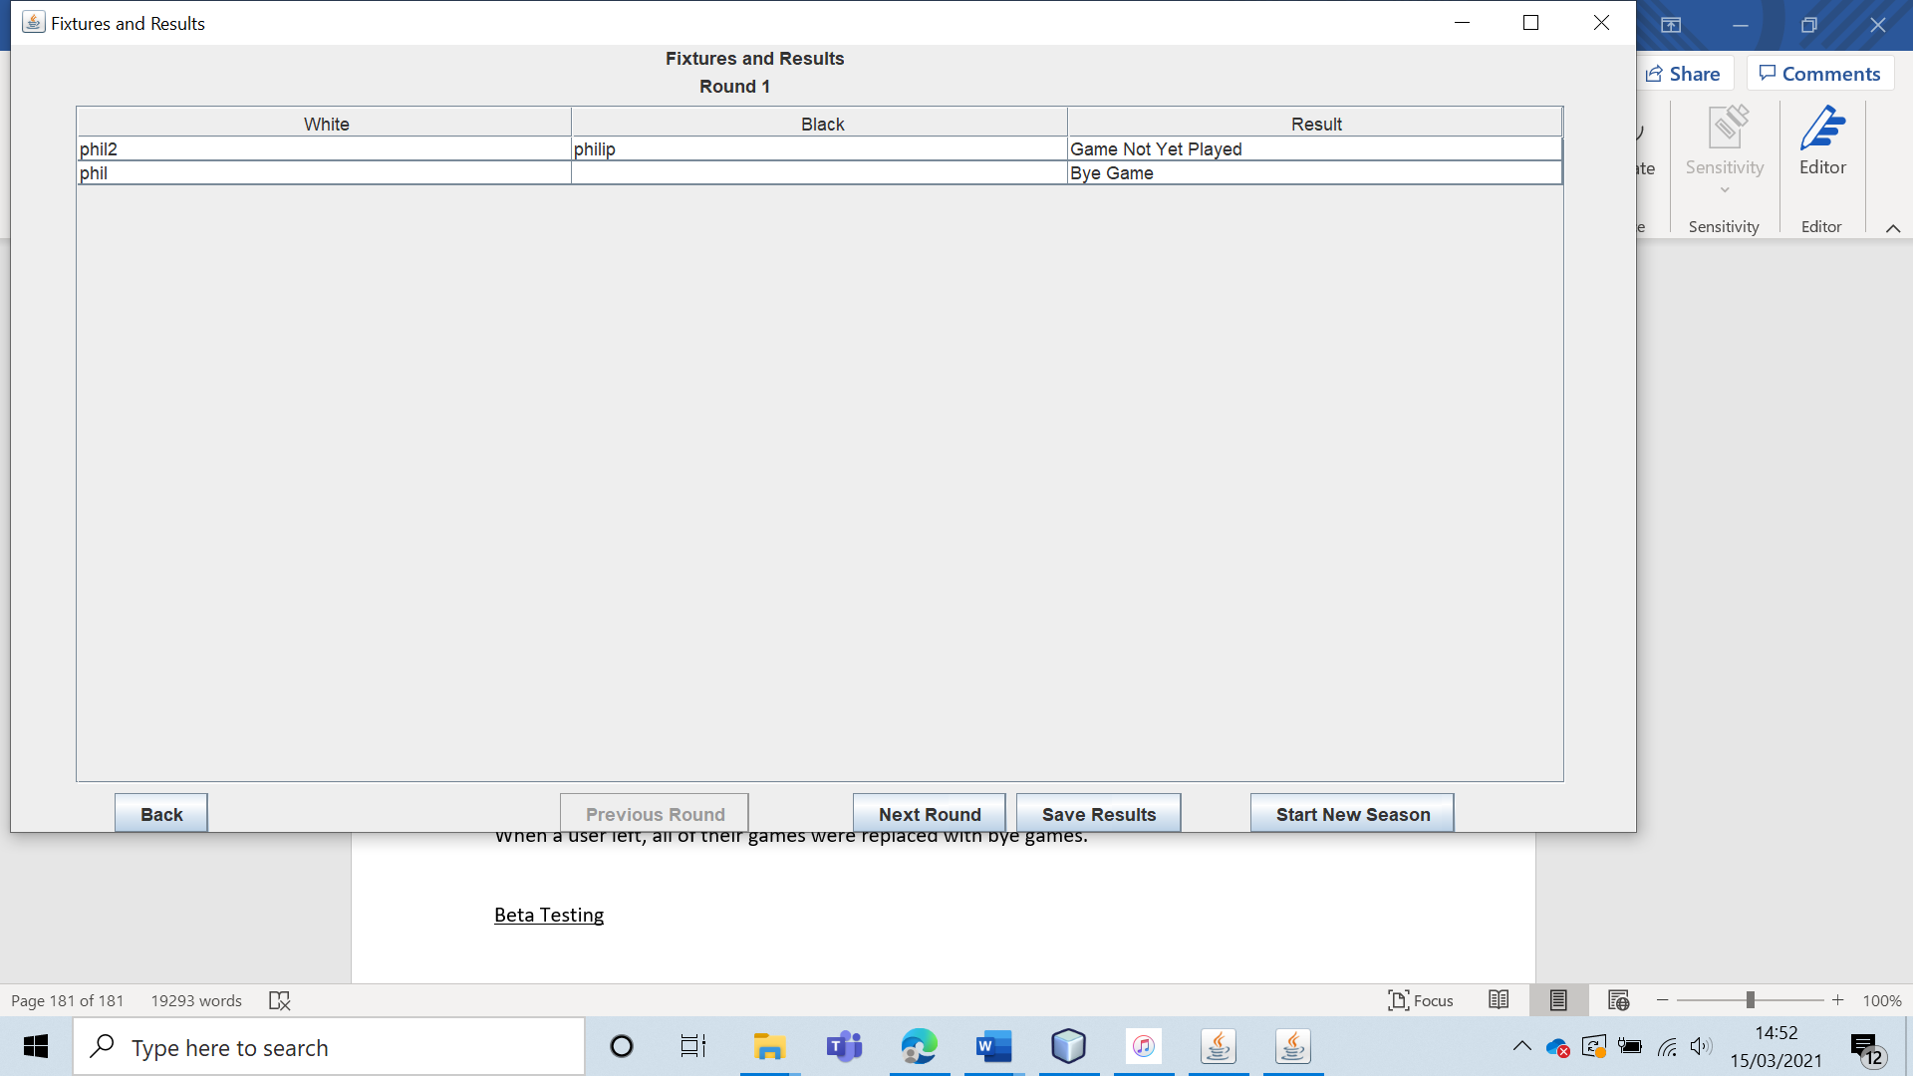

I also tested the system when there were three members initially.

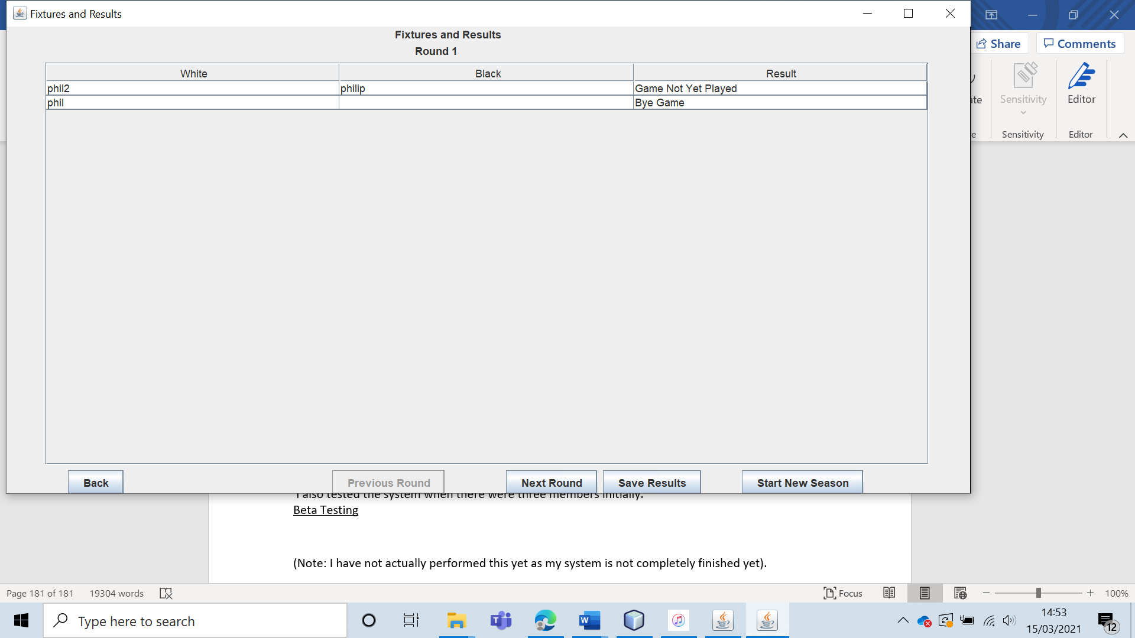

When a user left, they were also replaced with a bye game.

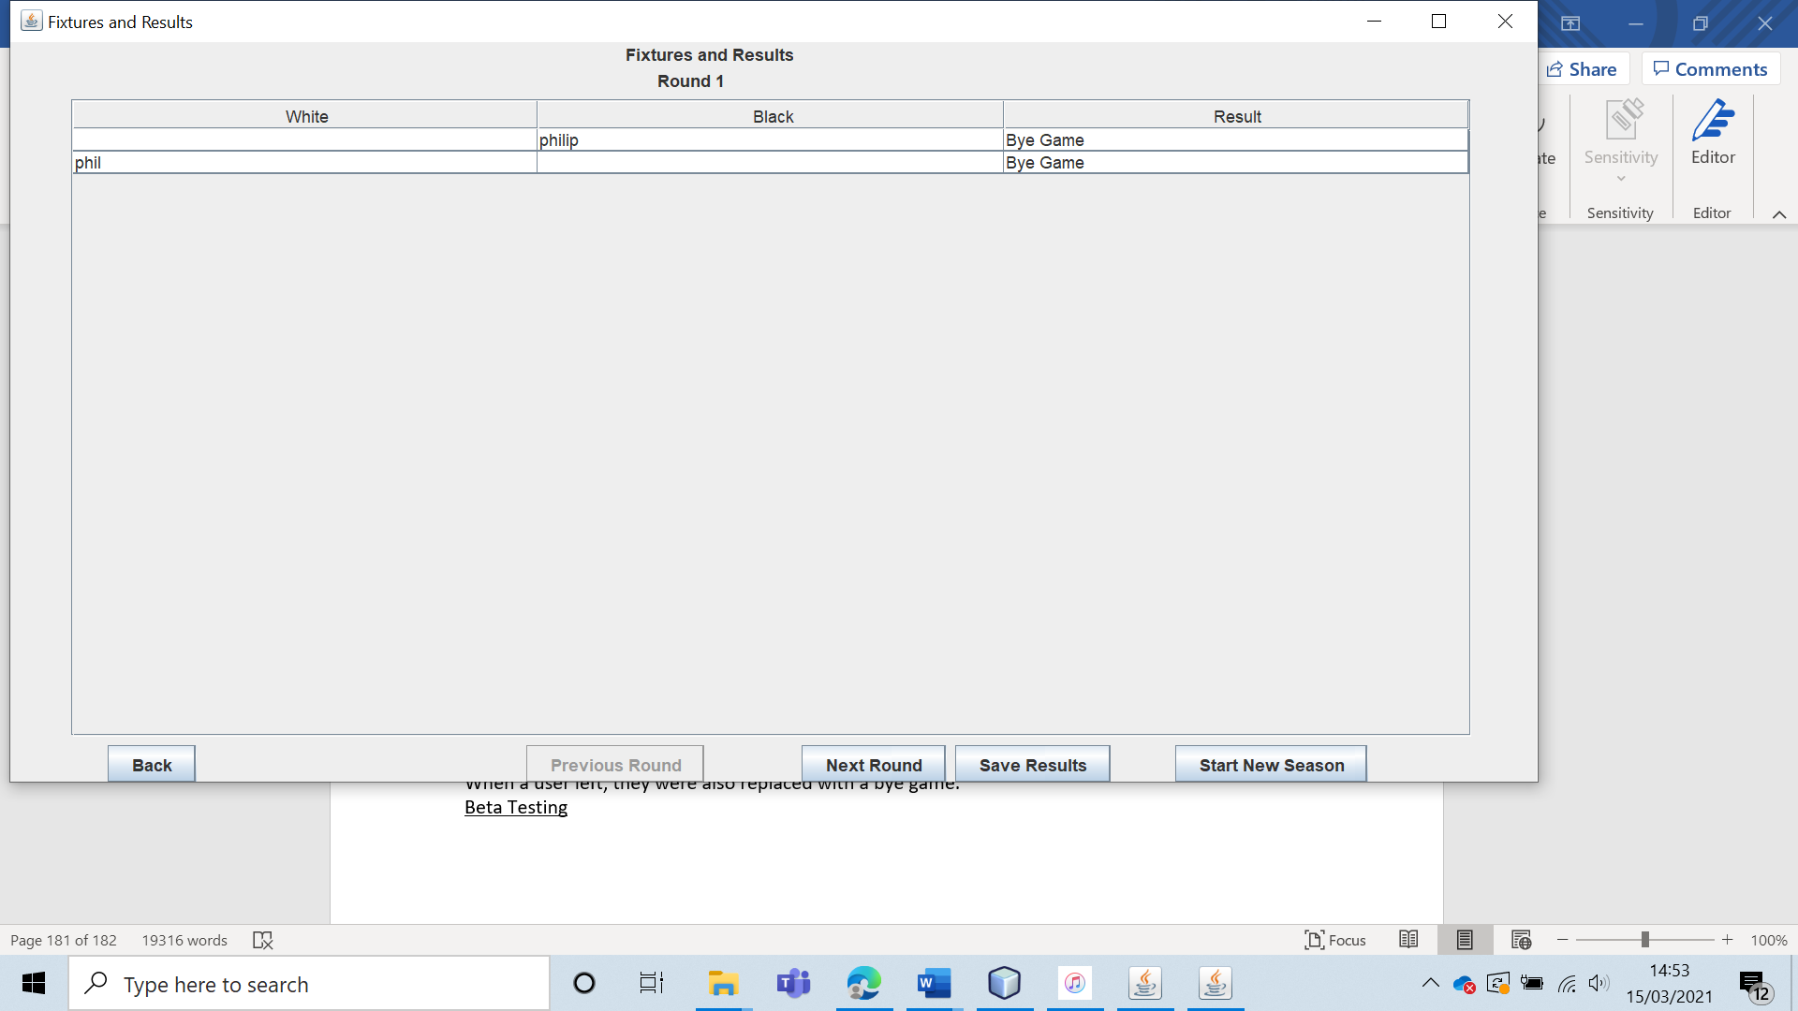

Hence the system works. However, it is interesting to note that a better system would check to see if any games had been played. If no games had been played, the fixtures would simply be generated from scratch. This would be very easy to implement and is certainly something I would look to do in the future if I were to continue with this project.

|  |  |  |  |  |  |  |
| --- | --- | --- | --- | --- | --- | --- |
| 49 | Have a user join the club midway through a season. | To ensure that the fixture generation algorithm works. |  | The user should not be included in any of the fixtures. | 9, 9a and 9ai. | The user was added to the club, however they were not included in any of the fixtures. |

Test 49

To test this, I generated a season with four members and set the first round of games to have been played.

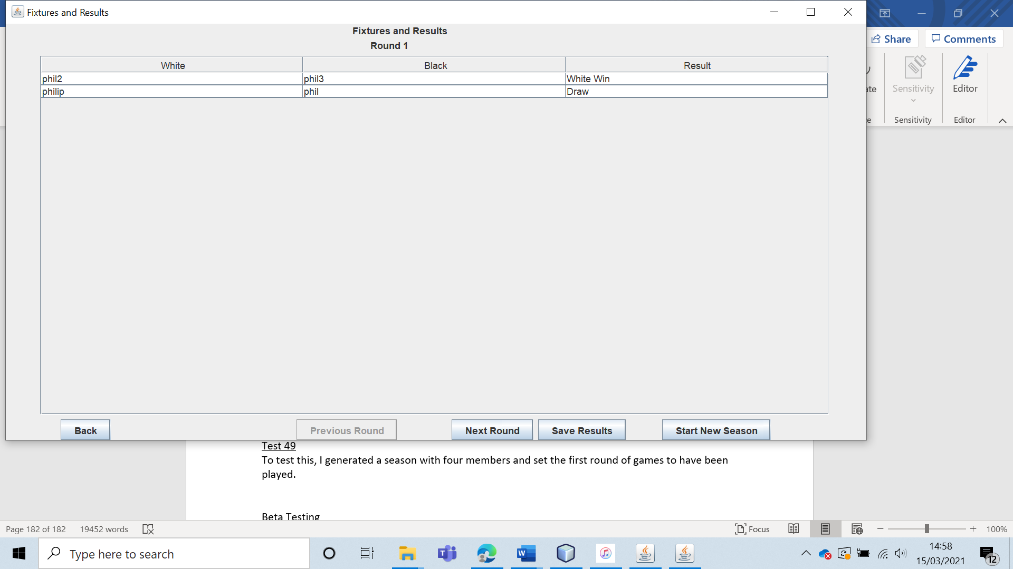

Then, I had a user (“phil4”) join the club.

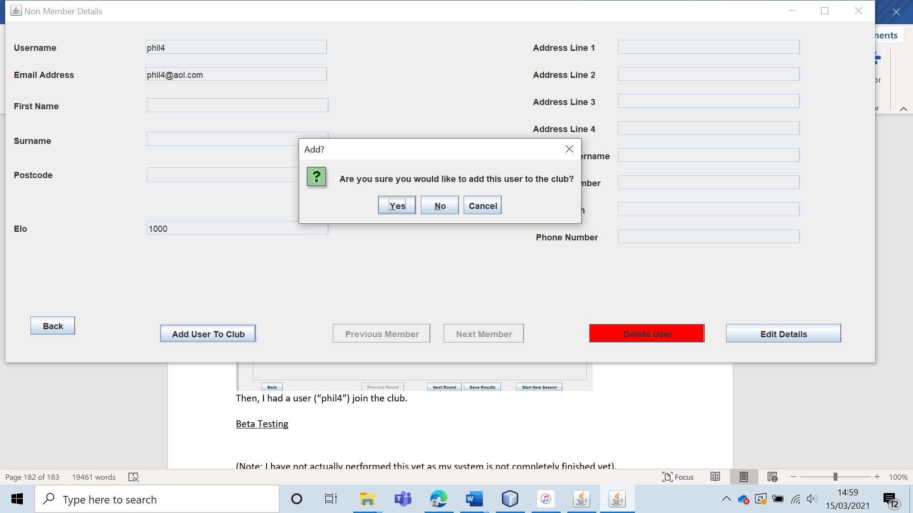

The user was added to the club; however they were not added to any of the fixtures.

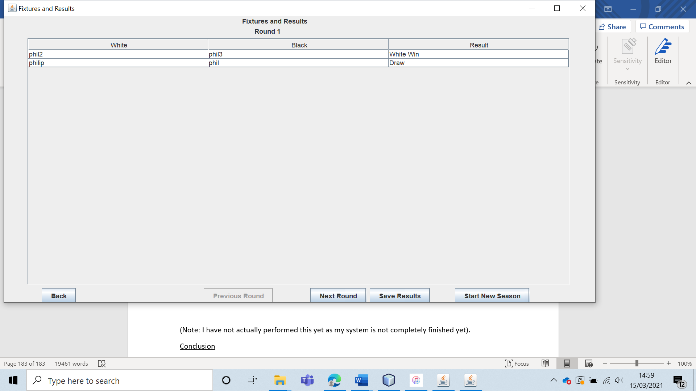

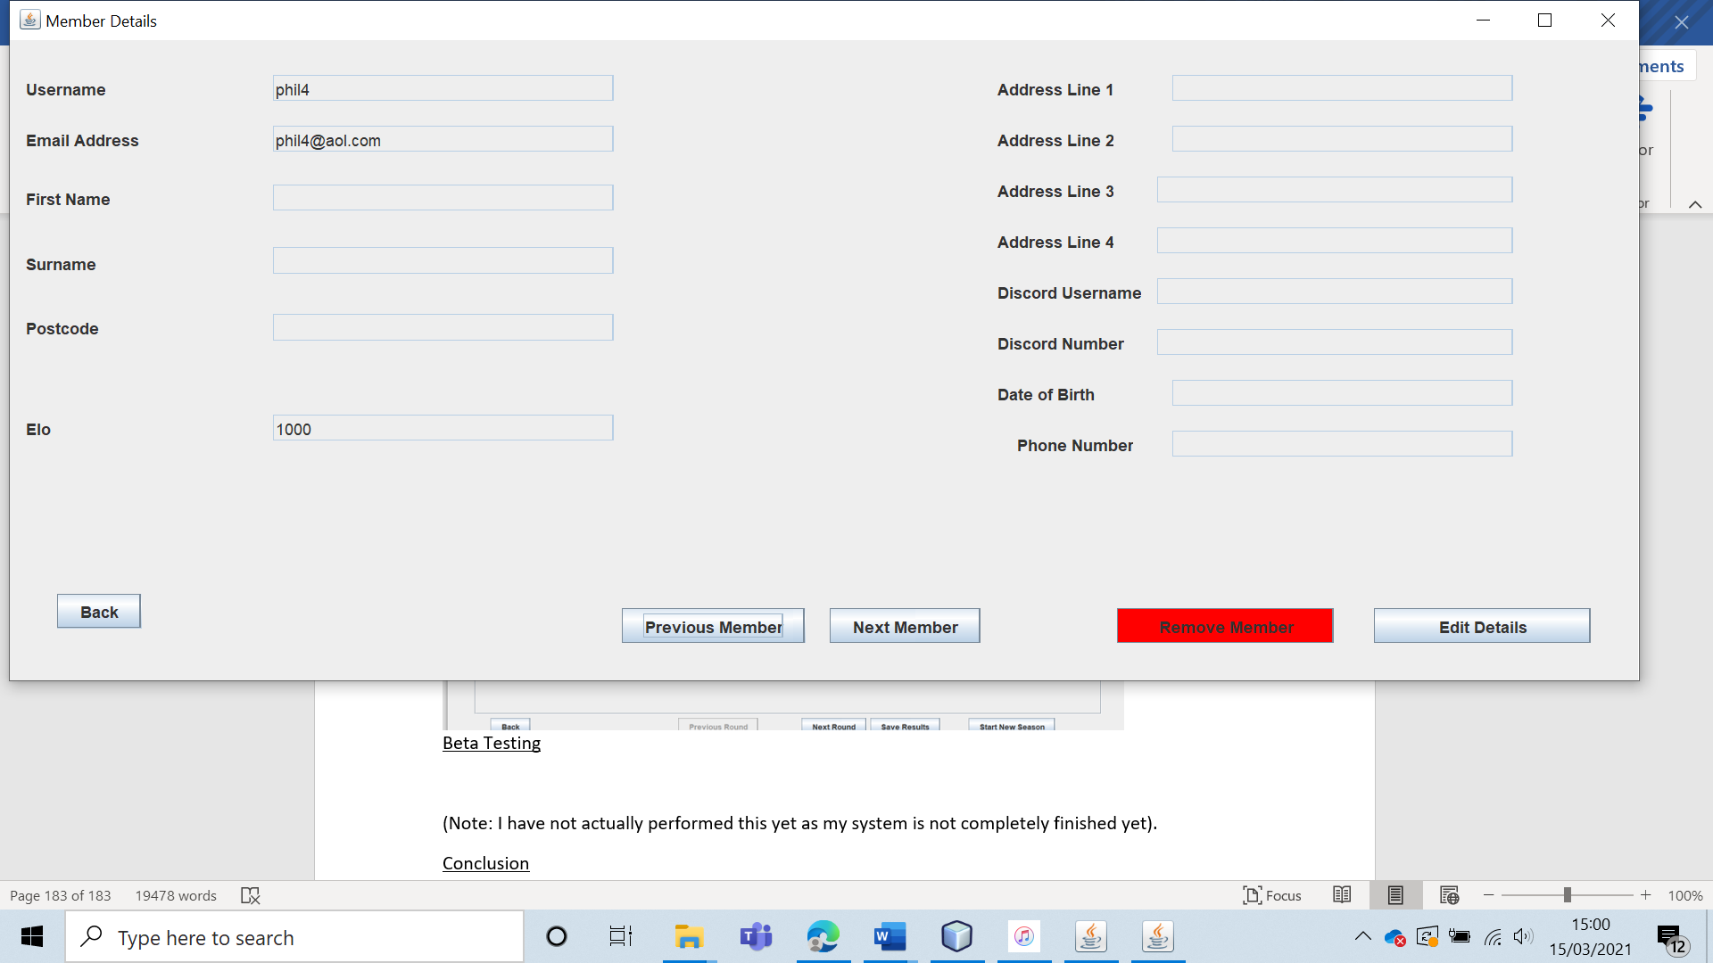

|  |  |  |  |  |  |  |
| --- | --- | --- | --- | --- | --- | --- |
| 50 | Have a user join the club before any of the games have actually been played. | To ensure that the fixture generation algorithm works. |  | The fixtures should be generated from scratch and include the user who has joined the club. | 9, 9a and 9ai. | The fixtures were generated from scratch and included the member who had just joined. |

Test 50

To do this, I had four members in the club initially, with no games having been played.

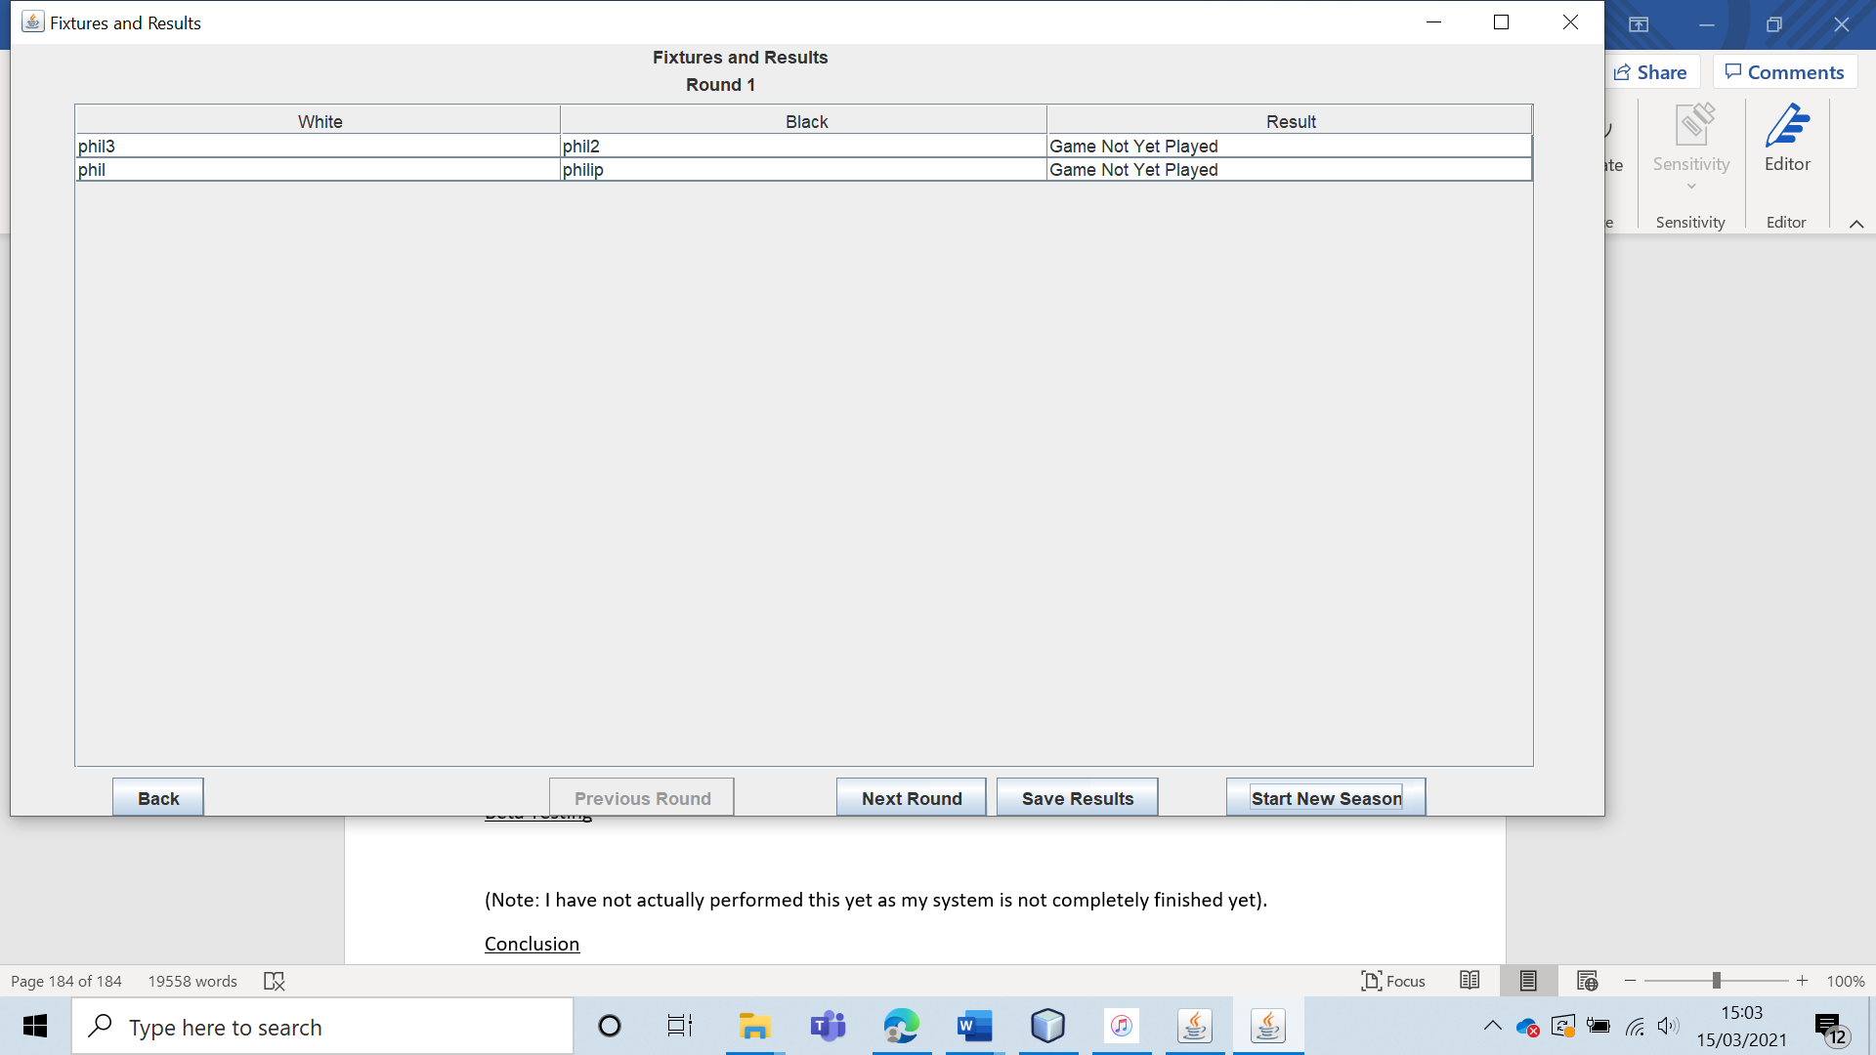

Then “phil4” joined the club.

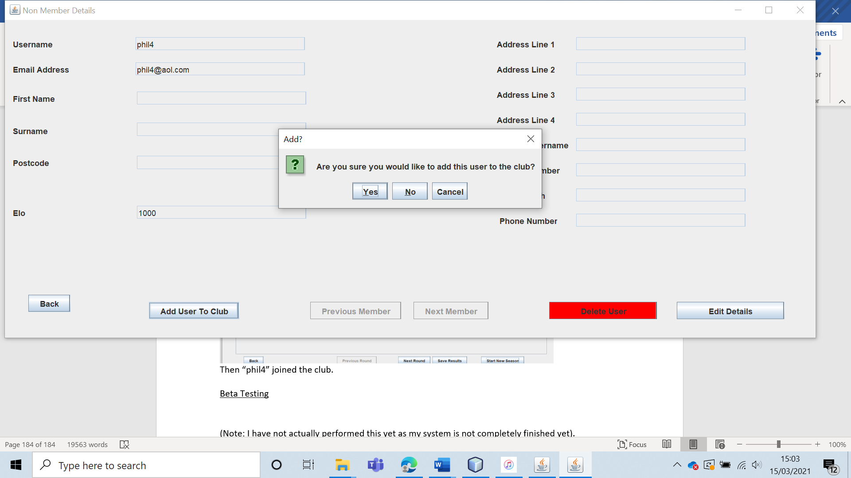

The system did in fact then generate the fixtures again from scratch, so that the now included “phil4”.

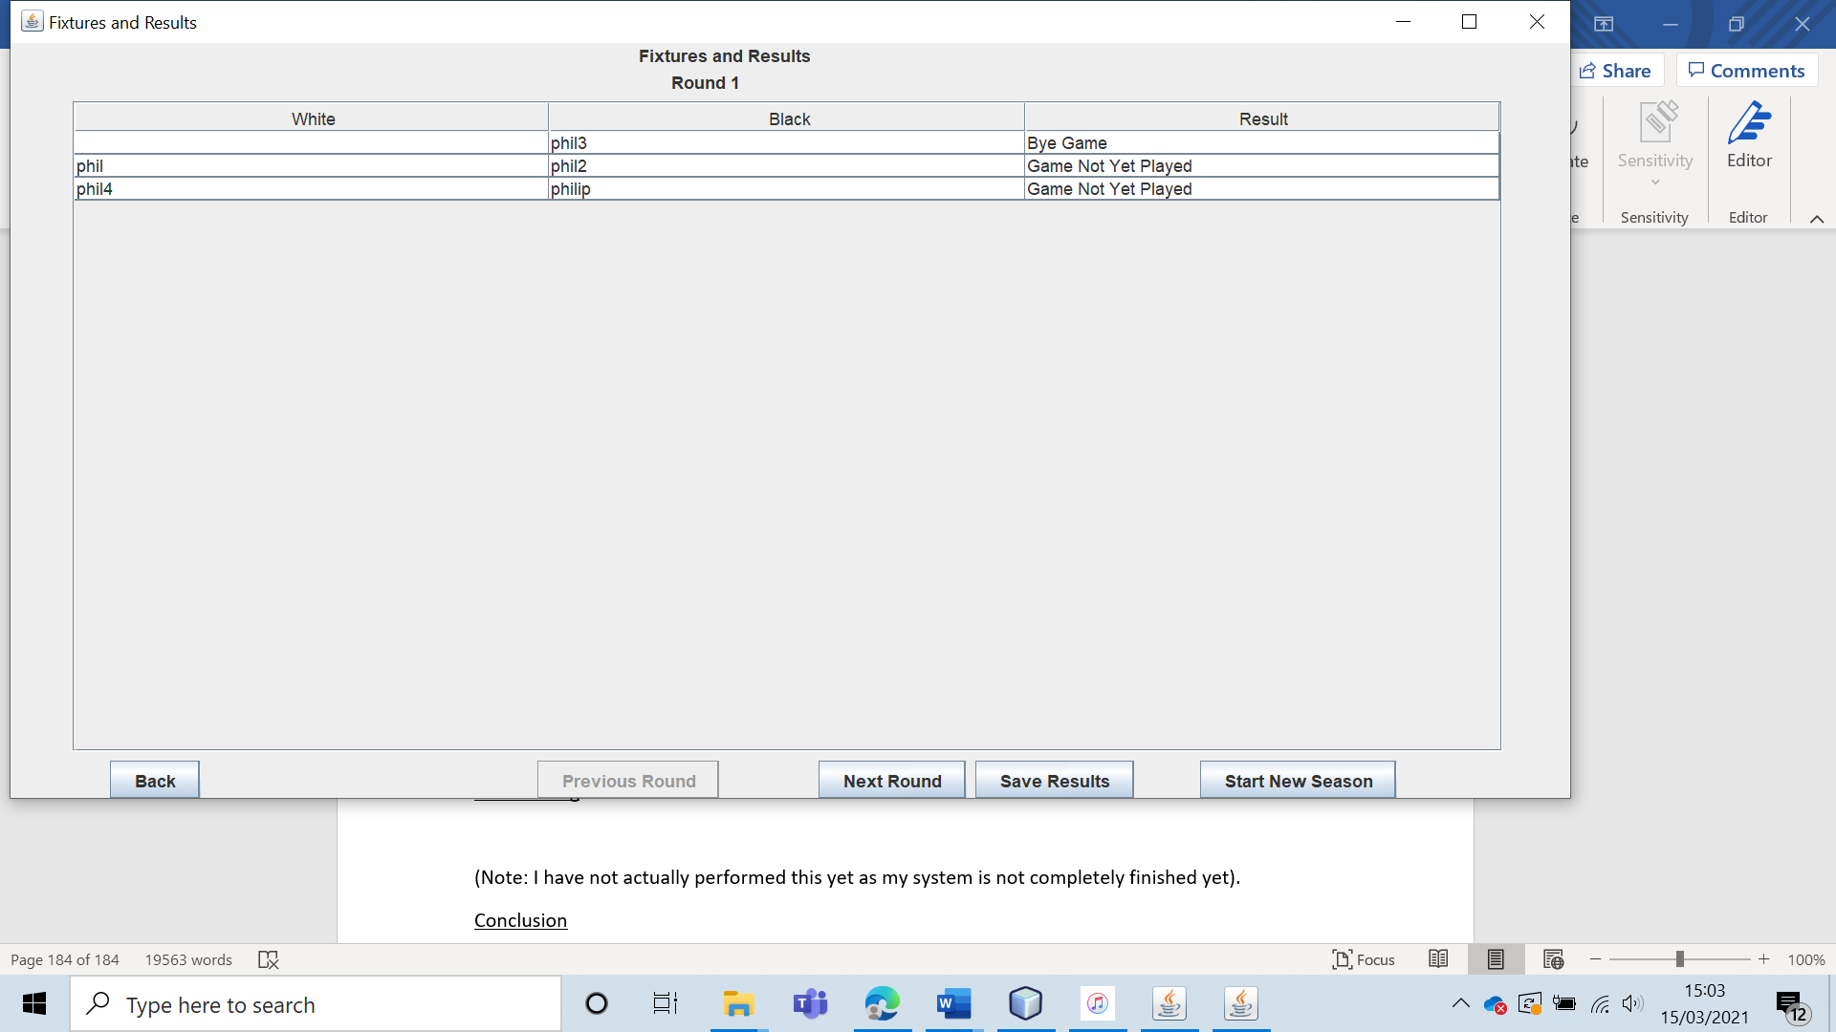

|  |  |  |  |  |  |  |
| --- | --- | --- | --- | --- | --- | --- |
| 51 | Have the leader select the game result for games. Verify this for each of the possible game states: white win, black win, draw, game not yet played and bye game. | To ensure that results generation and league table generation work. |  | The result should be saved, and the league table should be updated to reflect this. | 9b, 9bi, 9c and 9ci. | The results were stored, and the league table was updated to match the results. |

Test 51

To test this, I generated a new season with just two members.

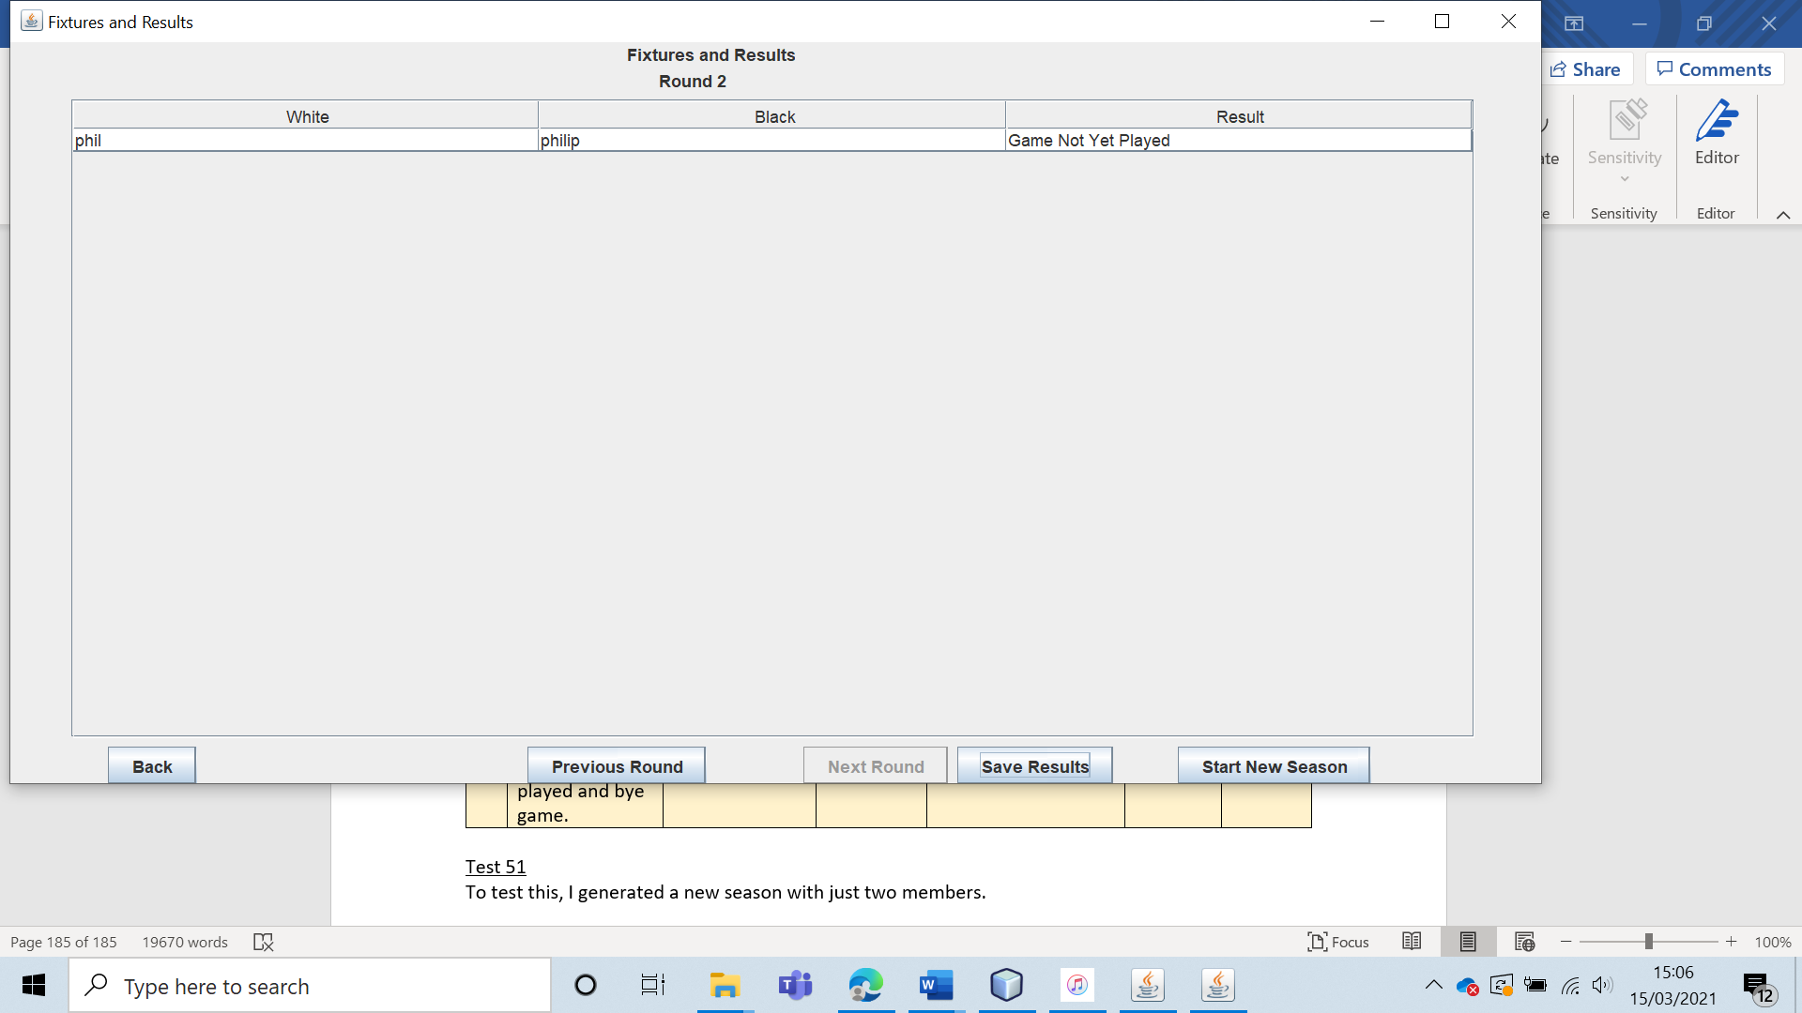

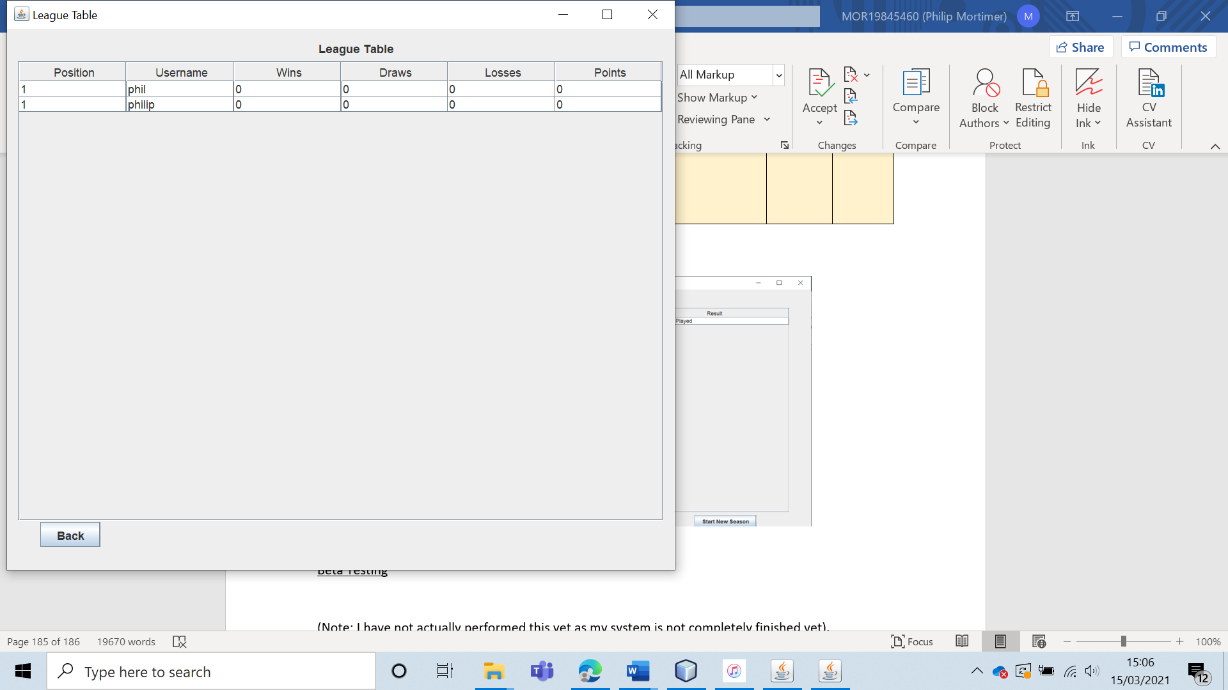

I then entered every possible combination of games to see whether the league table and fixture list was updated accordingly. (I have not included screenshots as 75 photos is too many when the results can be presented in a simple table).

|  |  |  |
| --- | --- | --- |
| Game 1 State | Game 2 State | Table and Fixture List Correctly Updated (Yes / No) |
| White Win | Black Win | Yes |
| White Win | Draw | Yes |
| White Win | Game Not Yet Played | Yes |
| White Win | Bye Game | Yes |
| White Win | White Win | Yes |
| Black Win | Black Win | Yes |
| Black Win | Draw | Yes |
| Black Win | Game Not Yet Played | Yes |
| Black Win | Bye Game | Yes |
| Black Win | White Win | Yes |
| Draw | Black Win | Yes |
| Draw | Draw | Yes |
| Draw | Game Not Yet Played | Yes |
| Draw | Bye Game | Yes |
| Draw | White Win | Yes |
| Game Not Yet Played | Black Win | Yes |
| Game Not Yet Played | Draw | Yes |
| Game Not Yet Played | Game Not Yet Played | Yes |
| Game Not Yet Played | Bye Game | Yes |
| Game Not Yet Played | White Win | Yes |
| Bye Game | Black Win | Yes |
| Bye Game | Draw | Yes |
| Bye Game | Game Not Yet Played | Yes |
| Bye Game | Bye Game | Yes |
| Bye Game | White Win | Yes |

From this page, we can see that the system works flawlessly for two members. I also tested it with four members, although I did not try every single possible combination. I was unable to find any errors in this instance either. Both the editing of the results, and the updating of the league table worked as expected. Therefore, I conclude that both the saving of game results and the league table generation function.

|  |  |  |  |  |  |  |
| --- | --- | --- | --- | --- | --- | --- |
| 52 | Have the leader try to change the results of a bye game. | To ensure results generation works. |  | The result should not be editable as the result of bye games is not editable. | 9b, 9bi, 9c and 9ci. | The leader was unable to edit all non-bye games, but was unable to edit the result of any bye game. |

Test 52

I logged in as the leader and attempted to change the results of a bye game. I was able to edit the results of a normal game:

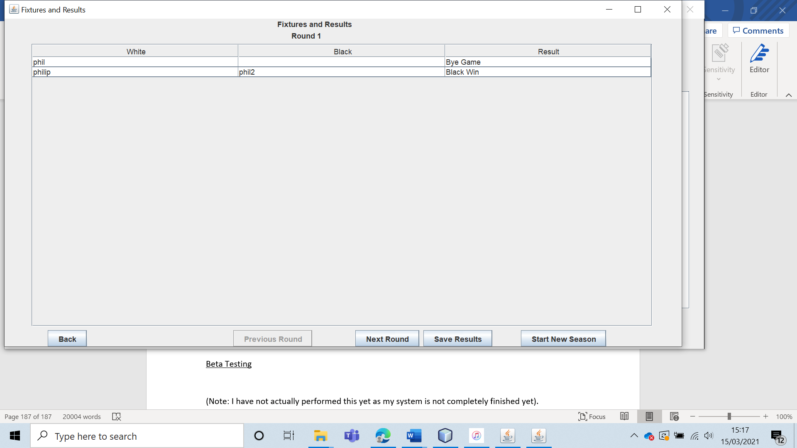

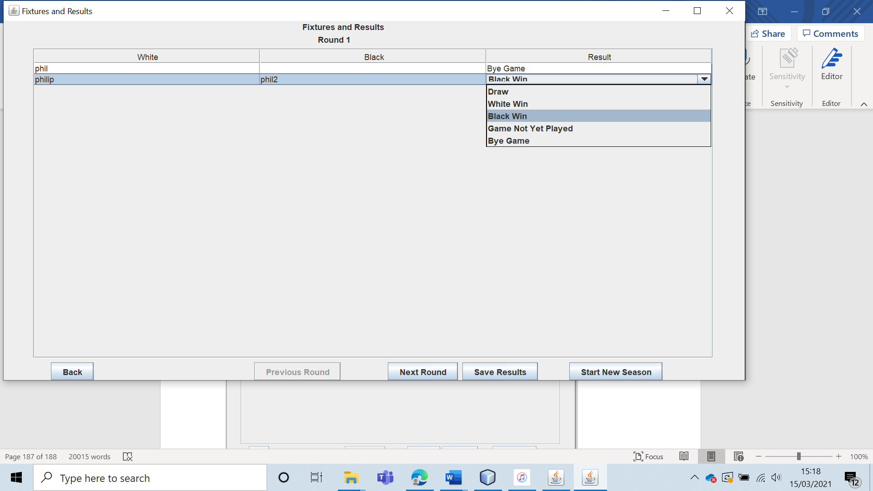

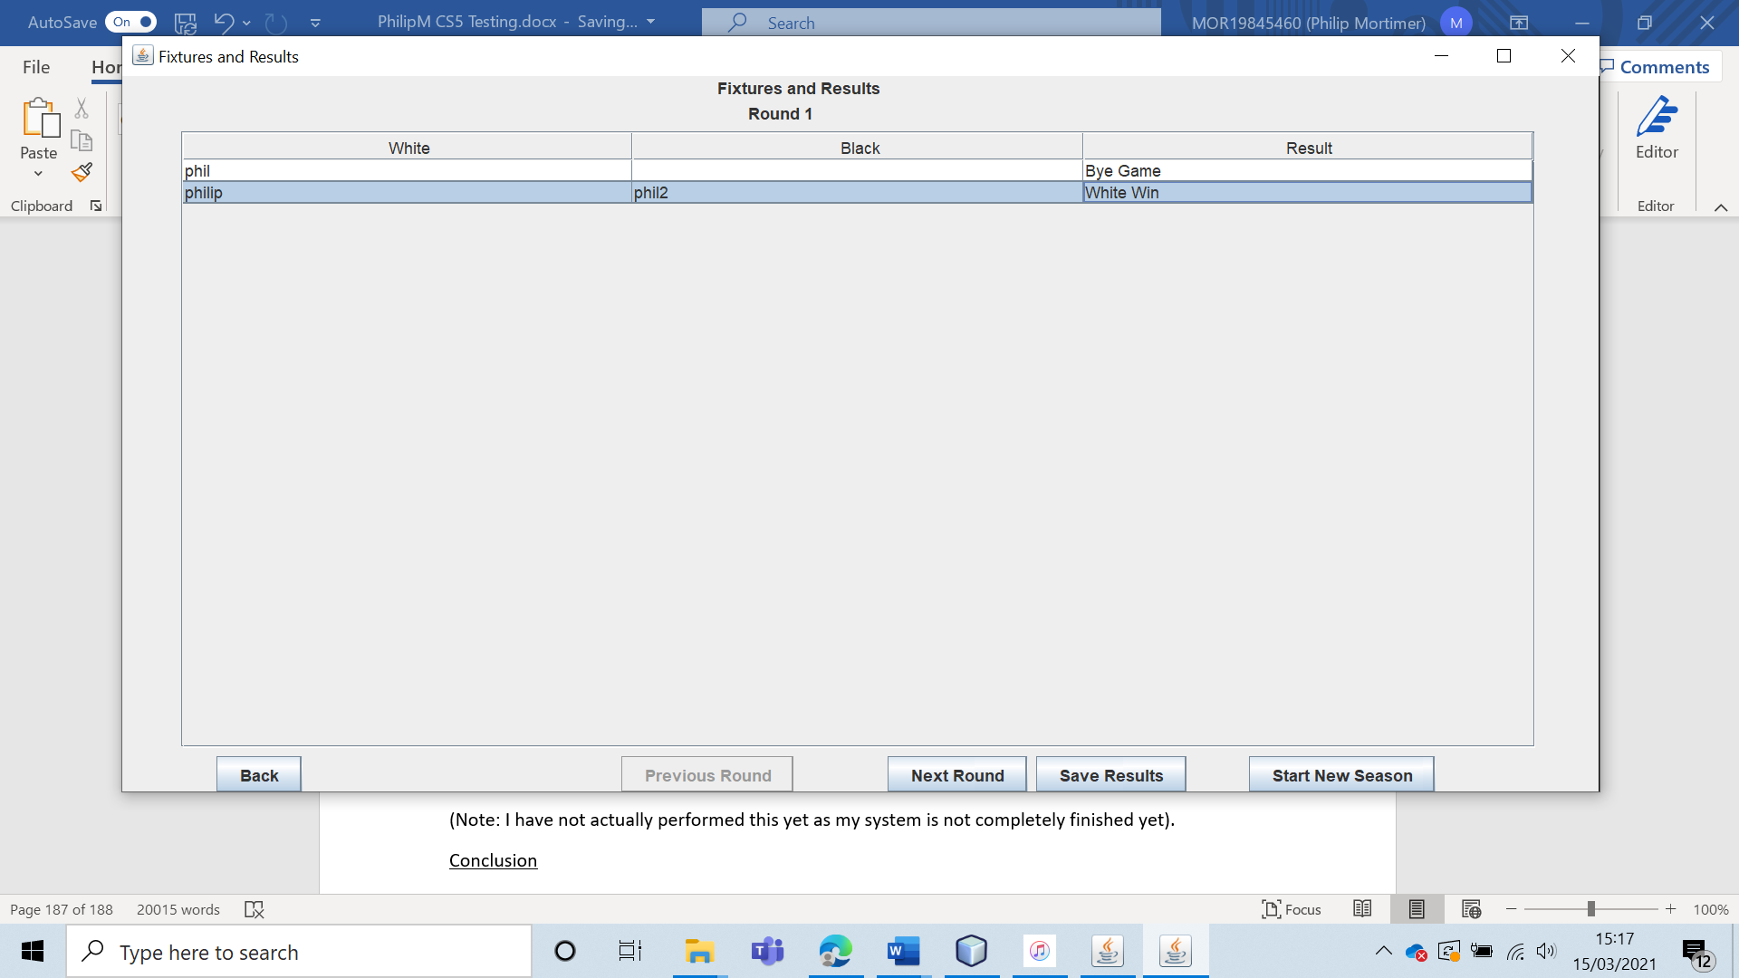

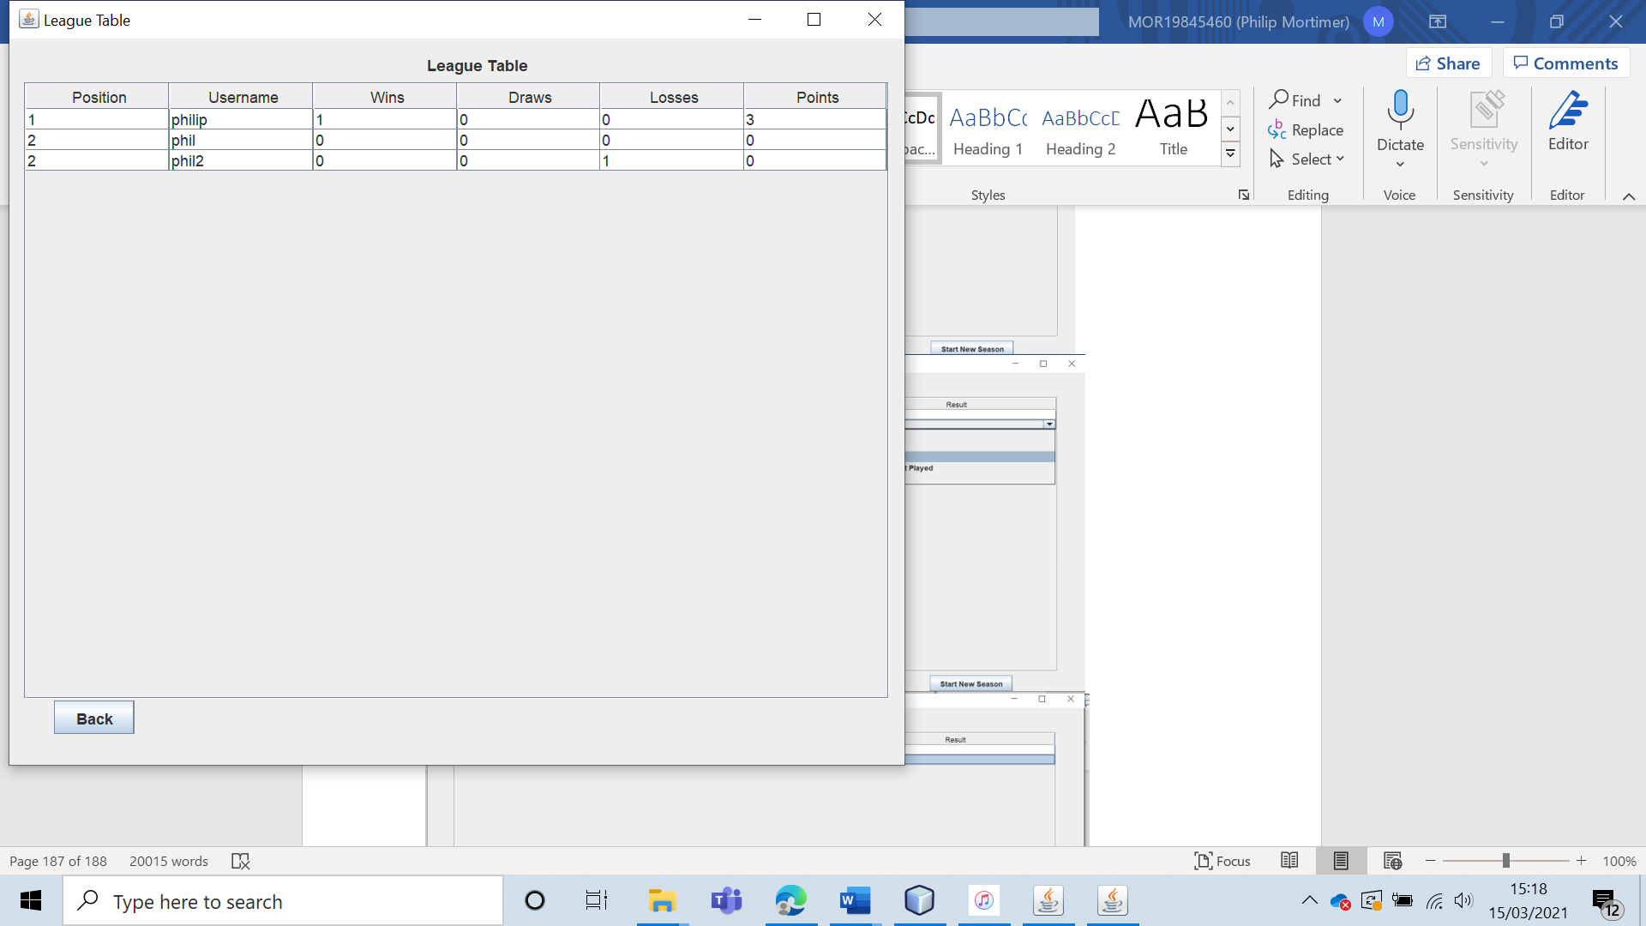

However, when attempting to replicate this with a game marked as “Bye Game”, the editor never appeared, and I was unable to alter the result. This confirms that bye games can not have their results altered.

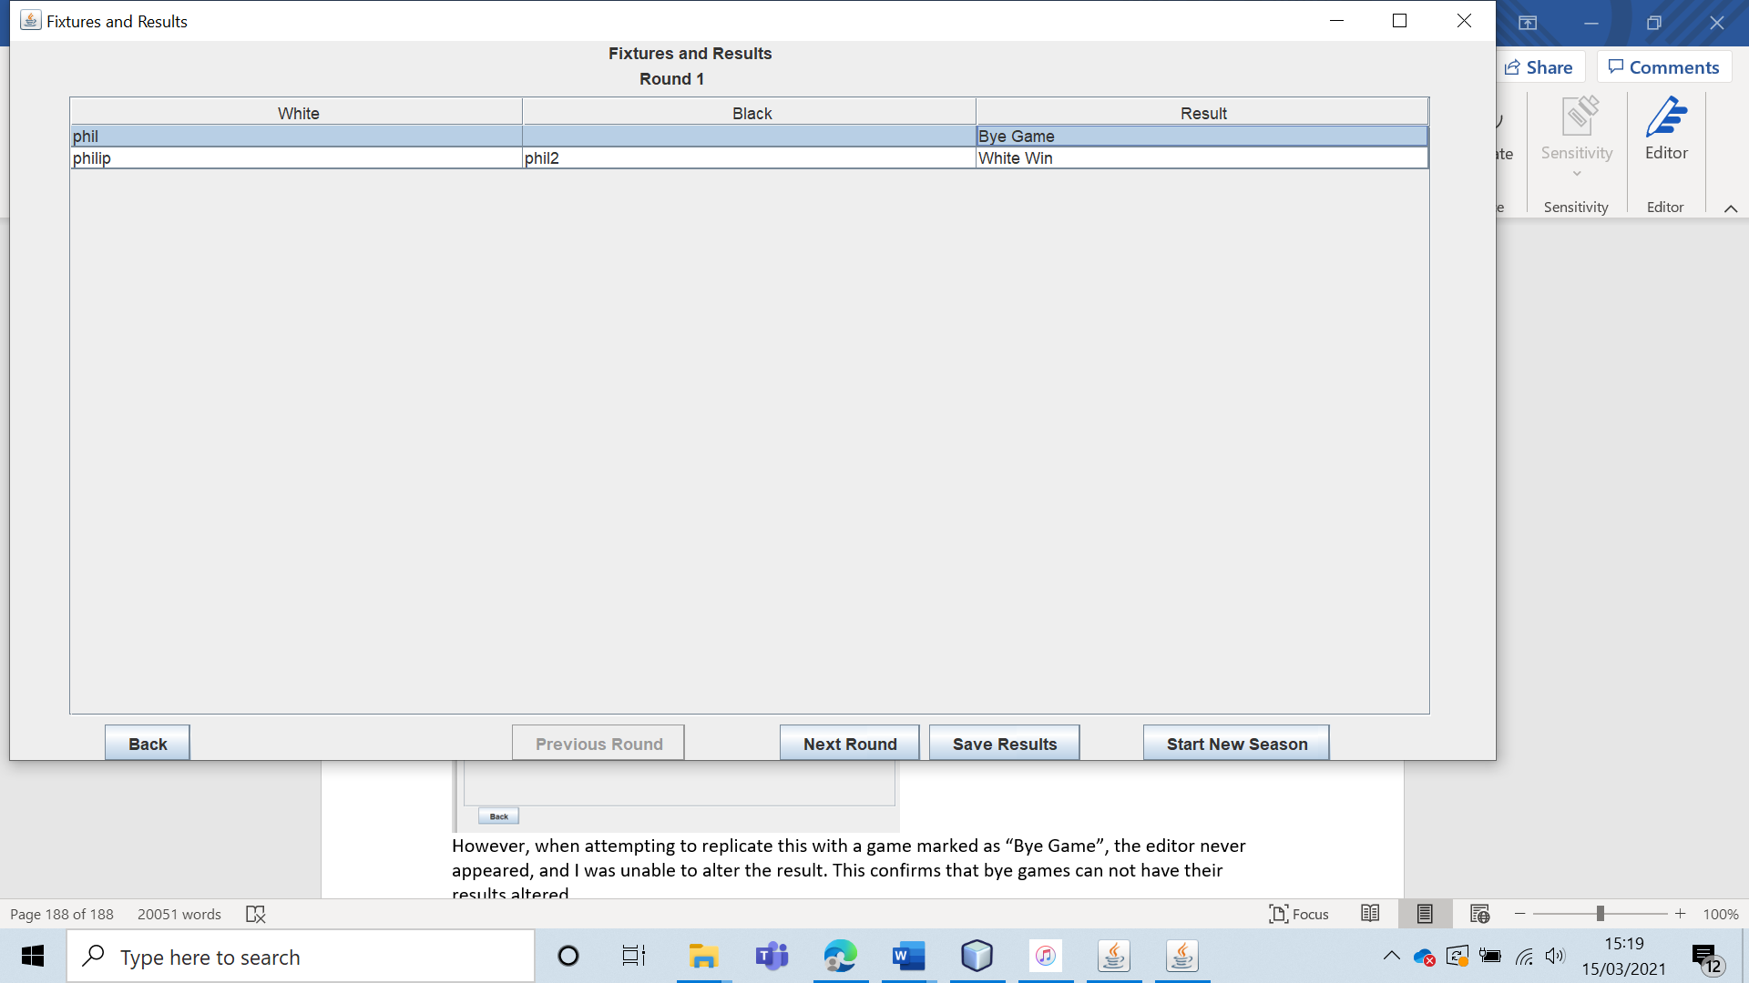

|  |  |  |  |  |  |  |
| --- | --- | --- | --- | --- | --- | --- |
| 53 | Ensure that non-leader members can view the fixtures and results but cannot edit them. | To ensure that members can view the club’s fixtures and results. |  | The users should be able to view the results and fixtures. However, they should not be able to edit them in any way. | 9b and 9bi. | The non-leader member was able to view the correct league table and fixtures / results list. However, they were unable able to edit the fixtures /results. |

Test 53

I logged in to a non-leader, member account (“phil”). I was able to view both the league table and fixtures.

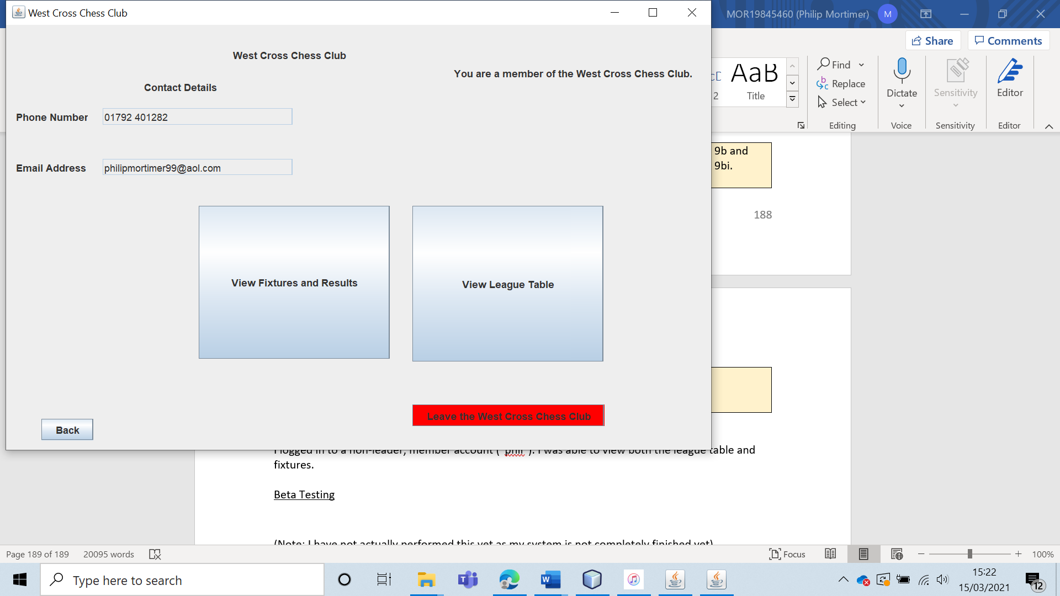

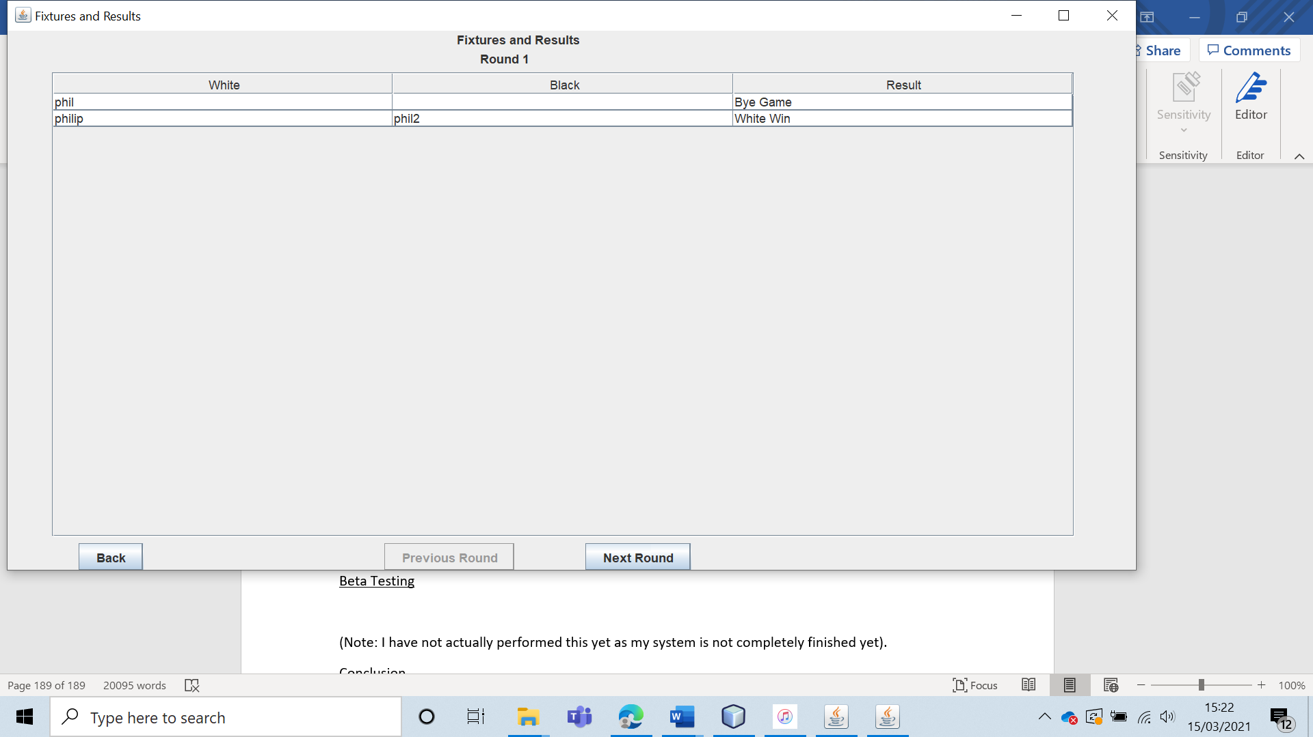

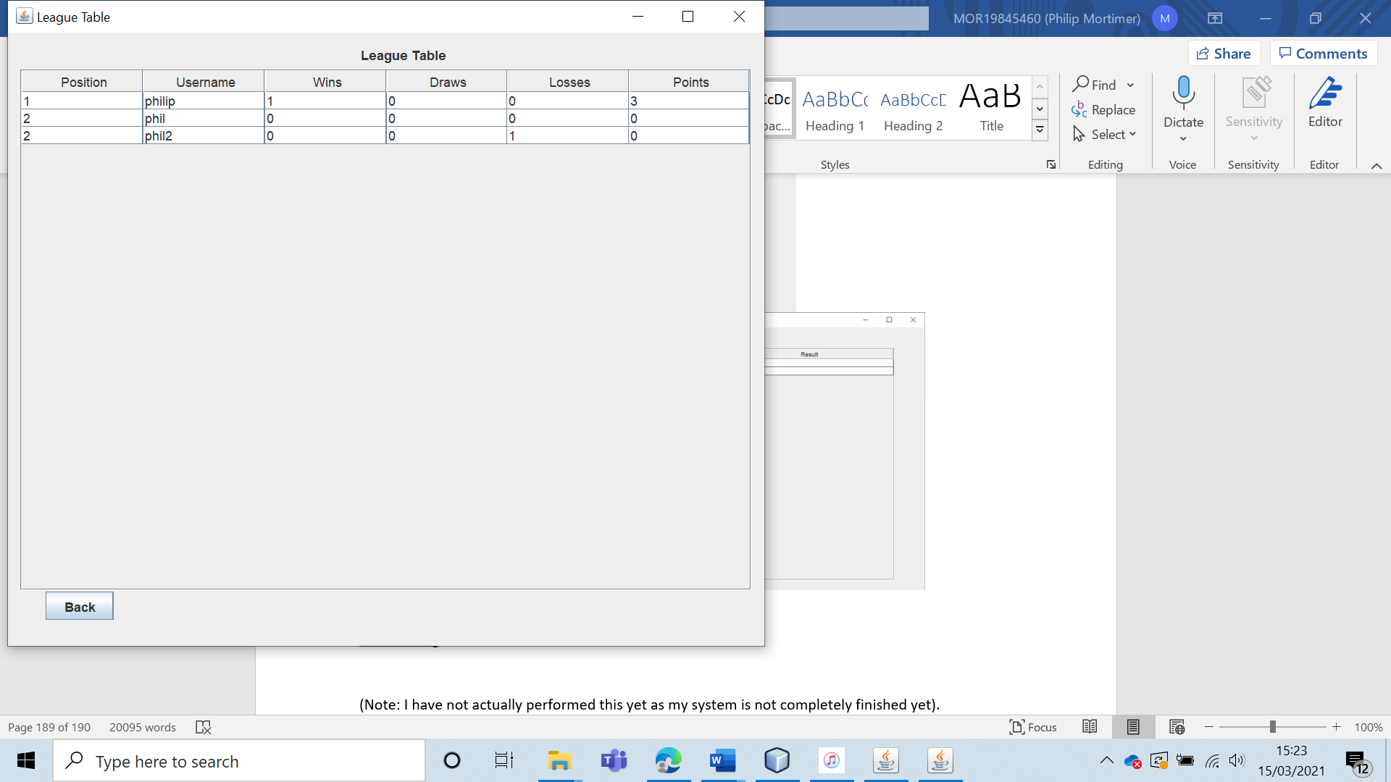

However, I was unable to alter the values of any of the results.

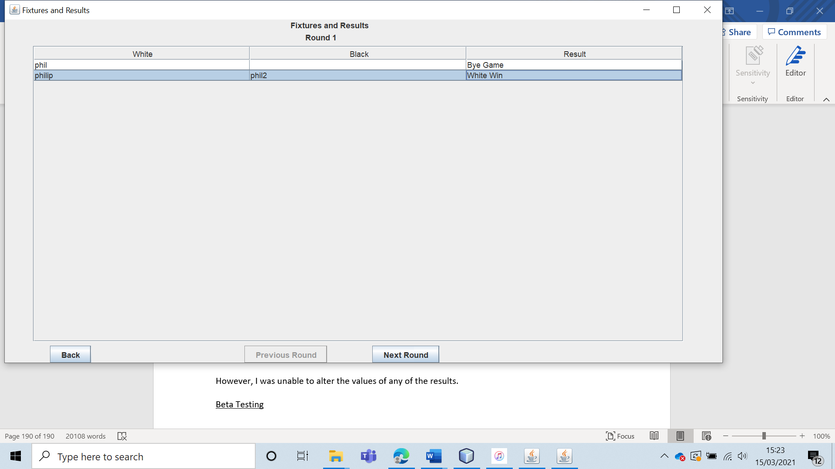

|  |  |  |  |  |  |  |
| --- | --- | --- | --- | --- | --- | --- |
| 54 | Get the current club leader to transfer the leadership to another existing non-member user. | To ensure that the leadership can be transferred to any user. |  | The leadership should be transferred to the chosen user. They should have access to all club leader features. | 11, 11a and 11ai. | The leadership is successfully transferred to the non-club member. |

Test 54

For this test run, I will have the current leader “philip” assign the leadership to a current non-member user (“phil”).

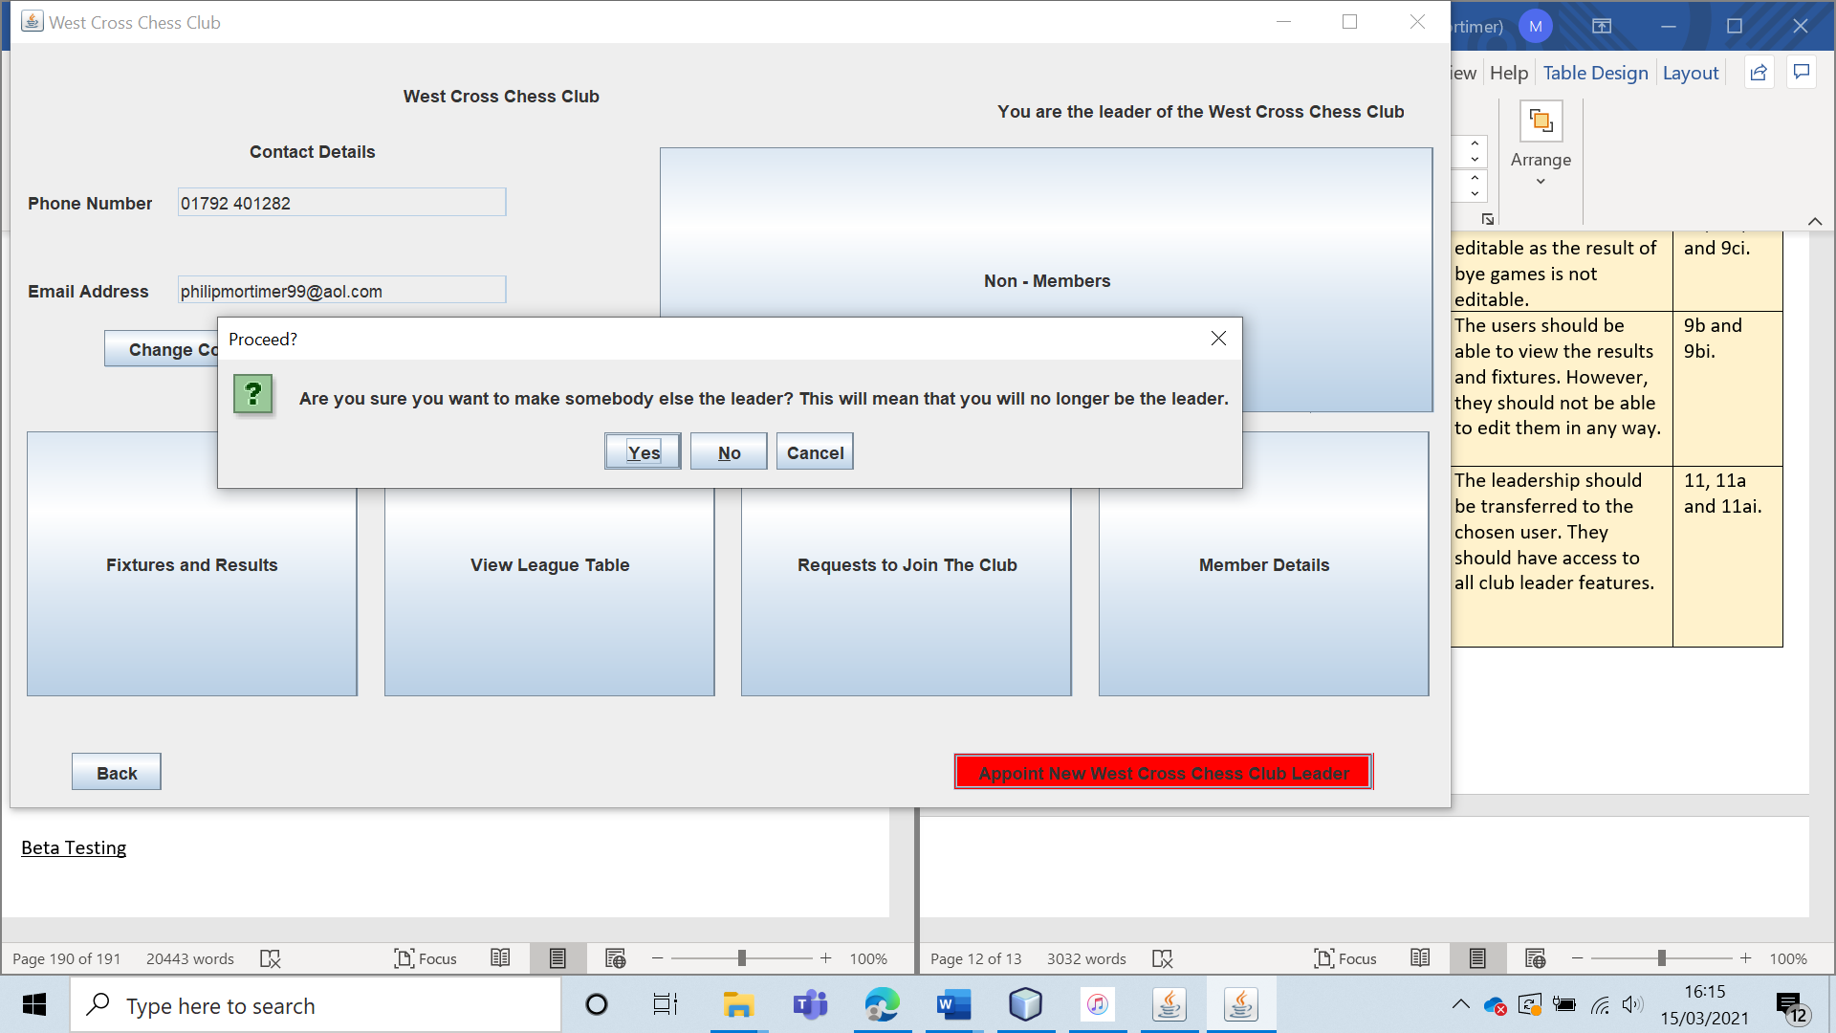

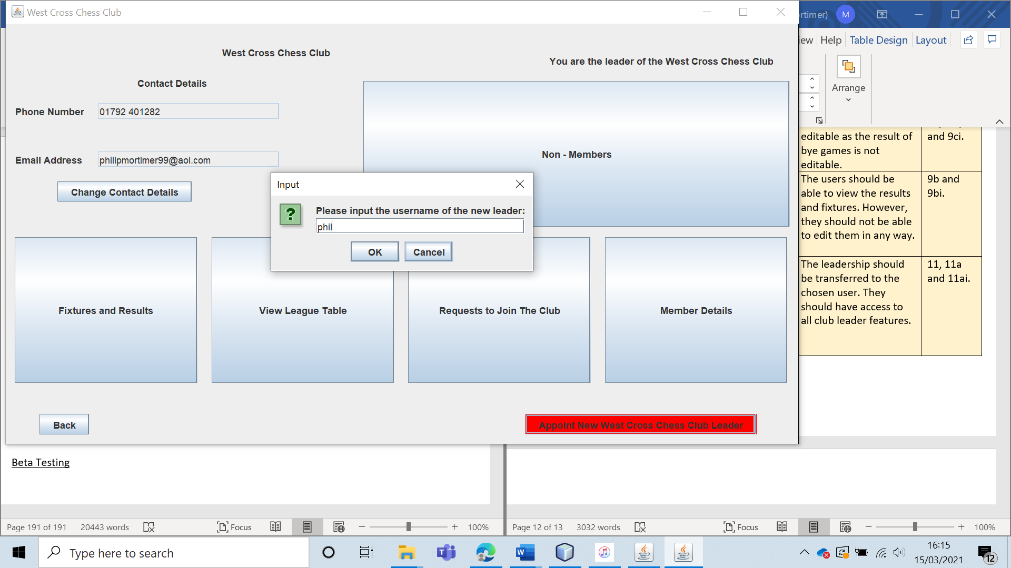

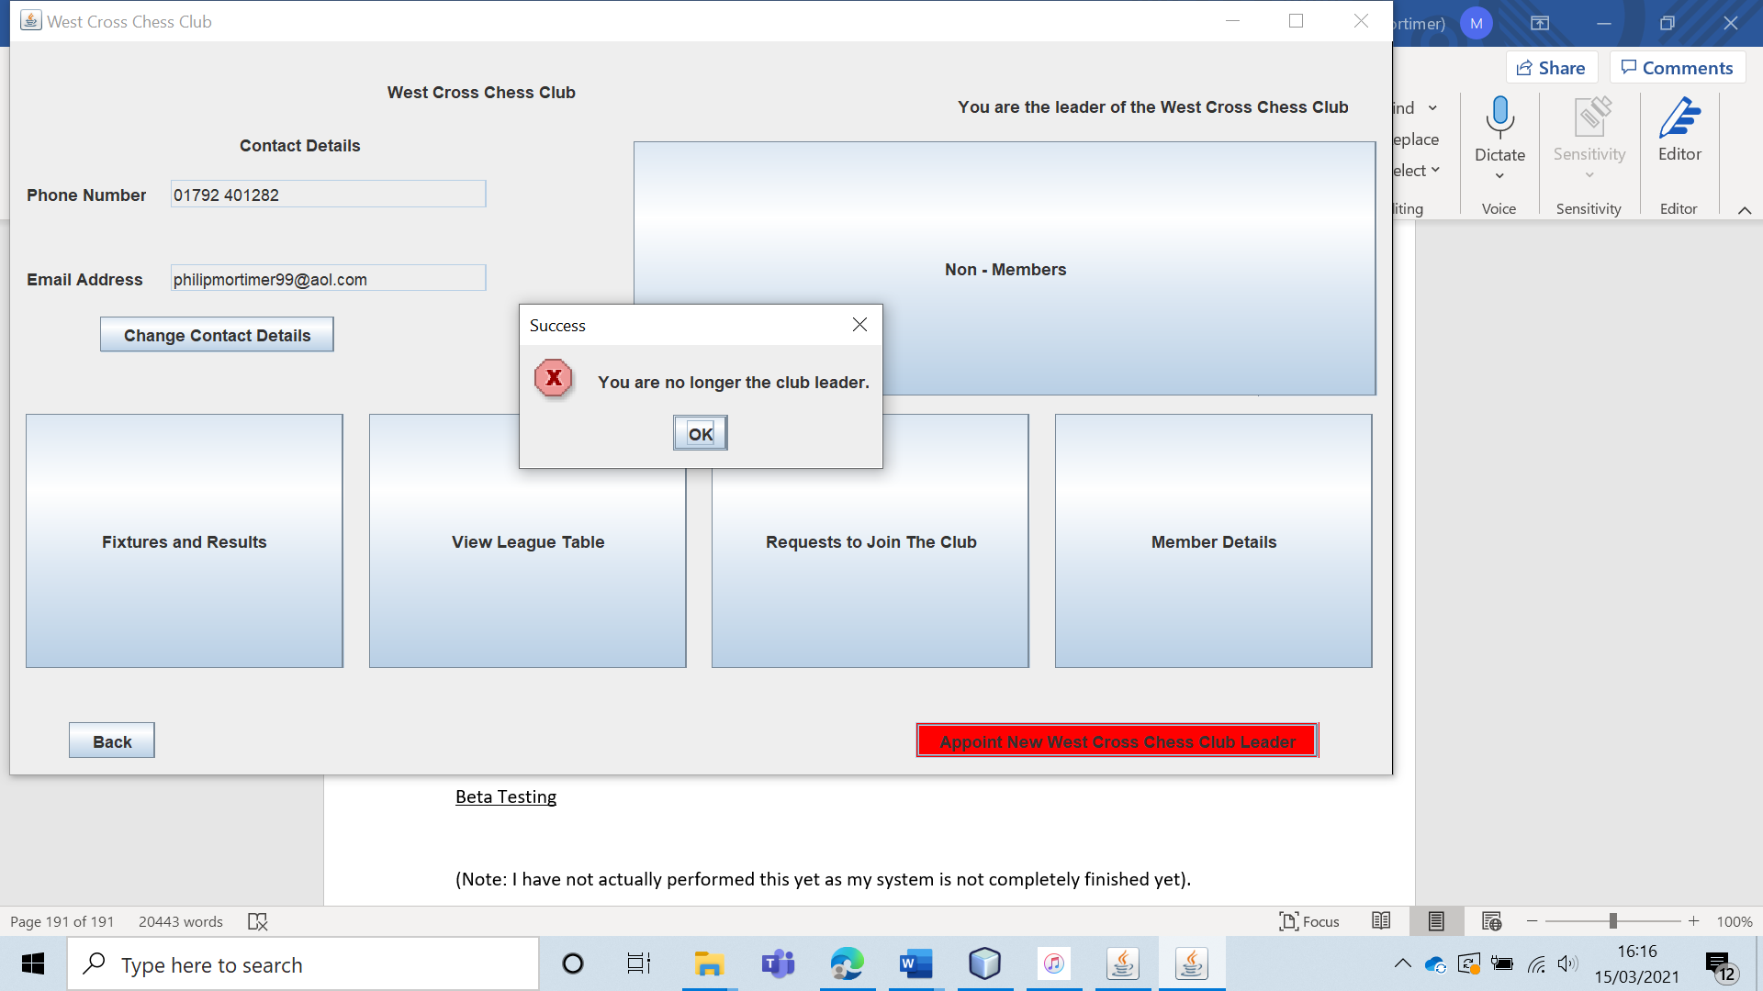

The system displays that “philip” is no longer the club leader. The former leader now only has access to features that a club member would have access to.

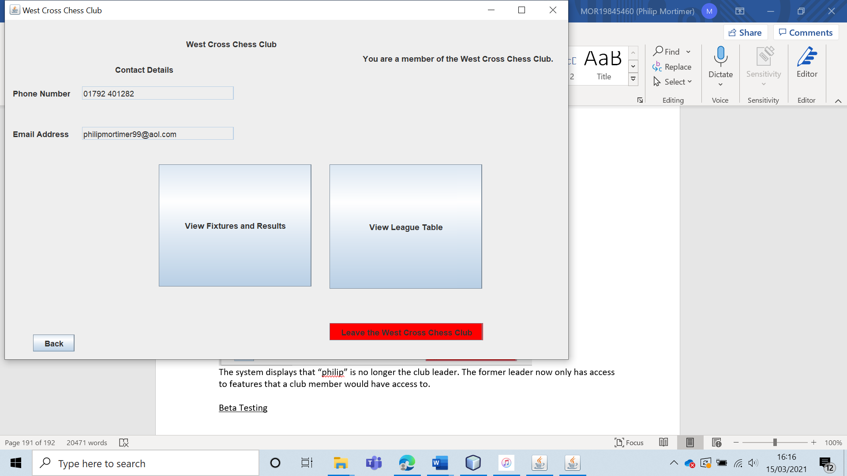

Meanwhile, “phil” now has access to all features that the club leader does.

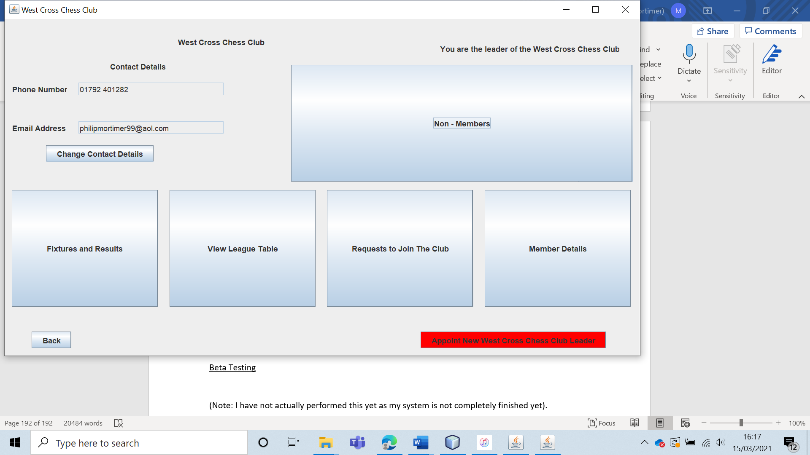

Hence, the system has correctly transferred the leadership from one user to another.

|  |  |  |  |  |  |  |
| --- | --- | --- | --- | --- | --- | --- |
| 55 | Get the current club leader to transfer the leadership to another existing member user. | To ensure that the leadership can be transferred to any user. |  | The leadership should be transferred to the chosen user. They should have access to all club leader features. | 11, 11a and 11ai. | The club leadership is successfully transferred. |

Test 55

To do this, I transferred the leadership from the current club leader “philip” to “phil”, who is currently only a club member.

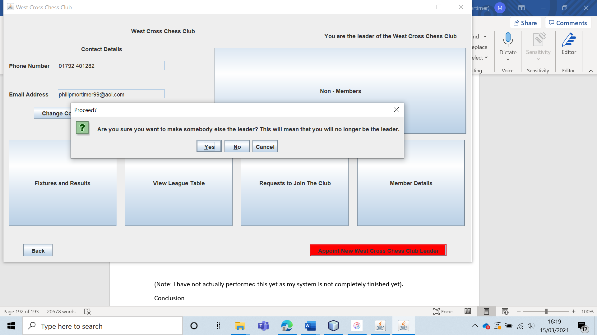

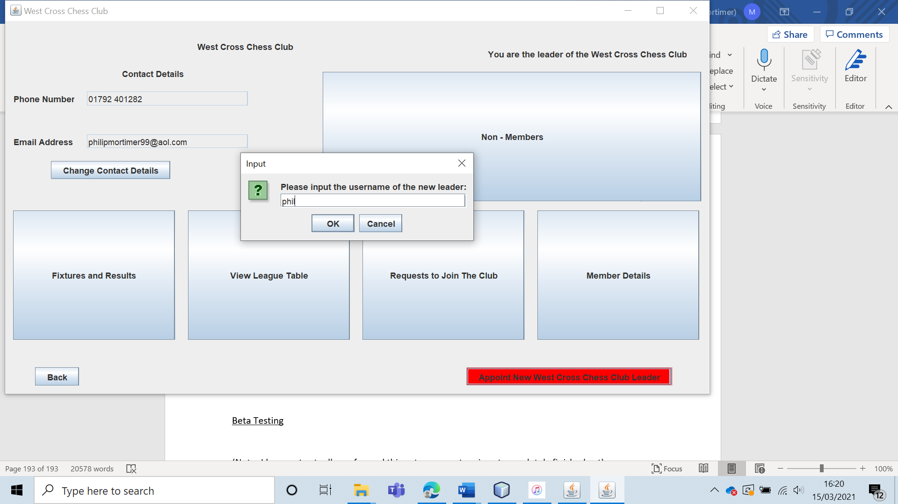

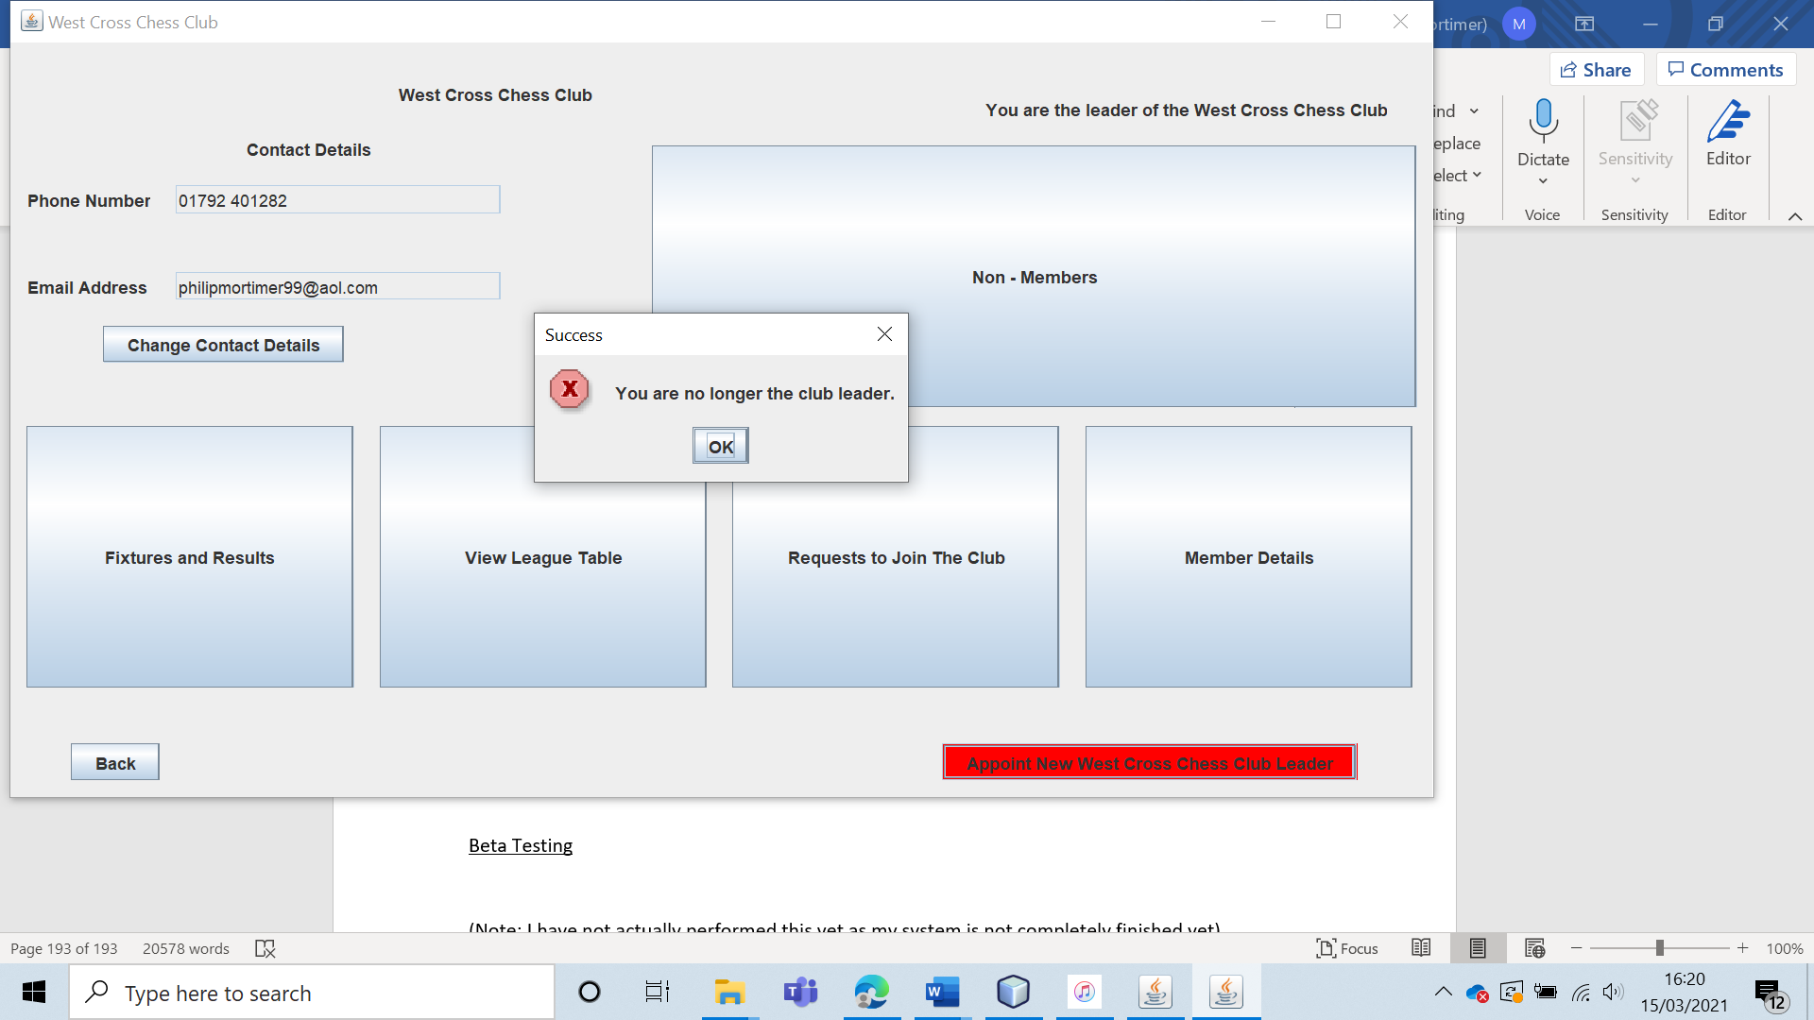

The leadership is successfully transferred. “philip” is now only able access features for club members who are not the leader.

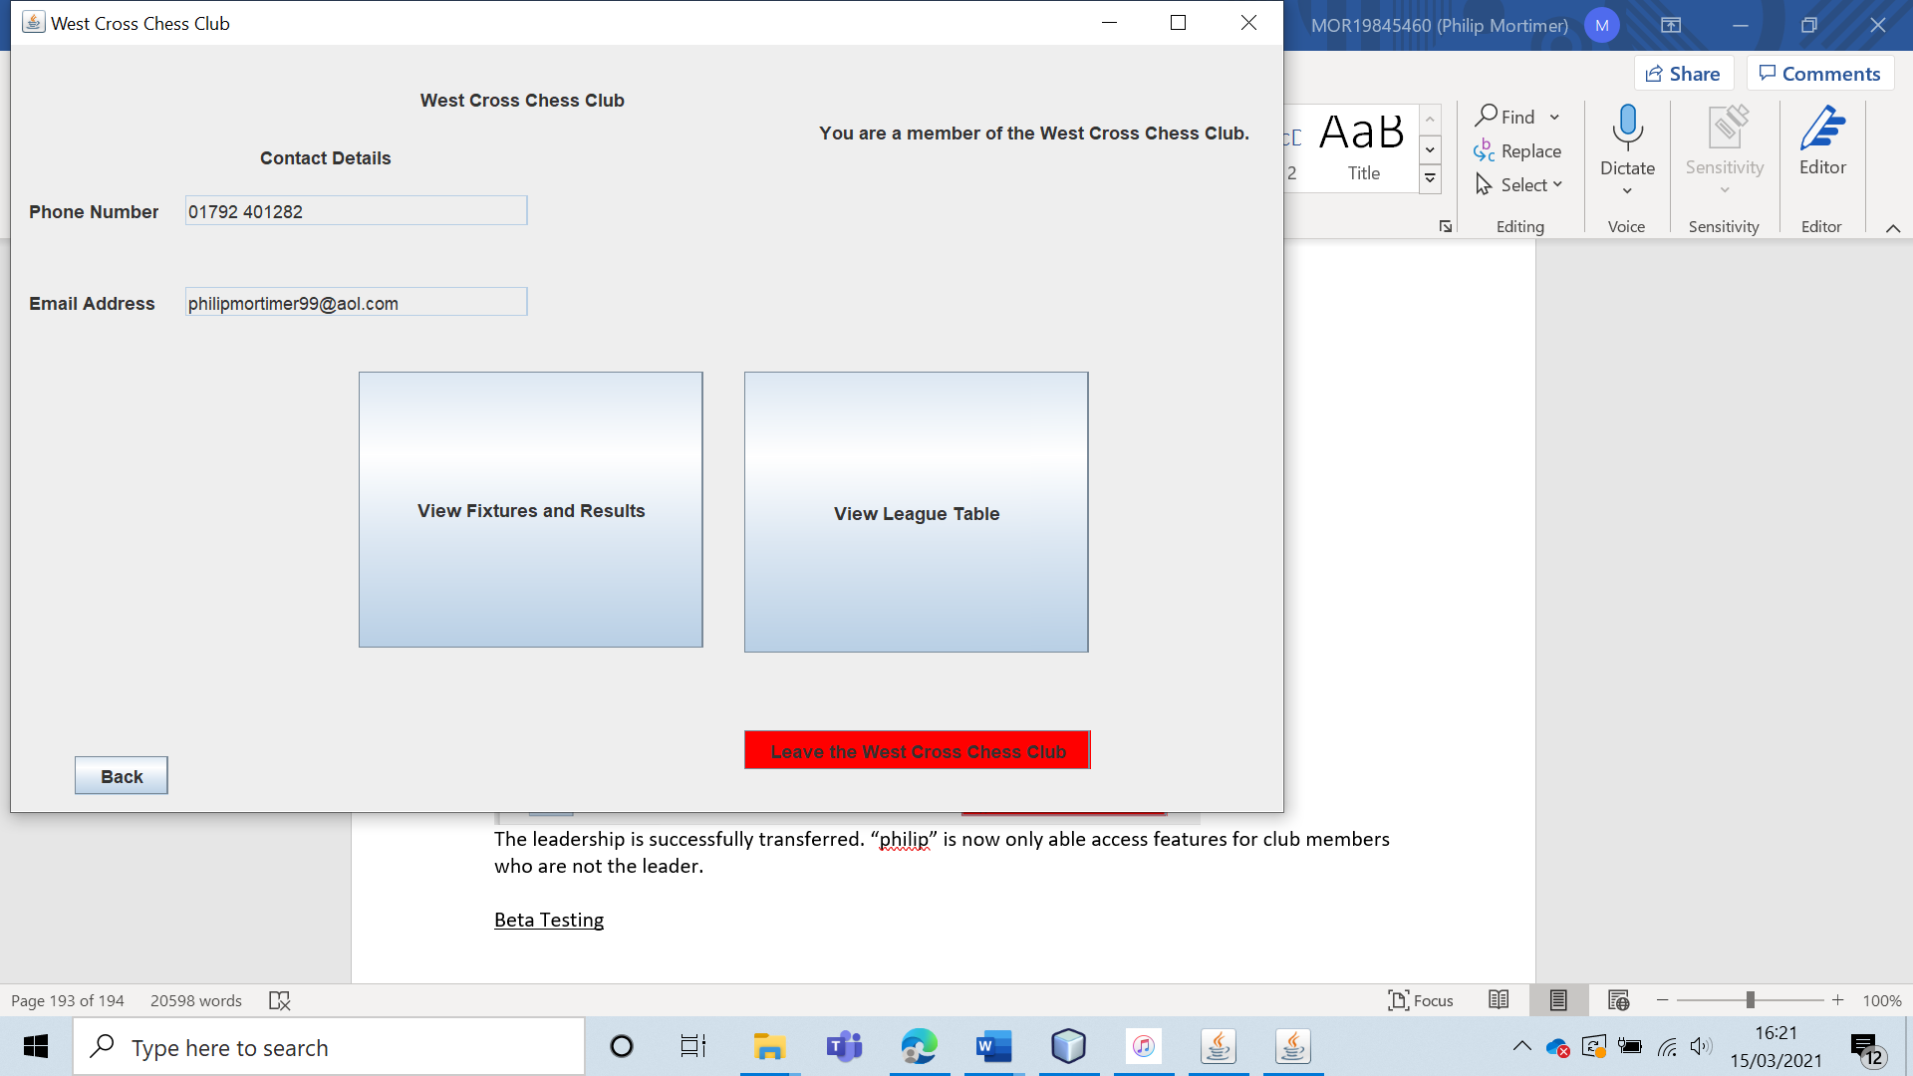

Meanwhile, “phil” is able to access all features intended for the chess club leader. This shows that the transfer of club leadership has worked.

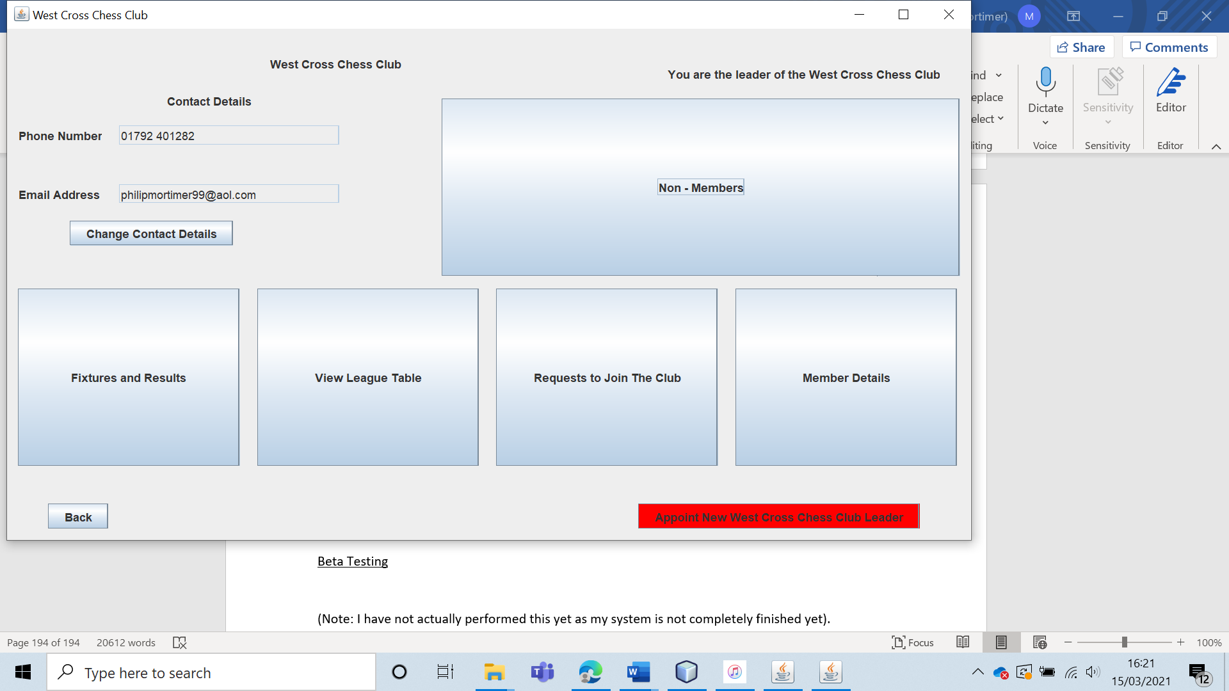

|  |  |  |  |  |  |  |
| --- | --- | --- | --- | --- | --- | --- |
| 56 | Get the current club leader to attempt to transfer the leadership to a user that does not exist. | To ensure that the leadership can only be held valid users. |  | The leadership should not be transferred, and the system should tell the user that the user inputted does not exist. | 11, 11a and 11ai. | The leadership is not transferred and the system tells the user that a valid username must be selected. |

Test 56

To do this, I will attempt to transfer the leadership from the current leader “philip” to the “userThatDoesNotExist”. (“userThatDoesNotExist” is not a real user).

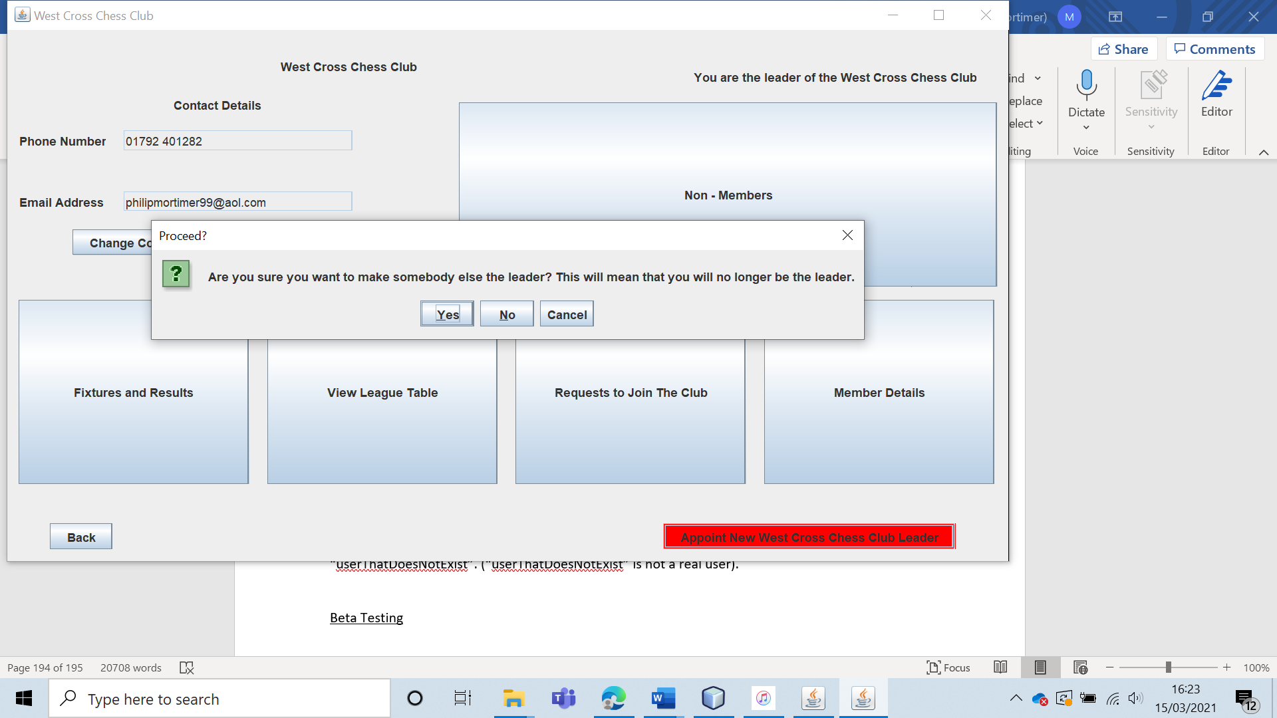

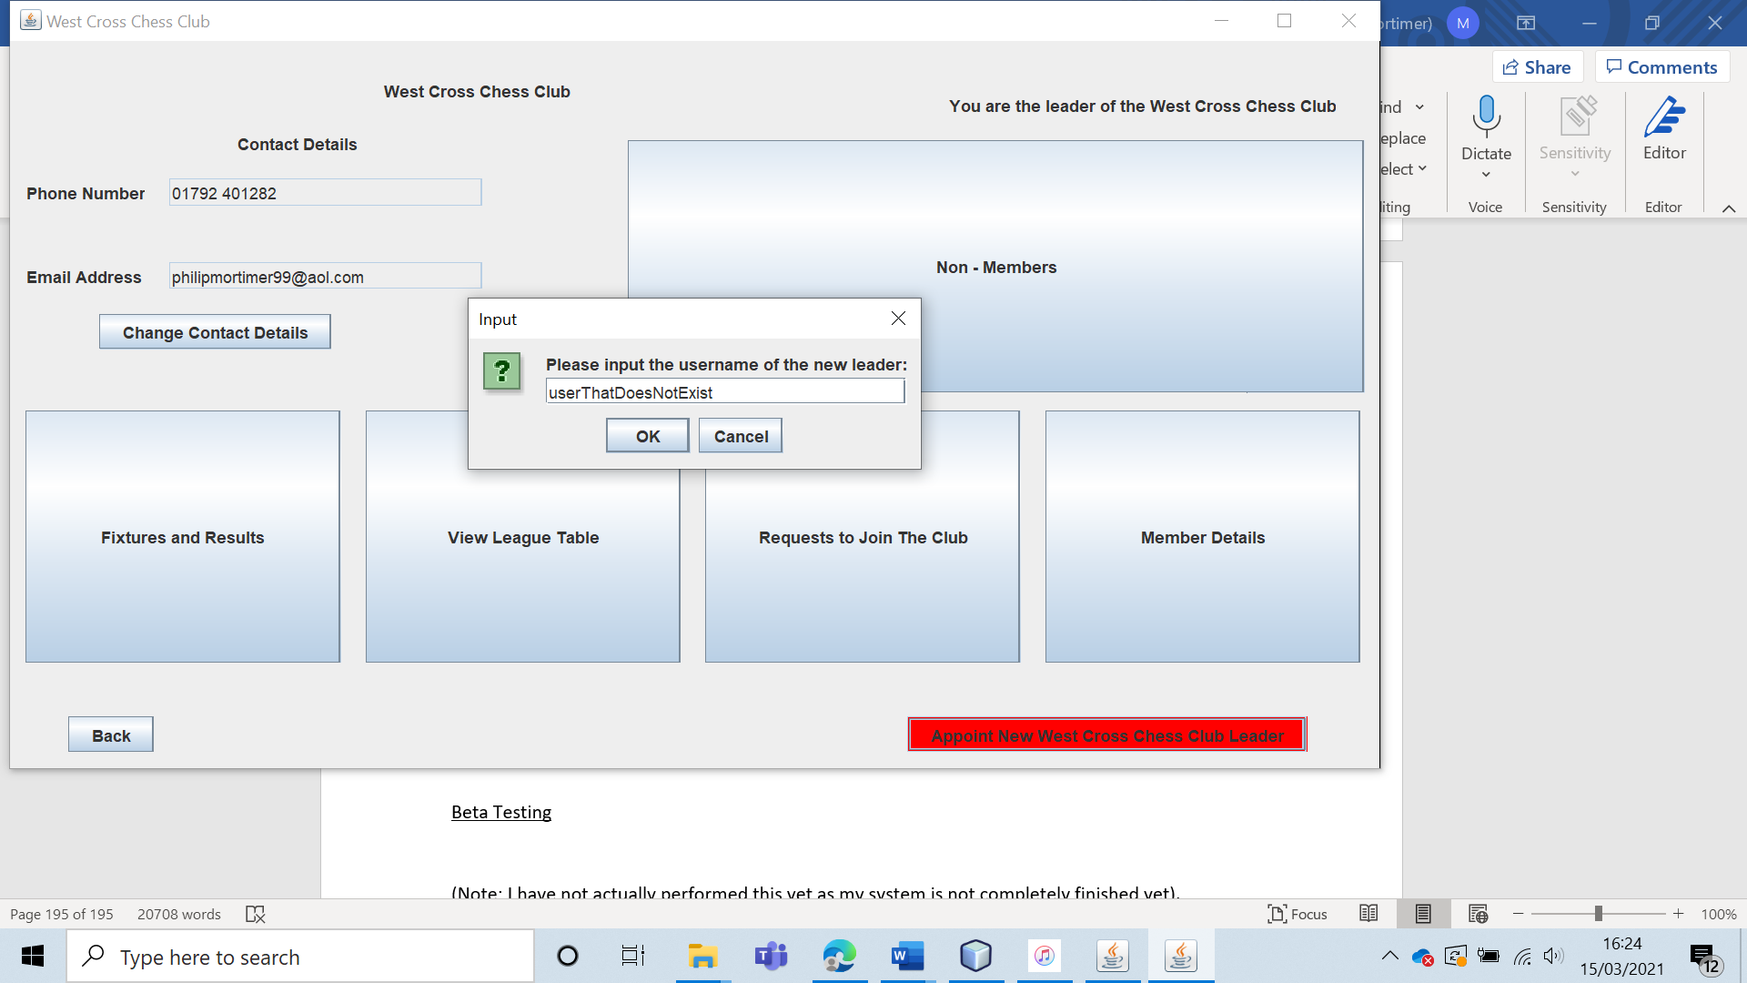

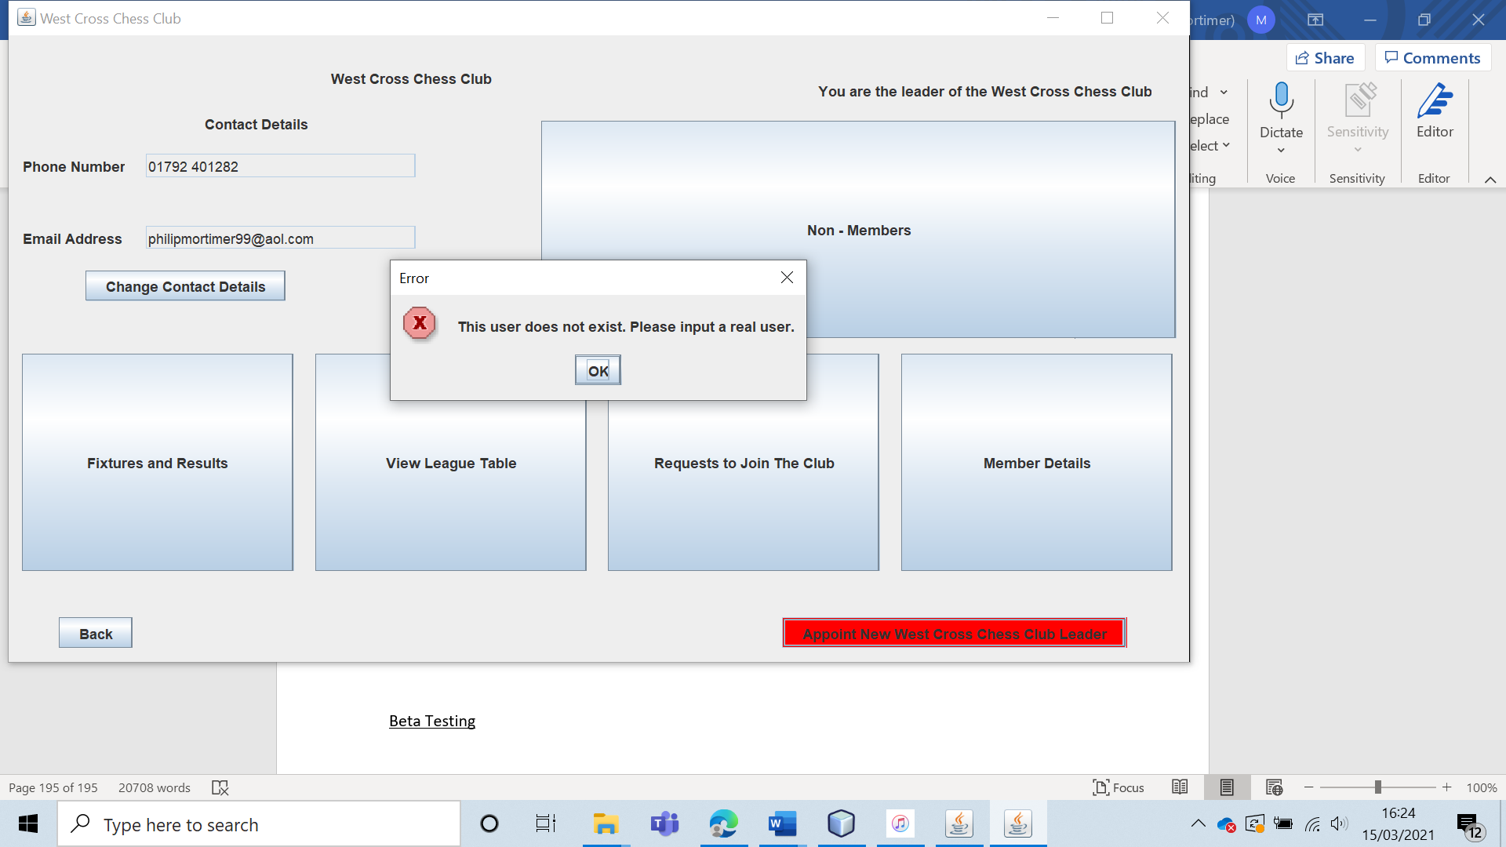

The leadership is not transferred, and a clear message is displayed telling the leader that they must select a valid leader to replace them.

|  |  |  |  |  |  |  |
| --- | --- | --- | --- | --- | --- | --- |
| 57 | Get the current club leader to attempt to transfer the leadership to themselves. | To ensure that the leader cannot transfer leadership to themselves unnecessarily. |  | The system should do nothing. The leadership should not be reset either as it may lead to the leader being needlessly removed from fixtures. | 11, 11a and 11ai. | Nothing occurs when the current leader attempts to transfer the leadership to themselves. |

Test 57

To test this, I will attempt to transfer the leadership from the current leader “philip” to “philip”. My system should not transfer the leadership. To test this, “philip” must still be the user. However, for the test to succeed, the fixtures / results must be unchanged. This shows that the system in not simply removing “philip” from the club and then adding him back very quickly. Here are the fixtures / results before the attempt.

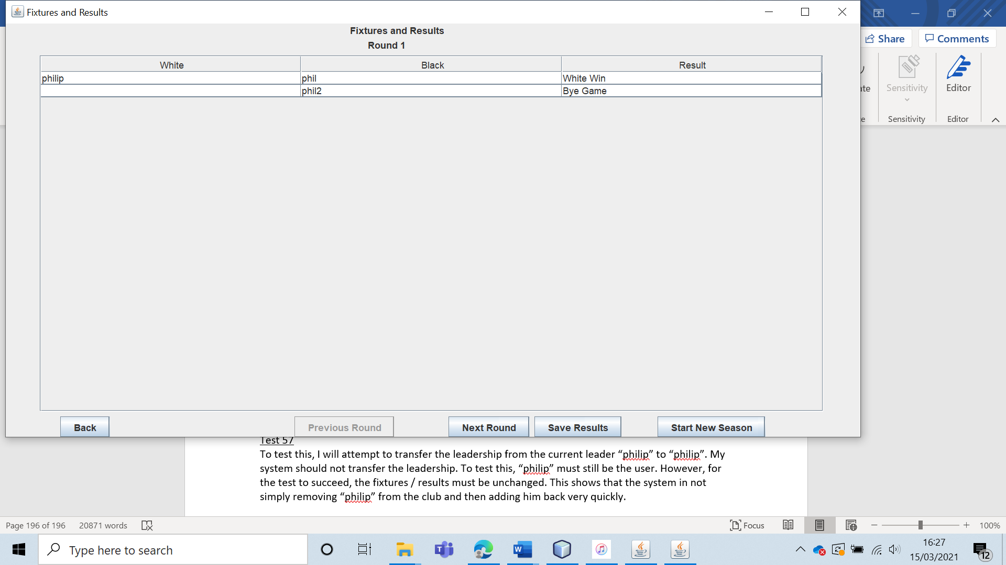

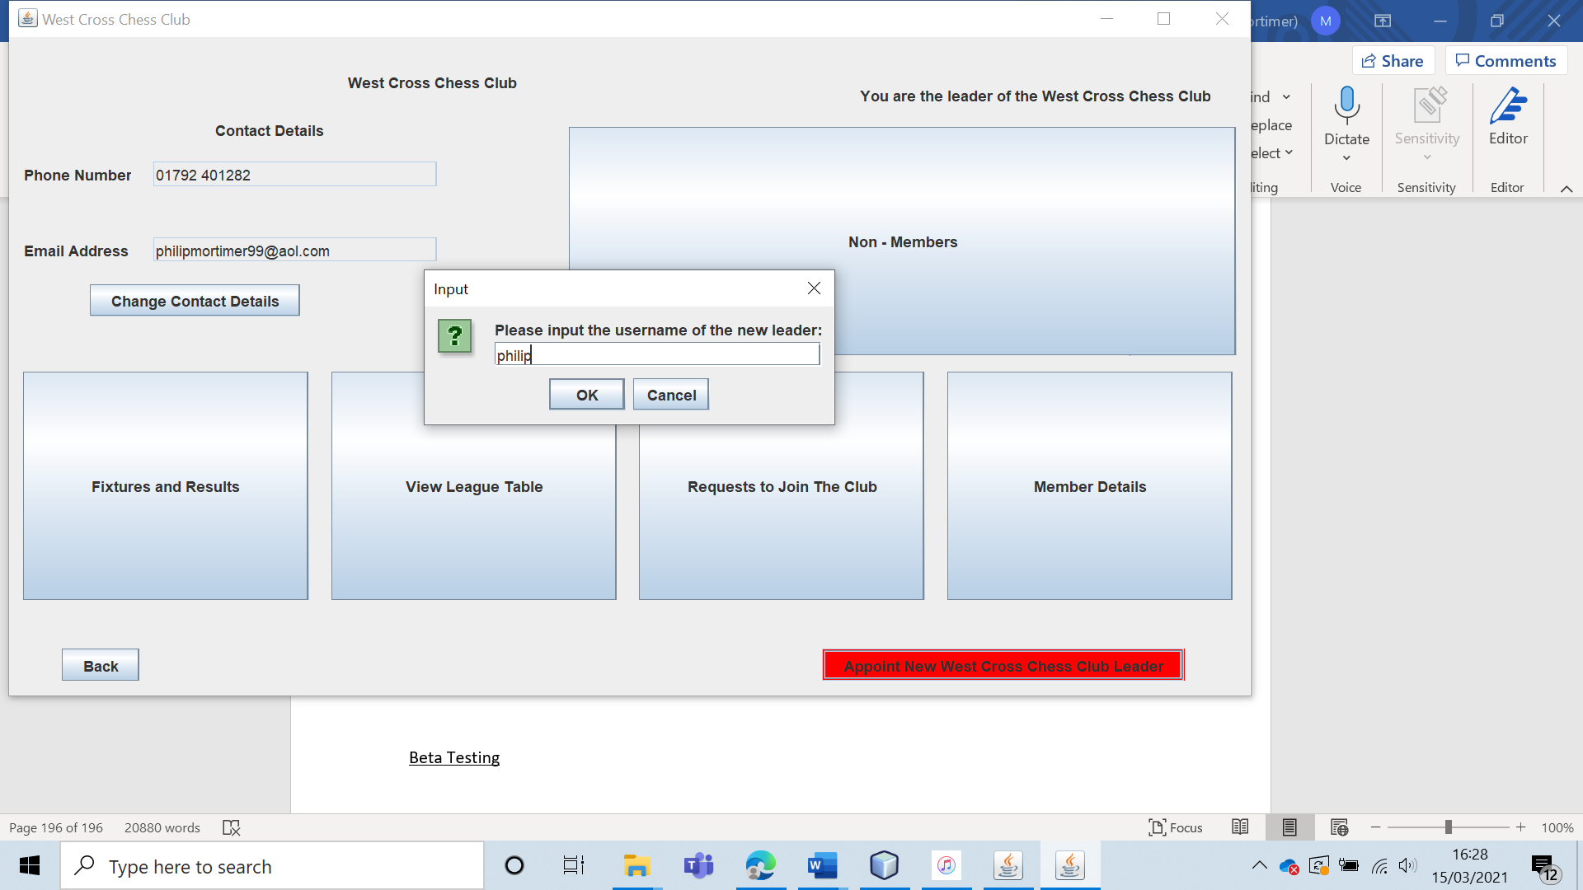

When this is executed, nothing occurs. Additionally, the fixtures / results are unchanged.

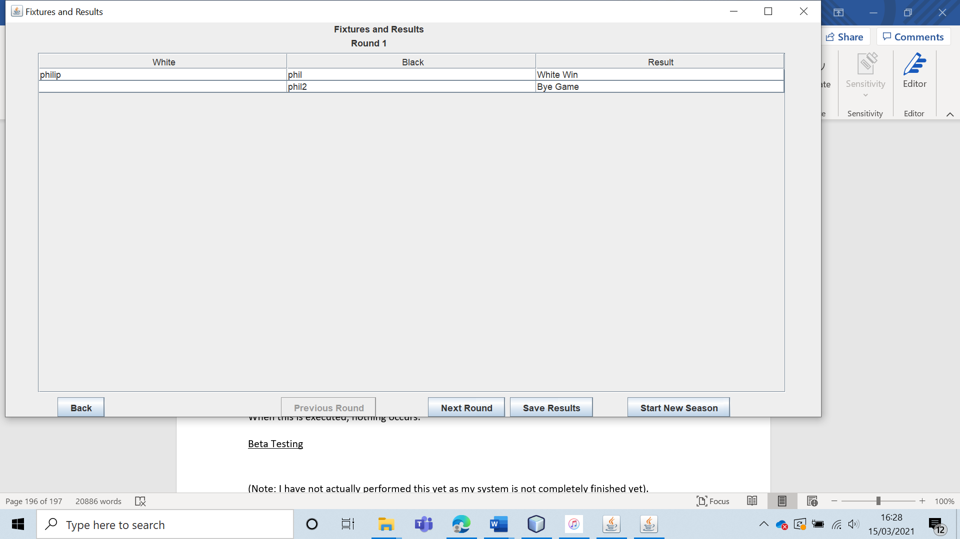

This shows that the system simply ignores a request to transfer the leadership from the current leader to the current leader.

|  |  |  |  |  |  |  |
| --- | --- | --- | --- | --- | --- | --- |
| 58 | Verify that chess board used is a two-dimensional board. Ask five members of the West Cross Chess club whether they feel that the control scheme is intuitive. Ask the same five members whether the board is visually pleasing and looks like a typical chess board. Verify that board visual settings function as intended. (Note: this test is arguably a combination of acceptance and beta testing). | To verify that the game looks good and is easy to use. To verify that the system requirements are met. |  | The board should have two layout choices. All five members will hopefully say that the control scheme is intuitive and that the board looks good. | 12, 12a and 12ai. | All of the visual features work as intended and the chess club members agree that the board looks very good and that the control scheme works very well. |

Test 58

First of all, I will verify that all visual settings can be used. First, I will check that players can switch between the two chess board styles.

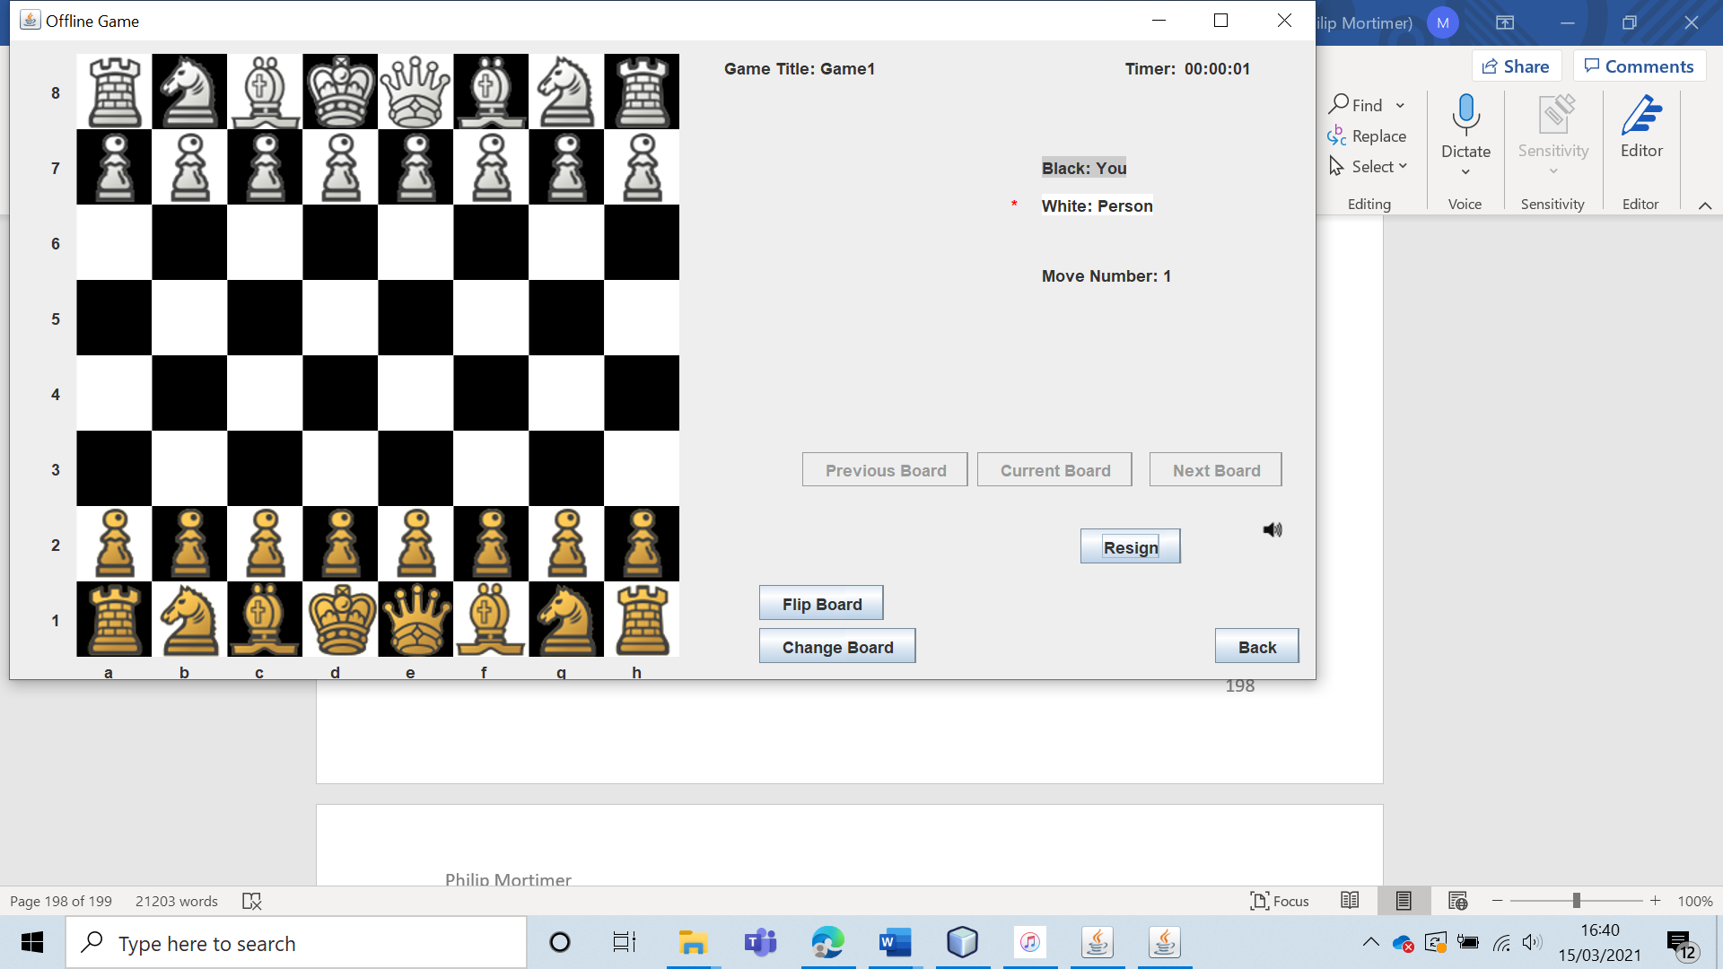

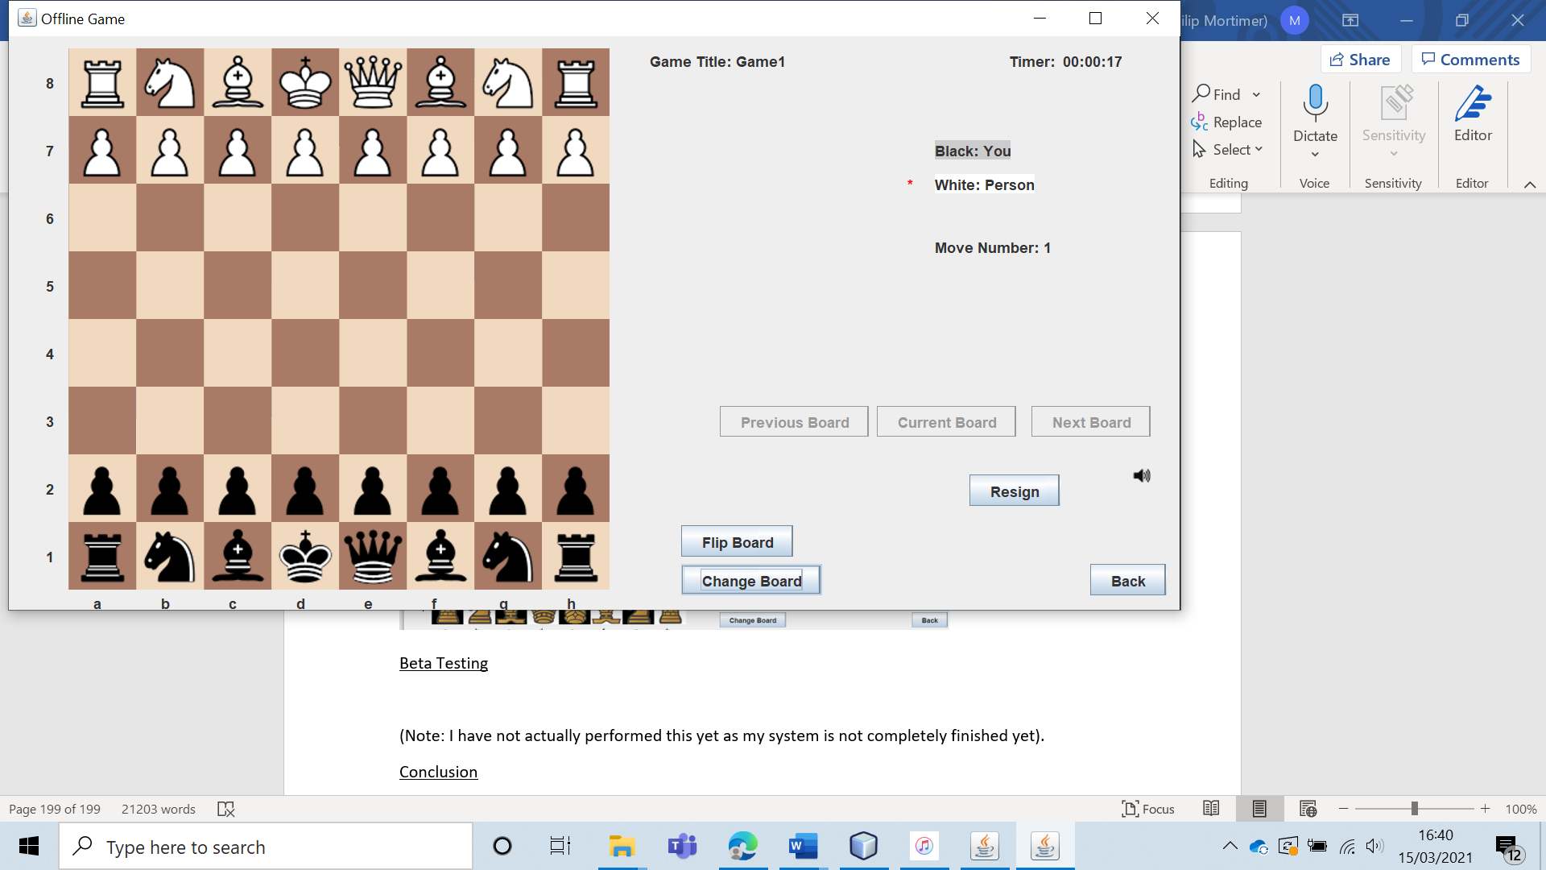

By pressing “Change Board”, the user is able to change the board style however they please.

Furthermore, by pressing “Flip Board”, the user is able to flip the board round.

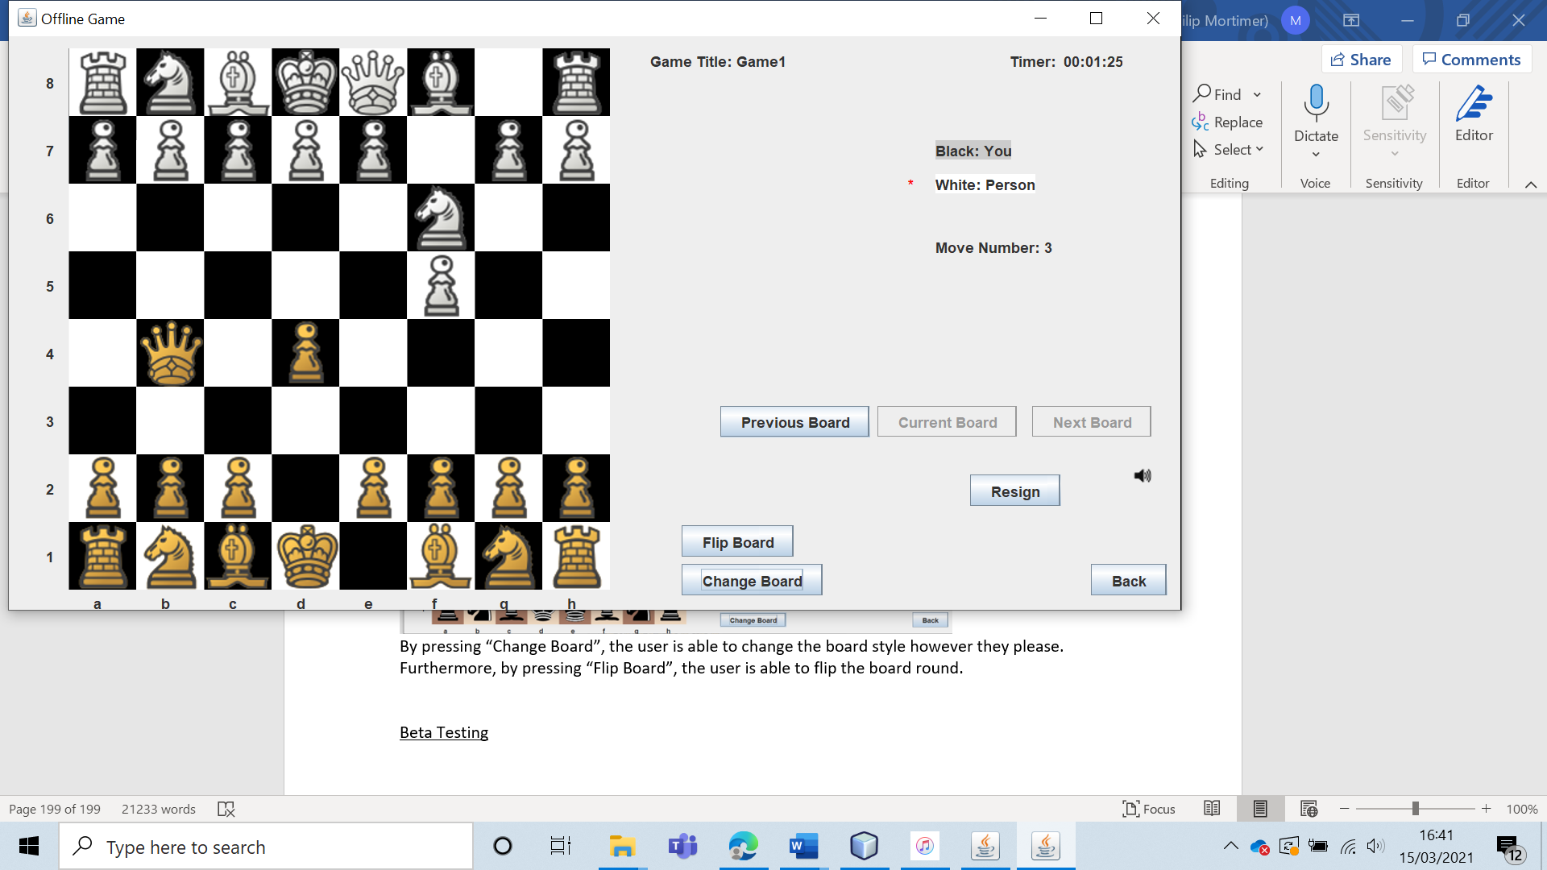

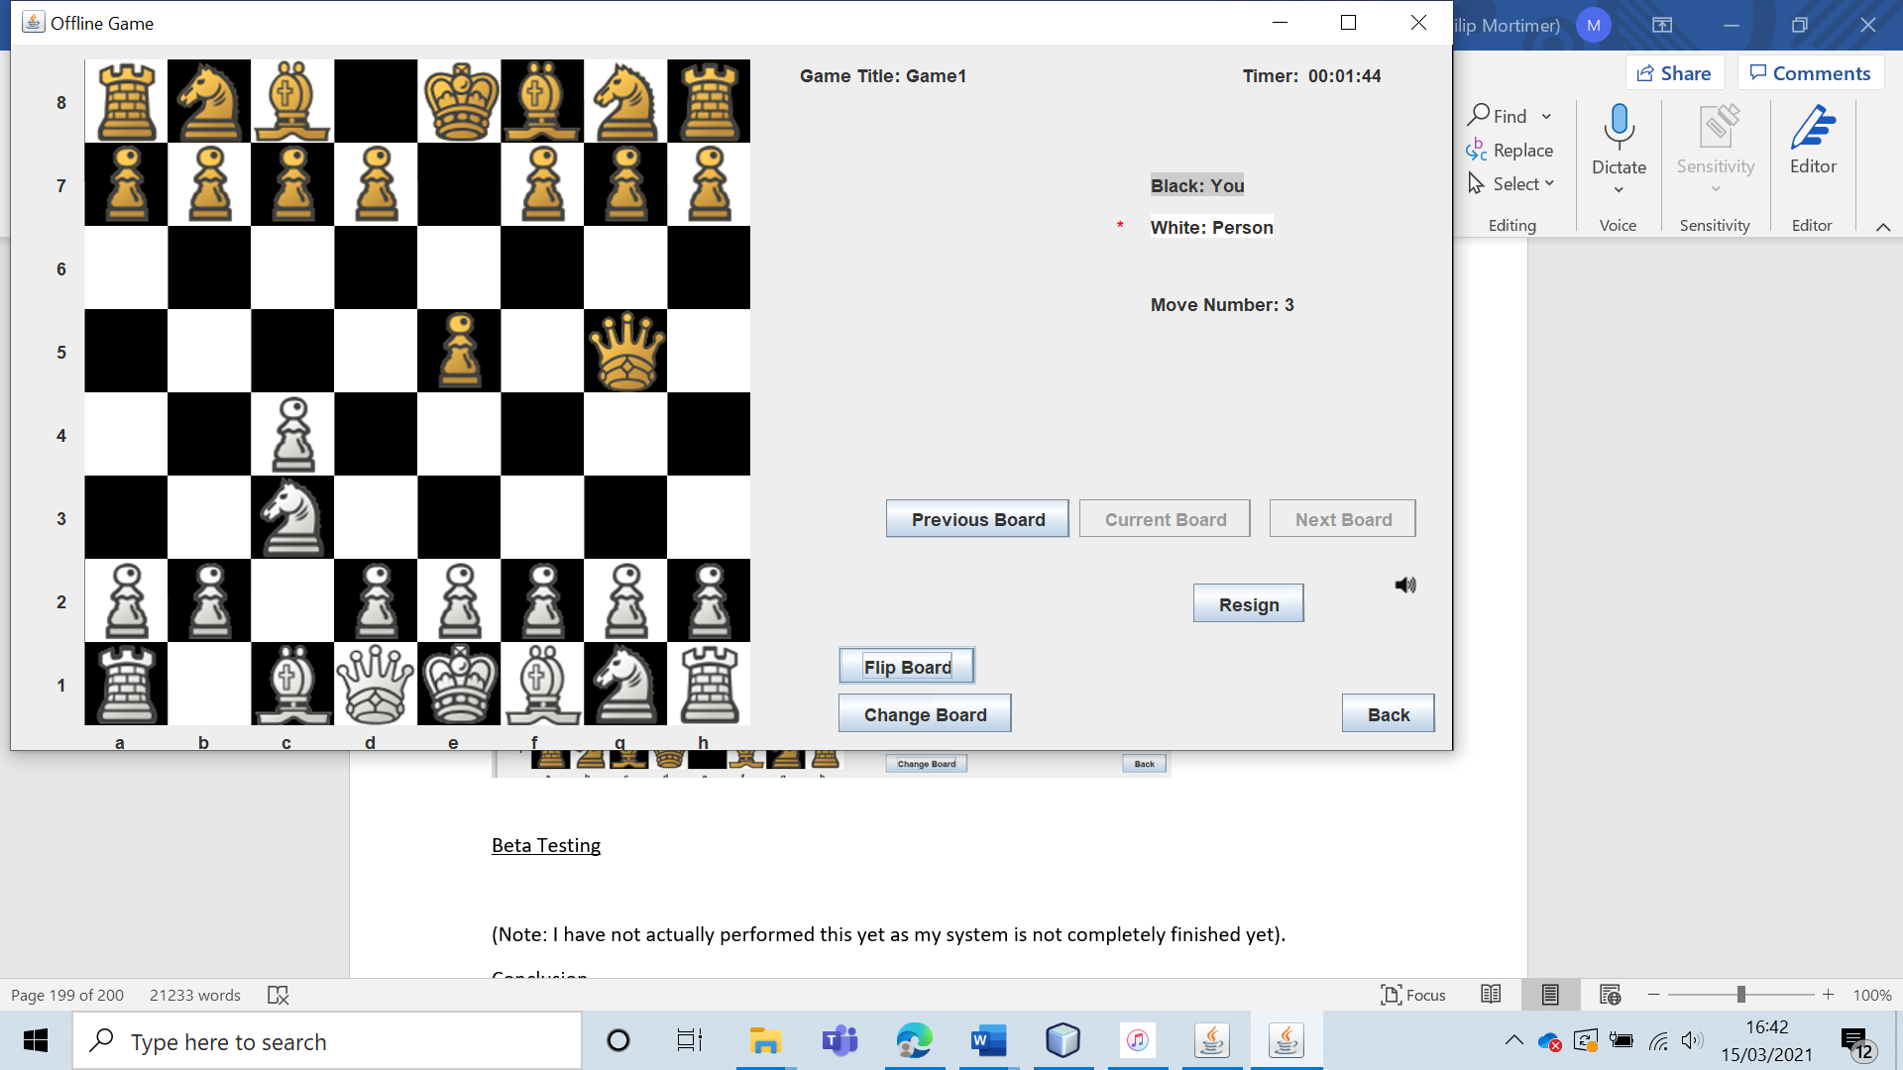

The user is able to navigate through all board states by pressing the three buttons title “Previous Board”, “Current Board”, “Next Board”. I have tested this by playing three games and cycling through all board states.

The user is also able to turn the sound for pieces being moved on or off by selecting the speaker icon.

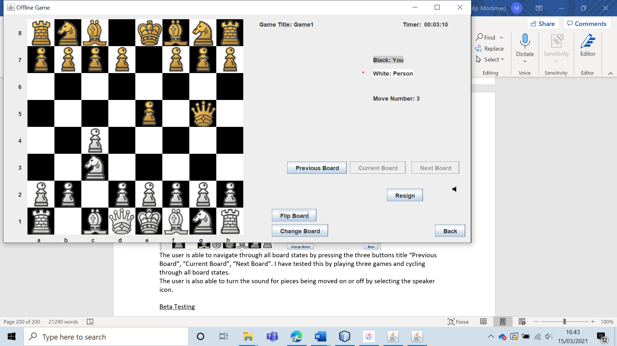

This works as intended, with the speaker icon updating to reflect whether or not sound is enabled. Furthermore, the red star that indicates who’s move it is updates when each move is made.

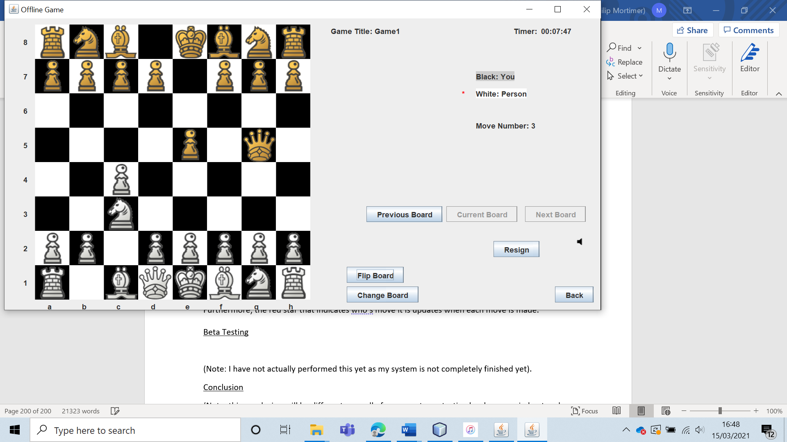

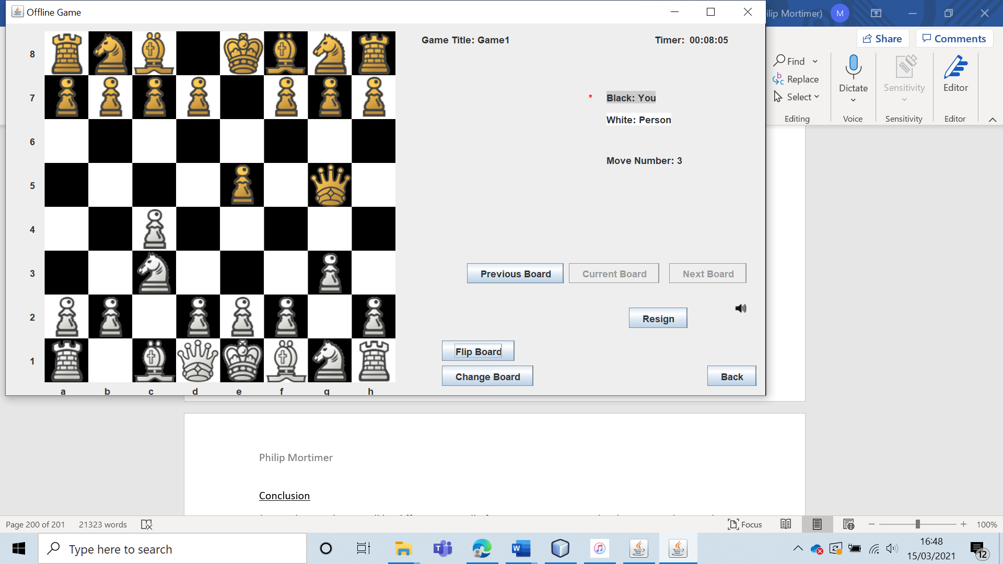

Therefore, I conclude that all of the visual features of my system that make the experience as usable as possible function.

Now, I will see whether the five members of the West Cross Chess Club agree.

I asked them two questions (after giving them access to the system):

1. How visually pleasing is the chess board? Give your answer from 1 – 5. 5 indicates very visually pleasing and on par with major chess software. 1 indicates that the board looks very bad.
2. Please rate on a scale from 1- 5 how easy and intuitive it is to play a game of chess using my system. 5 indicates very easy and intuitive and 1 represents extremely difficult and obtuse.

Pleasingly, all five members gave answered five to both questions. This shows that my system is very visually pleasing and easy to use. It shows that the system is extremely good for people who just want to play chess.

|  |  |  |  |  |  |  |
| --- | --- | --- | --- | --- | --- | --- |
| 59 | To verify that users can access all system features available to them from the main menu. | To ensure that the menu functions as designed. |  | The menu should take the user to all areas of the club that are accessible for their user level. | 13 | All user types can access the appropriate forms from the menu. |

Test 59

To test this, I will test that guests, non-member users, non-leader members and the leader can access the appropriate forms from the main menu.

First, I will test this for guests.

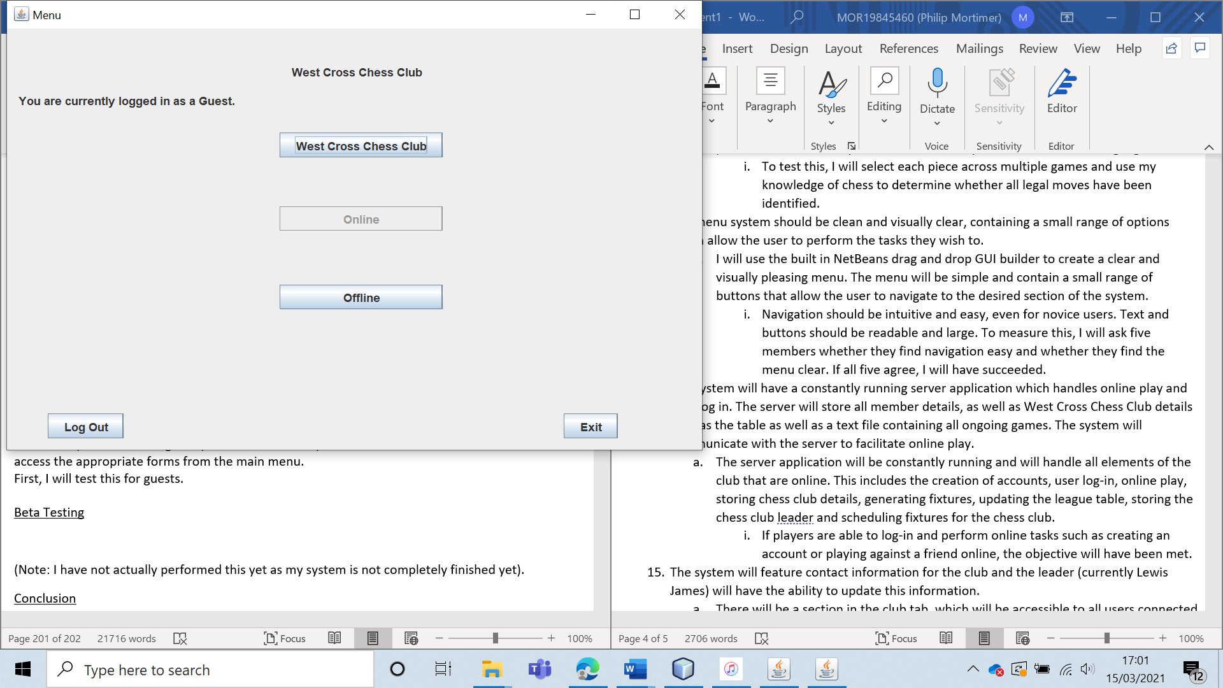

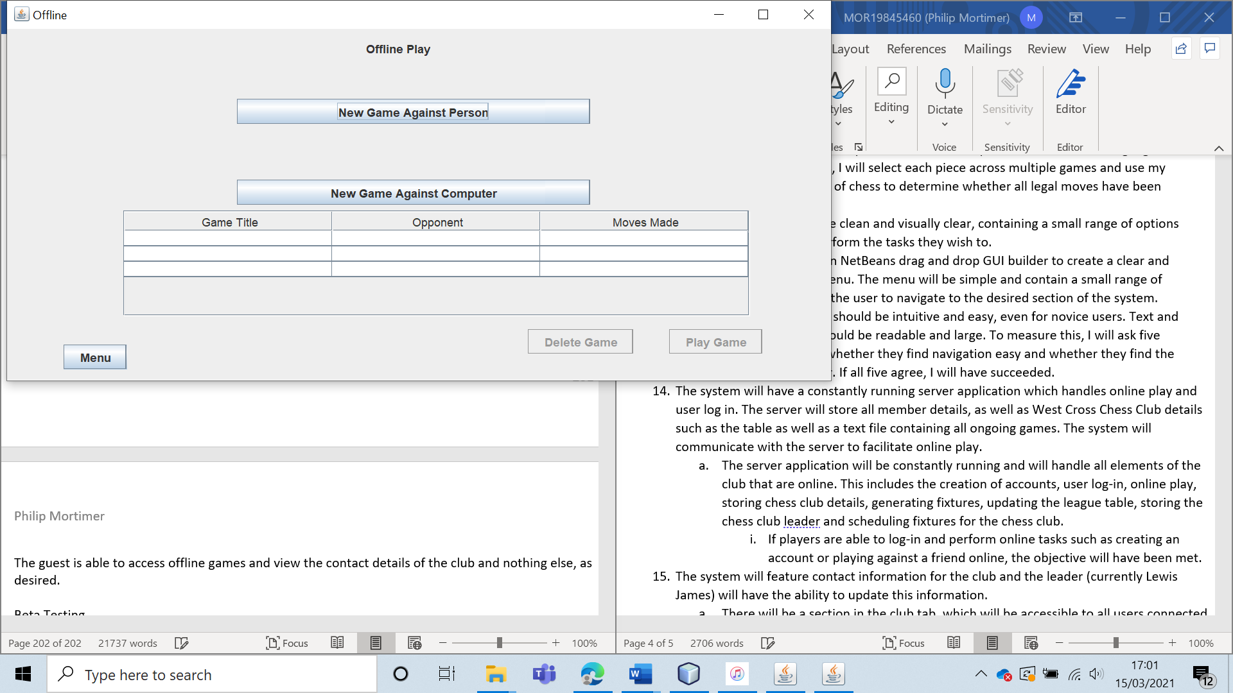

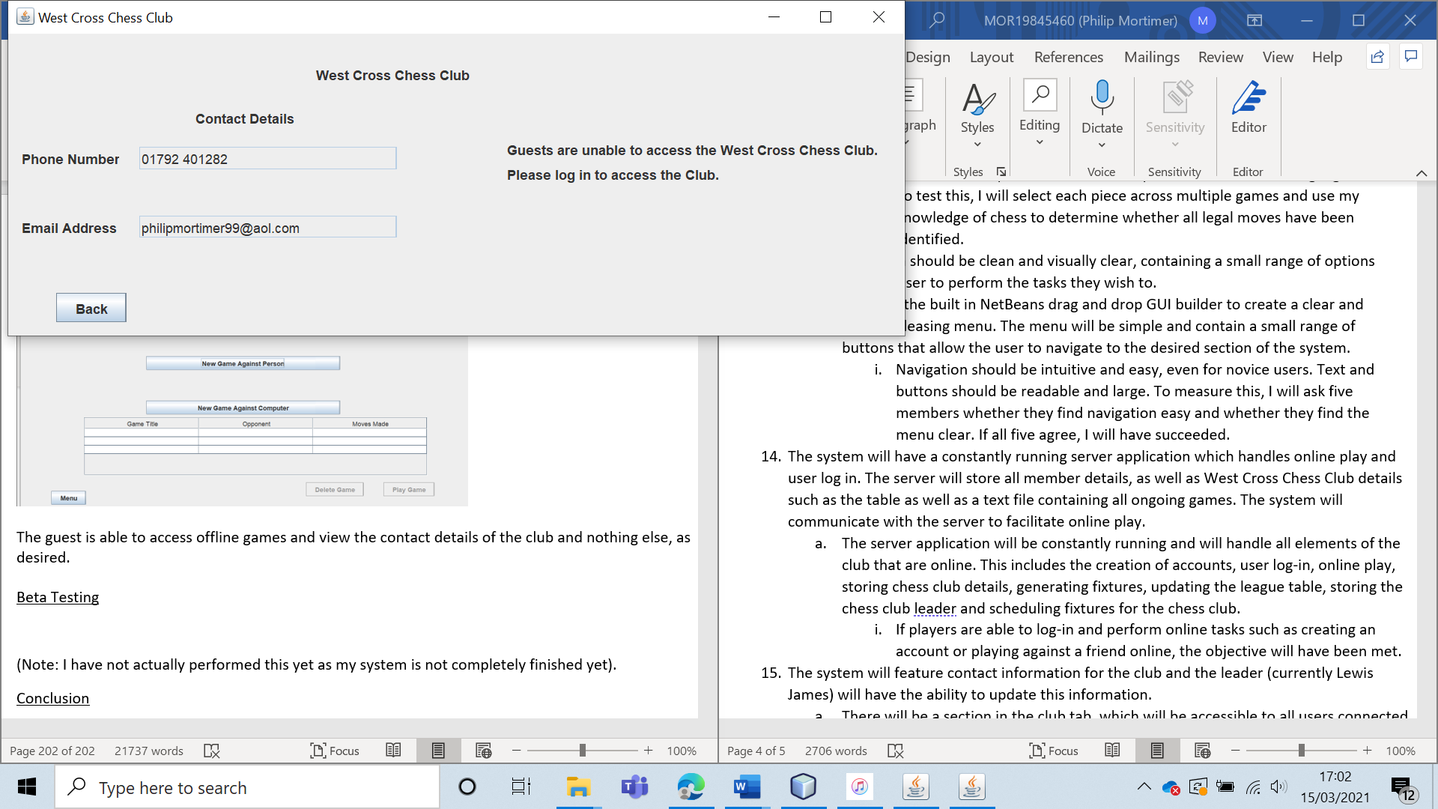

The guest is able to access offline games and view the contact details of the club and nothing else, as desired.

Next, I will test this for the non-member user.

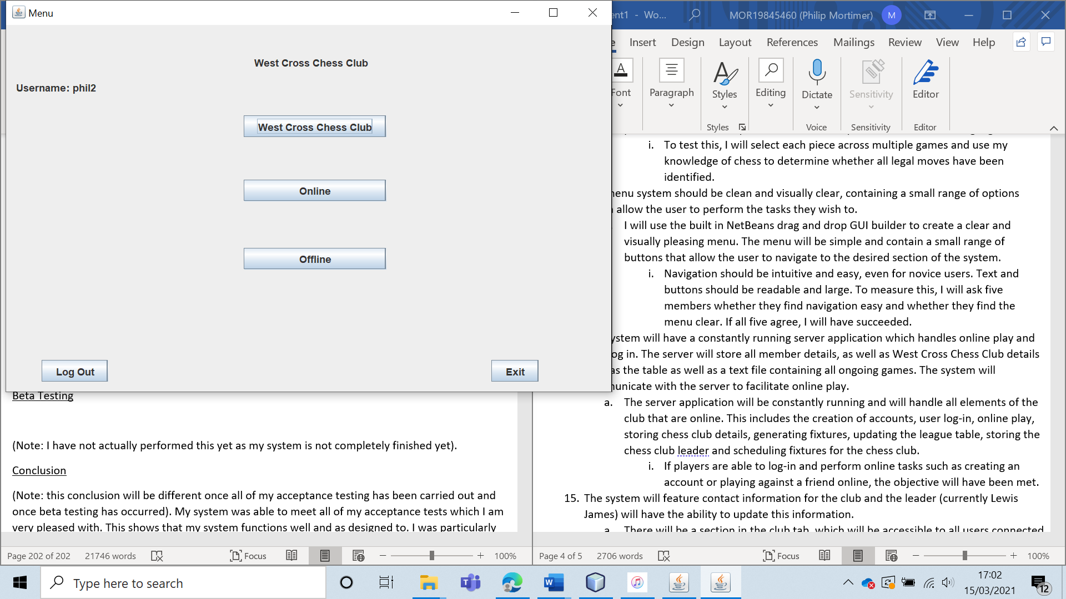

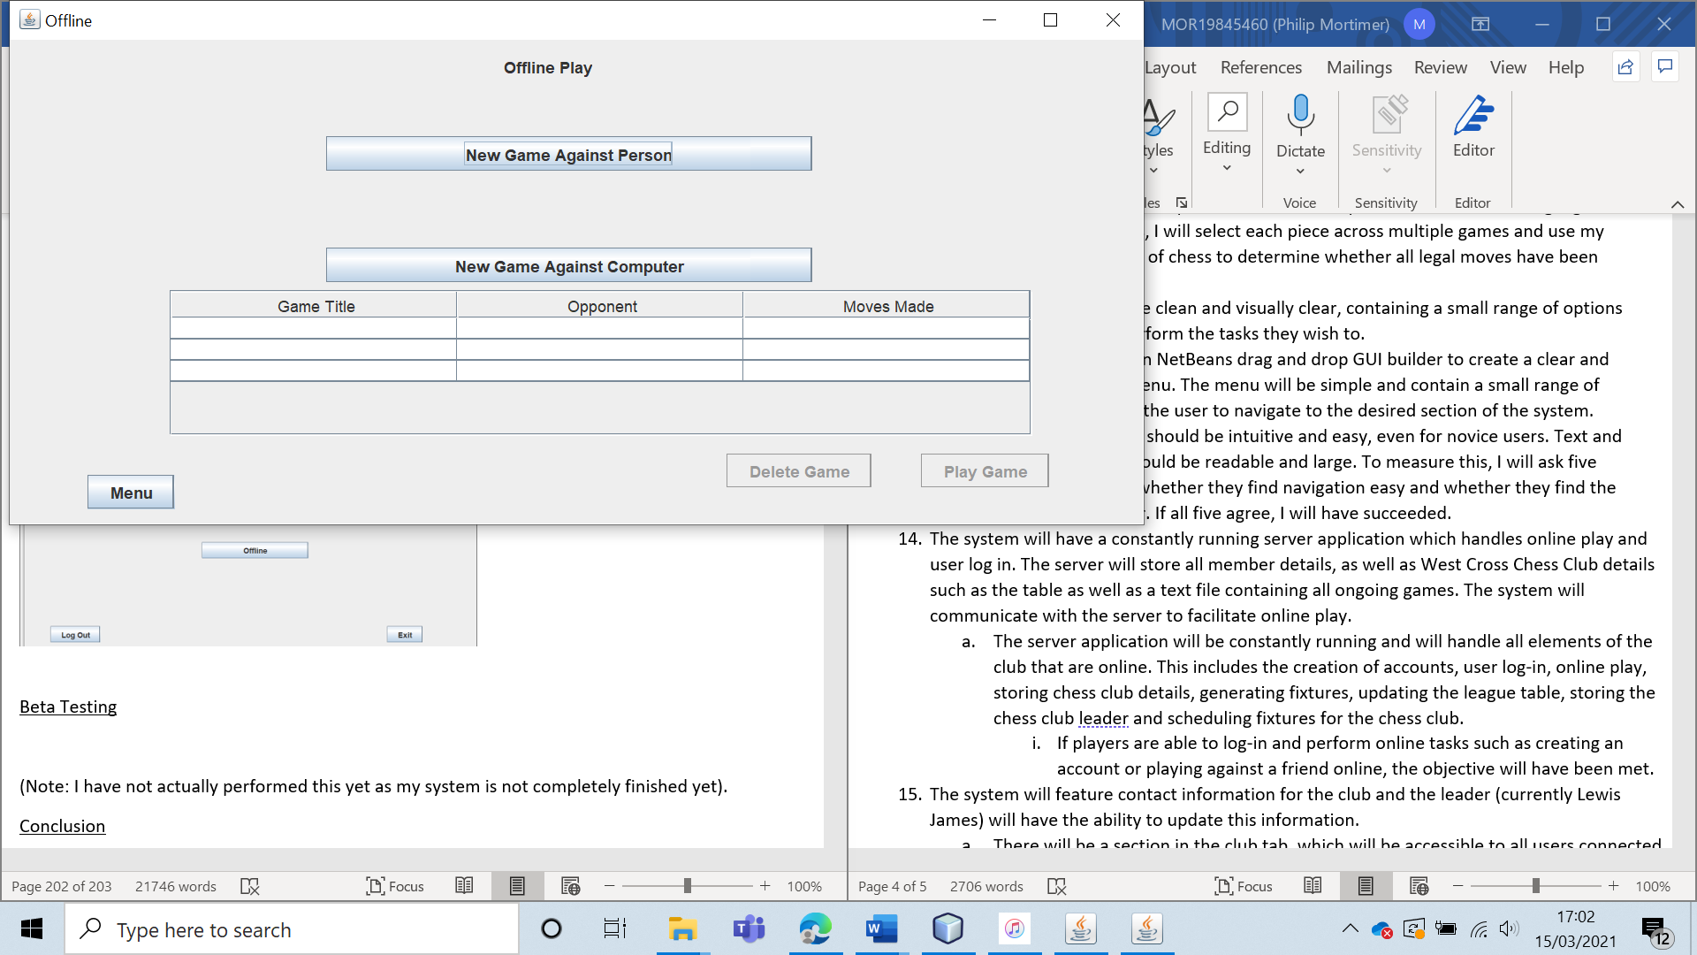

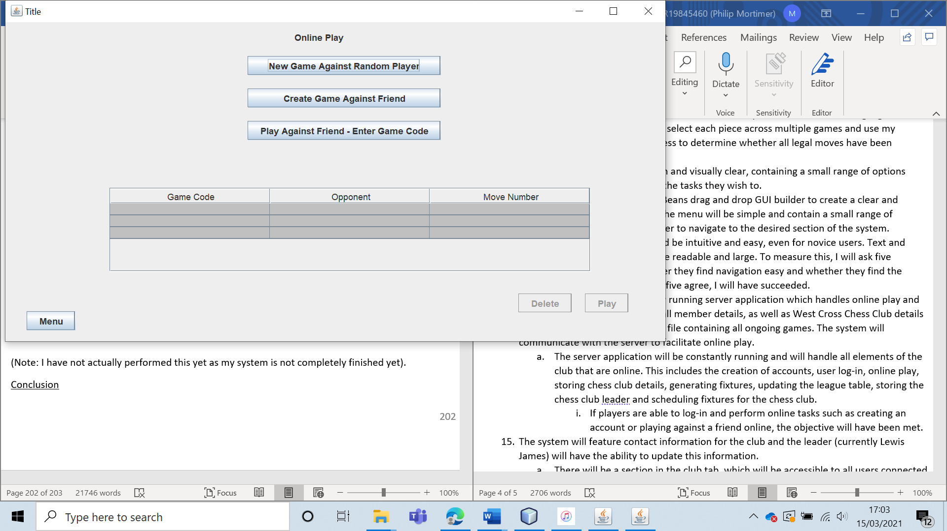

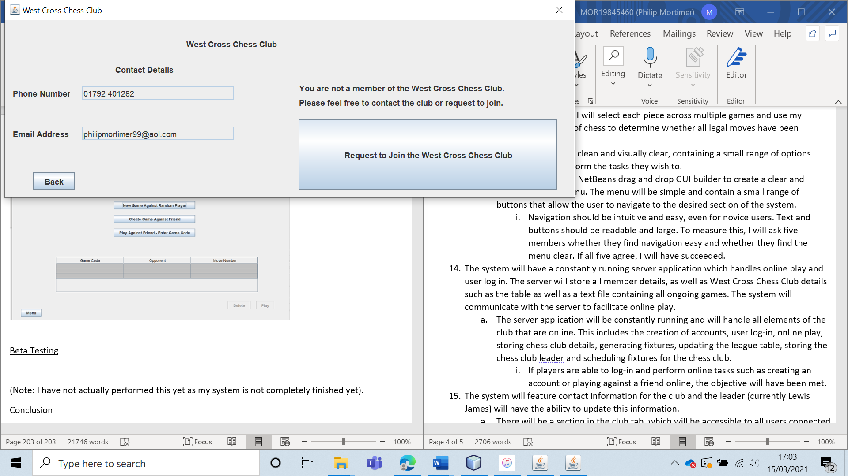

The non-member user is able to access all necessary forms from the main menu.

Next, I will test this for a member who is not the leader.

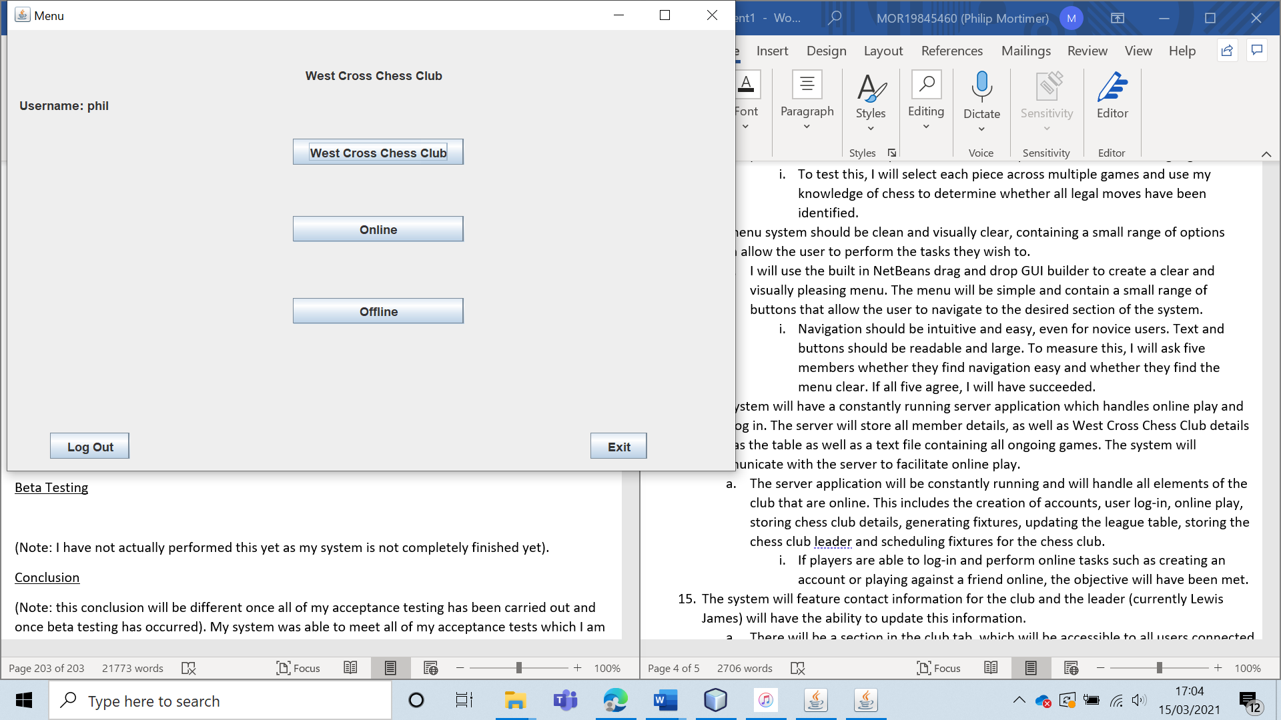

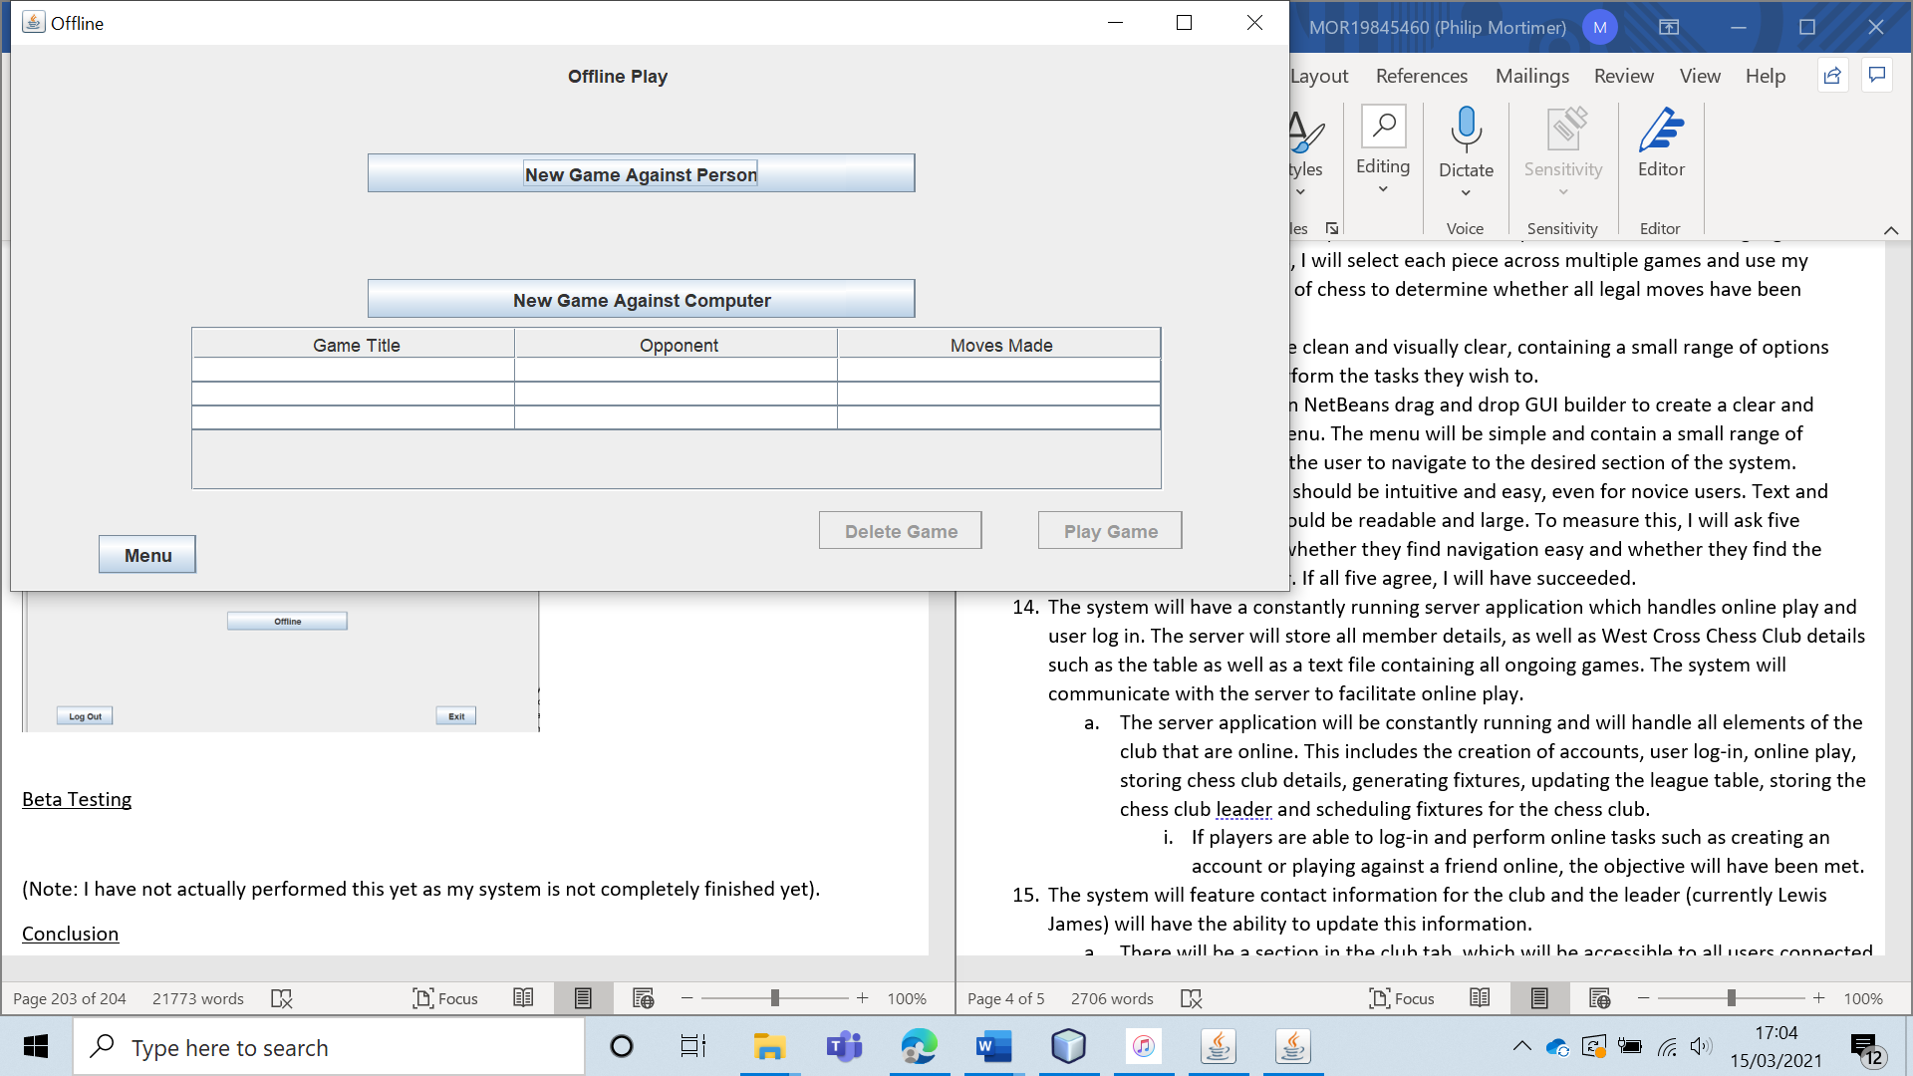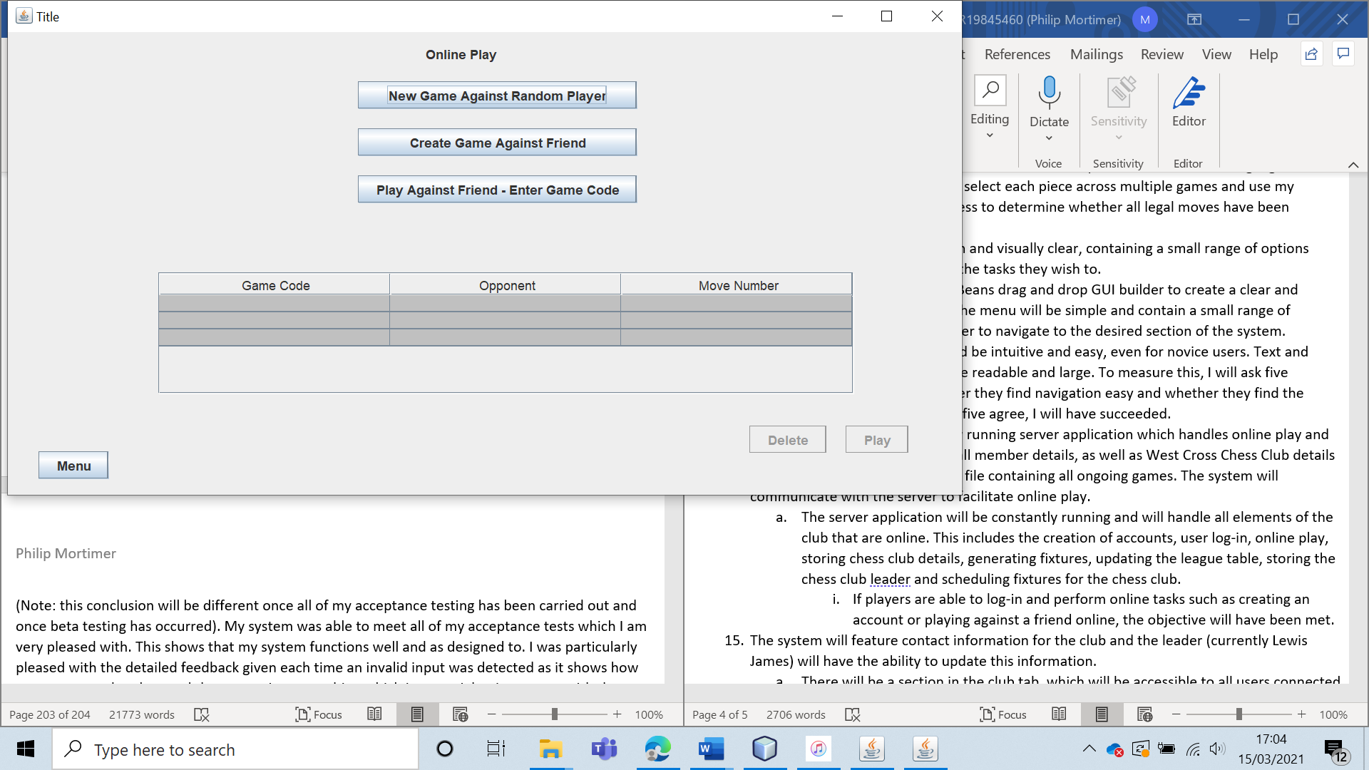

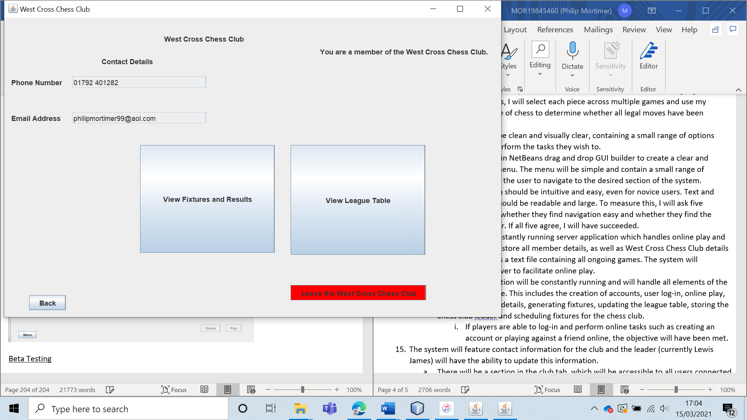

The non-leader member is able to access all forms that they should be able to.

Finally, I will test the access for the leader.

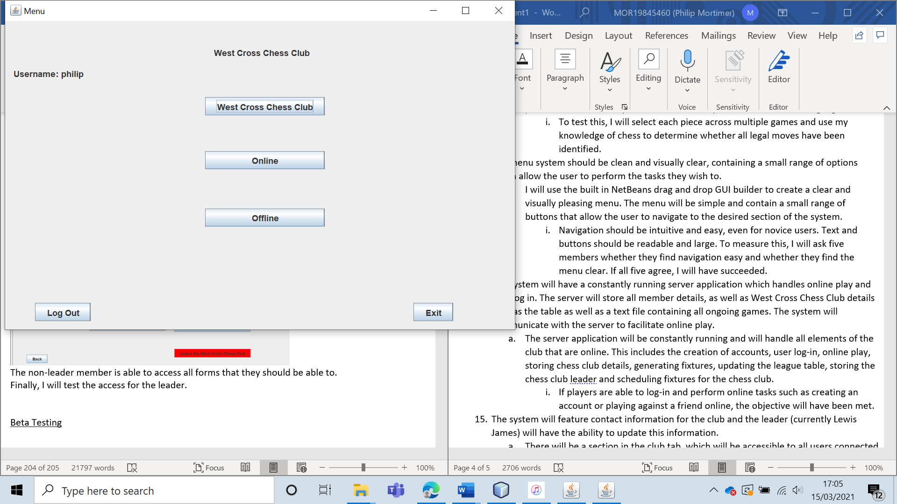

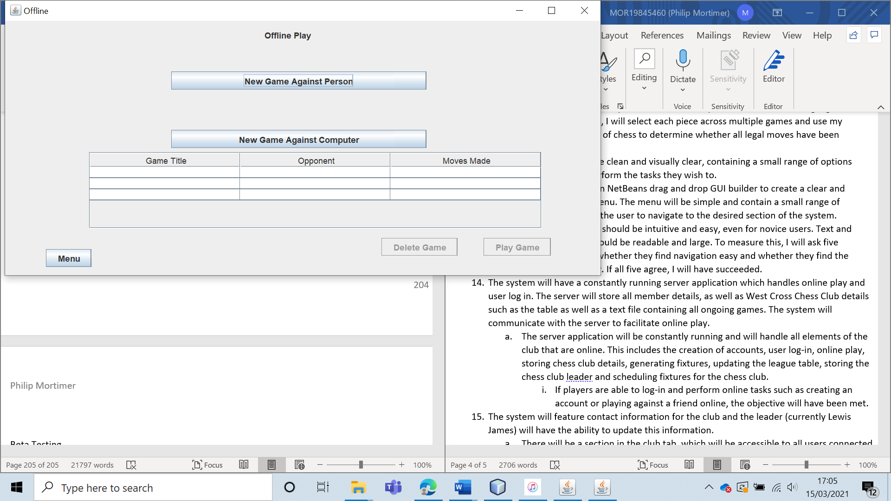

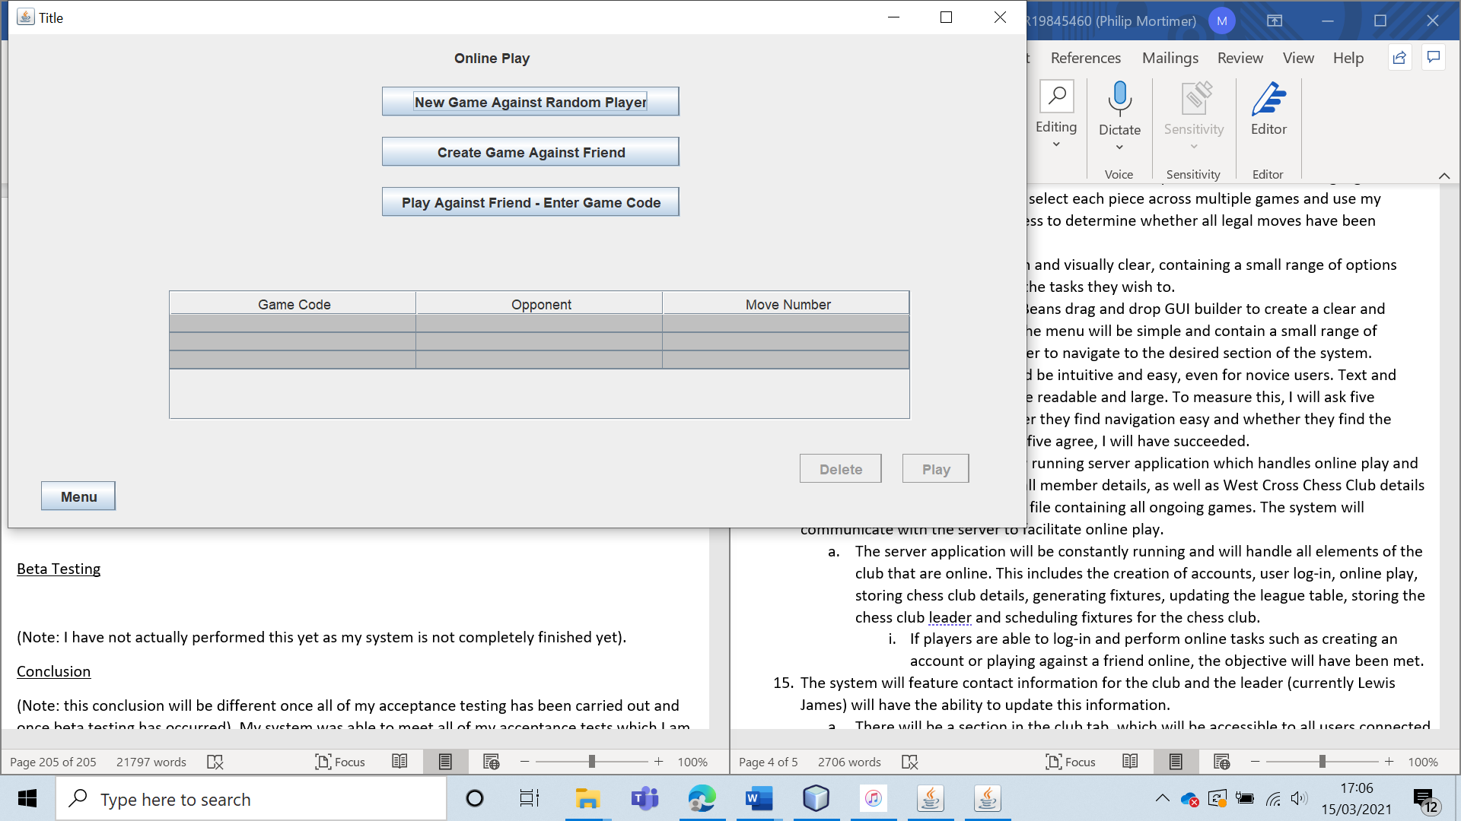

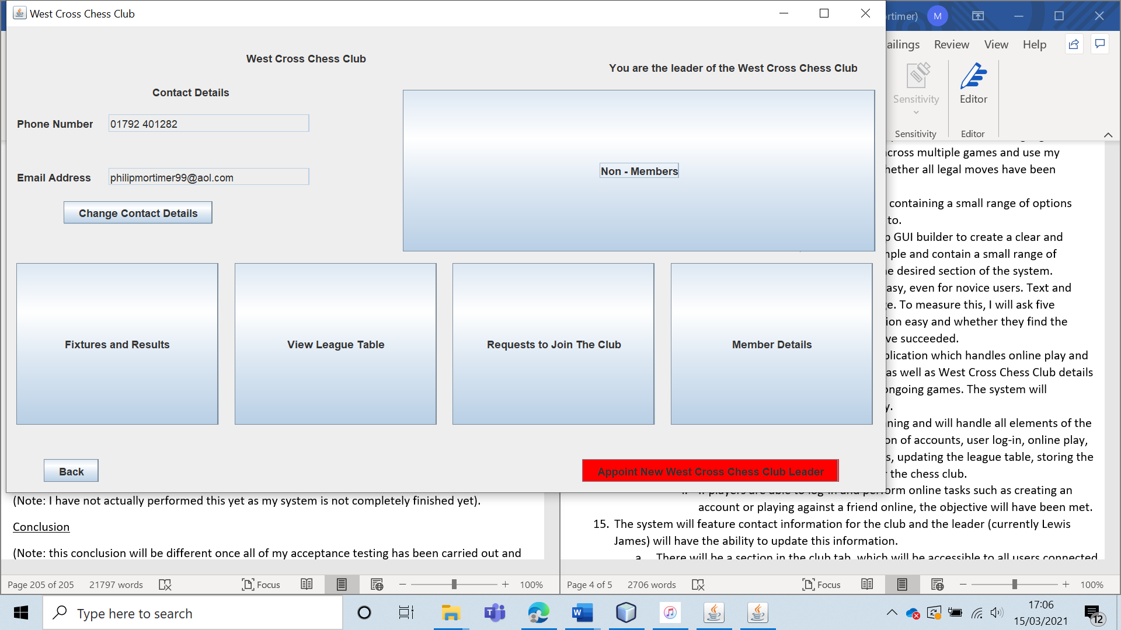

The leader is also able to access all relevant forms. Hence, all users (regardless of user type) are able to access the correct forms from the menu.

|  |  |  |  |  |  |  |
| --- | --- | --- | --- | --- | --- | --- |
| 60 | I will ask five members of the West Cross Chess Club whether they find the menu clear and easy to navigate. (Beta test). | To ensure that the menu is easy to navigate and contributes towards a good user experience. |  | I will ask them to rate how easy the menu is to navigate out of five points. I hope that all five members will give the menu a score of five or four points. | 13, 13a 13ai, 18e and 18ei. | The users overwhelming stated that they found the menu clear and the entire system easy to use and navigate. |

Test 60

I asked five members of the West Cross Chess Club the following questions:

1. How easy is it to navigate through the system? Please answer with a number from 1 – 5 with 5 being very easy and 1 being very difficult.
2. On scale of 1 – 5, how clear is the menu? 5 is very clear whilst 1 means that the menu is very tricky to navigate.

For question 1, I got a score of 23/25 and for question 2, I got a score of 25/25. This is a very positive result and does in fact show that my system is well laid out and designed, making it easy to navigate. Whilst I did not achieve a perfect score for question 1, all of the responses were still a score of 4 or more. This shows a successful system. Whilst the experience could still be improved, I suspect that had I given the members more time to familiarise themselves with the system, I may have achiveded 25/25 as well.

|  |  |  |  |  |  |  |
| --- | --- | --- | --- | --- | --- | --- |
| 61 | Verify that the server form allows the user to turn the server on and off. | To ensure that the server side of the system works. |  | When the server is off, logging into an account should not be possible. When the server is on however, a log in should happen. | 14, 14a and 14ai. | The user system was only able to access online features when the server was turned on, indicating that the form does in fact control whether the server is on or not. |

Test 61

To test this, I will attempt to log in to the account “philip” using valid log-in credentials. I will do this once when the server is off on the server form and once when it is on. First, I will attempt to log-in when the server is off.

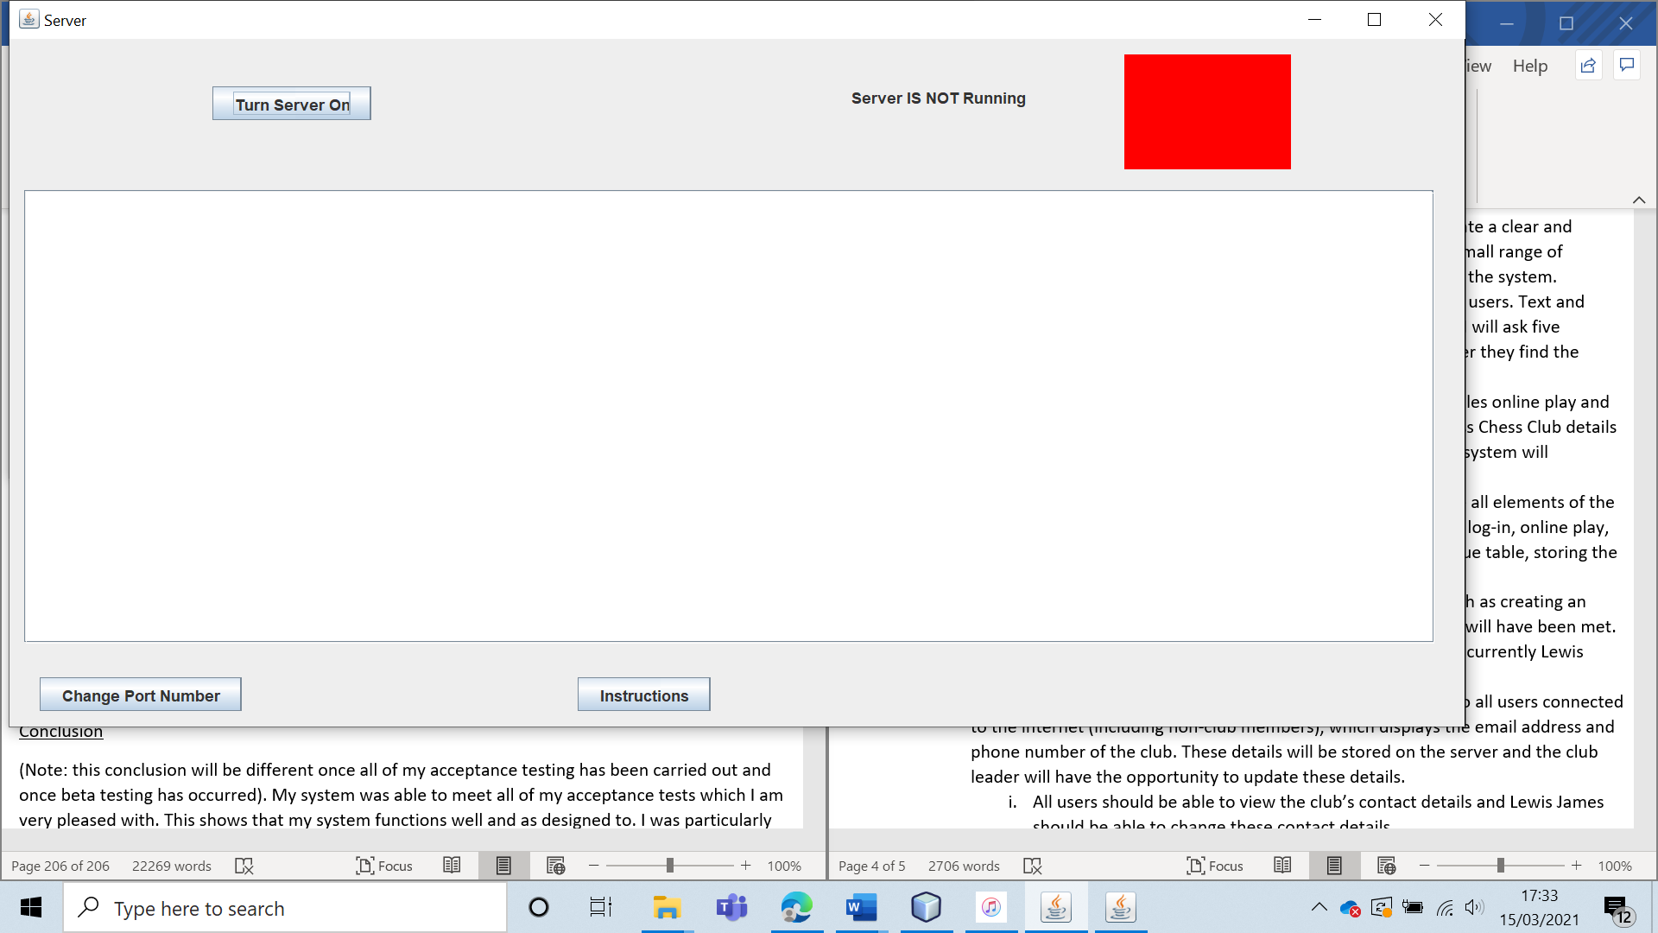

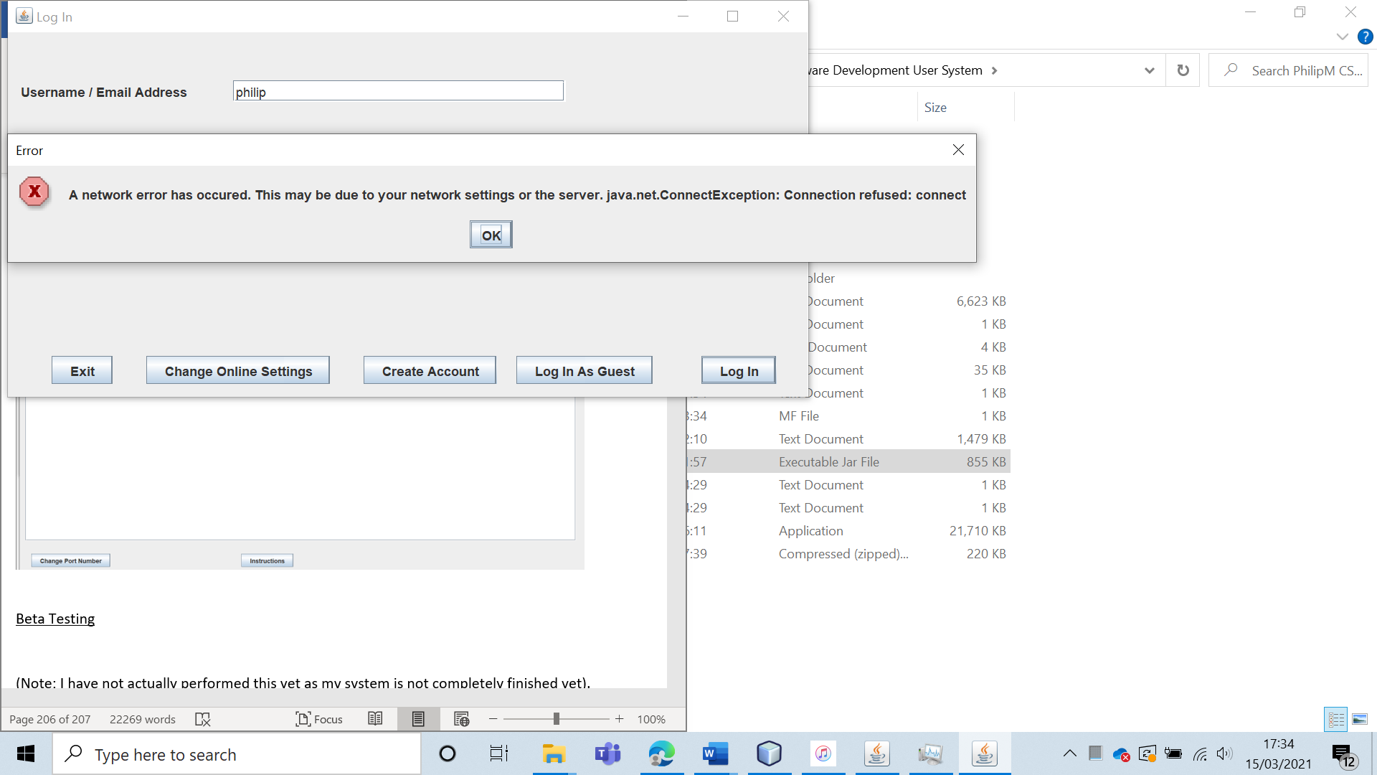

As expected, the log-in does not occur. The user is told that the log-in failed due to network issues.

Then, I logged in with the server turned on.

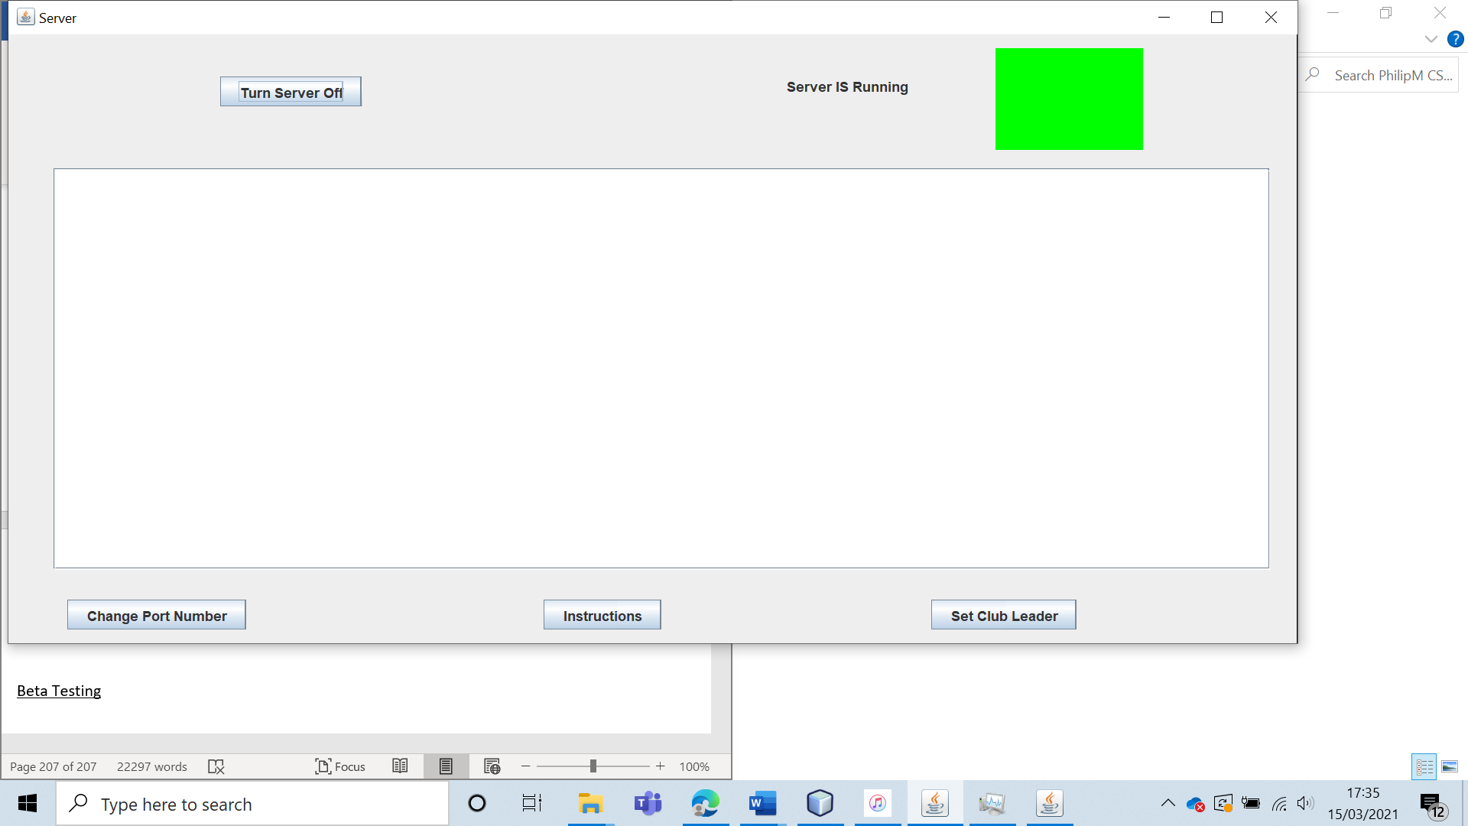

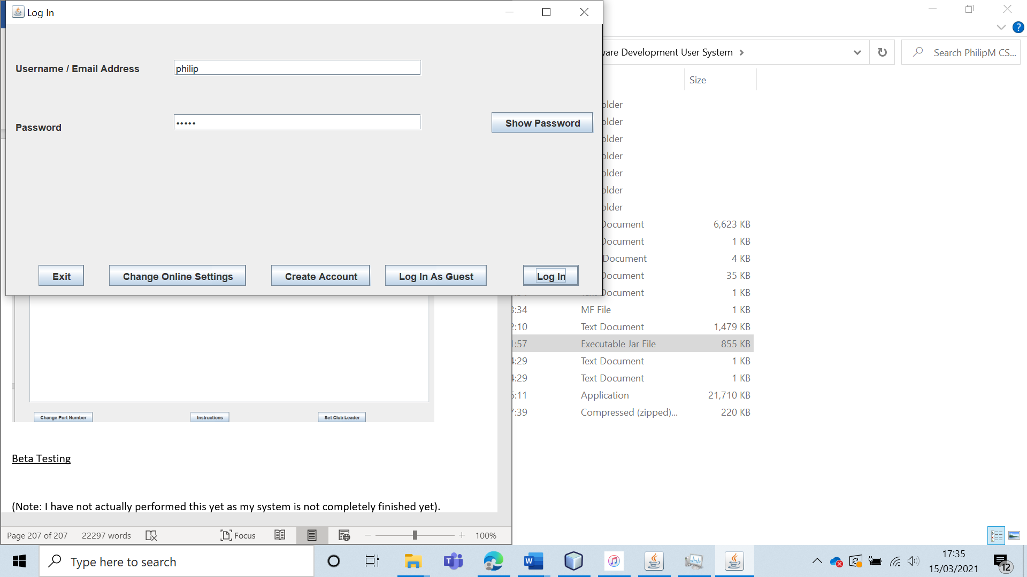

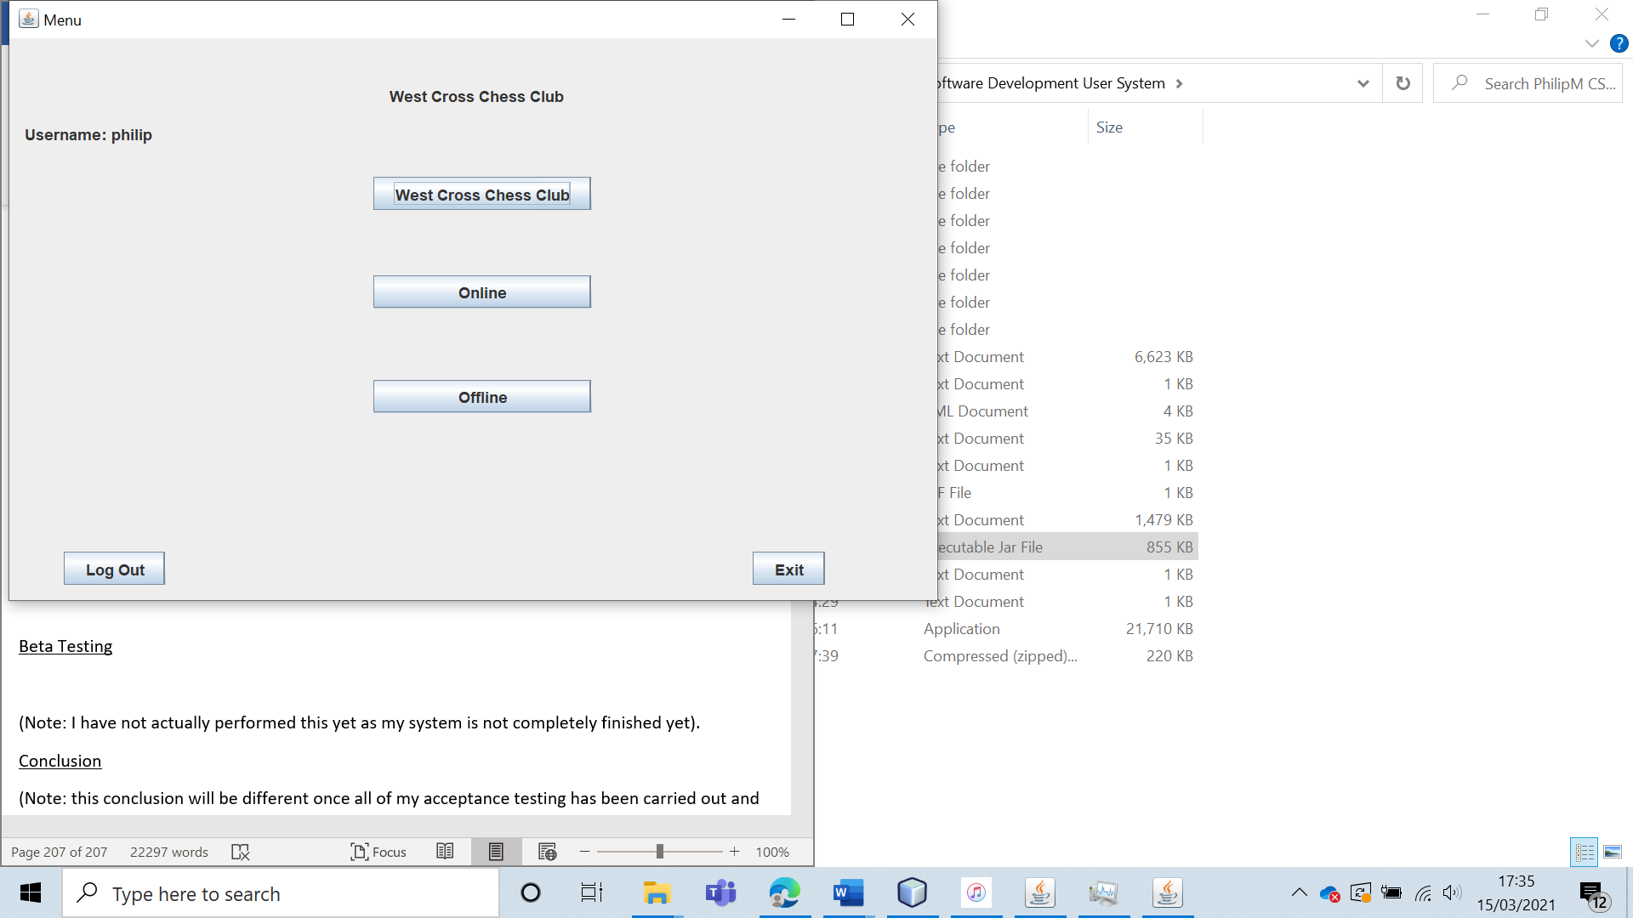

When the server was turned on, all online features functioned and were accessible (including logging in).

|  |  |  |  |  |  |  |
| --- | --- | --- | --- | --- | --- | --- |
| 62 | Play an online game against a user and have the game be a draw. Verify that the ELO update functions. | To verify that the ELO rating is calculated correctly. | D1 | The ELO rating should be updated to the calculated value. | 16, 16a, 16ai, 18d and 18di. | The ELO rating was correctly updated for the draw. |

Test 62 (D1)

To play this game, I will play “phil” against “philip”. Both users have a rating of 1000 ELO before the game.

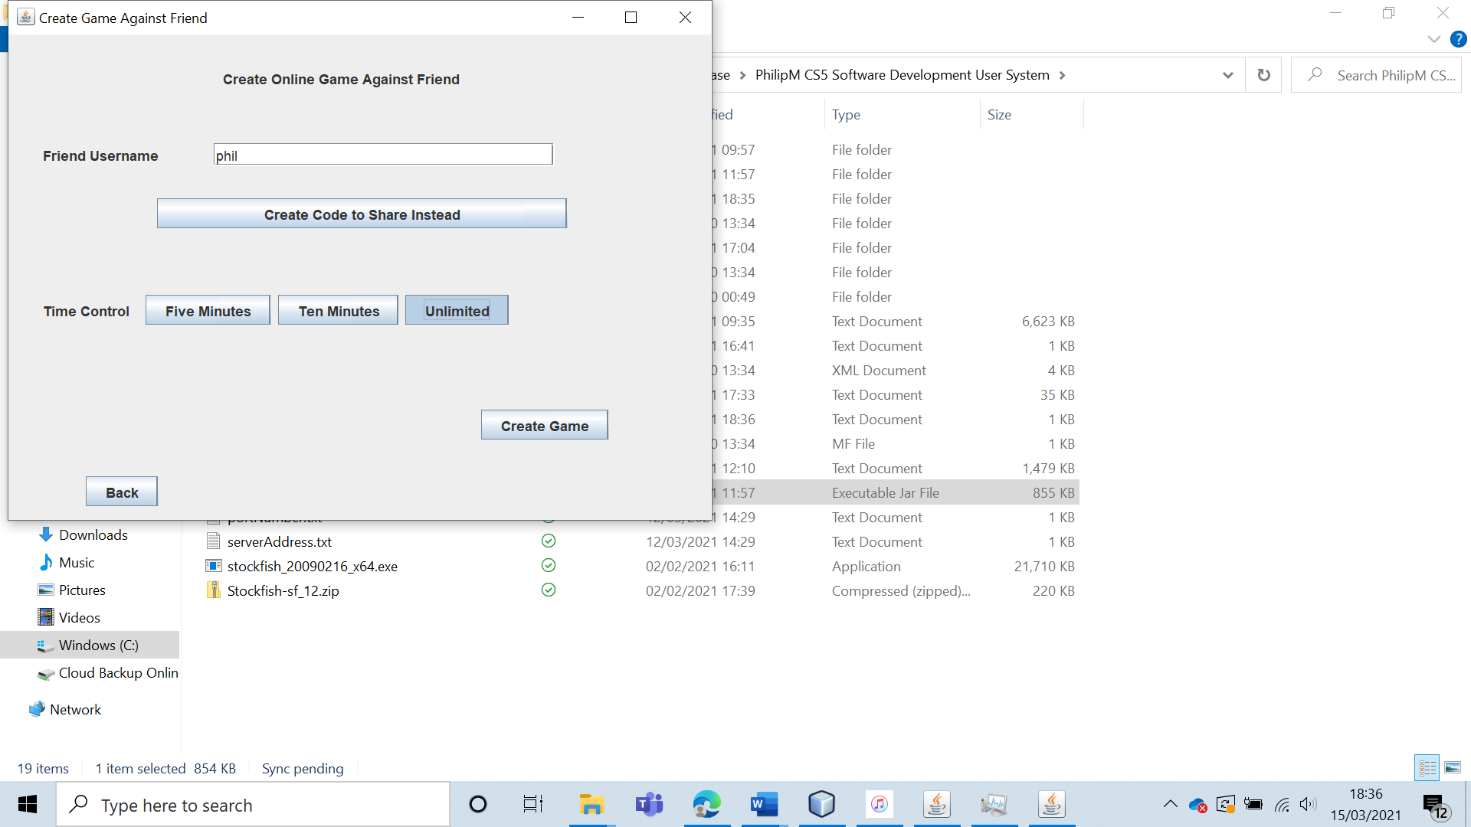

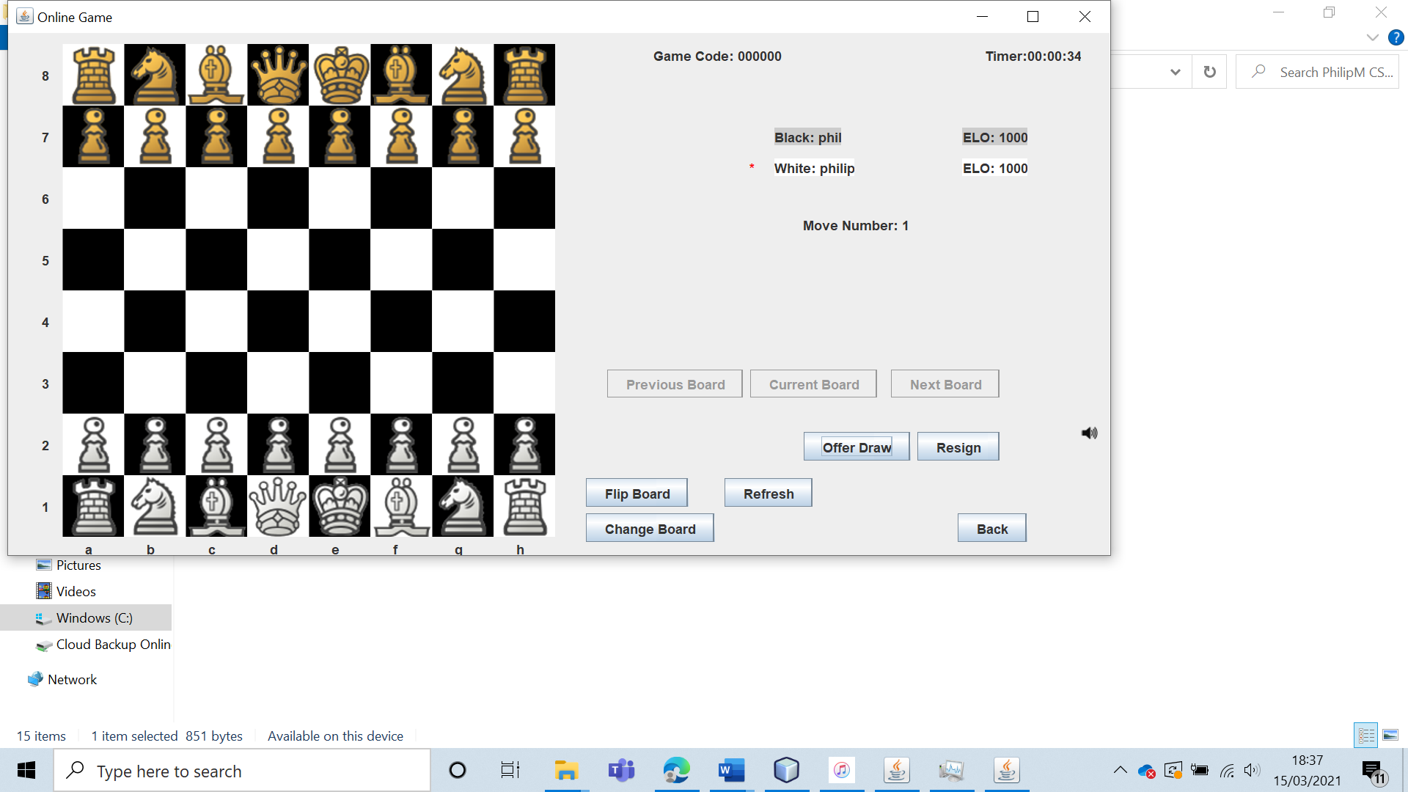  
This game was then drawn.

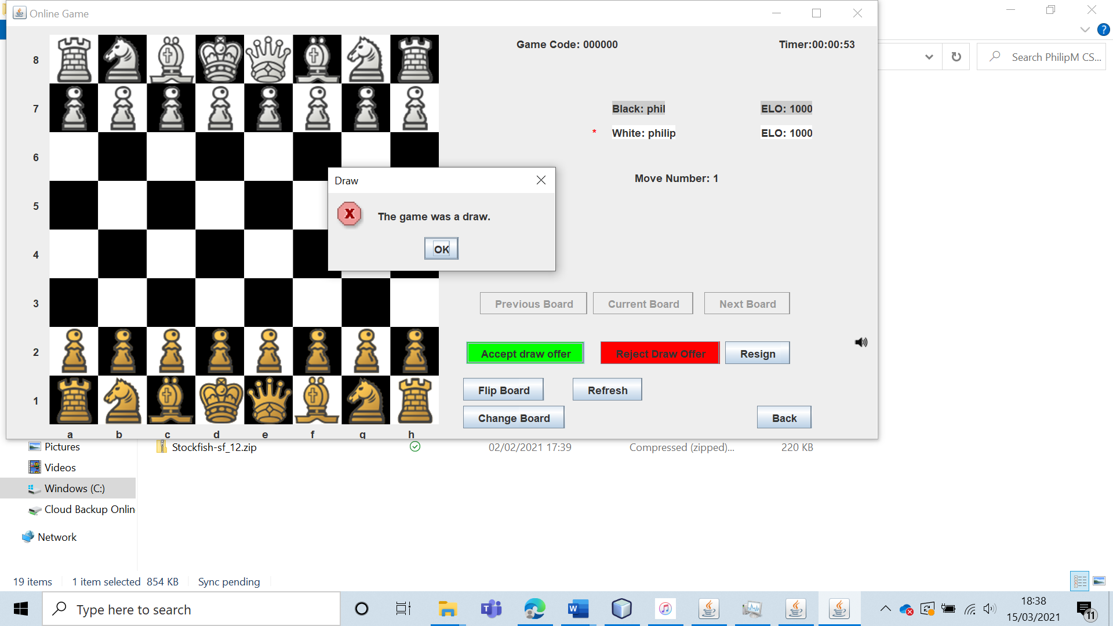

Both users had their ELO ratings remain unchanged at 1000.

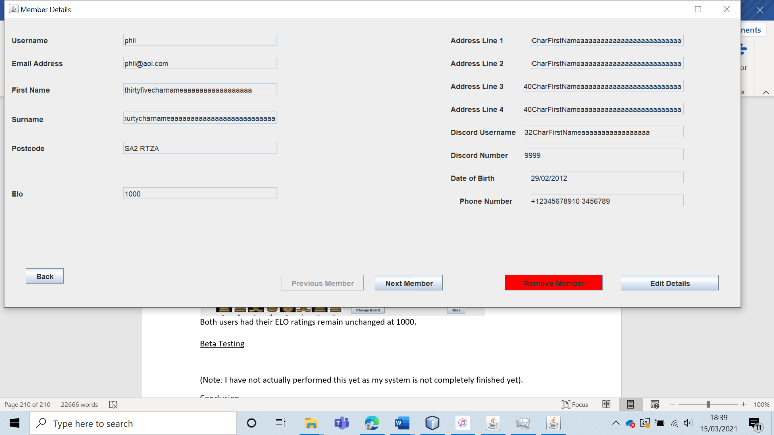

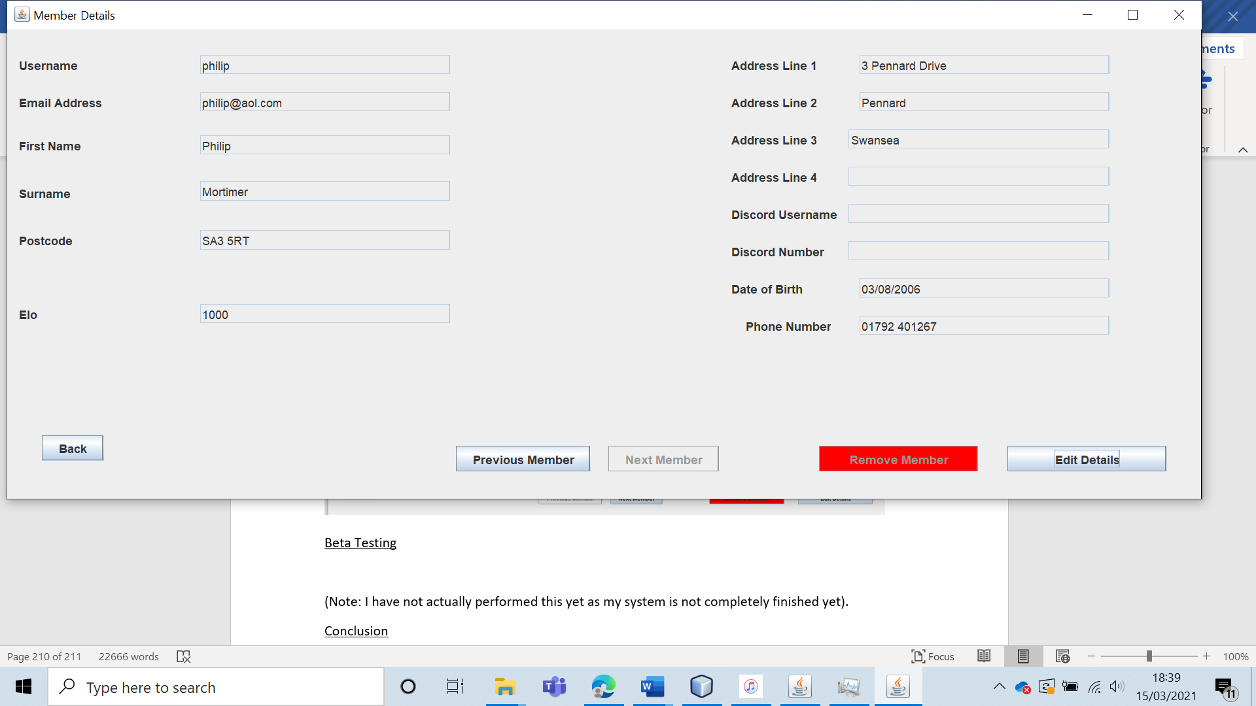

|  |  |  |  |  |  |  |
| --- | --- | --- | --- | --- | --- | --- |
| 63 | Play an online game against a user and have white win the game. Verify that the ELO update functions. | To verify that the ELO rating is calculated correctly. | D2 | The ELO rating should be updated to the calculated value. | 16, 16a, 16ai, 18d and 18di. | The ELO of both players was correctly updated. |

Test 63 (D2)

I will have the user “philip” play as white against “phil”. I will have “phil” resign the game, leading the game to result in a white win.

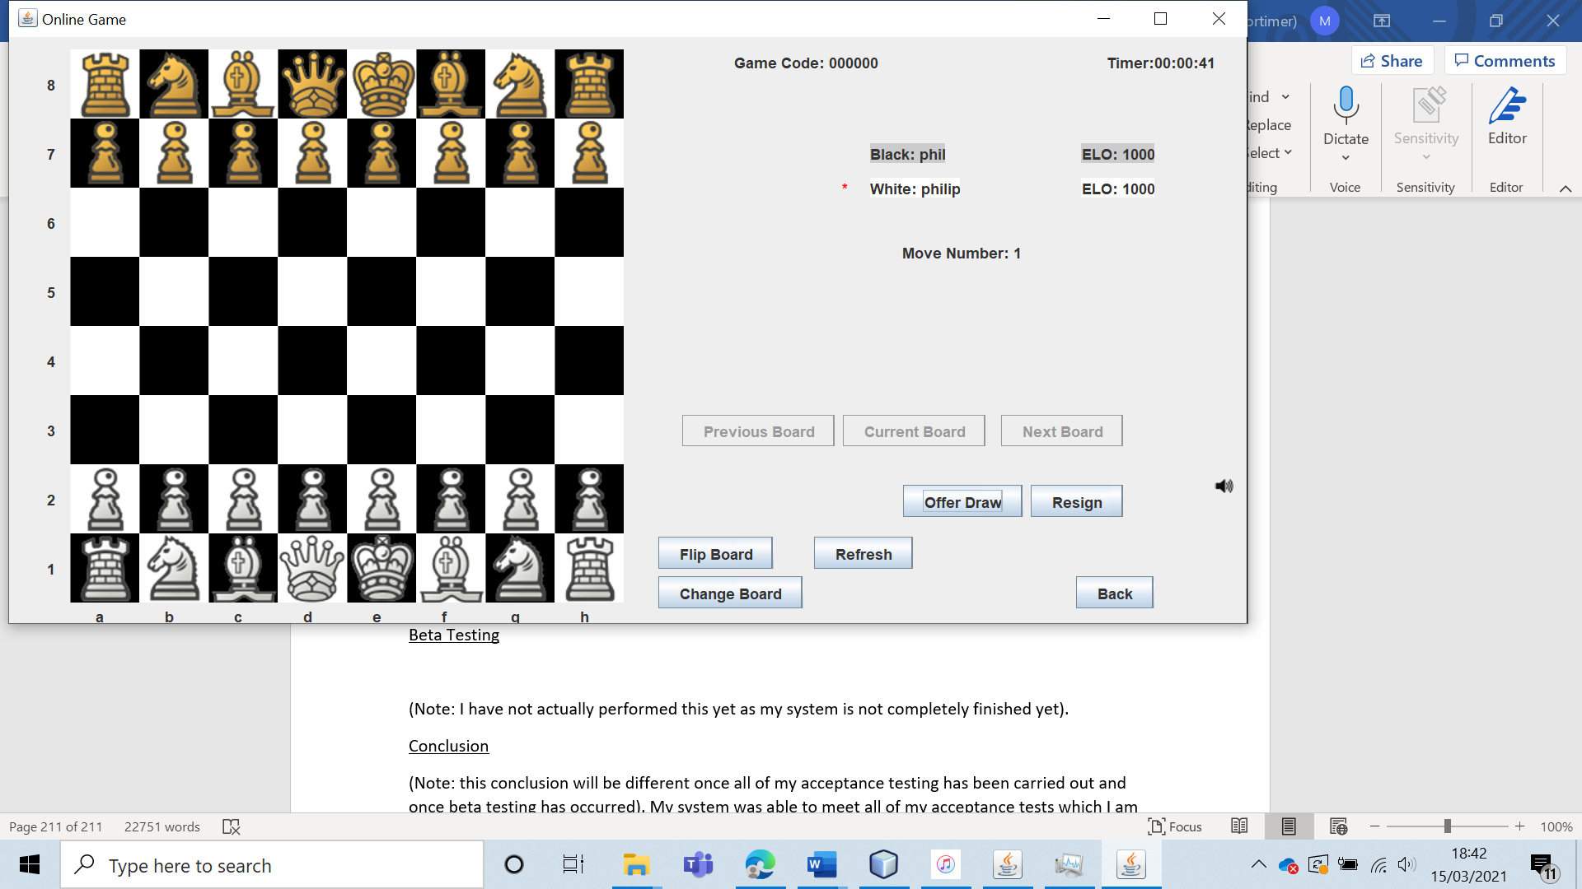

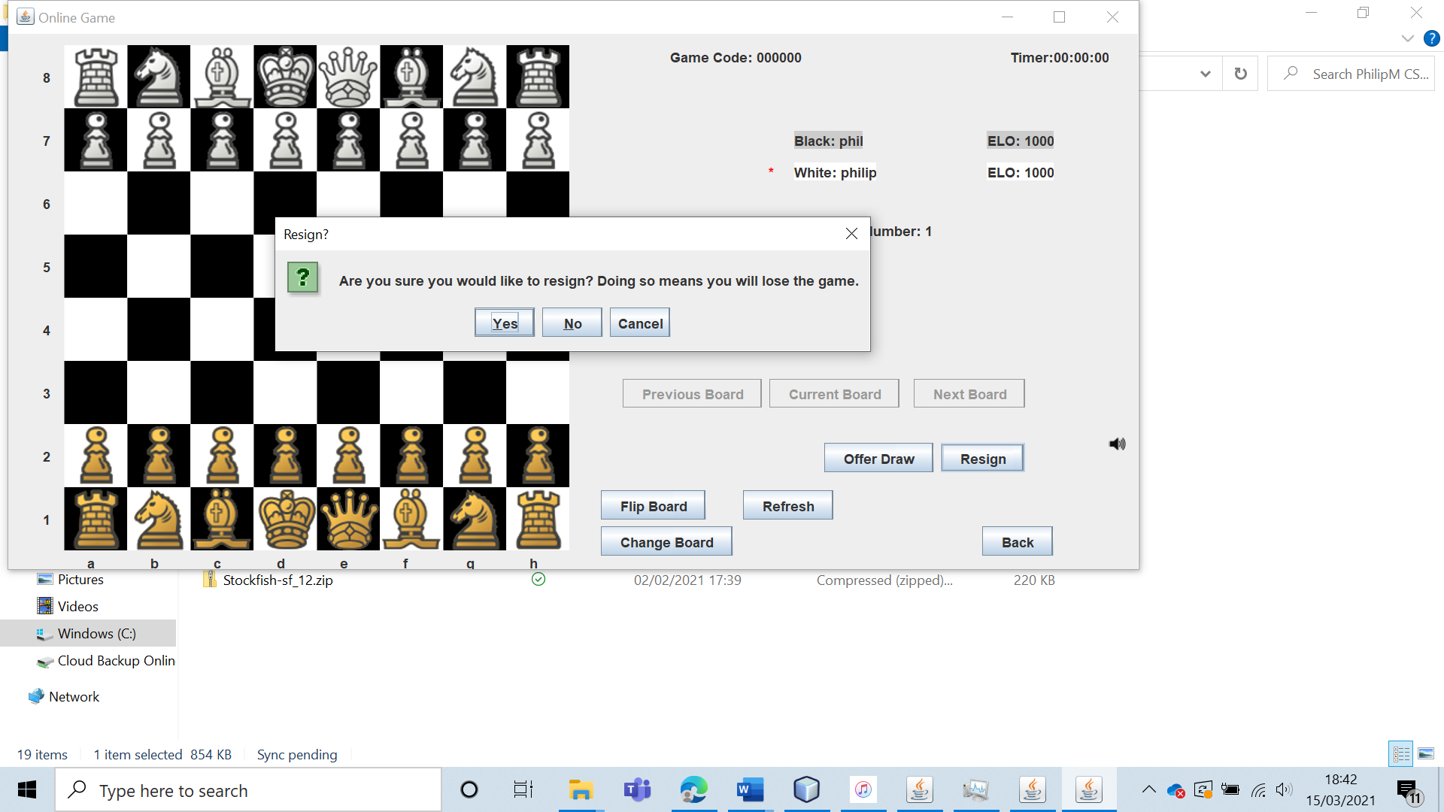

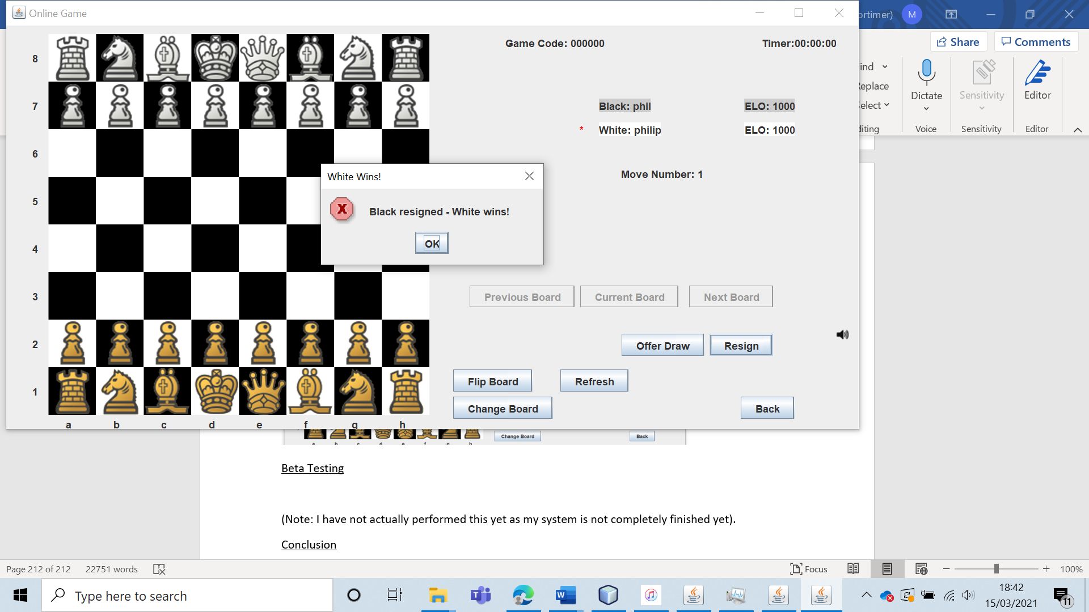

As expected, the White player’s ELO was updated to be 1012 whilst the black player’s ELO was set to be 988.

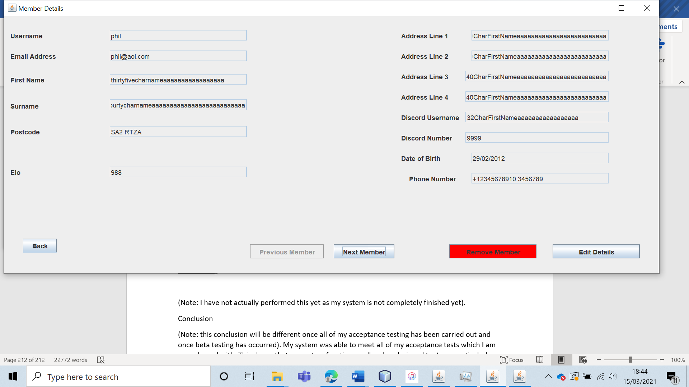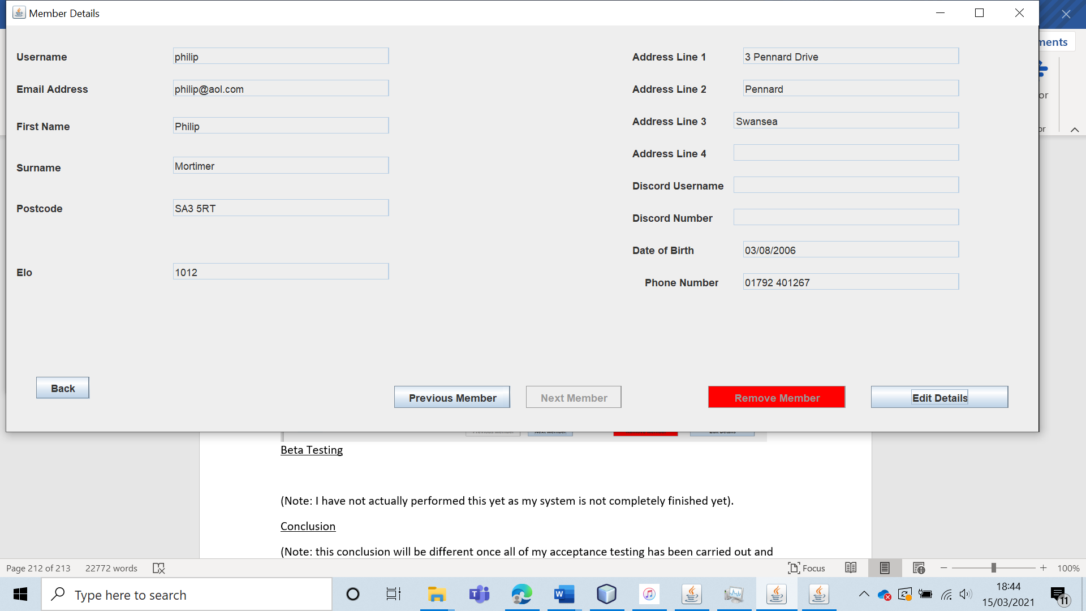

|  |  |  |  |  |  |  |
| --- | --- | --- | --- | --- | --- | --- |
| 64 | Play an online game against a user and have black win the game. Verify that the ELO update functions. | To verify that the ELO rating is calculated correctly. | D3 | The ELO rating should be updated to the calculated value. | 16, 16a, 16ai, 18d and 18di. | The ELO scores are updated to the correct values. |

Test 64 (D3)

To test this, I had the user “philip” play against “phil”. Both users started with an ELO rating of 1000.

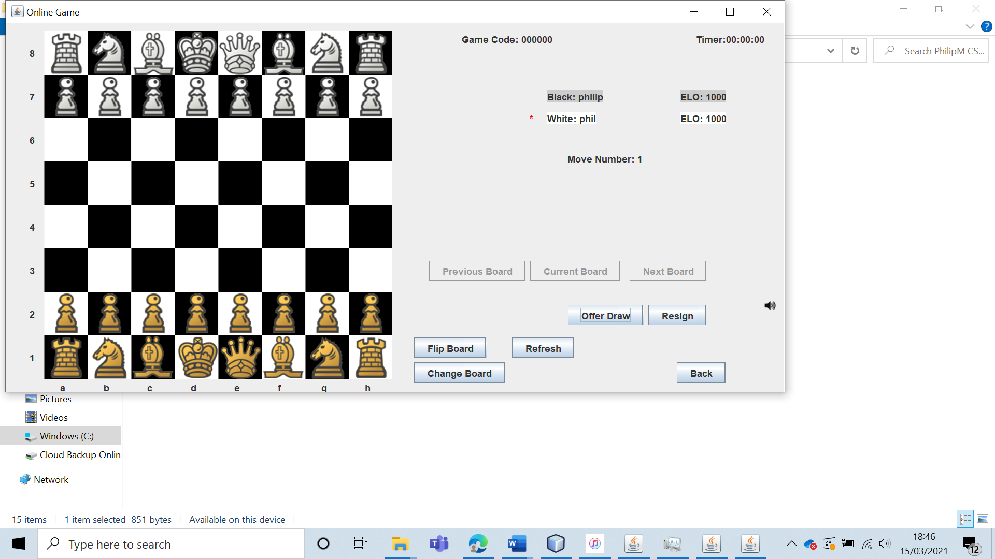

Then, I had the white player (“phil”) resign the game.

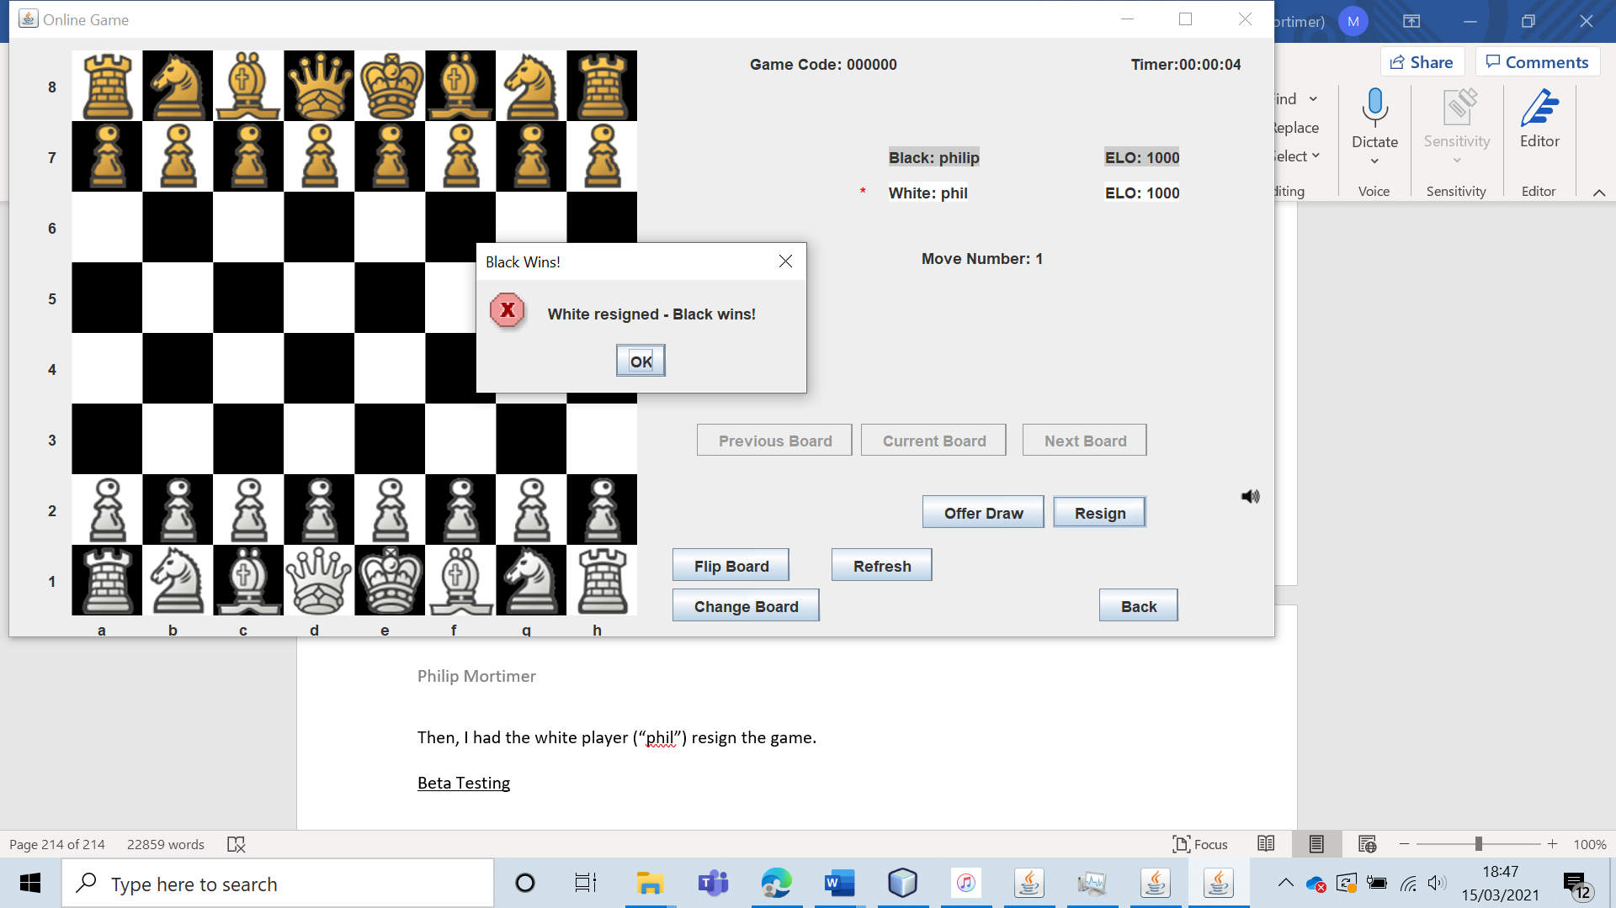

Following this win for black, the ELO of both users was updated to the expected value.

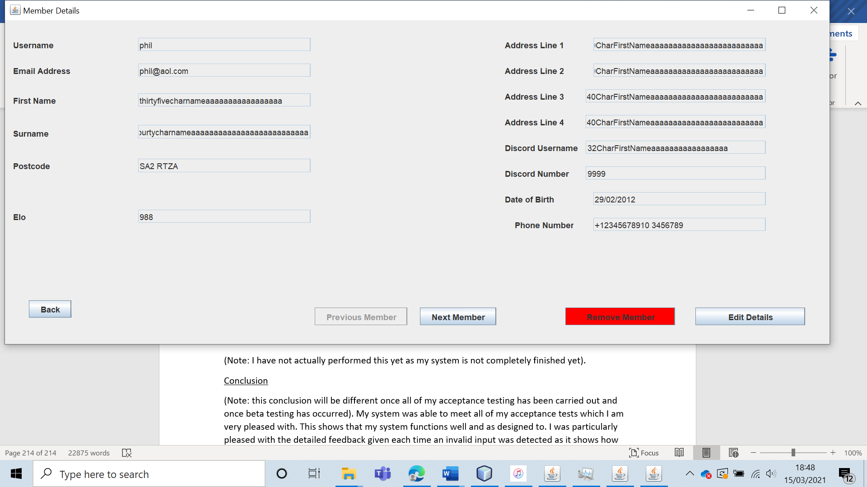

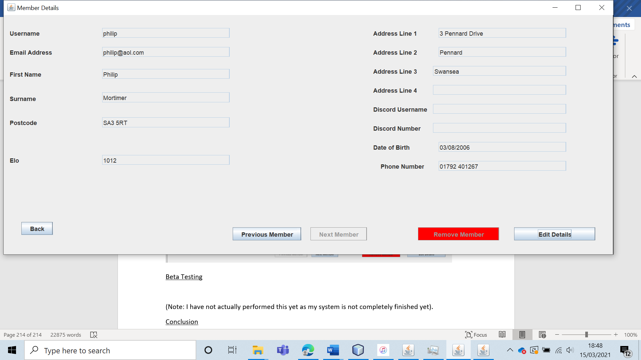

This clearly shows that the ELO calculation is implemented correctly.

|  |  |  |  |  |  |  |
| --- | --- | --- | --- | --- | --- | --- |
| 65 | Get all user types to view the club contact information and verify that the data for each user is displayed. | To ensure that all users connected to the internet can view the chess club’s contact information. |  | The contact information should be visible to all user types. | 15, 15a and 15ai. | The club contact information was visible to all users. |

Test 65

To do this, I logged in as a guest, non-member user, non-leader member and as the leader. In each of these instances, the club contact information was correctly displayed in the West Cross Chess Club section.

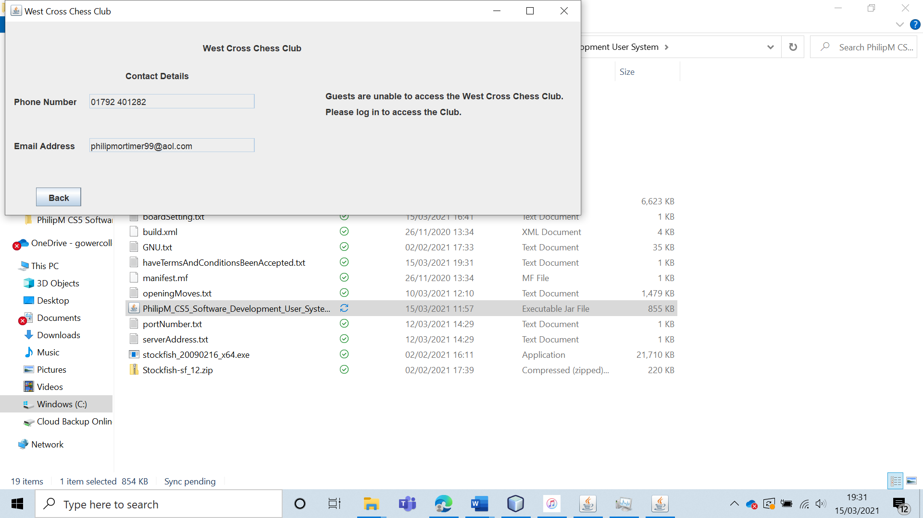

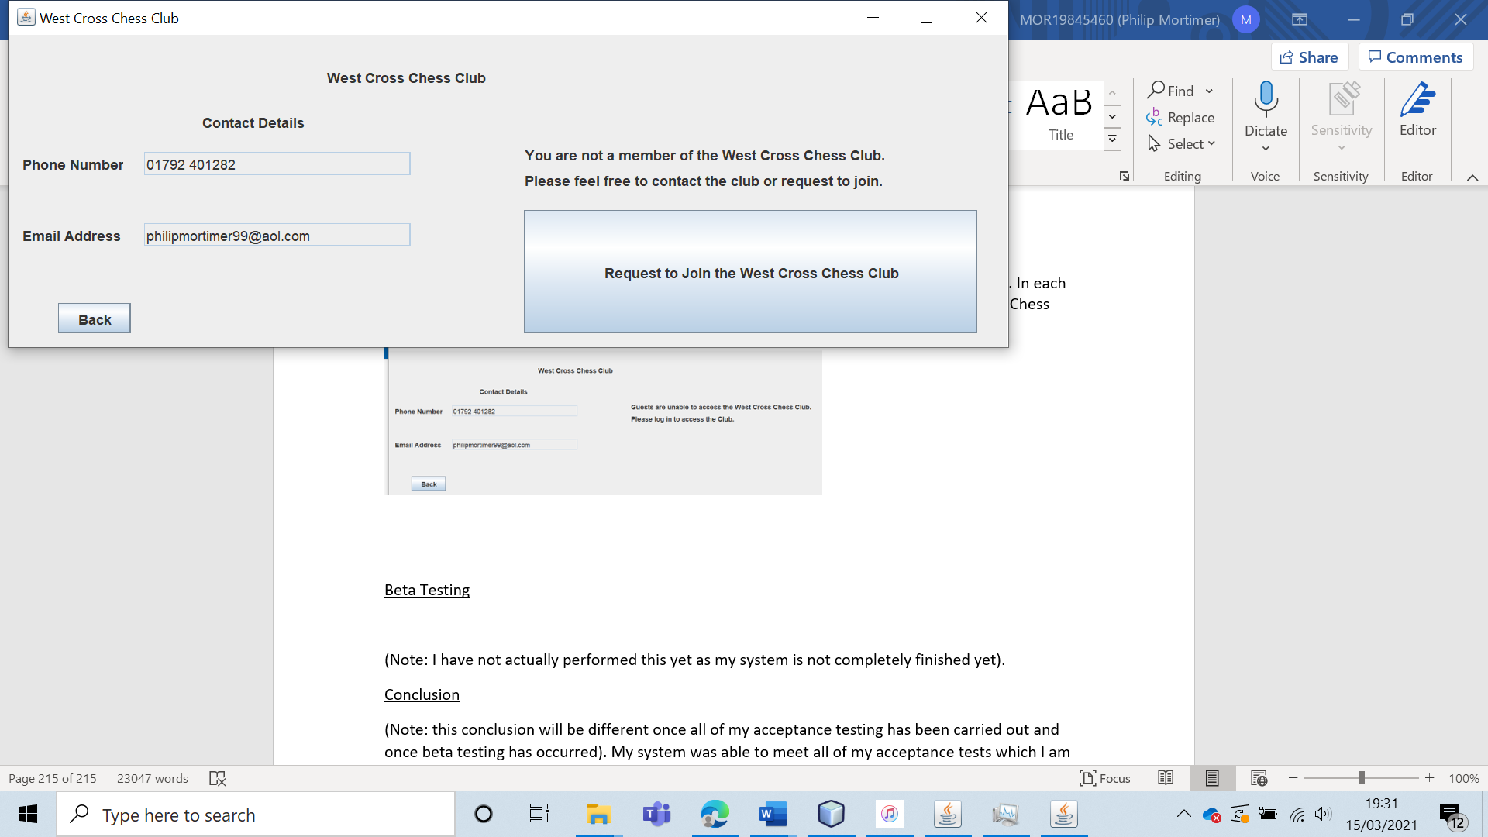

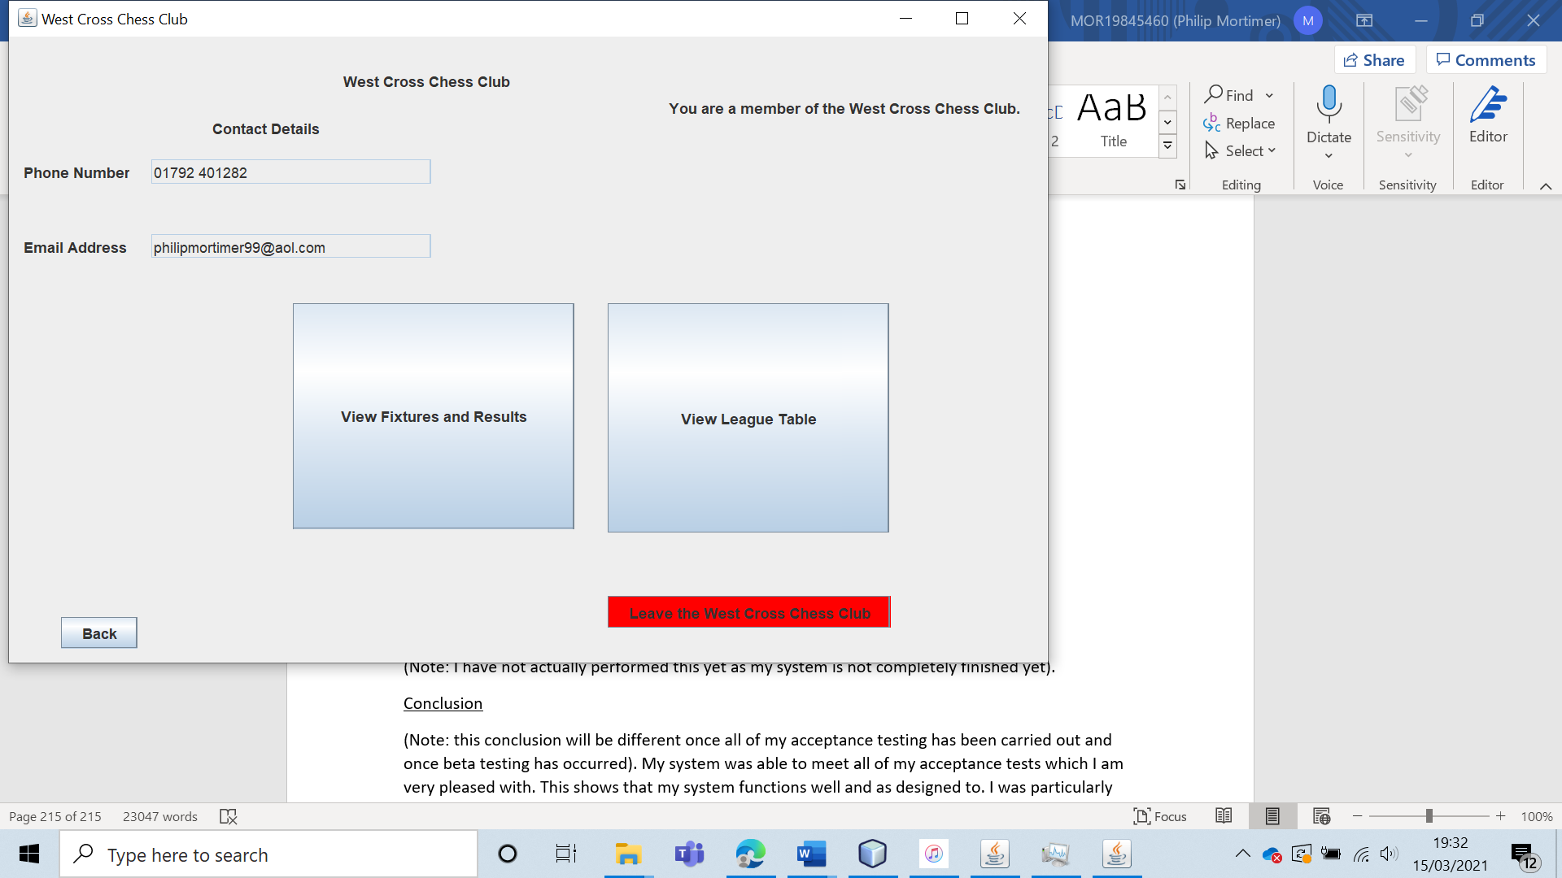

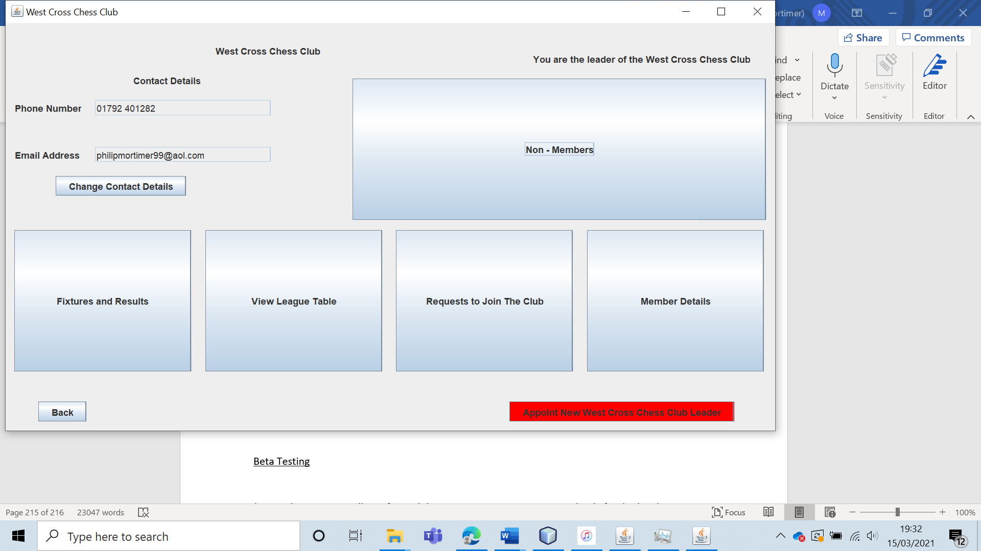

|  |  |  |  |  |  |  |
| --- | --- | --- | --- | --- | --- | --- |
| 66 | Get the club leader to change the club contact information and verify that the change is saved. | To verify that the leader can edit the club contact details |  | The new club contact information should be saved and displayed to all users. | 15, 15a and 15ai. | The contact details are updated and saved. |

Test 66

To do this, I logged in as the club leader and changed the club contact email address from “philipmortimer99@aol.com” to “philip@gmail.com”. I changed the phone number from “01792 401282” to “07983 929268”.

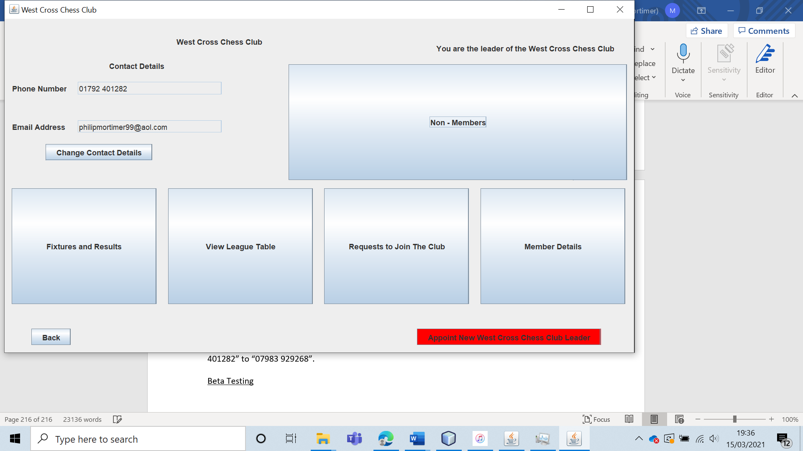

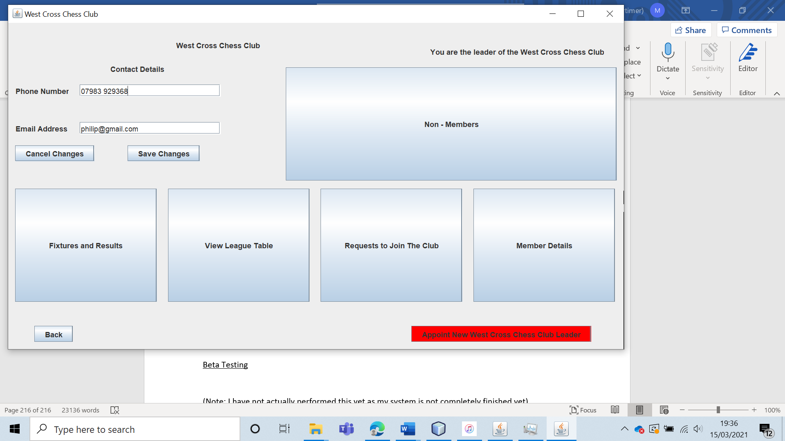

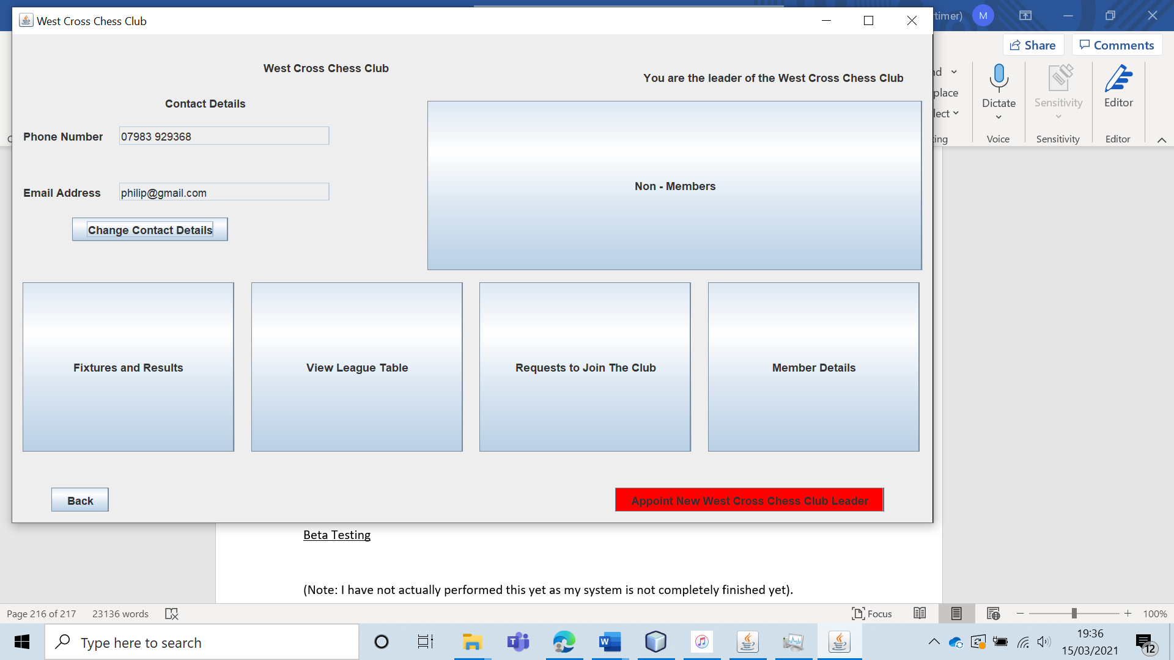

And sure enough, the contact details are updated to their new values.

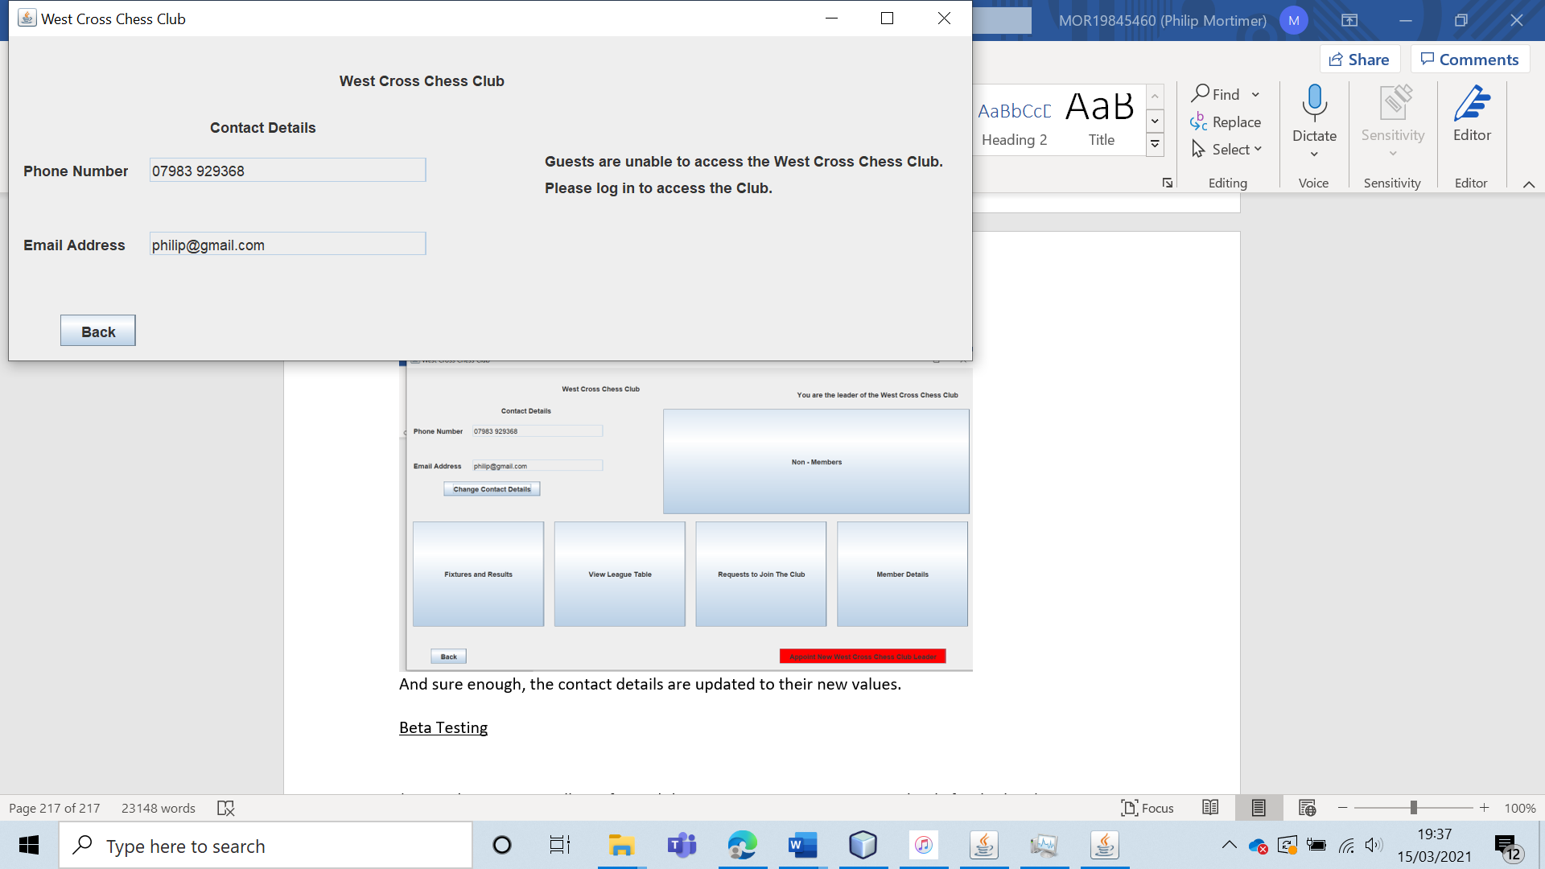

|  |  |  |  |  |  |  |
| --- | --- | --- | --- | --- | --- | --- |
| 67 | Play online game with two different accounts and verify that both usernames and ELO ratings are displayed. | To verify that both players in an online can see both their own username and ELO rating as well as that of their opponent. |  | The correct username and ELO score of both players should be displayed. | 17, 17a and 17ai. | The system displays both players’ usernames and their ELO ratings. |

Test 67

To test this, I created a game of “philip” against “phil”. The user “phil” has an ELO rating of 988 and the user “philip” has an ELO rating of 1012.

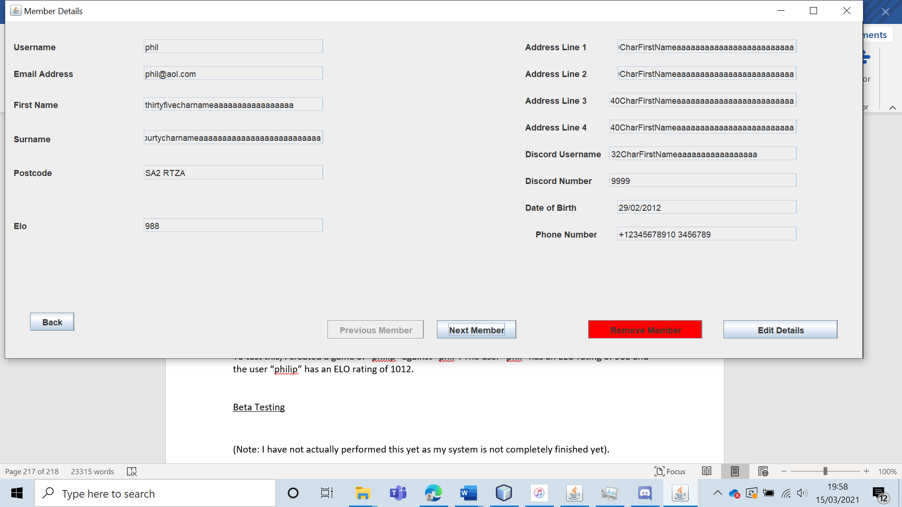

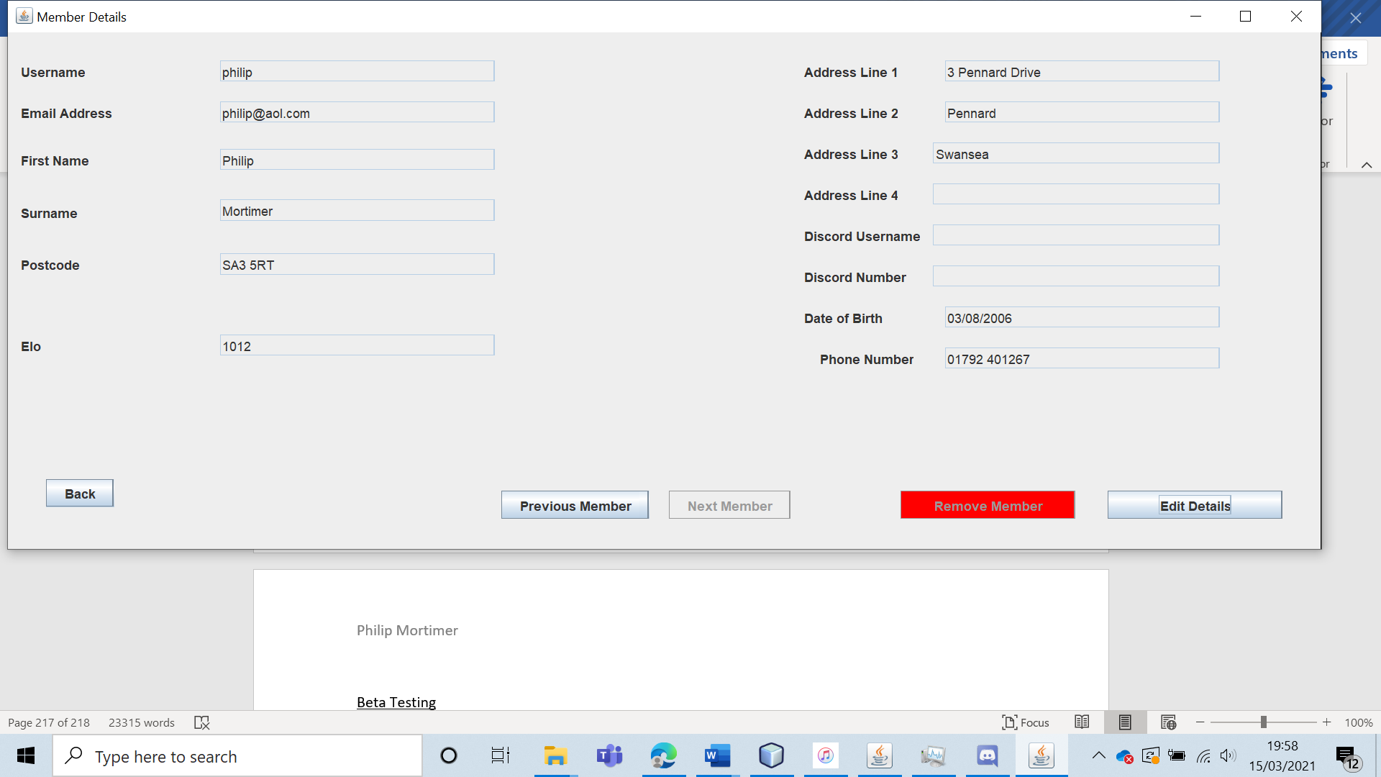

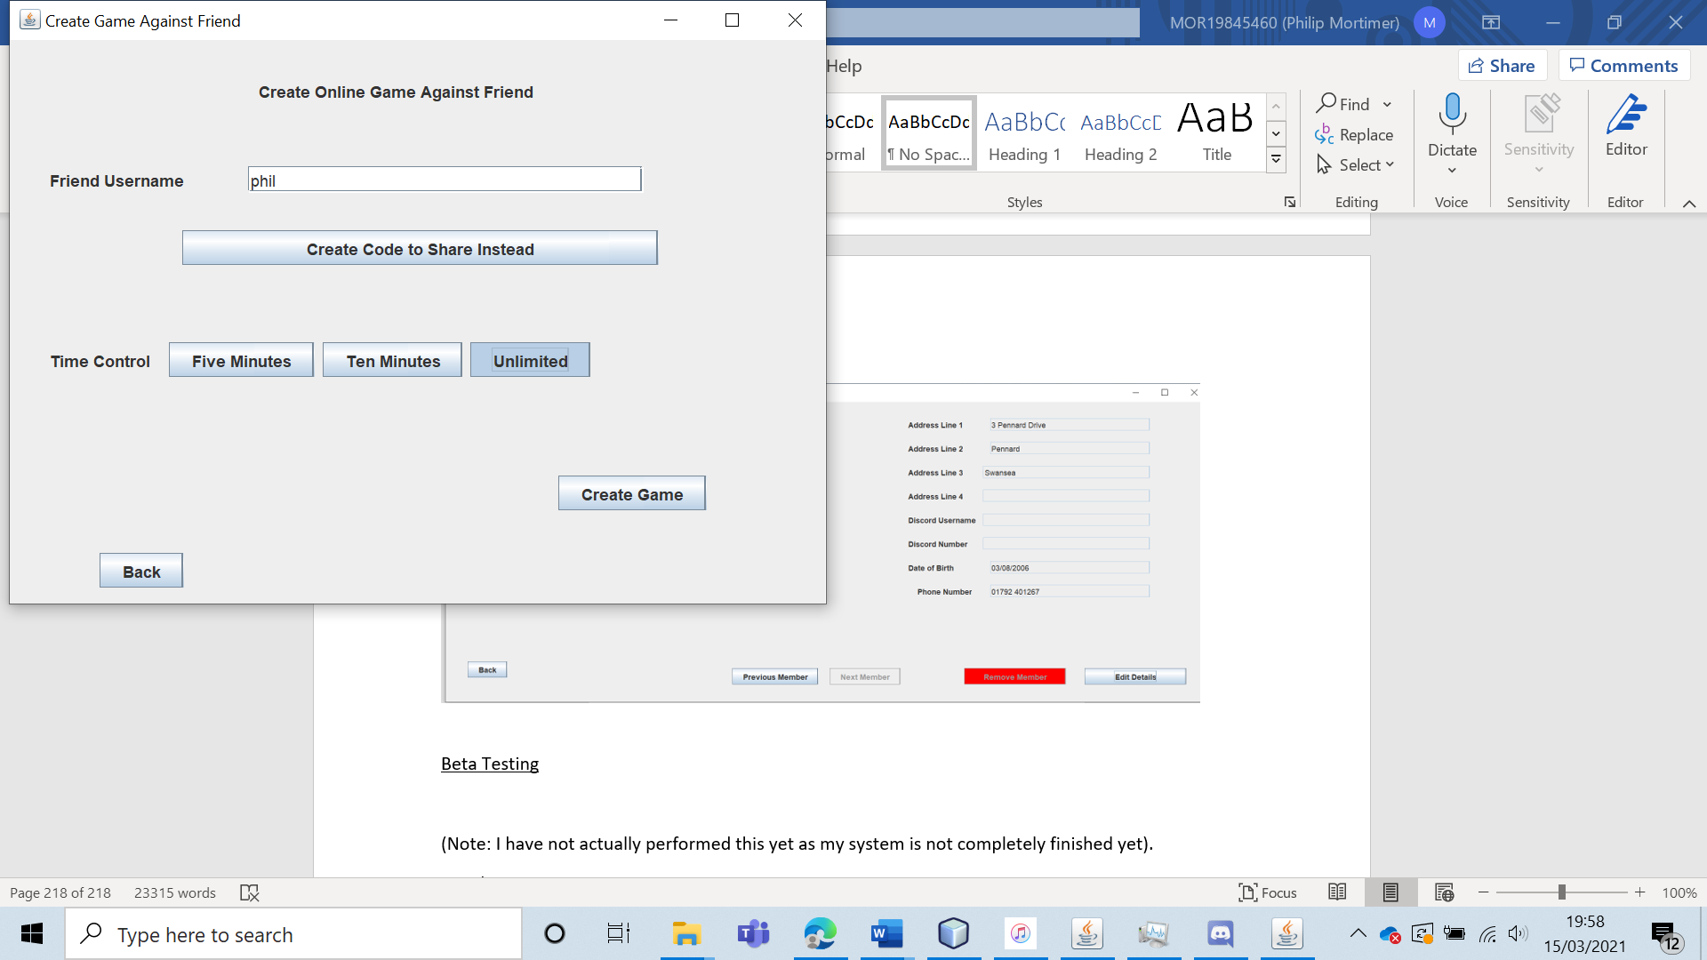

When playing the game, the ELO rating of both players and their usernames are clearly visible.

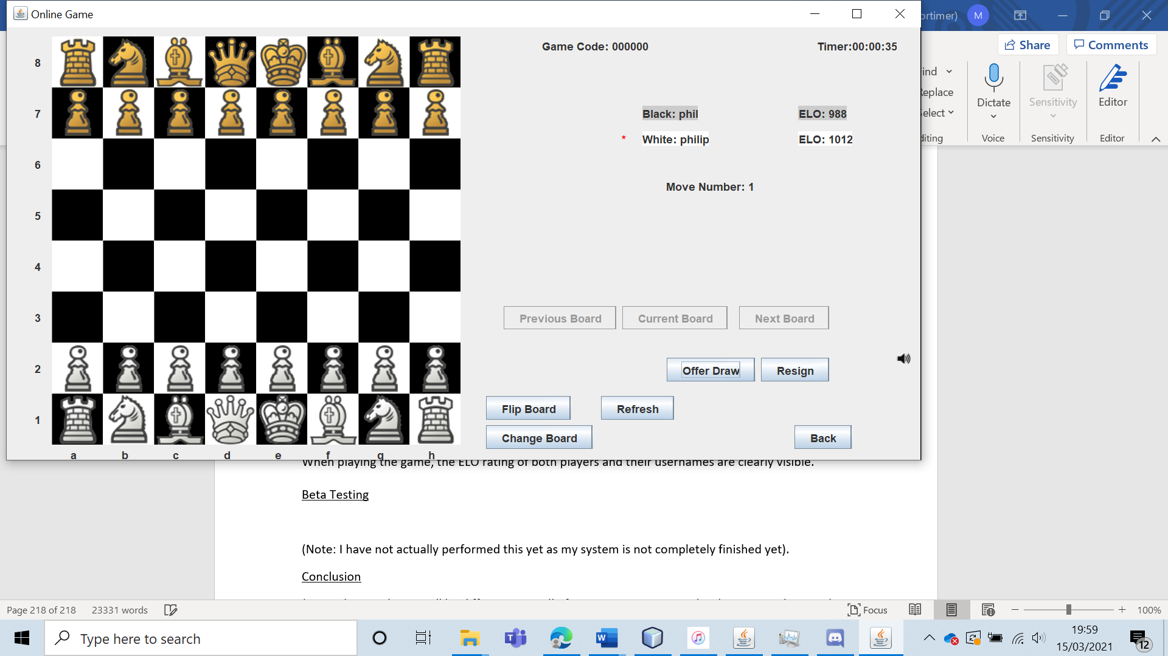

|  |  |  |  |  |  |  |
| --- | --- | --- | --- | --- | --- | --- |
| 68 | I will ask my client whether the system meets his requirements. | To verify that the system meets the demands of my client. |  | Hopefully, Lewis James (my client), will feel that the system does meet his vision. | 18b and 18bi. | Lewis James says that the system does everything he asked for / wanted it to do. |

Test 68

To test this, I asked Lewis James whether the system fully meets the system requirements and does everything he wishes it would do.

His response to “Does the system fully meet your system requirements and perform everything you want it to?” was “Absolutely, it does everything I want it do and it does it very well.”. This is strong validation for the success of my project and shows that I have meet my client’s demands.

Beta Testing

For the beta test, I gave five West Cross Chess Club Members access to the completed system for a week. I also gave the system to five of my friends (who are not member of the West Cross Chess Club) for the week. Lewis James (the West Cross Chess Club leader and my client) was also given full access to the system during the week. I used such a wide pool of users to cover all potential types of system users, who will have different requirements from the system. This should help me to get a strong idea of how suitable the system is – both in terms of number of errors in the code and in terms of whether it meets the full requirements of its target audience. To gauge how the system performed, I had all beta test participants fill out a questionnaire. Here is a copy of the questionnaire form.

1. Please select the status that best describes your involvement with the West Cross Chess Club. No involvement Member of the Club Leader of the Club
2. How easy is it to navigate through the system? Please answer with a number from 1 – 5 with 5 being very easy and 1 being very difficult. 1 2 3 4 5
3. On scale of 1 – 5, how clear is the menu? 5 is very clear whilst 1 means that the menu is very tricky to navigate. 1 2 3 4 5
4. How visually pleasing is the chess board? Give your answer from 1 – 5. 5 indicates very visually pleasing and on par with major chess software. 1 indicates that the board looks very bad. 1 2 3 4 5
5. Please rate on a scale from 1- 5 how easy and intuitive it is to play a game of chess using my system. 5 indicates very easy and intuitive and 1 represents extremely difficult and obtuse. 1 2 3 4 5
6. How suitable are the range of computer opponents? Highly Unsuitable Somewhat Unsuitable Suitable Highly Suitable
7. Which of these best describes how the system functions? Frequent number of serious errors and minor errors Some serious errors and frequent minor errors Few to no serious errors and some minor errors Few to no serious errors and few to no minor errors
8. How enjoyable has online chess play been? Very poor Poor Enjoyable Highly Enjoyable
9. How useful has the West Cross Chess Club section been for your needs? Useless Not very useful Useful Very useful
10. Does the system have all major features you would want it to have? No Yes
11. If you answered yes to question 10, please elaborate on what other features you would wish to see in the system.

……………………………………………………………………………………………………………………………………………

Here are the results of the form:

Overall Results

1.

|  |  |  |
| --- | --- | --- |
| No involvement | Member of the Club | Leader of the Club |
| 5 | 5 | 1 |

2.

|  |  |  |  |  |
| --- | --- | --- | --- | --- |
| 1 | 2 | 3 | 4 | 5 |
| 0 | 0 | 1 | 3 | 7 |

3.

|  |  |  |  |  |
| --- | --- | --- | --- | --- |
| 1 | 2 | 3 | 4 | 5 |
| 0 | 0 | 0 | 3 | 8 |

4.

|  |  |  |  |  |
| --- | --- | --- | --- | --- |
| 1 | 2 | 3 | 4 | 5 |
| 0 | 0 | 0 | 0 | 11 |

5.

|  |  |  |  |  |
| --- | --- | --- | --- | --- |
| 1 | 2 | 3 | 4 | 5 |
| 0 | 0 | 0 | 2 | 9 |

6.

|  |  |  |  |
| --- | --- | --- | --- |
| Highly Unsuitable | Somewhat Unsuitable | Suitable | Highly Suitable |
| 0 | 0 | 1 | 10 |

7.

|  |  |  |  |
| --- | --- | --- | --- |
| Frequent number of serious errors and minor errors | Some serious errors and frequent minor errors | Few to no serious errors and some minor errors | Few to no serious errors and few to no minor errors |
| 0 | 1 | 4 | 6 |

8.

|  |  |  |  |
| --- | --- | --- | --- |
| Very Poor | Poor | Enjoyable | Highly Enjoyable |
| 0 | 0 | 0 | 11 |

9.

|  |  |  |  |
| --- | --- | --- | --- |
| Useless | Not very useful | Useful | Very Useful |
| 0 | 1 | 7 | 3 |

10.

|  |  |
| --- | --- |
| No | Yes |
| 0 | 11 |

*11.No responses*

Analysis of Beta Test Results

All users report that the system was easy to navigate, with the most common answer by far being that the system is “very easy to navigate”. This conclusively shows that the system is designed in a way that makes it very easy to navigate. This shows that I have designed a user interface that is easy to use and highly effective. This is supported by the fact that the vast majority of users thought that the menu was very clear and easy to use. One of the core focuses of my system was making it very friendly to those not very experienced with technology as it was one of the biggest problems with some of the existing systems. I feel that my beta test shows beyond doubt that the system is very easy to use and very user friendly.

All 11 respondents stated that the interface used for the chess board looked “very visually pleasing and on par with major chess software”. This is important as a board needs to look good in order to make the playing experience enjoyable. This once more demonstrates that the user experience is a highly positive one.

When asked about how intuitive and easy to use the control scheme was, 9 participants gave the most positive score and the remaining 2 gave the next most positive score. This shows that the users all found the control experience to be enjoyable. This is encouraging as it highlights that users of all backgrounds are able to easily play chess in a way that is enjoyable and satisfying. Users have overwhelming said that the chess board looks visually pleasing and that the process of playing chess is easy and enjoyable. This shows that the actual process of playing chess is very refined and highly enjoyable and suitable for users.

Once more, the users overwhelmingly said that the range of computer opponents was very suitable. This shows that I have succeeded in the coding and designing of all computer opponents. The beta test has already highlighted that the actual process of playing chess is enjoyable. Hence, I feel that the beta test shows that the offline play section is well implemented and really enjoyable for users to use.

The fact that this is the most negative feedback for the entire beta test highlights that the system is highly suitable for its purpose and target audience. Only one user experienced a serious error, and the majority of users reported no errors (including the club leader). This is encouraging and shows that my system has been well designed and coded. Disappointingly, a fairly large group of the beta testers did encounter a small number of minor errors. However, minor errors are annoying but do not significantly impact the system’s function. If I were to spend more time on the project, I would certainly spend more time debugging the system. It was also very pleasing that no server-side errors occurred throughout the entire beta testing process. The only major error occurred when one of the users was playing an online game and lost internet connection momentarily. They were shown about 5 error messages before they were finally sent to the main menu. Whilst this error is certainly valid, it did not impact the online game record in any way and the user still able to use the system as intended (although there were far too many errors). Whilst the error is serious, the system did eventually manage to handle the error and return to a stable state, showing that the error did not actually prevent any system functionality. However, if given more time, I would look at fixing this and handling thread termination for online play more elegantly. All other minor errors encountered had previously been encountered and discussed in the acceptance testing. I am still pleased with my system as no errors occurred that led the system to crash or function incorrectly. All of the errors led to some form of user inconvenience but did not impact the performance of the system. The fact that the majority of respondents said that the encountered no errors at all is very encouraging and shows that my system is well coded and that a general user can expect to encounter little to no bugs. Given more time, I could certainly fix all of the bugs, showing that they are minor code issues as opposed to systemic flaws.

All of the users stated that they found online chess play “highly enjoyable”. This is very promising and shows that the online section of the club has also succeeded. It also highlights that the general user experience is very enjoyable. Given the result of this question and previous questions, I feel that beta testing has conclusively shown that both online and offline play is of very high quality and fully meets the system requirements.

The results of question 9 shows that the West Cross Chess Club fully meets the system requirements. The club leader stated that it was “Very Useful” showing that the system fully meets his requirements (which is the most important part of the system). Furthermore, all of the club members said that the system was “Useful” or “Very Useful”. This is highly positive and shows that the system meets the needs of its audience. Given that the system for members is just a way of viewing data, I was surprised to see how useful the ability to view a league table and fixtures and results was. I suppose this highlight how poor the old system is, with all data being handled by the club leader. For those not involved with the club, the club section was still viewed as “useful”. This is very good and shows that should a user ever wish to join the club; they can do so very easily. Although, the club section is not tailored towards non-members, the fact that it was still deemed as useful shows that the system is well designed and meets user demands.

Finally, all respondents stated that the system had all major features that they would want out of the system. This is shows that my system does fully meet the needs of my client and the user base. I feel that this question shows very strongly that my system has succeeded by both meeting all demands of the users and meeting all of the aims and objectives set for it.

In conclusion, my beta test clearly shows that the system performs everything my client and the members of the West Cross Chess Club would want it to. The beta test shows that all areas of the system function very well and are very enjoyable to use. The feedback was overwhelmingly positive for all questions. The most major flaw with the system at the moment is a few minor bugs that make the user experience slightly annoying at times. However, no bugs that completely break the system were discovered in the beta test phase, showing that the code is robust and that the system functions well. Overall, I would say that the beta test shows that my system is successful as it meets the demands of my client, the target audience and the system’s aims and objectives.

Conclusion

My acceptance testing was remarkably positive, with the system passing all tests. Some minor bugs were discovered (which led some acceptance test to fail), but these were easy to fix. Upon fixing the bugs, all acceptance tests were passed. My acceptance testing demonstrates that all aims and objectives of the system have been met. Some minor visual errors were uncovered but not fixed, although these errors were minor and had very little impact on the user experience (and no impact on the system functionality). My testing was very thorough, covering all system features (and aims and objectives) and made use of a wide range of testing data for all places in the system where manual data entry was present. My system passed all of these tests, handling extreme, typical and erroneous data with specific messages that tell the user exactly what is wrong with their input (where appropriate). From my acceptance tests, I have full confidence that the system meets all aims and objectives and performs as expected. I also discovered no bugs that actually “broke” the system (i.e., prevented the system from functioning as intended). This shows me that the system is robust and functional. Following my beta testing, I found that the system was received positively by my client and the members of the chess club (who are my intended audience). The beta testing shows that all areas of the system function well and were both easy and enjoyable to use. My client stated the system had all required features and performed everything very well. The beta testing highlighted that a significant minority of users encountered a small number of minor bugs when using the system. Hence, I would say that the most significant improvement I could make to the system is to fix these minor bugs. However, my alpha and beta testing show beyond doubt that my system meets all of its aims and objectives. The tests show that the system does everything it should do, and that the system does it very well. In short, my tests show that I have achieved what I had set out to do when making the system and that the system is successful.